UNIVERSITY OF WAIKATO
Hamilton
New Zealand

The Value of Statistical Life and Cost-Benefit Evaluations of
Landmine Clearance in Cambodia

Michael Cameron, John Gibson, Kent Helmers, Steven Lim,
John Tressler and Kien Vaddanak

Department of Economics
Working Paper in Economics 04/08
March 2008
Corresponding Author

John Gibson
Economics Department
University of Waikato
Private Bag 3105
Hamilton
NEW ZEALAND

Tel: +64 (0) 7-838-4045

Email: jkgibson@waikato.ac.nz
Homepage: http://www.mngt.waikato.ac.nz

Michael Cameron  Department of Economics  University of Waikato  mcam@waikato.ac.nz |  | Kent Helmers  Independent  Consultant  kenthelmers@yahoo.com |  | Steven Lim  Department of Economics  University of Waikato  slim1@waikato.ac.nz
 | John Tressler  Department of Economics  University of Waikato  tressler@waikato.ac.nz |  | Kien Vaddanak  Disaster Management Dept.  Cambodian Red Cross  dmd.crc@bigpond.com.kh

Abstract

Development agencies spend approximately US$400 million per year on landmine clearance. Yet many cost-benefit evaluations suggest that landmine clearance is socially wasteful because costs appear to far outweigh social benefits. This paper presents new estimates of the benefits of clearing landmines based on a contingent valuation survey in two provinces in rural Cambodia where we asked respondents questions that elicit their tradeoffs between money and the risk of death from landmine accidents. The estimated Value of a Statistical Life (VSL) is US$0.4 million. In contrast, most previous studies of landmine clearance use foregone income or average GDP per capita, which has a lifetime value of only US$2,000 in Cambodia. Humanitarian landmine clearance emerges as a more attractive rural development policy when appropriate estimates of the VSL are used.

Keywords

benefit-cost analysis
contingent valuation
landmines
value of statistical life

JEL Codes

J17; O22

Acknowledgements

We are grateful for funding from the Waikato Management School and the Asia 2000 Foundation and to assistance from the team of Cambodian interviewers, and especially the respondents. The paper has also benefited from the comments of audiences at the AARES and NEUDC conferences and a seminar at the Australian National University. All errors and omissions are the responsibility of the authors.

1. Introduction

The Value of a Statistical Life (VSL) is a key input into cost-benefit evaluations of interventions that save lives. One such intervention that is at the intersection of environmental and development economics is the clearance of landmines and unexploded ordnance (UXO) from rural areas of developing countries. Global reported casualties from landmines and UXO are approximately 8000 per year but informed estimates are as high as 15,000-20,000, being highest in Iraq, Afghanistan and Cambodia. (ICBL, 2006). Since 1992, the global community has spent over US$2.5 billion on humanitarian mine clearance and other mine action (e.g. fencing off suspected minefields, and education programs), with annual spending peaking at approximately US$400 million in 2004 (ICBL, 2006). In Cambodia, which is the setting for this paper, annual spending on humanitarian mine clearance since 2000 has been approximately US$25 million, with about 98% of this from donors.

Despite this large investment, many cost-benefit analyses (CBA) of landmine clearance conclude that it is socially inefficient. Harris (2000) estimates that expenditure to remove landmines from Cambodia would produce benefits – in the form of saved lives, reduced injuries and medical costs, and greater agricultural output – worth just 2% of the costs. Elliot and Harris (2001) estimate benefits in Mozambique worth only 10% of costs. For Bosnia and Herzegovina, Mitchell (2004) concludes that demining cannot be justified on development grounds. More recent studies consider targeted clearance of areas needed for existing infrastructure and new development projects, since this is a better representation of how mine clearance agencies actually operate. In Cambodia, there appear to be positive benefit-cost ratios for targeted clearing of irrigation systems, water supplies, roads and bridges, school premises, health stations and historical sites, but costs still generally exceed benefits for the clearance of agricultural land (Gildestad, 2005).

Inadequate data may have biased CBA evaluations of landmine clearance since most studies value injuries and premature death using the present value of lost earnings (or lost GDP). This foregone earnings approach is no longer popular in developed countries because it greatly underestimates the value of life (Rosen, 1988). Instead, researchers and policymakers routinely use VSL estimates calculated either from reports by survey respondents of how much they would be willing to pay for a small reduction in risk (or how much they would need to be paid to accept a small increase in risk) or from market based, revealed preference studies. These VSL estimates are typically up to 200 times GDP per capita in developed countries (Miller, 2000). There are too few estimates from developing countries to know whether the same ratio holds. The theoretical superiority of VSL measures is recognised in the landmine literature (e.g. Harris, 2000) but since few estimates exist for landmine affected countries imperfect foregone earnings methods are used. Perhaps as a result, saved lives and disabilities provide only a small part of the calculated benefit of landmine clearance, whereas the value of statistical life is easily the largest benefit of environmental, health and safety rules in developed countries (Shogren and Stamland, 2002).

While CBA evaluations may have underestimated the value of lives saved, mine clearance agencies may overestimate these values. Most landmines are located in poor countries, but most landmine clearance is paid for by rich country donors and NGOs. Elliot and Harris (2001) suggest that donors may value the lives saved by clearing mines using standards from their own (rich) countries. Over-valuing saved lives could explain why landmine clearance standards are so strict, requiring 100% removal of mines and UXO (UNMAS, 2003) which is argued by some to put mine clearance programs into the suboptimal range where marginal cost exceeds marginal benefit (Keeley, 2006).

Without reliable estimates of the VSL, any CBA evaluation of mine clearance is uncertain. One approach sometimes used in settings without VSL estimates is to base CBA calculations on VSLs transferred from elsewhere, using an assumed elasticity of the VSL with respect to income (e.g., Aunan et al, 2007). But it is not clear that this approach can give reliable estimates since the VSL should also differ with levels of risk and awareness of the particular source of risk. For example, Gibson et al (2007) carry out a CBA of landmine clearance in Cambodia, using VSL estimates transferred from a survey in Northern Thailand. However, almost none of the respondents in the Thai survey had first-hand experience of landmines so it is not clear that their stated VSL would be the same as for rural villagers in Cambodia for whom landmines are a much more salient risk. Therefore the most reliable input into CBA evaluations of landmine clearance should be from VSL estimates that are generated in the affected areas rather than transferred from elsewhere.

The present paper represents an attempt to estimate the VSL using the contingent-valuation (CV) method in rural Cambodia. With over 46% of Cambodian villages still contaminated by landmines (CMAC 2002), landmine removal is vital to economic progress in Cambodia’s rural areas. Moreover, the number of civilian landmine victims has not fallen significantly over the last six years of demining activity, suggesting that direct removal efforts are slow relative to the total size of the problem. In fact, a reliance on painstaking manual clearance methods has seen only 171 km² cleared between 2000 and 2005, at a cost of almost US$1million per km² ($10,000 per hectare), compared with an estimate from CMAC (2002) of 4,500 km² suspected to be contaminated by landmines and UXO.

To illustrate the implications of the VSL estimates for CBA studies of mine clearance, we reconsider the study by Gildestad (2005) of targeted mine clearance in Cambodia. The VSL we estimate is approximately US$350,000, while Gildestad assumes a present value of just $25,000 for foregone income and leisure, so this change has a major impact on the CBA calculations. In particular, use of our more plausible VSL measure increases the importance of human benefits relative to development benefits in assessing targeted clearance and is decisive in making judgements about the economic value of clearing agricultural land.

The outline of this paper is as follows. Section 2 reviews some previous estimates of value of lives saved in studies of the benefits of mine clearance. The methodology used in the survey to measure the VSL is described in Section 3. The results of the survey are reported in Section 4. In Section 5 the cost-benefit studies of Harris (2000) and Gildestad (2005) are reconsidered using our VSL estimates. Section 6 concludes the paper.

2. Previous Valuations of the Life Saving Benefits of Landmine Clearance

Table 1 summarises the ways in which lives saved as the result of landmine clearance have been valued in several previous studies. These studies have treated the benefit resulting from the saving of lives as the present value of lifetime income (or GDP) foregone. However, income forgone (or net income after deducting an allowance for consumption) has long been recognised as inadequate as a basis for assessing the value of statistical lives saved (Rosen, 1988). Using that method, no value is placed on life itself, the trauma of death, or the psychological effect of living in fear of premature death resulting from a particular risk. Perhaps because of this, the value of lives saved represents only a small proportion of the estimated benefits in existing studies of mine clearance.

A large literature uses contingent valuation or revealed preference methods to estimate the VSL in developed countries for a wide variety of risks. Miller (2000) uses 68 studies, 38 from outside the U.S., to study the relationship between the VSL and income. The VSLs are significantly higher than estimates based on the present value of lifetime income foregone. For developed countries as a whole suggested VSL estimates are between 137 and 195 times GDP per capita, or approximately 14 to 20 times larger than the present value of lifetime GDP per capita for a 40 year working life and 10% discount rate. The ratio of VSL measures to lifetime income may be even higher for developing economies. For example, in Thailand, VSL estimates for air pollution and traffic accident risk in Bangkok range from US$1.3-$1.5 million, giving a ratio to lifetime earnings of about 60:1 (Vassanadumrongdee and Matsuoka, 2005). The ratio of the VSL to lifetime earnings in the landmines study by Gibson et al (2007) in rural Thailand is approximately 40:1. Even higher VSL estimates, of up to US$3.1 million, come from compensating wage differentials for fatalities in India’s manufacturing sector, which give a ratio to lifetime earnings of over 400:1 (Shanmugam, 2001). Hence, CBA evaluations of landmine clearance may have substantially understated the benefits by using lifetime income as a proxy for the VSL.

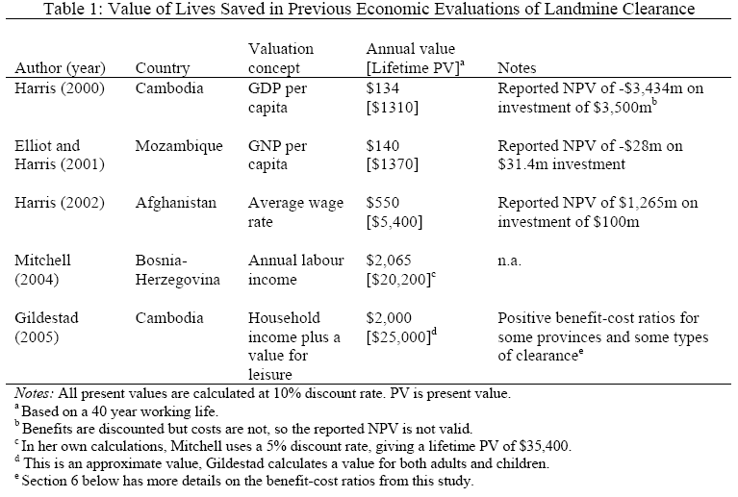

3. The Survey
3.1 Outline of the Approach

A contingent valuation survey was carried out by the authors in Kampong Speu and Siem Reap provinces of Cambodia in November 2004, with the assistance of the Red Cross and a team of local interviewers. This survey was a significant extension of the approach used in an earlier survey in rural Northeast Thailand (Gibson et al, 2007). In contrast with that earlier work, the two provinces surveyed here have considerable landmine and UXO contamination. According to survey estimates from CMAC (2002), these two provinces rank 6th and 18th (of 24) in terms of landmine and UXO casualties in Cambodia, with causality rates of 3.3 and 0.3 per 10,000 of population (the national average is 1.7 per 10,000).

The survey used two series of questions to determine tradeoffs between alternatives. The first questions related to the tradeoff between the risk of death resulting from landmine accidents and income, i.e. a ‘risk-money’ tradeoff. To establish this tradeoff we asked respondents to state their preferences for two different areas in which their village might be located, differing in both the risk of death and cash income. Since the income that was adjusted was for the area with the higher risk of death, this can be considered a ‘willingness to accept’ format. The second set of questions determined the tradeoff between the risk of injury from a landmine accident and the risk of death, i.e. a ‘risk-risk’ tradeoff. While tradeoffs between injury risk and money were not considered directly, they can be imputed from the other two sets of tradeoffs in the survey.

In determining risk-money tradeoffs the respondents were not directly asked about their willingness to pay for a reduction in risk, or the amount they required to accept an increase in risk. Hence we can avoid issues associated with who will or should pay, how payments will be made, and exactly what the payments are for. These would be important questions for the low income communities included in this survey, particularly since the majority of landmine clearance in Cambodia is conducted by local non-government organisations supported by international donor programs. The statement of alternatives also made clear the precise nature of the change in risk to be considered. This is important because it is likely that in communities with significant experience with landmine problems risk comparisons may be influenced by actual perceptions of landmine accident risk.

A large literature notes that VSL estimates based on CV methods are sensitive to the nature of the risks considered, the way the risks are presented, the size of the risk change, and many other factors (Beatty et al, 1998). In low income rural communities these factors may be even more significant. Therefore, to aid interpretation, the risks in this study were presented in terms of the frequency of occurrence of an event, e.g. a change in the risk of death from 2 per year in a commune of 10,000 to 4 per year. Also, several questions were used to aid and check the comprehension of respondents. Initially they were given show cards illustrating risks of 2 in 10,000 and 6 in 10,000 and were asked to choose the commune with the lower risk. They were then shown cards with risks of 2 in 10,000 and 2 in 20,000 and asked to choose the commune with the lower risk. If they failed either of these tasks the interpretation of the show cards was explained again. As a final check of comprehension they were asked to choose between areas in which one area was dominant, since it had both a higher cash income level and a lower probability of death. If a respondent failed to select the dominant area the nature of the risk and the selection task was explained again. The interview was terminated if the respondent failed on a second attempt.

Respondents were also asked a set of questions designed to determine their awareness of landmine affected areas, and knowledge and association with those injured or killed by landmines. Familiarity with landmines and landmine accidents is likely to influence preferences, and thus the VSL estimates and risk-risk tradeoffs. Demographic variables and wealth indicators were also collected from each respondent and these allow comparison with a national survey with the same indicators, so that the results can be re-weighted to reflect all of rural Cambodia rather than just the two provinces where the survey was fielded.

3.2 Risk-Money Tradeoffs

The first set of questions was designed to determine for each respondent the difference in income that would make them indifferent between two areas (labelled Commune A and Commune B) given a specified difference in the risk of death from a landmine accident. This then enables the VSL to be calculated. Following Viscusi et al (1991), assume that risk preferences can be represented by the utility function 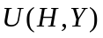 if the individual is healthy or 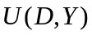if death occurs from a land mine accident, where Y is total income. Let I_{a} and I_{b} be the cash income levels in Communes A and B and W the common value of income from other sources (in our case this would include income from subsistence sources). The probabilities of death are X_{a} and X_{b} respectively. Indifference between the two areas implies that

(1)

Again following Viscusi et al (1991), assume that the utility function is additively separable in health status and income, and the marginal utility of income is constant and equal to one for the range of income changes considered. Therefore,

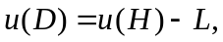 (2)
where
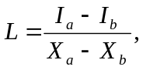 (3)
and 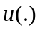is the utility function for health status. For example, if I_{a}=R1,460,000, I_{b}=R1,660,000, X_{a}=0.0002 and X_{b}=0.0004, then L=R1,000,000,000 or u(H)=u(D)+R1,000,000,000.

To determine the income difference at which the respondent is indifferent between each commune for a given change in the risk of death, an initial alternative was presented and then adjusted given the area chosen. Initial alternatives were selected after a pre-test in several villages in Kampong Speu province. Such pre-testing reduces the likelihood of starting point bias and minimises the number of iterations required to establish indifference.
The initial alternatives used in the final survey were:

Commune A | Commune B
Cash Income of R1,460,000 per year | Additional Cash Income of R200,000 per year
Risk of Death per year of 2/10,000 | Risk of Death per year of 4/10,000
If Commune B was selected as the preferred commune, the additional cash income in Commune B was revised down by R50,000 and the respondent was asked to reconsider the alternatives. This process was continued for up to four iterations until preference switched to Commune A or the additional cash income in Commune B reached zero. Any switch in preference provides a range within which the income level that would make the respondent indifferent between the two communes should lie. The respondent was then asked what level of additional cash income in Commune B would make the two communes equally desirable. If this value was inconsistent with the range of incomes implied by the preference switch, then interviewers prompted the respondent for a suitable response. If the respondent still gave an inconsistent value, then this survey response was disregarded. This process provided an additional consistency check. If Commune A was selected given the initial alternatives, the additional cash income in Commune B was revised upward by R50,000 for up to four iterations until either Commune B was selected or the level of additional cash income reached R400,000. Again, the respondent was asked for the value of additional cash income in Commune B that would make the two communes equally desirable.

  - Risk-Risk Tradeoffs

A second set of questions was designed to determine the willingness of respondents to tradeoff increases in the risk of injury from a landmine accident for a decrease in the risk of death from a landmine accident. Landmine accidents cause a variety of injuries of different severity, including loss of legs, feet, arms, hands and sight. The loss of a leg, either above or below the knee, is the most common serious injury sustained. In this survey the respondents were asked to treat all injuries as involving a loss of a leg below the knee. Clearly, different injuries would generally be associated with different tradeoffs.

As for the risk-money tradeoffs, respondents were asked for their preference between two alternative communes. The questions sought to find the risk combination that would make the respondent indifferent between Commune A and B, assuming that all other aspects of the communes were identical. Following Viscusi et al (1991), consider a state-dependent utility model where u(D) is the utility associated with death from a landmine accident, u(J) the utility of living with an injury, and u(H) the utility associated with full health. Let X_{a} and Y_{a} be the annual probabilities of death and injury in Commune A and X_{b} and Y_{b} be the corresponding probabilities in Commune B. Given indifference between communes,

(4)

It follows that
(5)

where the tradeoff between injury and death is defined as
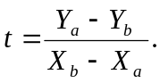 (6)
For example, if Y_{a} = 0.002 and X_{a} = 0.0002 in Commune A while Y_{b}=0.0012 and X_{b}=0.0004 in Commune B then indifference between the areas implies an injury-death tradeoff of 4.0.

The procedure used to determine the risk-risk alternatives that made the respondent indifferent between communes was similar to the procedure used for risk-money tradeoffs. The initial alternatives were:

Commune A | Commune B
Risk of Injury per year of 20/10,000 | Risk of Injury per year of 12/10,000
Risk of Death per year of 2/10,000 | Risk of Death per year of 4/10,000
If Commune A was chosen the number of injuries per 10,000 people in Commune B was revised down by two. The process was repeated until preference switched or there were zero injuries. The respondent was then asked what number of injuries per 10,000 people would make the two communes equally desirable. As with risk-money tradeoffs, this question provided a consistency check. If, given the initial alternatives, Commune B was chosen, the number of injuries per 10,000 people in Commune B was revised up by two and the process repeated until preference switched or the number of injuries reached twenty per 10,000.

  - Implicit Value of Statistical Injury

Using the estimates obtained for the value of statistical life, L, and the injury risk-death risk tradeoff, the implicit value of a statistical injury can be calculated. From equations (2) and (5) it follows that
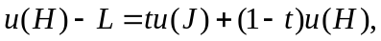 or
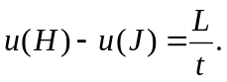 (7)

  - Application of the Survey and Sample Characteristics

An experienced team of Cambodian interviewers were recruited locally and trained in the survey methodology. Using local interviewers ensured that interpretations and language in the survey were consistent with those in use in the survey area. The villages in the survey were selected from the national Cambodian Socio-Economic Survey (CSES) sample so that we could compare key variables from the surveys and re-weight the VSL sample to obtain nationally representative estimates. Seven villages were selected from Kampong Speu province, and ten villages from Siem Reap province. Of these villages, two from Kampong Speu were used in pre-testing and did not form part of the final sample. Participation in the survey was voluntary, but the refusal rate was zero. Dropping any respondents who failed any of the dominance or consistency checks left a sample of 440 responses.

A wealth index was calculated from survey responses about the ownership of durable goods and dwelling attributes. The calculation of the index follows the principal components method of Filmer and Pritchett (2001), who show that this index gives a similar ranking to that from more detailed household expenditure data and can be used when such data are unavailable. Figure 1 shows the distribution of the wealth index from the VSL survey and from the rural component of the national CSES, in the form of smoothed densities. It is apparent that respondents in the VSL survey have somewhat higher wealth so un-weighted statistics calculated from the VSL survey may not be representative of rural Cambodia. Instead we derive a set of weights from a semi-parametric procedure designed to counter-factually shift the density for the VSL survey to mimic the density for the CSES. Details of this weighting procedure are in Appendix 1. All statistics from the VSL survey are reported below both with and without these weights being applied. The main impact of the weights is to reduce the value of the calculated VSL, which is consistent with the fact that the rural households in the national survey have somewhat lower wealth than those in the VSL survey.

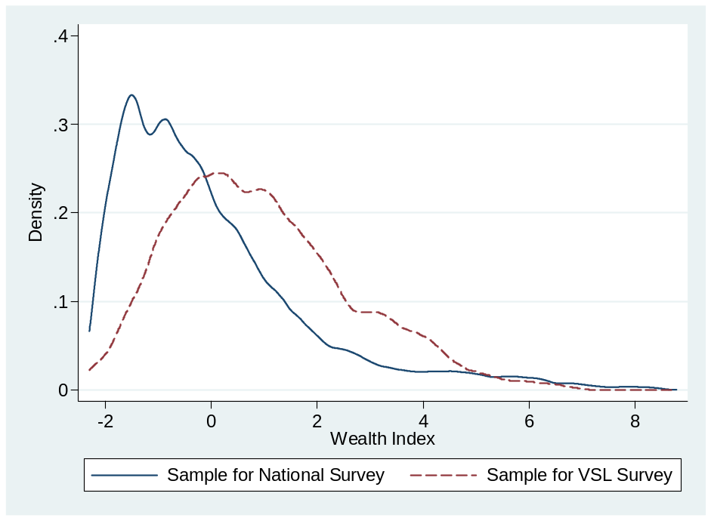
Figure 1: Distribution of Wealth Index from VSL and National CSES Samples

Table 2 provides a summary of the sample characteristics and consistency checks for responses from the survey, and compares these with the earlier Thai study (Gibson et al, 2007). Most respondents in Cambodia had significant personal knowledge of the effects of landmines and the location of landmine-affected areas. Over half of respondents had experience caring for someone injured by a mine, compared with none in Thailand. Only three of the survey respondents failed the consistency checks, with all failures occurring in dealing with risk-money tradeoffs.
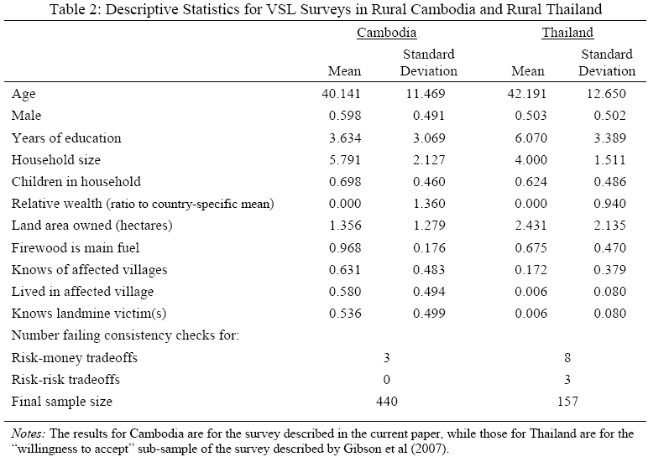

4. Results
4.1 Risk-Money Tradeoffs and the VSL Estimates

To simplify comparisons with other studies all VSL estimates are converted to $US using the exchange rate prevailing during the survey. The survey responses suggest that the mean VSL is approximately US$446,000 when unweighted and $423,000 when weighted to be representative of all rural Cambodia (Table 3). The 95% confidence interval around the weighted mean is $353,097-$491,620. The medians are lower for both the unweighted and weighted estimates, at $422,000 and $357,000.

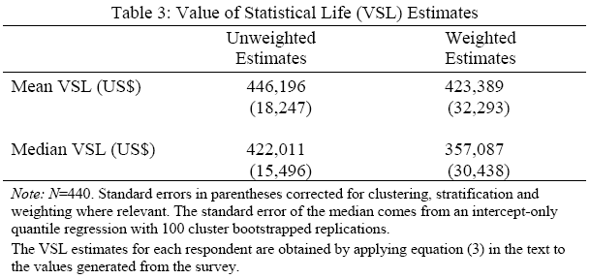
How does this estimate compare with the foregone income approach that has been used previously in CBA evaluations of landmine clearance in Cambodia? The average income per capita in Cambodia as a whole in 2001 was approximately $270. Given the high share of the population in rural areas, the rural mean will be similar to this overall estimate. Thus, for a 40 year working life and a discount rate of 10% the present value of forgone lifetime income would equal $2,640, giving a ratio of the weighted median VSL to the present value of lifetime earnings is around 135:1. Consequently, the use of these two different types of estimates is likely to make a big difference to CBA evaluations of landmine clearance (see Section 5 below).

There is a positive skew in the distribution of VSL estimates, which is indicated by the means being above the medians. This is confirmed in Figure 2 which uses smoothed densities to show the underlying distribution of both the unweighted and the weighted responses. In light of this skewness the median will better measure central tendency than the mean. Hence we use the weighted median of $357,087 as the best point estimate of the VSL for rural Cambodia when the risk considered is death from landmines or UXO.

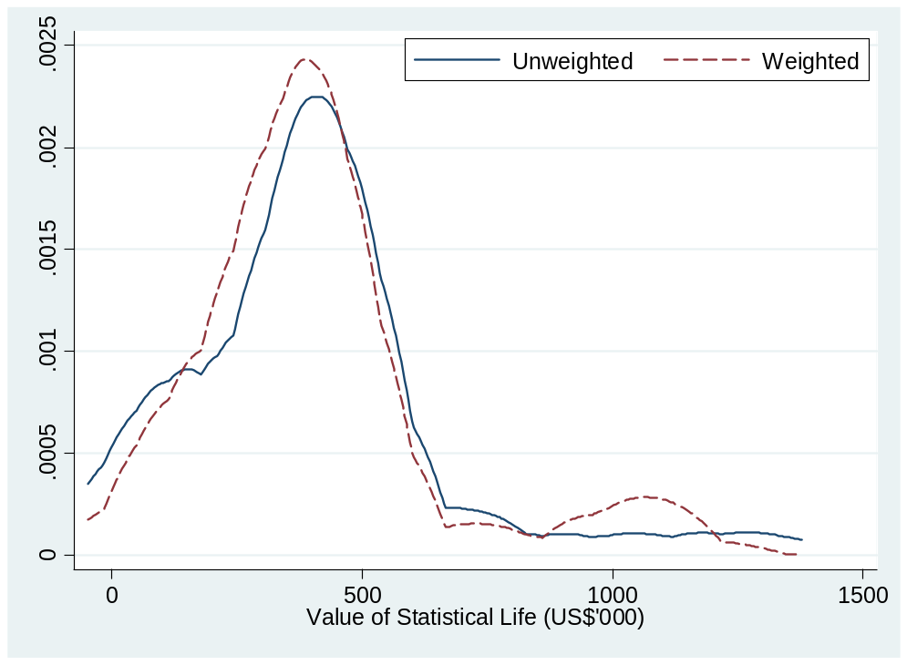
Figure 2: Smoothed densities for the value of statistical life estimates

The weighted median for Cambodia is approximately $50,000 higher than the median VSL estimated from an earlier study of landmines in rural Thailand (Gibson et al, 2007). This may seem surprising when it is considered that rural Cambodia has lower per capita income than rural Thailand. To see how much of this difference can be explained by differences between the two samples in characteristics such as personal experience of landmines a regression decomposition is conducted. Decomposition methods differ according to the parameter vector used to weight the difference in average characteristics, 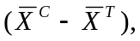with the approach used here being the most general, of applying parameter vector β* from a regression on both samples pooled (Neumark, 1988). The mean (or equivalently, median) gap can then be expressed as:

(8)

The last term in equation (8) reflects the part of the gap in VSL estimates explained by differences in average characteristics. The first two terms reflect unexplained differences due to unequal coefficient vectors estimated on the Cambodia sample, β^{c} and the Thai sample, β^{T}.

The regression estimates reported in Table 4 suggest that the VSL declines with the age of the respondent, does not vary with their gender or education, and is lower for those from large households and without children. The wealth indicator used in the regression is relative to the mean in each country, so as to not capture differences in average income levels, since the purpose of the regressions is to see how much of the gap is due to factors other than income differences. This variable suggests that the relatively wealthy have a higher VSL especially if land ownership is also considered a wealth indicator (significant in the Thai sample but not in Cambodia). Risk factors and experience also affect the reported VSL, with higher VSLs for those who know landmine victims and those who rely primarily on firewood (which has to be collected from the forest, where many landmine accidents occur), and lower VSLs for those who have lived in an affected village.

When the regression coefficients in Table 4 are combined with the mean values of the characteristics in Table 2, it is possible to use equation (8) to assign part of the difference in VSL estimates between Thailand and Cambodia to differences in characteristics. The estimates at the bottom of Table 4 suggest that just under one-half of the higher VSL reported from the Cambodia sample is due to characteristics other than income. The main contributing factors are higher risk due to greater reliance on firewood in Cambodia, the greater knowledge of landmine victims, greater knowledge of and residence in affected villages, and differences in household size between the two samples.
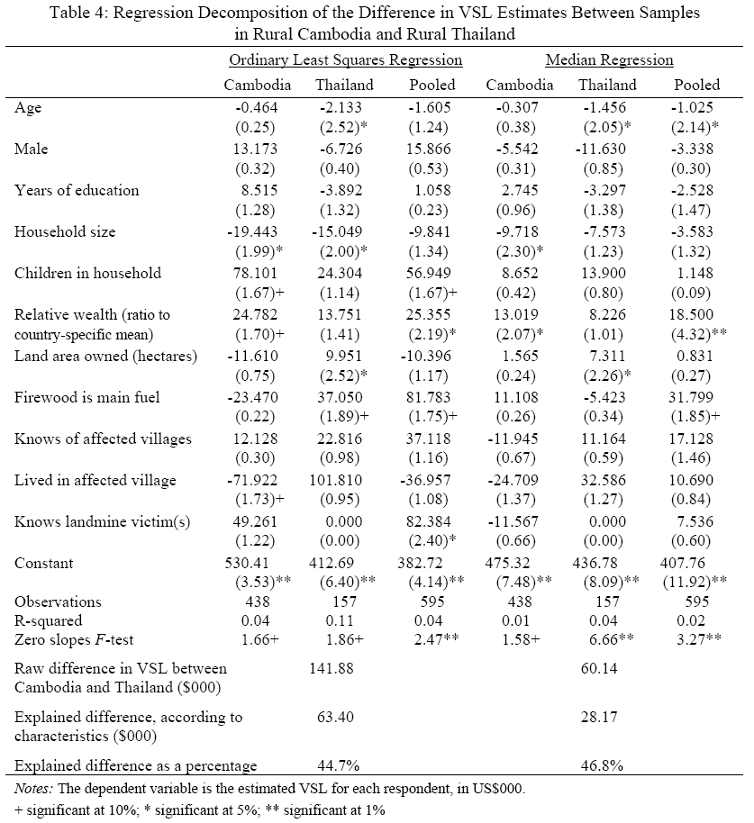

4.2 Injury Risk-Death Risk Tradeoffs

Table 5 reports summary statistics for the tradeoffs between the risk of injury from a landmine accident and the risk of death. As noted above, injury here refers to an accident resulting in the amputation of a leg below the knee. According to the indifference estimates provided by the survey respondents, the median tradeoff is 5.0 injuries per death while the (weighted) mean tradeoff is 5.5 injuries per death. These are comparable to the earlier study from Thailand where the median was 6.0 and the mean 5.1 (Gibson et al, 2007).

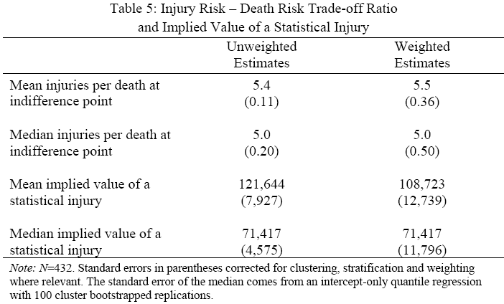

The implied value of a statistical injury is obtained by combining the injury-death tradeoffs with the VSL estimates, using equation (7). The median value of a statistical injury is $71,417 and the (weighted) mean is $108,723. This median value of statistical injury and the median VSL of $357,087 are the key inputs into a cost benefit analysis of landmine clearance in Cambodia, which is reported in the next section.

5. VSL Estimates and Cost-Benefit Studies of Mine Clearing

The significance of the landmine/UXO problem in Cambodia has made it an important case in research on the benefits and costs of mine clearance. This research has been controversial. While Harris (2000) suggests that the benefits of clearance are only 2% of the costs, Gildestad (2005) finds overall benefits of a targeted demining programme 38% higher than costs. Here we replicate the work of Harris and Gildestad using the VSL and injury-death trade-off estimates obtained in this paper. This clearly shows the importance VSL estimates both in assessing mine clearance and setting priorities for demining programmes.

Harris (2000) estimates costs and benefits of removing mines from 500,000 hectares of contaminated arable land, with demining taking place over a period of 25 years. An assumed demining cost of $7,000 per hectare gives a total cost of $3,500m. Although actual expenditure is assumed to be undertaken over the 25 years, the $3,500m is not discounted. Three major benefits of demining are considered. Benefits resulting from saved lives are valued at the average income earned for the years of productive life remaining, with reduced injuries and resulting disabilities valued at half the income of a healthy individual. Cost savings from reduced medical costs include both the initial medical costs saved, and the reduced on-going costs of artificial limbs for amputees. Gains in agricultural output are measured by the value-added from previously unused or under-utilized land.

The benefits of the first year of demining are shown in Table 6. Over time these benefits compound as more demining takes place. Using a discount rate of 10% Harris finds a net present value of -$3,434m on an investment of $3,500m. Paterson (2001) criticises Harris for the failure to discount costs while discounting benefits. If the costs are discounted the net present value would be -$1,329m , i.e. benefits would be 4.9% rather than 1.9% of costs.

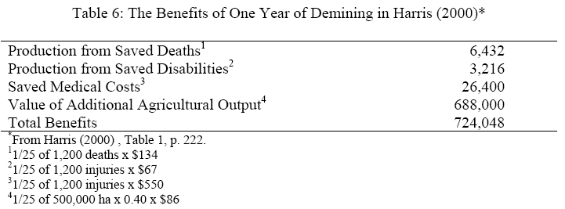

Harris does not use a VSL in valuing the benefits from saved lives and injuries. The implied value of a life saved in the analysis in Harris is $1,338. In introducing VSL estimates into the analysis undertaken by Harris it is assumed that the full value of a life or injury saved is included as a benefit in the year the accident occurs. Table 7 compares the results from Harris with equivalent calculations based on a VSL of $357,087 and an injury-death trade-off of 5. Keeping the other assumptions used by Harris, benefits now represent 51% of costs, and the benefits of lives and injuries saved 96.6% of total benefits. If, following Paterson, costs are discounted a positive net present value of $399m would result, with the present value of benefits exceeding the present value of costs by 29%.

As emphasised by Paterson, landmine programmes involve targeted clearance not the clearance of large ‘average’ areas as assumed by Harris. Mine fields with high expected benefits relative to costs will tend to be demined first. By treating all areas demined as the same, the approach taken by Harris may seriously underestimate the benefits of targeted clearance. Gildestad (2005) estimates the costs and benefits resulting from the clearance of one km² of high priority contaminated land for a variety of uses across the principal mine affected provinces in Cambodia. Two demining cost figures are used based on the costs of existing mine clearance programmes, $0.70 m² and $0.90 m². Benefits from clearance include human benefits, the value of casualties and medical costs saved, development benefits, revenue from new production or tourism and travel costs saved.
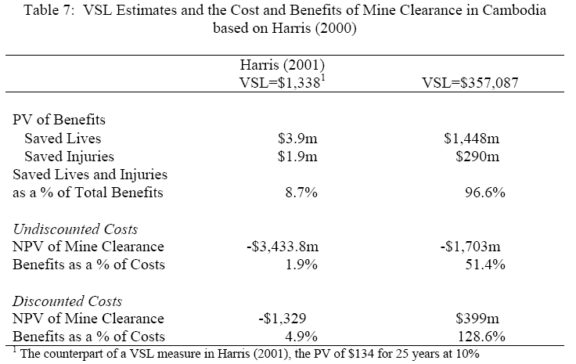

To estimate human benefits Gildestad assumed casualties decline in proportion to the area of land cleared, down to 10% of the current rates. Reduced casualties are assumed to occur in each year of the 20 year time horizon used for the study. The value of casualties is based on the productive value of victims assuming a present adult income of $1,000, with an additional amount of $1,000 for the value of leisure. Adult productive income is assumed to grow at 3.5% per annum for 10 years and 2.5% thereafter. Adults work for 35 years and children are treated as having 5 unproductive years followed by 40 years of work. For fatalities full productive value is lost, for amputees it is assumed that 70% of productive value is lost, while for other injuries 40% of productive value is lost.

Methods of estimating development benefits depend on land use. For agricultural land and irrigation systems they are based on the additional value of farm revenues. For roads and bridges, wells and water supplies, schools and health stations, estimates are based on reductions in travel costs while for historical and cultural sites additional tourist revenue is calculated. All future benefits are discounted at a rate of 10%. Costs are assumed to be incurred in the current period.

As in the work of Harris, the method used by Gildestad to value the human benefits of mine clearing does not explicitly include a VSL estimate. To show the impact of VSL estimates we follow the approach used above and assume that the full value of a life saved is included as a benefit in the year the life is saved. The VSL is assumed to be $357,087.

Gildestad distinguishes between adults and children in calculating the human benefits of clearance. In his model an adult life saved in the first year would have a present value of approximately $25,000 compared with a value of $21,000 for a child’s life saved. In applying our VSL estimates we have ignored possible differences between adult and child VSL measures. VSLs can also be expected to change over time as real incomes increase. Miller (2002) suggests income elasticities in the range of 0.85-1.0, while Viscusi and Aldy (2003) report elasticities of 0.5-0.6. We apply the growth assumptions used by Gildestad and an income elasticity of 0.5 to revise the VSL estimates for lives saved in the future. The median injury risk-death risk tradeoff of 5.0 is used to estimate of the value of reductions in amputations. Following Gildestad, we assume that value of reductions in other injuries is 57% of the value of an amputation saved.

Table 8 compares the results obtained for the clearance of agricultural land by province obtained by Gildestad given a clearance cost of $0.90 m² with the equivalent calculations based on our VSL estimates. For all but Pailin province the estimates obtained by Gildestad suggest that the clearance of agricultural land is uneconomic. Given the VSL values estimated in this paper clearing agricultural land would be economic in all provinces except Pursat and Siem Reap. Thus, for agricultural land the VSL measure used is likely to be decisive in making judgments about the economic value of clearance.

For other types of land use considered by Gildestad the value of productive benefits are much larger, dominating cost-benefit calculations. The inclusion of VSL measures acts to increase the importance of human benefits and the magnitude of the net benefit-cost ratio. Table 9 compares Gildestad’s results for land use types with those obtained based on our VLS estimates. The VSL estimated in this paper suggests that targeted clearance for all land use types is economic, and in the case of the net benefits of clearing irrigation systems is over six times cost.
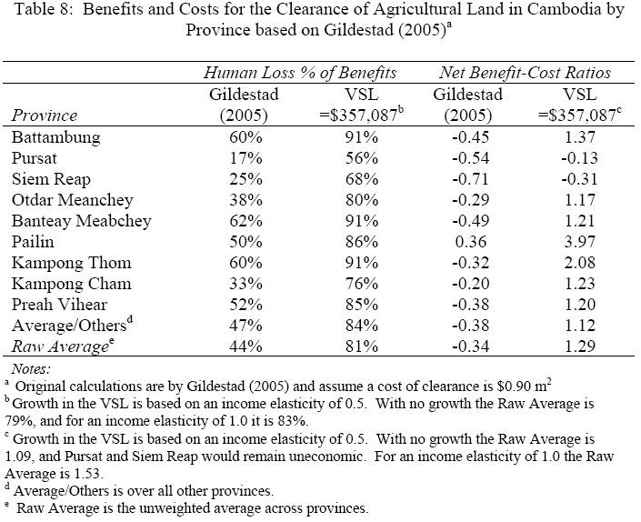

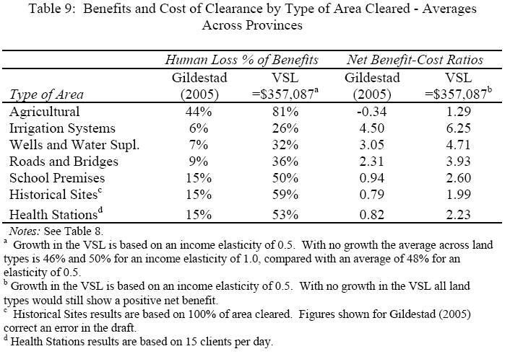

- Conclusion

Reliable estimates of the value of the tradeoff between risk reduction and income generation are necessary to evaluate many interventions that save lives. In the context of developing countries, the desirability of demining in particular locations and the extent of mine clearance that is optimal depends crucially on the Value of Statistical Life. Using a survey in two provinces in Cambodia we estimated the VSL at approximately US$357,000. This estimate is an order of magnitude higher than previous proxies for the VSL, such as the present value of lost income, that have been used in the literature on landmine clearance.

The importance of VSL estimates in judging the desirability of landmine clearance programmes has been demonstrated by reworking two important studies of the economics of mine clearance in Cambodia. Harris (2000) estimates that landmine clearance of general land in Cambodia would generate benefits worth just 2% of costs. We show that if our estimated VSL is used benefits would be 51% of costs. Further, if as suggested by Paterson (2001) costs as well as benefits are discounted, benefits would exceed costs by 29%. We also apply our estimates to the study of targeted mine clearance by Gildestad (2005). Whereas Gildestad shows that mine clearance of agricultural land is generally uneconomic, our work shows that in all but two provinces benefits exceed costs when our estimated VSL is used and the targeted clearance of all land types is economic. Since landmines and other risks are widespread in rural areas of developing countries, surveys that provide more plausible estimates of VSLs in a wide range of settings should make a growing contribution to the literature in both development and environmental economics.

Appendix I:
The Wealth Index and Reweighting

The survey was conducted in only two provinces in Cambodia but landmine and UXO contamination affects most rural areas in Cambodia. To reweight results to reflect conditions in other parts of rural Cambodia we use a larger, national-level survey, the 1999 Cambodia Socio-Economic Survey (CSES). A wealth index formed from household’s dwelling characteristics and ownership of physical assets was used as an alternative to either total household income or total household expenditure because (a) the VSL survey did not collect detailed income or expenditure information that was compatible with the methods used to collect income and expenditure in the CSES, and (b) there are major discrepancies between the two rounds of the CSES survey for the income and expenditure estimates (Gibson, 2000) but the information on dwelling characteristics and assets appears to be consistent between the two rounds.

To aggregate the information on dwelling facilities and assets into a single index, the first principal component was used, following Filmer and Pritchett (2001) who show that in settings where household expenditure data is unavailable this principal component produces a similar ranking in explaining wealth-dependent outcomes. The components of the wealth index are listed in Appendix Table 1, along with the weights in the index. The mean value of each of the indicator variables is displayed for the bottom (poorest) and top (richest) quintiles obtained from the wealth index, as are the means from the two surveys. It is apparent that the wealthier quintiles score more highly for characteristics with a positive scoring factor (e.g. floor area, ownership of a TV) while the poorer households score more highly for characteristics with a negative score (e.g. having a thatched roof on their dwelling). There are also several differences between the means for the two surveys in terms of dwelling facilities and ownership of durables such as a TV or motor scooter and these are assumed to reflect wealth differences between the two samples.

Appendix Table 1: Characteristics of the Constructed Household Wealth Index
Characteristic | Scoring factors | mean | Std dev | Mean Values of the Characteristic
 |  |  |  | Poorest 20% | Richest 20% |  | CSES | VSL Survey
Floor area of dwelling | 0.169 | 39.505 | 42.311 | 23.911 | 64.858 |  | 39.504 | 43.611
Dwelling has bamboo walls? | -0.328 | 0.527 | 0.499 | 0.995 | 0.069 |  | 0.527 | 0.206
Dwelling has thatched roof? | -0.316 | 0.428 | 0.495 | 0.993 | 0.026 |  | 0.428 | 0.320
Dwelling has modern floor? | 0.238 | 0.141 | 0.349 | 0.000 | 0.435 |  | 0.141 | 0.081
Has electricity? | 0.348 | 0.103 | 0.304 | 0.000 | 0.589 |  | 0.103 | 0.053
Has piped water/public tap? | 0.212 | 0.025 | 0.156 | 0.000 | 0.172 |  | 0.025 | 0.261
Has tube/protected well? | -0.037 | 0.429 | 0.495 | 0.462 | 0.376 |  | 0.429 | 0.229
Has a flush toilet? | 0.372 | 0.074 | 0.261 | 0.000 | 0.532 |  | 0.074 | 0.032
Has no toilet? | -0.331 | 0.812 | 0.391 | 1.000 | 0.259 |  | 0.812 | 0.745
Cooks with firewood? | -0.179 | 0.958 | 0.201 | 1.000 | 0.829 |  | 0.958 | 0.970
Has bicycle? | 0.080 | 0.584 | 0.493 | 0.442 | 0.639 |  | 0.584 | 0.836
Has cart? | -0.043 | 0.358 | 0.479 | 0.321 | 0.186 |  | 0.358 | 0.519
Has boat | -0.008 | 0.100 | 0.300 | 0.085 | 0.055 |  | 0.100 | 0.016
Has radio/cassette recorder? | 0.194 | 0.418 | 0.493 | 0.224 | 0.691 |  | 0.418 | 0.379
Has TV? | 0.333 | 0.220 | 0.414 | 0.000 | 0.710 |  | 0.220 | 0.531
Has motor vehicle or scooter? | 0.320 | 0.187 | 0.390 | 0.000 | 0.658 |  | 0.187 | 0.360
Note: Each variable other than floor area takes the value of 1 if true, 0 otherwise.
The proportion of the covariance explained by the first principal component is 21%. The value of the first eigenvalue is 3.32 and the second eigenvalue is 1.66.

A set of weights that can adjust results for the wealth differences between the two samples (and also reweight the VSL summary statistics to reflect conditions in overall rural Cambodia, at least as captured by the national-level CSES) are calculated by adapting a procedure developed by DiNardo, Fortin and Lemieux (1996). This procedure reweights the overall distribution rather than just the mean and notes that the observed density of the wealth index for an observation from the VSL survey (CSES=0) with characteristics x is:

The counterfactual density if observations from the VSL survey were given the characteristics of the national-level CSES can is:
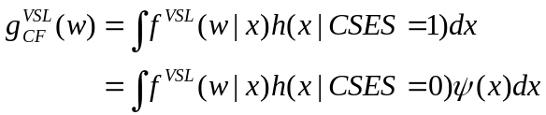

which is based on a reweighting factor, ψ(x):
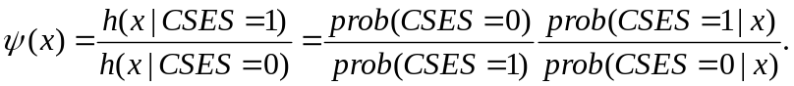

The first part of this reweighting factor is just the ratio of number of observations from the VSL survey to number of observations from the CSES survey in the pooled database. To calculate the second part of this reweighting factor, which is the ratio of two conditional probabilities, a logit regression is estimated, with survey type (CSES or VSL) as the dependent variable and explanatory variables from the components of the wealth index. The results for this regression are reported in Appendix Table 2.

Appendix Table 2: Results of Logit Regression For Survey Type (CSES=1)
 | Coefficient | Standard error | t-statistic | p-value
Floor area of dwelling | -0.001 | 0.002 | -0.44 | 0.661
Dwelling has bamboo walls? | 1.594 | 0.218 | 7.33 | 0
Dwelling has thatched roof? | -1.043 | 0.241 | -4.33 | 0
Dwelling has modern floor? | 1.036 | 0.271 | 3.82 | 0
Has electricity? | 2.738 | 0.441 | 6.21 | 0
Has piped water/public tap? | -3.520 | 0.420 | -8.38 | 0
Has tube/protected well? | 0.962 | 0.152 | 6.34 | 0
Has a flush toilet? | 2.214 | 0.462 | 4.79 | 0
Has no toilet? | 0.929 | 0.164 | 5.66 | 0
Cooks with firewood? | 0.229 | 0.348 | 0.66 | 0.509
Has bicycle? | -0.940 | 0.163 | -5.76 | 0
Has cart? | -0.765 | 0.230 | -3.32 | 0.001
Has boat | 2.172 | 0.410 | 5.3 | 0
Has radio/cassette recorder? | 0.471 | 0.168 | 2.8 | 0.005
Has TV? | -0.942 | 0.189 | -4.98 | 0
Has motor vehicle or scooter? | -1.062 | 0.169 | -6.29 | 0
Intercept | 8.053 | 0.409 | 19.69 | 0

The reweighting factor, ψ(x) is used to calculate weighted summary statistics from the VSL survey which should reflect the distribution of the household wealth index in the national level CSES survey rather than the distribution in the more localised VSL survey.

References

Ashenfelter, O. 2006. Measuring the value of a statistical life: Problems and prospects. The Economic Journal 116(510): C10-C23.

Aunan, K., Berntsen, T., O’Connor, D., Persson, T., Vennemo, H., and Zhai, F. 2007. Benefits and costs to China of a climate change policy. Environment and Development Economics 12(3): 471-497.

Beattie, J., Covey, J., Dolan, P., Hopkins, L, Jones-Lee, M., Loomes, G., Pidgeon, N., Robinson, A. and Spencer A. 1998. On the contingent valuation of safety and the safety of contingent valuation: Part 1-caveat investigator. Journal of Risk and Uncertainty 17(5): 5-25.

Cambodian Mine Action Committee (CMAC) 2002. Cambodia National Level 1 Survey. Phnom Penh.

DiNardo, J., Fortin, N. and Lemieux, T. 1996. Labor Market Institutions and the Distribution of Wages. Econometrica 64(5): 1001-1044.

Elliot, G., and Harris, G. 2001. A cost-benefit analysis of landmine clearance in Mozambique. Development Southern Africa 18(5): 625-633.

Filmer, D., and Pritchett, L. 2001. Estimating wealth effects without expenditure data—or tears: an application to educational enrolments in states of India. Demography 38(1): 115-132.

Gibson, J., Barns, S., Cameron, M., Lim, S., Scrimgeour, F., and Tressler, J. 2007. The value of statistical life and the economics of landmine clearance in developing countries. World Development 35(3): 512-531.

Gildestad, B. 2005. Cost-benefit Analysis of Mine Clearance Operations in Cambodia, 2nd Draft Report. Nordic Consulting Group, for the Cambodian Mine Action Authority (CMAA) and UNDP.

Harris, G. 2000. The economics of landmine clearance: case study of Cambodia. Journal of International Development 12(2): 219-225.

Harris, G. 2002. The economics of landmine clearance in Afghanistan. Disasters 26(1):49-54.

Herriges, J. and Kling, C. 1999. Nonlinear income effects in random utility models. Review of Economics and Statistics 81(1): 62-72.

International Campaign to Ban Landmines [ICBL]. 2006 Landmine Monitor Report 2006: Toward a Mine-Free World New York, Human Rights Watch.

Jones-Lee, M. W. 1976. The Value of Life: An Economic Analysis. Martin Robertson, London. Keeley, R. 2006. Are we setting the wrong target? Journal of Mine Action 9(1): 1-4.

Merrouche, O. 2006. The human capital cost of landmine contamination in Cambodia. Households in Conflict Network Working Paper No. 25, Institute of Development Studies, University of Sussex.

Miller, T. 2000. Variations between countries in values of statistical life. Journal of Transport Economics and Policy 34(2): 169-188.

Mitchell, S. 2004. Death, disability, displaced persons and development: the case of landmines in Bosnia and Herzegovina. World Development 32(12): 2105-2120.
Neumark, D. 1988. Employers’ discriminatory behaviour and the estimation of wage discrimination. Journal of Human Resources 23(2): 279–95.

Paterson, T. 2001. Commentary on ‘the economics of landmine clearance: case study of Cambodia’. Journal of International Development 13(3): 629-634.

Perreira, K. M. and F. A. Sloan 2002. Living healthy and living long: Valuing the nonpecuniary loss from disability and death. Journal of Risk and Uncertainty 24(1): 5-29.

Rosen, S. 1988. The value of changes in life expectancy. Journal of Risk and Uncertainty 1(3): 285-304.

Shanmugam, K. 2001. Self selection bias in the estimates of compensating differentials for job risks in India. Journal of Risk and Uncertainty 22(3): 263-275.

Shogren, J. and Stamland, T. 2002. Skill and the value of life. Journal of Political Economy 110(5): 1168-73.

United Nations Mine Action Service [UNMAS]. 2003. International Mine Action Standards United Nations, New York.

Vassanadumrongdee, S. and Matsuoka, S. 2005. Risk perceptions and the value of statistical life for air pollution and traffic accidents: evidence from Bangkok, Thailand. Journal of Risk and Uncertainty 30(3): 261-287.

Viscusi, W. K. 1993. The value of risks to life and health. Journal of Economic Literature 31(4): 1912-1946.

Viscusi, W.K. and Aldy, J.E. 2003. The value of statistical life: A critical review of market estimates throughout the world. Journal of Risk and Uncertainty, 27(1): 5-76.

Viscusi, W. K., Magat, W. A. and Huber, J. 1991. Pricing environmental health risks: Survey assessments of risk-risk and risk-dollar trade-offs for Chronic Bronchitis. Journal of Environmental Economics and Management 21: 32-51.

In addition to these casualties, landmines can hinder human capital development, with Merrouche (2006) estimating a 0.4 year (almost 10% of the mean) reduction in completed school years in Cambodia due to landmine contamination.
As noted by Paterson (2001), the study by Harris (2000) is flawed because it discounts the benefits of mine clearance but not the costs, even though the clearance program is spread over 25 years. While discounting costs substantially reduces the size of the negative NPV, the estimated benefits are still only 5% of costs.
Gildestad (2005) also includes an allowance for the value of leisure time.
The general approach is described in Ashenfelter (2006).
However, since a lot of the suspect land is already under cultivation recent estimates suggest that the remaining contamination may only be 460 km² (ICBL, 2006). But even with that smaller target, over a decade of clearance effort and several hundred million dollars is still required.
For an excellent survey of early studies of the valuation of life and a critique of these studies see Jones-Lee (1976). Harris (2000), Harris (2002) and Eliot and Harris (2001) do not value the psychological costs associated with the risk of death.
For a now dated, but useful review see Viscusi (1993). For a recent critical review of market based estimates see Viscusi and Aldy (2003).
Our earlier research in Thailand compared this with a ‘willingness to pay’ format where the income that was revised was in the area with the lower risk of death. Differences between the two formats were statistically insignificant, so only the ‘willingness to accept’ format was used in Cambodia, since it appeared to be more informative. Also, the ‘willingness to accept’ format avoided presenting alternatives that look significantly worse than the respondents’ current village, at least in terms of cash income, and therefore avoided potential confusion where respondents would prefer neither alternative.
For example, cost of living differences can be used to represent the money component of risk-money tradeoffs (e.g. Viscusi et al, 1991) but these can be hard for low income rural villagers to understand since there is no housing market and subsistence agriculture provides a substantial proportion of household income. Instead, in this survey cash income and the difference in cash income between areas were used to represent the money component of risk-money tradeoffs.
Overall, three respondents failed the dominance tests and their responses are excluded from the analysis.
This assumption is less restrictive than it may appear. Herriges and Kling (1999) provide evidence that welfare estimates from models of discrete choice which assume constant marginal utility of income are very close to the estimates from much more complex non-linear models.
In Viscusi et al (1991) I_{a}-I_{b}=Z, the difference in the cost of living between two areas A and B.
This would correspond to a VSL of US$259,699 using the average exchange rate over the period during which the survey was undertaken.
Respondents were asked to assume that all other aspects of the areas considered were similar except for the cash income levels they would earn and the risk of death. They were asked to assume that these other aspects of the areas were similar to the present location in which they lived.
An example of the flowchart similar to that used in this study is reported by Gibson et al (2007).
These utilities can be treated as those derived from the two variable utility functions used above under the assumption of additive separability. For risk-risk comparisons the values of total income in the two communes are identical.
To reduce the number or iterations the last step involved a decrease of 4 injuries per 10,000 people.
The average official exchange rate during the survey was 3850.607 Riel per US dollar. However the parallel exchange rate available in most markets is 4000 Riel per US dollar. Using the parallel exchange rate would decrease all VSL estimates by 3.7%.
Data obtained from the World Bank.
Using an Epanechnikov kernel, with a bandwidth of $80,000.
All comparisons with the data from Thailand are for those obtained using the ‘willingness to accept’ format of the CV questionnaire, which is comparable to what was used in Cambodia.
Harris (2000) considers a number of scenarios. We replicate only the base case or Assumption Set One.
Relevant casualties are assumed to include all mine casualties and 30% of UXO casualties. UXOs are more dispersed and thus casualties are less likely to decline as a result of targeted clearance programmes.
Although Gildestad does not use a VSL measure, his estimates are based on a current annual income per victim of $1,000 compared with household income in Cambodia estimated to be between $300 and $700. His estimates include an additional $1,000 for leisure. Although arbitrary, these assumptions do make human benefits closer to those expected from a VSL estimate. In comparison Harris (2000) assumes a productive income per victim of $134 per year.
Results are substantially the same if the VSL does not change with growth or with an income elasticity of 1.0. An indication of the impact of different income elasticities is provided in the footnotes to the tables below.
The benefits obtained are likely to underestimate the benefits from clearing agricultural land. As noted by Paterson (2001) the clearance of highly productive land would normally be targeted first.

