UNIVERSITY OF WAIKATO

Hamilton
New Zealand

Dairying in the Waikato Region of New Zealand:
An Overview of Historical Statistics

Michael P. Cameron and Kendon Bell

Department of Economics
Working Paper in Economics 13/08
September 2008

Corresponding Author

Michael P. Cameron
Economics Department and Population Studies Centre
University of Waikato, Hamilton, New Zealand
Email: mcam@waikato.ac.nz

Kendon Bell
Economics Department
University of Waikato, Hamilton, New Zealand
Email: kmb56@waikato.ac.nz

Abstract

The dairy industry is an important contributor to the economy of the Waikato region of New Zealand. An understanding of the history and development of the dairy sector in the different districts of the Waikato region is important in terms of informing future policy. Unfortunately there are currently no consistent long-run spatially disaggregated data sets available for the districts of the Waikato region that extend any further back than 1990. In this paper, we present the current state of dairy farming data available for the territorial local authorities within the Waikato region, and briefly discuss a set of methods that will be employed to develop consistent long-run spatially disaggregated data series for (i) milk production; (ii) total number of productive dairy cattle; (iii) total number of dairy farms; and (iv) total effective hectares devoted to dairy production.

Keywords

dairy
statistics
Waikato
New Zealand

JEL Classification

Q10, Q15

Acknowledgements

The catalyst for this research was the Creating Futures project, funded by the Foundation for Research, Science, and Technology under Contract ENVW0601 to Environment Waikato. The authors gratefully acknowledge the helpful comments and suggestions of Thiagarajah Ramelan, Frank Scrimgeour, Dan Marsh, Daniel Rutledge, and Garry McDonald. Any remaining errors or omissions are our own.
Introduction
The dairy industry is an important contributor to the economy of the Waikato region. In the September 2004 year it directly provided 7.4 percent of gross regional product (in value-added terms) and 6.6 percent of full-time equivalent employment (Hughes et al., 2005). When dairy processing is also included this rises to 10.1 percent of gross regional product and 8.0 percent of employment. In short, the dairy industry provides the highest contribution to gross regional product, and is second only to retail trade in terms of employment.

Dairy farming has been an important component of the Waikato economy for many decades, and its importance has increased over time with the conversion of farmland to dairy production. In particular, Taupo District has seen a large number of dairy conversions in the period since 1990 (see below). The high milk payout for the 2007/08 season, combined with comparatively low returns from beef and sheep farming, may encourage further dairy conversion throughout the region.

An understanding of the history and development of the dairy sector in the different districts of the Waikato region is important in terms of informing future policy. For instance, the recent trajectory of Taupo District in terms of dairy conversion could potentially be followed by South Waikato District and other areas. Other issues of current interest for policymakers include the intensification of dairy farming, and the consolidation of smaller farms into larger landholdings. Unfortunately there are currently no consistent long-run spatially disaggregated data sets available for the districts of the Waikato region that extend any further back than 1990.

In this paper, we present the current state of dairy farming data available for the territorial local authorities within the Waikato region, and briefly discuss a set of methods that will be employed to develop consistent long-run spatially disaggregated data series for (i) milk production; (ii) total number of productive dairy cattle; (iii) total number of dairy farms; and (iv) total effective hectares devoted to dairy production. These long-run data series could be used for modelling and other purposes, and ultimately provide useful information for policy and other decision makers.
The paper proceeds as follows. Section 2 presents the data collection method, then Section 3 summarises the currently available statistics in their current raw form. Section 4 proposes a number of methods that will be employed to convert the raw statistics into consistent long-run spatially disaggregated data series, and Section 5 concludes.

- Data Collection Method
Dairy statistics in New Zealand are typically available from two main sources, Statistics New Zealand, and the New Zealand Dairy Board or Livestock Improvement Corporation Ltd. Since 1922, the Census and Statistics Office (1922 to 1952), Department of Statistics (1953 to 1993), and Statistics New Zealand (1995 onwards) has produced an annual (with some exceptions) publication variously titled “Statistical report on the agricultural and pastoral production of the Dominion of New Zealand” (1922 to 1947), “Statistical report on the agricultural and pastoral production of New Zealand” (1948 to 1950), “Report on the agricultural and pastoral statistics of New Zealand” (1951 to 1952), “Report on the farm production statistics of New Zealand” (1953 to 1962), “Statistics of farm production” (1963 to 1966), “Farm production” (1967 to 1969), “Agricultural Statistics” (1970 to 1985), “Agriculture Statistics” (1986 to 1996), “Agricultural Production Survey” (1999 and 2003 to 2006), and “Agricultural Production Census” (2002 and 2007). A detailed description of this series of publications is given in Statistics New Zealand (2006). These publications include data on stock numbers and the number of dairy farms, both at the county level for the period 1922 to 1989, and at the territorial local authority (TLA) level from 1990 to 2007.

Since 1925, the New Zealand Dairy Produce Control Board (1925 to 1934), New Zealand Dairy Board (1935 to 1961 and 1970 to 1988), New Zealand Dairy Production and Marketing Board (1962 to 1969), and Livestock Improvement Corporation (1989 onwards) have produced an annual publication variously titled, “Annual Report and Statement of Accounts” (1925 to 1961), “Farm production report and summary of Board’s work” (1962 to 1969), “Farm production report” (1970-1984), “Livestock Improvement Report” (1985 to 1987), “Annual Report (Livestock Improvement Division)” (1988), and “New Zealand Dairy Statistics” (1989 onwards). These publications include data on production, stock numbers, dairy land use, number of dairy farms and milk prices, both at the county level for the period 1944 to 1989, and at the territorial and local authority (TLA) level from 1990 to 2007. Some data in these publications have only been published at the ‘farming region’ level.
Data for this paper were collected and summarised from the above two sources. Not all issues of either series were available, and some issues, particularly those earlier in the series, did not contain data that was detailed enough to be included. The coverage of the data presented here is for the longest time period from those data sources, with periods of missing or occasional data denoted by dotted lines in the figures below.

- Statistics
  - Real Milk Prices 1974-2008
Data on milk prices (per kilogram of milk solids) were obtained from the Livestock Improvement reports since 1974. These data, in 2007 dollars, are presented in Figure 1. The overall trend in real milk prices was downwards over the period from 1973 to 1991, where prices fell from $6.53 to a low of $3.35 for the 1990/91 season. The low in that year was due to both a downturn in world prices and the New Zealand Dairy Board reducing its’ level of debt (“Slashed dairy payout hides debt diversion”, 1991). Over the period from 1992 to 2007 the real milk price remained between $4 and $5 with the exception of the higher 2000/01 and 2001/02 seasons, and then peaked at $7.90 for the 2007/08 season as a result of unusually high commodity prices driven by increased global demand for dairy products.

Figure 1: Real Milk Prices 1974-2008 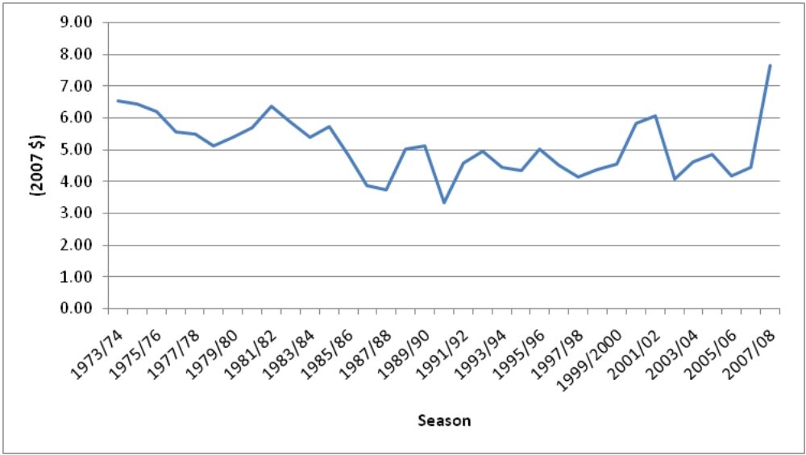
Source: Livestock Improvement Corporation (1999, 2007), New Zealand Herald (2008).
  - Milk Fat Production 1964-1986
Data on milk fat production were obtained from the Livestock Improvement/New Zealand Dairy Board reports over the period 1964 to 1986. Unfortunately these data are only available for the South Auckland farming region for the period up to 1982, and not at a lower spatial disaggregation. As the Waikato region is likely to have produced most of the dairy output for the South Auckland farming region, this series is likely to provide a good approximation for trends in the Waikato region. These data are presented in Figure 2. The data reveal a general upward trend in milk production for the South Auckland region over the period 1964 to 1986, with production increasing by 55 percent between 1964 and 1986. Most of this growth in production has occurred since the 1974 season.

Figure 2: Milk Fat Production in the South Auckland Region 1964-1986
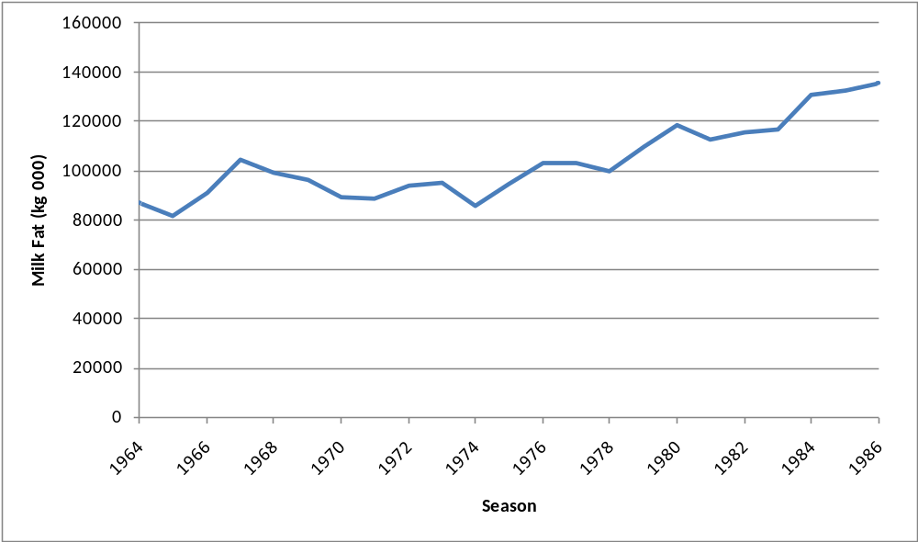

Source: New Zealand Dairy Production and Marketing Board. (1964 to 1969, annual), New Zealand Dairy Board (1970 to 1986, annual).

From 1982 to 1986 these data are available at the county level, as presented in Figure 3. Again, the general trend is upwards in all counties over this period, although some counties experienced a drop in production from 1982 to 1983.

Figure 3: Milk Fat Production by County 1982-1986
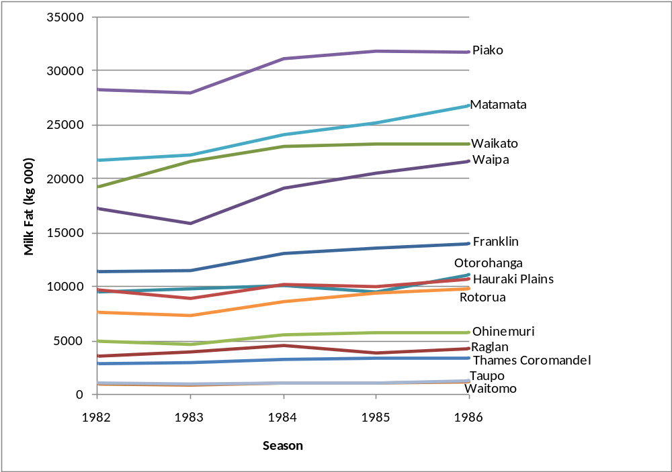
Source: New Zealand Dairy Board (1982 to 1986, annual).

  - Milk Fat Production 1990-2007
Data on milk fat production by TLA since 1990 were obtained from the Livestock Improvement/New Zealand Dairy Board reports. These data are presented in Figure 4. The overall trend in the production of milk fat for each of the TLAs over this period continues the observed upward trend from the 1980s. In particular, production in Taupo District increased by 950% from 1990 to 2007, mostly due to the large number of dairy conversions. Most TLAs experienced a significant dip in production in the 1999 and 2000 seasons, due to a combination of dry weather and facial eczema outbreaks (MAF, 2002).
Figure 4: Milk Fat Production by TLA 1990-2007
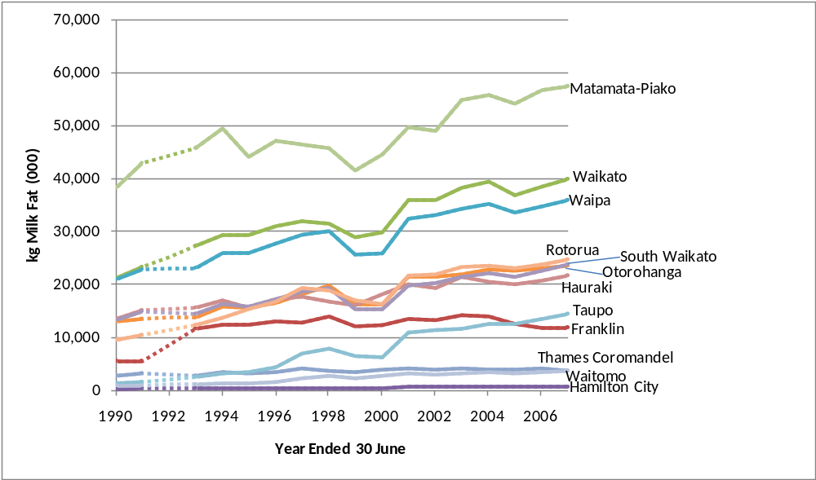
Source: Livestock Improvement Corporation Limited (1990 to 2007, annual).

  - Milk Protein Production 1993-2007
Data on milk protein production by TLA since 1993 were obtained from the Livestock Improvement/New Zealand Dairy Board reports. These data are presented in Figure 5. The overall trend in milk protein production for most TLAs was upwards over this period. The only exception to this is the Franklin district, where milk protein production increased by just 2 percent, compared with a weighted average increase of 53 percent across the other TLAs in the Waikato region.

Figure 5: Milk Protein Production by TLA 1993-2007
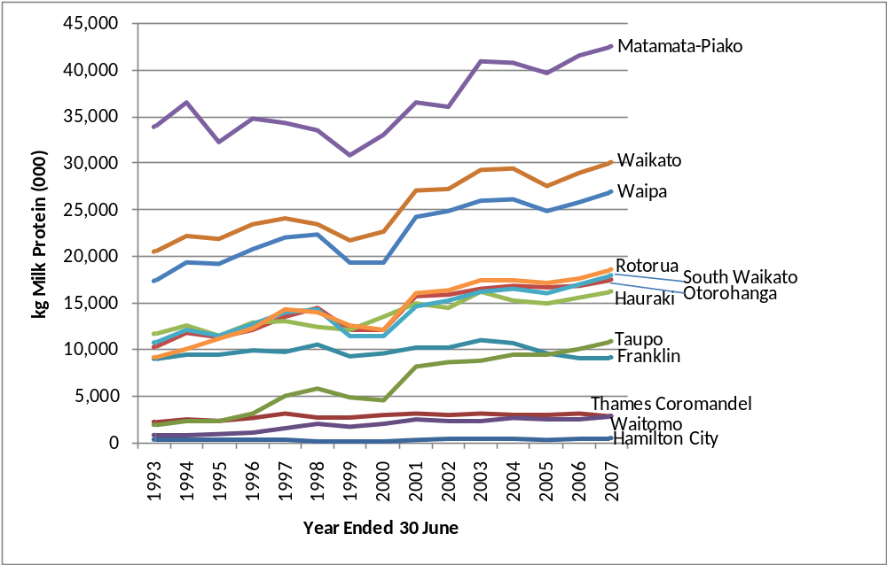
Source: Livestock Improvement Corporation Limited (1993 to 2007, annual).

  - Milk Solids Production 1993-2007
Data on milk solids production by TLA since 1993 were obtained from the Livestock Improvement/New Zealand Dairy Board reports. These data are presented in Figure 6. Since milk solids production is simply the sum of the milk protein production and milk fat production, the overall upward trends in milk fat and milk protein are repeated here, again with the exception of Franklin District.

Figure 6: Milk Solids Production by TLA 1993-2007
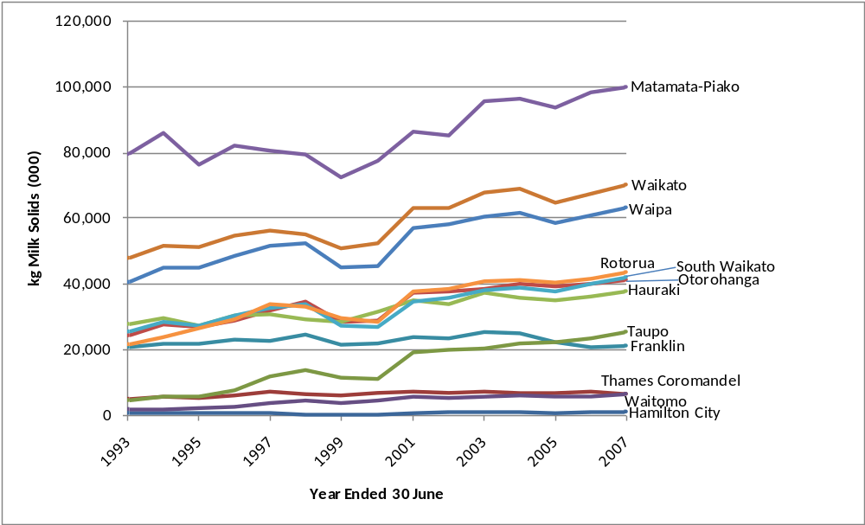
Source: Livestock Improvement Corporation Limited (1993 to 2007, annual).

  - Stock Numbers 1922-1990
Data on number of dairy cows by county over the period 1922 to 1990 were obtained from Statistics New Zealand publications. These data are presented in Figure 7, and represent the total number of dairy cows, not just cows in milk. This data clearly demonstrate the vast growth in dairying in the Waikato since 1922, in particular in Matamata, Piako, Waikato and Waipa counties.

There are two challenges in the presentation of this data as a single set of data series. First, there are two significant periods of unobserved data: between 1923 and 1931, and between 1941 and 1952. Second, there appears to be a significant structural break in the data between 1970 and 1971, with significantly lower stock numbers being recorded in 1971 than in earlier years. This break coincides with the change in the date of measurement of stock numbers from 31 January (for years up to and including 1970) to 30 June (for years from 1971 onwards). Significantly lower recorded stock numbers in June than January is consistent with the culling of stock that occurs at the end of summer, and development of a consistent long-run data series will need to adjust for this change in data collection method (see Section 4).

Figure 7: Total Dairy Cows by County 1922-1990
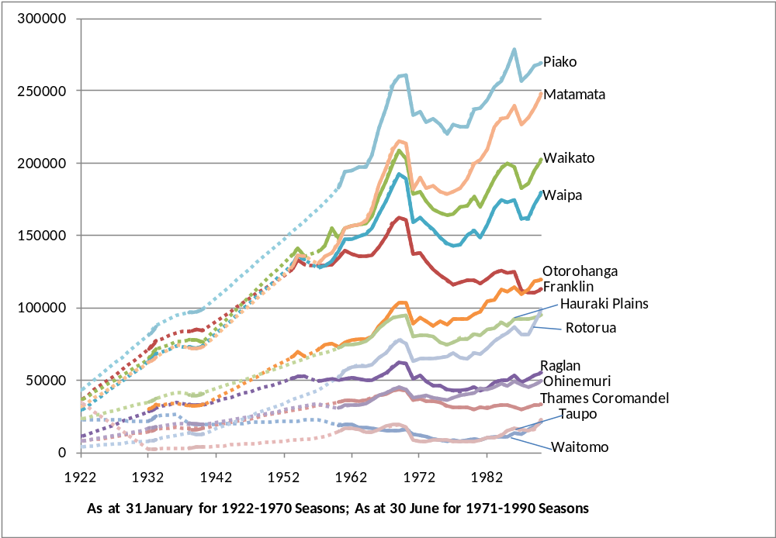
Source: Census and Statistics Office (1922 to 1952, annual). Department of Statistics (1953-1990).

  - Stock Numbers 1982-86
Data on number of dairy cows by county over the period 1982 to 1986 were also obtained from Livestock Improvement/New Zealand Dairy Board publications. These data are presented in Figure 8. Consistent with the Statistics New Zealand data shown earlier, the trend in dairy stock numbers is upwards in all counties over this period. The largest increases, in percentage terms, occurred in the Rotorua and Waipa counties.

Figure 8: Total Dairy Cows by County 1982-1986
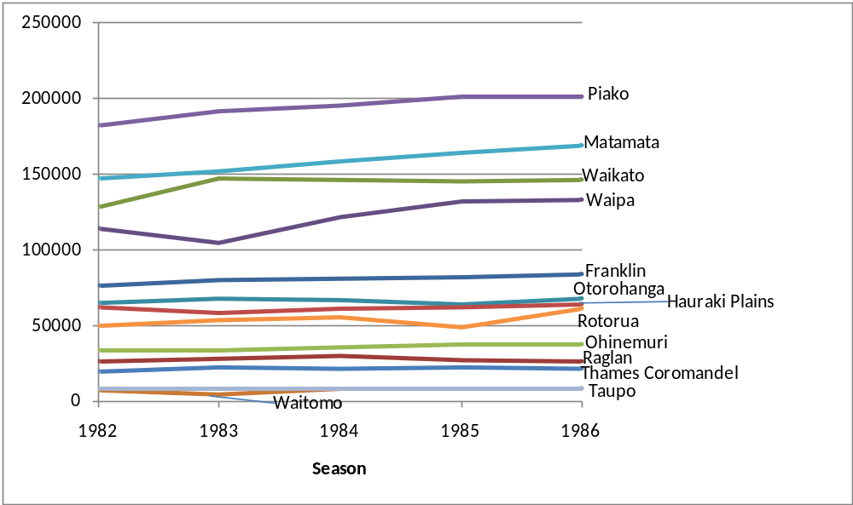
Source: New Zealand Dairy Board (1982 to 1986, annual).

  - Stock Numbers 1990-2007
Data on number of dairy cows by TLA over the period 1990 to 2007 were obtained from Livestock Improvement/New Zealand Dairy Board publications. These data are presented in Figure 9. The general trend in cow numbers is upwards in all TLAs with the exception of Franklin District, which experienced a 17 percent drop in stock numbers of between 1993 and 2007. The growth of the dairy industry in Taupo District is evident here, with dairy stock numbers increasing by 308 percent between 1993 and 2007.

There also a significant challenge in the presentation of this data as a single series. The data on stock numbers for 1990 and 1991 included only “cows lactating on 31 December and excluded those in town supply herds” (LIC, 1993 p. 10), whereas the data on stock numbers from 1993 included “all cows lactating in that season” (LIC, 2007 p. 6). The data for most TLAs increase significantly between 1991 and 1993; however, LIC (2007) claim the change has had a “small effect” on reported cow numbers. The data for Franklin District are impacted significantly due to the high proportion of town supply herds in that district, as well as there being a significant absolute effect on the data for some other districts.
Figure 9: Total Dairy Cows by TLA 1990-2007
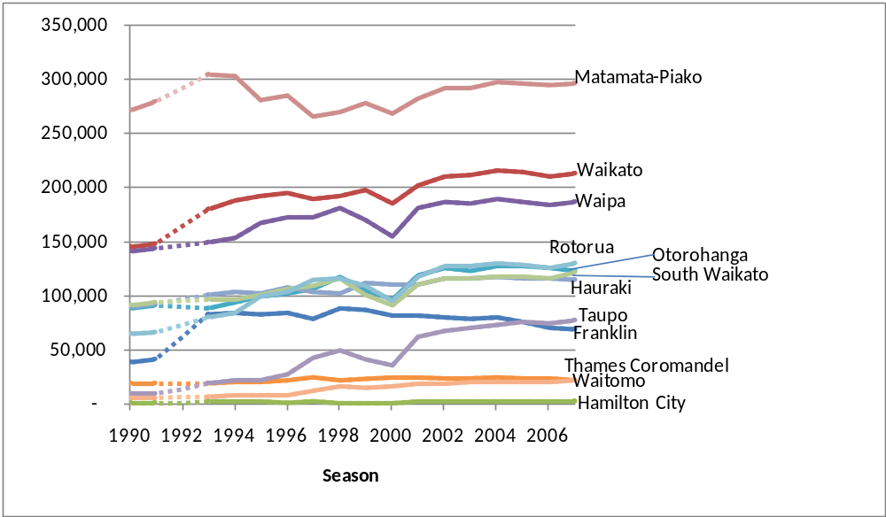
Source: Livestock Improvement Corporation Limited (1990 to 2007, annual).

  - Farm Numbers 1944-1991
Data on number of dairy farms by county over the period 1944 to 1985 were obtained from Statistics New Zealand publications. These data are presented in Figure 10. There are two distinct trends in the number of dairy farms from 1944 to 1985. From 1944 to 1951, in most counties there was a general increase in the number of dairy farms, followed by a period of decline over the period from 1951 to 1985. Exceptions include Rotorua and Taupo, where there were modest increases in the number of farms, and Matamata County where the number of dairy farms was relatively unchanged after 1960. The largest absolute decline in the number of dairy farms was experienced by Franklin County. These observed results are consistent with a trend of consolidation of dairy farming into larger landholdings in most areas of the Waikato region, to take advantage of economies of scale.

One challenge in the presentation of this data series is that there are significant periods with no available data, including the periods from 1953 to 1957 and from 1962 to 1967.

Figure 10: Number of dairy farms by county 1944-1985
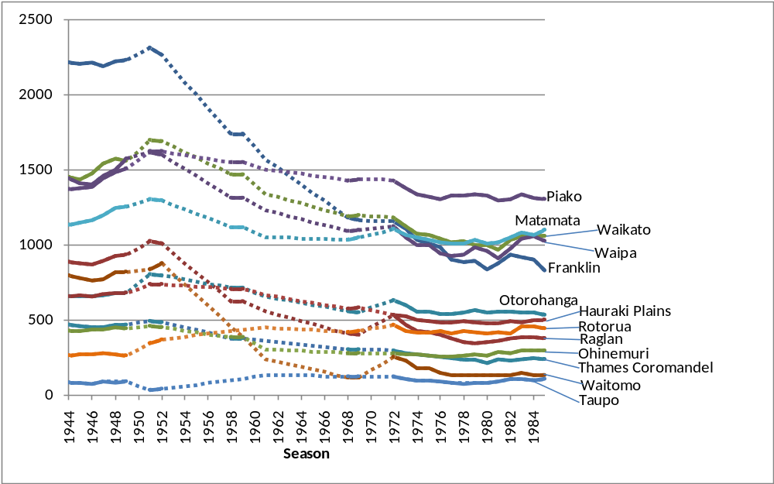
Source: Census and Statistics Office (1944 to 1952, annual). Department of Statistics (1953-1985).

Data on number of dairy farms for the South Auckland farming region over the period 1944 to 1990 were obtained from New Zealand Dairy Board publications. These data are presented in Figure 11. The trends observed in this data are similar to those described above, with an initial increase in the number of dairy farms up to 1957, followed by a period of decline.

Figure 11: Number of Dairy Farms in the South Auckland Farming Region 1944 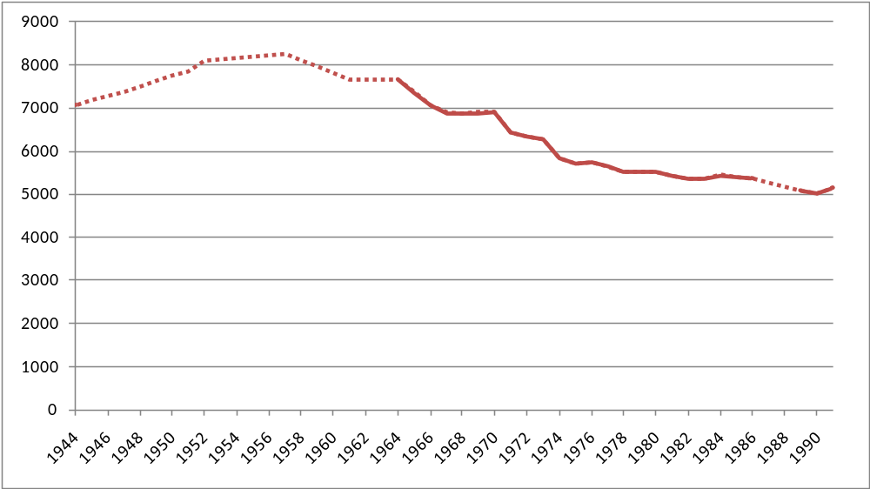
Source: New Zealand Dairy Produce Control Board (1944 to 1934, annual). New Zealand Dairy Board (1935 to 1961, annual). New Zealand Dairy Production and Marketing Board. (1962 to 1969, annual), New Zealand Dairy Board (1970 to 1987, annual). Livestock Improvement Corporation Limited (1989 to 1991, annual).

From 1982 to 1986 these data from Livestock Improvement/New Zealand Dairy Board publications are available at the county level, as presented in Figure 12. Consistent with the Statistics New Zealand data and aggregate South Auckland data presented earlier, the trends in the number of dairy farms are a modest decline or little change over this period.

Figure 12: Number of Dairy Farms by County 1982-1986
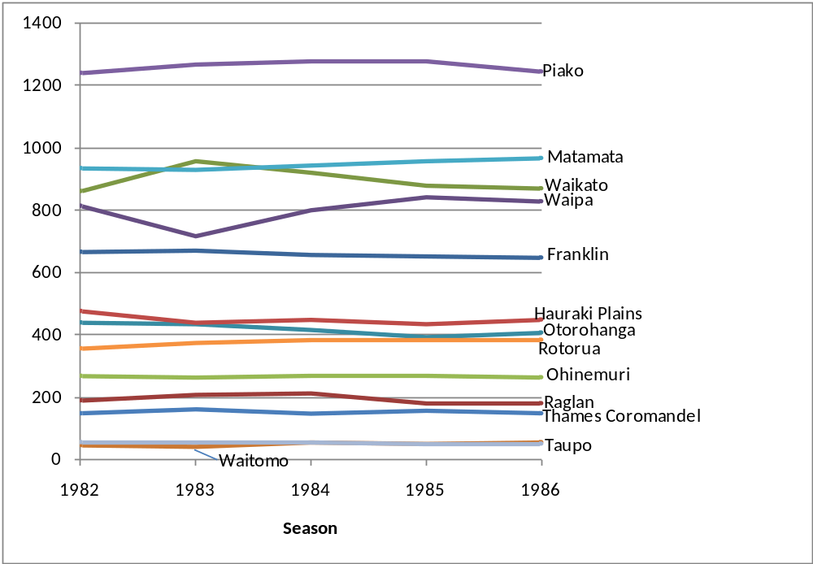
Source: New Zealand Dairy Board (1982 to 1986, annual).

  - Farm Numbers 1990-2007
Data on number of dairy farms by TLA over the period 1990 to 2007 were obtained from Livestock Improvement and New Zealand Dairy Board publications. These data are presented in Figure 13. The declining trend in the number of dairy farms in the 1980s and earlier continued in those TLAs with a large number of dairy farms, while those with fewer dairy farms saw relatively little change, or even modest increases.

The data on the number of dairy farms for 1990 and 1991 do not include town supply herds and are thus slightly understated. This also explains the significant increase in the number of dairy farms recorded in 1993 compared with the earlier years. As with the number of dairy cows (above), the data for Franklin District are especially impacted due to the high proportion of town supply herds in that district, as well as there being a significant effect on the data for Matamata-Piako and Waikato Districts.

Figure 13: Number of dairy farms by TLA 1990-2007
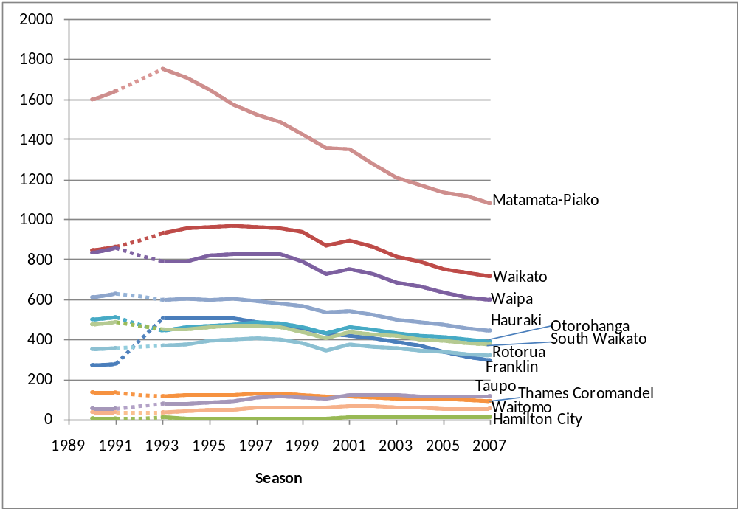
Source: Livestock Improvement Corporation Limited (1990 to 2007, annual).

  - Land area Devoted to Dairy Farming 1964-1968, 1989-1991
There is a paucity of data available on the total land area devoted to dairy farming prior to 1991. Some data on total area (in hectares) devoted to dairy farming by region were obtained from Livestock Improvement and New Zealand Dairy Board publications, but only for the years 1964, 1967, 1968, and the period 1989 to 1991, and only for farming regions. These data are presented in Table 1. The data suggest that there has been a decline in the amount of land used for dairying between the 1960s and the late 1980s. This difference may be due to a difference in measurement between the two periods, and will require further investigation.

Table 1: Land Area Devoted to Dairy Farming (ha.) by Region 1964-68 and 1989-1991
 | Region
Year | Central Auckland | South Auckland | Central Plateau | Western Uplands
1964 | 148981 | 396786 | 36894 | 15567
1967 | 136011 | 361793 | 35583 | 14259
1968 | 137215 | 364099 | 35132 | 13889
1989 | 47680 | 315146 | 28934 | 3773
1990 | 41459 | 317760 | 34318 | 2990
1991 | 43869 | 326967 | 36756 | 3049

  - Land area Devoted to Dairy Farming 1990-2007
Data on the total effective hectares used in dairying by TLA over the period 1990 to 2007 were obtained from Livestock Improvement and New Zealand Dairy Board publications. These data are presented in Figure 14. The trend in most TLAs over this period has been a modest increase in the amount of land used for dairying, with the exception of Taupo District, which has seen a significant increase in dairy land, consistent with the large number of dairy conversions in that district through the 1990s.

As with total dairy cows and number of farms (above), the data for 1990 and 1991 do not include town supply herds and are thus slightly understated. As above, this appears to have a significant effect on the data for Franklin District, as well as Matamata-Piako and Waikato Districts.

Figure 14: Land area devoted to dairy farming (ha.) by TLA 1990-2007
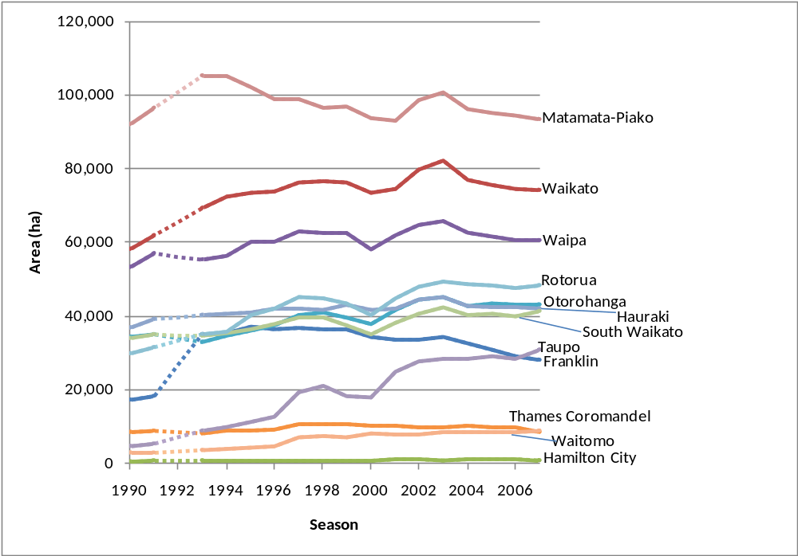
Source: Livestock Improvement Corporation Limited (1990 to 2007, annual).

- Generating Consistent Long-Run Spatially Disaggregated Data Series
The data and discussions presented above highlight the many challenges in developing consistent long-run spatially disaggregated data series for the Waikato dairy sector. These challenges all relate to the lack of consistency in the existing data, with spatial and temporal inconsistencies within existing data sources of data, and definitional inconsistencies both within and between the two main sources of data. Sometimes a change in survey method or definitions has resulted in obvious structural breaks in the data, such as between 1970 and 1971 in the stock numbers from Statistics New Zealand. A set of proposed methods for overcoming (or at least minimising the impact of) these inconsistencies is presented below.

  - Spatial and Temporal Inconsistencies
Spatial inconsistencies in the data have arisen primarily from two sources. First, and most significantly, the local authority boundary reorganisation in 1989 changed the spatial allocation of land, with new district boundaries created that were inconsistent with old county and borough council boundaries. Second, some of the reported data are aggregated, and the aggregations are not consistent, i.e. some data are reported at a regional level broadly consistent with local authority boundaries at the time, while other data are reported for ‘farming regions’. In order to convert the data into a consistent spatial disaggregation, a number of assumptions will need to be applied.

Our proposed method for converting county-level data prior to 1990 into TLA-level data consistent with current TLA boundaries is to use an apportionment based on the relative geographical areas. For instance, when the boundaries were re-drawn in 1989 part of Raglan County was included in Waikato District (say X percent), and part in Franklin District (say Y percent). An appropriate apportionment would include X percent of Raglan’s total number of cows, land area, production, etc. in Waikato District, and Y percent in Franklin District. This apportionment will involve a detailed examination of local authority boundaries and areas, and at this stage will assume that dairy land is evenly distributed across all districts, which of course is not true. However, in the absence of accurate land use data (see for example Rutledge et al., 2008), this may provide a useful approximation.

We propose an alternative apportionment method for dealing with data aggregated at higher spatial resolutions, e.g. farming regions. Using existing data we can estimate the share of total cows, land area, production, etc. for each of the current TLAs (as a share of the South Auckland farming region, or other spatial aggregation). By projecting the series backwards in the form of each TLA’s share of the total, we may be able to estimate the series using the aggregated data. A range of different assumptions may then be employed in the projections of these time series (of course, the projection is backwards in time rather than forwards), and standard time series forecasting (or in this case, back-casting) techniques, such as exponential smoothing, may be applied (Diebold, 2007). Alternatively, or in parallel, we can use some series that have relatively complete data to help produce estimates of data in incomplete series, either using simple assumptions or a structural model. For instance, some simple assumptions about the productivity of each cow may allow an estimate of total production within a TLA area, if the number of cows is known (or has been estimated from other data). A combination of these two methods is likely to yield plausible series where there is significant missing data at a spatially disaggregated level (such as for dairy production statistics).

  - Definitional Inconsistencies and Structural Breaks
There are a number of cases where Statistics New Zealand and New Zealand Dairy Board/Livestock Improvement have similar series, but they differ significantly on a definitional basis. For instance in stock numbers, Statistics New Zealand have published data on total dairy cows whereas the New Zealand Dairy Board published data only on cows in milk. This creates a problem when combining the two series into a single series for dairy stock numbers in each TLA. For some of these consistencies between the existing data sets, there are additional data available that could be of use. For instance, in most years Statistics New Zealand also published data on cows in milk. This could be used to determine the ‘normal’ proportion of dairy cows that are in milk, and then that estimated proportion could be used to scale Statistics New Zealand’s series into a ‘cows in milk’ series (which is likely to be of more use as a long run data series).

There are similar issues within existing data series. For instance, in the Livestock Improvement Corporation data, after 1992 town supply is included but in 1991 and earlier within the same series it was not. Also, there is a significant structural break in the Statistics New Zealand stock numbers series, occurring when the date of counting changed from 31 January (prior to 1971) to 30 June (from 1971 onwards). To overcome these problems, a combination of time series modelling and structural modelling similar to that described in Section 4.1 will need to be employed.

  - Sampling Errors
Finally, all published data have been derived from surveys and as such, are subject to sampling and non-sampling errors. In deriving long run data series from these published data, these errors will be carried over into the final data set. It is probably safe to assume that sampling errors are unbiased and that the estimated long run series are therefore also unbiased, or at least as unbiased as the original series were. Unfortunately it should be acknowledged that there is no way to accurately assess the possibility or potential size of non-sampling errors, whether originating from the original data collection and publication or from subsequent modelling and forecasting on our part.

Conclusions
A data-informed understanding of the history and development of the dairy sector in the different districts of the Waikato region is important for informing future policy decisions. Unfortunately, there are significant problems with the consistency of available published data on the dairy sector in the Waikato region. In this paper we have presented the current state of dairy farming data available for the Waikato region, and briefly discussed a method that will be employed to develop consistent long-run spatially disaggregated data series for (i) milk production; (ii) total number of productive dairy cattle; (iii) total number of dairy farms; and (iv) total effective hectares devoted to dairy production.

There are a significant number of challenges that must be overcome in order to develop consistent long-run spatially disaggregated data series, including a lack of consistency in the existing data, with spatial and temporal inconsistencies within existing data sources of data, and definitional inconsistencies both within and between the two main sources of data. Overcoming these challenges will require the application of a variety of time series and structural modelling techniques.

References

Census and Statistics Office. (1922 to 1947, annual). Statistical report on the agricultural and pastoral production of the Dominion of New Zealand. Wellington, New Zealand: Govt. Printer.

Census and Statistics Office. (1948 to 1950, annual). Statistical report on the agricultural and pastoral production of New Zealand. Wellington, New Zealand: Govt. Printer.

Census and Statistics Office. (1951 to 1952, annual). Report on the agricultural and pastoral statistics of New Zealand. Wellington, New Zealand: Govt. Printer.

Census and Statistics Department. (1953 to 1962, annual). Report on the farm production statistics of New Zealand. Wellington, New Zealand: Govt. Printer.

Department of Statistics. (1963 to 1966, annual). Statistics of farm production. Wellington, New Zealand: Govt. Printer.

Department of Statistics. (1967 to 1969, annual). Farm production. Wellington, New Zealand: Department of Statistics.

Department of Statistics. (1970 to 1985, annual). Agricultural Statistics. Wellington, New Zealand: Department of Statistics.

Department of Statistics. (1986 to 1993, annual). Agriculture Statistics. Wellington, New Zealand: Department of Statistics.

Diebold, F.X. (2007). Elements of forecasting, 4th ed. Mason, Oh.: Thomson/South-Western.

Hughes, W., Scrimgeour, F., and Cameron, M. (2005). Exploring Waikato futures: An examination of opportunities and threats, presented at the Australia and New Zealand Economic and Regional Development conference, Manukau, 27-30 September.

Livestock Improvement Corporation Limited. (1999 to 2007, annual). Dairy Statistics. Retrieved July, 2008 from http://www.lic.co.nz/

Livestock Improvement Corporation Limited (1989 to 1998). Dairy Statistics. Hamilton, New Zealand: Livestock Improvement Corporation Limited.

Ministry of Agriculture and Fisheries. (2002). 2000 Dairy Monitoring Report. Retrieved July 8, 2008, http://www.maf.govt.nz/mafnet/rural-nz/statistics-and-forecasts/farm-monitoring/fmdairy00/dairy00-08.htm

New Zealand Dairy Produce Control Board. (1925-1934, annual). Annual Report and Statement of Accounts. Wellington, New Zealand: New Zealand Dairy Produce Control Board.

New Zealand Dairy Production and Marketing Board. (1962-1969, annual). Farm production report and summary of Board’s work. Wellington, New Zealand: New Zealand Dairy Production and Marketing Board.

New Zealand Dairy Board. (1935-1961, annual). Annual Report and Statement of Accounts. Wellington, New Zealand: New Zealand Dairy Board.

New Zealand Dairy Board. (1988). Annual Report (Livestock Improvement Division). Wellington, New Zealand: New Zealand Dairy Board.

New Zealand Dairy Board. (1970-1984, annual). Farm Production Report. Wellington, New Zealand: New Zealand Dairy Board.

New Zealand Dairy Board. (1985-1987, annual). Livestock Improvement Report. Wellington, New Zealand: New Zealand Dairy Board.

New Zealand Herald. (2008). Fonterra record payout revealed. Retrieved August 26, 2008, from http://www.nzherald.co.nz/section/3/story.cfm?c_id=3&objectid=10513446.

Rutledge, D., Price, R., Cowell, S., and Briggs, C. (2008 in review). Geospatial Land Use Classification for New Zealand: Findings and Recommendations. Statistics New Zealand Official Statistics Research Series Volume 4. Wellington: Statistics New Zealand.

Slashed dairy payout hides debt diversion. (1991, 18 October). National Business Review. p.5.

Statistics New Zealand. (1995 to 1996, annual). Agriculture Statistics. Wellington, New Zealand: Statistics New Zealand.

Statistics New Zealand. (1999). Agricultural Production Survey. Retrieved July, 2008, from www.stats.govt.nz.

Statistics New Zealand. (2002). Agricultural Production Census. Retrieved July, 2008, from www.stats.govt.nz.

Statistics New Zealand. (2003 to 2006, annual). Agricultural Production Survey. Retrieved July, 2008, from www.stats.govt.nz.

Statistics New Zealand. (2006). Information about the Agricultural Production Survey – Guide to Interpreting Data. Retrieved July 4, 2008.
http://www2.stats.govt.nz/domino/external/omni/omni.nsf/0bcb74e1baef32fd4c25689b000f2d1e/5f560be9a9f8b1eccc2572ae001492a2?OpenDocument#Guide.

Statistics New Zealand. (2007). Agricultural Production Census. Retrieved July, 2008, from www.stats.govt.nz.

We have included all of Franklin District and all of Rotorua District, although only parts of those districts are contained within the Waikato region.
For instance in some publications, data were only reported at the national level.
Inflation adjustments were made using the CPI.
This series was generated using a combination of three different series from the Dairy Board publications: number of herds, average herd size, and average milk fat production per cow. The total milk fat produced is therefore given by: Milk Fat = (Number of Herds) x (Average Production per Herd) x (Production per Cow) Alternatively, the series could have been constructed using alternative data from the same source and the formula: Milk Fat = (Number of Herds) x (Average Production per Herd) The two methods produce similar values, the differences being purely due to rounding.
The series was constructed using the formula: Milk Fat = (Number of Herds) x (Average Production per Herd) where the average production per herd and the total number of herds included town supply herds.
There is little data available on land use in general prior to 1991 (see for example Rutledge et al., 2008).

