UNIVERSITY OF WAIKATO

Hamilton
New Zealand

A Summary of Ecosystem Service Economic Valuation Methods
and Recommendations for Future Studies

Pamela Kaval

Department of Economics

Working Paper in Economics 10/02

April 2010

Pamela Kaval

Economics Department
University of Waikato
Private Bag 3105
Hamilton, New Zealand

Tel: +64 (7) 838 4045
Fax: +64 (7) 838 4331

Email: pkaval@mngt.waikato.ac.nz; pam98k@yahoo.com

Abstract

This short working paper summarizes ecosystem service economic valuation methods. The paper begins with an introduction to ecosystem services, and then describes the various methods that can be used to value them. An extensive literature review was carried out, illustrating those ecosystem service studies that attempted to value three or more ecosystem services using original data and more than one valuation method. Recommendations are then offered on how to conduct ecosystem service valuation studies.

Keywords

ecosystem services
market valuation
non-market valuation

JEL Classification

Q57; Q51; Q5

Ecosystem services include all services that enable life on earth to exist. In this context, life not only refers to people, but all flora and fauna. More specifically, ecosystem services include:

- Genetic and medicinal resources,
- Plant and animal refugia,
- Purification and regulation of air and water,
- Soil formation,
- Detoxification and decomposition of wastes,
- Plant pollination,
- Natural pest and biological control,
- Nursery function,
- Seed dispersal,
- Nutrient cycling,
- Biodiversity maintenance,
- Protection from the sun’s ultraviolet rays,
- Partial climate stabilization,
- Natural disturbance regulation,
- Raw materials,
- Food production,
- Erosion control,
- Aesthetic beauty,
- Human culture,
- Recreation,
- Preservation (includes existence, bequest and option value), and
- Science and education (Costanza, d'Arge et al. 1997; Daily 1997; Daily,
Alexander et al. 1997; de Groot, Wilson et al. 2002).

In reading through the list of ecosystem services, it becomes easy to understand how they contribute directly to life. For example, plants produce oxygen, a gas we need to breathe, while the ozone layer protects us from the sun’s ultraviolet radiation. However, it is difficult to understand the comparison between how much oxygen one tree produces, how much oxygen a person needs, how well the ozone layer helps us from getting skin cancer, 50 tons of lumber, 3 hours of hiking, and the 100 worms per square meter of soil that help to aerate the soil for plant growth. The easiest way to compare these ecosystem services is convert them into one type of unit.

Economists have devised a methodology that enables us to use a dollar value as the common unit of comparison. Placing dollar values on ecosystem services makes it simpler for everyone, from farmers to politicians, to understand the value of a service, because most people use currency as a form of exchange (Costanza, dArge et al. 1997; Daily 1997; Daily, Alexander et al. 1997; de Groot, Wilson et al. 2002).

Placing a dollar value on ecosystem services requires consideration of the interconnectedness of the ecosystem to determine their monetary value. In this way, the total economic value is considered. This is easier said than done, as ecosystem services consist of many different types of values, from market values such as the cost of gold, to anthropocentric (human related) non-market values such as birdwatching, to ecocentric (nature related) non-market values such as the safety of a baby bird in a nest on a tall cliff (Pearce and Turner 1990; Merlo and Croitoru 2005).

Because there are so many types of ecosystem services, it is often preferable to group them together before attempting to calculate their value. The Millenium Ecosystem Assessment (2005) divided ecosystem services into four categories: supporting, provisioning, regulation and cultural services. Similarly, de Groot et al. (2002) also divided ecosystem services into four categories: regulation, habitat, production and information. In relation to economic valuation, it may be easier to think of these services according to the type of value they provide (Figure 1). For consumptive goods, such as harvested fish and logged timber, we can consider the market values, in that a specific amount of money is exchanged directly on the market for these products. Ecosystem services that cannot be measured in terms of market values have a non-market value (anthropocentric or ecocentric), but no direct exchange of money takes place (Pearce and Turner 1990; Hartwick and Olewiler 1998; Freeman 2003; Council 2005; Anderson 2006; Tietenberg 2006).

Non-market values can be subdivided into non-use values and use values. Non-use values include those values such as preservation value, where the resource is not directly used. Use values, on the other hand, focus on the resource being used and can be further subdivided into direct use values, such as swimming and birdwatching, and indirect use values, such as erosion control and ultraviolet radiation protection (Pearce and Turner 1990; Hartwick and Olewiler 1998; Freeman 2003; Council 2005; Anderson 2006; Tietenberg 2006).

Figure 1. Ecosystem Service Valuation Types

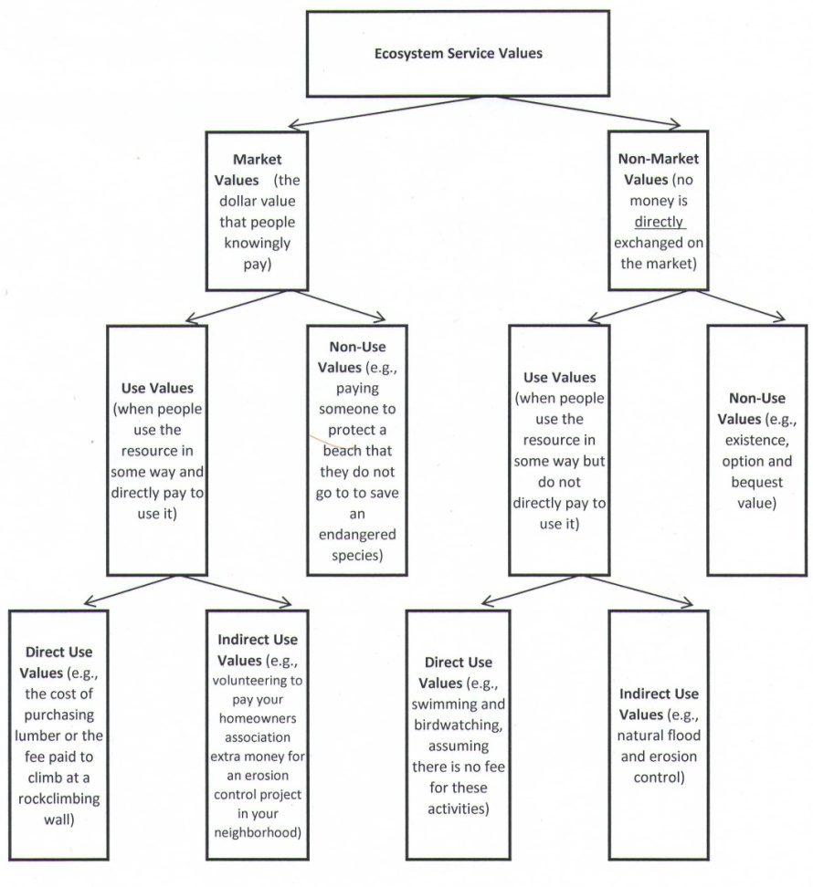
Note: Market values are typically measured as direct use values, whereas indirect use and non-use values are more commonly measured as non-market values.

The process of calculating ecosystem service values is complicated and there are currently no valuation standards. For market values, we can simply consider the cost of the product in the market, such as the price of an ounce of gold or the entrance fee to a park. Non-market values are more difficult to account for. Some common methods used today include the contingent valuation method, the travel cost method, choice experiments, hedonic pricing and the benefit transfer method. These methods are described briefly:

The contingent valuation method is sometimes called the willingness-to-pay or willingness-to-accept method; it is a stated preference method, in that a person ‘states’ what they will do if a hypothetical situation were to arise. More specifically, with contingent valuation, they state how much they are willing-to-pay (willing-to-accept) for a change in a particular good or service. An example is the amount of money they would be willing-to-pay to hunt for deer in an area, if they were guaranteed to see at least ten deer on a particular hunting trip (Pearce and Turner 1990; Hussen 2000; Haab and McConnell 2002; Daly and Farley 2004; Kahn 2005; Anderson 2006; Hackett 2006).

The travel cost method is a revealed preference method in that the respondent is revealing something that they actually did. Here, they value how much it costs to take a specific trip, costs that they would not have spent normally. An example is determining the cost of travelling to a lake to fish and camp. To do this, extra money is spent on gas/petrol and camping fees, assuming the person already has all their fishing equipment (Pearce and Turner 1990; Haab and McConnell 2002; Kahn 2005; Anderson 2006; Hackett 2006).

Choice experiments are a stated preference method that involves asking a series of questions about a respondent’s preferences for various management strategies. There will typically be three or four alternative strategies with similar attributes (per question) presented to the respondents. An example of choice experiment alternatives include the number of picnic areas available, the percentage of harvested trees, the percentage of species diversity, as well as a dollar value, such as an entrance fee or a fee in your annual taxes/rates (Louviere, Hensher et al. 2000; Bateman, Carson et al. 2002; Hensher, Rose et al. 2005; Street and Burgess 2007).

Hedonic pricing is a revealed preference method that investigates the prices people pay for specific goods for the purpose of valuing an environmental resource. Oftentimes, the price that is investigated is a house/property price. For example, to determine the value of seeing the beach from a house, the researcher could compare the price of houses overlooking a beach to those one block away (Pearce and Turner 1990; Hussen 2000; Haab and McConnell 2002; Kahn 2005; Anderson 2006; Hackett 2006).

Benefit transfer or value transfer is a method used as a result of time limitations and/or budget constraints and focuses on using secondary data. In this method, a researcher uses existing economic valuation information conducted in a particular area and transfers those values to a new site or area, sometimes called the policy site. Care should be made to transfer values from an area that is similar to the policy site (Kaval and Loomis 2003; Kahn 2005). While this method is listed under non-market valuation methods, it can also be used to transfer market values.

These methods, together with direct market values, can aid us in valuing many ecosystem services. But they fall short of valuing all ecosystem services, for which other methods must be employed. These include the avoided cost method, the replacement cost method, the restoration cost method and factor income.

Avoided cost methods attempt to quantify the costs we do not have to pay when nature is providing a particular good. An easy way to conceptualize this is to imagine an area, such as a picnic area, being completely bulldozed and paved. If this were to happen, what ecosystem services would disappear? There will no longer be plants to produce oxygen; no biological control will take place by insects; nutrients will no longer be recycled; rain will run off, potentially flooding the area around it; nothing will be pollinated, as there are no plants to pollinate and no insects to pollinate the plants; genetic resources have been removed; the climate is no longer being regulated as it was (perhaps only the sun’s rays are reflecting heat off the black pavement); wastes are not being treated; and most fauna can no longer use the area for food or habitat. The value of these lost ecosystem services are the avoided costs (Daily 1997; Daily, Alexander et al. 1997; Cleveland, Betke et al. 2006).

Replacement cost is a method used to calculate the cost of replacing a service with a human-created product, such as fertilizers to replace the nutrients that worms create for the soil (Hussen 2000; Kahn 2005).

Restoration cost is a method used to calculate the cost of restoring an ecosystem to the natural state that existed prior to an environmental damage, such as the cost of repairing the environmental damage caused by the Exxon Valdez Oil Spill of 1989 (Bragg, Prince et al. 1994; Kahn 2005).

Factor income is the value of an ecosystem service that enhances market value ecosystem services. For example, bees pollinate the flowers of the agricultural crops sold on the market (Woodward and Wui 2001; Brander, Florax et al. 2006).

Table 1 provides a list of ecosystem services, their value types, as well as the methods commonly used to calculate their dollar value. As can be seen, researchers use different methods to calculate values. Recreation, for example, is a direct use value and can be calculated as a market or non-market value. If you paid money to use an indoor climbing wall, the price paid is a market value. However, if you went to a park to climb that does not charge an entrance fee, this would be considered a non-market value. Non-market valuation methods that are commonly used to calculate recreation values include the contingent
Table 1. Ecosystem Services and the Commonly Used Methods
for Calculating their Dollar Values

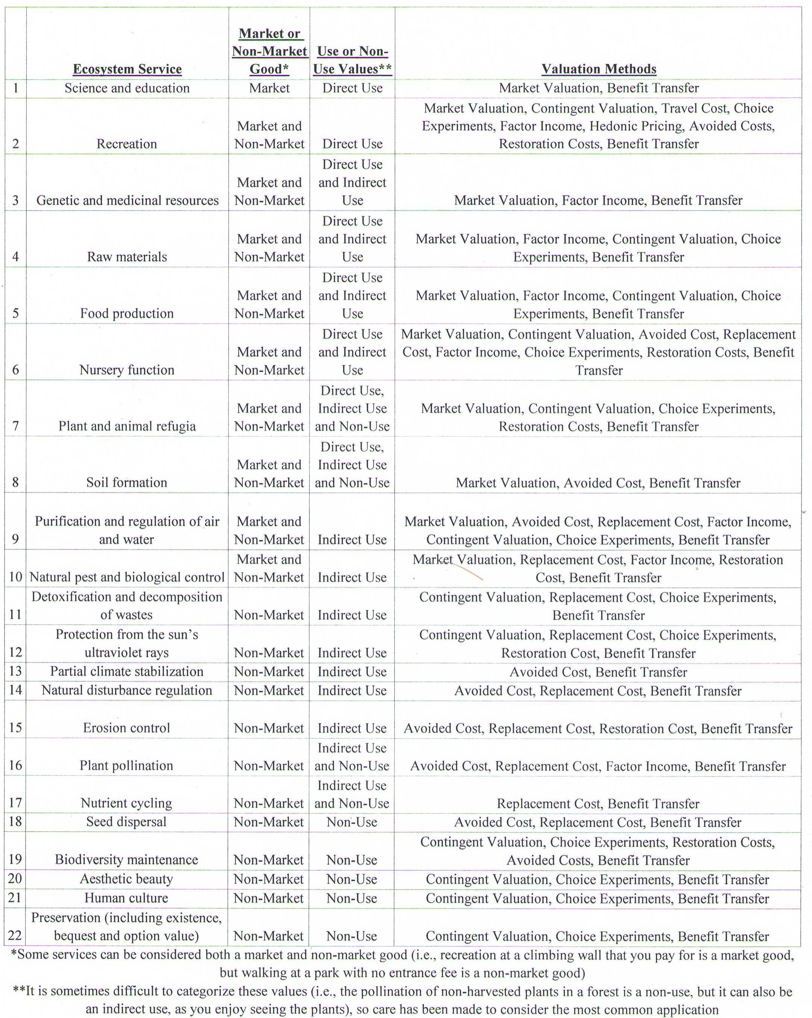
Note: This table is a modification and extension of a table from de Groot et al. (2002). It includes commonly used valuation techniques, but is not exhaustive.

valuation method, travel cost method, choice experiments, factor income, hedonic method, avoided costs, restoration costs and the benefit transfer method. Science and education, on the other hand, are considered a market value and a direct use. Valuation methods that are commonly used for science and education include market valuation and benefit transfer (Hartwick and Olewiler 1998; de Groot, Wilson et al. 2002; Kahn 2005).

Ecosystem service studies are well represented in the literature, even if they were not termed as such. One of the first and most thorough original longitudinal ecosystem service studies that predated this discipline was a Rhone Poulenc farm management study conducted by Higginbotham (1996, 1997, 1999, 2000). In this seminal study that began in 1994 on 57 hectares in Essex, they compared organic farming to reduced input and conventional farming for a variety of crops. They not only estimated the values, costs, and yields of the crops, but also measured food quality, the taste of the final goods, earthworm populations, weed populations, and insect populations. This project began in the early 1980s and is believed to be still in progress.
(http://www.hgca.com/publications/documents/cropresearch/).

As the discipline is being advanced, people are now using the term ecosystem service valuation more often. In conducting this investigation, it was discovered that some researchers that conduct an ecosystem service valuation study focused on one particular value (such as recreation), some focused on one particular valuation method (typically contingent valuation or choice experiments), some solely present conceptual models, while others focus on using a benefit transfer or value transfer approach, such as the Constanza et al. (1997) study. Several researchers have used the values presented in the Costanza et al. (1997) work to create their own estimates. All of these works provide valuable insight into ecosystem service valuation. However, this study focuses on a select few articles that attempted to value three or more ecosystem services using original data and more than one valuation method (Table 2). Due to practical limitations, the studies listed here may not be exhaustive, although all attempts were made to include all studies that fit the guidelines.

The selected articles used a wide variety of valuation methods. In the Cesar and Van Beukering (2004) and Cesar et al. (2004) studies, values included recreation, fisheries, amenity values and biodiversity research. Study locations included the coral reefs of Hawaii and the marine ecosystem of Seychelles. Calculations were made using market values, the travel cost method, the contingent valuation method and replacement costs. In the Grêt-Regamey et al. (2008) article, focus was placed on avalanche protection, timber production, scenic beauty, and habitat in the Swiss Alps (Europe); methods used included contingent valuation, replacement costs, and market values. Johnston et al. (2002) investigated the values for an estuary in New York. Ecosystem services of interest included amenities, recreation, habitat and preservation. In this study, methods included choice experiments, market values, travel cost and hedonics.

Table 2. Summary of Original Ecosystem Service Valuation Studies Valuing Three or More Ecosystem Services Focusing on a Particular Area and Using more than One Valuation Method

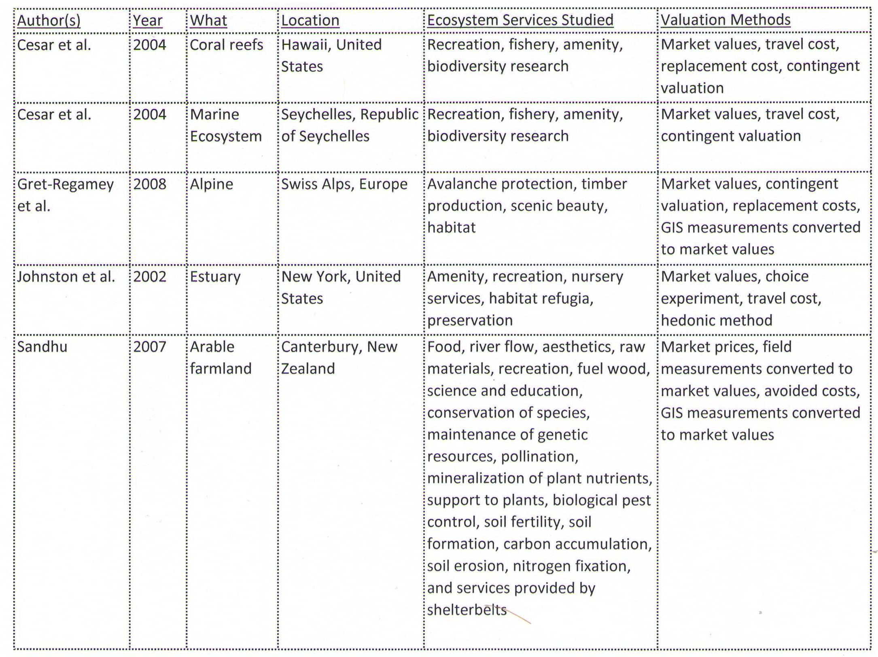

In the Sandhu (2007) study, ecosystem service values were calculated for conventional and organic farming systems in Canterbury, New Zealand. Values included the biological control of pests, mineralization of plant nutrients, soil formation, food, raw materials, carbon accumulation, nitrogen fixation, soil fertility, river flow, aesthetics, pollination, and shelterbelts, all of which were assessed experimentally. Economic value was calculated from the predation rate on aphids and fly eggs, the value of the earthworms for soil formation and the mineral cycling of plant nutrients, to name a few.

As demonstrated in Table 2, there are no standard methods for ecosystem service valuation. When planning to conduct an ecosystem services valuation, it is important to consider the strengths and weaknesses of candidate methods and how these are related to your research objectives. For example, if you are investigating grazing impacts on the Sevilleta National Wildlife Refuge, a 93,000 ha state park located in New Mexico, you should firstly determine the ecosystem types that may be impacted. This particular park represents a variety of ecosystem types, including the Chihuahuan Desert, Great Plains Grassland, Great Basin Shrub-Steppe, Piñon-Juniper Woodland, Bosque Riparian Forests, Wetlands and Montane Coniferous Forest (United States Fish and Wildlife Service, 2007). Grazing cattle on the Great Plains Grassland area may have impacts on adjacent ecosystems and therefore extend the study area. You might also want to consider the broader effect, such as clean air provision through photosynthesis, as well as effects on downstream aquatic values.

There are many issues that can be considered in an ecosystem service valuation study, but given the practical constraints on time and funding, the following guidelines will be helpful in focusing your investigation:

- Define the boundaries of your research area (e.g., all of Sevilleta National Wildlife Refuge, all areas the refuge effects or only the Great Plains Grassland area).

- Define the ecosystem types located in your research area (i.e., in the Sevilleta National Wildlife Refuge, it may include the Chihuahuan Desert, Great Plains Grassland, Great Basin Shrub-Steppe, Piñon-Juniper Woodland, Bosque Riparian Forests, Wetlands and Montane Coniferous Forest).

- Determine what ecosystem services (Table 1) are currently functioning (or could be functioning if something is changed) in the research area.
  - Determine which people benefit from these services (location, demographics).
  - Determine the scarcity of these services in the region.
  - Determine whether these services have readily available regional natural or man-made substitutes.
  - Determine whether these services are restorable in this area.

- Determine the ecosystem response to the changes being investigated (e.g., an invasive species enters the area, grazing stops, grazing begins, the land is paved over and no ecosystem services exist there anymore)
a. Determine which of the defined ecosystem services will change
b. Determine different scenarios for the types of change possible (e.g., the invasive species spreading quickly vs. the invasive species spreading slowly)

- Determine the most appropriate valuation methods to use to value the ecosystem services, given your objectives, as well as your funding and time constraints.

- Conduct your research according to the guidelines you have defined.

According to the Millenium Ecosystem Assessment (2005), over the last half of the 20th century, humans have been rapidly and extensively affecting ecosystems and their services, resulting in substantial and irreversible biodiversity losses, while attempting to meet worldwide demands for the basic human needs of food and shelter. As a result, it is not only important to conduct ecosystem service valuations for the sake of the services, but also because of their rapid and extensive losses.

Some studies also consider discourse based methods to obtain values for ecosystem services. In a discourse based study, people get together in a designated location and discuss their values for an ecosystem good or service. However, this method focuses on qualitative values. Since the focus of this chapter is quantitative methods, this method is not being considered here.

