**UNIVERSITY OF WAIKATO**

**Hamilton**

**New Zealand**

Australia’s Pacific Seasonal Worker Pilot Scheme (PSWPS):

Development Impacts in the First Two Years

John Gibson

*University of Waikato*

and

David McKenzie

*World Bank, BREAD, CReAM, and IZA*

**Department of Economics**

**Working Paper in Economics 09/11**

June 2011

*Corresponding Author*

|  |  |
| --- | --- |
|  | **John Gibson**  Economics Department  University of Waikato  Private Bag 3105  Hamilton, New Zealand  Tel: +64 (7) 838 4045  Email: jkgibson@waikato.ac.nz |

**Abstract**

Australia launched the Pacific Seasonal Worker Pilot Scheme in August 2008. This program was designed to alleviate labour shortages for the Australian horticultural industry by providing opportunities for workers from Kiribati, Papua New Guinea, Tonga, and Vanuatu to undertake seasonal work. This paper presents an analysis of the development impacts of this program in the first two years, and compares them to those from New Zealand’s seasonal worker program in the same countries. The overall development impact of the scheme to date is small, since only 215 individuals participated in the program in the first two years. We examine the selection of these workers, finding they tend to come from poorer areas of Tonga, but within these locations, appear to be of average income levels, and indeed are similar in many respects to the workers going to New Zealand. We estimate the gain per participating household to be approximately A$2,600, which is a 39 percent increase in per-capita annual income in participating Tongan households. The aggregate impact to date is small, but the experience of New Zealand’s program shows that seasonal worker programs can potentially have large aggregate effects. Finally we provide some evidence on worker’s opinions about the program.

**Keywords**

development impacts

seasonal migration

Pacific Islands

**JEL Classification**

O12; J61; F22

**Acknowledgements**

We thank Halahingano Rohorua for her outstanding work in surveying for this project; John Corcoran and Richard Bedford for managing the survey in Kiribati; the interviewers in Tonga and Kiribati; Geua Boe-Gibson for constructing the maps; Leitumai Malaulau and Manjula Luthria of the World Bank for their support, insights, and work coordinating the Phase I surveys in Australia; AusAID for funding this work and for letting us know when recruitment was happening; and all the survey respondents. All opinions expressed in this document are those of the authors alone, and should not be taken to represent those of the World Bank, Ausaid or any other agency.

1. **Introduction**

Seasonal migration programs are widely used around the world, and are increasingly seen as offering a potential ‘triple-win’- benefiting the migrant, sending country, and receiving country. Labor mobility has long been of importance in the Pacific Islands, whose small population sizes, remote locations, and other features have limited employment opportunities (World Bank, 2006). In the 2005 Pacific Forum, policymakers widely expressed the belief that increased labor market access, especially for unskilled workers, is a central component of regional economic integration under the Pacific Plan (Maclellan and Mares, 2006). This desire has lead to New Zealand starting a seasonal worker program, the Recognised Seasonal Employer (RSE) program in 2007, followed by Australia launching the Pacific Seasonal Worker Pilot Scheme (PSWPS) in August 2008.

This paper assesses the initial development impact of the PSWPS during its first two years, using survey data collected in Australia, Tonga, and Kiribati. The Pacific Seasonal Worker Pilot Scheme was designed to ‘examine whether a seasonal worker scheme could contribute to economic development in Pacific countries through seasonal workers’ employment experience, remittances and training and the benefits to growers in the Australian horticultural industry who demonstrate they cannot source local labour’.[1] The pilot scheme set a total quota of 2,500 short-term working visas to be available to workers from Kiribati, Papua New Guinea, Tonga and Vanuatu for work in the Australian horticultural industry.[2] The pilot consists of two phases: Phase I, between November 2008 and June 2009 was allocated 100 visas. Phase II, between July 2009 and June 2012 was allocated the remaining visas.

This quota is small relative to other seasonal worker programs (2500 over three years, versus *annual* quotas of 5000-8000 workers in New Zealand’s RSE program, and about 24,000 per year in Canada’s SWAP program). Moreover, the PSWPS is far from meeting this quota. Only 56 of the 100 visas available in Phase I were taken up, consisting of 50 Tongan workers who arrived in February 2009 and 6 ni-Vanuatu workers who arrived in April 2009. Phase II has also been slow to see significant recruiting numbers: in the first 20 months of the second phase, between July 2009 and February 2011, only 214 of the available 2400 visas were issued. Moreover, since 55 of the visas were issued to workers returning for a second season, the 270 visas issued up until the end of February 2011 correspond to only 215 individuals participating in the program. The majority of these are from Tonga: there were only 14 workers from Vanuatu and 19 from Kiribati, with the remaining 181 coming from Tonga. No workers have come from Papua New Guinea to date. The main activities of the workers who have come have been harvesting citrus fruits, harvesting almonds, and pruning grape vines.

Several reasons have been identified for the low number of workers recruited to date, including global economic conditions, a lack of flexibility in the regulations under which growers can recruit workers, a potential lack of economies of scale from piloting on such a small scale, and the existence of a pool of competing seasonal labor in Australia including illegal migrants (see for example Ball, 2010 and TNS Social Research, 2010). A separate report has also been submitted by the World Bank to the Australian Government which identifies issues with both the design and implementation of the program, and which offers proposals for modifying both the design and the management of the scheme in order to better achieve the development goals set out. As a result of these issues identified during a mid-term review of the program, changes were made to the scheme in December 2010 to allow some additional flexibility in the length of time employers can hire workers for, and a reduction in the share of travel costs that employers have to cover. It remains to be seen how much these changes spur additional use of the program.

We begin in Section 2 by describing the initial impetus and original plan for evaluating the development impact of the PSWPS program, the data that were collected, and the resulting methods we use to estimate the impact of the program. Section 3 then examines the selection of the workers into the program, and their spatial targeting. We find that PSWPS workers are selected from poorer, more rural areas, but within these areas they do not differ in poverty levels, education, or household assets from non-participating workers and their households. An interesting finding is that workers undertook a non-trivial amount of internal migration to make it easier for themselves to get recruited for the program. Section 4 then looks at the incomes earned, costs born, remittances sent, and overall net gain for workers participating in the program. A typical worker earned A$12,000-13,000 in Australia, of which we estimate approximately A$5,000 gets remitted, and the net gain is around A$2,600 after taking account of opportunity costs of what the workers would have contributed to household production in their home countries. Based on these calculations and the number of participants, we calculate the aggregate net gain for the participating countries, and compare to the net gain from the RSE program, and to export and bilateral aid flows into these countries. Finally, Section 5 summarizes some of the subjective data collected from worker opinions about the program, and Section 6 concludes.

1. **Initial Impetus and Plan for Evaluating the Development Impact**

At the time of the launch of the PSWPS program, the World Bank was already well underway on an evaluation of the impact of the New Zealand RSE seasonal worker program on development outcomes in Tonga and Vanuatu. The basic strategy for evaluation consisted of surveying households with and without seasonal workers before migration occurred, and then re-interviewing these same households multiple times over the next two years to see how household outcomes change with participation in the seasonal worker program. In the short-run this allowed for an analysis of which types of households were more likely to have members participate in the RSE (Gibson et al, 2008, McKenzie et al, 2008), finding that poorer, more rural workers were more likely to participate from Tonga, whereas in Vanuatu, the average household sending a worker, while poor by global standards, was still richer than the average household not sending workers in the program.[3]

In the longer-term, four rounds of survey data on 450 households in each country were used to ascertain the development impacts of the RSE program (Gibson and McKenzie, 2010). The results showed very positive development impacts, with per capita incomes rising 30 percent, subjective economic welfare improving, households increasing ownership of durable goods and making home improvements, increased use of bank accounts, and in Tonga, large increases in school attendance for 16 to 18 year olds.

The initial goal was to pursue the same approach to analyze the development impacts of the PSWPS in the participating countries. However, the small number of participating workers spread out over many months, coupled with their geographic dispersion has made this difficult. For example, we would sporadically get an alert of the nature that a particular employer was in the process of recruiting 3 workers or 10 workers from Tonga, about 3 weeks before these workers were due to arrive in Australia. It was not cost effective to try and react to each and every hiring, and so we had to be selective in order to try and attain a reasonable sample size within budget.

* 1. **Data Collected**

*Surveys of Workers in Australia:* In late 2009 we conducted pre-return interviews in Australia with 42 of the Phase I group of 50 Tongan workers (3 workers had already returned home early due to the loss of family members in the MV Princess Ashika ferry tragedy), and with all 6 Phase I ni-Vanuatu workers. The survey collected basic personal details of the seasonal worker, some information on the situation of their household before they left for Australia, and detailed questions on their experience while in Australia.

In June 2010 we conducted a further survey in Australia of 56 Tongan workers; consisting of a group of 20 return-workers who had been in Phase I and returned again to work in Robinvale (Victoria), and two new groups of 32 and 4 who worked in Mundubbera (Queensland). In addition, 11 i-Kiribati workers in Robinvale were interviewed.

*Surveys of Households in Tonga:* In March-April 2009 we surveyed 127 households in Tonga. This sampling was based around the Phase I worker’s households. These households were quite spread out throughout Tonga, requiring fieldwork in almost every District in Tonga. The typical worker participating in Phase I was the only one from their village to participate, and two-thirds of the workers came from the Outer Islands of Tonga (`Eua, Ha’apai, and Va’vau). We selected 27 households with absent PSWPS workers from these villages to interview, balancing spatial coverage against the high cost of travelling to individual islands, especially within the Ha’apai group, where a quota of individual islands to travel to was set in advance.

Once a household with a PSWPS worker was identified, the interviewers attempted to find a household with a PSWPS applicant in the same village and then a random sample of two to three other households from each of these same villages to act as comparison groups. A very small number of households (*n*=5) chosen into the comparison group had members who had previously or were currently involved in New Zealand’s RSE scheme. The low degree of overlap reflects the heavier recruitment into the RSE from Tongatapu, while the PSWPS and the survey fieldwork concentrated more heavily on the outer islands.

Between April and September 2010 we then carried out a second round of surveying in Tonga. This re-interviewed 125 of the initial 127 households, plus 148 additional households to reflect the expansion of the PSWPS.[4] In total this second round contained data on 80 households with workers who had participated in the PSWPS in either of the first two years of the pilot.

In addition we use data from surveys taken in Tonga for the RSE evaluation (see Gibson and McKenzie, 2010) in order to be able to compare the PSWPS seasonal workers to RSE workers, and to a broader sample of non-seasonal migrant households.

*Surveys of Households in Kiribati:* In July and August 2010 we interviewed 120 households in Kiribati. Surveying was restricted to Tarawa and two outer islands, Abemama and Abaiang. The survey included 11 households with a PSWPS, 7 households with RSE workers, 18 sea-faring households, and the remainding 84 non-migrant households from the same communities.

The 2011 survey rounds of households in Tonga and Kiribati is currently taking place, but these data are not yet ready to be included in this report.

**2.2. What can we say about the Development Impacts to date?**

At one level it is easy to evaluate the development impact of the PSWPS to date – the overall development impacts have to be small given the really small number of workers involved. Yet this small number of participating households also makes it difficult to achieve enough statistical power to econometrically estimate the impacts on the participating households – and even if the program is currently having minimal effects on the participating countries as a whole, it would be nice to know how the few households that are participating in it are faring.

We thus pursue two complementary approaches to learn what we can about the development impacts so far. The first examines the process of selection into the PSWPS (as was done for the RSE in Gibson et al, 2008 and McKenzie *et al*, 2008). This lets us determine if the workers participating come from poor or rich households, and how they compare to other individuals of the same age in their home areas. Secondly, we attempt to indirectly estimate the impact on participating households by using the data collected on incomes earned abroad, costs born by workers, and remittances and savings sent back, and our analysis of the RSE program to get a sense of the opportunity cost of participation (what workers would have earned at home had they not gone abroad).

1. **Selection into the PSWPS**

**3.1 Selection of Workers**

Workers are recruited under the PSWPS by labour-hire companies, who had been selected by the Australian Government to recruit and supply workers to farmers and growers. Farmers and growers then negotiate with the labour-hire company to get the workers they need. We are not aware of much documentation of how the labour-hire companies actually set about recruiting workers from the participating Pacific Islands. Our surveys of workers in Australia directly asked workers how they found out about the program, and how they were selected.

The small group selected from Kiribati all said they found out about the program through their village elders and village council, who were also the ones to select them. In Tonga there seems to be a difference in the Phase I and Phase II workers in how they found out about the program, and how they were selected. A majority of the Phase I workers learned of the program through radio and TV, or from village town officers, but for the Phase II new workers sampled, the most common way of finding out about the program was through relatives in Australia. Anecdotally we heard during surveying of some selection from the more remote islands through family connections with the recruiters in Australia, and others who had previously visited Australia on tourist visas and worked on farms during that time, allowing them to form connections.

Table 1 uses the various datasets collected to compare the characteristics of the workers selected for the PSWPS and their households to those of other households in their same villages, and to the RSE worker households in Tonga.

Consider first the Tongans, who form the majority of PSWPS workers. The PSWPS workers are from households which are similar in many socioeconomic dimensions to the non-PSWPS households in the same villages: the workers have similar education levels as other adults in their village, and per-capita income and consumption is very similar in PSWPS and non-PSWPS households. Many of those participating in the PSWPS are poor by global standards, with 16 percent living in households earning less than US$1 per capita per day, and 40 percent in households earning less than US$2 per capita per day. Moreover, on these dimensions the PSWPS households look quite similar to the baseline characteristics of households with workers participating in New Zealand’s RSE program. Gibson *et al*. (2008) show that the RSE households are poorer on average than the average Tongan household, so the same will hold true of the PSWPS households. However, the evidence in Table 1 suggests this selectivity on wealth is occurring mostly geographically – the PSWPS households are not differentially richer or poorer than other households in their same villages, but are coming from poorer villages. This conforms with the initial selection being widespread to outer islands and rural areas, rather than picking most workers from the higher-income parts of Tongatapu.

Although we do not see selection in terms of income, consumption, durable assets, or education, the PSWPS workers in Tonga do differ along some important dimensions from other males in their same villages. Their households are a little larger, and they have slightly fewer pigs and chickens. They are much more likely to have previously gone to Australia (38 percent vs 6 percent of non-PSWPS males), and significantly more likely to have worked for pay before (55 percent vs 23 percent). They also rate themselves as more likely to take risks than the non-participating workers. This is again consistent with those who have previously been in Australia and perhaps even done short-term paid work on farms there while visiting being the ones most likely to get selected in the Phase II expansion of the pilot.

The average Tongan PSWPS worker has 10.4 years of completed education, or about the same as the average Tongan participating in the RSE. Their prior occupations are similar too for those who have worked before – apart from agricultural work, other prior occupations include carpentry, cleaning, plumbing, a driver, a security guard, a painter, and one teacher. With the exception of the teacher, the remainder of the workers are not in occupations where there is likely to be concerns about large negative effects on others of their absence.

**Table 1: How do the characteristics of the PSWPS workers compare to other individuals from the same countries?**

**Ni-Vanuatu**

Other 21-45 year old

Other 21-45 year old

PSWPS

Male Adults

RSE

PSWPS

Adults

PSWPS

Workers

in same villages

Workers

Workers

in same villages

Workers

Proportion Male

0.95

1

0.94

0.73

0.47

0.67

Mean Age

34.2

33.1

34.9

33.3

30.1

29.0

Proportion Married

0.60

0.69

0.72

0.91

0.90

0.17

Mean Years of Education completed

10.4

10.1

10.3

6.91

10.67

9.17

Proportion literate in English

0.76

0.79

0.92

0.91

0.81

0.83

Proportion ever previously in Australia

0.38

0.06***

0.01

0.00

0.10

0.50

Proportion ever previously in New Zealand

0.41

0.32

0.74

0.09

0.12

0.00

Proportion who have ever worked for pay

0.55

0.23***

0.17

0.00

0.60

0.50

Mean risk-seeking score (10 = most risk-seeking)

9.02

8.21***

n.a.

10.00

9.64

n.a.

Household Size

5.72

5.04**

5.70

10.09

7.28

n.a.

Asset index

-0.21

0.00

0.41

-0.26

n.a.

Mean number of pigs

4.99

7.10***

5.57

2.36

2.86

n.a.

Mean number of chickens

3.57

6.66***

5.11

0.00

2.38

n.a.

Semi-annual per capita consumption (pa'anga and $A)

626

667

829

1361

900

n.a.

Semi-annual per capita income (pa'anga and $A)

1024

1063

979

1849

1410

n.a.

Proportion with income per capita below US$1 per day

0.16

0.12

0.19

0.00

0.00

n.a.

Proportion with income per capita below US$2 per day

0.40

0.44

0.49

0.09

0.09

n.a.

Sample Size

78

154

193

11

58

6

Note: Ever previously in Australia and in New Zealand for the RSE sample refers to ever having lived, worked, or studied there, whereas in the

PSWPS samples it also includes tourist visits.

n.a. denotes not available as question wasn't asked in this survey.

*, ** and *** denotes non-PSWPS Tongan households statistically different from PSWPS Tongan households at the 10, 5 and 1% levels respectively.

**Tongans**

**i-Kiribati**

**3.2. Spatial Targeting**

In addition to the within-village process of selection into the PSWPS there is also a spatial component to the selection, in terms of which villages supply workers. There are potential tradeoffs between spatial equity and efficiency, since cost-minimizing employers would prefer to hire from the most convenient locations, which may limit the geographic spread of benefits from participation. On the other hand, there is considerable internal movement of people within Pacific Island countries, especially because extended family structures and flexible land use rights allow many people to resettle in response to local economic incentives. This movement can potentially undermine attempts to spatially target particular islands or villages as beneficiaries of programs, since there may be inflow of people from outside the targeted areas to gain eligibility.

Therefore our surveys in 2010 asked returned workers, in both Tonga and Kiribati, and the current workers in Australia, whether they had moved location within-country in order to make it more convenient to be recruited for seasonal work. The returned workers were also asked if they had moved alone, or with the rest of their family.

Amongst the 11 i-Kiribati workers surveyed in Robinvale, eight had moved within Kiribati to make recruitment more convenient. Amongst these movers, three had left Abaiang and five had left other outer islands. Similar patterns were noted in the recruitment of i-Kiribati for the RSE, with applicants from the outer islands often living with relatives in Tarawa for several weeks before being recruited (if indeed they were recruited).

The logistical difficulties of internal travel in Tonga are substantial, but not as extreme as for some parts of the Kiribati. This is reflected in a lower rate of internal movement to facilitate recruitment, with 23 out of the 56 Tongan workers interviewed in Australia having moved location. Of these 23, 19 moved with their family and 4 moved by themselves. Moreover, in contrast to the situation in Kiribati where the movement was uniformly towards a more convenient location for recruitment, workers from Tonga moved both in from and out to the outer islands. Map 1 demonstrates these patterns for the 23 Tongan workers who had moved.

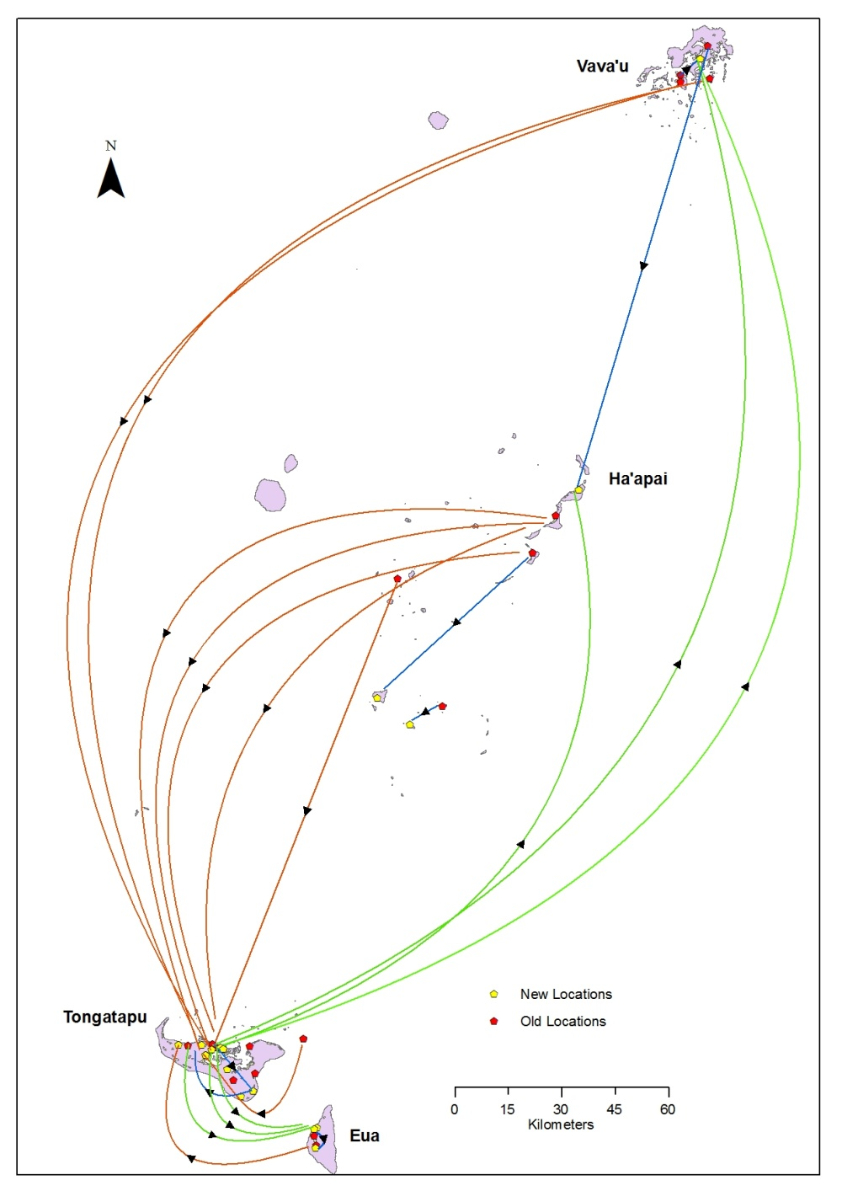

**Map 1: Movements within Tonga to Facilitate PSWPS Recruitment – Worker Survey in Australia**

While some workers had moved from outer islands onto Tongatapu, and within Tongatapu from outer areas to closer to Nuku’alofa, there were also movements in the opposite direction. Anecdotally we heard during surveying that some people who were interested in participating in the PSWPS believed the odds of being selected would be greater in the outer islands, and so utilized their family networks to move to those locations with higher perceived recruitment probabilities. A similar pattern is apparent from the survey of returned workers (Map 2). But the overall incidence of internal movement was lower for this group than for the workers surveyed in Australia, with only 10 of 70 returned workers having reported changing location.

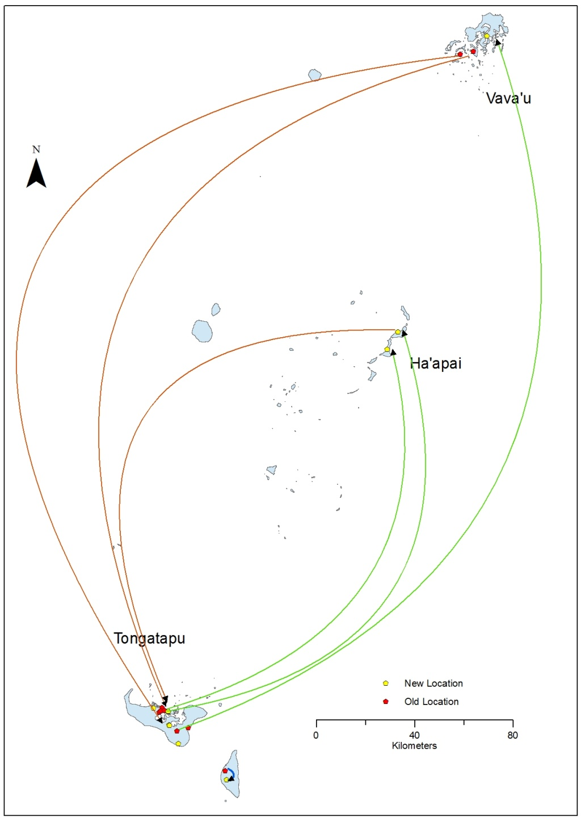

Movements within Tongatapu not shown

**Map 2: Movements within Tonga to Facilitate PSWPS Recruitment – Returned Worker Survey**

1. **Earnings, Costs and Remittances**

We next use the survey data to examine the income (after taxes) earned by seasonal workers in Australia, the initial and recurring costs workers pay while in Australia, and the remittances sent back to their home families. Before looking at these data, four caveats must be noted. First, the data are self-reported by the workers, not administrative data from employers. Nevertheless, the magnitudes on most line items appear appropriate. Second, our data include the Tongan Phase I workers who were temporarily without work for a few weeks of their stay due to Timbercorp, the company on whose almond plantations they were working on, going into administration. Earnings would therefore be slightly higher for individuals employed for the full amount of time. Third, recent modifications of the policy have changed slightly the cost-sharing arrangements, allowing employers to recover up to A$100 in costs of internal transfers to and from the airport in Australia, and changing the share of the airfare cost borne by employers to 35% for Kiribati and 80% for Vanuatu, compared to 50% for all countries in the initial phases. This will increase slightly the costs faced by workers. Fourth and finally, the timing of our surveys was such that total earnings and total remittances could be measured well for the Phase I sample (who were interviewed at the end of their work period in Australia), but not for the Phase II sample who were interviewed only part way through their time in Australia.

With these caveats in mind, Table 2 presents data on the earnings, costs, and remittances for the Tongan and i-Kiribati sample. The small size of the ni-Vanuatu sample (only 6 workers) coupled with the fact that these workers had difficulty understanding the costs paid and net income due to many costs being deducted from their pay checks lead us not to use this subsample. Mean weekly net earnings are in the A$450-515 range for both groups, leading to total net income over 6 months averaging A$12,000-13,000. This would correspond to an average hourly wage after taxes of A$15.40-17.20 if workers averaged the 30 hours per week that is the minimum required by law. TNS Social Research (2010) reports the Phase I workers averaged 32 hours per week. The minimum (pre-tax) hourly wage in Australia is A$15, and seasonal workers are taxed at the non-resident tax rate of 29%. Clearly the potential exists for workers to earn more by working more hours, but this is only possible to the extent that sufficient work is available week-in and week-out. It seems more typical for workers to have some weeks where they are able to work more hours, and then others where the amount of work available is more limited.

By way of comparison, RSE workers in New Zealand earn an average of NZ$12,000 after taxes, or approximately A$9,800. This reflects the fact that many RSE workers spend shorter than 6 months in New Zealand, and that hourly wages are lower in New Zealand than Australia. However, the tax rate facing RSE seasonal workers was only 15 percent, and from April 1, 2011, has been reduced to 10.5%.



Consider next the costs. Employers are required to cover half of the airfare, and the costs of internal transportation to and from the airport in Australia (until the recent changes). The initial costs of the worker’s half of the airfare, a passport, police clearance, medical check-ups, the visa, internal travel within the home country, and clothing costs (for some warmer clothing) average A$1063 for Tongans, and A$1644 for i-Kiribati, with the higher cost in Kiribati reflecting the higher cost of air travel from this country. Most fees here would be comparable for workers travelling to New Zealand also for seasonal work, although New Zealand’s RSE visa fee for Tongans is 292 pa’anga ($A173) and in Kiribati is A$155, so this cost is cheaper when going to New Zealand.

Recurrent weekly costs total A$200 per week for the Tongan sample and A$280 per week for the i-Kiribati sample. Accommodation costs were cheapest for the Phase I Tongan workers, who typically reported expenses of A$60 a week, with the Phase II Tongan workers reporting A$80 per week, and the i-Kiribati workers reporting A$80-100 per week. The other major expenses are food, health insurance, transport to and from accommodation to the farm, and telephone calls. The typical worker reports communicating with their family at home at least once a week, spending A$30 per week in the Tongan case and A$75 per week in the i-Kiribati case on average. The latter strikes us as high, but it does appear that the cost per minute is higher to call Kiribati. For example, Vodafone charges A$6.95 per minute to Kiribati for a call from its pre-paid mobile phone, versus A$4.68 per minute to Tonga.[5] The typical calling card charges A$1 per minute to Kiribati versus 40-50 cents per minute to Tonga.[6] Our surveys did not collect data on the cost per minute of the calls, but with rates to the Pacific very high, it does not seem unreasonable that migrants might spend A$30 per week at least on phone calls.

By way of comparison, our survey data from RSE workers in New Zealand find the average Tongan worker there paying weekly costs of around A$138 per week, or A$62 per week less than the Tongan workers in Australia. Accommodation costs are similar, but food, health insurance, transportation, and communication costs are all cheaper for the seasonal workers in New Zealand. As a result, over 6 months, a seasonal worker would pay around A$1680 less in costs if working in New Zealand than if they were working in Australia, reducing the gap in take-home pay between the two countries.

Comparing the income after taxes with the costs seasonal workers must pay gives a net amount of between A$4500 and A$6000. The Phase I Tongan workers report having remitted back an average of A$5000 – of which A$4600 was to their own household and A$400 to other individuals in the home country. So these numbers seem to add up.[7] This compares to mean remittances and repatriated savings of A$4400 for RSE workers. Since the Kiribati workers and their families were surveyed part way during their migration spell, total remittances are not available for these households. But based on the calculations in Table 2, remittances in the A$3500-4000 range seem likely, being slightly lower than in the Tonga case as a result of the higher costs faced by the i-Kiribati workers.

**4.1 From Remittances to Net Development Impacts**

The amount remitted is likely to be an overestimate of the net impact on financial resources of the migrant-sending household because it fails to account for the opportunity cost of seasonal work, which is the income that the migrant would have earned at home. It also ignores any adjustments that the sending household makes to its labor supply and production as a result of having an absent member. The crudest estimate of this opportunity cost would be to just take the average wage income that the migrant earned in the home country prior to engaging in seasonal work, and calculate the value of six months of these lost wages. Conditional on working the average Tongan earned 150 pa’anga per week, or A$2300 over six months. However, since only 38 percent of Tongan seasonal workers had any wage income at the time of starting seasonal work, the average opportunity cost calculated this way would only be A$887. Based on this naïve estimate, the net gain would then be A$4600 – A$887 = A$3713, or A$651 per capita given an average household size of 5.7 in the sending households.

However, this is still an overestimate of the gain since it fails to take account of the contributions to household farming production (including both production of food for own consumption and production of food for sale) that the seasonal worker would make at home. Given the similarity between ASWPS workers and RSE workers seen in Table 1, it seems reasonable to use the detailed RSE evaluation results in Gibson and McKenzie (2010) to further adjust the naïve estimate of the gain. Their detailed analysis and comparison with accounting of the sort done in Table 2 suggests that the true net gain is about 70 percent of the naïve estimate- so about A$2600 per participating household, or A$456 on a per capita basis. From Table 1, annual household income per capita is 2000 pa’anga, or around A$1183. So the percentage increase in per capita household income from the PSWPS is approximately 39 percent – as compared to a 33 percent increase from the RSE.

**4.2 The Aggregate Development Impact**

We use this estimate of A$2600 per participating PSWPS household along with the number of seasonal workers during the first two years of the program to calculate the aggregate impact on national income, which is shown in Table 3. We assume given available evidence that this gain is similar in Kiribati and Vanuatu, although it could be slightly less in Kiribati due to higher transportation costs. This is a first-order approximation, since it ignores any multiplier effects from spending money earned abroad on goods produced by others in the local economy, and also ignores any longer-run gains from investments in human capital or other productivity enhancing investments. However, given the small size and recent nature of the PSWPS program, these factors can be safely ignored in making short-term calculations. The aggregate impact is then compared to the aggregate impact of the RSE program in its first two years (using Gibson and McKenzie, 2010 to calculate the net income gain from this program), to New Zealand and Australian annual bilateral aid flows to these participating countries, and to total annual exports of the three participating Pacific nations.

The results show that the overall development impact of the PSWPS program to date is quite small, with total contribution of around A$343,000 to Tonga’s economy over the first two years, and contributions of less than A$30,000 to the economy’s of Kiribati and Vanuatu. Such amounts are only 2 percent of annual Australian bilateral aid to Tonga, and less than 0.25 percent of annual Australian bilateral aid to Kiribati and Tonga.

However, the potential for scaled-up seasonal worker schemes to have a large aggregate effect is seen through the impacts of the RSE program. Our estimates suggest that Tonga had a net benefit of A$4 million during the first two years of the RSE, which is 40 percent of New Zealand’s annual total bilateral aid and 44 percent of Tonga’s total annual export earnings. Vanuatu had a net benefit of almost A$8 million, which is almost half total annual bilateral aid from New Zealand to Vanuatu, and 20 percent of total annual export earnings. Participation numbers from Kiribati in the RSE have been considerably lower than in Tonga and Vanuatu, so the overall impact has been relatively modest for this country.



1. **Subjective Measures and Worker’s Opinions**

In addition to objective measures of earnings and the development impact of the PSWPS, we obtained information on general satisfaction with seasonal work. The workers surveyed in Australia were asked whether their earnings were what they expected, whether they wanted to come back and work in Australia again next year, and their overall level of satisfaction with the experience of working in Australia (on a 10-point scale). There appears to be high levels of satisfaction, with 100% of the surveyed workers wanting to return the following year. The mean overall satisfaction level was 10.0 for the i-Kiribati workers and 8.7 for the Tongan workers. The Phase I Tongan workers didn’t earn as much as they expected, due to the period with no work when Timbercorp collapsed and to less hours of work than they hoped, but the Phase II workers all reported earning as much as they expected.

The main difficulties workers experienced were similar to those reported by RSE workers: namely separation from family, and that working in winter was colder than they were used to. The main skills they said they learned were specific farming skills (like how to prune and pick), with some of the Phase II workers in particular also saying they had learned budgeting skills and improved their English.

The surveys also obtained opinions from the workers about the suitability of seasonal work for men and women, and about the allocation of remittance spending that they would prefer to see. These same questions were also asked of the families of workers (specifically, the household head, or temporary head if the head was in Australia as a seasonal worker) in Tonga and Kiribati. At least in the context of remittances, there is some evidence that migrant workers may have different preferences over how remittances are spent in their home country than the preferences of the remittance recipients (Ashraf *et al*. 2011). Therefore it is interesting to see if opinions differ, on average, between the workers in Australia and their families – keeping in mind the small number of respondents, any differences are only likely to be suggestive of the role that better information may have in aligning the expectations of future seasonal workers and their families and remittance recipients.

The opinions of workers and their families about gender roles in seasonal work are very closely aligned, while they differ between countries. Amongst the workers from Tonga, 95 percent felt that seasonal work in Australia was more suitable for men than for women, and 98% of the household heads in Tonga, from the worker’s households, felt the same way (Table 4). However, all of the i-Kiribati workers, and the respondents from their households (which was only a small number) felt that seasonal work was equally suitable for men and women.



To get at the preferences of workers for how their seasonal work earnings might be spent by their households at home, workers were asked how they would distribute A$1000 sent as remittances from their earnings into 13 categories of expenditure. These categories ranged from everyday expenses to school fees, savings and investments, and church offerings and customary obligations. For three of the major categories shown in Table 4, the Tongan workers would have one-half of the funds remitted spent on everyday expenses, 17 percent on school fees and seven percent on formal savings or investments. The i-Kiribati workers put a similarly small allocation on savings, but the average comes from a very small number of respondents.

The same questions were asked in Tonga and Kiribati, of respondents who were either already recipients of PSWPS remittances or were expecting to be recipients. In contrast to the workers, the hypothetical allocations from recipients were more towards savings and less towards current consumption. This pattern is contrary to what might be expected (and contrary to what Ashraf et al, 2011 found), since migrants are felt to be keen for recipients to build up savings, either because they don’t expect to remit permanently or because they have a target investment goal for their migrant earnings when they return home.[8] One possible explanation is that once PSWPS workers have experienced the scale of labor demand in Australian horticulture, they perhaps conclude that there will be a permanent need for seasonal labor from the Pacific, so that seasonal work earnings can be treated as a component of permanent income and therefore there is less need to save than if the earnings were just transitory. If such expectations are misguided, there may be scope for interventions that provide information on saving and investment opportunities for seasonal work earnings so that even temporary participation in the Australian labor market may have permanent impacts in their Pacific homes.

1. **Conclusions**

The experience of New Zealand’s RSE program shows it is possible for seasonal worker programs to make a meaningful development contribution to Pacific Island nations. To date Australia’s PSWPS program has not reached this potential, with only a small number of participating workers. Truly delivering widespread development benefits from this program will require large increases in the number of workers participating. There is some suggestion that the December 2010 changes in the program rules are having some effect, with the total number of workers participating anticipated to reach 540 workers by June 2011. There is certainly a large supply of potential workers eager to participate in the program, so the question remains as to whether the program is now flexible enough to encourage employers with labor shortages to participate.

Although overall numbers are small to date, the workers that have participated in the program have benefited by reasonably large amounts, increasing annual incomes for their households by almost 40 percent. The workers who participated in the Australian program appear reasonably content with their experiences, and all say they would recommend the program to other workers from their villages. Evidence from the recent evaluation of the New Zealand RSE program shows broader positive impacts on household durable asset acquisition, subjective standard of living, and, in Tonga, secondary schooling attendance. It seems reasonable to expect the same benefits could be realized from the Australian program if sufficient numbers get a chance to participate in it.

**References**

Ashraf, Nava, Diego Aycinena, Claudia Martinez and Dean Yang (2011) ‘Remittances and the problem of control: A field experiment among migrants from El Salvador’ *Working Paper* University of Michigan.

Ball, Rochelle (2010) ‘Australia’s Pacific Seasonal Worker Pilot Scheme and its interface with the Australian horticultural labour market: is it time to refine the policy?’, *Pacific Economic Bulletin* 25(1): 114-130.

Gibson, John and David McKenzie (2010) ‘The Development Impact of a Best Practice Seasonal Worker Program’, *World Bank Policy Research Working Paper no. 5488.*

Gibson, John, David McKenzie and Halahingano Rohorua (2008) ‘How pro-poor is the selection of seasonal migrant workers from Tonga under New Zealand’s Recognised Seasonal Employer (RSE) program?’, *Pacific Economic Bulletin* 23(3): 187-204.

Maclellan, Nic and Peter Mares (2006) ‘Labour Mobility in the Pacific: Creating seasonal work programs in Australia’, Chapter 8 in Stewart Firth (ed.) *Globalisation and Governance in the Pacific Islands.* ANU E-press (http://epress.anu.edu.au/globalgov_citation.html).

McKenzie, David, Pilar García Martinez and L. Alan Winters (2008) ‘Who is coming from Vanuatu to New Zealand under the new Recognised Seasonal Employer (RSE) program?’, *Pacific Economic Bulletin* 23(3): 205-28.

TNS Social Research (2010) ‘Interim evaluation of the Pacific Seasonal Worker Pilot Scheme’ <http://www.deewr.gov.au/Employment/Programs/PSWPS/Documents/PSWPSEvaluationExecSummary.pdf> [accessed April 28, 2010].

World Bank (2006) *At Home and Away: Expanding Job Opportunities for Pacific Islanders through Labour Mobility.* World Bank: Washington, D.C.

1. Source: PSWPS Factsheet <http://www.immi.gov.au/skilled/pacific-seasonal-worker/_pdf/factsheet-pswps.pdf> [ accessed April 19, 2011].
2. To date no workers have arrived from Papua New Guinea, so we do not discuss this country in the rest of the paper.
3. Likely causes of these differences are variation across countries in the process used to screen and select workers, and variation in average levels of human capital such that workers selected to do the same task in New Zealand may come from the upper tail (Vanuatu) or lower tail (Tonga) of the human capital and income distribution in the home country. Hence there are potential risks in extrapolating from the experience of the single country when evaluating seasonal work programs, given the wide variation in economic and social conditions in the Pacific.
4. The sample size expanded by more than the expansion in the number of PSWPS workers recruited, given the design of selecting 2-3 comparison group households per household with a member participating in the PSWPS.
5. http://www.vodafone.com.au/personal/services/idd/iddratesforprepaidcaps/index.htm
6. https://www.ephonecards.com.au/Rates.aspx?Id=322&Country=Tonga
7. Our survey also asked workers how much they planned to bring home in savings. The mean answer was $4300, which is pretty close to the mean amount remitted to their own families. Although our intention was to capture additional repatriated savings that the worker would physically take home with them rather than remit, our sense is that workers were instead reporting the total amount they would have sent home during this time. Indeed the math from Table 2 shows it would be impossible for them to bring back this amount of additional savings. The modal respondent said they sent remittances back more than once a month, making it likely that they would remit paycheck by paycheck, rather than saving it all to bring back in one lump sum.
8. Ashraf *et al.* (2011) study permanent migrants rather than seasonal migrants, and the design of their survey uses actual money, in the form of a raffle, to elicit the preferences of respondents for how remittances should be allocated over spending and investment categories.