**UNIVERSITY OF WAIKATO**

**Hamilton**

**New Zealand**

**Evaluation of Agri-Environmental Policies**

**for Water Quality Improvement Accounting for Firm Heterogeneity**

Graeme J. Doole, Dan Marsh and Thiagaragah Ramilan

**Department of Economics**

**Working Paper in Economics 13/11**

July 2011

*Corresponding Author*

**Graeme J. Doole**

Faculty of Natural and Agricultural Sciences

University of Western Australia

Crawley, Western Australia, 6009

*and*

Economics Department

University of Waikato

Hamilton, New Zealand, 3240

Email: gdoole@waikato.ac.nz

|  |  |
| --- | --- |
| **Dan Marsh**  Economics Department  University of Waikato  Hamilton, New Zealand, 3240. Email: dmarsh@waikato.ac.nz | **Thiagaragah Ramilan**  School of Land and the Environment  University of Melbourne  Melbourne, Australia. Email: ramilant@unimelb.edu.au. |

**Abstract**

Policy makers worldwide are interested in the identification of cost-effective policy instruments to reduce diffuse pollution. A large economic model representing heterogeneous farms is used to evaluate a broad set of policies for reducing nitrate regulation within a large catchment dominated by dairy production. A policy instrument that allows the level of abatement to vary among producers according to differences in abatement cost is most cost-effective. The primary goal of 26 kg N ha-1 can be achieved at a cost of $15 ha-1 under this cap and trade policy, while a uniform cap on emissions for all farmers would be more than three times as expensive ($49 ha-1). In contrast, requiring uniform reductions in stocking rate, banning the application of nitrogen fertiliser, and land retirement perform poorly. These instruments are at least three times more costly than a cap and trade policy over all simulated reductions. Moreover, the differentiated policy does not greatly alter the distribution of farm profit, relative to what exists without regulation. The use of a large, complex economic model incorporating disaggregated farms provides unique insight into the economic benefits accruing to a differentiated policy.

**JEL Classification:**

D78; Q15; Q53

**Keywords**

diffuse pollution

economic model

cap and trade policy

## 1. Introduction

The quality of many freshwater resources throughout the world is decreasing because of diffuse pollution from pastoral agriculture (Campbell *et al.,* 2005; Drewry *et al.,* 2006). Indeed, diffuse sources are now the primary polluters of water ways worldwide, as effective regulation is difficult given the unobservability of pollutant loads and the multiple agents typically responsible (UNEP, 2008). Dairy production is the primary export industry in New Zealand, but urine deposition by grazing cows across 1.5 million ha of temperate grassland incurs leaching losses of nitrogen (N) well in excess of those that can be sustained by freshwater ecosystems (Monaghan *et al.,* 2007). This is similar to Australia, where N losses under dairy production are much greater than those of other forms of pastoral agriculture (Drewry *et al.,* 2006). Much reliance has been placed on voluntary mechanisms to promote abatement among New Zealand dairy producers, such as the Clean Streams Accord 2003. However, there is growing evidence that these measures are too weak to achieve the level of abatement required to achieve nutrient reductions commensurate with the value of environmental assets to society (Doole and Paragahawewa, 2010; Bewsell and Brown, 2011), consistent with Australian evidence (e.g. Cary and Roberts, 2011).

The inability of voluntary mechanisms to achieve environmental goals has stimulated the analysis of various regulatory policies to reduce diffuse pollution from New Zealand dairy farms. Ramilan et al. (2010) found, using a deterministic model, that standards (legislated decreases in pollution level) are more cost-effective than taxes applied to nitrate emissions. However, this finding contradicts established theory that shows that both instruments have identical impacts in a deterministic setting (Griffin and Bromley, 1982; Hanley *et al.,* 2007). Moreover, this study did not include the presence of discrete mitigation practices, such as feed pads, and ignored farm heterogeneity through the analysis of representative farms. Doole (2010) demonstrated that failing to represent farm heterogeneity can restrict insight into the relative value of alternate instruments. Indeed, using a model providing a detailed description of individual farms, policies targeted at restricting polluting inputs (cows and nitrogen fertiliser) were shown to be more cost-effective when each regulated farm could reduce their use by different amounts under a cap and trade (i.e. differentiated) policy. However, the type of instruments and mitigation practices evaluated were very limited and only a small collection of farms was investigated.

There has as yet been no analysis of the broad set of policies that environmental regulators have considered for the regulation of dairy production in New Zealand, yet alone one that considers inter-farm heterogeneity. The objective of this analysis is to overcome this deficiency through the identification of the cost-effectiveness of a broad range of policies for reducing nitrate leaching from dairy production in a catchment in the Waikato region of New Zealand.

The Waikato area is the primary dairy farming region of New Zealand and recent evidence confirms that water quality within the Waikato River, the primary water way in this region, is declining due to intensive dairy production within its catchment (Semadini-Davies *et al.,* 2008). The set of scenarios evaluated in this study is formulated through consultation with the local regulatory agency (Environment Waikato) charged with achieving the sustainable management of natural resources, including water quality, through the Resource Management Act 1991. This study appears to be the first to evaluate a broad set of realistic policy instruments using an economic model that describes a large population of individual agents at a comprehensive level of detail, calibrated to real data, and allows them to respond optimally to simulated incentives. This approach is favourable given the complexity of agricultural systems and the many strategies, most of which are interdependent, that affect both farm profit and pollutant load. The large model consists of over two million equations and describes management across 332 individual agents.

The analysis indicates that representing inter-firm heterogeneity is valuable since abatement cost can be reduced through the trading of pollution entitlements among farmers who possess different costs of abatement. Moreover, this instrument is demonstrated to have little implication for the distribution of farm income across the sample population. These findings emphasise the importance of representing individual agents in models used for policy evaluation and the benefits of implementing regulatory instruments that consider the differences in the cost of abatement across producers.

The paper is structured as follows. Section 2 provides an overview of the model and the policy scenarios. Section 3 presents results and discussion. Section 4 concludes.

## 2. Policy Model

### **2.1 Policy Scenarios**

The model simulates part of the Waikato River catchment in the North Island of New Zealand. The analysis is restricted to optimal regulation of dairy farming since this land use dominates this catchment in terms of land allocation and nitrate emissions. Moreover, understanding how farm heterogeneity impacts the optimal regulation of dairy farming is important given the national significance of this industry and current uncertainty regarding the cost-effectiveness of alternate policies. However, the inclusion of additional land uses is the subject of ongoing research.

### The catchment model incorporates 332 individual farms with a total area of 41,205 ha; 123,885 cows; and annual production in 2008/09 of around 40,225 tonnes of milk solids. The individual farm models are calibrated to real farm-specific data to ensure simulation of actual conditions in the catchment, both in terms of average and total values, and in the distribution of these values across farms.

Six policy instruments were identified through discussion with policy makers and evaluation of the relevant literature (Table 1). In each case, the policy was applied to the catchment model to simulate reduction in nitrogen leaching to the target level of 26 kg N ha-1 and to alternate levels of 22 and 30 kg N ha-1. The latter two goals represent deviations from the target level to demonstrate how different targets affect farm management and profitability.

**Table 1. Details of policy instruments evaluated in the model**

|  |  |  |
| --- | --- | --- |
|  | **Policy** | **Description** |
| 1. | Uniform cap on stocking rates | Every dairy farm in the catchment must limit stocking rates to a specified level |
| 2. | Ban N fertiliser, 1 Mar–31 July | Dairy farms are prohibited from applying N fertiliser between 1 March and 31 July |
| 3. | Ban N fertiliser application | Dairy farms are prohibited from applying N fertiliser at any time |
| 4. | Uniform cap on nitrogen emissions | Every dairy farm in the catchment must limit average N emissions to 22, 26, or 30 kg N ha-1 or less |
| 5. | Cap on nitrogen emissions, trading allowed | Total N emissions across the catchment equal 22, 26, or 30 kg N ha-1, but abatement varies over farms depending on farm characteristics |
| 6. | Replace dairy with sheep and beef farms | Specific farms are selected for conversion out of dairying to achieve emission targets at least cost |

The individual farm models described in Section 2.3 are used to evaluate the first four policies. These individual models are coupled to identify the impacts of trading leaching entitlements in the fifth scenario. Optimal land retirement (policy 6) is determined through the use of output from the dairy farm models in a separate optimisation framework (Section 2.5).

### **2.2 Relative Efficiency of Differentiated and Uniform Instruments**

A key focus of this analysis is policy instruments that allow the trading of pollution entitlements (Table 1). It is useful to review the basic arguments for their superiority over uniform instruments here (Hanley *et al.,* 2007), given the importance of differentiated policies in this study (Section 3.2).

Assume the catchment consists of two farms. Figure 1 delineates two marginal abatement cost curves:  and  for farm 1 and 2, respectively. Abatement cost increases in each firm as greater mitigation is performed. Denote the unregulated pollution level as  and  for each farm (Figure 1). Suppose the target level of pollutant is reduced below baseline levels and tradable permits are introduced that give farms the right to leach a given amount of nitrate. Then, optimal pollution intensity will reduce to  where , shown in Figure 1 as the intersection of both curves. The loss of profit associated with the policy is the sum of lost profit for farm 1 (area A) and farm 2 (area B).

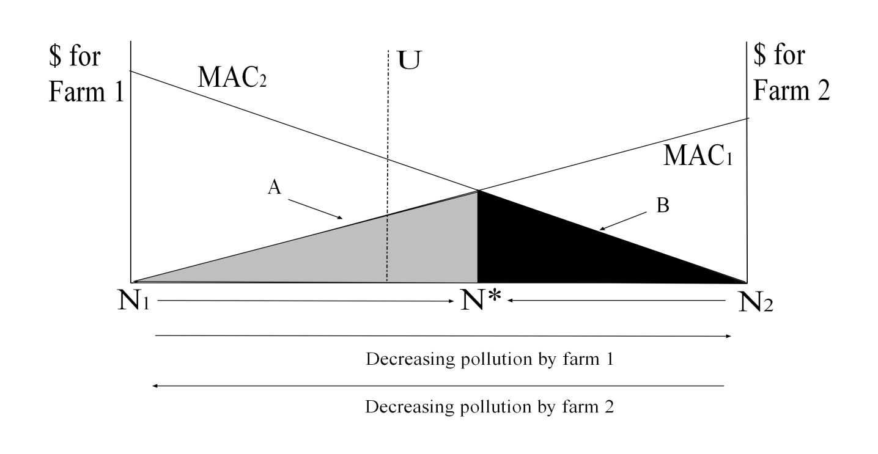**Figure 1. Abatement cost in a two-farm catchment with the implementation of trading for pollution entitlements.**

*Notes: MAC* denotes the marginal abatement cost curve for each farm. *A* = Loss of profit for farm 1 with trade. *B* = Loss of profit for farm 2 with trade. *U* denotes a hypothetical allocation of abatement between both farms with a uniform policy targeted at N emissions.

Instead, suppose a uniform policy (*U*) was introduced that requires each farm to leach a given amount of N or below (e.g. 26 kg N ha-1). Except under exceptional circumstances, each farm would undergo a different amount of abatement than what would occur under . For example, with policy *U* in Figure 1, farm 2 would perform much more abatement than farm 1, incurring a much higher cost. This disequilibrium position demonstrates how total abatement cost may be reduced through increasing the abatement that farm 1 performs and decreasing that which farm 2 performs until . This shows how a differentiated instrument can lower total abatement cost through allowing the trading of pollution entitlements.

**2.3 Model Structure**

This section provides a brief description of the Doole (2010) model, which is extended in this analysis to incorporate a greater number of currently recommended management practices (CRMPs) and farms. Further detail is presented in Doole (2010) and the Appendix. A complex description of each individual farm is provided in the model since this gives a more accurate description of the mitigation strategies available to producers. For example, if a feed pad is adopted, this will impact feed management across the year in this model, but would not be considered in less-sophisticated frameworks.

Each year is divided into 26 fortnightly feed periods to provide detailed insight into temporal feed allocation. Cows consume grazed pasture and supplementary feeds, namely concentrates, grass silage, and maize silage. Farm area in each period is grazed, harvested for grass silage, or spelled. Grazing or silage production can only occur between pasture biomass thresholds that ensure the maintenance of seasonal feed quality and maximise opportunities for subsequent regrowth. Moreover, silage can only be produced at certain times of the year when pasture supply is excess to livestock requirements. Nitrogen fertiliser application increases pasture biomass in subsequent periods. Yield responses and the lag between application and improved growth depend on the time of fertiliser application.

Metabolisable energy (ME) is that available for livestock growth and maintenance after the digestion of feed. The supply of ME for allocation between livestock classes is the sum of all feed sources available in a given period. The five sources are: land allocation to grazing, grass silage produced in previous periods, additional pasture growth from nitrogen fertiliser application, and purchased supplements (concentrates and maize silage). Feed pools are allocated between livestock classes, each of which requires a given level of ME in each period. There are 216 different cow herds, each with different temporal energy demands given disparity in calving date, herd status (cull versus standard), lactation length, and productivity. Feed intake constraints ensure that cows do not consume unrealistic amounts of energy.

Total nitrate load from a given farm is defined as a function of nitrogen fertiliser application, livestock intensity, milk production, and maize silage consumption. Nitrate loads can be reduced through changes in production management or through the adoption of CRMPs. Changes in management are the options of feeding low protein feed or reducing nitrogen fertiliser application, stocking rate, or per-cow milk production. CRMPS are low-rate effluent application, improved dairy shed management of effluent, deferred effluent application, use of a feed pad, or application of nitrification inhibitors. Low-N feed reduces N excretion by livestock. Low-rate effluent application means less N is lost to leaching since it is applied more in line with plant requirements. Improved dairy shed management of effluent involves the use of automated yard cleaning to reduce the effort of effluent collection at milking and reduce effluent volume. Leaching can be reduced by deferring effluent application until drier periods. A feed pad reduces leaching by removing cows from pasture during periods of high leaching risk. Nitrification inhibitors reduce N leaching by preventing the conversion of ammonium to nitrate during the process of nitrification.

It is assumed that each farmer aims to maximise farm profit. Total revenue is earned from the sale of milk, culled cows, and excess calves. Total cost is the sum of general variable costs incurred for each cow, fixed costs incurred per hectare of farm area, cost of silage production, cost of maize silage, cost of concentrates, and cost of nitrogen fertiliser.

Each farm model is calibrated to micro-level data from a variety of sources. Variables that drive important sources of heterogeneity in farming systems that are represented in this analysis are farm size, distance from the waterway, milk production per cow, soil mix, and stocking rate. This data is drawn from AsureQuality, DairyNZ, Livestock Improvement Corporation, and New Zealand Land Resources Inventory information. Each farm model involves fixed farm size, distance from the waterway, and soil types. Each model is also calibrated to report their actual stocking rate and milk production for the 2008/09 milking season. The use of constraints in the optimisation models to achieve calibration reduces their ability to change from the observed situation, in response to the simulation of alternative policies. Accordingly, positive mathematical programming (Doole, 2010) is adopted to ensure the representation of historical relationships, but without loss of flexibility.

The trading of leaching entitlements is represented through the coupling of the individual farm models. These are joined through the addition of the constraint , where  is an aggregate emissions target and  is total emissions from firm *j*. An Augmented Lagrangian procedure (Conejo *et al.,* 2006) is employed, which involves appending the coupling constraint to the profit function of each farm model through the use of a shadow price and a quadratic penalty function. Every farm model is then solved in each iteration. The shadow price for the coupling constraint is updated in each iteration until the coupling constraint is satisfied optimally (Doole, 2010).

All models are solved using nonlinear programming in the CONOPT3 solver in GAMS Distribution 23 (Brooke et al. 2008). Each farm model contains 6,540 constraints and 4,600 decision variables. Thus, the full catchment model contains around 2 million constraints and 1.5 million decision variables.

### **2.4 Parameter values**

Parameters from the 2008/09 milking season are used. All monetary values are stated in 2008/09 New Zealand dollars. N fertiliser responses and minimum, maximum, and residual pasture masses are taken from McCall et al. (1999). Feed energy, substitution, and utilisation rates are taken from McCall et al. (1999) and Dexcel (2008a). Average pasture production is taken from Dexcel (2008b). Energy demand for each cow attribute combination as a function of grazing, milk production, and pregnancy is computed using a simulation model constructed using information from Dexcel (2008a).

Leachate burdens are calculated for different soil types using numerous combinations of maize silage amounts, milk production, N fertiliser use, and stocking rate using the OVERSEER model (Monaghan *et al.,* 2007). The metamodel is generated through linear regression of this data using SHAZAM econometric software (Whistler *et al.,* 2004). The efficacy of mitigations are taken as the midpoint from ranges computed in the BMP toolbox (Monaghan, 2009).

The milk price for 2008/09 ($5140 t-1 MS) is taken from LIC (2009). Production costs are drawn from AgFirst Waikato (2009), Chaston (2008), DairyNZ (2009), and Longhurst and Smeaton (2008). The costs of the mitigations are taken from AgFirst Waikato (2009), Longhurst and Smeaton (2008), and Monaghan (2009).

**2.5 Land Retirement Model**

The model described in Section 2.1 is unsuitable for the investigation of optimal land retirement. A separate model is therefore developed:

, (1)

subject to:

, and (2)

, (3)

where *S* is total profit in the catchment,  is an index of farm number,  is the profit for a given farm,  is the size of a given farm,  is an indicator variable showing whether a farm is retained in dairy production () or retired and used as a sheep and beef farm (),  is the profit for an average sheep and beef farm in the study period and region,  is the emissions target,  is the nitrate emissions of a given farm, and  is the nitrate emissions of an average sheep and beef farm in the study period and region.

, , and  are taken from the individual dairy farm models described in Section 2.3.  is an estimate of leaching under an average sheep and beef farm in the district.  is the profit per hectare for a Waikato sheep and beef farm in 2008/09 (MAF, 2009). The model described in eqs. 1–3 is solved using integer programming in the COIN GLPK solver in GAMS Distribution 23.

## 3. Results and Discussion

### **3.1 Baseline Farm Data**

Farm-level statistics from the simulation model are presented in this section and compared with actual data from various sources. Histograms showing model outputs for milk production, cow numbers, and N fertiliser application levels are presented in Figure 2

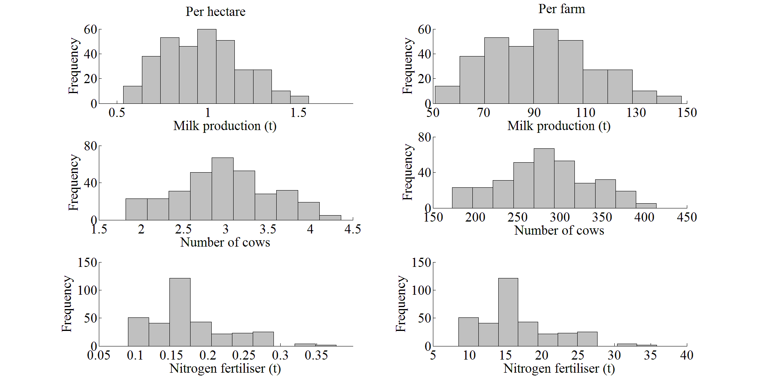

**Figure 2. Probability distributions of milk production, cow number, and nitrogen fertiliser use per hectare and per farm**

Milk production defined both per hectare and per farm is highly variable. Average milk production is 4 per cent below the reported mean of 327 kg MS cow-1 for the Waikato region in 2008/09 (LIC, 2009). The number of cows per hectare and per farm is also highly variable. These variables are approximately normally distributed, with an average stocking rate 1.3 per cent below the reported mean of 3.02 cows ha-1 for the Waikato region in 2008/09 (LIC, 2009). The modelled distribution for nitrogen fertiliser has a strong peak at 150–175 kg ha-1, and includes some higher levels of application, up to 375 kg ha-1. The modelled distribution is representative in that the mean is only 4 per cent above the mean (166 kg ha-1) reported for the Waikato region in 2008 (EW, 2008).

Model outputs for farm profit and nitrate leaching are shown in Figure 3. High rates of leaching have been reported for some farms in this region (e.g. AgFirst Waikato, 2009), consistent with the higher values shown here. This is balanced by a number of farms with lower rates of leaching, especially those on podzol soils. Hence, average nitrate leaching is almost equal to the national mean reported by Basset-Mens et al. (2009). Overall, output of the catchment model is broadly representative of industry statistics, thus supporting its use for policy evaluation.

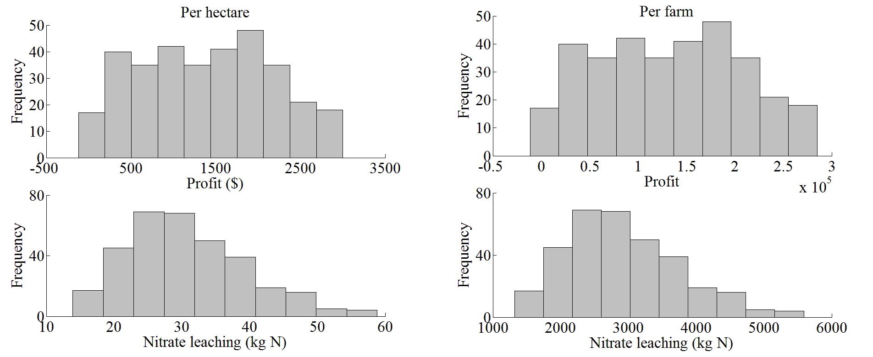

**Figure 3. Probability distributions of farm profit and nitrate leaching per hectare and per farm**

### **3.2 Abatement costs for each policy instrument**

The abatement cost of each policy per hectare with and without CRMPs is presented in Table 2. The most cost-effective policy instrument across all nutrient targets is a tradable-permit system targeted at nitrate emissions. For example, with CRMPs, the tradable-permit instrument achieves the 26 kg N ha-1 goal for the catchment at a cost of $14.79 ha-1, which is 70 per cent less than the $49.47 cost of a uniform policy where every farm must restrict average emissions to 26 kg N ha-1 or less (Table 2). This result indicates that there is wide variation in the slope of abatement costs across producers, in accordance with the substantial heterogeneity evident in Figure 3. It also reinforces the suitability of the approach taken to representing farm-level heterogeneity in the model.

The importance of policy-instrument selection is further demonstrated by the very wide range of policy costs reported in Table 2. A uniform cap on stocking rate and land retirement would cost $123.47 ha-1 and $154.77 ha-1, respectively, to achieve a goal of 26 kg N ha-1; more than eight times the cost of a differentiated policy targeted at N emissions. The most expensive instrument at this target level of leaching is a complete ban on nitrogen fertiliser, which would cost $193.93 ha-1.

**Table 2. Abatement cost for all simulated policies expressed per hectare**

|  |  |  |
| --- | --- | --- |
| **Policy** | **No CRMPs1** | **CRMPs** |
|  | **Cost per hectare ($ ha-1)** | **Cost per hectare ($ ha-1)** |
|  | *22 kg N ha-1* | |
| 1. Cap cow no. | 295.53 | 295.53 |
| 2. Ban N fert. | 193.93 | 193.93 |
| 4. Cap emissions (no trade) | 204.54 | 96.6 |
| 5. Cap emissions (trade) | 115.83 | 54.39 |
| 6. Land retirement | 404.91 | 404.91 |
|  |  |  |
|  | *26 kg N ha-1* | |
| 1. Cap cow no. | 123.47 | 123.47 |
| 2. Ban N fert. | 193.93 | 193.93 |
| 4. Cap emissions (no trade) | 102.85 | 49.47 |
| 5. Cap emissions (trade) | 35.78 | 14.79 |
| 6. Land retirement | 154.77 | 154.77 |
|  | *30 kg N ha-1* | |
| 1. Cap cow no. | 5.84 | 5.84 |
| 2. Ban N fert. | 193.93 | 193.93 |
| 4. Cap emissions (no trade) | 50.79 | 22.9 |
| 5. Cap emissions (trade) | 1.07 | 0.69 |
| 6. Land retirement | 41.06 | 41.06 |

*Notes:* A complete ban on N fertiliser application achieves all goals at a cost of $21.08. A ban on N fertiliser application from 1 March to 31 July is ineffective at achieving any goal.

1 CRMP = Currently Recommended Mitigation Practices.

The use of CRMPs, such as improved effluent management and the construction and use of feed pads, greatly reduces mitigation costs for both a uniform cap and a cap and trade policy targeted at N emissions. For example, with the 26 kg N ha-1 goal, the cost of a uniform cap on emissions would fall from $102.85 ha-1 to $49.47 ha-1 with the use of CRMPs, while the cost with cap and trade would fall from $35.78 ha-1 to $14.79 ha-1 with CRMPs. This emphasises the importance of including CRMPs in the analysis of alternative policies. Moreover, it highlights the value of economic modeling for estimating the optimal response of producers, given the interdependency between many of the factors that determine profit and pollution in the model.

Reducing nitrogen fertiliser application is a key mitigation used by producers to satisfy the nutrient leaching goals specified in the simulation model. Indeed, imposing a total ban on nitrogen fertiliser application across the catchment exactly achieves the goal of 22 kg N ha-1. However, the total ban also reduces income substantially (Table 2), as the marginal value of the additional feed provided by its application is significant. In contrast, prohibiting nitrogen fertiliser application between 1 March and 31 July has no impact on either leaching or profit in this model. This is intuitive given that the benefit of such applications is low since cows are ending lactation and responses to N application are variable at this time.

Land retirement is the most-expensive form of regulation when the ban on N fertiliser application is not considered. Land retirement involves the replacement of selected dairy farms with an average sheep and beef farm (Section 2.5) to achieve nutrient reductions. It is a costly policy across all nutrient goals (Table 2) since the different rates at which abatement costs increase as greater mitigation is performed across farms is not accounted for in instrument design, converse to a differentiated instrument. Rather, one land use changes to a much less-profitable type of agriculture and farmers bear a significant opportunity cost.

The 22, 26, and 30 kg N ha-1 goals can be achieved by imposing stocking rate caps of 2.25, 2.65 and 3.5 cows ha-1, respectively, across all farms in the catchment. These caps achieve large reductions in leaching load, as stocking rate is a key driver of nutrient losses in New Zealand dairy farming systems given the high N content of urine patches (Monaghan *et al.,* 2007). However, though effective, this policy has a high opportunity cost since stocking rate is a key determinant of farm profit and the focus of the regulatory instrument on stocking rate does not allow producers to use CRMPs to offset the requirements of policy, converse to those policies aimed at reducing emissions levels directly.

One possibility is that pollution could increase with the implementation of a maximum stocking rate across the catchment, as producers may increase inputs to maximise the value they obtain from a herd of a fixed size (input enhancement). For example, the application of nitrogen fertiliser could increase to lift milk production within a herd in which livestock numbers are fixed, increasing the overall amount of N lost from the system. The model takes this into account through the identification of a stocking rate consistent with achieving a given nutrient goal under profit maximization (Section 2.1). Nonetheless, if stocking rate limits are determined exogenously to a decision model, input enhancement must be considered. Doole (2010) showed that input enhancement is not optimal in one setting, given the flatness of marginal profit curves for key inputs (Doole, 2010).

Cost differences between uniform cap and cap and trade policies are further explored in Figures 3a and 3b. Under a uniform policy, there is an approximate, straight line relationship between base leaching load and the required level of abatement on farms where mitigation is required (Figure 4a). (The number of zero levels reported for abatement for a uniform policy in Figure 4a is for farms that emit less than 26 kg N ha-1 in the absence of regulation.) In comparison, the proportion of base leaching load that is mitigated on individual farms varies under cap and trade (Figure 4a). On average, with a cap and trade instrument, farmers with higher baseline loads do less abatement than would occur under a uniform policy and farmers with lower baseline loads do more abatement than would occur with a uniform policy (Figure 4a). Thus, abatement costs under a cap and trade instrument increase for farms with lower emissions and decrease for farms with higher emissions, relative to a uniform policy (Figure 4b).

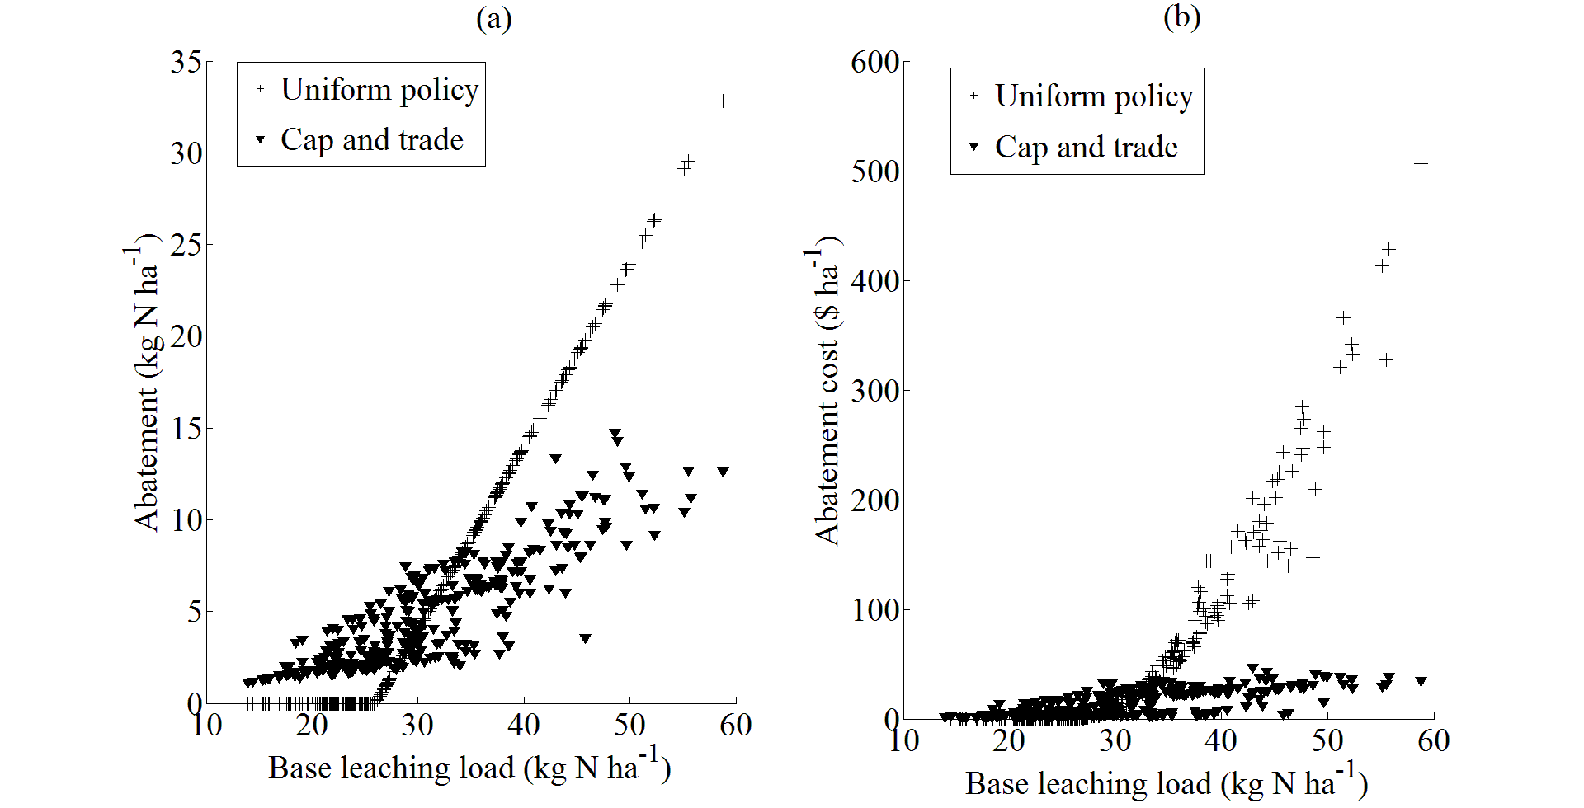

**Figure 4. (a) Absolute level of abatement and (b) the cost of performing this abatement for all farms for uniform and cap and trade policies set to achieve 26 kg N-1 across the catchment**

### **3.3 Adoption of mitigation practices**

In this section, the effect of a reduction of leaching to 26 kg N ha-1 on farms with different stocking rates and emissions levels is examined. Model outputs for three dissimilar farms on volcanic soils are presented in Table 3. Nitrate leaching increases with stocking rate and nitrogen fertiliser application (Table 3). No mitigations are used on any farms without regulation since their use is costly. Indeed, none of the CRMPs are profitable in the absence of regulation, so the model predicts that broad scale voluntary adoption is unlikely to occur, in line with recent research (e.g. Bewsell and Brown, 2011).

**Table 3. Key model output for low, medium, and high emissions farms without regulation and with uniform and differentiated policies set at 26 kg N ha-1**

|  |  |  |  |
| --- | --- | --- | --- |
| **Policy** | **Low-emissions farm** | **Medium-**  **emissions**  **farm** | **High-**  **emissions**  **farm** |
|  | *Without regulation* | | |
| Stocking rate (cows ha-1) | 1.8 | 3.2 | 4.3 |
| Nitrogen fertiliser (kg ha-1) | 95 | 186 | 377 |
| Nitrate leaching (kg N ha-1) | 18.3 | 34.8 | 51.5 |
| Profit ($ ha-1) | 656 | 1944 | 2704 |
| CRMPs | None | None | None |
|  | *Uniform regulation targeted at leaching load* | | |
| Stocking rate (cows ha-1) | 1.8 | 3.0 | 3.8 |
| Nitrogen fertiliser (kg ha-1) | 95 | 122 | 131 |
| Nitrate leaching (kg N ha-1) | 18.3 | 26 | 26 |
| Profit ($ ha-1) | 656 | 1896 | 2338 |
| CRMPs | None | Improved dairy shed management of effluent  Deferred effluent application | Improved dairy shed management of effluent  Deferred effluent application  Nitrification inhibitors |
|  | *Cap and trade regulation targeted at leaching load* | | |
| Stocking rate (cows ha-1) | 1.8 | 3.1 | 4.2 |
| Nitrogen fertiliser (kg ha-1) | 89 | 162 | 324 |
| Nitrate leaching (kg N ha-1) | 16.8 | 27.9 | 40.9 |
| Profit ($ ha-1) | 654 | 1919 | 2672 |
| CRMPs | Improved dairy shed management of effluent  Deferred effluent application | Improved dairy shed management of effluent  Deferred effluent application | Improved dairy shed management of effluent  Deferred effluent application |

A uniform regulation of 26 kg N ha-1 does not affect the management of the low-emissions farm since it leaches less than this under current practices. However, both the medium- and high-emissions farms must reduce leaching to meet the policy goal. Both farms reduce pollutant level through reducing stocking rate and nitrogen fertiliser application. Under a uniform regulation, CRMPs are used to meet the nutrient goal at lower cost. Effluent management is improved on both the medium- and high-emissions farms and nitrification inhibitors are applied on the high-emissions farm to reduce leaching due to nitrification and increase pasture production (Table 3). This costs the medium- and high-emissions farms around $48 and $366 ha-1, respectively. This result reinforces the fact that high-emissions farms bear a higher cost under a uniform policy, as displayed in Figure 4b.

In comparison, all farms are responsible for mitigation across the catchment under a cap and trade policy (Table 3). This is achieved through reductions in stocking rate and nitrogen fertiliser application and the adoption of improved effluent management on each farm. The overall result is the achievement of a low abatement cost on all farms, with profit falling by less than 1.3 per cent across the population. Indeed, profit on each farm decreases by only $2, $25, and $32 ha-1 on the low-, medium-, and high-emissions farms, respectively. These results reinforce the economic benefits of a cap and trade policy brought about by the significant differences between the abatement characteristics of farms in the catchment.

### **3.4 Distributional Effects of Policy**

A policy can impact on the distribution of profit among a regulated population. This is important to consider since some firms could be substantially worse off after the introduction of a given regulation. This is explored using cumulative distribution functions. The length of a cumulative distribution function for farm profit indicates the variability of profit, while its location indicates what levels of profit are earned with this policy.

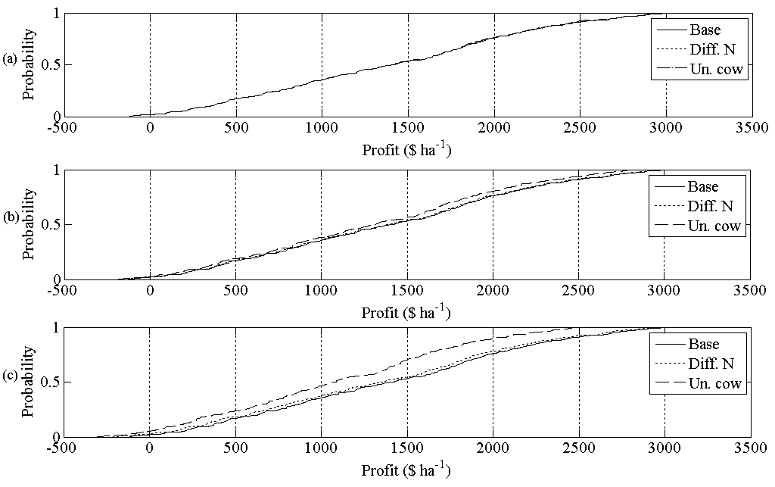**Figure 5. Cumulative distribution functions for farm profit ($ ha-1) in the base scenario (Base), with a differentiated emissions standard (Diff. N), and with a uniform cow reduction (Un. cow) set to achieve a catchment-wide goal of (a) 30 kg N ha-1, (b) 26 kg N ha-1, and (c) 22 kg N ha-1**.

*Notes:* Results for a uniform N reduction are not shown since these are very similar to those for the differentiated policy. Results for land retirement are not considered given the high cost of this policy, relative to the other instruments.

The policies have a similar impact on the distribution of farm profit for leaching limits of 30 kg N ha-1 (Figure 5a) and 26 kg N ha-1 (Figure 5b). However, the distributional effects of regulatory policy are more disparate with a nutrient goal of 22 kg N ha-1 (Figure 5c). The base scenario has the highest level of profit, but also the greatest variability. A differentiated instrument has a low expected impact on profit and its distribution, particularly compared to the base scenario. This emphasises that the use of a cap and trade policy over all nutrient reductions is beneficial for the regulation of diffuse pollution in this catchment, as it has minimal impact on the distribution of income among producers. Nonetheless, the uniform cow reduction decreases profit significantly, especially compared to all other scenarios shown in Figure 5.

## 4. Summary

Diffuse pollution from pastoral agriculture threatens water quality throughout the world. Like many nations, New Zealand faces a difficult balancing act between protection of freshwater resources and the profitability of an economically and politically important agricultural industry. Dairy farms are a major contributor to nitrate leaching and will have to modify current practices to reverse this trend. However, producers and policy makers are concerned with the costs of achieving higher environmental standards, which are uncertain and potentially significant. Thus, the identification of cost-effective policy instruments for the regulation of N leaching from New Zealand dairy farms is of vital importance.

This analysis explores the cost and distributional impacts of a broad set of regulatory instruments on a large population of dairy farms in the Waikato region of New Zealand. It explicitly deals with heterogeneity between agents through modelling individual farms in significant detail and calibrating these models to real data. This approach provides novel insight into the impacts of policies that require individual farms to undergo certain changes or allow those farms who can abate more cheaply to mitigate the most.

The analysis highlights a number of important points for policy makers:

1. A policy instrument that allows the level of abatement to vary among producers according to differences in marginal abatement cost is most cost-effective. The medium goal of 26 kg N ha-1 can be achieved at a cost of $15 ha-1 under cap and trade, while a uniform cap on emissions for all farmers would be more than three times as expensive ($49 ha-1).
2. Requiring uniform reductions in stocking rate, banning the application of nitrogen fertiliser, and land retirement perform poorly, relative to a cap and trade policy. These instruments are at least three times more costly than a differentiated policy over all simulated reductions and are often many times more expensive.
3. All policy instruments have a similar impact on the distribution of farm profit across the catchment. Most importantly, the differentiated policy does not greatly alter the distribution of farm profit, relative to what exists without regulation.
4. Cost differences between policies are large when extrapolated across the catchment. The annual cost of achieving the 26 kg N ha-1 goal with the three most cost-effective instruments is predicted to be around $0.6 million with cap and trade, $2 million with a uniform cap on N, and $5.1 million with a uniform cap on stocking rate.
5. Mitigation practices are important for reducing abatement cost. However, their optimal use varies given heterogeneity between farms. This highlights a key role for economic modelling to guide the cost-effective utilisation of abatement activities.

Most policy makers in New Zealand and throughout the world have thus far seemed reluctant to adopt cap and trade approaches for water quality management. However, the capacity of these instruments to account for abatement cost heterogeneity among farms promotes their cost-effectiveness, relative to a range of alternative instruments. The magnitude of these cost savings, relative to the transaction costs associated with a cap and trade policy, are worthy of further research.

## Appendix

Feed supplies are measured using tonnes of dry matter (t DM). The static model describes a management year consisting of 26 fortnightly periods (), beginning on 1 July. The model describes the rotation of a cow herd between multiple paddocks. The area of pasture grazed at time *t* that has not been grazed since period *i* is represented by . Similarly,  denotes the area harvested for silage production (i.e. ensiled) at time *t* that has not been grazed since period *i*. In addition,  represents the area of pasture grazed at time *t* that was ensiled in period *i*. These three activities collectively describe the rotational land-use system.

Each producer is assumed to be a profit-maximising agent who owns a farm consisting of a fixed area of  hectares. Total land use at time *t* is constrained by:

. (A1)

The first term on the right hand side describes land use at time *t*. The second and third terms describe land that is rested for future use.

Grazing ceases at a residual biomass () to ensure pasture persistence, improve pasture regrowth, and maintain cow intake. Total feed production in period *t* () for is represented as:

, (A2)

where  is pasture biomass growth in period *g*. Eq. 2 specifies that the total amount of feed available at time *t*, following previous defoliation at time *i*, consists of the amount of pasture remaining after the previous defoliation (), the amount of pasture remaining after the current defoliation (), and pasture growth between time *i* and *t* ().

The feasibility of production activities defined in eq. A2 is conditioned by the bounds:

, (A3)

where minimum biomass levels () are maintained to ensure an adequate rate of regrowth and maximum biomass levels () prevent grazing of grass with low digestibility.

Pasture supply may be promoted using nitrogen fertiliser. This is described through:

, (A4)

where  is the pasture biomass (t ha-1) produced through nitrogen fertilisation in period *t*,  is the amount of nitrogen fertiliser (t ha-1) applied during period *i*, and  is the yield response (t DM) in time *t* following application of one tonne of nitrogen fertiliser in period *i*. Use of nitrogen fertiliser is constrained to represent agronomic and environmental constraints.

Pasture production may also be increased through the use of nitrification inhibitors—a chemical that reduces nitrate and cation leaching by restraining the process of nitrification (Monaghan *et al.,* 2007). This is represented through:

, (A5)

where  is the additional proportion of pasture growth obtained at time *t* due to the use of nitrification inhibitors and *NI* is the number of hectares on which the inhibitor is applied.

Metabolisable energy (ME) is that available for livestock growth and maintenance after the digestion of feed. The supply of ME for allocation between livestock classes is the sum of all feed sources available in a given period. Feed pools supply energy to cows that possess one of 216 attribute combinations, each with different temporal energy demands driven by disparity in calving date, herd status (cull and standard), lactation length, and productivity. Calving begins on July 1, July 15, or August 1. Cull cows are milked for 180, 210, 240, 270, or 300 days and are then killed. In contrast, standard herds are milked for 240, 270, or 300 days. There are nine levels of inherent milk production that reflect genetic diversity.

The demand and supply of ME is calculated for each fortnightly period through the equation:

, (A6)

where  represents the number of cows with attribute combination *h*,  represents the energy requirement (measured in MJ of ME per fortnightly period) of a cow with attribute combination *h* at time *t*,  represents the proportion of the feed that is consumed by livestock (e.g.  represents pasture utilisation),  is the energy content of each feed specified in MJ of metabolisable energy (ME) per tonne of DM,  is the total amount of silage fed to cows (compared to  that is the total amount of grass silage produced),  is the amount of maize silage (t DM) fed to cows at time *t*, and  is the amount of palm kernel extract (t DM) fed to cows at time *t*.

It is important that the feed intake of cows is constrained to prevent the herd consuming unrealistic amounts of feed. This is represented by:

, (A7)

where  is the maximum per cow intake of pasture dry matter at time *t* (t DM cow-1),  is the substitution rate of pasture to forage supplements (grass and maize silage), and  is the substitution rate of pasture to palm kernel extract.

Total nitrate leaching is defined as:

, (A8)

where *M* is the proportion of nitrate leaching decreased through additional mitigation strategies (see eq. A9),  is a constant term,  is annual milk production (t cow-1) of a cow in herd *h*, and  are slope coefficients describing the relationship between nitrate leaching and N fertiliser application, cow number, milk production, and maize silage feeding, respectively. The attenuation factor represents losses of N in the process of transport from field to waterway, due to factors such as deep drainage, volatilisation, and plant uptake. The term in square brackets in (8) calculates the nitrate leaching arising from relevant decision variables within the model. This is modified through the use of CRMPs, described through:

, (A9)

where  for  is the proportional decrease in nitrate leaching achieved with mitigation ,  is the extent to which low-rate effluent application is used,  is the extent to which dairy shed innovation (i.e. a Dungbuster® system) is used to reduce effluent volumes,  is the extent to which deferred effluent application is used, and  is the number of cows in herd *h* maintained on a self-feeding pad for 10 weeks (70 days) from 21 April to 31 June. The ratios in (9) are defined .

The objective function is:

, (A10)

where  is firm profit,  is the price received for milk solids (MS) ($ t-1),  is annual milk production (t cow-1) of a cow in herd *h*,  is the price received for one cull cow ($ cow-1),  is the price received for one calf ($ calf-1),  is the calving rate,  is the replacement rate,  is the variable cost associated with a single cow ($ cow-1),  is the cost of conserving grass silage ($ t DM-1),  is the cost of maize silage ($ t DM-1),  is the cost of palm kernel extract ($ t DM-1),  is the cost of nitrogen fertiliser ($ t-1),  is the fixed cost of production ($ ha-1), and  is the cost of individual CRMPs with full utilisation.

**References**

AgFirst Waikato (2009), *Upper Waikato nutrient efficiency study*, AgFirst Waikato, Hamilton.

Basset-Mens, C., Ledgard, S.F., and Boyes, M. (2009), ‘Eco-efficiency of intensification scenarios for milk production in New Zealand’, *Ecological Economics* 68, pp. 1615–1625.

Bewsell, D., and Brown, M. (2011), ‘Involvement: a novel approach for understanding responses to nutrient budgeting’, *New Zealand Journal of Agricultural Research* 54, pp. 45–52.

Brooke, A., Kendrick, D., Meeraus, A., and Raman, R. (2008), *GAMS—A user’s guide*, GAMS Development Corporation, Washington D. C.

Campbell, N., D’Arcy, B., Frost, A., Novotny, V., and Sansom, A. (eds.) (2005), Diffuse pollution, IWA, London.

Cary, J., and Roberts, A. (2011), ‘The limitations of environmental management systems in Australian agriculture’, *Journal of Environmental Management* 92, pp. 878–885.

Chaston, T. (Ed.) (2008), *Financial budget manual 2008*, Lincoln University, Christchurch.

Conejo, A.J., Castillo, E., Minguez, R., and Garcia-Bertrand, R. (2006), *Decomposition techniques in mathematical programming*, Springer-Verlag, Berlin.

DairyNZ (2009), *DairyNZ economic survey 2007–08*, DairyNZ, Hamilton.

Dexcel (2008a), *Feed information sheet*, Dexcel, Hamilton.

Dexcel (2008b), *Average pasture growth data for New Zealand dairy farms*, Dexcel, Hamilton.

Doole, G.J. (2010), ‘Indirect instruments for nonpoint pollution control with multiple, dissimilar agents’, *Journal of Agricultural Economics* 61, pp. 680–696.

Doole, G.J. and Paragahawewa, U.H. (2010), ‘System-level evaluation of dicyandiamide (DCD) for improved environmental outcomes on New Zealand dairy farms’, *Proceedings of the New Zealand Grasslands Association* 72, pp. 67–70.

Drewry, J.J., Newham, L.T.H., Greene, R.S.B., Jakeman, A.J., and Croke, B.F.W. (2006), ‘A review of nitrogen and phosphorus export to waterways: context for catchment modelling’, *Marine and Freshwater Research* 57, pp. 757–774.

Environment Waikato (EW) (2008), *The condition of rural water and soil in the Waikato region: risks and opportunities*, Environment Waikato, Hamilton.

Griffin, R., and Bromley, D. (1982), ‘Agricultural runoff as a nonpoint externality: a theoretical development’, *American Journal of Agricultural Economics* 64, pp. 547–552.

Hanley, N., Shogren, J., and White, B. (2007), *Environmental economics*, Palgrave Macmillan, Hants.

Livestock Improvement Corporation (LIC) (2009), *2008/09 dairy statistics*, Livestock Improvement Corporation, Hamilton.

Longhurst, R.D., and Smeaton, D.C. (2008), *Improved nutrient efficiency through integrated catchment management in Little Waipa and Waipapa*, AgResearch, Hamilton.

McCall, D.G., Clark, D.A., Stachurski, L.J., Penno, J.W., Bryant, A.M., and Ridler, B.J. (1999), ‘Optimised dairy grazing systems in the Northeast United States and New Zealand. I. Model description and evaluation’, *Journal of Dairy Science* 82, pp. 1795–1807.

Monaghan, R.M., Hedley, M.J., Di, H.J., McDowell, R.W., Cameron, K.C., and Ledgard, S.F. (2007), ‘Nutrient management in New Zealand pastures—recent developments and future issues’, *New Zealand Journal of Agricultural Research* 50, pp. 181–201.

Monaghan, R.M. (2009), ‘The BMP Toolbox—selecting the right best management practice for mitigating farming impacts on water quality’, In: Currie, L.D. and Yates, L.J. (Eds.), *Nutrient management in a rapidly changing world*, Fertiliser and Lime Research Centre Occasional Report No. 22, Massey University, Palmerston North, pp. 328–334.

Ramilan, T., Scrimgeour, F., Levy, G., Marsh, D., and Romera, A.J. (2011), ‘Simulation of alternative dairy farm pollution abatement policies’, *Environmental Modelling and Software* 26, pp. 2–7.

Semadini-Davies, A., Elliott, S., McBride, G., and Shankar, U. (2009), *Using CLUES to identify impact catchments - Waikato River Catchment Pilot Study*, NIWA Report HAM2009-101, Hamilton.

United Nations Environment Program (UNEP) (2008), *Water quality for ecosystems and human health*, United Nations Global Environmental Monitoring System, Ontario.

Whistler, D., White, K.J., Wong, S.D., and Bates, D. (2004), *SHAZAM Version 10 user’s manual*, Northwest Econometrics, Gibsons.