UNIVERSITY OF WAIKATO
Hamilton
New Zealand

Which Future for the Hurunui?

Combining Choice Analysis with Stakeholder Consultation
Dan Marsh and Yvonne Phillips

Department of Economics
Working Paper in Economics 17/12
December 2012

Corresponding Author
Dan Marsh
Economics Department
University of Waikato
Private Bag 3105
Hamilton
New Zealand, 3240

Email: dmarsh@waikato.ac.nz

Yvonne Phillips
PhD Student
Economics Department
University of Waikato
Hamilton, New Zealand

Email: ysm1nz@gmail.com

Abstract

The future of the Hurunui River and its catchment has been hotly contested between those who seek to store and/or divert water from the river in order to increase agricultural production and those who would like to see the river undeveloped and the quality of natural resources in the river and catchment improved. The Canterbury Regional Council wished to develop an approach to manage catchment nutrient loads across the region in order to achieve the objectives of its Natural Resources Regional Plan (NRRP) for water quality and aquatic habitats. Our approach, combining stakeholder consultation with choice analysis, was developed and tested in the Hurunui catchment in 2010-2011.

The policy objective of the choice experiment was to describe and quantify the preferences of Canterbury Region residents with respect to existing conditions (the status quo) and potential future land use and water quality scenarios for the catchment. It was envisaged that this quantitative information on preferences across the region would be used by policy makers at the same time as they considered the outcomes of the stakeholder deliberative process.

At the conclusion of the consultation process there was ‘general acceptance’ of a future development strategy for the Hurunui catchment that would maintain water quality in the main river at 2005-2009 levels while improving the tributaries to 1990-1995 water quality. Results from the choice experiment are broadly supportive of this approach. Canterbury region residents would require substantial compensation (mean $244-$315 per household per year) before they would accept a decline in water quality in the main river or in the tributaries. Willingness to pay for improvements in the main river is lower with a mean of $25-$33 per household per year.

Keywords

choice experiment
scale factor
error variance
water quality
New Zealand

JEL Codes

Q25, Q51, Q53

Acknowledgements
We are indebted to Riccardo Scarpa for original ideas and advice on the methodological approaches used in this research. Any errors or omissions are our own.

Background

Clean, fresh water has long been close to the heart of the majority of New Zealanders. ‘Fresh water is a major driver of our economy, it sustains our unique environment, it is deeply embedded in our culture and life-style, and for many of us it is part of our identity. Fresh water is one of New Zealand’s most important advantages – it is a national Taonga’. (Land and Water Forum 2012)

Water remains relatively clean and abundant in New Zealand but there has been a steadily increasing level of concern over declining water quality in lowland rivers and streams and in nationally significant lakes. At the same time, water is also causing disputes – ‘disputes about Water Conservation Orders and water infrastructure development; disputes about the intensification of farming and about run-off; disputes about water infrastructure in cities and towns, its discharges, and how it should be organised and paid for; disputes about who should be involved in its management, including around the role of iwi’ (Land and Water Forum 2012).

The Land and Water forum emerged in 2009 from a belief that New Zealand has often made a poor job of managing water. Key stakeholders came together in the forum to work collaboratively towards improved water management and have built substantial agreement in support of a new fresh water management framework:

Communities will collaborate (within a national regulatory framework and assisted by national guidance) to identify the specific issues in each catchment, set objectives and limits, and decide on solutions to address those issues effectively and meet their aspirations. All activities in the catchment which have an impact on water quality and flow will be accounted for and brought into the management framework. This in turn will create a more transparent, secure and enabling environment for business and investment decisions.

At the same time, the Canterbury Regional Council (CRC) wished to develop an approach to managing catchment nutrient loads across the region in order to achieve the objectives of its Natural Resources Regional Plan (NRRP) for water quality and aquatic habitats. This approach, now recommended by CRC and partner organisations, involved extensive stakeholder consultation. It aligns well with the recommendations of the Land and Water Forum. This paper describes a method for using the stakeholder consultation process to design and implement a rank-ordered choice experiment.

Discrete choice experiments have been used widely in environmental valuation since the earliest application by (Boxall, Adamowicz, Swait, Williams and Louviere 1996). They are well-suited to situations where policy alternatives have multiple impacts and the objective is to estimate the value of these impacts. Rank-ordered choices provide richer preference information than methods which elicit only the favourite choice (Hausman and Ruud 1987) since the marginal benefit of asking repeated questions about alternatives within a choice situation is generally greater than the marginal cost.

Empirical Context

The Hurunui River is widely regarded as being the most scenic and unspoilt of the seven major alpine rivers in the Canterbury Region of New Zealand’s South Island. From its headwaters in the Southern Alps, the Hurunui Rivers flows through alpine lakes and foothills before crossing the Amuri Plains and flowing through a gorge on its way to the Hurunui Estuary about 200 kilometres from its source. The river is highly significant to Ngai Tahu and nationally important for fishing and kayaking. It also provides an important habitat for a number of endangered fish and bird species (Environment Canterbury 2010).

The future of the Hurunui River and its catchment has been hotly contested between those who seek to store and/or divert water from the river in order to increase agricultural production and those who would like to see the river undeveloped and the quality of natural resources in the river and catchment improved. The Canterbury Regional Council, concerned about the cumulative effects of intensive land use on surface and ground water quality, developed an approach to managing catchment nutrient loads across the region aimed at achieving the objectives of its Natural Resources Regional Plan (NRRP) for water quality and aquatic habitats. One approach, drawing on deliberative and systems methods, was developed and tested in the Hurunui catchment in 2010/11 as part of the Land Use and Water Quality Project.

The Land Use and Water Quality Project involved three distinct work streams: policy, science and community issues. It included stakeholder workshop groups addressing issues at a regional level and a series of catchment level stakeholder workshops held in the Hurunui District. The workshops benefited from findings from the policy and science streams. A key project outcome was the drafting of a preferred approach for the management of the cumulative impacts of land use on water quality in the catchment (Brown et al. 2011, Wedderburn et al. 2011).

A scenario approach was used in order to assess ‘the acceptability of a range of environmental, economic, social and cultural outcomes for the catchment …’ (Wedderburn et al. 2011). This was based on an analysis of the current situation in the catchment alongside alternative future scenarios and ‘business as usual’ (Table 1).

Table 1: Future Land Use Scenarios

1. Current land use | Based on current land use.
2. Business as usual* | Some intensification in line with historic trends. All border dyke irrigation converted to spray irrigation.
3. Extensive irrigation* | Full irrigation of suitable land. All border dyke irrigation converted to spray irrigation.
A. Conservative | All productive land was converted to forestry, aimed at achieving the highest level of confidence of meeting NRRP objectives for periphyton.
B. 1990-1995  Hurunui Water Quality | A combination of some land use change and mitigations that aim to meet water quality as it was in the Hurunui River in the early 1990s. All border dyke irrigation converted to spray irrigation.
C. 2005-2009  Water Quality in Main Stem  1990-1995  Water Quality in Tributaries | A staged approach to achieving a combination of some land use change and mitigations that aim to meet water quality as it was in the Hurunui River in 2005 to 2009 and in the tributaries in 1990 to 1995. All border dyke irrigation converted to spray irrigation.
*Assumes current land use practice; no additional mitigation.
Source: Adapted from Brown et al. (2011).

Brown et al. (2011) report that:

there was a general acceptance that the option that would ‘probably’ achieve all environmental outcomes was the appropriate risk management approach. This value judgement reflects an acceptance of only modest risk of breaching environmental outcomes - i.e. outcomes are likely to be achieved most, but not all, of the time and occasional breaches were, upon weighing all values, tolerable for the Group…

The scenario that would ‘probably’ achieve the Canterbury Natural Resources Regional Plan objectives in the Hurunui main stem is a ‘current use’/maintain water quality at 2005-2009 levels. For the tributaries it meant a land use scenario that would lead to improvement on the current state (i.e. Scenario B returning to 1990-1995 water quality).

The policy objective of the choice experiment outlined in this paper was to describe and quantify the preferences of Canterbury Region residents regarding existing conditions (the status quo) and potential future land use and water quality scenarios for the catchment. In particular, the study involves estimates of the amount Canterbury region residents would be willing to pay (WTP) for improvement in water quality attributes and the level of compensation that they would be willing to accept (WTA) for deterioration in water quality attributes. This quantitative information on preferences across the region could then be used by policy makers as they considered the outcomes of the stakeholder deliberative process.

Survey Design

Attribute Selection

Attributes selected for inclusion in the choice experiment were determined by catchment level stakeholder workshops where qualitative methods were used to identify the most important attributes for different stakeholders. Participating stakeholders were chosen by Environment Canterbury (ECan) staff to represent the views of:

- Environment Canterbury
- Arable, horticulture and forestry sectors
- Senior school students
- Energy companies (Meridian, Contact)
- District and City councils
- Community and public health workers
- Dairy, sheep, beef and pork farmers
- Agribusiness (fertiliser companies, irrigators)
- Environmental groups (Water Rights Trust, Fish and Game, Forest and Bird)
- Ngai Tahu runanga environment group
- Department of Conservation
- Recreationists (kayakers, jet boaters).

Stakeholder selection was based on ‘those impacted by the “common problem” and those who may be impacted by any policy or action to address the problem’. Stakeholder groups were then presented with details of alternative scenarios and asked to select and weight a set of the most important attributes they believed would be impacted by the scenarios. In order to provide an overview of the most reported stakeholder concerns, the attributes and weights reported by each stakeholder group were classified into categories and summed across all groups. The outcome is shown in Table 2. Four of the five top-ranked attribute categories were included in the final design of the choice experiment. Issues around water quantity (ranked 4th) were excluded at the request of Environment Canterbury.

Table 2: Qualitative Attribute Scores from Stakeholder Consultation Exercises
Rank |  | Attribute Category |  | Category  Score |  | Percent
1 | Water quality |  | 145.25 |  | 13%
2 | Ecosystems and biodiversity |  | 130.25 |  | 12%
3 | Enterprise profitability |  | 118.75 |  | 11%
4 | Water quantity and reliability |  | 117 |  | 11%
5 | Community services and economy |  | 116.25 |  | 11%
6 | ‘Other’ attributes (several) |  | 69 |  | 6%
7 | Community wellbeing |  | 53 |  | 5%
8 | Water quality ‐drinking and stock |  | 46.5 |  | 4%
9 | Unobstructed flow |  | 46 |  | 4%
10 | Employment and jobs |  | 41 |  | 4%
11 | Soil health and fertility |  | 37 |  | 3%
12 | Water flows |  | 34 |  | 3%
13 | Heritage protection and history |  | 30.5 |  | 3%
14 | Regulations and compliance |  | 29 |  | 3%
15 | Public access |  | 24 |  | 2%
16 | Cultural values |  | 23 |  | 2%
17 | Landscape and trees |  | 20 |  | 2%
18 | Weed/pest disease management |  | 10 |  | 1%
19 | Water use efficiency |  | 9.5 |  | 1%
 |  |  |  |  |  | 100 %

Attribute selection and survey design was also determined by discussion with environmental economists familiar with local water quality issues and with technical experts assisting with development of the ‘preferred approach’. Advice from experts developing the preferred approach was also used to define attributes and levels for a range of future scenarios. The final set of six attributes selected were suitability for swimming and recreation, ecological health, salmon and trout populations, tributary water quality and changes in number of jobs in the region.

Since some scenarios would result in a reduction in environmental quality, the payment of variable (local taxes) could either increase, indicating a willingness to pay for improved environmental quality or could decrease, indicating a willingness to accept compensation for reduced quality. A specific attribute describing water quality in tributaries was included in order to better understand the relative importance of water quality in the main river (currently satisfactory) versus the lowland tributaries (currently not satisfactory).

Defining Attribute Levels

The attribute levels in the choice experiment were determined primarily by using the analysis provided under the science stream of the land use and water quality project. Scientists working on this stream described the current state of water quality in the Hurunui River and its tributaries as well as expected conditions under alternative scenarios e.g. ‘business as usual’ and agricultural intensification. An example of the science-based data used to assist this process is shown in Table 3. These data were translated into levels which would be understandable to the general public.

Table 3: Values and Assessment by Scenario
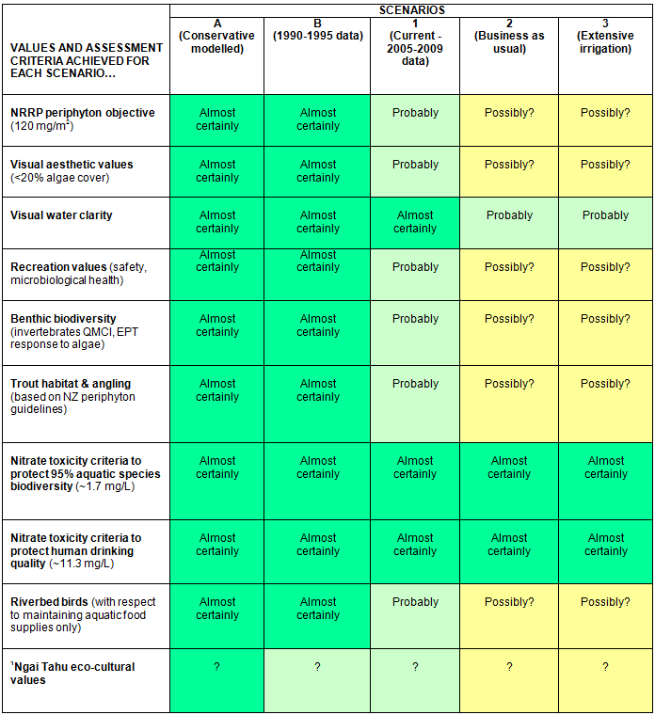Hurunui River at Highway 1
Source: Norton and Kelly (2010), updated version emailed by Ned Norton 21 Jan 2011.
Table 4: Attribute Levels
Attribute  Heading | Attribute  Description | Current Situation | Other  Levels
Suitability  for  Swimming and Recreation | This is a combined measure of water clarity,  algae levels, and levels of e-coli bacteria.  Good: ECan objectives always met or exceeded. Water always clear and safe and free of algae.  Satisfactory: ECan objectives usually met.  Water is usually clear and safe and free of algae.  Not satisfactory: ECan objectives not met.  Water is usually murky and unsafe; too much algae. | Satisfactory | Not Satisfactory Good
Ecological  Health | This is a measure of the life-supporting capacity  of the river. It covers aquatic ecosystems,  associated significant habitats of indigenous fauna  and areas of significant indigenous vegetation.  Good: ECan objectives always met or exceeded. Satisfactory: ECan objectives usually met.  Not Satisfactory: ECan objectives not met. | Satisfactory | Not Satisfactory Good
Salmon  and Trout | This is a measure of the life-supporting capacity  of the river for trout and salmon.  Good  Satisfactory  Not satisfactory  (As above) | Satisfactory | Not Satisfactory Good
Tributary  Water  Quality | This is an overall measure of the health of Hurunui tributaries. It covers water clarity, sedimentation,  algal growth, suitability for contact recreation, ecosystem health and habitat values . (As above). | Not Satisfactory | Poor Satisfactory Good
Number  of Jobs | The regional economy may be affected by intensification or de-intensification of  agricultural land in the Hurunui catchment. The  impact is measured in terms of job losses or  gains compared with a business-as-usual scenario. | Stay about  the same | 250 less jobs,  250 more jobs,  500 more jobs in the region
Cost  to You | There may be an increase or decrease in local or national taxes as a result of this scenario. This is  the net cost to you, per year, for the next 10 years. | $0 | $200 increase  $75 increase  $25 increase  $25 decrease  $50 decrease  $100 decrease
Note: All attributes have four levels including the status quo, while the payment variable (Cost to Household)
has six levels.
With a view to ensuring policy relevance we made use of the minimum standards set by Canterbury Regional Council in defining attribute levels. An attribute that meets the minimum standard is defined as ‘satisfactory’. If it does not it is ‘unsatisfactory’. Exceeding the minimum standard is defined as ‘good’. Tributary water quality is currently unsatisfactory and expected to decline under some scenarios so an extra level ‘poor’ was added to represent this decline. The levels for changes in jobs were based on potential effects on the agricultural sector and the wider economy resulting from different water management scenarios, drawing on work by Simon Harris, described in Brown et al. (2011). The levels are: 250 fewer jobs, no change, 250 more jobs or 500 more jobs. The final set of attributes and levels are shown in Table 4.

Pilot, Pre-test and Final Survey Design

Early versions of the questionnaire were piloted with selected workshop participants, Canterbury residents and technical experts. At this stage interviewees were debriefed on their experience in filling in the questionnaire with the survey instrument being improved and clarified as a result. An on-line version of the questionnaire was then pretested using Canterbury region residents. Respondents for the final version of the survey were recruited from an online market research panel in June 2011 and invited to fill in the survey online. There were quotas on age, gender and education level in order to help achieve a representative sample. People who resided outside the Canterbury region were excluded, as were people who completed the survey in less than five minutes.

Figure 1 is an example of a choice card as it was presented to participants. When participants selected an alternative it was hidden and they were then instructed to select another alternative until they had ranked all alternatives on each choice card. They were then shown their ranking results and asked to confirm these before proceeding to the next card.

Figure 1: Example of a Choice Card
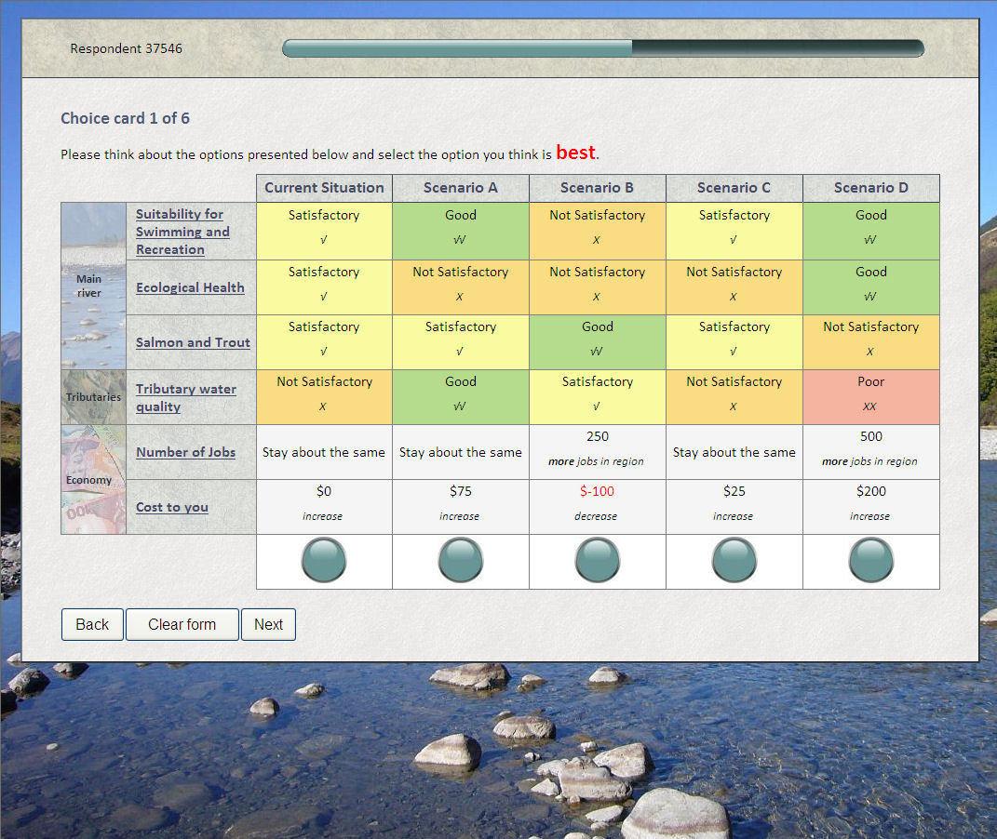

Efficient Design

We generated a D-efficient design in six blocks using the Ngene software package (Institute of Transport and Logistics Studies 2007). Efficient designs require a smaller number of respondents to achieve a given level of statistical significance of the parameters (Scarpa and Rose 2008).

We used information from other water quality non-market valuation studies in New Zealand such as (Marsh, Mkwara and Scarpa 2011, Tait and Baskaran 2011) and incorporated this information into the initial Bayesian priors. Bayesian priors make the design efficiency more robust to misspecification than optimising with fixed priors (Ferrini and Scarpa 2007). We then updated the prior distributions with values obtained from pilot tests of the survey. The design mean D-error was 0.21 with a standard deviation of 0.008.

Rather than specifying cost as a continuous attribute we specified a large number of levels at $25 increments between -$100 and $200. A constraint was imposed so that each level appeared at least once in a block. This meant that participants saw a variety of costs without imposing too much of a penalty on design efficiency. A negative cost represents a decrease in the household’s annual rates bill. Negative costs were required because water quality attributes are expected to decline under some scenarios of agricultural intensification. If cost was constrained to be positive it would be difficult to avoid dominated choice situations and design efficiency would be much lower.

Choice Experiment Structure

For this study we obtain full rankings of the five alternatives in each choice situation and use an exploded logit specification to take into account the sequential way in which the ranks are obtained (Lancsar and Louviere 2008). The complete ranking of J alternatives in a choice set is a sequence of J-1 discrete choices drawn without replacement from the starting set of five alternatives. The utility structure for each choice task is:

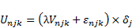 (1)

where U is the utility for each task, V is observed utility, ε_{njk} is the error term, n are individual respondents, j are the alternatives, k is the number of alternatives remaining for each choice and δ_{j} denotes whether alternative j is available or was selected previously. The scale parameter, or inverse Gumbel error, is denoted by λ.

Participants in ranking tasks may be left to decide how to achieve full ranking or given specific instructions on the order in which to select the rankings as in Louviere (2004). One elicitation technique known as ‘best-worst’ ranking involves asking respondents to choose sequentially the best and worst alternatives until all are ranked as in Louviere, et al. (2008). Researchers, however, could theoretically instruct participants to rank the alternatives in any order.

We divided the sample into two groups who were given different instructions. Half the respondents were directed to use a ‘best-worst’ ranking technique and the other half were directed to repeatedly select their favourite from the alternatives remaining (‘repeated best’). In both treatments, the first choice involved selecting the favourite alternative from a set of five. The favourite alternative was then hidden. Respondents in the best-worst treatment were then directed to select their least preferred option, while the other group was directed to select their next favourite. The process was repeated until the five alternatives were all ranked.

In rank-ordered choices, the Gumbel error and scale parameter vary across ranks, an issue first addressed by Hausman and Ruud (1987). Errors in welfare estimates may result if rank-order data is pooled without controlling for this scale heterogeneity (DeShazo and Fermo 2002). However, parameter estimates derived from preferred choice models are consistent with those obtained from first rankings once the scale differences are accounted (Caparros, Oviedo, and Campos 2008). Using a parameterized heteroskedastic model, we test whether the elicitation (best-worst versus repeated-best) method also has implications for the scale parameter.

Results

- Sample Statistics and Model Estimation

Sample statistics for the final sample of 505 completed surveys are presented in Table 5. Comparison with data from the 2006 census suggests that the sample is broadly representative of the region although it should be noted that certain groups are over or under represented. In particular, our sample somewhat over represents females, those with a post-school qualification and those in the 18-30 age bracket and under represents low income households (less than $30,000).

Table 5: Sample Statistics
Treatment Group |  |  |  | Best-worst | Repeated-best | 2006 Census
Count of participants |  |  |  | 250 | 255 | 521,832
 |  |  |  | Per cent
Gender | Female |  |  | 62% | 55% | 51%
 | Male |  |  | 38% | 45% | 49%
Age | 18-30 |  |  | 23% | 27% | 20%
 | 30-44 |  |  | 34% | 27% | 29%
 | 45-59 |  |  | 24% | 24% | 26%
 | over60 |  |  | 19% | 22% | 25%
Post-school qualification |  |  |  | 56% | 62% | 51%
Annual household income | Less than $30,000 |  |  | 20% | 16% | 22%
 | $30,000 to $50,000 |  |  | 16% | 21% | 20%
 | $50,000 to $70,000 |  |  | 20% | 20% | 21%
 | $70,000 to $100,000 |  |  | 17% | 18% | 19%
 | Greater than $100,000 |  |  | 12% | 15% | 18%
 | Declined |  |  | 14% | 10%
Location of residence | Christchurch city |  |  | 70% | 75% | 67%
 | Other Canterbury |  |  | 30% | 25% | 23%
Involved in farming |  |  |  | 10% | 4%
Seen the Hurunui or a tributary in last 12 months |  |  |  | 38% | 44%
Visited the Hurunui or a tributary in last 12 months |  |  |  | 16% | 15%
Average
Concern about water pollution from farming |  |  |  | 4.16 | 4.25
Self-rated understanding of choices  (1 to 10 - understood) |  |  |  | 6.04 | 5.88
Self-rated ease of making choices (1 to 10 - easy) |  |  |  | 5.60 | 5.24
Time taken per choice card (seconds) |  |  |  | 63 | 54
The fully-ranked choice sets are decomposed into a series of choices as per the exploded logit specification detailed by (Lancsar and Louviere 2008). The best-worst method results in different comparisons to the repeated-best method, which means the selection order needs to be taken into account in the decomposition. The sign of the utility parameters were reversed in situations where respondents were selecting the ‘worst’ alternative.

We estimated four different models using the maximum (simulated) likelihood estimate in BIOGEME (Bierlaire 2003) and present the attribute coefficients in Table 6. Model 1 is a fixed parameter MNL model; Model 2 is a fixed parameter MNL with scale parameterization; Model 3 is a panel random parameters logit (RPL) model and Model 4 a panel RPL with scale parameterization.

- Homogenous Tastes: Models 1 and 2

In the first MNL model, all the parameters except for ‘250 more jobs’ are significant at least at the 5 percent level. All coefficients have the expected sign, with levels representing a decline in quality having negative values. The attributes which have two improvement levels, jobs and tributary water quality, have a larger coefficient for the best level, thereby conforming with the weak axiom of revealed preference. The parameters are not directly comparable between the two models but are similar in relative magnitude with some important exceptions detailed below.

The cost levels include both negative and positive values. We therefore use a piecewise linear specification similar to Hess, Rose, and Hensher (2008) to account for asymmetry. Cost is normalised to take a similar range to the other parameters by dividing by $200. The cost coefficient is negative and the negative cost dummy parameter is positive in all models. This is consistent with the endowment effect and means people are more willing to forgo a reduction in rates rather than spending their existing monetary endowment. In Model 1, the WTP values are 152 percent higher when the overall package cost is negative. However, in Model 2 it is only 110 percent higher.

Among the other parameters, the absolute value of the negative coefficients are larger than the improvement parameters. This is a common finding in studies comparing WTP and WTA (Lanz, et al. 2009). The WTA to avoid 250 jobs lost is much higher than the WTP to gain 500 jobs. As the other parameters have categorical levels, the degree of asymmetry cannot be determined. The status quo parameter is significant and positive in both models, indicating that respondents slightly preferred the 'no change' scenario, other things being equal. The status quo bias is another manifestation of loss aversion (Kahneman, Knetsch, and Thaler 1991). In Model 2, the status quo parameter is relatively lower compared with all other attributes. This may be another effect of controlling for scale variation caused by negative cost alternatives.
Table 6: Results
Attribute Coefficients and Model Fit

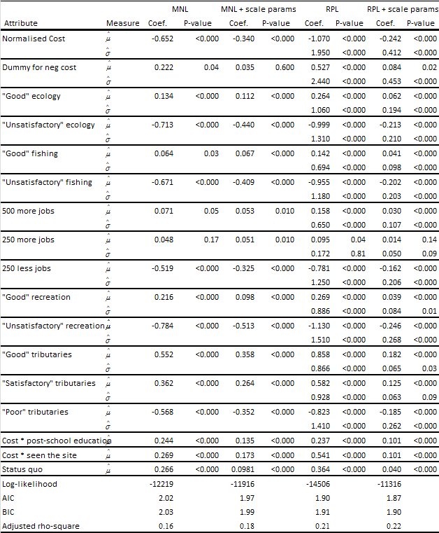

A large number of interaction terms were tested. The two terms that were consistently significant were the cost x post-school education interaction and cost x seen where post –school education is a dummy indicating whether an individual has completed a post school qualification while ‘seen’ is a dummy variable indicating the individual has personally seen the Hurunui River or its tributaries. Both of these interactions are positive, which means that people who have more education, or have seen the site, tend to be willing to pay more for environmental quality. Income and education are highly correlated so the education interaction effect is probably a combination of income effect and environmental awareness.

- Heterogeneous Tastes: Models 3 and 4

Models 3 and 4 are panel mixed logit models with random parameters for cost, jobs, and environmental attributes. The unconditional mean parameter estimates are very similar to those in the fixed parameter models. 500 Halton draws were used to estimate the random parameters. Uniform distributions were used because this carries a lower risk of misspecification than less flexible distributions (Hess and Axhausen 2005). The RPL models have improved model fit, with adjusted McFadden r-squared values 0.21 and 0.22 versus 0.16 and 0.18 for Models 1 and 2.

The negative cost dummy parameter is relatively larger in the RPL models. In Model 3, WTP is 197 percent higher when the overall cost is negative. In Model 4, it is 154 percent higher. Similarly to the MNL models, the inclusion of the scale parameters has the effect of reducing the relative magnitude of the negative cost and status quo parameters. There is a small decrease in variance of the asymmetry as well.

Most of the random parameters standard deviations are significant at the one percent per cent level. In Model 3, the standard deviation for ‘250 more jobs’ is not significantly different to zero. In Model 4, ‘250 more jobs’ and ‘satisfactory tributaries’ are significant at the 10 percent level only, while ‘good tributaries’ is significant at five percent. Almost all of the random parameter standard deviations are smaller in Model 4 than in Model 3. The exception is ‘250 more jobs’, but neither the means nor standard deviations were statistically significant for this parameter in either model. It appears that failing to control for scale variation in Model 3 magnified the estimated variance in individual preferences, as predicted by Louviere (2004).

- Willingness-to-Pay Results

Willingness-to-pay for an improvement in environmental quality, or willingness-to-avoid a decline in quality, is calculated by dividing the attribute coefficient by the cost coefficient. Due to asymmetry in our cost parameter, we report two sets of unconditional mean WTP/WTA values for each model in Table 7. The first column for each model is WTP/WTA under a situation where the household faces an overall increase in rates. The second column is WTP/WTA in a situation where household faces an overall decrease in rates. We also include the effect of cost x education and cost x seen interactions by using the population mean for education and, due to a lack of population data, the sample mean for the number of people who have seen the river.

Table 7: Mean Marginal WTP/WTA
under Cost Increase/Decrease Scenarios
 |  | Model 3  (random parameters) |  |  |  | Model 4  (including scale parameters) |  |  |  | Model 5  (excluding non-attenders to cost)
 |  | Cost  Increase |  | Cost Decrease |  | Cost  Increase |  | Cost Decrease |  | Cost  Increase |  | Cost Decrease
‘Good’ ecology | $74 |  | $290 |  | $88 |  | $219 |  | $44 |  | $67
‘Unsatisfactory’ ecology | -$282 |  | -$1,098 |  | -$302 |  | -$753 |  | -$166 |  | -$254
‘Good’ fishing | $40 |  | $156 |  | $58 |  | $143 |  | $25 |  | $39
‘Unsatisfactory’ fishing | -$269 |  | -$1,049 |  | -$287 |  | -$714 |  | -$160 |  | -$244
‘Good’ recreation | $76 |  | $296 |  | $55 |  | $136 |  | $33 |  | $50
‘Unsatisfactory’ recreation | -$319 |  | -$1,242 |  | -$349 |  | -$869 |  | -$206 |  | -$315
‘Good’ tribs | $242 |  | $943 |  | $258 |  | $643 |  | $147 |  | $225
‘Satisfactory’ tribs | $164 |  | $640 |  | $177 |  | $442 |  | $87 |  | $133
‘Poor’ tribs | -$232 |  | -$904 |  | -$262 |  | -$654 |  | -$147 |  | -$224
500 more jobs | $45 |  | $174 |  | $43 |  | $106 |  | $29 |  | $44
250 more jobs | $27 |  | $104 |  | $19 |  | $48 |  | $23 |  | $35
250 less jobs | -$220 |  | -$858 |  | -$230 |  | -$572 |  | -$135 |  | -$205

For brevity, we report the results for three models. Model 3 is the RPL model, Model 4 is RPL with scale parameters, and Model 5 is the same as Model 4 except a latent class is used to exclude people who did not attend to (or ignored) the cost attribute. Non-attendance to cost is a form of protest behaviour in which people select the scenario which gives their preferred environmental outcome regardless of the cost. No relative implicit price can be calculated for these individuals, and pooling the data will lead to upward biased welfare estimates. See Scarpa, Gilbride, Campbell and Hensher (2009) for an in-depth explanation of attribute non-attendance and the latent class method. We find that only 36 percent of individuals attend to the cost parameter under a latent class framework with different attribute coefficients constrained to zero. In Model 4, the difference between the two columns of WTP/WTA values is smaller than in Model 3 due to the smaller estimated asymmetry effect. In Model 5, all the values are smaller in magnitude, as expected.

4.5. Distribution of Willingness to Pay

Plots of individual specific estimates of willingness-to-pay provide a valuable illustration for policymakers of the range of preferences for different attributes. The procedure described above enables improved estimation as it takes into account negative and positive price, the scale factor and non-attendance. Unfortunately this procedure does not allow the creation of individual specific WTP estimates. The distribution of WTP and WTA plotted in Figures 2 and 3 were estimated using an alternative set of model assumptions in Nlogit that does not take account of non-attendance (see Appendix). Kernel density (on the y axis) indicates relative frequency for each WTP/WTA value.

Figure 2: Distribution of WTP for Improvements (RPL Model)
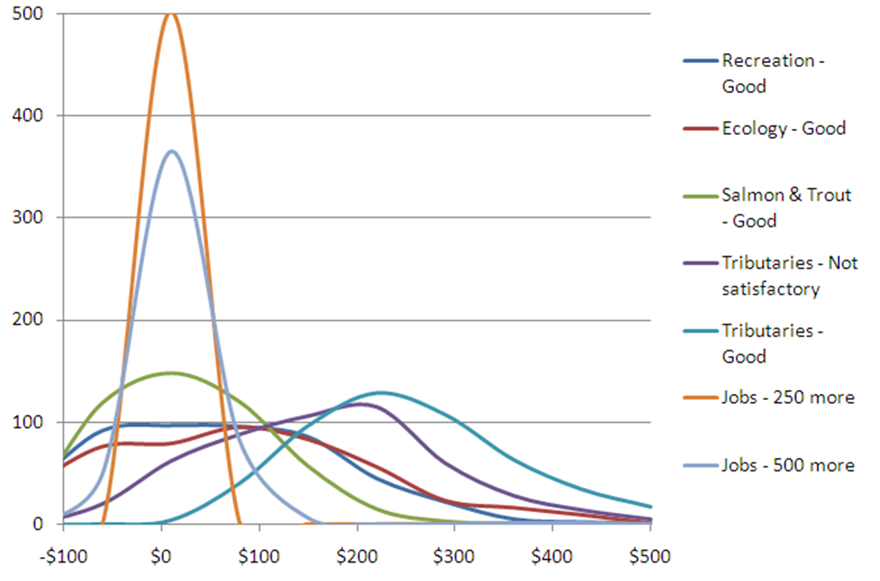

Figure 3: Distribution of WTA for Declines (RPL Model)
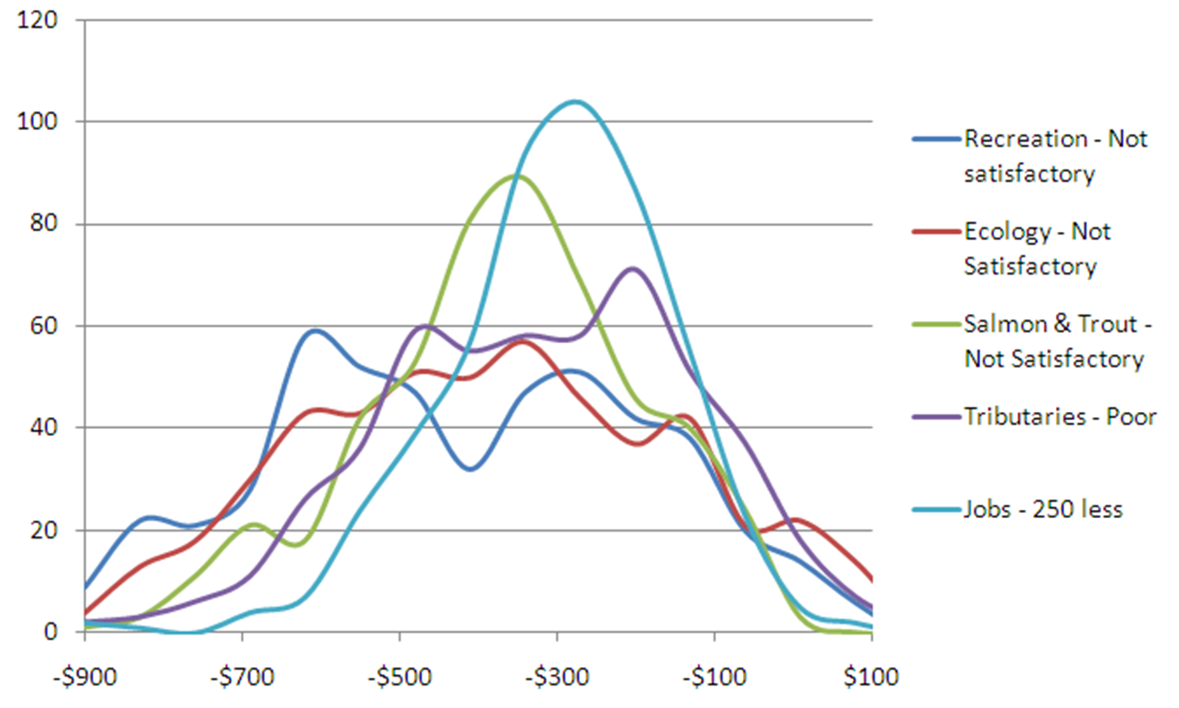

These results are not directly comparable with the estimates reported in Table 7 but provide a useful illustration of the spread of WTP/WTA values across the population. For example, preferences for more jobs (250 or 500 more) are tightly distributed within the range -$100 to +$100 (Figure 2). It can be seen that a sizeable minority are not concerned about the job attribute thereby leading to negative value estimates. Preferences for water quality, that is, of good quality for salmon, are more widely distributed ranging from negative values (not concerned) up to $300. The distribution of WTP for good water quality in tributaries suggests that most respondents have a positive WTP ranging from $0 to more than $500 per household per year.

Discussion and Conclusions

This study contributes to the literature in two ways. First, it contributes to our knowledge of the willingness-to-pay for improved water quality in New Zealand. We have provided quantitative information on the preferences of Canterbury Region residents that should assist decision-making about the development of the Hurunui catchment. We have also contributed by investigating methodological issues relating to scale variation and the ranking of alternatives in choice experiments. These aspects are reported in a separate paper (Marsh and Phillips 2012) that will be further developed with a view to subsequent publication.

We found that the property rights of Canterbury region residents had a major effect on the magnitude of our value estimates. Specifically, WTA greatly exceed WTP for a similar change in environmental quality. This finding is consistent with empirical results reported in the literature (Anderson, Vadnjal and Uhlin 2000, Hanemann 1991, Rowe, D'arge and Brookshire 1980, Willig 1976 and by Horowitz and McConnell 2002) who found that disparities between WTP and WTA tend to be higher for public goods than private goods.

If it is assumed that residents have a right to clean water that is not declining in quality, then willingness to accept compensation for deterioration, provides the appropriate estimate of value. Using Model 5 (excluding non-attenders to cost), residents would require compensation of $315 per household per year before they would accept a deterioration in water quality in the main river from ‘satisfactory for recreation’ to ‘unsatisfactory’. Likewise they would require compensation of $254 for a similar reduction in ecology or $244 for a decline in suitability for salmon and trout, see Table 8.

One of the research questions addressed by the survey was the importance of water quality in the main river (currently satisfactory) versus the lowland tributaries (currently not satisfactory). Would people, be willing to accept a decline in water quality in tributaries as long as water quality was maintained in the main river? Results from the choice experiment suggest that residents assign similar importance to these two attributes. They would, for example, require compensation of $224 to accept a decline in tributary water quality from not-satisfactory to poor. This estimate is only 29 percent less than the $315 that they would require to accept deterioration in the quality of the main river.

When water quality is currently satisfactory, and residents would like to see improvements, then willingness to pay provides the most appropriate measure. The following estimates are drawn from Model 5, for choices where residents faced an increase in cost. They would be willing to pay $33, on average, to improve water quality in the main river from satisfactory to good, $44 to improve ecology from satisfactory to good and $25 to improve suitability for trout and salmon from satisfactory to good. Given that water quality in tributaries is currently not satisfactory, results from the cost decrease (compensation) column are more relevant. Residents, for example, would be willing to pay $133 to increase water quality from not satisfactory to satisfactory.

The jobs attribute provides information on preferences for increases or decreases in the number of jobs in the region. It also captures some associated concerns regarding the level of economic activity and services in rural areas. Furthermore, it provides a useful reminder to respondents that the regional economy may be affected by intensification or deintensification of agricultural land in the Hurunui catchment with the impact being measured in terms of job losses or gains compared with a ‘business-as-usual’ scenario.

Table 8: Willingness to Pay or Accept Compensation
Attribute | Level |  | Marginal Mean
Suitability for swimming & recreation  Satisfactory to: | Not satisfactory | -$315
 | Good | $33
Ecological health  Satisfactory to: | Not satisfactory | -$254
 | Good | $44
Salmon and trout  Satisfactory to: | Not satisfactory | -$244
 | Good | $25
Tributary water quality  Not Satisfactory to: | Poor | -$224
 | Satisfactory | $87  ($133 for cost decrease)
 | Good | $147
Number of jobs in Canterbury | 250 fewer jobs | -$205
 | 250 more jobs | $23
 | 500 more jobs | $29

Notes: WTP/WTA estimates are based on results for a cost decrease (for example, compensation) for deterioration and a cost increase for improvements. All results are from Model 5 and so exclude non-attenders to cost.

We find that the characteristics and order of magnitude of preferences for job losses or gains is similar to those revealed for the environmental attributes. Respondents selecting alternatives with a positive cost would be willing to pay $23 for 250 more jobs in the region or $29 for 500 more jobs. As with the environmental attributes our estimates of WTA are considerable higher; respondents would require compensation of $205 before accepting an alternative that would results in 250 fewer jobs. It should be noted that these estimate for job losses should not be directly traded off against environmental attributes in a social cost benefit analysis. This avoids double counting of the employment effect, when the cost of mitigation policies already incorporates employment loss (Marsh 2012).

Findings from the choice experiment provide quantitative evidence that policymakers can consider at the same time as they consider the outcomes of the stakeholder deliberative process. This process arrived at ‘general acceptance’ of a future development strategy for the Hurunui catchment that would maintain water quality in the main river at 2005-2009 levels, while requiring that actions are undertaken to return water quality in the tributaries to ‘1990-1995 water quality’. Results from the choice experiment are broadly supportive of this approach. Canterbury region residents would require substantial compensation (mean $244-$315 per household per year) before they would accept a decline in water quality in the main river or in the tributaries. Willingness to pay for improvements in the main river is lower with a mean of $25-$33 per household per year.

References

Anderson, J., Vadnjal, D., and Uhlin, H. (2000) Moral dimensions of the WTA–WTP disparity: An experimental examination. Ecological Economics, 32, 53–162
Bierlaire, M. (2003) BIOGEME: a free package for the estimation of discrete choice models.
Boxall, P.C., Adamowicz, W.L., Swait, J., Williams, M. and Louviere, J. (1996). A comparison of stated preference methods for environmental valuation. Ecological Economics, 18(3) 243-253.
Brown, I., Norton, N., Wedderburn, L., Monaghan, R.M., Harris, S. and Hayward, S. (2011) Nutrient Management in Hurunui: A Case Study in Identifying Options and Opportunities: Environment Canterbury.
Caparros, A., Oviedo, J.L. and Campos, P. (2008) Would You Choose Your Preferred Option Comparing Choice and Recoded Ranking Experiments. American Journal of Agricultural Economics, 90(3) 843-843. doi: 10.1111/j.1467-8276.2008.01137.x
DeShazo, J.R. and Fermo, G. (2002) Designing Choice Sets for Stated Preference Methods: The Effects of Complexity on Choice Consistency. Journal of Environmental Economics and management, 44(1) 123-143. doi: 10.1006/jeem.2001.1199
Environment Canterbury (2010, 19 July) [Potential moratorium on the Hurunui River and its tributaries. Letter to the Minister for the Environment].
Ferrini, S. and Scarpa, R. (2007) Designs with a priori information for nonmarket valuation with choice experiments: A Monte Carlo study. Journal of Environmental Economics and Management, 53(3) 342-363.
Hanemann, W.M. (1991) Willingness to Pay and Willingness to Accept: How Much Can They Differ? American Economic Review, 81(3) 635-647.
Hausman, J.A. and Ruud, P.A. (1987) Specifying and testing econometric models for rank-ordered data. Journal of Econometrics, 34(1–2) 83-104. doi: 10.1016/0304-4076(87)90068-6
Hess, S. and Axhausen, K.W. (2005) Distributional assumptions in the representation of random taste heterogeneity.
Hess, S., Rose, J.M. and Hensher, D.A. (2008) Asymmetric preference formation in willingness to pay estimates in discrete choice models. Transportation Research Part E: Logistics and Transportation Review, 44(5) 847-863. doi: 10.1016/j.tre.2007.06.002
Horowitz, J.K. and McConnell, K.E. (2002) A Review of WTA/WTP Studies. Journal of Environmental Economics and Management, 44, 426-447.
Institute of Transport and Logistics Studies (2007) Ngene - A Software Capability to Design and Generate Choice Experiments: University of Sydney.
Kahneman, D., Knetsch, J.L. and Thaler, R.H. (1991) Anomalies: The endowment effect, loss aversion, and status quo bias. Journal of Economic Perspectives, 5(1) 193-206.
Lancsar, E. and Louviere, J. (2008) Estimating individual level discrete choice models and welfare measures using best-worst choice experiments and sequential best-worst MNL. University of Technology, Centre for the Study of Choice (Censoc) 08-004.
Land and Water Forum (2012) Third Report of the Land and Water Forum: Managing Water Quality and Allocating Water. Wellington, New Zealand.
Lanz, B., Provins, A., Bateman, I., Scarpa, R., Willis, K.G. and Ozdemiroglu, E. (2009) Investigating willingness to pay-willingness to accept asymmetry in choice experiments.
Louviere, J.J. (2004) Complex statistical choice models: Are the assumptions true, and if not, what are the consequences? Advancing the Methodology of Discrete Choice Experiments in Health Economics, Oxford University, September.
Louviere, J.J., Street, D., Burgess, L., Wasi, N., Islam, T. and Marley, A.A.J. (2008) Modeling the choices of individual decision-makers by combining efficient choice experiment designs with extra preference information. Journal of choice modelling, 1(1) 128-163.
Marsh, D. (2012) Water resources management in New Zealand: Jobs or algal blooms? Journal of Environmental Management, 109(30) 33-42.
Marsh, D., Mkwara, L. and Scarpa, R. (2011) Do Respondents’ Perceptions of the Status Quo Matter in Non-Market Valuation with Choice Experiments? An Application to New Zealand Freshwater Streams. Sustainability, 3(9) 1593-1615.
Marsh, D. and Phillips, Y. (2012) Difficult choices: What influences the error variance in a choice experiment. Paper presented at the New Zealand Agricultural and Resource Economics Society Conference, Nelson.
http://ageconsearch.umn.edu/bitstream/139651/2/Marsh%20Phillips%202012%20(1).pdf
Norton, N. and Kelly, D. (2010) The effects of scenarios on environmental values. Paper presented at the Hurunui catchment workshop 3. Environment Canterbury: Land use and water quality project.
Rowe, R.D., D'arge, R.C. and Brookshire, D.S. (1980) An experiment on the economic value of visibility. Journal of Environmental Economics and Management, 7, 1-19.
Scarpa, R., Gilbride, T.J., Campbell, D. and Hensher, D.A. (2009) Modelling attribute non-attendance in choice experiments for rural landscape valuation. European Review of Agricultural Economics, 36(2) 151-174. doi: 10.1093/erae/jbp012
Scarpa, R. and Rose, J.M. (2008) Design efficiency for non-market valuation with choice modelling: how to measure it, what to report and why*. Australian Journal of Agricultural and Resource Economics, 52(3), 253-282. doi: 10.1111/j.1467-8489.2007.00436.x
Tait, P. and Baskaran, R. (2011) Incorporating Local Water Quality in Welfare Measures of Agri-environmental Policy: A Choice Modelling Approach Employing GIS. [Conference paper]. Proceedings of EAAE 2011 Congress ‘Change and Uncertainty’, Zurich, Switzerland.
Wedderburn, L., Bewsell, D., Blackett, P., Brown, M., Kelly, S. and Mackay, M. (2011) Developing a preferred approach for managing the cumulative effects of land uses on freshwater quality. Report prepared for P21 environment programme and Environment Canterbury.
Willig, R. (1976) Consumer’s surplus without apology. American Economic Review, 66, 589-597.
Appendix

Table A1: Results: Mixed Logit Model used for Figures 2 and 3

Attribute | Outcome | Mean | Standard Deviation
Cost |  | - 0.003 *** | 0.003 ***
Suitability for Swimming | Not Satisfactory | -1.030 *** | 1.415 ***
And Recreation | Good | 0.209 *** | 0.826 ***
Satisfactory to:-
Ecological Health | Not Satisfactory | - 0.842 *** | 1.323 ***
Satisfactory to:- | Good | 0.221 *** | 0.901 ***
Salmon and Trout | Not Satisfactory | - 0.828 *** | 0.991 ***
Satisfactory to:- | Good | 0.150 *** | 0.592 ***
Tributary Water Quality | Poor | -0.741 *** | 1.132 ***
Not Satisfactory to:- | Satisfactory | 0.528 *** | 0.790 ***
 | Good | 0.742 *** | 0.680 ***
Number of Jobs in | 250 Fewer Jobs | -0.663 *** | 0.904 ***
Canterbury | 250 More Jobs | 0.081 * | 0.046
No change to:- | 500 Fewer Jobs | 0.125 *** | 0.293 *
Status quo |  | 0.386 ***

Referred to as ‘values’ in the stakeholder workshops and in Wedderburn et al. (2011).
Statistics New Zealand Household Labour Force Survey 2011

