UNIVERSITY OF WAIKATO

Hamilton New Zealand

Beyond ‘the Beamer, the boat and the bach’?
A Content Analysis-Based Case Study
of New Zealand Innovative Firms

Les Oxley, Shangqin Hong and Philip McCann

Department of Economics

Working Paper in Economics 12/13

September 2013

Corresponding Author  Shangqin Hong  Economics Department  University of Canterbury  Private Bag 4800  Christchurch  NEW ZEALAND, 8140  Email: hongshangqin@hotmail.com | Les Oxley  Economics Department  University of Waikato  Private Bag 3105  Hamilton  NEW ZEALAND, 3216  Email: loxley@waikato.ac.nz

Philip McCann
Faculty of Spatial Sciences
University of Groningen
PO Box 800 9700 AV Groningen
THE NETHERLANDS

Email: p.mccann@rug.nl

Abstract

In this paper we will use case studies to seek to understand the dynamic innovation processes at the level of the firm and to explain the apparent 'enigma' between New Zealand's recent innovation performance and economic growth. A text-mining tool, Leximancer, (version 4) was used to analyse the case results, based on content analysis. The case studies reveal that innovation in New Zealand firms can be best described as 'internalised', and the four key factors that affect innovation in New Zealand firms are ‘Product’, ‘Market’, ‘People’ and ‘Money’. New Zealand may be an ideal place for promoting local entrepreneurship, however, many market/technology opportunities cannot be realized in such a small and isolated economy, hence the poor economic performance.

Keywords

innovation
New Zealand
case study
content analysis

JEL Classification

O31, O33, O38

Introduction

Over recent years, the concept of innovation has taken a central role, worldwide, in discussions about economic growth, no more so than in New Zealand where, although ranked number one (out of 144 countries) in three important ‘growth fundamentals’ categories reported by the World Economic Forum, the country is the ‘middle of the pack’ (or worse) when it comes to economic growth, productivity and innovation.

The research presented here will focus on New Zealand. The first question might be ‘why study a small, distant, open economy when all the action must be elsewhere?’ However, New Zealand remains an enigma where, despite all/most of the ‘enabling infrastructures’, the country wallows in economic growth stagnation within a relative desert of innovative activity. The traditional notion of the frontiers Kiwi ‘no8 wire’ mentality for adaption due to isolation, seems to have been replaced by the desire for the ‘Beamer, the boat and the bach’. To understand whether this is true, and if so why, will add some crucial pieces into the jigsaw which is the study of innovation.

Despite numerous macro level discussions, innovation is fundamentally a micro level phenomenon, where firms engage in innovative activities because they are hoping to develop a new product or process that will allow them to increase profits and maintain or improve their market position over time.

In some highly successful innovation cases, significant innovations can afford a firm a dominant market position and long-term monopoly rents, but more typically innovation outcomes tend to relate to more modest, but nonetheless important, market gains. As a general principle, Baumol (2002) regards innovation as a ‘life-and-death matter for a firm’ in which the constant need of fighting for survival and the threat of competition encourage firms to innovate.
In practice, however, different firms conduct innovation differently: some conduct research and development (R&D) in house and actively pursue patenting; others co-operate with outside partners or acquire technology externally via licensing; other engage in less-formalised means of promoting innovation such as supporting good practices in design, marketing research and staff training, all of which have becoming increasingly popular.

Initially introduced in anthropology, the use of case studies first appeared around 1900 (Johansson 2003). In the business-related fields, case studies were used introduced into strategic management as late as the 1970s (Campbell 1975, Miles 1979). Recently, interest in this methodology has seen a revival in the approach. See, for example, Eisenhardt and Graebner (2007) and Siggelkow (2007). Suited to both qualitative and quantitative evidence, case study as a research strategy (Yin 1981) should not be confused with other types of evidence (for example, qualitative and quantitative data) and types of data collection methods (for example, phenomenology, ethnography and grounded theory). It is appropriate to answer ‘what’ and ‘how’ questions, ‘preferred in examining contemporary events, when the relevant behaviours cannot be manipulated’ (Yin 2003, p.7), and it studies complex phenomena in their context rather than independent of context (Pettigrew 1973). Compared to other research methods, the case study has often been criticised for its lack of methodological rigor where Miles (1979 p.600) stated that ‘qualitative research on organiations cannot be expected to transcend story-telling’ without renewed efforts at methodological inquiry. Yin (1981) agreed that improvements in methodology can still be made, but reaffirmed the case study as a systematic and valid research tool.

In this paper, we will use case studies drawn from New Zealand firms to seek to understand the dynamic innovation processes at the level of the firm in the main to try and explain away the ‘enigma’ that is New Zealand’s recent innovation and economic growth experience. The use of case studies in economics is somewhat unusual in the context of trying to understand innovation, in part, perhaps as a result of the growing availability of large-scale firm level innovation surveys which seem to offer the benefits of large-scale, consistently measured, unit record data. However, the formalized, confidential and often rigid structure of such surveys rarely provide opportunities for ‘open ended’ answers or 'additional comments', while the case study approach is typically designed to overcome just these issues. As a result, we might wish to view large-scale anonymous surveys and in-depth case studies of a small number of firms, as complements rather than substitutes, and this is the approach we propose to follow here.

The paper is organized as follows. Section 2 provides some background information on definitions and sources of innovation while Section 3 and 4 introduce the research methods used in the study including the use of a text-mining tool Leximancer (version 4) whose theoretical underpinnings are based on content analysis to extract complex information. Section 5 reports the case study results and the final Section discusses the findings and potential implications.

Background

Definitions of Innovation
In principle, innovation can be more readily identified than technological progress, still difficulties remain as to what exactly is innovation, and how can we capture it? The earliest definition of innovation was proposed by Schumpeter (1934 p.66), where he suggests that innovation is the:

‘introduction of new goods (…), new methods of production (…), the opening of new markets (…), the conquest of new sources of supply (…) and the carrying out of a new organisation of any industry’.

Following the traditional approach, Schumpeter divides the process of technical change into three parts: invention, innovation and imitation, and emphasises innovation as a ‘change in the form of the production function’. This is similar to Solow’s definition of technological change (Solow 1956), except that Schumpeter did not include capital in the production function. Ruttan was not convinced by Schumpeter’s theory, and tried to distinguish between invention, innovation and technological change as these terms have been become almost synonymous. He argued that there was no theoretical basis for the observed pattern of innovative behaviour suggested by Schumpeter, invention is a ‘subset of technical innovations which are patentable’ (1959 p.605). He also argued that we should use Usher’s concept of invention (1954) as a definition of innovation, which is ‘the process of new things emerging in science, technology and art’. Tinnesand (1973) was also interested in the interpretation of the meaning of the word ‘innovation’, where he collected a large number of definitions from 188 publications and classified the meaning of the word into six different categories. The findings were:

- The introduction of a new idea: 36 percent;
- A new idea: 16 percent;
- The introduction of an invention: 14 percent;
- An idea different from existing ideas: 14 percent;
- The introduction of an idea disrupting prevailing behaviour: 11 percent;
- An invention: 9 percent.

Although each category is slightly different, they are clearly related to the concept of new creations. ‘Creativity’ was generally recognised as an important precursor to innovation, until in the late 1960s the definition of innovation has subtly changed (Cumming 1998). A new idea cannot be defined as an innovation until its practicality has been demonstrated. As Badawy (1988) suggested, ‘creativity brings something new into being’ and innovation ‘brings something new into use’. With these ideas the distinction between invention and innovation becomes clearer; an invention is a discovery without any necessary practical use, and an innovation is an invention that provides economic value to other parties beyond the inventors.

During the late 1980s, the definition of innovation has become richer by including the concept of success. A typical example is used by Udwadia (1990), where he defined innovation as ‘the successful creation, development and introduction of new products, processes or services’. With the intention to construct a succinct definition of innovation that meets current thinking, Cumming (1998) described innovation as ‘the first successful application of a product and process’. Up to this point, most authors defined innovation from an ‘outsider point of view’. Gordon and McCann (2005) took the insider or the innovator’s standpoint, and argued that all identifiable innovations possess three common features: newness, improvement and the overcoming of uncertainty.

During the development of definitions of innovation, most concentrate on technological innovations. Nelson and Winter (1977 p.37) suggested using the term innovation ‘as a portmanteau to cover the wide range of variegated processes by which man’s technologies evolve over time’. Within technological innovation, a distinction is normally made between product and process innovation. Freeman (1982) made this distinction very clear in his definition of innovation, ‘first commercial application of a new process or product’, where process innovation involves adopting new technology in the actual production of new goods (or services) and product innovation involves incorporating new technology into new or existing goods (or services). Since 2005 the sole focus on technological innovation has changed as the notion of innovation has been extended in the third edition of the Oslo Manual (OECD 2005) to include non-technological innovation such as organisational and marketing innovation, which defined innovation as:

‘the implementation of a new or significantly improved product, or process, a new marketing method, or a new organisational method in business practices, workplace organisation or external relations’.

One of the main purposes of the case studies is to create a useful link between theory and practice. While defining innovation theoretically can be challenging, quantifying innovation in practice is even more difficult. The perspectives on innovation among entrepreneurs, academics and policy makers can be quite different, see for example, Massa and Testa’s (2008), study on Italian SMEs.

Sources of Innovation

In terms of sources of innovation, one basic approach explores issues based on the idea of ‘demand-pull’ theories, which suggests that innovation is driven by market forces, encouraged by an existing desire of the users. Schmookler (1966 p.184) regarded innovation as an economic activity pursued for profit, technical problems and unsatisfied consumer needs or wants, which offer opportunities for potential economic gain, that is, ‘demand induces the inventions that satisfy it’. If innovation is demand induced, the first step is for the need to be recognised, and as such market intelligence becomes valuable. In this case, the most efficient way to gather market information is by communicating with suppliers of raw materials/machinery and equipment (Rothwell 1992) and customers (the highest level of communication is carried out in terms of co-operation, which has been discussed before).

The communication with customers can take the form of personal visits (Rochford and Rudelius 1992), feedbacks via phone or post (Chiesa, Coughlan and Voss 1996), or quantitative market research (Khan and Manopichetwattana 1989a). In addition, the firm can obtain external information by networking with others (Souitaris 2002). Environmental scanning and sharing of market information can also be effective in detecting market opportunities (Kohli and Jaworski 1990, Slater and Narver 1995). Although networking and inter-firm linkages seem to be much more than a communication tool, they reduce the risks and uncertainty, which accompanies the innovation process, quoting Arndt and Sternberg (2000 p.481), ‘innovative activities or the business innovation process can be viewed as a network process, in which business interrelations and interactions with other partners play a significant part’. Once the needs are recognised, to obtain the greater expected profit the firm has greater incentive to innovate, and hence creates a set of strategies that promote innovation. A list of strategy-related variables which have potential impact on innovation have been identified in the literature (Cooper 1984).

First, the existence of an innovation budget and its consistency can be crucial factors for innovation (Rothwell 1992). Their existence shows others the intension to innovate and provides continuality and consistency which are essential. Secondly, firms tend to have higher innovation rates if there is a well defined and well-communicated business strategy with a long term horizon, including plans for new technology investment (Khan and Manopichetwattana 1989b, Koc and Ceylan 2007, Swan and Newell 1995). Thirdly, the literature indicates that top executives of innovative firms have different management attitudes. They believe that the company’s performance is driven by manageable practices and the uncontrollable environmental influences have limited impact, in other words, they have internal locus of control instead of external (Miller, Kets de Vries and Toulouse 1982). Innovative firms are less risk adverse (Khan and Manopichetwattana 1989a) and more optimistic about the business (Souitaris 2002). In addition, younger CEOs are more keen to innovate if they are actively involved in running of the business (Khan and Manopichetwattana 1989a).

Finally, organisational status and some operational procedures can also impact upon the innovation process. The debate on flexible production and the associated vertical disintegration of production recognises the importance of organisational status (Sternberg and Arndt 2001). Chon and Turin (1984) found that innovative firms are less formalised, where the argument goes that openness and flexibility are regarded as precondition for the initiation of new ideas (Shepard 1967). McGinnis and Ackelsberg (1983) present a similar idea using the notion of loose coupling of groups and flat hierarchy in the organisational structure. Cross-functional interdisciplinary teams can be more efficient on innovations (Hise, O'Neal, Parasuraman and McNeal 1990). Offering incentives to employees for new ideas generation can enhance innovative potential (Chiesa et al. 1996), even the ‘slack’ time of engineers and managers can improve the business innovative performance (Souitaris 2002).

The pure demand-pull theories have been criticised on three different levels (Dosi 1982). The first and perhaps the greatest concern relates to its underlying approach, which is undermined by the general theory of prices, which contends that prices are set by both supply and demand functions. The second difficulty arises in defining demand functions using utility functions given the feasibility of the utility concept. Thirdly, there are logical as well as practical difficulties in interpreting the innovative process through such an approach, for example, the demand-pull theory has limited power in explaining why an innovation occurs at a definite point in time given the range of potential needs is close to infinite. In addition, the complex process between the recognition of a consumer need and the final outcome of a new product is omitted. In conclusion, Dosi (1982 p.150) summarised three weaknesses in innovation theories which are based upon demand-pull:

‘first, a concept of passive and mechanical ‘reactiveness’ of technological changes vis-à-vis market condition; second, the incapability of defining the why and when of certain technological developments instead of others and of a certain timing instead of others; third, the neglect of changes over time in the inventive capability which do not bear any direct relationship with changing market conditions’.

Empirical evidence suggests that the source of innovation varies significantly across industries (von Hippel 1988), as a result, it leads us to the other basic approach in this literature, the so called ‘technology-push’ theories. This approach suggests that innovation is stimulated by the suppliers based on the presence of a technological opportunity. Rosenberg (1974 p.92) gave great credit to Schmookler’s analysis of the demand-pull theory, and recommended it should be ‘the starting point for all future attempts to deal with the economics of inventive activity and its relationship to economic growth’. However, the overwhelming emphasis on demand and the ignorance of the supply side was criticised as the whole story.

The demand-pull and technology-push hypothesis was tested by Scherer (1965). First, he ran a linear regression of patents granted on sales for all industries, and it explained 42.2 percent of the variation in patents. He then ran separate regressions for each of the 14 industries and 84.7 percent of the variation was explained in this case with an incremental gain of 42.5 percent. This suggests that inter-industry difference is at least as important as the inter-firm difference. Four broad classes were created based on the levels of the estimated regression coefficients: (1) electrical (2) a combined group of general chemicals, stone, clay and glass (3) the moderates, which consists of petroleum, rubber products, fabricated metal products, machinery and transportation equipment and (4) the unprogressives, which consists of food and tobacco, textiles and apparel, paper and allied products, miscellaneous products, miscellaneous chemicals, primary metals. Separate regressions of patents on sales for these four groups explained 83.6 percent of the variance in patenting, which indicates that the four group classification has counted for most significant inter-industry differences in patenting relative to sales.

A decade later, Evolutionary Economists introduced the notion of ‘technological trajectories’, that is, the patterns of normal problem solving activity on the grounds of technological paradigms (Dosi 1982), or cumulative and self-generating directions of technical development without repeated reference to a firm’s external environment (Souitaris, 2002). Pavitt (1984) popularized the concept, and based on his initial results many researchers presented their own variations (Archibugi, Cesaratto and Sirilli 1991). Pavitt’s three part taxonomy aims to explain the sectoral differences in three areas: sources of technology, users’ needs and means of appropriating. The three categories of firms he uses are supplier-dominated, production-intensive (large scale producer and specialised suppliers) and science-based. Although the firms within each class have technology-related similarities, they are not necessarily homogenous (Niosi 2000).
De Marchi, Napolitano and Taccini (1996) tested Pavitt’s model based on survey data for technological innovations in the Italian manufacturing industry during the 1981-1985 period. Both the realism of the predicted association between industrial sectors and patterns of technical change, and the predictive power of the model were examined. With one exception, the test results appear to be consistent with the model’s predictions. Since the model is a coherent set of predictions, even one unrealistic prediction should lead to rejection of the model as a whole. Souitaris (2002) attempted to assess whether firms in different Pavitt technological trajectories have significant differences in innovation determinants. The research proposition gained empirical support for Greece, where there was a difference in innovation determinants within the four classes of firms. For ‘supplier dominated’ firms, competitive environment, strength of marketing, acquisition of external information, inclusion of technology plans in the business strategy, attitude towards risk and internal co-ordination are the most important determinants of innovation. For ‘scale intensive’ firms, the ability to finance innovation projects and quality of personnel (education and experience) had the largest effect on innovation. For ‘specialised supplier’ firms, high growth rate, export, and promotion of new ideas are essential for high rates of innovation. Finally, technology-related variables, quality of personnel, growth rate of profits and panel discussion with customers affect the ‘science-based’ firms the most.

In summary, perhaps the view of Mowery and Rosenberg (1979, p.150), receives traction where they state:

‘both the underlying, evolving knowledge base of science and technology, as well as the structure of market demand, play central roles in innovation in an interactive fashion, and neglect of either is bound to lead to faulty conclusions and policies.’

The discussion above has introduced a range of possible ‘sources or drivers of innovation’; some emphasizing demand over supply; others emphasizing the role of in-house R&D, etc. Studies from a range of countries provide support for some, but not others, however the relative importance of market demands and technology will likely vary by sectors and countries of interest.

The unique demographic, economic conditions and geographic location makes New Zealand, an interesting case of the study of innovation. Although the country appears to have the classic facilitators for innovation and growth, the evidence does not bear this out. Therefore, it is likely that the drivers of innovation in New Zealand firms are different from those in other countries and in the next sections we seek to identify these differences, as a precursor to potential policy responses aimed at encouraging additional innovation at the firm level.

Research Methods

Initially introduced in anthropology, the use of case studies first appeared around 1900 (Johansson 2003). In the business related fields, case studies have been used in strategic management since at least the late 1970s (Campbell 1975, Miles 1979), but they remain relatively rare in pure economics. Recently, however, interest in this methodology has seen a revival in the approach (Eisenhardt and Graebner 2007, Siggelkow 2007). Suited to both qualitative and quantitative evidence, case study as a research strategy (Yin 1981) should not be confused with other types of evidence (for example, qualitative and quantitative data) and types of data collection methods (for example, phenomenology, ethnography and grounded theory). It is appropriate to answer ‘what’ and ‘how’ questions, ‘preferred in examining contemporary events, when the relevant behaviours cannot be manipulated’ (Yin 2003, p.7), and it studies complex phenomena in their context rather than independent of context (Pettigrew 1973). Compared to other research methods, case study has often been criticized for its lack of methodological rigor. Miles (1979 p.600) stated that ‘qualitative research on organizations cannot be expected to transcend story-telling’ without renewed efforts at methodological inquiry. Yin (1981) agreed that improvements in methodology can still be made, but reaffirmed case study as a systematic and valid research tool.

Modern case study methodologies are guided by two key approaches proposed by Stake (1995) and Yin (2003), where they use different terms to describe a variety of case studies. Based on the distinguishing characteristics of the case study, Yin’s multiple-case studies is particularly appropriate for understanding innovation at the firm level. Our principle research questions are listed below:

- What does innovation mean to New Zealand firms?
- What are the drivers and sources of innovation in New Zealand firms?
- What issues are currently faced by innovating firms in New Zealand?

Case Selection

Selection of cases is an important aspect of case study research. Establishing the unit of analysis, research boundaries and the sample selection criteria are critical for a rigorous case study design (Baxter and Jack 2008).

In the analysis that follows, and based on the research questions of interest, the unit of analysis is a firm that has developed or introduced at least one new or significantly improved goods and services; operational processes; organisational/managerial processes; marketing methods in the last three financial years.

The objective of the case selection is not to design a statistically representative sample, but to allow analytical generalisation, which is a process separate from statistical generalisation, and generalise from empirical observations to theory, rather than a population (Gibbert, Ruigrok and Wicki 2008). Such a sampling method is often referred to as ‘theoretical sampling’, where both ‘literal’ and ‘theoretical’ replications are necessary for analytical generalisation (Yin 2003). In our particular case, ‘literal’ replication requires the theoretical sample to include firms that face similar market dynamics to ensure similar results are observed with different cases, while ‘theoretical’ replication aims to identify contrasting results by including firms with different characteristics. Eisenhardt (1989) recommended a cross-case analysis involving four to 10 case studies to provide a good basis for analytical generalization and this approach is the one that we support and follow.

New Zealand depends heavily on international trade due to its geographical isolation and small population. Mabin (2011) justified the importance of the tradable sector by suggesting exporting firms are more productive on average and the sector helps to reduce the country’s external vulnerabilities. In fact, exports of goods and services account for nearly one third of real expenditure GDP (New Zealand Treasury 2010). Currently, there is no official definition of what defines the ‘tradable sector’, however the New Zealand Treasury measures the sector:

‘as the volume of output (i.e. real GDP) in primary and manufacturing industries (highly exposed to overseas trade) combined with the volume of service (as it is difficult to estimate what services are tradable)’, and ‘non-tradable output is estimated as a residual with total real GDP, and therefore includes government’ (Mabin 2011, p. 4).

As a rule of thumb, the tradable sector typically includes internationally competitive industries, and industries within the non-tradable sector that have a heavy domestic focus, which means that firms operating within the tradable sector face different market dynamics and risk factors compared to their counterparts in the non-tradable sector. To ensure the logic of literal replication, the research boundaries are defined as ‘all private firms that at the selection date were engaging in the production of goods and services in New Zealand’s tradable sector’.

In order to generate a level of variation within the sample, the firms were differentiated according to their size (employment), industry and location. Based on the number employed (both part-time and full time), four size groups were then selected. The smallest size group is 0-19 employees, where as at February 2012, 97 percent of enterprises in New Zealand employed fewer than 20 employees (Statistics New Zealand 2012). This size group reflects the importance of small and medium enterprises (SMEs) to the New Zealand economy and demonstrates how small these SMEs actually are. The two intermediate size groups are 20-49 and 50-99. Enterprises that fall into these categories are no longer small and their growth potential cannot be ignored. Enterprises with 100 or more employees accounted for less than one percent of total enterprises, but employed 48 percent of total employees. The 100+ threshold is necessary to acknowledge these firms’ economic contribution. The selection of industries was limited to the tradable sector, which strictly follows the boundaries of the study. When estimating output for the tradable sector, the New Zealand Treasury has included three broad groups of industries: agriculture, manufacturing and the export service sector. At least one company from each sector should be selected to ensure diversity.

Geographically, New Zealand comprises two main adjacent islands, the North and the South Island. As at June 2011, 24 percent of the population resides in the South Island and 76 percent in the North Island. The population is heavily concentrated in the northern half of the North Island, with nearly one third of the total population living in the Greater Auckland Region. Also, Auckland is the most popular business location, and has the largest employee count by broad region. It generates the greatest regional GDP in the country. Such economic significance makes Auckland the first targeted region of the study.

The Canterbury Region has been chosen as the other targeted area for a similar reason. In the South Island, Canterbury hosts more than half of the businesses, employs more workers than the rest of the Island, and is the largest GDP contributor. Nevertheless, selecting cases outside the target regions are also important, as they can act as a comparison and are used to identify any regional based advantages.

Data Collection

The case studies took the form of semi-structured face-to-face interviews. Based on the sample selection criteria proposed in the previous section, a list of suitable companies were selected from the NZMEA (New Zealand Manufacturers and Exporters Association) database. Invitation letters were sent to the Managing Director or Senior Manager of the company, a short questionnaire on firm characteristics (see Appendix 1) was also attached to ensure the company fits our selection criteria. The final list included four companies, which were selected to maximise expected variation.

As part of each company case study, a background analysis was compiled based on publicly available company information, which were used to construct customised interview guides. A list of interview questions were sent to the interviewee(s) one week prior to the session, and focused upon three areas of enquiry (see Appendix 2). First, we were interested to understand the market environment in which the company operates. Second, we investigated the underlying motivation for innovating by focusing on ‘business perspective of innovation’ and ‘innovation in practice’, more specifically, what are the sources and drivers of innovation and what factors are important for the innovation process? Lastly, our focus turned to ‘spatial factors’ that businesses may or may not be concerned about and whether there are any changes that can or should be made to encourage innovative activities. Very little structure was imposed on the interviews. By asking open-ended questions the informants were able to express their opinions using their own constructs. As interviews progressed, follow-up questions were asked to elicit greater detail or clarification, where these seemed to be relevant. The interviews were recorded digitally and each took around 60 minutes.

A total of four companies were selected for analysis, the respondent companies are identified as Company A to D for confidentiality purposes. The company profiles are listed in Table 1. As a part of the case selection process, firm characteristics such as employment size, sector and the location are predetermined to allow theoretical replication. Specifically, the companies studied each fell within different employment size groups, where the smallest company employs eight people and the largest 350. Two of the four companies are manufacturers in the North Island, and the software and primary processing companies are located in the South Island.

Table 1. Company Profiles
Company | A | B | C | D
Number of Employees | 8 | 40 | 90 | 350
Sector | Service - Software | Manufacturing | Manufacturing | Primary -Processing
Headquarter Location | South Island-Canterbury | North Island-Auckland | North Island | South Island
Number of Establishments | 2 | 5 | 7 | 3
Age | 10 | 11 | 30 | 70
Innovator | Yes | Yes | Yes | Yes
Export Intensity | 80% | 99% | 45% | 80%
Market Structure | Monopolistic competition | Monopolistic competition | Oligopoly | Oligopoly

Despite these differences there are similarities between these companies, such that they all have more than one physical site, have been in operation since 2002, have carried out at least one type of innovation during the last three financial years, and a large percentage of sales revenue comes from exports. In terms of market structure, Company A and B are working within monopolistic competition markets, where there are many competitors and low barriers to entry, they are price takers and sell differentiated products. Company C and D are oligopolies, who are price makers facing limited competition due to large barriers to entry.

4. Data Analysis

Traditionally, the first step when analysing qualitative data involves the development of an elaborate coding scheme, followed by extensive coding efforts. Many researchers have deemed the process messy, burdensome and unrewarding, others found themselves overwhelmed by the amount of information and confused by conflicting interpretations (Miles, 1979; Vaivio, 2008). With the advancement in computer technology, however, a growing number of researchers are opting to use Computer-Aided Qualitative Data Analysis Software (CAQDAS) such as NVivo, NUD*IST, and ATLAS.ti (Chua and Mahama 2007, Rogge, Schneider and Hoffmann 2011, Whiting 2008). Crofts and Bisman state that utilisation of CAQDAS will not only reduce the enormity of data, but can also ‘enhance systematisation, logic, transparency, speed, and rigour in the research and analysis process’ (2010 p183).

To analyse our case study results, an Australian-developed text-mining tool, Leximancer, (version 4) was used. Its theoretical underpinnings are based on content analysis. Weber (1990) who provides a concise introduction to the methodology and the various techniques used. The software was evaluated by Smith and Humphreys using a set of evaluation criteria taken from content analysis, namely stability, reproducibility and correlative validity, and they concluded that ‘there is an abundance of rich and complex information that can be extracted by means such as Leximancer’ (2006 p.277).

After each interview, the oral recording was transcribed verbatim and the accuracy of the transcription was verified against the original recording and the hand-written interview notes taken by researchers during the interview. Each transcription was kept in a separate Word document for each reference, and these files were uploaded into the software. In order to focus on the responses of the interviewee, the questions asked by the interviewers were excluded from the analysis.

To analyse the data, Leximancer converts the raw documents into a more useful format by applying the appropriate tags such as, dialog tags for each speaker and file tags for an individual file, punctuation and stop words such as ‘and’ and ‘of’ are removed. A ranked list of terms (the so-called concept seeds) is automatically generated using word frequency, position and co-occurrence usage. The merging of word variants, such as singular and plurals of the same concept were allowed and additional modifications made to the auto concept list are shown in Appendix 3. Starting with these concept seeds, the thesaurus learning process intelligently develops a thesaurus of terms associated with each seed, thereafter higher level ‘themes’ are identified, which are clusters of concepts.

The concept frequency and co-occurrence are used to compile a co-occurrence matrix and from the statistical algorithm, two-dimensional concept maps were generated to show the relationships between concepts and themes.

Results

The semi-automatic content analysis tool is capable of analysing a document or collection of documents. The four cases were analysed individually and then collectively to allow both within-case and across-case comparisons. The corresponding concept maps are presented as Figure 1 to Figure 5. Here are a few hints for reading a concept map.

- The concepts are shown as black text labels, the larger grey dot point behind the label indicates more frequent use of the concept across the text.

- The themes are heat-mapped according to the colour wheel, which means the ‘hottest’ or most important themes appears in red, and the next hottest in orange, and so on.

- The size of the theme shows the concept groupings, the default rate of 33 percent is used. All the themes will disappear from the map if the theme size is set to zero percent.

- The name of the theme is taken from the name of the largest concept within the theme circle, which is indicated using an underscore.

- The grey line joining the concepts shows the most-likely connection between concepts. It should not be used to identify causal relationships.
Figure 1. Concept Map: Case 1
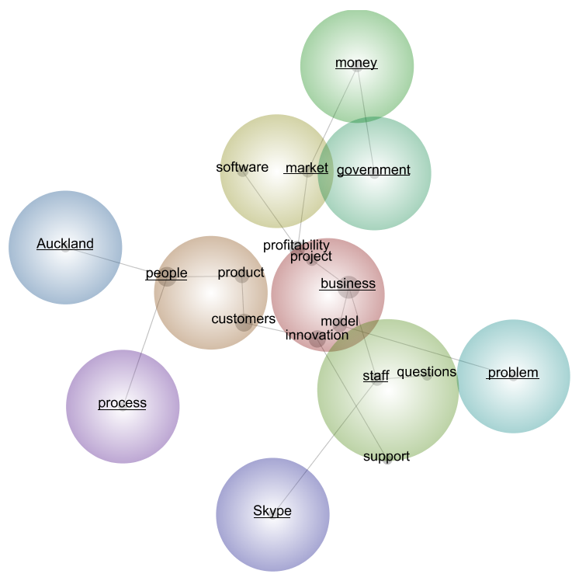

Figure 2 Concept Map: Case 2
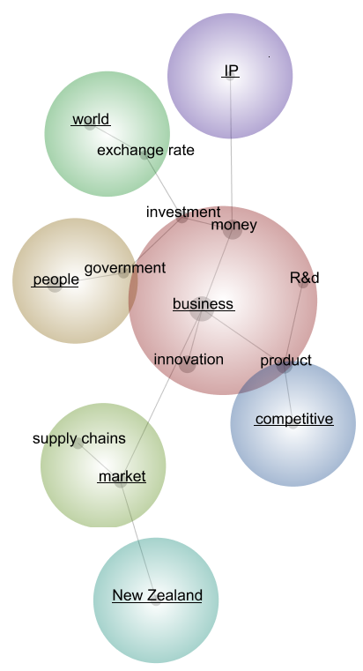

Figure 3 Concept Map: Case 3
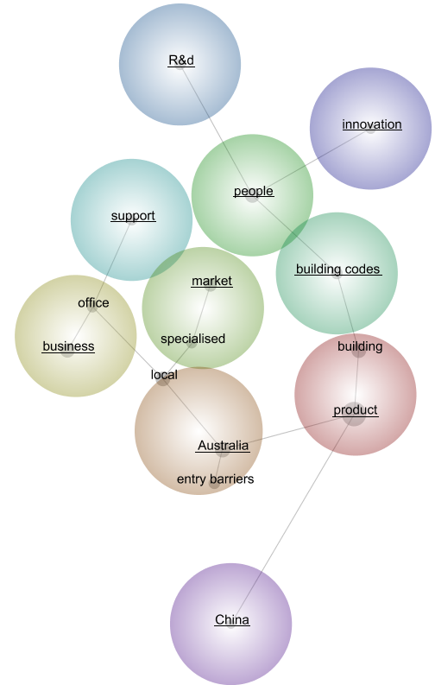

Figure 4 Concept Map: Case 4
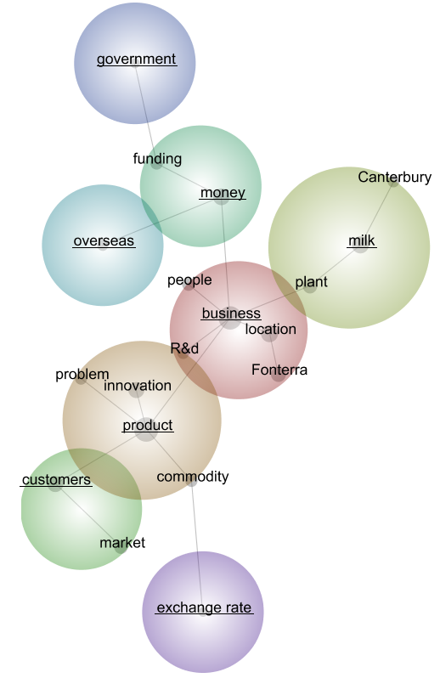

Figure 5 Concept Map: All Cases
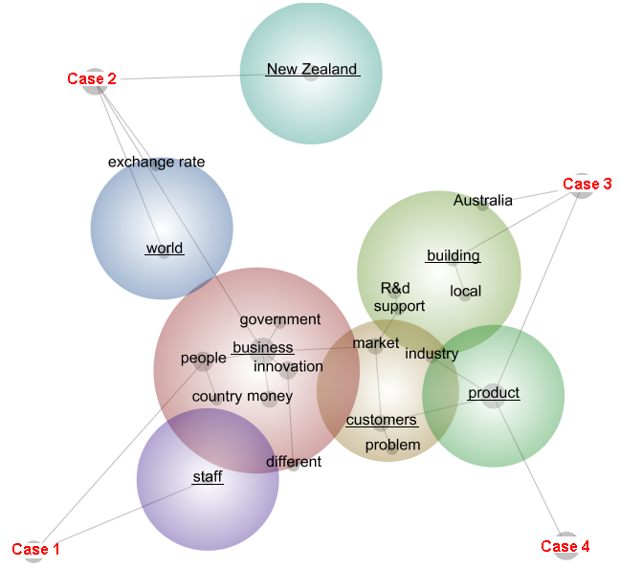

Dominant Themes

During the analysis, several themes were identified. The top five themes and their connectivity are listed in Table 2 below, where connectivity is the summed co-occurrence counts of each concept within the theme, with all available concepts. It provides an estimate of the coverage of a theme across the data.

For individual case results, the theme ‘business’ has been identified in all four cases by Leximancer, and the highest connectivity (100 percent) was achieved in every case except in Case 3. This term is used by interviewees to denote themselves, other similar organisation or trade. The next popular themes were ‘people’ and ‘market’ found in three of the four cases, followed by ‘product’ and ‘money’, which were found in two of the cases. Interpret these themes literally, and consider them as matters that our interviewees are concerned about. The variation in themes also indicates the structural difference between the concept maps, in particular the structure of the concept maps are very similar for Case 1, 2 and 4, such that the top theme ‘business’ were surrounded by other lower ranked themes.

When analysing the cases collectively, the case tags have been included in the concept map, the connections between themes and cases are shown using the grey lines. ‘Business’ remained the top theme, followed by themes such as ‘customers’, ‘building’, ‘product’ etc. Based on the distribution of themes, Case 1 and 2 are more closely related, while there are more similarities between Case 3 and 4.

Next, the results of the interpretive analysis will be presented to reflect each research question proposed in Section 3. Please refer to the concept maps to allow for a better understanding of the cases, both individually and collectively. Interview participants will be identified by the codes corresponding to their respective companies, for example, the interviewee from Company A will be referred to as Informant A.

Table 2. Top Five Themes
Case | Top 5 Themes | Connectivity | Case | Top 5 Themes | Connectivity
1 | business | 100% | All | business | 100%
 | people | 67% |  | customers | 37%
 | market | 17% |  | building | 31%
 | staff | 17% |  | product | 31%
 | money | 9% |  | New Zealand | 14%
2 | business | 100%
 | people | 22%
 | market | 18%
 | world | 12%
 | New Zealand | 6%
3 | product | 100%
 | Australia | 81%
 | business | 44%
 | market | 39%
 | people | 31%
4 | business | 100%
 | product | 81%
 | milk | 47%
 | customers | 33%
 | money | 32%

Business Perception of Innovation

One of the main purposes of the case studies was to create a useful link between theory and practice. While defining innovation theoretically can be challenging, quantifying innovation in practice is even more difficult. The perspectives on innovation among entrepreneurs, academics and policy makers can be quite different, see for example, Massa and Testa’s, (2008) study on Italian SMEs. During the interview, the interviewees were asked to define innovation, so that their meaning of innovation could be revealed.

Unlike academics and policy makers, businesses tend to define innovation based on their own experiences. Although innovation was not a foreign concept for our interviewees, the perceptions of innovation were slightly different between interviewed firms. Note all companies had separate R&D departments except Company A.

Informant A understands innovation as something new and fresh, and prefers to use the word ‘solution’ as their business model is based on problem solving. Aiming to create a competitive advantage across the entire supply chain, Informant B extends the definition of innovation from product development to other parts of the business such as procurement, manufacturing and marketing. Concentrating on product innovation, Informant C describes innovation as ‘supplying products that are perhaps a little smarter than those offered by the opposition and that enables the customers’ needs to be met better than they had been previously’. Lastly, Informant D regards innovation as ‘doing something completely new’, but more importantly it is about finding ‘a better, more efficient or cost effective way to do things’.

Despite the definitional differences, all four companies see innovation as an important part of their ‘day-to-day’ operations, and a successful innovation must deliver higher margins. As suggested by Informant D ‘if [the new product] doesn’t return significantly more, it’s usually around the 15 to 20 percent mark, than an equivalent commodity product, then we don’t do it, and we won’t go near it’.

The non-technological innovations (that is, managerial process and marketing innovations) are often carried out to complement the introduction of new products and processes, however these practices are rarely identified by interviewees as a type of innovation with the exception being Informant B. Government’s preference toward technological innovation has also contributed to the apparent neglect of non-technological innovation.

Innovation Drivers and Sources

Companies at different stage of their life cycle innovate to achieve different business goals. Aiming for a healthy level of profitability, Company A innovates to keep up with the current technologies and the increasing competition. Taking a more proactive approach, Company B innovates to lead the market and gain competitiveness. Compared with the younger/smaller firms, maintaining and increasing market share are the main priorities for Company C and D, where cost savings and higher profitability can also prompt innovation.

As with many things in business, innovation is easier said than done. Based on our case study results, there is no evidence to suggest that larger firms are more innovative than smaller ones, nonetheless smaller firms seem to follow a different model of innovation that revolves around people, specially entrepreneurs. In Informant A’s words, ‘the question about what drives innovation, should be who drives innovation’. The same view was shared by Informant B, who asserts that innovation ‘starts off with a visionary leader who identifies the market opportunity and then motivates a team of people to go and attack that market’. In comparison, innovations in large firms are more systematic and less dictated, the role of entrepreneurs is replaced by high level business plans and strategies, supported by other key skills within the organisation.

Regarding the source of innovation, evidence was found to support both demand-pull and supply-push theories (see Section 2.2 for more detail). The more visionary Company B, was the only interviewed company that adopted the ‘lead the market approach’ and actively developing supply-pushed innovation. As described by Informant B, ‘if you want to follow the market you ask a customer, if you want to lead the market you’ve got to predict where the market’s going to go’. In contrast, other companies have a heavy focus on the demand side, and proportionally smaller effort on the supply side. Informant A reports: ‘70 to 80 percent of [product] functionality is directly driven by customer feedback, and the rest would be driven by technical feedback’. Informant C says that ‘a lot of [innovation] is driven by listening carefully or observing problems being experienced by the customer’, and ‘the actual project initiation would, very rarely come from R&D’. Similarly, Informant D states ‘everything…in terms of innovation, in terms of products, all comes from customers’.

Given customers are the leading sources of new ideas for innovation, other parties within the innovation system also play a role in providing innovative ideas. Both Company B and C have close relationships with their suppliers, as it is impossible to ‘build a new product without knowing what components are available in the market’. ‘Watching the literature pretty carefully… and attend[ing] a number of trade shows’, Company C keeps a close watch on ‘where other companies are heading with their products, not necessarily with a view to copying but more, to see what’s interesting and maybe [there is] something that can be done’. Informant D calls themselves a fast follower, as they ‘haven’t got the biggest R&D department…in the country or in the world, …so [they] let the big player come up with the new products and work out how they have been done and very quickly implement a very similar or better product’. Cooperation with higher education and research institutes are more common in some sectors due to the available government incentives and the available resource. ‘[Universities] have a lot of equipment that we need every now and then, and we can’t justify getting them ourselves, so we work with them’ says Informant D. In other sectors, companies don’t see the need for cooperation as ‘we sort of know what we’re doing and we’re ahead of the university’.

Common Challenges

Innovation at the firm level tends to be integrated into businesses’ daily operations. Starting with a simple idea, the operationalisation of innovation requires the necessary funds and skills, and once in product form commercialisation will take the innovation to market where hopefully the successful sales records will allow the firm to continue to innovate. During the case study interviews, a number of common challenges were identified by our interviewees, which were skill shortages, funding issues and the overall environment.

Skill Shortages

People are at the heart of the business and the skills they bring are crucial throughout the entire innovation process. As at March 2012, New Zealand’s unemployment rate was 6.7 percent, yet skill shortages were still reported by the interviewed companies. In particular, the larger companies believe there is a shortage of employees with technical skills. Technical personnel are regarded by many as ‘the brain of the business’, responsible for transforming an idea into an innovative product. A shortage of such key skills can significantly reduce a firm’s ability to innovate. Informant D describes finding skilled and experienced staff as like ‘find(ing) a needle in a haystack’, ‘we’re looking overseas as well, then you will run into visa issues and payment issues, what we can offer in New Zealand is a salary in New Zealand dollars, which is often half the value they can get overseas’.

For smaller firms, their main problem is about establishing markets, and turning innovation into profits, and they perceive that there is a shortage of sales skills. Informant A criticises New Zealand businesses’ commercialisation skills and refuses to hire university graduates on the sales role, as an ideal candidate will need to have ‘some sort of real world business background and not educational business background’. Informant B also pointed out the importance of commercialisation and found it difficult to attract the ‘tier 1 people’ to ‘get products from New Zealand into the market and sold’.

Funding Issues

Innovation is a tricky business, it is both time consuming and financially costly. There are few ways to fund an innovation. Risk averse owners will typically run the project using cash flows or retained earnings. Informant A depicts its business strategy as ‘bootstrapping’, such that the company will ‘only spend what [is available] and only scale according to what can be handle’. Company B undertook a ‘ground up’ development in 2008 and since then they spent every cent that they made on R&D. Similarly, Company C is ‘very wary about debt, …[and] reluctant to borrow to fund new projects’. The self-funding method brings certainty to the project, though the growth of the company is limited at ‘a certain rate based on current turnover and profitability’.

Companies can overcome this disadvantage by getting access to other funding sources, and two of interviewed companies have funded innovation using government grants. ‘We’re getting a lot of [government] support at the moment, …everyone [in our industry] is using as much funding as they can. Everyone finds it extremely good’ says Informant D. Since most government grants are project based contestable funds, it means there is no guaranteed approval, and only a handful of companies can benefit. Even then successful companies will need to adjust their RandD programme/business plan to suit. ‘A gap between…the $200,000, $300,000 funding projects’ was identified by Informant D. Company C was forced to use a recommended outside consultant, which turned out to be ‘more of a hindrance than a help’. He prefers the non-discretionary schemes such as the R&D tax credit, and considers the application process as non-transparent, and ‘the Government is playing games by trying to pick winners’. Informant A refused to apply for government assistance as the application process ‘was taking more time than [the company] was saving money’.

Overall, innovating firms in New Zealand have limited ability to access capital for innovation. While some firms were disadvantaged by the under-developed capital markets, the immature angel/venture capital markets and the small private equity market, others were avoiding the more risky funding sources by choice.

Business Environment

The business environment is a set of conditions that the firm operates within, mostly uncontrollable in nature which directly and indirectly affect the functioning of the businesses as well as their innovation capability. Many of these environmental factors are embedded within the area/region that the business operates in.

As part of sample selection process, companies were selected on the basis of the location of their headquarter locations. While the initial decisions on business location were either intuitive or happenstance, as the business grows over time, expanding/shifting operation to other parts of the country and overseas became a strategic decision. All regions have their pros and cons, but available infrastructure and skill availabilities were some of the main issues concerning businesses.

Informant A says: ‘[the sales and support team] moved out of Christchurch because Christchurch [broadband] infrastructure is failing us…the power cuts, distractions, emotions [because of the earthquake] are just distractions you don’t need’. Informant D suggests that ‘having a deep water port that [the company could export directly from] would save an enormous amount of money’.

Informant C worries about their ability to attract skills and the limited skill pool, ‘we’ve done ourselves no favours being located in Wellington, probably Christchurch or Auckland would be better, because they’ve both got engineering school. [When advertised] you don’t get 50 applicants, you get maybe two or three and if you’re lucky one of those people will be very good’.

Since our interviewed companies are actively exporting, this means that their business performance is influenced by other international markets. The biggest problem currently facing Company A is cancellations from their US customers, and a lot of it is due to the recent global economic conditions. Focusing on building a robust business model, Informant A believes their business ‘will be able to weather the economic storm’. Likewise, the number one concern for Company C is the global financial crisis as their business is ‘dependent on the fortunes of the building industry…and building work stops during a recession’. Informant C ‘noticed that Australia and New Zealand cycles tended not to be in sync’, taking a more active approach, the company moved into the Australian market to ‘provide a slightly better continuity in terms of manufacturing side, … [and] a form of insulation’.
Also confronting the challenging global economic conditions, the main concern expressed by Informants B and D was the high exchange rate risk. Informant B sees the exchange rate as the biggest single determinant of business success, the volatile exchange rate means ‘one minute [the business is] making 30, 50 [percent] margin, and the next minute [it’s] shipping money with every product [it] sells’. Being in the primary industry, Informant D reckons ‘[the exchange rate] is more of an influence…than commodity prices’. In fact, they [can do all the cost savings [they] want in the plant, make all the products that [they] want, but when that dollar goes up … all hell breaks loose’. As the biggest company in our sample, Company D is the only company that has a hedging policy, ‘we buy foreign exchange a long way ahead to try and mitigate that risk, sometimes we win, sometimes we lose but at least we know what our rate is going to be’ says informant D.

Discussion and Some Possible Implications

Overall, a number of interesting findings were revealed from the case studies. In particular, the study approach identified four key factors that affect innovation in New Zealand firms; ‘Product’, ‘Market’, ‘People’ and ‘Money’.

- Product. As an important part of daily operation, New Zealand businesses are highly aware of the importance of innovation, although most businesses have concentrated a majority of their innovation efforts on improvements to existing products or new product developments. Other types of innovation also exist in firms, but mainly as a complement to product innovations.

- Market. Most firm-level innovations in New Zealand are market oriented, or in other words, demand driven. Innovation is carried out to fulfill customer needs, technology providers such as higher education and research institutes have limited participation during the innovation process, as there often is a mismatch between market opportunities and the technology available.

- People. People are the key to any successful business and the skills they bring are crucial throughout the entire innovation process. New Zealanders are well known for their innovative mentality, however competing within a highly mobile labour market, the lack of key technical and commercialisation skills has prevented our businesses from reaching their full innovative potential.

- Money. Like most business ventures, innovation requires a significant amount of investment. Sufficient levels of funding are the prerequisite for any successful innovation. Compared with other countries, businesses in New Zealand tend to be small in size and risk adverse. The limited cash flow and capital options mean that many businesses are pursuing incremental innovations with lower investment requirements and quicker returns. However, these more affordable innovations have limited economic benefits, and innovations with high growth impact are mostly sold to overseas companies.

In sum, innovation in New Zealand firms can be best described as ‘internalised’. In a textbook sense, New Zealand is institutionally almost ideal for promoting local entrepreneurship and the importance of innovation is well recognised by firms. However, in a small and isolated economy, market/technology opportunities can only be realised if there are necessary skills and funds available and likewise a local market to trial the innovations, which means businesses are most likely to pursue incremental innovations with lower investment requirements and faster returns. While most New Zealand businesses are continuous innovators, the more affordable innovations have limited economic benefits, and innovations with high growth impact are generally sold to overseas companies. As a result, New Zealand has become an innovative country with a relatively poor economic performance. For the exact same reasons, businesses tend to source their innovative ideas from customers or suppliers, while higher education and research institutes play little or no role which is particularly true for SMEs with non-agriculture focus.

As a long time member of the OECD, New Zealand seems obsessed with comparing itself with other developing countries based on various indicators; following international guidelines and world best practices, but seem to have forgotten how different New Zealand is compared to the rest of the world, which means that adopting off-the-shelf policies may not benefit New Zealand.

Disadvantaged by the small size and isolated geographical position, New Zealand’s textbook-perfect macroeconomic and institutional framework is making local firms vulnerable in the international trade system. Policy intervention seems required to maximise the country’s innovation potential. Until then, the ‘beamer, the boat and the bach’ may be as much as the typical firm owner in New Zealand aspires to where stepping-up beyond this leads to ‘too much risk’; ‘too much external control’ (especially of debt which is often avoided) and ‘too much stress’ – what they have been working hard to eliminate in their life.

Appendix 1

Pre-Interview Questionnaire

Name(s):______________ Company:___________________________

Email:______________________________ Ph:___________________

Physical Address: _______________________________________________ _______________________________________________________________

- How many staff work for your company including both part-time and full-time employees? __________________

- Does your business export? □ Yes / □ No

If yes, approximately what percentage of sales comes from exports (i.e. 30%)? _____

- How long has your business been in operation (to the nearest year)? _____

- How many establishments (sites/physical locations) does your company have?

□ One □  More than one, how many? ________

- In the last three financial years, did your business develop or introduce any new or significantly improved goods and services; operational processes; organisational/ managerial processes; marketing methods? □ Yes / □ No

Appendix 2

Case Study Questions

Firm Characteristics
1. Please describe the competition your business faces?
2. What is the current key strategy or main focus of your firm?
3. What are the problems your firm is currently facing?
4. Do you consider your firm to be a leader of your sector of business?

Innovation-Related Questions
5. What does the term innovation mean to you and your business? How would you define innovation?
6. Did your business introduce any new products (goods or service), new processes or new marketing or organisational methods in the past year? If yes which kind, how many and what motivated the innovation(s)?
7. How does your business innovate? Is innovation a part of day to day operation or are specific activities and resources devoted to the process (e.g. R&D, IP protection, market research and etc.)?
8. Why does your business innovate? Do you think innovation increases your business’ productivity and profitability?
9. What’s do you think are the key drivers of successful innovation outcomes? (Skills, Capital, Networks or opportunity)? What role do customers, suppliers and other firms play during the process?
10. Does your firm collaborate with other businesses or academic establishments as part of the innovation process?
11. Do you think New Zealand firms are generally innovative when compared with overseas firms?
12. What role do you think government and government agencies should have in the innovation process/system? Have you received any funding to support innovation in your firm through government agencies?

Spatially-Related Questions
13. Why did your business locate at its current location? How was the initial decision made?
14. Is your business happy with its current location? Are you planning to move location in the near future? If yes, why?
15. What kind of relationship does your business have with your main suppliers and customers and where are they located?
16. Does location play a role in the innovation process in your firm? e.g. proximity to universities; customers; suppliers; similar firms, etc?
17. Do you look overseas for examples of successful innovations (new products; processes, etc) if so where?

Appendix 3

Modifications Made to Auto Concepts Generated by Leximancer
Modification | Case 1 | Case 2 | Case 3 | Case 4 | All cases
Automatically generated concepts manually removed | couple, day, doing, million, saying, sell, talking, things, time, top, trying, understand, use, whole, work | cos, cost, create, doing, level, look, million, real, sell, shift, stuff, things, time, trying, whole, work | better, course, doing, example, flat, means, sense, sorts, terms, things, time, work | better, cos, different, difficult, doing, guess, look, making, moment, pay, things, time, whole, work, year | better, coming, cos, day, doing, example, look, pay, probably, real, saying, sell, talking, terms, things, time, trying, whole, work, year
Concepts merged | customers/users; people/ person | business/company; product/hardware; money/dollars | business/company; Australia/ Australian; product/ product names* | business/company; place names* | business/company; product/ product names*
Compound concept created | Nil | supply chain, exchange rate | entry barriers, building codes | exchange rate | exchange rate
* Concept names omitted for privacy reasons

References

Archibugi, D., Cesaratto, S., and Sirilli, G. (1991). Sources of innovative activities and industrial organisation in Italy Research Policy, 20(4), 299-313.
Arndt, O., and Sternberg, R. (2000). Do manufacturing firms profit from intraregional innovation linkages? An empirical based answer European Planning Studies, 8(4), 465-486.
Badawy, M. K. (1988). How to prevent creativity mismanagement. IEEE Engineering Management Review, 16(2), 63.
Baumol, W. J. (2002). The free-market innovation machine: Analyzing the growth miracle of capitalism. N. J.: Princeton University Press.
Baxter, P., and Jack, S. (2008). Qualitative case study methodology: Study design and implementation for novice researchers. The Qualitative Report, 13(4), 544-559.
Campbell, D. T. (1975). Degrees of freedom and the case study. Comparative Political Studies, 8, 178-193.
Chiesa, V., Coughlan, P., and Voss, C. A. (1996). Development of a technical innovation audit. Journal of Product Innovation Management 13(2), 105-136.
Chon, S. F., and Turin, R. M. (1984). Organisational structure, decision making procedures and the adoption of innovations. IEEE Transactions on Engineering Management, 31, 154-161.
Chua, W. F., and Mahama, H. (2007). The effect of network ties on accounting controls in a supply alliance: field study evidence. Contemporary Accounting Research, 24(1), 47-92.
Cooper, R. G. (1984). The strategy-performance link in product innovation. RandD Management 14(4), 247-259.
Crofts, K., and Bisman, J. (2010). Interrogating accountability- An illustration of the use of Leximancer Software for qualitative data analysis. Qualitative Research in Accounting and Management, 7(2), 180-207.
Cumming, B. S. (1998). Innovation overview and future challenges. European Journal of Innovation Management, 1(1), 21.
De Marchi, M., Napolitano, G., and Taccini, P. (1996). Testing a model of technological trajectories. Research Policy, 25, 13-32.
Dosi, G. (1982). Technological paradigms and technological trajectories. Research Policy, 11(3), 147-162.
Eisenhardt, K. M. (1989). Building theories from case study research. Academy of Management Journal, 14(4), 532-550.
Eisenhardt, K. M., and Graebner, M. E. (2007). Theory building from cases: opportunities and challenges. Academy of Management Journal, 50(1), 25-32.
Freeman, C., Clark, J., and Soete, L. (1982). Unemployment and technical innovation. London: Frances Printer.
Gibbert, M., Ruigrok, W., and Wicki, B. (2008). What passes as a rigorous case study? . Strategic Management Journal, 29, 1465-1474.
Gordon, I. R., and McCann, P. (2005). Innovation, agglomeration, and regional development. Journal of Economic Geography, 5, 523-543.
Hise, R. T., O'Neal, L., Parasuraman, A., and McNeal, J. U. (1990). Marketing/RandD interaction in new product development: Implications for new product success rates. Journal of Product Innovation Management, 7(2), 142-155.
Hong, S., McCann, P., and Oxley, L. (2012). A survey of the innovation surveys. Journal of Economic Surveys, 26(3), 420-444.
Johansson, R. (2003). Case study methodology. Paper presented at the the International Conference on Methodologies in Housing Research, Stockholm.
Khan, A. M., and Manopichetwattana, V. (1989a). Innovative and non innovative small firms: types and characteristics. Management Science, 35(5), 597-606.
Khan, A. M., and Manopichetwattana, V. (1989b). Models for distinguishing innovative and noninnovative small firms. Journal of Business Venturing, 4(3), 187-196.
Koc, T., and Ceylan, C. (2007). Factors impacting the innovative capacity in large-scale companies. Technovation, 27(3), 105-114.
Kohli, A., and Jaworski, B. J. (1990). Market orientation: The construct, research proposition, and managerial implications. Journal of Marketing, 54(2), 1-18.
Mabin, G. (2011). New Zealand's exchange rate cycles: Impacts and policy. Wellington New Zealand Treasury
Massa, S., and Testa, S. (2008). Innovation and SMEs: Misaligned perspectives and goals among entrepreneurs, academics, and policy makers. Technovation, 28(7), 393-407.
McGinnis, M. A., and Ackelsberg, M. R. (1983). Effective innovation management: Missing link in strategic planning? . Journal of Business Strategy, 4(1), 59-66.
Miles, M. B. (1979). Qualitative data as a attractive nuisance: the problem of analysis Administrative Science Quarterly 24(4), 590-601.
Miller, D., Kets de Vries, M. F. R., and Toulouse, J. M. (1982). Top executive locus of control and its relationship to strategy, environment and structure. Academy of Management Journal, 25(2), 237-253.
Mowery, D. C., and Rosenberg, N. (1979). The influence of market demand upon Innovation: A critical review of some recent empirical studies Research Policy, 8(2), 102-153.
Nelson, R., and Winter, S. (1977). In search of a useful theory of innovation Research Policy, 6, 36-76.
Niosi, J. (2000). Science-based Industries: a new Schumpeterian taxonomy. Technology in Society, 22(4), 429-444.
OECD (2005). Oslo manual: Guidelines for collecting and interpreting innovation data (3rd ed.). Paris: OECD.
Pavitt, K. (1984). Sectoral patterns of technical change: Towards a taxonomy and theory. Research Policy, 13, 343-373.
Pettigrew, A. (1973). The politics of organisational decision marking. London, UK: Tavistock.
Rochford, L., and Rudelius, W. (1992). How involving more functional areas within a firm affects the new product process. Journal of Product Innovation Management, 9(4), 287-299.
Rogge, K. S., Schneider, M., and Hoffmann, V. H. (2011). The innovation impact of the EU emmission trading system- finding of company case studies in the German power sector. Ecological Economics 70, 513-523.
Rosenberg, N. (1974). Science, invention and economic growth The Economic Journal, 84(333), 90-108.
Rothwell, R. (1992). Successful industrial innovation: critical factors for the 1990s. RandD Management, 22(3), 221-239.
Ruttan, V. W. (1959). Usher and Schumpeter on invention, innovation, and technological change. Quarterly Journal of Economics, 73(4), 596-606.
Scherer, F. M. (1965). Firm size, market structure, opportunity, and the output of patent inventions. The American Economic Review, 55(5), 1097-1125.
Schmookler, J. (1966). Invention and economic growth. Cambridge: Harvard University Press.
Schumpeter, J. A. (1934). The theory of economic development Cambridge: Harvard University Press.
Shepard, H. A. (1967). Innovation-resisting and innovation-producing organisations. Journal of Business 40(4), 470-477.
Siggelkow, N. (2007). Persuasion with case studies. Academy of Management Journal, 50(1), 20-24.
Slater, S. F., and Narver, J. C. (1995). Market orientation and the learning organisation Journal of Marketing, 59(3), 63-74.
Smith, A. E., and Humphreys, M. S. (2006). Evaluation of unsupervised semantic mapping of natural language with Leximancer concept mapping. Behavior Research Methods, 38(2), 262-279.
Solow, R. M. (1956). A contribution to the theory of economic growth. Quarterly Journal of Economics, 70(1), 65-94.
Souitaris, V. (2002). Technological trajectories as moderators of firm-level determinants of innovation. Research Policy, 31, 877-898.
Stake, R. E. (1995). The art of case study research. Thousand Oaks, CA: Sage.
Statistics New Zealand (2012). New Zealand business demography statistics (Structural): at February 2012. Wellington: Statistics New Zealand.
Sternberg, R., and Arndt, O. (2001). The firm or the region: What determines the innovation behavior of european firms? Economic Geography, 77(4), 364-382.
Swan, J. A., and Newell, S. (1995). The role of professional associations in technology diffusion. Organisation Studies, 16, 846-873.
The New Zealand Treasury (2010). New Zealand economic and financial overview 2010. Wellington: The New Zealand Treasury.
Tinnesand, B. (1973). Towards a general theory of innovation. University of Wisconsin, Madison, WI.
Udwadia, F. E. (1990). Creativity and innovation in organisations. Technological Forecasting and Social Change, 38(1), 66.
Usher, A. P. (1954). A history of mechanical inventions. Cambridge: Harvard University Press.
Vaivio, J. (2008). Qualitative management accounting research: rationale, pitfalls and potential. Qualitative Research in Accounting and Management, 5(1), 64-86.
von Hippel, E. (1988). The sources of innovation. New York: Oxford University Press.
Weber, R. P. (1990). Basic content analysis (2nd ed.). Newbury Park, Calif: Sage.
Whiting, R. H. (2008). New Zealand chartered accountants' working/family strategies and consequences for career success. Pacific Accounting Review, 20(2), 111-137.
Yin, R. K. (1981). The case study crisis: some answers. Administrative Science Quarterly, 26(1), 58-65.
Yin, R. K. (2003). Case study research: Design and methods (third ed.). Newbury Park: Sage Publications.

See, for example, http://www.weforum.org/
New Zealand is ranked first in terms of ‘ease of setting-up businesses’, ‘investor protection’ and ‘fewest trade barriers’.
No. 8 wire is a type of British gauge fence (wire) and the idea is that (almost) anything can be made/fixed using it. It has become a euphemism for ingenuity, self-sufficiency and adaptability, but perhaps not innovation.
The ‘Beamer’ here relates to a BMW (car) and bach (pronounced ‘batch’) is a New Zealand holiday home, typically at the beach. The folklore here is that New Zealand business people are driven to acquire all three and then retiring.
In the New Zealand case the best known of these is the Business Operations Survey. See, for example, Hong et al. (2012).
Scherer (1965a p.1121) defined technological opportunity as the ‘differences in technical investment possibilities unrelated to the mere volume of sales and typically opened up by the broad advance of knowledge’.

