**UNIVERSITY OF WAIKATO**

**Hamilton**

**New Zealand**

**Cash Inflows and Bubbles in Asset Markets**

**with Constant Fundamental Values**

Charles Noussair and Steven Tucker

**Department of Economics**

**Working Paper in Economics 03/14**

February 2014

|  |  |
| --- | --- |
| *Corresponding Author*  **Steven Tucker**  Economics Department  University of Waikato  Private Bag 3105  Hamilton  New Zealand, 3240  Email: steven.tucker.nz@gmail.com | **Charles Noussair**  Economics Department  Tilburg University  P.O. Box 90153  5000 LE Tilburg  The Netherlands  Email: c.n.noussair@uvt.nl |

# Abstract

Kirchler *et al.* (2012) make a number of contributions to experimental research on asset markets. One of their findings is that the levels of cash holdings of traders do not affect asset prices when fundamentals follow a constant time trajectory. We report a new experiment in which we replicate their findings for the specific cash levels they use. However, a new treatment is also included, in which cash holdings are at high levels early in the life of the asset. In this treatment, overpricing and market bubbles are observed, indicating that greater cash levels are indeed associated with higher prices, even when fundamental values are constant over time.

# Keywords

experimental asset markets

bubbles

**JEL Classification**

C90, D03, G02, G12

**1. Introduction**

In a recent, yet already influential, paper, Kirchler *et al.* (2012, hereafter KHS) make a number of contributions to experimental research on asset markets. They study markets with the structure originally introduced by Smith *et al.* (1988), which is currently the dominant paradigm used in experimental finance to study markets for long-lived assets. This paradigm features a multi-period, finitely-lived asset paying a positive expected dividend in each period, but with no terminal value. In such markets, price bubbles are consistently observed. This consistency makes the setting a popular one for identifying and studying which factors promote or dampen bubbles (see Palan 2013, for a survey of this literature). It is known that some key market parameters influence prices and the tendency for bubbles to form. The speed and effectiveness of price discovery, the tendency of market prices to track fundamentals, depends on the time path of the fundamental value trajectory (Noussair and Powell 2010, Giusti *et al.* 2012, Breaban and Noussair 2013). A trajectory that is constant over time generates closer adherence to fundamental values than a time-path that is monotonically decreasing (Noussair *et al.* 2001). Furthermore, it is well established that in the case of decreasing fundamentals, the price level is affected by cash endowment levels, i.e. the amount of cash that individuals have at their disposal to bid up prices. Greater cash endowments lead to higher prices (Caginalp *et al.* 1998, 2000 and 2001, Caginalp *et al.* 2008, Haruvy and Noussair 2006).

KHS replicate these results and establish several new ones. The finding we are concerned with in this paper is their result that increases in cash endowments do not affect prices in the case of constant fundamental values. The result is important because it calls into question the generality of the positive relationship between asset prices and available cash. This result is also surprising at first glance because it is not evident why traders’ availability of cash would increase prices when fundamentals are decreasing, but not when they are constant.

In this literature, cash endowment levels are typically normalized into a measure called the Cash-to-Asset (C/A) ratio (Caginalp *et al.* 2001). This is the ratio of cash in the economy, the total amount available for purchases of assets, to the value of all of the units of asset in the economy, evaluated at the fundamental value. In period *t*, the cash asset ratio is given by:

$${\left(C/A\right)}_{t}={\sum_{i}{c_{it}}}/{\sum_{i}{q_{it}f_{t}}}$$

where (C/A)*t* is the cash-to-asset ratio in period *t*, *cit* is the cash available to trader *i* in period *t*, *qit* is the quantity of units that trader *i* holds in period *t*, and *ft* is the period *t* fundamental value. The ratio can be interpreted as the ratio of the largest long position to the largest short position an average trader can take, assuming that the price is equal to the fundamental.

**Figure 1: Comparison of the C/A ratio across Treatments**

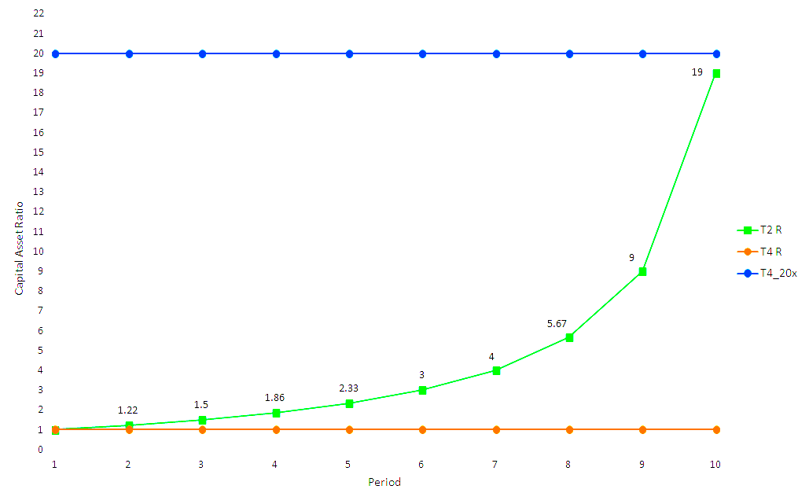

In two of the treatments of KHS, the fundamental value is constant for the entire life of the asset so that *ft = fo* for all *t*. In the treatment they call T4, the C/A ratio also remains constant throughout the life of the asset at a value equal to one, identically to the series labeled T4_R in Figure 1. In this figure, the horizontal axis indicates the period number *t*. The vertical axis is the C/A ratio prevailing in the current period. In treatment T2, the cash asset ratio is equal to 1 in period 1, but is increased throughout the life of the asset with cash infusions disbursed to each trader in each period. The resulting time profile of the C/A ratio is illustrated in Figure 1, in the series labeled T2_R. The cash infusions are relatively small in the early periods, and increase monotonically over the life of the asset. By the end of the life of the asset, the C/A ratio equals 19. The time profile of the cash injections is chosen for reasons of experimental design, specifically, to enable a direct comparison with another treatment.[1] KHS find that prices track fundamental values closely in both the T4 and T2 treatments.

A reader could easily interpret this result as suggesting that long-lived assets with constant fundamental values readily track fundamental values, regardless of the cash that traders have at their disposal to make purchases. In this article, we show that this interpretation is incorrect. We make two main points. The first is that prices do not necessarily adhere to fundamental values under a constant fundamental value trajectory. The second is that, just as in the case of declining fundamentals, increasing the cash available to traders by a sufficient amount does increase prices and generates bubbles even when fundamental values are constant.

We demonstrate these points with a new experiment consisting of three treatments. Two of the treatments, T4_R and T2_R, replicate the T4 and T2 conditions of KHS. We obtain results that are nearly identical to theirs. Prices adhere very closely to fundamental values throughout the life of the asset. However, in our third treatment, T4_20x, where we impose a constant C/A ratio of 20 for the entire life of the asset, we consistently observe price bubbles and crashes.

This suggests that the reason that bubbles are not observed in cases where the C/A ratio increases gradually via increasing infusions of cash, such as treatment T2_R, is that the injections of cash occur too late in the life of the asset to allow bubbles to form. To illustrate this, we can think of the C/A ratio as the ratio of the largest long position to the largest short position an individual can take at a price equal to the fundamental value. Because short-selling is not permitted, the maximum short position one can take is to sell all of one’s units. This results in revenue for the seller exactly equal to one multiple of the C/A ratio. The maximum long position one can take is to spend all of one’s cash on units of asset. Suppose, for example, we have a market with homogeneous endowments and a C/A ratio of 1. This allows an individual to double the number of shares he holds at the fundamental value. At a C/A ratio of *k*, a bullish individual can purchase assets to acquire a maximum inventory of *k* + 1 times her initial endowment. Thus, it takes only one bullish trader making purchases, offsetting the selling of *k* bearish traders to maintain a price equal to fundamentals. Similar arguments apply on an average basis for markets with heterogeneous endowments of units and cash. The implication is that in a market with a high C/A ratio, even a small fraction of bullish traders can launch a bubble as the available supply from other traders is bought up. On average, in a market with lower C/A ratios, a greater percentage of bullish traders are required to cause a bubble to form.

This bullishness may stem from a number of sources, but two appear most plausible, and have the most support in prior experimental work. One of these is a speculative motive; the belief in the possibility of selling at a higher price in the future. Because the life of the asset is finite, and has a fixed buyout value at the end of the asset’s life, a speculator presumably expects prices to equal fundamentals at the end of the final period of trading. Thus, in order to entice him to buy for speculative purposes, there must be sufficient time remaining to have a high likelihood of selling to another trader at a sufficiently high price to realize a profit. At the end of the life of the asset, it is redeemed for its intrinsic value. Thus, as the end of the life of the asset approaches, such speculation becomes more risky and speculative demand declines. Another possible source of bullishness is confusion (Lei *et al.* 2001, Lei and Vesely 2009, KHS 2012) about the experimental environment. The greater the available cash, the looser the constraints are on the highest purchase prices that confused traders can offer or accept. Such confusion can be presumed to be more likely early in the time horizon, when it is more likely that a trader has not understood how to properly value the asset. The confusion-reducing effect of experience may be enhanced when prices in initial periods track fundamental values, as they are likely to when C/A ratios in the first few periods are close to one. Therefore, the timing and size of the cash infusion appear to both be critical influences on whether and how large is the resulting effect on prices.

The rest of the paper is structured as follows. Section 2 describes the experimental design and procedures. Section 3 presents the results and section 4 the conclusions.

**2. The Experiment**

The experiment consisted of twelve sessions that were conducted in November 2011 at the University of Canterbury in Christchurch, New Zealand. A total of 112 subjects participated in the experiment. They were recruited from undergraduate courses across the university using ORSEE (Greiner 2004). Some of the subjects had participated in previous experiments, but all were inexperienced with asset markets and only participated in a single session of this study. The experiments were computerized and programmed with the z-Tree software package (Fischbacher 2007). The experimental currency used in the markets was Taler, which was converted to New Zealand Dollars at the end of the experiment at a predetermined, publicly known, conversion rate. Each session lasted approximately one hour, including an instructional period and the payment of subjects. Subjects earned on average $20NZ.[2]

In each session, either eight or ten subjects traded assets in a market in a sequence of ten trading periods.[3] In all treatments, each unit of the asset paid an uncertain dividend at the end of each trading period as well as a final terminal payment at the end of the tenth period. Fundamental values followed a constant time trajectory. The dividends per period were drawn from a two-point dividend distribution of either -5 or 5, with each value occurring with equal probability.[4] Therefore, the expected value of the dividend payment in any period was equal to zero. The asset had a terminal value of 50 Taler. Thus, the fundamental value in any period was 50 Taler. Subjects were endowed with Taler and assets at the beginning of each session.

Table 1 presents an overview of the treatments.[5] In all treatments, we employed the procedures of KHS, including the use of their z-Tree program, instructions and questionnaires. The treatments differed only in the time profile of the C/A ratio. Treatments T2_R and T4_R were identical to the T2 and T4 treatments of KHS. In the T4_R treatment, half of the subjects were endowed with 20 units of assets and 3,000 Taler, and the other half were endowed with 60 units of asset and 1,000 Taler. Given that the initial fundamental value of the asset was 50 Taler, the expected value of each subject’s endowment was 4,000 Taler. Because 2,000 of this value is in cash, and 2,000 in the asset, the resulting C/A ratio was equal to one.

**Table 1: Summary of Treatments in the Experiment**

|  |  |  |  |  |
| --- | --- | --- | --- | --- |
|  | T2_R | T4_R | T4_20x | |
| Expected Dividend | 0 | 0 | 0 |
| Fundamental Value | 50 | 50 | 50 |
| Total Asset Endowment | 400 | 400 | 400 |
| Total Cash Endowment | 20,000 | 20,000 | 400,000 |
| C/A Ratio | 1 to 19 | 1 | 20 |

Our only treatment variable was the time profile of cash endowment, and thus that of the C/A ratio. The T4_20x treatment was exactly the same as T4_R, except that the total cash endowment was 20 times greater. Half of the subjects were endowed with 20 assets and 41,000 Taler, and the other half were endowed with 60 assets and 39,000 Taler. Therefore, the total cash endowment in the market with 10 traders was 400,000 Taler in the T4_20x treatment, compared to 20,000 Taler in T4_R. The expected value of each subject’s endowment in T4_20x, taking into account units and cash, was 42,000 Taler. With 40,000 of this value in cash and 2,000 in units of asset, the C/A ratio was constant over time at 20.

The T2_R treatment had an increasing C/A ratio, ranging from one in the first period to 19 in period 10. In order to create the increasing C/A ratio, exogenous cash injections were made to each trader’s cash account at the end of each period. The amounts of these payments are presented in Table 2, which indicates the relationship between the per capita cash injection and the period number in T2_R. The resulting C/A ratios are depicted in Figure 1. In all treatments, the dividend payments, whether positive or negative, were added to or subtracted from a separate account so that they did not affect the amount of cash available for purchases of asset. This enables us to control the cash-to-asset ratio precisely over the course of a session.

**Table 2: Treatment T2_R Cash Injections**

|  |  |  |  |  |  |  |  |  |  |  |
| --- | --- | --- | --- | --- | --- | --- | --- | --- | --- | --- |
| Period | 1 | 2 | 3 | 4 | 5 | 6 | 7 | 8 | 9 | 10 |
| Payment | 444 | 556 | 714 | 953 | 1333 | 2000 | 3333 | 6667 | 20000 | 0 |

The trading institution in all markets was a computerized open book continuous double auction. Short-selling of assets and negative cash balances were not allowed. Each of the ten trading periods was 120 seconds long. Individual inventories of assets and Taler carried over from one period to the next. There were no interest payments on cash holdings and no transaction costs on trades.

At the beginning of each session, the subjects were given 15 minutes to read the instructions on their own.[6] Afterwards, the experimenter provided a detailed description of the trading screen, which was presented on an overhead projector. Two practice trading periods were conducted to allow subjects to become comfortable with the interface. Upon completion of the market at the end of the session, the subjects were asked to complete the same questionnaire used by KHS, which tested their understanding of the dividend and fundamental value processes, and requested some demographic data. Five sessions were conducted under each treatment.

**3. Results**

Figures 2a – 2c show the time series of average transaction prices by period in each session of the three treatments. In the figures, the vertical axis measures price and fundamental value in terms of Taler, and the horizontal axis indicates the market period. Each time series corresponds to one session. Figure 2a presents the data for T4_R, and shows that prices adhere closely to the fundamental value for the entire life of the asset. Figure 2b, which displays prices in T2_R, reveals a nearly identical pattern. Both of these treatments closely replicate the T4 and T2 treatments of KHS. Figure 2c illustrates the data from T4_20x, and shows a strong tendency for price bubbles to form. In all five sessions, prices are at least as great, or greater, than the fundamental value in every period. Prices exceed the fundamental value by at least 50% on average in each period beginning in period 6.

**Figure 2a: Average Prices in Treatment T4_R**

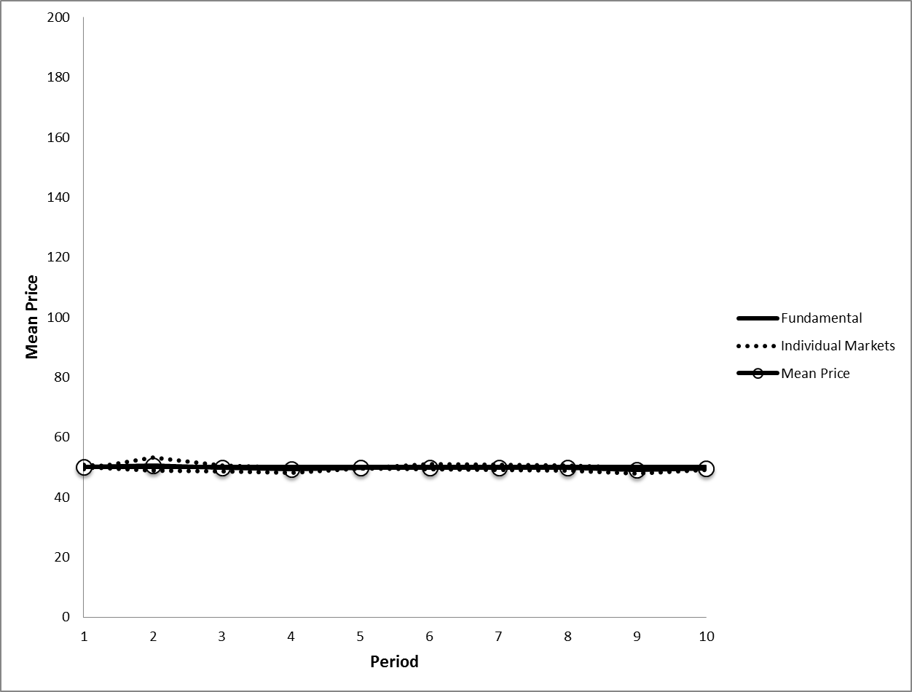

**Figure 2b: Average Prices in T2_R**

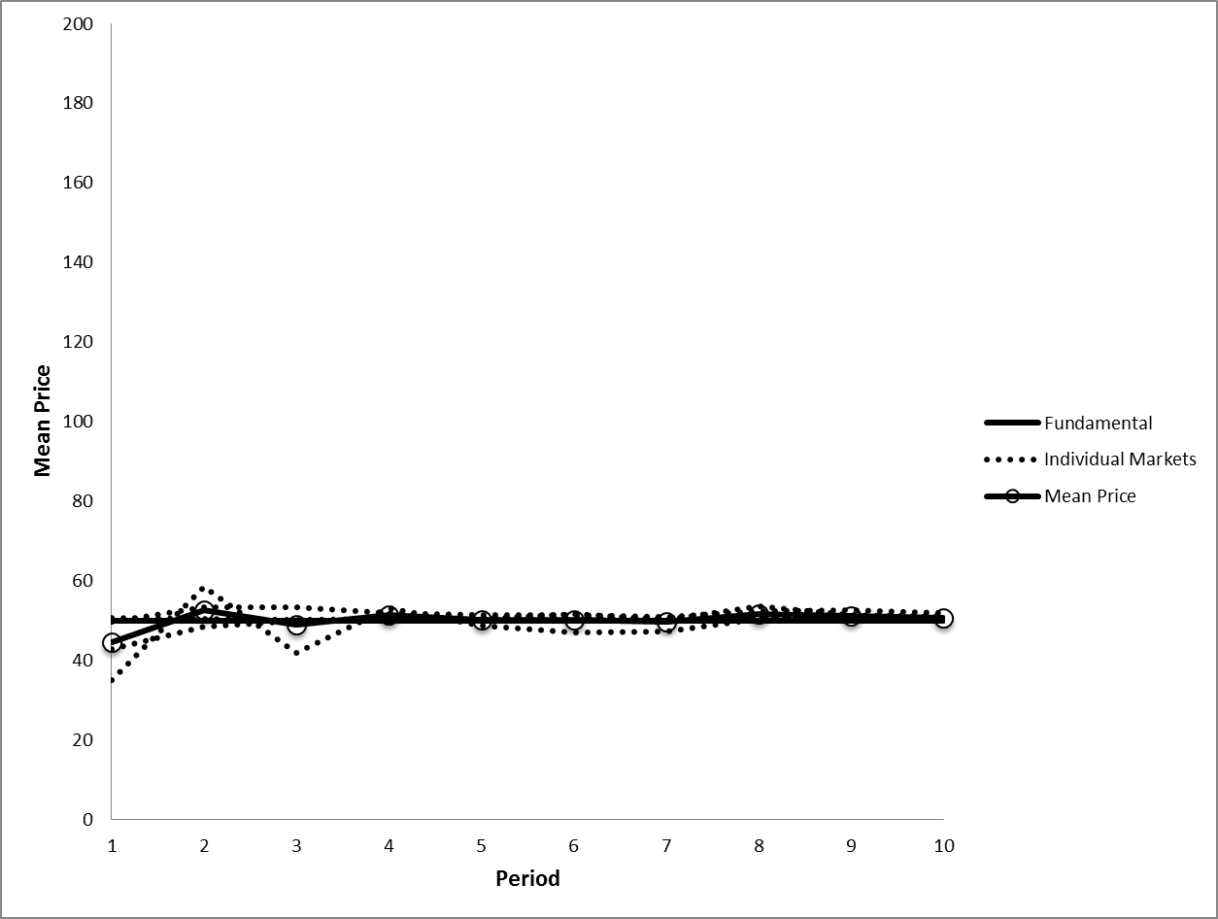

**Figure 2c: Average Prices in Treatment T4_20x**

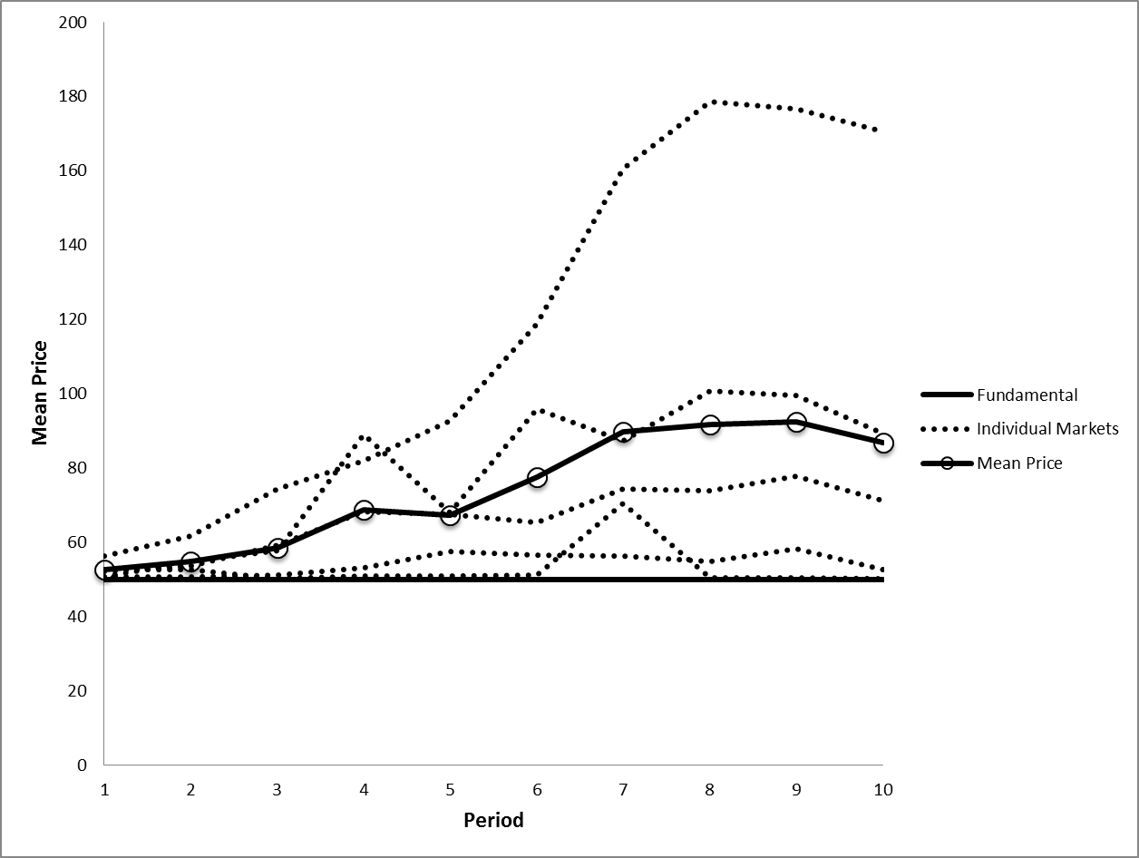

The upper portion of Table 3 shows the average value of the bubble measures employed by KHS, *Relative Absolute Deviation* (RAD), and *Relative Deviation* (RD), as well as *Turnover*, in each treatment.[7] The averages are taken over the five sessions that comprise each treatment. RAD is a measure of absolute difference from fundamental value, while RD is a measure of price level relative to fundamental values. Both of these measures were first proposed by Stoeckl *et al.* (2010). If prices track fundamentals, both measures take on low values. If they exceed fundamentals by a considerable amount in a sustained manner, both measures will be positive. If prices are below fundamentals, RAD will be positive and RD negative. Turnover (Van Boening *et al.* 1993) equals the total quantity of units of asset traded over the entire lifespan of the asset divided by the total stock of units in the market. Although units are traded among agents, the total stock of units of asset remains constant over time, since no units are added or subtracted from the total inventory held by all agents at any time. A high turnover indicates a high volume of trade, which in experimental markets is typically associated with prices becoming decoupled from fundamental values. The intuition for this pattern is that markets that track fundamentals are more likely to be characterized by common expectations among traders about future prices, and less disagreement about future prices leads to lower trade. The table shows that the value of each of the measures is much greater in the T4_20x treatment than in every other treatment. Furthermore, the value of the RAD measure, the clearest indicator of mispricing, is greater in every session of T4_20x than all but one of the sessions of the other treatments.

**Table 3: Bubble Measures across Treatments**

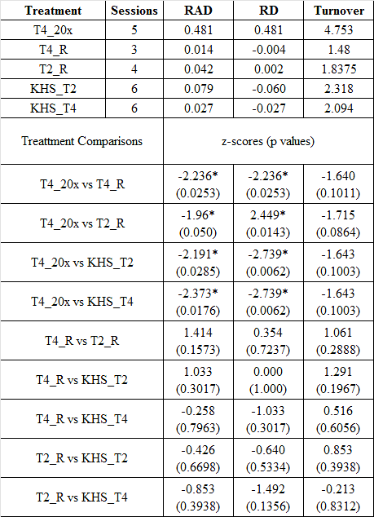

To determine whether these differences are statistically significant, we conduct Mann-Whitney-Wilcoxon Rank-Sum tests. The unit of observation is an individual session. The bottom part of Table 3 reports the z-scores and corresponding significance level for each pairing of treatments and for each bubble measure. The table shows that both T2_R and T4_R generate bubble measures close to those of the comparable treatments of KHS, and insignificantly different from each other. These results reflect the close adherence of prices to fundamental values in each of these conditions. In contrast, T4_20x generates values of both RAD and RD that are significantly greater at *p* < .05 than in T4_R and T2_R, as well as significantly greater than the T4 and T2 treatments of KHS. Thus, the differences are significant at the 5% level in all eight comparisons of RAD and RD between T4_20x and every other condition. Furthermore, T4_20x has more twice the transaction volume as the other two treatments.

**4. Discussion**

KHS (2012) report a number of important results concerning experimental markets for long-lived assets. One of these is that increases in the liquidity available for purchases increases price levels, and consequently, bubble magnitudes, when fundamental values are decreasing over time but not when they are constant. It is not clear why the positive association between liquidity and prices, so robust in the case of decreasing fundamentals (Caginalp *et al.* 1998 and 2001, Haruvy and Noussair 2006) would not carry over to the constant fundamental value case. In this paper, we show that had KHS specified the time profile of cash holdings differently, they would have indeed obtained the result that increased cash increases prices and exacerbates bubbles when fundamentals are constant. The positive relationship between cash holdings and price level is more general than would be concluded from their paper.

Experimental markets for assets with decreasing and constant fundamental values differ in a number of ways that make bubbles more likely in the decreasing case, regardless of the amount of liquidity available. Negative dividend realizations are common in the typical implementation of constant fundamentals while they are not possible under decreasing fundamentals. This may deter demand from loss-averse agents in the constant case, leading to lower prices. In the declining fundamental value case, frequent changes of fundamental values to a new level each period may make the price discovery process more difficult. The fact that the dividend payments in the declining case go to individuals who have been purchasing the asset, and thus with the greatest propensity to buy, disproportionally directs more cash to them that they can use to bid up prices. It is likely that all of these forces make it more likely that price discovery is more effective for assets that have constant fundamental value trajectories.

Nevertheless, in markets with either constant or with decreasing fundamental values, increasing the liquidity available for asset purchases increases market prices. The size and timing of the cash infusion seems to play a critical role in bubble formation in the case of constant fundamental values. In treatment T2 of KHS, the relatively large cash injections appear to have been introduced too late in the life of the asset for them to have an impact. As we have argued in section one, confusion is likely to be less prevalent and speculation is typically more risky, later in the life of the asset. If confusion and speculation are the sources of demand that generate bubbles, it is less likely that bubbles occur the later the cash is injected. High levels of cash at the outset readily lead to prices that exceed fundamentals.

**References**

Breaban A. and C. N. Noussair 2014. 'Fundamental Value Trajectories and Trader Characteristics in an Asset Market Experiment', working paper, CentER, Tilburg University.

Caginalp, G. and V. Ilieva. 2008. 'The Dynamics of Trader Motivations in Asset Bubbles,' *Journal of Economic Behavior and Organization*, 66(3-4), 641-656.

Caginalp, G., D. Porter and V. Smith. 1998. 'Initial Cash/Asset ratio and asset prices: An experimental study,' *Proceedings of the National Academy of Science*, 1998, USA, 95, 756-761.

Caginalp, G., D. Porter and V. Smith. 2000. 'Momentum and Overreaction in Experimental Asset Markets,' *International Journal of Industrial Organization*, 18, 187-204.

Caginalp, G., D. Porter and V. Smith. 2001. 'Excess Cash, Momentum, and Incomplete Information,' *Journal of Psychology and Financial Markets*, 2, 80-99.

Fischbacher, U. 2007. 'z-Tree: Zurich Toolbox for Ready-made Economic Experiments,' *Experimental Economics*, 10(2), 171–178.

Greiner, B. 2004. 'Forschung und wissenschaftliches Rechnen 2003, An Online Recruitment System for Economic Experiments,' ed. Kurt Kremer and Volker Macho, 79–93. GWDG 63rd report Society for Scientific Data Processing, Goettingen.

Giusti, G., J. H. Jiang and Y. Xu. 2012, March 12. *Eliminating Laboratory Asset bubbles by Paying Interest on Cash*. Munich.

Haruvy, E. and C.N. Noussair. 2006. 'The Effect of Short Selling on Bubbles and Crashes in Experimental Spot Asset Markets,' *Journal of Finance*, 61, 1119-1157.

Kirchler, M., J. Huber and T. Stöckl. 2012. 'Thar She Bursts - Reducing Confusion Reduces Bubbles,' *American Economic Review*, 102(2), 865-83.

Lei, V., C. N. Noussair and C. R. Plott. 2001. 'Non-Speculative Bubbles in Experimental Asset Markets: Lack of Common Knowledge of Rationality or Actual Irrationality,' *Econometrica*, 69, 830-859.

Lei, V and F. Vesely, 2009. 'Market Efficiency: Evidence From A No-Bubble Asset Market Experiment,' *Pacific Economic Review*, 14(2), 246-258.

Noussair, C.N. and O. Powell. 2010. 'Peaks and Valleys: Price Discovery in Experimental Asset Markets with Non-monotonic Fundamentals,' *Journal of Economic Studies*, 37(2), 152-180.

Noussair, C.N., S. Robin and B. Ruffieux. 2001. 'Price Bubbles in Laboratory Asset Markets with Constant Fundamental Values,' *Experimental Economics*, 4(1), 87-105.

Palan, S. 2013. 'A Review of Bubbles and Crashes in Experimental Asset Markets,' *Journal of Economic Surveys*, 27(3), 570-588.

Smith, V., G. Suchanek and A. Williams. 1988. 'Bubbles, Crashes, and Endogenous Expectations in Experimental Spot Asset Markets,' *Econometrica*, 56, 1119-1151.

Stöckl, T., J. Huber, and M. Kirchler. 2010. 'Bubble Measures in Experimental Asset Markets,' Experimental Economics,13, 284-298.

Van Boening, M., A. Williams and S. LaMaster. 1993 'Price Bubbles and Crashes in Experimental Call Markers,' *Economics Letters* 41, 179-185.

**Appendix A**

**Experiment Instructions[8]**

Dear Participant!

We welcome you to this experimental session and kindly ask you to refrain from talking to each other for the duration of the experiment. If you face any difficulties, contact one of the supervisors.

**General Information**

This experiment is concerned with replicating an asset market where traders can trade the stocks of a fictitious company for 10 consecutive periods.

**Market Description**

The market consists of ten subjects. Five of the ten traders get an initial endowment of 20 assets and a working capital of 3000 (*41000*) Taler, another five are endowed with 60 assets and 1000 (*39000*) Taler at the outset. At the beginning of the experiment the asset has a fundamental value (FV) of 50. Evaluating the asset at its initial FV yields that each subjects’ wealth adds up to 4000 (*42000*) Taler. In every period you can sell and/or buy assets, and your asset and Taler inventories are transferred to the next trading period, respectively. Each trading period automatically terminates after two minutes.

Trade is accomplished in form of a double auction, i.e., each trader can appear as buyer and seller at the same time. You can submit any quote of assets with prices ranging from 0 to a maximum of 999 Taler (with at most two decimal places). For every bid you make, you have to enter the number of assets you intend to trade as well. Note that your Taler and asset inventory cannot drop below zero.

At the end of each trading period, every asset pays a dividend (profit) of 5 Taler or causes holding costs of -5 Taler with equal probability. Thus, an asset’s average payout amounts 0 Taler at the end of each period. Dividends and holding costs are collected in a separate account. Assets feature a life-span of 10 trading periods. At the end of period 10 assets are bought back by the experimenter at a price of 50.

For the current period you do not get any information whether a dividend will be paid out or holding cost will accrue. The only thing you know is that the dividend payment and the holding cost either takes the value of +5 or –5 (per asset) in each period. At the end of a period you will be informed whether a dividend is paid out or holding costs accrued for the expired period.

**Fundamental Value (FV)**

The subsequent table might help you to make your decisions. The first column, labelled 'Current Period', indicates the period during which the FV is being calculated. The second column, labelled 'Average Payment Per Period', gives the average amount that the dividend/holding cost will be in each period for each unit held in your inventory. The third column, labelled 'Fundamental Value Per Unit of Inventory', gives the average value for each unit held in your inventory from now until the end of the experiment. That is, for each unit you hold in your inventory for the remainder of the experiment, you will earn on average the amount listed in column 3.

|  |  |  |
| --- | --- | --- |
| Current Period | Average Payment  per Period  (-5 or +5 with equal prob.) | Fundamental Value  per Unit of Inventory |
| 1 | 0 | 50 |
| 2 | 0 | 50 |
| 3 | 0 | 50 |
| 4 | 0 | 50 |
| 5 | 0 | 50 |
| 6 | 0 | 50 |
| 7 | 0 | 50 |
| 8 | 0 | 50 |
| 9 | 0 | 50 |
| 10 | 0 | 50 |

**Saving Account**

Your dividend earnings (positive) and holding costs (negative) during the course of the experiment are directly transferred to a saving account. At the end of the experiment your cumulated earnings/losses are added to/subtracted from your TOTAL EARNINGS.

**Asset Trading**

If you buy assets, your Taler holding is diminished by the respective expenditures (price*volume). Inversely, if you sell assets, your Taler holding will be increased by the respective revenues (price*volume).

**Calculate Your Earnings**

**At the end of each period earnings of external investments are added to your Taler holdings.**

|  |  |  |  |  |  |  |  |  |  |  |
| --- | --- | --- | --- | --- | --- | --- | --- | --- | --- | --- |
| **End of Period** | **1** | **2** | **3** | **4** | **5** | **6** | **7** | **8** | **9** | **10** |
| **Earnings** | **444** | **556** | **714** | **953** | **1333** | **2000** | **3333** | **6667** | **20000** | **0** |

Your total earnings at the end of the market (after 10 periods) are your Taler holdings plus your balance on the saving account (dividend payments minus holding costs) plus the value of your asset holdings (number of assets*50).

**Your TOTAL EARNINGS at the End of the Experiment**

= Taler holdings + balance on the saving account + (# of assets * 50).

Your total earnings in this experiment are converted into dollars at a rate of _____ Taler = $1

**Important Information**

* No interest is paid for Taler holdings.
* Each trading period lasts for 120 seconds.
* The experiment ends after 10 periods.
* Use the full stop (.) as decimal place.

**Trading Screen**

By means of the following figure, the procedure of trading (buying and selling) will be illustrated.



**History Screen**

This screen appears after each trading period (for 10 seconds), providing you with information of past periods:



**Appendix B**

**Bubble Measures for Each Session**

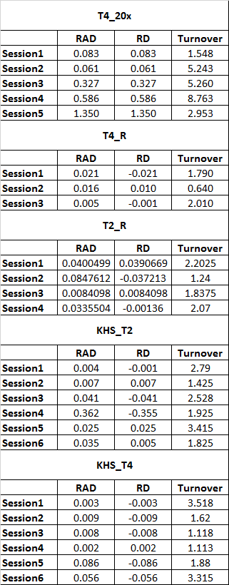

1. The reason that they chose this specific sequence of cash infusion magnitudes was to allow for the clean comparison of the case of a constant fundamental value trajectory to the case of a decreasing trajectory. The typical implementation of a decreasing fundamental value time profile features the payment of dividends into traders’ cash accounts. This has the effect of increasing the cash available for transactions and thus increasing the C/A ratio. Fundamental values are decreasing over time linearly, which causes further increases in the C/A ratio at an increasing rate over time. The overall effect is an acceleration in the C/A ratio over the life of the asset, similarly to the T2_R treatment shown in Figure 1.
2. At the time of the experiment, the minimum wage was 13NZD per hour (1USD = 1.26NZD).
3. We recruited with an expectation of ten traders participating in each session. Unfortunately, in four of the sessions, only eight subjects appeared. Thus, one session of T4_20x, one session of T4_R, and two sessions of T2_R had eight traders, while the remaining markets had ten traders.
4. KHS randomly drew a stream of dividend payments prior to running of any of the sessions and used the pre-determined sequence of dividend payments in all of their sessions. Likewise, we used the same dividend payment sequence in all of our sessions.
5. The asset endowment in the sessions with eight traders was 320 and total cash endowment was 16,000 and 320,000 in the T4_R and T4_20x treatments respectively.
6. The instructions are provided in appendix A.
7. RAD, relative absolute deviation, is defined as 1/*T*\*(*Σt*|*pt* – *ft|*)/(*Σtft*/*T*), where *T* is the total number of periods in the life of the asset, *pt* is the price in period *t*, and *ft* is the fundamental value in   
   period *t*. RD, relative deviation, is equal to 1/*T*\*(*Σt*(*pt* – *ft*))/(*Σtft*/*T*) . Turnover is equal to *Σtqt*/*TSU*, where *qt* is the quantity transacted in period *t* and *TSU* is the total stock of units. The values of the bubbles measures for each individual session are given in Appendix B.
8. The instructions used for T2_R and T4_R are identical to those used in the KHS study, who provided the translations from German to English with the published paper. The ztree programs used were provided by KHS and translation from German to English within the program was completed via the screenshots provided within the translated instructions. The instructions are for T4_R, text changes in T2_R are in bold and T4x20 are in *italics*.