**UNIVERSITY OF WAIKATO**

**Hamilton New Zealand**

**The Geography of Inventiveness in the Primary Sector:**

**Some Initial Results for New Zealand, 1880-1895**

Rebecca Williams and Les Oxley

**Department of Economics**

**Working Paper in Economics 16/03**

March 2016

|  |  |
| --- | --- |
| *Corresponding Author*  **Les Oxley**  Economics Department  University of Waikato  Private Bag 3105  Hamilton  NEW ZEALAND, 3216  Em[ail: loxley@waikato.ac.nz](mailto:gmhassan@waikato.ac.nz) | **Rebecca Williams**  Reserve Bank of New Zealand  2 The Terrace  Wellington  NEW ZEALAND, 6011 |

**Abstract**

At the turn of the twentieth century, New Zealand was one of the wealthiest nations in the world on a per capita basis. We examine the role of innovation in explaining New Zealand’s economic performance. Using a new dataset on patent applications for the period 1880-1895, we consider whether the geographical concentration of innovative activity influenced economic activity. We find relationships between agricultural and pastoral output indices and inventiveness and between different regions and related industries. The results, however, are relatively weak. We conclude that tests of agglomeration effects in New Zealand during this period deserve further attention.

**Keywords**

inventiveness

agglomeration

patents

knowledge spill-overs

New Zealand

**JEL Classifications**

O3, N7, N1

**Acknowledgements**

We wish to thank the Marsden Fund

for financial support in completing this research.

**1. Introduction**

There is widespread agreement that by the late nineteenth and into the twentieth century, New Zealand was one of the wealthiest nations in the world on a per capita basis[1] How New Zealand achieved its precocious growth leadership position remains debated, but a range of modern theories of economic growth and economic geography emphasize the role of technology and endogenous innovation in the growth process.[2] In these types of models, knowledge spillovers are hypothesised to generate a virtuous cycle in which innovation promotes growth and agglomeration; larger spatial agglomerations are more innovative and therefore enjoy faster growth.

Perhaps less well known, and the subject of this paper, is New Zealand’s world leadership in patent applications (per capita) over a similar period to its economic growth leadership. Modern endogenously-based economic theories all have an important role for innovation, with some particularly emphasising the geography of innovation and the geography of growth. They present a potentially fruitful source of investigation and hypothesis development to pursue.

In this paper we introduce measures of New Zealand’s innovativeness (patent application counts by industry of association, and by location of patentee) into the debate on the causes of its economic growth leadership during the late nineteenth and early twentieth centuries. We examine whether a causal relationship exists between patent applications and economic activity focusing on New Zealand’s primary sector. Furthermore, we look for evidence of regional knowledge flows or spillovers

If we consider the historical data and tests of the effects of technological change on economic growth, the existing literature tends to be bifurcated. First are the studies of major modern economies over relatively recent historical periods;for example, the pioneering work of Griliches (1990) popularised the notion that patent count statistics are a valid and useful measure of innovation, and that such statistics can, to some extent, help explain economic growth.[3] More recent work has provided a more nuanced view that ‘not all patents are born equal’ and considered the impact of patents based on their impact as measured by citations in other patent applications.[4]

The second major strand of the literature (which tends to run alongside these macro-level patent counts), typically focuses on earlier historical periods via a more ‘micro’ view of patenting; investigating individual inventors and in some cases alternatives to patent data, for example prizes, as a measure of innovation itself.[5] Some spatial elements have been extracted and discussed in this strand of the literature, but links between micro-inventiveness (and geography) and macro-economic outcomes (national/regional economic growth) have typically not been drawn or investigated.

In this paper we bring elements of the two strands of the literature together via an example: New Zealand during the late nineteenth century. During this time, the data suggest the nation led the world in terms of both per-capita economic growth and *i*nventiveness. As these are initial results, one of our major conclusions is that ‘there appears to be a case to answer’ – in terms of a potential explanation of New Zealand’s precocious growth experiences – between inventiveness and economic growth, but that before the case is proven more research is required, but that research is feasible and with great potential.

Given some of the apparent time series properties of the data and, in the case of New Zealand, the non-existence of a number of regional conditioning variables, the results presented here will focus only on the robust Toda and Yamamoto (1995) type, Granger causality test results. [6]

The paper is organised as follows: Section 2 provides a brief overview of the relevant New Zealand historiography including a discussion of her patenting laws and processes, so that the empirical results presented can be gauged in the context of the actual experiences and observations at the time. Section 3 describes the data taken from the *Appendices to the Journals of the House of Representatives* for the years 1880 to 1895 inclusive. We categorise and count patent applications over the period by ‘most relevant industry of association’ and geographic location of the patentee. This section discusses how the new dataset was created, its characteristics, strengths and weaknesses. Section 4 presents the methods used and our results where we consider the extent to which any spatial, or geographic patterns of patenting exist and whether they shift over time and space, or agglomerate. We also present some preliminary results on the existence of Granger-causal relationships between agricultural and pastoral output and inventiveness, measured by the patent counts allocated by space and industry-type, created in the first stage. Section 5 provides a conclusion and appeals for further work in this area.

**2. New Zealand’s Economic History and the Nature of Patenting**

New Zealand’s early economic development was based on an abundance of land and natural resources relative to labour and capital. The attractions of her natural resources (initially timber, seals and whales, and by the 1850s and 1860s tussock grass and gold) drew New Zealand, into the international economy. Staple trades and the flows of people, capital and technology are at the core New Zealand’s economic development. Gold production peaked in 1871 and wool or kauri gum exports offered limited development prospects.[7] Knowledge-related opportunities for re-invigorating development were connected primarily to closer settlement, the more intensive use of land by cultivation of grasses, and to the integration of farm and factory within a New Zealand system of mass production.

From the mid-1870s to the mid-1890s, however, New Zealand was affected unfavourably by weak export prices which resulted in some years in outward migration. In the 1890s however, wool prices began to recover at the same time that the new exports of meat and dairy products, facilitated by refrigerated transportation, began to dominate.

By the beginning of the twentieth century, average income per capita in New Zealand was similar to that of California, and thus around 50 per cent higher than in the USA generally. New Zealand’s average incomes in 1900 were 30-46 per cent above those of the UK and Australia, and more than twice the level of Argentina, Canada and Uruguay. New Zealand’s average income growth slowed after 1900 although her income per capita was similar to that of the USA in 1939 and above that of the UK and the other western offshoots.

New Zealand had a distinctive staple export boom of dairy and meat products whose impact went far beyond extending the cultivated area and the size of the Dominion’s economy. The technological change of refrigeration saw the first shipment of New Zealand frozen meat in 1882. Technological changes promoting dairy products and frozen meat exports transformed the farming landscape, patterns of land ownership, and the organization of manufacturing. A key feature of New Zealand’s staple exports was the extent that processing, in meat or dairy factories, was needed. Integration of farm with factory was central to the emergence of a ‘New Zealand System’ of manufacturing, and required a variety of technology.

New Zealand’s patent system was created by a sequence of legislation from 1860, and essentially followed the British system. Prior to 1889, only complete specifications could be submitted, and changes to patent legislation were primarily to reduce the cost of patenting. New Zealand’s 1889 Act allowed provisional or complete specifications to be submitted (at a cost of £0.5) and if provisional, nine months were allowed to submit the complete specification (again a cost of £0.5). Letters patent (for uncontested patents) were issued within 15 months for a further payment of £2. Patents could remain in effect for 14 years, on payment of a further £5 after four years, and £10 after seven years. Earlier patent legislation followed similar procedures (other than the provisional specification) and generally reduced the cost of patenting, for example the 1882 Act reduced the cost of applications to £1, the cost of letters patent to £2, and post-5 year extension costs to £7.[8] Most patents did not run for 14 years; in 1905 around one-third of patents were extended after four years, and around half of those total were extended again after seven years.[9]

Patenting activity in New Zealand was unusually high. The Registrar of Patents (C.J. Haselden) noted in 1893, ‘it is believed in proportion to its population there are more applications for patents (in New Zealand) than in any other country in the world.’[10] Details of patent application were initially reported in the *New Zealand Gazette* (and two months given for appeals) and summarized in the annual reports of the Registrar of Patents in the *Appendixes to the Journals of the House of Representatives* (hereafter *AJHR*). Shorter summaries appear in *Statistics of New Zealand* (1871-1919) and subsequently in *New Zealand Official Yearbooks*. These records provide data on the numbers and the purpose of patent applications as well as the names and addresses of applicants. Annual applications reached 50 in 1878, 503 in 1886, 1,093 in 1897 and 2,199 in 1920. In the period 1871-1939 patents applications peaked at 2,251 in 1929. In 1913 around 66 per cent of applications were from New Zealand residents; by 1939 the ratio had fallen to 38 per cent[11]

Haselden’s belief that patenting in New Zealand around the start of the twentieth century was unusually high receives support from the summary data in Table 1 below. In 1900 patenting per capita in New Zealand was around 20 per cent higher than its nearest rivals, Belgium and Austria, and more than twice the rate of most western European countries and the USA.

Some English-speaking settler regions, including the Australian state of Victoria and Canada had relatively high patenting activity; around two-thirds the New Zealand rate. In contrast Argentina, Brazil and Japan had low patenting activity.

Several strands of the technology central to New Zealand’s economic development, including refrigeration and the centrifugal separation of cream, had overseas origins O’Rourke (2007). How these were assimilated, adapted and utilized are central to New Zealand attaining high average incomes. On New Zealand farms integrated machine milking and centrifugal cream separation forged ahead more quickly than in the USA (Philpott 1937). Further, farm and factory were integrated in a distinctive New Zealand system of mass dairy production Belshaw (1927). By the 1920s New Zealand’s largest co-operative dairy factories in the Waikato region had twice the capacity and higher productivity than plants in Wisconsin (Russell and Macklin 1926).

|  |  |  |  |
| --- | --- | --- | --- |
| **Table 1: Patent Applications in 1900** | | | |
|  | Applications | Population (000s) | Applications per capita |
| Argentina | 318 | 4693 | 0.067 |
| Australia | 1610 | 3741 | 0.430 |
| Victoria | 972 | 1175 | 0.827 |
| Austria | 6409 | 5973 | 1.072 |
| Belgium | 6943 | 6719 | 1.033 |
| Brazil | 389 | 17984 | 0.021 |
| Canada | 4628 | 5457 | 0.848 |
| Denmark | 1430 | 2561 | 0.558 |
| France | 12789 | 40598 | 0.3150 |
| Germany | 20321 | 52753 | 0.3852 |
| Hungary | 3511 | 7127 | 0.4926 |
| Italy | 4033 | 33672 | 0.1197 |
| Japan | 2006 | 44103 | 0.0454 |
| Mexico | 629 | 13607 | 0.0462 |
| New Zealand | 1009 | 807 | 1.250 |
| Norway | 1451 | 2230 | 0.650 |
| Portugal | 283 | 5404 | 0.052 |
| Sweden | 2258 | 5117 | 0.441 |
| Switzerland | 2759 | 3300 | 0.836 |
| UK | 23924 | 41555 | 0.5757 |
| USA | 39673 | 76391 | 0.5193 |

*Sources:* World Intellectual Property Organization 2008, *Annual Patent Statistics. Official Yearbook of the Commonwealth of Australia,* 1, 1901-07.

**3. Data**

To analyse and test for agglomeration and its effects on innovation and growth during this period of New Zealand’s economic history, a unique data set was created.[12] Patent information was collected from the *Appendices to the Journals of the House of Representatives of New Zealand*, 1880 - 1895 which contains the names of the patentees, their specific location, the year of application and the description of the innovation.[13] These observations are patent applications, as opposed to granted patents, because data on granted patents (including the location of patents) are not separately available. Patent applications are, however, a powerful indication of inventive activity, even if they contain less information about the quality of innovation than granted patents.

The data collected for the years 1880 to 1886 contain all patents applied for in each year, and have been divided into industry categories, broadly similar to those used by Magee (2000) and are shown in *Appendix A*. For the period 1887 to 1895 only data relating to patents from a certain limited number of industries were collected. The industries selected for this period were mainly those that had previously been contained in the 'Primary sector' category, with the addition of food refrigeration and preservation. Specifically, this period contained patents regarding land cultivation, which included basic land farming innovations, wire and fencing innovations, the sheep industry (meat and wool), the dairy industry, food refrigeration and preservation, the grain industry, the flax industry, animal pest removal innovations and 'other' primary sector industries such as poultry. The fishing industry was excluded due to the small number of patents (three in total, two of which were from Australia) and this category was not included in the analysis.

These categories were selected partly because they contained the most numerous entries from 1880 to 1886 (summary statistics can be found in Appendix B), and primarily because of previous findings of industry contribution to overall output (Greasley and Oxley 2010a). In addition, various forms of farming have widely been recognised as a key feature of New Zealand’s heritage, and continuing to the present day. Relevant patent observations from the period 1880 to 1886 were re-categorised and added to the second data set, giving a set of 'key industries' data from 1880 to 1895 inclusive.

Summary statistics from the collected data provide insights into the nature of patenting during this period. By examining the average number of patents per inventor, we can see whether New Zealand’s high patent per capita ratio was the result of a few prolific patentees or widespread innovative activity. The percentage of patentees that patented a given number of times is presented in Figure 1.

Most inventors in this sample patented only once or twice the median in both samples is one patent. A few patented multiple times, with the maximum being eighteen patents. Overall, it appears that the high level of per capita patenting in New Zealand was the result of many people patenting once or twice as opposed to several 'professional' inventors who patented prolifically.

Patent statistics are used widely in the literature as a means of examining and comparing the extent of innovation (Griliches 1990). Differences in innovative activity between countries, however, may depend on the form of legislation (Moser 2005). For example, patents may only be important in some industries (Cohen, Nelson and Walsh 2000). The main reasons for patenting are to prevent other firms from copying, to enhance firm/individual reputation and to evaluate the effectiveness of research and development departments Cohen *et al*. 2000). Factors that impact on individuals’ willingness to patent include the ease of inventing around a patent, the cost of a patent, the disclosure of information contained in a patent and the difficulty in demonstrating novelty.[14] Some authors attempt to measure quality by using the number of patent citations as a proxy for quality but this cannot be done during this period in countries such as New Zealand (Nuvolari 2004 and Nuvolari and Tartari 2009).

**Figure 1: Percentages of Patentees that Patented a Given Number of Times**

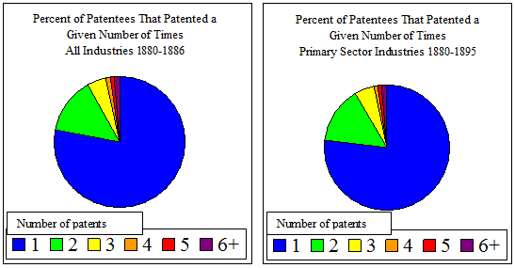

The lack of patent citation data in this period means that commonly used approaches for examining the importance of spatial proximity cannot be used. Instead, we created patent geographical density measures from which relationships between these measures and sector output data in late nineteenth century New Zealand are considered. Fundamentally, this approach is supply driven, in that innovation has an impact on output, as opposed to the demand driven where higher output results in more innovation. It is possible, however, that the relationship exists in both directions, but this paper will focus on the innovation to output direction. The output data used in the paper are from Greasley and Oxley (2010a) Appendix Table 1.

**4. Methods and Results**

Our intention is to provide initial results on the relationship, potentially causal, between the type of patent (via its main association with a particular output sector), the place where it was registered (city or province) and association with sector of output, again measured at a spatial (location) level. The aim of the measurements is to consider (i) the extent to which patent applications (in a sector) correlated with or caused output in a particular sector; (ii) to consider whether there is any evidence of spatial, particularly agglomeration effects, in patenting behaviour over time and (iii) to ascertain whether we can identify sectoral or spatial effects of patent registrations over time.

Given that such aims involve considerations over time (and space) it is important that the methods that the empirical methods we employ are robust to the time series properties of the actual data. Furthermore, the data, as published, relate only to counts of patent applications and therefore require some form of transformation to provide useful indicators or indices.

We are interested in controlling for the per capita effects on the spatial location of patenting behaviour. Creating a useful numerical measure of patent density by geographical location is, however, problematic. On a map, patent locations could be represented by dots and it could clearly be seen where they were concentrated. This approach was the one famously taken by Dr. John Snow in 1854 in identifying the cause of a cholera outbreak in London (Tufte 1997). Not only is this difficult to interpret numerically, it is also unable to account for population. To give a simple indication of patent density in New Zealand during this period, patent density in terms of patents per capita in each region can be represented on a map. A similar approach was taken in Le Sage and Pace (2009) in their discussion of spatial econometrics.

Treating the null hypothesis as a uniform spatial distribution, we construct and use a measure of the relative frequency (or density) of patents in a particular region relative to the national average, taking account of differences in population densities. In particular we construct a simple numerical indicator to measure patent density in a given year. Our measure is perhaps closest in spirit to the measure presented in Ellison and Glaeser (1997), but is much simpler due to data limitations and our slightly different line of enquiry. Yet despite its simplicity, it has an intuitive interpretation. The measure or indicator of patent density was created both at an industry level and at a sector level, and can be seen in equation 1.

 (1)

Where *n* is equal to the number of regions (nine). If there was no geographical concentration of patents, each ratio of regional patents to regional population would be the same as the national ratio of patents to population, the difference would be zero and the total measure (sum of these squared differences) would be zero. As patent concentration increases in some regions, the ratio of patents to population in these regions becomes larger than the national ratio and the patent to population ratios of the remaining regions (who did not experience concentration) become smaller. As a whole then, the patent density measure becomes larger. Thus, a larger patent density measure indicates a greater level of geographical concentration*.* It is important to account for population because we would expect that areas with more people have higher levels of patents. The density of innovative behaviour in terms of agglomeration requires there be a greater level of patenting in a region than we would expect from the number of people living there. Regional population data were obtained from the New Zealand *Yearbooks* where nine regions were included in these summaries: Auckland, Hawke’s Bay, Taranaki, Wellington, Nelson, Marlborough, Canterbury, West Coast and Otago[15].

**4.1 Geographical Density of Patents and Sector Outputs**

In this section we will present results on the relationships between the patent density measures and output at the sector level (rom Greasley and Oxley 2010a, Appendix Table 1). If the geographical proximity of patenting has any effect on output, we would expect that the density measure would be significant and positive i.e. the closer patents are geographically the greater effect they have on output.

Figures 2 to 4 show the location of these regions and their determined boundaries. The dairy, sheep and agricultural industries are displayed as an illustration, as these industries have previously been shown to be important contributors to New Zealand’s economic growth.

These density maps show an overall increase in the number of patents per capita in these key industries between 1880 and 1895 (as warmer colours indicate higher patent density). They also demonstrate that within industries, some regions were patenting more than others relative to their population size. This is consistent with agglomeration of innovative activity. Although these maps provide a visual presentation of patent behaviour geographically, they do not reveal any relationship between innovative concentration and economic output. To do this, numerical measures are required.

Using the dataset of primary industry patents between 1880 and 1895, a set of density measures for each sector and for each industry was created for each year. As such, each industry only contains sixteen patent density observations and although this is unlikely to be sufficient to provide any robust evidence of agglomeration effects in innovation, it can provide results, which provide some insight into the empirical relevance of the various theories.

**Figure 2: Regional Density Maps in the Dairy Industry**

(Selected Years)

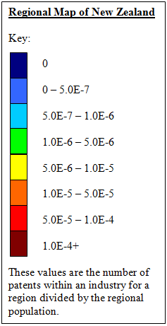 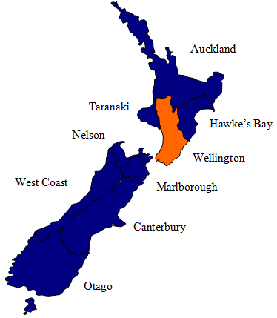

Dairy patents/capita 1880

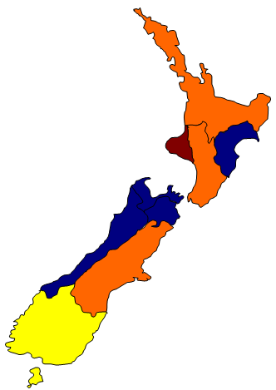 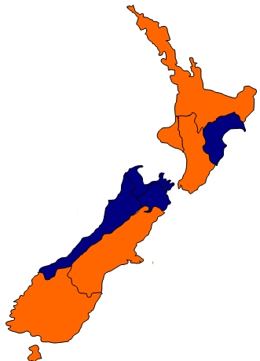 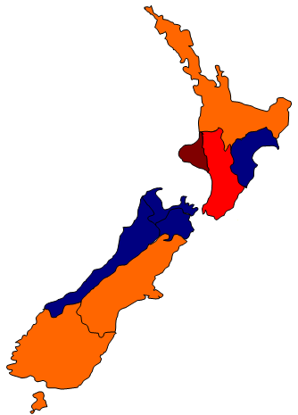

Dairy patents/capita 1886 Dairy patents/capita 1890 Dairy patents/capita 1894

**Figure 3: Regional Density Maps in the Sheep Industry**

(Selected Years)

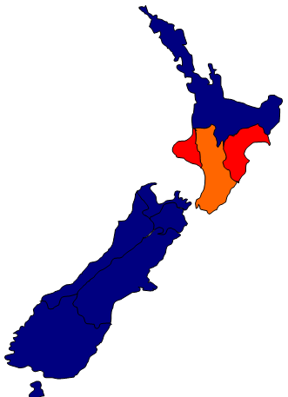 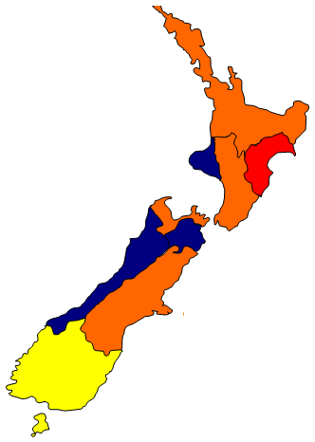 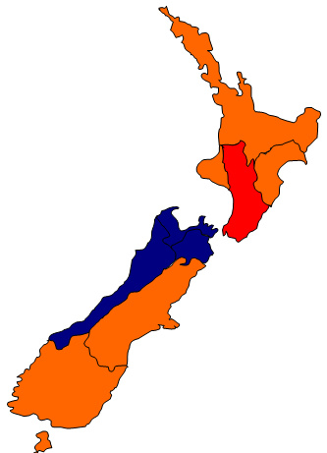

Sheep patents/capita 1883 Sheep patents/capita 1889 Sheep patents/capita 1895

**Figure 4: Regional Density Maps in the Agricultural Industry**

(Selected Years)

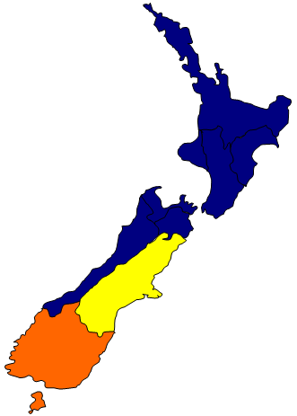 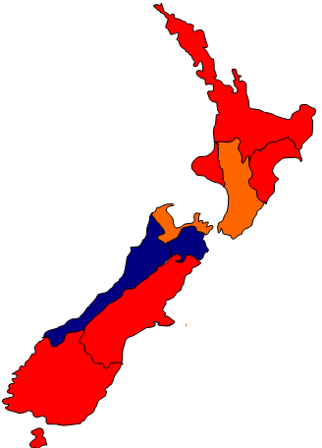 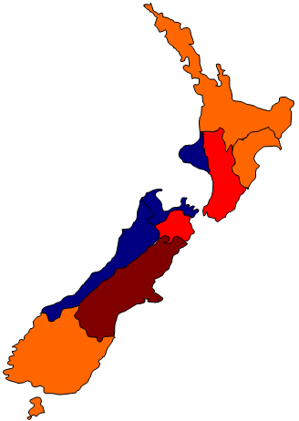

Agriculture patents/capita 1880 Agriculture patents/capita 1887 Agriculture patents/capita 1895

*Sources:* Craigie (2009).

A more formal way that relationships can be examined is by testing for Granger causality. Granger causality can indicates how patent density in one industry influences another or total output, as opposed to contemporaneous correlations which could be the result of a third factor simultaneously influencing both variables. The standard bivariate Granger causality procedure considers the relationship between two variables *X* and *Y* as follows (Greasley and Oxley 2010b):

 (2)

where *m, n, q* and *r* are specified lag lengths and *ut* and *vt* are zero-mean, serially uncorrelated random disturbances. In this paper, the lag lengths have been specified as one, two and three because there were only sixteen years under examination and it seemed unwise to include more and lose information. The test then looks at the significance of the coefficients of the lagged values of the other variable, where:

*Y* Granger causes *X* if H0: *γ1 = γ2 = γ3 =* 0 can be rejected against the alternative

H1: at least one *γj* ≠ 0, *j* = 1, 2 or 3.

*X* Granger causes *Y* if H0: *c1 = c2 = c3* = 0 can be rejected against the alternative

H1: at least one *cj* ≠ 0, *j* = 1, 2 or 3.

Here, the issue of the time series properties of the data becomes important. A range of unit root tests were performed which indicated that some variables were integrated at order 1, denoted I(1). They thus required first differencing to achieve stationarity. Other data were already stationary (order 0 or I(0)). As presented, equation 3 requires the variables to be I(1) and cointegrated, otherwise the levels-based estimation may result in spurious causality being reported. Consistent inferences can be generated, however, by the inclusion of an additional lag (Toda and Yamamoto 1995).

The results of Toda and Yamamoto-type causality tests are presented in Tables 2 and 3 below. A variable is deemed to Granger-cause another if the relationship is significant at the ten per cent level.

Considering the economic implications of these tests in more detail, the geographical concentration of patents in the flax industry appears to Granger cause agricultural output when one and three lags were specified. The geographical density of all agricultural patents also Granger caused agricultural output. Both of these results are consistent with theories about the agglomeration of inventiveness. When innovative activity is concentrated geographically it causes an increase in agricultural output. Agricultural output also Granger caused the geographical density of agricultural patents. This indicates that there could be some demand-side influences in addition to the supply-side influences focused on here.

Of the pastoral results, it appears that the geographical density of food preservation patents Granger caused the density of dairy patents when one, two and three lags were specified. If the density of food preservation patents Granger caused the density of dairy patents and the density of dairy patents was positively correlated with pastoral output, this indicates that the density of food preservation patents had an indirect effect on total output.

This outcome is also consistent with agglomeration effects in innovation. That the density of food preservation patents Granger caused the density of dairy patents is unsurprising, as dairy innovations became much more profitable and more opportunities for improvement were available once refrigeration became established. A profitable dairy industry in New Zealand required a greater level of technological advance to supplement the introduction of refrigeration (Hawke 1979). It is also unsurprising that the density of fencing patents Granger caused the density of dairy patents when three lags were included, as areas with improved fencing were more suitable for dairy farming. Better stock control means more profitable innovation; (i.e. it is not worth investing in improving cream separators if you cannot easily locate your stock and guide them to the milking station). The density of fencing patents Granger causing the density of food preservation patents is probably linked to the benefits both have for the dairy industry. This is again an indirect indication of agglomeration; if the geographical concentration of fencing patents Granger caused the density of food preservation patents, and this in turn Granger caused dairy patent density which had a positive correlation with pastoral output, it seems likely that the geographical location of innovative activity did matter for output.

Overall, the Granger causalities that consider the effects of greater geographical concentration of innovation within industries are consistent with there being an agglomeration effect of innovation. In particular, the positive and significant correlations of flax and dairy patent densities on agricultural and pastoral output indicate that there are some benefits which arise from the spatial proximity of innovations. In terms of Granger causality, the patent densities of industries related to the dairy industry in particular seem to have explanatory power.

**Table 2: Granger Causalities for the Agricultural Sector**

Lags in Parenthesis

|  |  |  |  |
| --- | --- | --- | --- |
|  | Agricultural Output  Index | Total Agricultural Patent Density | Flax  Patent Density |
| Agricultural Output Index | - | ↔ (3) | ← (1) (3) |
|  |  |  |  |
| Total Agricultural Patent Density | ↔ (3) | - |  |
|  |  |  |  |
| Flax Patent Density | → (1) (3) |  | - |

*Source:* Craigie (2009).

*Notes*

→ denotes unidirectional causality from the row variable to the column variable.

← denotes unidirectional causality from the column variable to the row variable.

↔ denotes bidirectional causality from the column/row variable to the row/column variable.

- denotes not applicable.

**Table 3: Granger Causalities for the Pastoral Sector**

Lags in parentheses

|  |  |  |  |  |  |  |
| --- | --- | --- | --- | --- | --- | --- |
| PD =  'Patent Density' | Dairy Patent Density | Sheep Patent Density | Fencing Patent Density | Pest Removal Patent Density | Food Preservat’n Patent Density | Other Patent Density |
| Dairy  Patent Density | - |  | ← (3) |  | ← (1)(2)(3) |  |
| Sheep Patent Density |  | - |  |  |  | → (2)(3) |
| Fencing Patent Density | → (3) |  | - |  | → (2)(3) | ← (1)(2)(3) |
| Pest Removal Patent Density |  |  |  | - | ← (1) |  |
| Food Preservation Patent Density | → (1)(2)(3) |  | ← (2)(3) | → (1) | - | ← (3) |
| Other Patent Density |  | ← (2)(3) | → (1)(2)(3) |  | → (3) | - |

*Source:* Craigie (2009).

*Notes*

→ denotes unidirectional causality from the row variable to the column variable.

← denotes unidirectional causality from the column variable to the row variable.

↔ denotes bidirectional causality from the column/row variable to the row/column variable.

- denotes not applicable.

Not all of the results are consistent with the agglomeration hypothesis. They may also suggest that there were large opportunity costs in inventing in particular industries, either because the benefit obtained from an additional invention was diminishing, or because there were simply too many people in a region spending too much time inventing the same thing. The regional density of patents in the sheep industry was never significant, yet the sheep industry is reputed to be one of New Zealand’s most important industries. Overall, these results suggest that the agglomeration of innovation was only important or present in some industries, most notably the dairy and flax industries.

**4.2 Intra-industry Regional Knowledge Spill-Overs**

In this section we seek to identify agglomeration effects in innovation at the regional level,looking for knowledge spillovers. If the concentration of patents within an industry, within a region, has a positive impact on the concentration of patents in the same industry within a neighbouring region, it would appear that a higher concentration of innovative activity has positive influences on the total innovation per capita of the country as a whole. Total innovation itself has already been shown to have positively contributed to the industry output levels in New Zealand during this period Greasley and Oxley (2010a). If patent density in one region encourages increased levels of patenting in neighbouring regions, overall output should increase. At the individual level, agglomeration theory suggests that innovative people clustered closer together result in higher output; this approach can examine whether a similar relationship can be seen at the regional level.

To assess whether regional knowledge spill-overs were occurring during this period, Granger causality tests were again used. The results are presented graphically as Figure 5 (where a variable is deemed to Granger cause another if the relationship is significant at the ten per cent level):

**Figure 5: Regional Granger Causalities in Pastoral, Dairy and Flax Patent Densities**

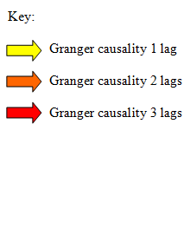 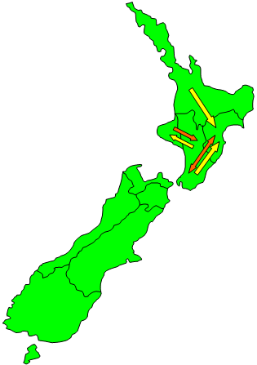

Agricultural patent density

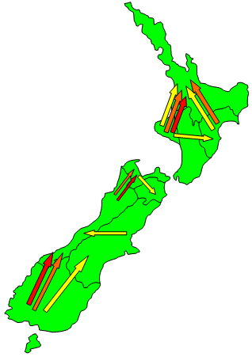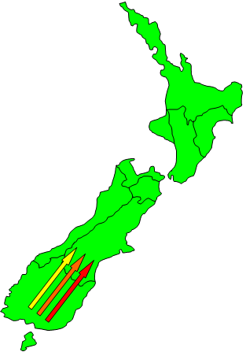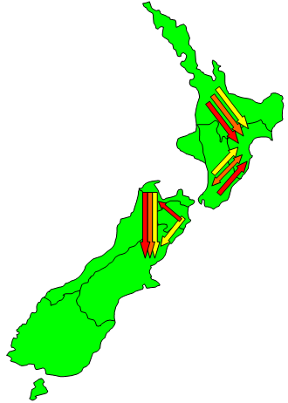

Pastoral patent density Dairy patent density Flax patent density

*Source:* Craigie (2009).

The Granger causality tests suggest that there are some inter-regional influences, consistent with an agglomeration of innovation effects. The most notable causalities are of the Otago (the most southern, South Island region) dairy patent density on Canterbury (the major South Island, East Coast, region) dairy patent density and Taranaki (most western North Island region) pastoral patent density on Auckland (current main city of New Zealand) pastoral patent density. The directions of both of these causalities are consistent with New Zealand’s economic history, which saw a northward shift in dairying during this period Hawke (1985). There are also Granger causalities within the flax industry, most notably from Auckland and Wellington to Hawke’s Bay.

It appears that agglomeration effects, in terms of regional knowledge spillovers indicated by the densities of innovative activity, again feature most prominently in the dairy and flax industries.

**4.3 Inter-industry Regional Knowledge Spill-Overs**

The third and final approach used here to examine whether there was an agglomeration of innovation effect during this period, was to consider inter-industry influences both within and across regions.

The inter-regional influence considered previously did not investigate whether the density of patents in one industry in a region influenced the density of patents in related industries in neighbouring regions. We would expect that skills used in some areas could also be used in related areas - an assumption that was made when the results of geographical density on sector output produced negative coefficients. Negative coefficients suggested the possibility of opportunity costs affecting innovations, as more naturally innovative people could be inventing in multiple industries but should have been inventing in the industry with the greatest returns.

The possibility of inter-industry regional patent density influences was examined by focusing on the dairy and sheep industries, as *a priori* these are the industries most likely to be affected by patenting density in other industries given that related industries are conducive to their productivity. In particular, we would expect that the patent density of the fencing, pest removal and food preservation industries could have some impact on dairy and sheep. This links with fencing and pest removal are intuitive; if better fences are in place and pest numbers are kept low it is more profitable to run a sheep or dairy farm, and thus there are greater incentives for innovative activity in these industries. An increase the density of food preservation patents should also increase the incentives for innovation in the dairy and sheep industries, as refrigeration makes it possible to transport product to a larger market.

Consistent with the previous two sets of results for testing the agglomeration effects of innovation, Granger causality tests were also used to identify possible inter-industry regional influences. The results are shown in Table 4.

**Table 4: Granger Causality Tests**

**for Inter-Industry Regional Influences**

|  |  |
| --- | --- |
| **Regional Industry**  **Patent Density** | **Granger-Caused by (lags specified)**  **at the ten percent level** |
|  |  |
| Auckland dairy | Auckland pest removal (1,2), Taranaki fencing (1), Hawke’s Bay sheep (1), Wellington sheep (1), **Wellington fencing (1,2,3)**, Hawke’s Bay fencing (2,3) |
| Auckland sheep | Auckland dairy (1), Taranaki dairy (1), **Hawke’s Bay pest removal (1,2,3), Wellington sheep (1,2,3)**, Wellington fence (1,2), |
| Auckland fencing | **Taranaki fencing (1,2,3)**, Hawke’s Bay sheep (1), Hawke’s Bay fencing (1,2), **Wellington sheep (1,2,3)** |
| Auckland pest removal | **Taranaki fencing (1,2,3)**, Hawke’s Bay pest removal (1), **Hawke’s Bay fencing (1,2,3)**, Wellington pest removal (1,3), Taranaki dairy (3), Wellington fencing (3), Wellington food preservation (3) |
| Auckland food preservation | Auckland dairy (1), Auckland fencing (1), Auckland pest removal (1,2), **Taranaki dairy (1,2,3)**, **Wellington pest removal (1,2,3)**, Taranaki fencing (2), Hawke’s Bay sheep (2), Hawke’s Bay fencing (3), Wellington fencing (3) |
| Hawke’s Bay sheep | Auckland pest removal (1,2), Wellington food preservation (3) |
| Hawke’s Bay fencing | Hawke’s Bay food preservation (2), Wellington food preservation (2) |
| Hawke’s Bay pest removal | Auckland fencing (1,2), Auckland pest removal (1) |
| Hawke’s Bay food preservation |  |
| Taranaki dairy | Auckland pest removal (1), Taranaki fencing (1), Wellington pest removal (1), Wellington fencing (1), Wellington food preservation (2,3) |
| Taranaki sheep | Auckland pest removal (3), Taranaki fencing (3) |
| Taranaki fencing | Taranaki fencing (2), Wellington fencing (2), Wellington pest removal (2,3), Auckland dairy (3), Taranaki dairy (3), Wellington food preservation (3) |
| Wellington dairy | Hawke’s Bay pest removal (1,2), Wellington sheep (1,2), Auckland fencing (2,3), Hawke’s Bay sheep (3) |
| Wellington sheep |  |
| Wellington fencing | Taranaki dairy (1) |
| Wellington pest removal | Auckland fencing (1,2), **Auckland pest removal (1,2,3)**, Hawke’s Bay sheep (1,2), Taranaki fencing (2,3), Taranaki dairy (2,3), Hawke’s Bay fencing (2,3), Wellington fencing (2,3) |
| Wellington food preservation | Hawke’s Bay food preservation (3) |
| Canterbury dairy | **Otago dairy (1,2,3)**, Otago sheep (1), Canterbury food (3) |
| Canterbury sheep | Otago pest removal (1,2) |
| Canterbury fencing | Otago food preservation (1), Canterbury food preservation (2) |
| Canterbury pest removal | Otago fencing (2,3), Canterbury dairy (3) |
| Canterbury food preservation | Otago fencing (2,3), Canterbury fencing (3) |
| Otago dairy | **Canterbury sheep (1,2,3),** Otago food preservation (2,3) |
| Otago sheep | Canterbury dairy (1,2), Otago dairy (1), Otago pest removal (1,2) |
| Otago fencing | Canterbury pest removal (1), Otago pest removal (1), Canterbury dairy (2) |
| Otago pest removal | Canterbury dairy (1) |
| Otago food preservation | Canterbury sheep (1,2), Otago sheep (2,3), Otago fencing (2) |

*Note*

Text in boldrepresents significant relationships found at, at least, the 5% level.

The results suggest that there were some inter-industry regional spill-overs during this period, most notably in the North Island where the density of Wellington fencing patents Granger caused Auckland dairy patent density and the density of Hawke’s Bay pest removal patents Granger caused Auckland sheep patent density. An increase in fencing patents in Wellington may have encouraged greater patenting activity in the dairy industry in Auckland because once fencing was improved the dairy industry would have become more productive. As a result, the incentives to invent would have been greater.

The density of Hawke’s Bay pest removal patents would also have made Auckland sheep farming more productive and led to greater incentives to invent. These results may have been driven by transport links between the regions, where sea/water based networks were important and hence proximity to the coast and a port were likely to be important.

The density of sheep patents in Canterbury also Granger caused the density of dairy patents in Otago; some innovations used in the sheep industry in Canterbury may have also been useful in the dairy industry and as such there may have been greater incentive to patent in the dairy industry in Otago. Given the limited number of years included in this dataset, it is difficult to reach any strong conclusions, however, the table above presents results that are consistent with inter-industry regional influences, which are consistent with agglomeration effects.

**5. Conclusions**

By the end of the nineteenth century, New Zealand led the world in terms of per capita real income and patenting activity. Technological change (especially refrigeration, but also new grasses) and the resultant opening-up of new export markets led to both a switch in the sectorial dominance of output (and exports) – from wool to meat and dairy products – and to a shift in the location of production and population growth.

In this paper, via the creation of a new dataset on patent applications we have provided some initial evidence on the causal relationships between patent types, sectoral outputs, and possible agglomeration and spill-over effects of innovation in New Zealand between 1880 and 1895 – a period where New Zealand began to experience a faster rate of per capita growth.

Three different approaches were used to identify any agglomeration effects and all produce results that are consistent with agglomeration. These agglomeration effects appear to be most important in the dairy and flax industries, which is consistent with the more technical nature of innovations in these industries. On a spatial level it appears that knowledge spillovers did occur, at least in a limited fashion, with technologies and innovations in the sheep Otago industry spreading into Canterbury as the composition of production changed and similarly from the Waikato and Taranaki northwards to Auckland and westward to Hawkes Bay. Such results on causality, for example, the role of fencing and pest control on dairy and sheep and the spatial knowledge spillovers associated with the general drift north of people and production, fit well within the existing historiography of the period. Fencing facilitated the establishment of property rights in a country that had adopted the Torrens system of land registration in 1870, and helped stock control (Greasley and Oxley 2009 and Hawke 1979).

There were, however, some negative aspects in the result, which could indicate large opportunity costs - both in terms of patenting in more productive industries and in productive behaviour other than innovation (such as farm work).

On balance, the overall results are of modest significance, which would appear to indicate that the geographical density of innovative activity offers little explanatory power for New Zealand’s economic growth and inventiveness experience. While the results may not be supportive of agglomeration effects, as one would expect from the modern growth literature, they are consistent with Figure I, which indicates that most inventors patented only once or twice. If such innovative activity was the result of individuals attempting to find their own solutions to problems in their own backyards, the importance and extent of knowledge spill-overs may have been limited. Whilst the data set analysed here provides some indication that agglomeration of innovation effects can partly explain New Zealand’s rapid economic growth at this time, an expanded data set that contained all industries and more years of observations would provide stronger conclusions. Nonetheless, the results do suggest that agglomeration effects in New Zealand during the late nineteenth and early twentieth century deserve further attention. Some progress is currently being made in this area (Gibbons and Oxley 2016).

**6. References**

Acs, Z.J. and Audretsch, D.B. (1988). *Innovation and small firms*, Cambridge, MA: MIT Press.

*Appendixes to the Journals of the House of Representatives*, 1888, H1, p. 24.

*Appendixes to the Journals of the House of Representatives*, 1905, H10.

Belshaw, H. (1927). Dairy industry of New Zealand, *Economic Geography*, 3, 281-96.

Cohen, W. M., Nelson, R. R. and Walsh, J. P. (2000). Protecting Their Intellectual Assets: Appropriability Conditions and Why U.S. Manufacturing Firms Patent (or Not). *NBER Working Paper No. 7552.*

 Craigie, R. (2009). *Agglomeration of inventiveness? Patent activity in late-nineteenth century New Zealand*'. Universirt of Canterbury, Thesis.

Ellison, G., and Glaeser, E. (1997). Geographic concentration in US manufacturing industries: A dartboard approach, *Journal of Political Economy*, 105, 5, 889-927.

Encel, A and Inglis, A. (1966). Patents, inventions and economic progress, *Economic Record,* 42, 572-88.

Galor, O., and Weil, D. (2000). Population, technology and growth: From Malthusian stagnation to the demographic transition and beyond, *American Economic Review,* 90(4), 806-827.

Gibbons, M., and Oxley L., (2016). Who were New Zealand’s inventors in the late 19th and early 20th centuries and where did they live? Department of Economics, Working Paper, University of Waikato.

Glaeser, E. (2011). *Triumph of the City: How Our Greatest Invention Makes Us Richer, Smarter, Greener, Healthier, and Happier*, Penguin Books.

Glaeser, E.L. and Mare, D. C., (2001). [Cities and Skills](https://ideas.repec.org/a/ucp/jlabec/v19y2001i2p316-42.html), [*Journal of Labor Economics*](https://ideas.repec.org/s/ucp/jlabec.html)*,* 19(2), 316-42

Greasley, D., Oxley, L., (2000). Measuring New Zealand's GDP: 1865–1933: a cointegration approach. *Review of Income and Wealth* 46, 351–368.

Greasley, D., Oxley, L., (2009). The pastoral boom, the rural land market, and long swings in New Zealand economic growth, *Economic History Review,* 62, 2, 324-49.

Greasley, D. and Oxley, L. (2010a). Knowledge, natural resource abundance and economic development: Lessons from New Zealand 1861-1939, *Explorations in Economic History*, 47, 443-459.

Greasley, D. and Oxley, L. (2010b). Cliometrics and time series econometrics: Some theory and applications, *Journal of Economic Surveys*, 24, 5, 970-1042.

Gordon, I. R. and McCann, P. (2005). Innovation, Agglomeration and Regional Development. *Journal of Economic Geography,* 5(5), 523-543.

Griliches, Z. (1990). Patent Statistics as Economic Indicators: A Survey. *Journal of Economic Literature.* 28(4), 1661-1708.

Hawke, G.R. (1979). Acquisitiveness and equality in New Zealand’s economic development, *Economic History Review*, 33, 376-90.

Hawke, G. R. (1985). *The Making of New Zealand: An Economic History.* Cambridge, New York, Melbourne: Cambridge University Press.

Henderson, R., Jaffe, A., and Trajtenberg, M. (2005). [Patent Citations and the Geography of Knowledge Spillovers: A Reassessment: Comment](https://ideas.repec.org/a/aea/aecrev/v95y2005i1p461-464.html), [*American Economic Review*](https://ideas.repec.org/s/aea/aecrev.html), vol. 95(1), 461-464, March.

Jaffe, A. and Trajtenberg, M. (2005)*.* [*Patents, Citations, and Innovations: A Window on the Knowledge Economy*](https://ideas.repec.org/b/mtp/titles/026260065x.html)*,* [MIT Press Books](https://ideas.repec.org/s/mtp/titles.html), The MIT Press, edition 1, volume 1, number 026260065x, June.

Khan, Z. (2013a). Selling Ideas: An International Perspective on Patenting and Markets for Technology, 1790-1930, *Business History Review*, vol. 87 (Spring**)** 39–68.

Khan, Z. (2013b). Going for Gold: Industrial Fairs and Innovation in the Nineteenth-Century United States, *Special Issue on Innovation without Patents*, *Revue Economique,* 64 (1) 89-114.

Khan Z. (2013c). A Page of History: Patents, Prizes, and Technological Innovation, *WIPO Journal,* *Special Issue on Intellectual Property and History,* 5 (1) 17-25.

Krammer, S.M.S. (2009). Drivers of national innovation in transition: Evidence from a panel of Eastern European countries, *Research Policy*, 38, 845-860.

Krugman, P. (1991). Increasing Returns and Economic Geography. *Journal of Political Economy,* 99(3), 483-500.

Krugman, P. (1995). Innovation and agglomeration: Two parables suggested by city-size distributions. *Japan and the World Economy,* 7(4), 371-390.

Krugman, P. (1998) What’s New About the New Economic Geography? *Oxford Review of Economic Policy,* 14(2), 7-18.

Lamoreaux, N. R. and Sokoloff, K. L. (2000). The Geography of Invention in the American Glass Industry, 1870-1925. *The Journal of Economic History,* 60(3), 700-730.

Le Sage, J. and Pace, R. K. (2009). *Introduction to Spatial Econometrics.* Boca Raton, London and New York: CRC Press Taylor and Francis Group.

Maddison, A. (2001). *World Economy: A Millennial Perspective*; Paris.

Magee, G. B. (1998). The Face of Invention: Skills, Experience, and the Commitment to Patenting in Nineteenth-Century Victoria. *Australian Economic History Review,* 38(3), 232-258.

Magee, G. B. (2000). *Knowledge Generation: Technological Change and Economic Growth in Colonial Australia.* Melbourne: Australian Scholarly Publishing.

McCann, P., (2007), Sketching Out a Model of Innovation, Face-To-Face Contact and Economic Geography, *Spatial Economic Analysis*, 2.2, 117-134.

Moser, P. (2005). How Do Patent Laws Influence Innovation? Evidence from Nineteenth Century World’s Fairs. *The American Economic Review,* 95(4), 1214-1237.

New Zealand Parliament: House of Representatives (1880-1895). *Appendix to the Journals of the House of Representatives of New Zealand.* Wellington: Government printer.

*New Zealand Official Yearbook* (various years). Government Printer, Wellington.

Nuvolari, A. (2004). Collective invention during the British Industrial Revolution: the case of the Cornish pumping engine. *Cambridge Journal of Economics,* 28, 347-363.

Nuvolari, A. and Tartari, V. (2009). Mr. Woodcroft and the Value of English Patents, 1617-1841. *Laboratory of Economics and Management Working Paper.* Can be found online at <http://www.ehs.org.uk/ehs/conference2009/Assets/NuvolariFullPaper.pdf>.

O’Rourke, K. (2007). Culture, conflict and cooperation: Irish dairying before the Great War. *Economic Journal,* 117, 1357-79.

Philpott, H.G. (1937). *A History of the New Zealand Dairy Industry, 1840-1935.* Wellington.

Prados de la Escosura, L. (2010). Improving Human Development: A Long-run View, *Journal of Economic Surveys* 24, 5, 841-894.

Prados de la Escosura, L. (2015). World Human Development, 1870-2007, *Review of Income and Wealth* 61, 2, 220-247

Rankin, K. (1992). New Zealand’s Gross National Product: 1859-1939, *Review of Income and Wealth,* 38, 49-69.

Romer, P. M. (1986). Increasing Returns and Long-run Growth. *Journal of Political Economy,* 94(5), 1002-1037.

Romer, P.M. (1990). Endogenous Technological Change, *Journal of Political Economy*, 98, 71-102

Romer, P.M. (1994). The Origins of Endogenous Growth, *Journal of Economic Perspectives*, 3-22.

Russell, H.L., and Macklin, T. (1926). Intensive dairying in New Zealand and Wisconsin: Agricultural experimental station report, 377, University of Wisconsin, Madison.

Scherer, F.M. (1965). Firm size, market structure, opportunity and the output of patent inventions, *The American Economic Review*, 55, 5, 1097-1125.

Schmiedeberg, C. (2008). Complementarities of innovation activities: An empirical analysis of the German manufacturing sector, *Research Policy,* 37, 1492-1503.

Schmookler, J. (1950). The interpretation of patent statistics, *Journal of the Patent Office Society,* 32, 2, 123-46.

Schmookler, J. (1953). Patent application statistics as an index of inventive activity, *Journal of the Patent Office Society,* 35, 7, 539-50.

Schmookler, J. (1962). Economic Sources of Inventive Activity. *The Journal of Economic History,* 22(1), 1-21.

Schmookler, J. (1966). *Invention and Economic Growth*. Cambridge University Press, Cambridge.

Sokoloff, K. (1988). Inventive activity in early industrial America: Evidence from patent records, 1790-1846. *Journal of Economic History,* 48, 813-50.

*Statistics of New Zealand* (various years), Government Printer, Wellington.

Tawney, R.H. (1921). *The Acquisitive Society*, London, Bell.

Toda, H.Y. and Yamamoto, T. (1995). Statistical inferences in vector autoregressions with possibly integrated processes. *Journal of Econometrics*, 66, 225-50

Tufte, E. R. (1997). *Visual and Statistical Thinking: Displays of Evidence for Decision Making.* Cheshire, Connecticut: Graphics Press.

**Appendix A**

**Industry Categories**

**Primary Sector**

1. Agriculture

2. Pastoral

3. Dairying, Fishing and Forestry

**Mining Sector**

4. General Mining

5. Mechanical and Chemical Mining and Metal Extraction

**Secondary Sector**

6. Construction

7. Treatment of Non-Metalliferous Mine and Quarry Products

8. Bricks, Pottery and Glass

9. Woodworking and Basketware

10. Furniture and Bedding

11. Carriages and Coaches

12. General Engineering Equipment

13. Industrial Metals

14. Machines, Implements and Metalworking

15. Clothing and Textiles

16. Skins and Leather (not clothing or footwear)

17. Preserving and Curing of Food

18. Refrigeration and Ice-Making

19. Foods and Non-Alcoholic Drinks

20. Alcoholic Beverages

21. Tobacco

22. Paper, Stationery, Print and Bookbinding

23. Heat, Light and Power

24. Chemicals, Dyes, Paint, Oils and Grease

25. Medicines and Drugs

26. Explosives

27. Other manufacturing

**Tertiary Sector**

28. Railway

29. Shipping

30. Communications

31. Service and Distribution

**Household Sector**

32. Household consumer goods

33. Household producer goods

*Source:* Magee (2000)

**Appendix B**

**Summary Statistics of Selected Categories**

|  |  |  |
| --- | --- | --- |
| **Category**  **(Relevant Categories**  **for 1880-1895 Dataset)** | **Number**  **of Patents**  **1880-1886** | **Percent**  **of Total Patents**  **1880-1886** |
|  |  |  |
| Agriculture  (Land cultivation, grain) | 284 | 20.31 |
| Pastoral  (Sheep, pest removal, fencing) | 44 | 3.15 |
| Dairying, fishing, forestry (Dairy, flax) | 43 | 3.08 |
| Preservation and Curing of Food and Refrigeration and  Ice-making  (Refrigeration and preservation) | 21 | 1.50 |

*Note*

The percentages may not seem particularly large. This is unsurprising given that there were thirty-three categories. These categories were chosen because previous research (Greasley and Oxley 2010a) has found them to be important contributors to overall output.

1. Greasley and Oxley (2000). Greasley and Oxley (2009), Maddison (2001), Rankin (1992), Prados de la Escosura (2010, 2015).
2. For examples of growth theory see Romer (1986, 1990, 1994) and Galor and Weil (2000). For the influence of geography see, for example, Krugman (1991, 1995, 1998), Glaeser (2011), Glaeser and Maré (2001), McCann (2007) and Gordon and McCann (2005).
3. Griliches (1990). Taking the intellectual lead from Schmookler (1950, 1962) authors, including Acs and Audretsch (1988), Krammer (2009), Scherer (1965) and Schmiedeberg (2008), have followed the patent count approach.
4. See, for example Jaffe and Trajenberg (2005) and Henderson, Jaffe and Trajenberg (2005).
5. See, for example, Kahn (2013a, 2013b, 2013c), Moser (2005), Sokoloff (1988), Lamoreaux and Sokoloff (2000) and Magee (1998).
6. Toda and Yamamoto (1995). The results are consistent, but not efficient. For a more extensive discussion see Greasley and Oxley (2010b).
7. Kauri gum is the fossil resin of kauri pine and used as a varnish or in linoleum manufacture.
8. *Appendixes to the Journals of the House of Representatives*, 1888.
9. *Appendixes to the Journals of the House of Representatives*, 1905.
10. *New Zealand Official Yearbook*, 1893, pp. 350-2.
11. Magee (1998) argues that higher rates of foreign patents do not necessarily indicate technological backwardness.
12. 1,398 observations were collected when including all categories of patents between 1880 and 1886. 1,580 observations were collected when including primary sector patents between 1880 and 1895.
13. The appendices were compiled by the New Zealand Parliament House of Representatives and published annually by the Government Printer from 1858.
14. For further discussion of the New Zealand case see Gibbons and Oxley (2016).
15. While these particular regional boundaries may not necessarily be the most suitable for assessing the relationship between innovative density and output, they allowed us to take account of population size. In addition, given that contemporary regional boundaries contain sixteen regions, establishing the regional boundaries of these nine regions posed more of a difficultly than might be expected. Since patents could be registered at any Post Office in New Zealand, it was important to know where regional boundaries were to ensure that each patent was included in the appropriate region. To find regional boundaries in the late nineteenth century, antique maps had to be consulted.