UNIVERSITY OF WAIKATO

Hamilton
New Zealand

Local Institutional Quality and Return Migration:
Evidence from Vietnam

Ngoc Thi Minh Tran, Michael P. Cameron and Jacques Poot

Department of Economics

Working Paper in Economics 10/17

May 2017

Corresponding Author
Ngoc Thi Minh Tran
Department of Economics
University of Waikato
Private Bag 3105
Hamilton 3240, New Zealand
Email: ngocminh@gmail.com

Michael P. Cameron
Department of Economics
and
National Institute of Demographic and Economic Analysis (NIDEA)
University of Waikato
Email: michael.cameron@waikato.ac.nz

Jacques Poot
National Institute of Demographic and Economic Analysis (NIDEA)
University of Waikato
Email: jacques.poot@waikato.ac.nz

Abstract

This paper examines the link between local institutional quality in the home country and locational choices of international return migrants. We scrutinize the locational choices of Vietnamese return migrants to the south central and the south regions in 2014. Binary and multinomial regression models are fitted to identify the influence of migrants’ individual attributes and the characteristics of regional destinations within Vietnam, with the main focus placed on regional institutional quality. Our analysis reveals that both individual-specific and region-specific variables are significantly related to Vietnamese return migrants’ choices when registering for permanent residency back in their home country. Older migrants are more likely to return to regions other than the central city, as are male migrants. More remarkably, we provide compelling evidence of the positive role of institutional quality at the local level in these migration decisions. Moreover, the effect of institutional quality differs by the characteristics of migrants: regions with better institutional quality are more attractive to younger return migrants, and to those who returned from host countries with better institutional quality. Our findings are strongly robust across different econometric specifications and alternative measures of host country institutional quality at the national level.

Keywords

return migration
institutional quality
locational choice
Vietnam

JEL Classification

F22; O15; R23

Acknowledgements
The first author presented this paper at the 19th Waikato Management School Student Research Conference on 17 October 2016. The feedback from the conference participants is gratefully acknowledged.

Introduction

Migration is a complex and often repeated process. During an international migrant’s life course, there can be re-migration to another destination country or return migration to the country of birth, and migration sequences can be repeated several times (OECD 2008). The movement of emigrants back to their home countries can be either temporary or permanent but return migration typically refers to migrants who return home to settle permanently.

The quality of political, economic, and other institutions is recognized as one of the many determinants of migration decisions (Bertocchi and Strozzi 2008, Hatton and Williamson 2011, Karemera, Oguledo and Davis 2000 and Rotte and Vogler 1998). On the other hand, there is also evidence of potential impacts of international migration on the institutional quality of the home country (Ammassari 2004, Batista and Vicente 2011, Beine and Sekkat 2013, Chauvet and Mercier 2014, Docquier, Lodigiani, Rapoport and Schiff 2016, Li, McHale and Xuan 2013, Mahmoud, Rapoport, Steinmayr and Trebesch 2014, Pfutze 2012, and Spilimbergo 2009).

Despite its potential importance, the role of institutional quality in return migration has not been properly assessed at the level of individual migrants’ decisions. Work done so far in this research domain has been mostly at the macro level, which provides average generalized results across countries. However, when making migration decisions, migrants must also consider specific locations at which to reside in the chosen destination country, and take local conditions into account. Hence, the question arises whether local institutional quality in the home country affects locational choices of return migrants. In the extant literature, evidence that addresses this question is limited. Although regional or provincial indicators of institutional quality are available in many countries, these have been under-utilised in analysing migration decisions. We therefore endeavour to enrich the migration literature by investigating in this paper the role of local institutional quality in migration decisions, specifically in the case of return migration.

In net migration terms, Vietnam is a sending country that offers a case study of particular interest given its considerable international migrant stock living worldwide and the heterogeneous composition of emigration flows. However, empirical evidence on return migration to Vietnam is still sparse. To the best of our knowledge, there has been no previous analysis that sheds light on the sub-national locational choice decisions of Vietnamese return migrants. Therefore, our paper provides the first empirical evidence of the linkage between local institutional quality in the home country and the locational choices of Vietnamese return migrants. In the extant literature, good institutional quality is known as a ‘pull’ factor for migration (Bertocchi and Strozzi 2008 and Hatton and Williamson 2011) and our findings derived from a Conditional Logit Model are consistent with the a priori perception of the attractor role of institutional quality in migration decisions. We find that regions with better local institutional quality are indeed more likely to attract return migrants.

Naturally, migrants are heterogeneous in terms of their demographic attributes, education level, income, motivation for initial migration, duration of living abroad and migration experience, all of which might affect return migrants’ locational choice in the home country. Additionally, such factors may also interact with the extent to which return migrants value institutional quality. Initially, we include age, gender and institutional quality in logistic regression models as determinants of the locational choices. We find significant evidence that older and male returnees are more likely to locate away from the big central city (Ho Chi Minh City).

Migrants at different stages of their life course might return to their country of birth for different purposes. Depending on the return motivation, they might place different weights on the contextual conditions in their home country. We find that local institutional quality in the home country matters more for younger returnees, who are more likely to return for motivations other than retirement. Additionally, living abroad can expose migrants to good institutional quality in developed host countries. The process of integration may affect migrants’ perceptions of good institutional quality, and this might be reflected in their expectation for the region of residency after returning to the home country. As we would expect, migration experience acquired in host countries with a high degree of freedom steers the returnees to regions characterized by relatively good institutional quality. Whereas having lived in a democratic host country has already been shown to have a positive impact on the likelihood of returnees participating in elections (Batista and Vicente 2011, Chauvet and Mercier 2014, Mahmoud et al. 2014 and Pfutze 2012), we show that migration experience also matters for the extent to which return migrants take institutional quality in the home country at the local level into account in their locational choices.

The remainder of this paper is organized as follows. Section 2 provides a very brief background on Vietnam’s international migration. Section 3 reviews the main determinants of return migration. Section 4 presents the methods used to investigate the links between local institutional quality and return migrants’ locational choice. Section 5 describes the data. Section 6 reports the results of our analysis and Section 7 concludes.

Vietnam's International Migration

Emigration from Vietnam has been common for a long time. The vast majority of the Vietnam-born currently living abroad left their home country during the second half of the twentieth century as a result of war, conflict and revolution. Since the end of the Second World War, Vietnam was beset with continuous wars for over thirty years, encompassing the First Indochina War (1946–1954), the Second Indochina War (1955–1975, also called the Vietnam War), and the Third Indochina War (1979, also called the Sino-Vietnam War). The cross-border movements of Vietnamese people in those days were characterized by a mass exodus of refugees who fled the wars and their aftermath. Since the mid-1980s the nature of Vietnamese migration has changed due to decades of economic reforms. Recent outflows of Vietnamese migrants are socially, politically and economically driven. Nowadays, the composition of Vietnamese migrant flows is mostly shaped by guest workers, students, and migrant brides. Moreover, the era of globalization, along with technological advances in transportation and communication, has made transnational mobility of people easier and cheaper than ever. Consequently, the Vietnamese diaspora keeps expanding in terms of quantity and spatial coverage.

There were roughly four million Vietnamese migrants and their descendants living in more than 100 host countries in 2012 (Ministry of Foreign Affairs of Vietnam, 2012). According to the World Bank (2011), Vietnam was in the top 30 countries in terms of the number of emigrants in 2010. Their recent estimation in 2013 recorded an increase of 17 percent in the stock of Vietnamese migrants between 2010 and 2013. Figure 1 presents the Vietnamese migrant stocks across five continents from 1960 to 2013. This figure reveals a sharp increase in the Vietnamese migrant stock in the Americas, particularly North America, during the 1970s and 1980s, which can be attributed to the aftermath of the Vietnam War. Since then, North America has remained the most popular destination for Vietnamese migrants. Europe and Oceania experienced similar growth over the same period. Since 2010, Europe has absorbed the second-largest number of Vietnamese migrants. Conversely, Asia had the largest Vietnamese migrant stock in the 1960s and 1970s; however, historical context and advances in transportation technology have since enabled Vietnamese migrants to choose destinations further afield than Asia.

Figure 2 identifies the ten countries with the largest Vietnamese migrant populations in 2014. About half of the Vietnamese migrants were living in the United States (2.2 million people), the rest being scattered across over 108 countries and regions. Notably, around 81 percent of the Vietnamese migrant population were residing in OECD countries.

It was not until 1994 that a legal framework allowing Vietnamese migrants to return permanently to Vietnam was established. Initially, the requirements that Vietnamese migrants had to satisfy to be eligible to return were quite strict, to ensure that returnees were made up of those more likely to benefit the home country. Those requirements have been eased to some extent since 1996. To return permanently to Vietnam now, returnees have to complete the formality of registering for permanent residency. This formality can be carried out at Vietnamese Diplomatic Missions or the Vietnam Immigration Department. Although the size of the return flows of Vietnamese migrants have not been large enough to constitute a need for measuring their impacts on the home country, successful stories of a sufficient number of Vietnamese returnees may trigger larger return flows in the future.

Figure 1: Vietnamese Migrant Stocks Across Continents
1960-2013
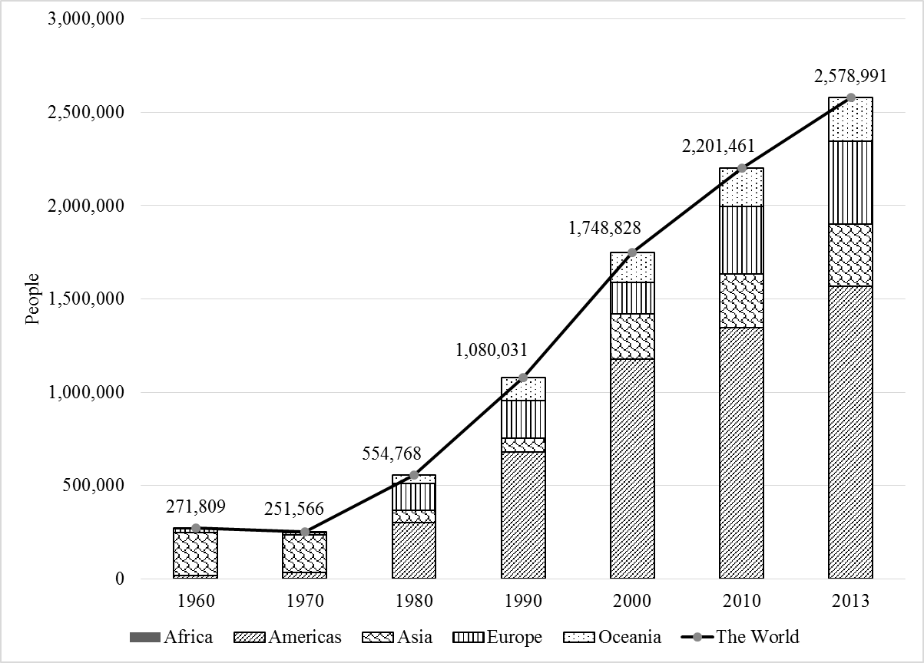
Source: World Bank

Figure 2: Vietnamese Population in Top Ten Destination Countries
2014
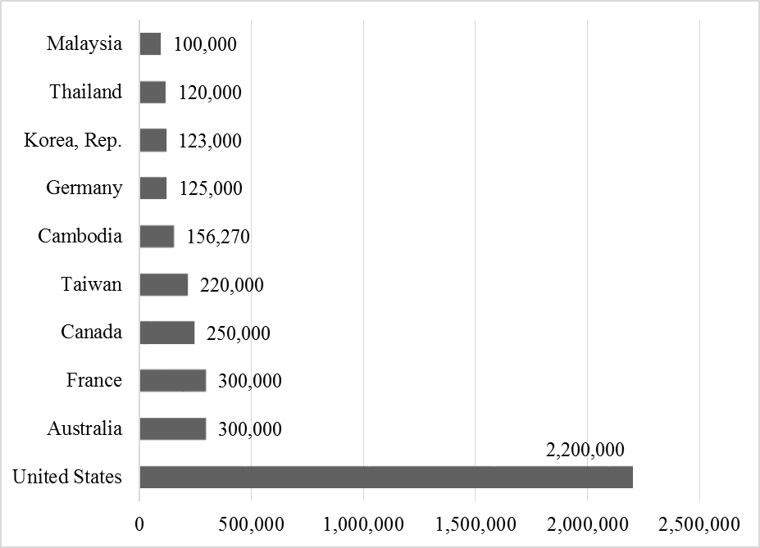
Source: World Bank

The Main Determinants of Return Migration

The extant literature on the determinants of return migration identifies four main theories:
1. Return as Failure;
2. Preference for Home Consumption;
3. Achieving Savings Goals and Returning to Invest, and
4. Human Capital Accumulation (OECD 2008).

According to the neoclassical approach to migration theory, spatial wage differentials are the dominant determinant of international migration (Sjaastad 1962). Prospective migrants make migration decisions based on their expected earning difference between the destination country and the origin country. If their real income in the destination turns out to be far lower than their expectation, they may reluctantly return to the origin country. Hence, neoclassical economists assume that return migrants are people who failed to achieve their desired objectives when migrating to a foreign country. In the 1970s, Yezer and Thurston (1976) and Allen (1979) modelled return migration in a framework based on the human capital model of Sjaastad (1962). Within their analyses, the reverse migration flows were primarily comprised of disappointed migrants who were not satisfied with their performance in the receiving country. These authors believed that imperfect information is the reason for this unplanned return. Migrants use inaccurate information about the labour market in the receiving country and err in their calculation of the expected income gained from migration. The lower the accuracy of information, the higher the propensity to return to the origin country.

In contrast, return migrants may instead be considered successful people who have achieved their goals when living abroad. Migrants with a higher probability of return to a low-wage origin country have higher mean income, save more, and work harder than comparable native-born workers in the high-wage host country (Galor and Stark 1990, 1991). Hill (1987) and Djajic and Milbourne (1988) established the foundation for explaining temporary migration phenomena based on the preference of migrants for locationally-fixed features in the origin country. This body of literature assumes that prospective migrants aim to maximize their lifetime utility from consumption and have a preference for consumption in the home country. Within this analysis framework, the utility gained from consumption in the origin country is assumed to be higher than the utility gained from similar consumption in the host country.

Economists in the New Economics of Labour Migration (NELM) extended this positive view of return migration by explicitly integrating a return strategy in their framework. While referring to the NELM’s view in a thorough review of the conceptual approach to return migration, Cassarino (2004, p.255) identified "return migration as the logical outcome of a 'calculated strategy' ". According to this approach, migrants accumulate income abroad to generate financial capital for investment purposes upon return to their home country. Moreover, different returnees with different durations of living abroad will have different motivations for return. Failed returnees may re-emigrate rather soon after initial migration, whereas migrants who return for home consumption are assumed to migrate back home at later stages of their working lives. Meanwhile, those who return to invest are argued to calculate the optimal duration of living abroad so that they can accumulate sufficient funds to set up businesses upon their return and enjoy the outcomes of their investments.

One further theory of return migration argues that human capital accumulation is the driver of the decision to return, because not all migrants engage in spatial mobility in response to wage differentials in labour markets. There are people who temporarily migrate primarily to accumulate knowledge, experience and skills or to acquire international higher education degrees that are expected to yield high returns in the home country. This literature helps to explain the return decisions of international students. Although the augmented human capital also enables migrants to perform more productively in the host country, which generates better income, they may choose to return because their home country highly rewards their contribution.

A number of empirical studies strongly confirm that there is a wage premium in the origin country for people with international migration experience in comparison with non-migrants (Ambrosini, Mayr, Peri and Radu 2012, Barrett and Goggin 2010, Barrett and O’Connell 2001, Co, Gang and Yun 2000, Lacuesta 2010, Poot and Roskruge 2013, Vreyer, Gubert and Robilliard 2010, Wahba 2004, 2015). Moreover, besides monetary rewards, international qualifications may be status symbols in developing countries that not only bring the holders high esteem, but also help them to gain higher positions within the hierarchy of the home country.

Since many episodes of migration are non-permanent, and temporary migration decisions might alter the behaviour of international migrants, Dustmann and Görlach (2016) developed a dynamic model to understand varying motives for return migration and how migration temporariness affects the economic choices of migrants. Their simple model produces four different motives for return migration: (i) preference for consumption in the home country; (ii) high purchasing power of the host-country currency in the country of origin; (iii) temporarily higher earnings in the host country and (iv) faster accumulation of skills in the host country. While the two former motives abstract from human capital accumulation to focus on the utility gained from consumption, the latter ones abstract from the heterogeneity in individual characteristics, consumption and price levels across countries, to highlight the role of human capital accumulation. Their basic dynamic model can be augmented to implement more complicated analysis by including such elements as changes in preferences, collective decision making, unemployment risk, repeat migrations, and so on.
Although there exists a literature on return migration, especially the return of international migrants from developed to developing countries, scholars in this field of study have not reached a consensus on the motives for return. The dominant arguments that underlie the motivations of return migration reviewed above centre on the success versus failure experience, which solely embraces individual decisions of the returnees themselves without accounting for individual perceptions of contextual conditions. Despite the fact that contextual factors have been embodied in migration theory since the early 1960s, initiated by the push-pull model of Lee (1966), scholars have been less likely to include the role of these factors in explaining the counter-currents of human mobility. However structuralists, who are inspired by the regional push and pull factors in the host and home countries, have developed another strand of literature that bridges this gap. The incentives for return are plausibly related to the reasons for initial emigration.

While there is evidence that contextual conditions matter for emigrants, they also matter for return migrants. If a migrant chooses to emigrate in part because they are disappointed with the institutional quality in their home country, an appropriate improvement in institutional quality back home may induce them to return. Furthermore, contextual conditions in the home country play an importance role in the re-integration process of return migrants, especially of those migrants who are not at the late stage of their life course and return with capital acquired from abroad.

Cerase (1974) argued that, apart from individualistic motivations of repatriation, it is crucial to understand the economic forces that push migrants abroad as well as awaiting problems of re-adaption faced by returnees in the home country. In particular, the return resolution of migrants depends on the extent to which the ‘reality’ meets their expectation. He identified two factors that account for success or failure of the return experience: the economy, and the power relations among classes in the society of the region of repatriation. His illustrations associate the decisions to return with the social, economic and institutional context in the home country. Shortly afterwards, Gmelch (1980) reviewed findings on return migration, and argued that the pull factors in the home country have more influence on return decisions than push factors in the host country.

Subsequent attempts to apply the structuralist approach, which are of relevance for this paper in terms of taking contextual conditions at the local level into account, include Morettini, Presbitero, and Tamberi (2012) and Junge, Revilla Diez, and Schätzl (2015). While the former ascertained the determinants of international migration, the latter analysed determinants of internal return migration. Morettini et al. (2012) synthesized variables linked to the socio-economic structure of provinces in Italy into an augmented gravity model. These variables contribute as pull factors for international migration flows originating from 142 countries to 103 Italian provinces. Junge et al. (2015) included both local and regional contextual pull factors in a regression analysis examining the determinants of internal return migration in Thailand and Vietnam. These two papers found significant evidence of the importance of local contextual conditions for migration decisions of international and internal migrants respectively. However, the local contextual conditions examined in these studies are limited to local socio-economic aspects of the destinations only. Neither paper assessed the role of local institutional quality as a pull factor for return migration.

Research Method

This paper examines the impacts of individual attributes of Vietnamese return migrants and characteristics of regional destinations in Vietnam on the locational choices of Vietnamese returnees by applying binary and multinomial regression models. The locational choices of Vietnamese migrants who returned in 2014 to the south central and the south regions of Vietnam are used as the dependent variable in our models.

First, a logistic regression model is fitted to identify the impacts of individual-specific variables on the choices of returning to Ho Chi Minh City (the largest city in Vietnam) versus somewhere else in the south central or south of Vietnam. In most countries, migrants are disproportionally drawn to the largest city, which tends to have the best international connectivity as well as the largest labour market. The model can be written as:

$$\frac{P_{i}}{1-P_{i}}=e^{X_{i}β}$$ | [1]

where $\frac{P_{i}}{1-P_{i}}$ is the odds ratio in favour of choosing a destination other than Ho Chi Minh City for return migrant i, X_{i} is a vector of individual-specific variables (age, gender and institutional quality of the host country), and $β$ is a vector of coefficients to be estimated. Taking the natural logarithm of Equation [1], we obtain the log odds ratio, which is a linear function of the migrant’s characteristics:

$$ln\left(\frac{P_{i}}{1-P_{i}}\right)=X_{i}β$$ | [2]

By estimating Equation [2], we aim to determine what makes a migrant choose a destination other than Ho Chi Minh City.

Secondly, as a robustness check, we re-examine the impacts of individual-specific variables using a Multinomial Logit Model (MLM), with locational choices based on four geographical regions – South Central Coast, Central Highlands, Southeast Region and Mekong River Delta – with Ho Chi Minh City again as the 'default' choice. Technically, Ho Chi Minh City is a part of the Southeast Region. However, more than 40 percent of the return migrants selected Ho Chi Minh City as their destination. There is no doubt that Ho Chi Minh City should be treated as an important alternative for the returnees to choose against other regions in the area. The MLM can be written as:

$$π_{ij}=\frac{e^{γ_{j}+δ_{j}X_{i}}}{\sum_{j=1}^{5}{e^{γ_{j}+δ_{j}X_{i}}}}$$ | [3]

where $π_{ij}$ is the probability that return migrant i chooses region j. In order to estimate the probability of choosing a particular region, Ho Chi Minh City is again chosen as the base region. The model can alternatively be expressed as log of odds ratios for the odds of each region versus the base region:
$$ln\left(\frac{P_{ij}}{P_{i5}}\right)=γ_{j}+δ_{j}X_{i}$$ | [4]

Thirdly, we fitted a Conditional Logit Model (CLM) to additionally examine the impacts of region-specific variables, including local institutional quality. We fit the CLM with the five regions defined for the MLM. The CLM can be written as:

$$π_{ij}=\frac{e^{φ+ωZ_{ij}}}{\sum_{j=1}^{5}{e^{φ+ωZ_{ij}}}}$$ | [5]

where $π_{ij}$ is the probability that return migrant i chooses region j and Z_{ij} contains values of region-specific independent variables (local institutional quality, population size, physical distance) that determine the probability migrant i chooses destination j (as in the logistic and MLM models, the actual observation for any individual is simply '1' if a particular destination has been selected, and ‘0' otherwise). Local institutional quality is the key variable of interest. Additionally, population size and physical distance to Ho Chi Minh City enter the model, as suggested by the gravity model of migration.

Analogous to Newton’s gravitational force concept, Zipf (1946) hypothesized that the migration volume between pairs of communities is positively related to the product of the two communities’ population sizes and negatively related to the distance between origin and destination communities. The population sizes represent the opportunities faced by potential migrants, while distance is used as a proxy for migration costs. Zipf’s idea inspired the later empirical work of other researchers in this field (see, for example, Poot, Alimi, Cameron and Maré 2016 for a recent review). As a result, today the extended gravity model includes other variables representing socio-economic, political, cultural, and demographic characteristics of both the origin and destination communities (Cameron 2017, Clark, Hatton and Williamson 2007, Fitzgerald, Leblang and Teets 2014, Karemera et al. 2000, Lewer and Van den Berg 2008 and Morettini et al. 2012). Basically, migration flows between pairs of countries are inversely related to the socio-economic, political, and cultural distances between countries.
The CLM can alternatively be expressed as log of odds ratios for the odds of region j versus region k:
$$ln\left(\frac{P_{ij}}{P_{ik}}\right)=(Z_{ij}-Z_{ik})'ω$$ | [6]
In this case, $ω$ represents a vector of coefficients that demonstrate the effects of region-specific variables on the log of odds-ratios for the odds of region j versus region k. Furthermore, we endeavour to demonstrate the link between individual attributes and regional characteristics through the use of two interaction terms in Equation (6), i.e. through defining $Z_{ij}=X_{i}Y_{j}$ in which $X_{i}$ is a characteristic of individual i and $Y_{j}$ is a characteristic of destination j. The first interaction term is between age and local institutional quality. Migrants at different states of their working lives are known to have different motivations for return and, therefore, the impacts of region-specific factors – local institutional quality in particular – in the home country on locational choices upon return are expected to be age dependent.

The second interaction term is between institutional quality in the host country and local institutional quality in the home country. This idea emerges from the gravity theory, suggesting that migration flow from country o to country d is impaired not only by physical distance but also by socio-economic, political or cultural distance, as noted above. This interaction term is employed to capture the non-physical distance. Accordingly, migrants from a host country with higher institutional quality are expected to be more likely to choose a region upon return that has higher local institutional quality. Therefore, our a priori expectation is that this interaction should have a positive sign.

Finally, we consider both sets of independent variables (individual-level and region-level) simultaneously by incorporating individual-specific variables in the CLM to create a Mixed Logit Model (MXL). Since the effect of age is captured in the first interaction term, we only control for gender by interacting this individual-specific variable with regional dummies excluding the base region (Ho Chi Minh City), and incorporating these interaction terms in the CLM. We use the Mixed Logit Model mainly as a robustness check, in terms of consistency with the results derived from other specifications.

Data

Data on the locational choices of Vietnamese return migrants were obtained from the database of Vietnamese return migrants assembled by the Overseas Vietnamese Committee of Ho Chi Minh City. This dataset records information on date of birth, gender, host country and provincial destination choices of 654 Vietnamese migrants who returned to provinces and cities in the south central and the south of Vietnam in 2014. We remove some outliers from our analysis, such as returnees whose ages were recorded as being over 100 at the time of their return. We also remove those who were under age 18, because they were unlikely to have been the decision-maker in terms of the migration decision. This leaves a sample of 628 Vietnamese returnees. A statistical summary across regions is presented in Table 1. Nearly 87 percent of the Vietnamese returnees chose Ho Chi Minh City, the rest of the Southeast Region, or the Mekong River Delta to reside upon return, whereas the South Central Coast and the Central Highlands attracted just 13 percent of the returnees.

Table 1: Summary Statistics
Locational Choices of Vietnamese Return Migrants 2014
Region |  | Age  (mean) | Number of  Returnees | Percent | Cum.  percent
Non-Ho Chi Minh City |  | 61.27 | 356 | 56.69 | 56.69
 | South Central Coast | 64.72 | 67 | 10.67 | 10.67
Central Highlands |  | 69.53 | 15 | 2.39 | 13.06
Southeast Region |  | 59.52 | 61 | 9.71 | 22.77
Mekong River Delta |  | 60.10 | 213 | 33.92 | 56.69
Ho Chi Minh City |  | 59.02 | 272 | 43.31 | 100.00
Total |  | 60.30 | 628 | 100.00 | 100.00

Individual-specific independent variables include age, gender, and institutional quality in the host country. Age is calculated based on the reported date of birth. This variable appears in the models in natural logarithm (lnage). The mean age of Vietnamese returnees in the sample at the time of their return was roughly 60. Gender (gender) is a dummy variable taking the value of 1 if a return migrant is male, and 0 otherwise. In regards to host country institutional quality, we employ the following five indicators reported by the Freedom House, the Fraser Institute, and the POLITY IV project, as alternative measures at the national level. The first indicator is the freedom status (freedom_host) of a country. This information is acquired from the Freedom in the World annual report on political rights and civil liberties by Freedom House, where each country is classified into three categories: free, partly free, or not free. Freedom status enters our analysis as a dummy variable taking the value of 1 if a country’s freedom status is 'free', and 0 otherwise.

The next two indicators are the global political rights index (pr_host) and civil liberties index (cl_host); both also from the report published by Freedom House. In these measures, each country is rated by a score that ranges from 1 (the most free) to 7 (the least free). This score is reframed to a range from 1 (the least free) to 7 (the most free) for convenience in interpreting the results (with a higher value of each indicator corresponding to higher institutional quality). The fourth indicator is the Economic Freedom of the World Index (efw_host) calculated by the Fraser Institute. This annual index is comprised of factors that make a country economically free, and is scored out of 10, with higher scores indicating a higher degree of freedom. The last indicator is the combined polity score (polity2_host) from the POLITY IV project computed by subtracting the Institutionalized Democracy score from the Institutionalized Autocracy score to come up with a unified polity scale that ranges from +10 (strongly democratic) to -10 (strongly autocratic). Table A1 in the Appendix provides summary statistics for these measures. Most of the returnees in our sample were from developed host countries with relatively high institutional quality.

Region-specific independent variables encompass regional institutional quality, regional population, and physical distance from Ho Chi Minh City (summary statistics are provided in Table A2 in the Appendix). Regional institutional quality (labelled pci) is proxied by the population-weighted average of the Provincial Competitiveness Index (PCI). PCI is an index that measures the economic institutional quality of provincial authorities in creating a favourable business environment for the private sector. This measure has been published annually since 2005 by the Vietnam Chamber of Commerce and Industry (VCCI) with the support of the United States Agency for International Development (USAID) (Malesky 2013).

The ten sub-indices of the PCI include: (1) entry costs; (2) land access and security of tenure; (3) transparency and access to information; (4) time costs and regulatory compliance; (5) informal charges; (6) policy bias; (7) proactivity of provincial leadership; (8) business support services; (9) labour and training; and (10) legal institutions. This index is based on surveys administered to businesses and published data sources. This yields a score for each region with a higher score indicating better institutional quality. Figure 3 maps the PCI scores of all provinces in Vietnam. Some patterns in the south central and the south areas of Vietnam are apparent. Although no province reached the threshold denoting excellent performance, not a single province was in the ‘mid-low’ or ‘low’ categories. Most of the high performers are located in the south central and the south areas. Nine out of seventeen provinces in the Mekong Delta, which may be considered the most 'dynamic' region, have the highest institutional quality. Meanwhile, there was no province in the ‘high’ category found in the Central Highlands.

Regional population (lnpop) is the natural log of total provincial population in each region, measured in thousands of people, assembled from the database of the General Statistics Office of Vietnam (GSO). Inter-regional distance is defined as the population-weighted average of distance measured in kilometres of road travel from each region to Ho Chi Minh City, obtained from Google Maps. Because the value of distance associated with Ho Chi Minh City to itself is zero, this variable enters the models as the natural log of one plus the distance (lndistance).

Figure 3: PCI Ranking of Provinces in Vietnam 2012
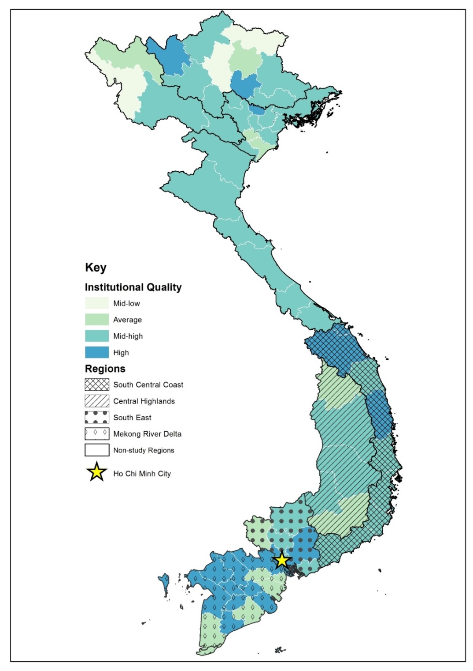
Notes  PCI Score for Each Tier  Excellent: PCI score ≥ 65  High: 60 ≤ PCI score < 65  Mid-high: 53≤ PCI score < 60 | Source: Malesky (2013)  Average: 51 ≤ PCI score < 53  Mid-low: 45 ≤ PCI score < 51  Low: PCI score < 45
It is worth noting that Vietnamese migrants who decided to return permanently to Vietnam have to complete a time-consuming permanent resident registration formality, which takes a couple of years. Consequently, all the independent variables capturing the national and regional characteristics used in this paper contain 2012 data (that is, data that would have been available or potentially known to the return migrants at the time of their decision to migrate in 2014).

Finally, some limitations of our data are worth noting. The dataset is not nationwide, and is limited to a single year of data from return migrants in 2014. Moreover, other personal information, such as education level, income, migration history and duration of stay in the host country, which could potentially explain the return decisions of Vietnamese return migrants, are not available in the dataset. These limitations are due to the unavailability of systematic migration data in Vietnam, especially data on return migration.

6. Results and Discussion

This section is organised into two sub-sections. We first interpret the results of the logistic regression models for which the independent variables are individual-specific. Second, we present the results of the Conditional Logit Models and Mixed Logit Models, which include both individual-specific and region-specific independent variables.

6.1 Logit and Multinomial Logit Models with Individual-Specific Variables

Table 2 displays the estimates for Equation [2], that is, the logistic regression model. Each of the five regressions uses a different measure of host country institutional quality. The estimated coefficients for age are statistically significant in all models, suggesting that the locational choices of Vietnamese return migrants differ significantly by age. Since the values of the odds ratios associated with age are greater than one, holding other variables constant, an increase in age is associated with lower odds of returning to Ho Chi Minh City (and higher odds of returning to other regions). In other words, while younger migrants were more likely to choose Ho Chi Minh City, the largest central city of Vietnam, to reside in upon return, older migrants prefer other destinations. This outcome might result from the variation in return motivations between different generations of migrants.

Returnees who are at a later stage of their working lives at the time of their return might be attracted to locationally-fixed features in their original home towns, where they probably enjoy living near their relatives and benefit from higher utility gained from consumption. Thus, it is plausible that large urban centres are possibly not their priority. In contrast, younger migrants are more likely to return to invest their capital acquired abroad. Thus, they tend to choose locations where more opportunities are available for them to develop their potential, as is the case in Ho Chi Minh City.
Table 2: Estimates for Logit Model
with Individual-Specific Variables Logit Model
Alternative Measures of Institutional Quality  in the Host Country | freedom_host | pr_host | cl_host | efw_host | polity 2_host
[lnage] | 2.1108** | 2.1113** | 2.1525*** | 2.0959** | 2.1041**
 | (0.6199) | (0.6198) | (0.6348) | (0.6184) | (0.6179)
[gender] | 1.5728*** | 1.5645*** | 1.5783*** | 1.5613*** | 1.5705***
 | (0.2635) | (0.2618) | (0.2643) | (0.2607) | (0.2626)
[Institutional quality  in the host country] | 0.2543* | 0.7998 | 0.8039 | 0.8284 | 0.9326
 | (0.2007) | (0.1217) | (0.1320) | (0.2915) | (0.0642)
Log Likelihood | -421.5439 | -422.1802 | -422.4763 | -423.3078 | -422.8866
Notes
Factor change in odds of Non-Ho Chi Minh City versus Ho Chi Minh City.
Exponentiated coefficients. Standard errors in parentheses.
N = 628.
* p<0.1, ** p<0.05, *** p<0.01

Likewise, we observe a significant difference between male and female migrants in their choices of return location. More specifically, all other things being equal, men were less likely to choose to return to Ho Chi Minh City than women. This result may be explained by the practice of ancestor worship in Vietnamese traditional culture. Almost every Vietnamese family has an altar to commemorate their ancestors and deceased family members. Beyond psychic beliefs, this is an important traditional value that strengthens the kinship among family members and relatives. Traditionally, men who are heads of families are responsible for taking care of ancestor worship. Therefore, it is understandable that Vietnamese male migrants (as well as older migrants) are more prone to returning to their original home towns where the worship practice takes place.

Institutional quality in the host country has an odds ratio of less than one, which implies that Vietnamese migrants who returned from the host countries with a high degree of freedom status or with a high score of institutional quality were more likely to choose Ho Chi Minh City. However, this coefficient is only statistically significant for one of the five measures of host country institutional quality. This may result from the fact that a small sample size of around 600 is underpowered to identify any effect when there are not large cross-country variations in the measures of institutional quality of host countries.

The estimates for Equation [4] are summarized in Table A3 in the Appendix. These results demonstrate that older return migrants prefer returning to the South Central Coast and Central Highlands regions over Ho Chi Minh City, while male migrants prefer the Southeast region and the Mekong Delta. Host country institutional quality is only statistically significant for the Southeast Region, which explains the inconsistent results in Table 2. The differences in effects between regions suggest that region-specific variables are likely to be an important determinant of migrants’ decisions, which we explore in the next sub-section.

6.2 Conditional Logit Models with Region-Specific Variables

Table 3 summarizes the results of the Conditional Logit Models with region-specific variables. Table 3 reports the results using freedom_host as the measure of host country institutional quality, while Tables A4 and A5 in the Appendix provide full reports of the results obtained with the alternative measures of host country institutional quality. Column (1) of Table 3 presents the estimates for Equation [6]. All of the coefficients are statistically significant, and the p-value of the log likelihood chi-squared indicates that our model fits the data well.

The estimates reveal a positive link between local institutional quality in the home country and the locational choices of Vietnamese return migrants. More specifically, increasing the PCI score for any of the regions would increase the odds of returning to that region, holding the PCI scores of the other regions as well as other variables constant. This result provides convincing empirical support for the role of institutional quality at the local level as a ‘pull factor’ for migration decisions. The direction of the effects of population and distance are consistent with the predictions from gravity models of migration. The larger the population size, the more inviting the region. The significant odds ratio of distance of less than one suggests that Vietnamese return migrants are less likely to choose to locate in a region the further it is from Ho Chi Minh City.

In column (2) we report results that include interaction terms between local institutional quality and both age and institutional quality in the host country. The inclusion of these interaction terms not only fortifies the impacts of the key region-specific variables, but also reveals some interesting insights about these impacts. First, the significant odds ratio on the interaction term between PCI and age shows that the higher the age, the less positive the effect of PCI on the locational choices of returnees. Specifically, older migrants are less concerned about the local institutional quality than are younger migrants. This is likely because of differences in motivation for return migration between older and younger migrants, with older migrants returning to their home village for retirement, while younger migrants return to Ho Chi Minh City for investment purposes.

Secondly, those who returned from a ‘freer’ country were more likely to choose a region with a higher PCI score. This finding demonstrates the link between international migration and institutional quality in the home country through the return channel. Specifically, migrants who have experienced higher quality institutions in the host country may be more likely to value higher quality institutions on their return to Vietnam.
Table 3: Estimates for Conditional Logit Model with Region-Specific Variables
and Mixed Logit Model with Both Individual-Specific and Region-Specific Variables

 | (1)  Conditional  Logit  Model | (2)  Conditional  Logit Model  with Interactions | (3)  Mixed  Logit  Model
[pci] | 1.2878*** | 5.2278*** | 6.0562***
 | (0.1232) | (3.0369) | (3.7543)
[lnpop] | 2.6670*** | 2.4282*** | 2.8523**
 | (0.7544) | (0.6972) | (1.4411)
[lndistance] | 0.8469*** | 0.8662*** | 0.8146**
 | (0.0450) | (0.0472) | (0.0783)
[lnage]x[pci] |  | 0.6652*** | 0.6408***
 |  | (0.0881) | (0.0877)
[freedom_host]x[pci] |  | 1.3737* | 1.4031*
 |  | (0.2416) | (0.2464)
[gender]x[South Central Coast] |  |  | 1.9868**
 |  |  | (0.5462)
[gender]x[Central Highlands] |  |  | 2.2834
 |  |  | (1.3506)
[gender]x[Southeast Region] |  |  | 1.5465*
 |  |  | (0.3600)
[gender]x[Mekong River Delta] |  |  | 1.3828*
 |  |  | (0.2591)
Log Likelihood | -807.0541 | -801.0016 | -796.7043
Notes
Factor change in odds of region j versus region k.
Exponentiated coefficients.
Standard errors in parentheses.
N = 628.
* p<0.1, ** p<0.05, *** p<0.01

Column (3) of Table 3 shows the results of the Mixed Logit Model fitted to include both individual-specific and region-specific variables. After controlling for gender, the estimates for the region-specific variables and the interaction terms remain consistent with those of the Conditional Logit Models in Columns (1) and (2). Moreover, the estimates for the interaction terms between gender and region dummies are also consistent with those of the Multinomial Logit Model in Table A3 in the Appendix.

The results obtained from different specifications discussed in this sub-section are strongly robust across different measures of institutional quality in the host country (see Tables A4 and A5 in the Appendix). Importantly, the variable of interest – PCI – is positive and statistically significant unless we use efw_host as the indicator of host country institutional quality. Although the interaction term between PCI and institutional quality in the host country loses its significance when using measures of institutional quality other than freedom status, they are still consistent in terms of their direction.

7. Conclusions

Earlier work has documented the role of institutional quality as a pull factor affecting the migration decisions of international migrants. This study is the first to extend this idea to the locational choices of return migrants. We use data on the locational choices of Vietnamese return migrants to investigate this issue. We found that younger and female returnees were more likely to choose to reside in Ho Chi Minh City rather than other regions, and that regions with better institutional quality attracted more returnees. In addition, the impact of local institutional quality on the locational choices of Vietnamese return migrants is related to their age and their migration experience. While local institutional quality has a significant role in return decisions of Vietnamese return migrants, younger returnees appear to be the most concerned about the institutional quality of the regions they were returning to.

Most importantly, migrants from host countries with higher level of freedom were more likely to choose to return to regions with higher local institutional quality. This finding not only reinforces the role of institutional quality as a determinant of migration decisions, but also contributes to the norm diffusion literature. Owing to the process of integration and assimilation, migrants are exposed to and adopt favourable attributes of institutional mechanisms in developed host countries, and they are expected to transfer their absorbed norms to the home country through the return channel (Batista and Vicente 2011, Chauvet and Mercier 2014, Mahmoud et al. 2014 and Pfutze 2012).

Norm diffusion derived from migration can be observed at different levels. As mapped out by Rüland, Kessler and Rother (2009), there are three pathways of norm diffusion: changes of attitudes at the individual level; collective action; and institutional change at the national and global levels. Our results provide convincing evidence of changes in attitudes at the individual level towards institutional quality reflected in the locational choices of Vietnamese return migrants upon returning to the home country. In particular, return migrants from ‘free’ host countries highly value local institutional quality.

Drawing from our findings, we observe a two-way relationship between migration and institutional quality. The locational choices of return migrants are shown to be dependent on local institutional quality. On the other hand, these choices intriguingly imply changes in return migrants’ attitudes toward institutional quality. These attitudinal changes are of decisive importance in terms of underpinning the further potential of return migrants to act as norm remitting agents at higher levels that induce influences on institutional quality in the home country.

Our findings also suggest that better local institutional quality may attract return migrants, who have high potential to contribute to regional development. In regards to policy implications, our results provide compelling evidence for policy makers in Vietnam (and potentially other similar developing countries that have large diasporas and large numbers of return migrants) that improving local institutional quality is a significant measure for attracting potential resources, especially human resources, from abroad.

References
Allen, J. (1979). Information and Subsequent Migration: Further Analysis and Additional Evidence. Southern Economic Journal, 45, 1274–1284.
Ambrosini, W., Mayr, K., Peri, G., and Radu, D. (2012). The Selection of Migrants and Returnees in Romania: Evidence and Long-Run Implications (IZA Discussion Paper No. 6664). Bonn: The Institute for the Study of Labor (IZA).
Ammassari, S. (2004). From nation-building to entrepreneurship: the impact of élite return migrants in Côte d’Ivoire and Ghana. Population, Space and Place, 10(2), 133–154.
Barrett, A., and Goggin, J. (2010). Returning to the Question of a Wage Premium for Returning Migrants. National Institute Economic Review, 213(1), R43–R51.
Barrett, A., and O’Connell, P. J. (2001). Is There a Wage Premium for Returning Irish Migrants? The Economic and Social Review, 32, 1–21.
Batista, C., and Vicente, P. C. (2011). Do Migrants Improve Governance at Home? Evidence from a Voting Experiment. The World Bank Economic Review, 25(1), 77–104.
Beine, M., and Sekkat, K. (2013). Skilled migration and the transfer of institutional norms. IZA Journal of Migration, 2(1), 1–19.
Bertocchi, G., and Strozzi, C. (2008). International migration and the role of institutions. Public Choice, 137, 81–102.
Cameron, M.P. (2017). Climate change, internal migration, and the future spatial distribution of population: A case study of New Zealand, Working Paper in Economics 17/03. Hamilton: Department of Economics, University of Waikato.
Cassarino, J.-P. (2004). Theorising Return Migration: The Conceptual Approach to Return Migrants Revisited. International Journal on Multicultural Societies (IJMS), 6(2), 253–279.
Cerase, F. P. (1974). Expectations and Reality: A Case Study of Return Migration from the United States to Southern Italy. International Migration Review, 8(2), 245–262.
Chauvet, L., and Mercier, M. (2014). Do return migrants transfer political norms to their origin country? Evidence from Mali. Journal of Comparative Economics, 42(3), 630–651.
Clark, X., Hatton, T. J., and Williamson, J. G. (2007). Explaining U.S. Immigration, 1971-1998. The Review of Economics and Statistics, 89(2), 359–373.
Co, C. Y., Gang, I. N., and Yun, M.-S. (2000). Returns to returning. Journal of Population Economics, 13, 57–79.
Djajic, S., and Milbourne, R. (1988). A General Equilibrium Model of Guest-Worker Migration. Journal of International Economics, 25, 335–351.
Docquier, F., Lodigiani, E., Rapoport, H., and Schiff, M. (2016). Emigration and democracy. Journal of Development Economics, 120, 209–223.
Dustmann, C., and Görlach, J.-S. (2016). The Economics of Temporary Migrations. Journal of Economic Literature, 54(1), 98–136.
Fitzgerald, J., Leblang, D., and Teets, J. C. (2014). Defying the Law of Gravity: The Political Economy of International Migration. World Politics, 66(3), 406–445.
Galor, O., and Stark, O. (1990). Migrants’ Savings, the Probability of Return Migration and Migrants’ Performance. International Economic Review, 31(2), 463–467.
Galor, O., and Stark, O. (1991). The probability of return migration, migrants’ work effort, and migrants’ performance. Journal of Development Economics, 35(2), 399–405.
Gmelch, G. (1980). Return Migration. Annual Review of Anthropology, 9, 135–159.
Hatton, T. J., and Williamson, J. G. (2011). Are Third World Emigration Forces Abating? World Development, 39(1), 20–32.
Hill, J. K. (1987). Immigrant Decisions Concerning Duration of Stay and Migratory Frequency. Journal of Development Economics, 25, 221–234.
Junge, V., Revilla Diez, J., and Schätzl, L. (2015). Determinants and Consequences of Internal Return Migration in Thailand and Vietnam. World Development, 71, 94–106.
Karemera, D., Oguledo, V. I., and Davis, B. (2000). A gravity model analysis of international migration to North America. Applied Economics, 32(13), 1745–1755.
Lacuesta, A. (2010). A Revision of the Self-selection of Migrants Using Returning Migrant’s Earnings. Annals of Economics and Statistics, (97/98), 235–259.
Lee, E. S. (1966). A Theory of Migration. Demography, 3(1), 47–57.
Lewer, J. J., and Van den Berg, H. (2008). A gravity model of immigration. Economics Letters, 99(1), 164–167.
Li, X., McHale, J., and Xuan, Z. (2013). Does Brain Drain Lead to Institutional Gain? (SSRN Scholarly Paper No. ID 2350203). Rochester, NY: Social Science Research Network.
Mahmoud, T. O., Rapoport, H., Steinmayr, A., and Trebesch, C. (2014). The Effect of Labor Migration on the Diffusion of Democracy: Evidence from a Former Soviet Republic (IZA Discussion Paper No. 7980). Bonn: The Institute for the Study of Labor (IZA).
Malesky, E. (2013). The Vietnam Provincial Competitiveness Index: Measuring Economic Governance for Private Sector Development-2012 Final Report (No. Vietnam Competitiveness Initiative Policy Paper #17). Ha Noi, Vietnam: Vietnam Chamber of Commerce and Industry and United States Agency for International Development’s Vietnam Competitiveness Initiative.
Ministry of Foreign Affairs of Vietnam. (2012). Review of Vietnamese Migration Abroad. Ha Noi: Ministry of Foreign Affairs of Vietnam.
Morettini, G., Presbitero, A. F., and Tamberi, M. (2012). Determinants of international migrations to Italian provinces (MPRA No. 36316).
OECD. (2008). International Migration Outlook: SOPEMI - 2008 Edition. France: OECD.
Pfutze, T. (2012). Does migration promote democratization? Evidence from the Mexican transition. Journal of Comparative Economics, 40(2), 159–175.
Poot, J., Alimi, O., Cameron, M. P., and Maré, D. C. (2016). The gravity model of migration: the successful comeback of an ageing superstar in regional science. Investigaciones Regionales; Madrid, (36), 63–86.
Poot, J., and Roskruge, M. J. (2013). Internationalisation of Education and Returns in the Labour Market. Studies in Regional Science, 43(1), 61–78.
Rotte, R., and Vogler, M. (1998). Determinants of International Migration: Empirical Evidence for Migration from Developing Countries to Germany (IZA Discussion Paper No. 12). Bonn: Institute for the Study of Labour (IZA).
Rüland, J., Kessler, C., and Rother, S. (2009). Democratisation Through International Migration? Explorative Thoughts on a Novel Research Agenda. European Journal of East Asian Studies, 8(2), 161–179.
Sjaastad, L. A. (1962). The Costs and Returns of Human Migration. The Journal of Political Economy, 70(50), 80–93.
Spilimbergo, A. (2009). Democracy and Foreign Education. The American Economic Review, 99(1), 528–543.
Vreyer, P. D., Gubert, F., and Robilliard, A.-S. (2010). Are There Returns to Migration Experience? An Empirical Analysis using Data on Return Migrants and Non-Migrants in West Africa. Annals of Economics and Statistics, (97/98), 307–328.
Wahba, J. (2004). Does international migration matter? A study of Egyptian return migrants. In Arab Migration in a Globalized World. Geneva: International Organization for Migration (IOM).
Wahba, J. (2015). Selection, selection, selection: the impact of return migration. Journal of Population Economics, 28(3), 535–563.
World Bank. (2011). Migration and Remittances Factbook 2011. Washington DC.
Yezer, A. M. J., and Thurston, L. (1976). Migration Patterns and Income Change: Implications for The Human Capital Approach to Migration. Southern Economic Journal, 42, 693–702.
Zipf, G. K. (1946). The P1 P2/D Hypothesis: On the Intercity Movement of Persons. American Sociological Review, 11(6), 677–686.

Appendix

Table A1: Summary Statistics
for Individual-Specific Independent Variables

 | Obs. | Mean | Median | SD | Min | Max | Freq. | Percent | Cum.
Age | 628 | 60.30 | 59.5 | 15.98 | 23 | 97
Gender | 628 | 0.61 | 1 | 0.49 | 0 | 1
Male |  |  |  |  |  |  | 386 | 61.46 | 61.46
Female |  |  |  |  |  |  | 242 | 38.54 | 100.00
Freedom Status in the Host Country | 628 | 0.98 | 1 | 1.23 | 0 | 1
Free |  |  |  |  |  |  | 617 | 98.25 | 98.25
Not-free |  |  |  |  |  |  | 11 | 1.75 | 100.00
Global Political Rights Index | 628 | 6.91 | 7 | 0.63 | 1 | 7
Civil Liberties Index | 628 | 6.90 | 7 | 0.55 | 2 | 7
Economic Freedom of World Index | 628 | 7.73 | 7.81 | 0.23 | 5.9 | 8.98
Polity Score | 628 | 9.76 | 10 | 1.29 | -7 | 10

Table A2: Summary Statistics
for Region-Specific Independent Variables
 | South  Central Coast | Central  Highlands | Southeast  Region | Mekong River  Delta | Ho Chi Minh  City
Regional Population | 9008.60 | 5363.30 | 7470.40 | 17379.60 | 7660.30
 | Average
PCI Score | 58.67 | 54.12 | 57.77 | 60.46 | 61.19
Distance to Ho Chi Minh City | 604.75 | 394.60 | 95.12 | 185.35 | 0.00
 | Population-Weighted Average
PCI Score | 58.91 | 54.77 | 58.94 | 60.53 | 61.19
Distance to Ho Chi Minh City | 626.95 | 380.56 | 91.97 | 182.55 | 0.00

Table A3: Estimates for Multinomial Logit Model with Alternative Measures of Institutional Quality in the Host Country
Multinomial Logit Model
Alternative Measures of  Institutional Quality in the Host Country | freedom_host | pr_host | cl_host | efw_host | polity 2_host
 | - South Central Coast
[lnage] | 4.0327*** | 4.0052*** | 4.0944*** | 3.9523** | 3.9188**
 | (2.1537) | (2.1376) | (2.1926) | (2.1200) | (2.0891)
[gender] | 1.7621* | 1.7427* | 1.7589* | 1.7326* | 1.7363*
 | (0.5156) | (0.5086) | (0.5139) | (0.5047) | (0.5062)
[Institutional quality in the host country] | 0.1946 | 0.7792 | 0.7738 | 0.8189 | 0.9568
 | (0.1979) | (0.1674) | (0.1900) | (0.5013) | (0.1180)
 | - Central Highlands
[lnage] | 18.3213** | 18.3329** | 17.0153** | 20.8764** | 15.8647**
 | (21.7318) | (21.7360) | (20.3056) | (25.2842) | (18.6688)
[gender] | 1.9010 | 1.9165 | 1.8753 | 1.9406 | 1.8705
 | (1.0918) | (1.1008) | (1.0784) | (1.1165) | (1.0760)
[Institutional quality in the host country] | 56323.1148 | 36762.8805 | 106953.5219 | 0.5011 | 345565.5866
 | (49200828.0022) | (22832979.5483) | (69587342.5918) | (0.5686) | (224700000)
 | - Southeast Region
[lnage] | 1.6396 | 1.6487 | 1.7319 | 1.7206 | 1.6409
 | (0.8680) | (0.8727) | (0.9201) | (0.9182) | (0.8695)
[gender] | 1.9764** | 1.9484** | 1.9932** | 1.9316** | 2.0056**
 | (0.6147) | (0.6039) | (0.6186) | (0.5957) | (0.6250)
[Institutional quality in the host country] | 0.0941*** | 0.6582** | 0.6230** | 0.3513** | 0.8414**
 | (0.0834) | (0.1152) | (0.1223) | (0.1808) | (0.0677)
 | - Mekong River Delta
[lnage] | 1.6769 | 1.6788 | 1.6883 | 1.6323 | 1.6742
 | (0.5539) | (0.5547) | (0.5604) | (0.5421) | (0.5539)
[gender] | 1.4259* | 1.4229* | 1.4276* | 1.4213* | 1.4237*
 | (0.2692) | (0.2686) | (0.2698) | (0.2682) | (0.2687)
[Institutional quality in the host country] | 0.4774 | 0.8897 | 0.9203 | 1.2057 | 0.9777
 | (0.4389) | (0.1594) | (0.1828) | (0.5091) | (0.0842)
 | - Ho Chi Minh City (base region)
Log Likelihood | -791.4577 | -792.5059 | -792.3775 | -793.1693 | -792.2402
Notes
Factor change in odds of a certain region versus the base region. Exponentiated coefficients. Standard errors in parentheses. N=628.
* p<0.1, ** p<0.05, *** p<0.01
Table A4: Estimates for Conditional Logit Model with Alternative Measures of Institutional Quality in the Host Country
 | Conditional Logit Model with Interactions
Alternative Measures of  Institutional Quality in the Host Country |  | freedom_host | pr_host | cl_host | efw_host | polity 2_host
[pci] |  | 5.2278*** | 4.7741*** | 4.6801** | 1.6452 | 5.8116***
 |  | (3.0369) | (2.8700) | (2.8970) | (1.7422) | (3.4096)
[lnpop] |  | 2.4282*** | 2.4426*** | 2.4498*** | 2.4378*** | 2.4640***
 |  | (0.6972) | (0.7003) | (0.7019) | (0.6988) | (0.7052)
[lndistance] |  | 0.8662*** | 0.8651*** | 0.8645*** | 0.8655*** | 0.8633***
 |  | (0.0472) | (0.0470) | (0.0469) | (0.0470) | (0.0468)
[lnage]x[pci] |  | 0.6652*** | 0.6643*** | 0.6623*** | 0.6545*** | 0.6681***
 |  | (0.0881) | (0.0882) | (0.0881) | (0.0879) | (0.0886)
[Institutional quality in the host country]x[pci] |  | 1.3737* | 1.0603 | 1.0652 | 1.2192 | 1.0186
 |  | (0.2416) | (0.0409) | (0.0508) | (0.1582) | (0.0201)
Log Likelihood |  | -801.0016 | -801.3634 | -801.5490 | -801.2111 | -801.9078
Notes
Factor change in odds of region j versus region k.
Exponentiated coefficients.
Standard errors in parentheses.
N=628.
* p<0.1, ** p<0.05, *** p<0.01

Table A5: Estimates for Mixed Logit Model with Alternative Measures of Institutional Quality in the Host Country
 | Mixed Logit Model
Alternative Measures of  Institutional Quality in the Host Country |  | freedom_host | pr_host | cl_host | efw_host | polity 2_host
[pci] |  | 6.0562*** | 5.4458*** | 5.2418** | 1.8325 | 6.5664***
 |  | (3.7543) | (3.4641) | (3.4008) | (1.9739) | (4.0897)
[lnpop] |  | 2.8523** | 2.8992** | 2.9065** | 2.9179** | 2.9289**
 |  | (1.4411) | (1.4610) | (1.4646) | (1.4684) | (1.4758)
[lndistance] |  | 0.8146** | 0.8115** | 0.8110** | 0.8104** | 0.8096**
 |  | (0.0783) | (0.0777) | (0.0777) | (0.0774) | (0.0775)
[lnage ]x[pci] |  | 0.6408*** | 0.6414*** | 0.6384*** | 0.6331*** | 0.6452***
 |  | (0.0877) | (0.0878) | (0.0876) | (0.0875) | (0.0881)
[Institutional quality in the host country]x[pci] |  | 1.4031* | 1.0635 | 1.0725 | 1.2242 | 1.0217
 |  | (0.2464) | (0.0411) | (0.0506) | (0.1593) | (0.0202)
[gender]x[South Central Coast] |  | 1.9868** | 1.9829** | 1.9949** | 1.9819** | 1.9893**
 |  | (0.5462) | (0.5452) | (0.5485) | (0.5450) | (0.5469)
[gender]x[Central Highlands] |  | 2.2834 | 2.2101 | 2.2398 | 2.1577 | 2.2134
 |  | (1.3506) | (1.2997) | (1.3191) | (1.2646) | (1.3051)
[gender]x[Southeast Region] |  | 1.5465* | 1.5377* | 1.5458* | 1.5348* | 1.5387*
 |  | (0.3600) | (0.3576) | (0.3597) | (0.3568) | (0.3578)
[gender]x[Mekong River Delta] |  | 1.3828* | 1.3816* | 1.3842* | 1.3820* | 1.3826*
 |  | (0.2591) | (0.2589) | (0.2594) | (0.2590) | (0.2590)
Log Likelihood |  | -796.7043 | -797.1431 | -797.2490 | -797.0362 | -797.6582
Notes
Factor change in odds of region j versus region k. Exponentiated coefficients.
Standard errors in parentheses. N=628.
* p<0.1, ** p<0.05, *** p<0.01

The host country and the home country are interpreted from the viewpoint of a migrant who is making a return decision. The host country is where a return migrant comes from. The home country is where a return migrant goes to, and is also the country where they were born.
https://freedomhouse.org/report-types/freedom-world
https://www.fraserinstitute.org/economic-freedom/dataset
http://www.systemicpeace.org/inscrdata.html
http://www.gso.gov.vn/

