**UNIVERSITY OF WAIKATO**

**Hamilton**

**New Zealand**

**The Organizing Framework of Ecosystem Services**

**and its use in River Management**

Pamela Kaval and Marjan van den Belt

**Working Paper in Economics 22/17**

October 2017

|  |
| --- |
| *Corresponding Author*  **Pamela Kaval**  Research Economist  Hawkes Bay  New Zealand  Email: [pam98k@yahoo.com](mailto:pam98k@yahoo.com) |

**Abstract**

An Ecosystem Services approach can be used as an organizing framework to enhance the management of ecosystems, as multiple values and trade-offs can be identified and communicated through an ecosystem services lens. This can support more systemic, rather than incremental, planning, decision-making, and longer term value propositions. As rivers and their catchments/watersheds (RCW) are the lifeblood of many ecosystems, ecosystem services must adequately be taken into account in RCW planning, decision-making, and management to sustain and/or enhance this important natural capital. In this literature review, we discuss if/how an ecosystem services lens has been applied in the peer reviewed literature in the context of RCW management. Overall, the results reveal continual increases worldwide in the popularity and importance of considering ecosystem services in terms of RCW. Our findings also reveal that most of these studies have focussed on the themes of modelling, valuation, and/or mapping, but have not necessarily comprehensively used all three. We conclude that there is room for an ecosystem services approach to reach its full potential as an organizing framework, in particular across regions/countries and at multiple levels of scale.

**Keywords**

ecosystem services

river

watershed

catchment

ecosystem service organizing framework

river management

**JEL Classification**

Q2; Q57; Q25; Q26; Q28

# **Acknowledgements**

This research was made possible through funding from the Ministry of Business Innovation

and Employment and the Bay of Plenty Regional Council in New Zealand.

# **1.0 Introduction**

The primary purpose of this review is to assess if and how an ecosystem services approach is being used as an organizing principal in relation to rivers and their catchments/watersheds (RCW). In particular, we are interested in what we can derive from this body of literature from the perspective of decision makers responsible for contemporary RCW management and the use of an ecosystem services framework in a long term, transformative manner. To accomplish this goal, we first detail the concepts of ecosystem services and the ecosystem services approach. We then discuss our methods in relation to our RCW literature review and present our findings to reach an audience of practitioners and researchers.

## 1.1 Ecosystem Services

Ecosystem services are the benefits people derive from ecosystems (Millennium Ecosystem Assessment, 2005). Well-functioning ecosystems can produce a multitude of ecosystem service benefits, while poorly functioning ecosystems frequently do not. These ecosystem functions and their resulting services are necessary to sustain life on earth (Daily 1997 and Costanza *et al.* 1997).

Bar place-based adjustments, the list of ecosystem services currently in use has remained fairly consistent across various frameworks and typically closely follows the classification of the Millennium Ecosystem Assessment of four general categories and 21 ecosystem services; these categories include provisioning services, regulating services, cultural services and supporting services (Table 1). The first category, provisioning services, are the products obtained from ecosystems, such as the water we drink and the food we eat. Regulating services, the second category, are the benefits we obtain from the regulation of ecosystem processes, which include the regulation of water (such as storm protection and erosion control) and the natural purification of our air and water. The third category, cultural services, is non-material in nature and includes recreation and educational values. Supporting services, the fourth category, are the services necessary to produce other ecosystem services, such as soil formation and nutrient cycling (Millennium Ecosystem Assessment, 2005).

**Table 1: Millennium Ecosystem Assessment Categorization**



*Source*: Millennium Ecosystem Assessment (2005)

## 1.2 Ecosystem Services Approach

An ecosystem services approach can bridge the worlds of natural science, economics, conservation, and development, as well as public and private policy (Braat and De Groot 2012). As such, an ecosystem services approach has the potential to be used as an organizing framework to overcome fragmentation and constructively guide otherwise divergent dialogues about the benefits that different stakeholders derive over space and time (Granek *et al.* 2010, van den Belt and Blake 2014 and United Kingdom (UK) National Ecosystem Assessment 2011).

Many people equate an ecosystem services approach with a monetary ecosystem services valuation. Such a valuation involves the calculation of market and non-market goods and services, where market values are what people pay for goods and services from ecosystems (for example, income from logging and horticulture) and non-market values are the use values and non-use values of ecosystems that people do not directly pay for; use values refer to the use of a resource (for example, hiking in a forest, swimming in a lake), while non-use values refer to the value of not directly using a resource (for example, knowing that the blue whale exists) (Kaval and Baskaran 2015). While the valuation of ecosystem services has heralded the popularity of an ecosystem services approach (Costanza *et al.* 1997 and Daily 1997), the monetary valuation of ecosystem services is only one component of the ecosystem services approach. There are many other components to making the benefits of ecosystems more relevant to decision making, and consequently, many tools are currently available and evolving (Braat and de Groot 2012).

In gaining a better understanding of ecosystem services, it becomes clear that the flow of ecosystem services is not linear or unidirectional, it is multidimensional. This multidimensionality is what makes it both difficult to investigate and ground for the use of tools that are suited to help our thinking with complexity, and consequently, support transformative actions.

To help the multidimensionality aspect, The Economics of Ecosystem Services and Biodiversity (TEEB) gave effect to the Millennium Ecosystem Assessment (2005) through various applications, rather than through standardization. The TEEB framework clusters and links themes into a process suitable for the decision support of projects, governments and businesses (TEEB, 2010). Its strength lies in case studies identifying steps toward the management of values that people derive from ecosystems (for example, TEEB processes are ideally implemented systemically, with appropriate feedback mechanisms for on-going assessments of all aspects, involved at multiple scales).

The TEEB is one of many frameworks developed for the transformative use of an ecosystem services approach. Another framework is Haines-Young and Potschin’s (2010a,b) ‘cascading framework,’ where ecosystem services trickle down to provide value. A sample of the other frameworks is illustrated in van den Belt and Blake (2014), who reviewed the agro-ecosystem literature for New Zealand.

This literature review revealed again that, for RCW management, there is no ‘one’ mechanistic ecosystem services approach. In response to the lack of a single mechanistic approach, the Ecosystem Services Partnership developed a set of thematic working groups, in which team members work together to provide a more pluralistic approach. In this way, advances in each theme will readily be taken into account, and hence, the themes will constantly evolve. As of March 2016, there were 13 ecosystem services themes, some of which have sub-themes (Table 2). Of these 13 ecosystem services themes, the Ecosystem Services Partnership (2014) states that most studies focus on the themes of 4-Mapping, 5-Modelling, and 6-Valuation; studies are also focussed on a set of ecosystem services for one specific nation or region, instead of an entire RCW.

**Table 2: Ecosystem Services Partnership Themes**

Ecosystem Services Partnership, 2014



## 1.3 Rivers and their Catchments/Watersheds (RCW)

Water is essential for all life in all ecosystems; consequently, human activities that sustain societies are highly dependent on water. Accordingly, water availability is one prerequisite for a safe operating space for humanity (Rockstrom *et al.* 2009). Human demand for water has increased to the point that clean, fresh water around the globe is a critically scarce resource (Hoekstra, Mekonnen, Chapagain, Mathews and Richter 2012 and Kummu, Ward, De Moel and Varis 2010). When water is scarce and poses a health threat to humans (Myers and Patz 2009), it also becomes scarce for many non-human organisms (Pittock and Lankford 2010) and, in turn, affects biodiversity.[1]

People derive many ecosystem services from rivers and their catchments/watersheds (hereafter RCW) when viewed over space, time, and value perspectives (Lautenbach *et al.* 2012). Perspectives on RCW providing services to people range widely from ‘waste removal/nitrogen retention’ and ‘transport arteries’ to ‘cultural/spiritual values’ (Braat and De Groot 2012). Consequently, a cultural RCW perspective likens water to the earth’s lifeblood and has spiritual meaning extending far beyond human use value.

People have a tendency to segment challenges to keep tasks regarding RCW manageable, rather than considering the interconnected social-ecological system. We acknowledge that, from the perspective of the human system, water is systemically and inextricably intertwined with topics such as food and energy. Hence, managing the true costs and benefits of RCW, including the intangible benefits people derive from ecosystems in an RCW, is complex. This is where an ecosystem services approach comes into play, as it can help organize societal challenges and natural science measurements (Braat and De Groot 2012); the collected information can then, in turn, be used in strategic RCW management, guiding both incremental and step changes. In this study, we conducted a literature review to reveal how an ecosystem services approach has been used in the RCW literature. The discussion will highlight opportunities for the alternative framing of value propositions using an ecosystem services approach.

# **2.0 Methods**

A worldwide literature search on RCW in relation to ecosystem services was conducted. The primary literature search began on 10 December 2014 and ended on 20 January 2015. As this article was written in 2016, to capture any new relevant studies, a second search was conducted on 31 March 2016. The examination of the literature included a variety of searches on Scopus, the Web of Science, *EconLit*, Google Scholar, Science Direct Freedom, and JStor, as well as a request sent out to the ResEcon (Land and Resource Economics Network) listserv. Keywords for the searches included: 'river management' or 'river' or 'watershed' and 'ecosystem services' and 'valuation'.

After removing the duplicates and irrelevant studies, 279 studies were left for review to determine whether they were relevant to our project. As can be seen (Figure 1), the number of studies located in the searches related to ecosystem services and RCW have been increasing over time, from virtually nothing before the study in 1991 to 60 in 2015. Consequently, we can conclude that the popularity and importance of considering ecosystem services in RCW related studies has been increasing worldwide over time.

In manually reading through the studies in the database, it was discovered that even though all the resources had the term ecosystem services in some location in the document, many of the studies did not use the term ecosystem services in the main body of the text. In these cases, ecosystem services was generally only located in the titles of other studies in the reference list. In total, 68 studies (24 percent) did not use the term ecosystem services in the main body of the text and were removed, leaving 211 studies.

Articles selected for review were based on the following criteria: (1) specific reference to ecosystem services; (2) specific reference to RCW; and (3) studies conducted between 2010 and 2016. After making sure all studies corresponded to the criteria, we were left with 103 studies to review. Details from each of the 103 studies were placed into an excel sheet for analysis. The primary categories included: year of publication, citation, whether the study focussed on a specific RCW or not, number of countries investigated in the study, country names, RCW names, water-related keywords used (for example, river, watershed, catchment, basin, stream), the number of ecosystem services investigated, the ecosystem service types investigated, whether they fell into the various 13 Ecosystem Services Partnership groups, the focus of the paper, the type of data used, and the general results of the investigation.

**Figure 1: Number of Ecosystem Service Related Studies**

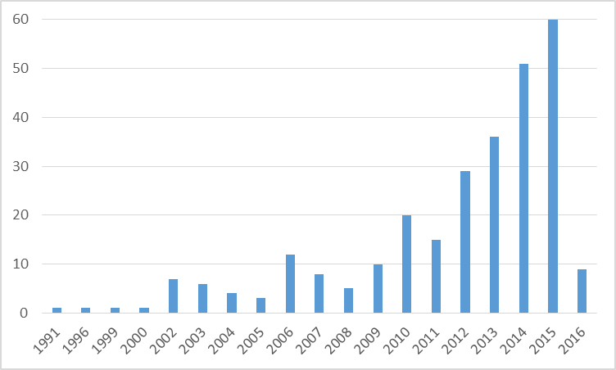

*Note*: The literature search for 2016 was conducted in March 2016. This explains the low

number of 2016 studies.

**3.0 Results**

In our manual review of the 103 studies, we found that many of the investigations, some of which that had ‘ecosystem services’ in their title, discussed ecosystem services in a generalized manner and did not break down ecosystem services into specific services. More specifically, some studies mentioned that they were looking at ecosystem services, but did not say which specific services (for example, air pollution, water quality, rainbow trout habitat) they were investigating. Others defined ecosystem services and its importance, but did not specify how specific ecosystem services factored into their discussion. Overall, 69 (67 percent) of the 103 studies investigated specific ecosystem services, while the remaining 34 (33 percent) did not.

## 3.1 Locations and Water Resources

While we know that RCWs are not bounded by geographical borders (for example, the Colorado River flows through many states in the United States and then into Mexico), the majority of the 103 studies were conducted on RCWs in one specific country (93 percent of the studies and 24 countries). Eight studies (7 percent) were conducted on RCWs contained in more than one country or more than one RCW (5 country groupings); and three of the eight studies were conducted on RCWs contained in both the United States and Mexico (that is, Colorado River Basin and San Pedro Watershed).

The United States (28), China (18), and Australia (12) had the most studies, by far (Figure 2). These were further broken down by countries with studies analysing specific ecosystem services (Appendix A). When this was conducted, the United States (21), China (16), and Australia (8) were still leading in the number of studies.

**Figure 2: River (or Watershed/Catchment) Specific Ecosystem Service Studies**

by Country/Countries

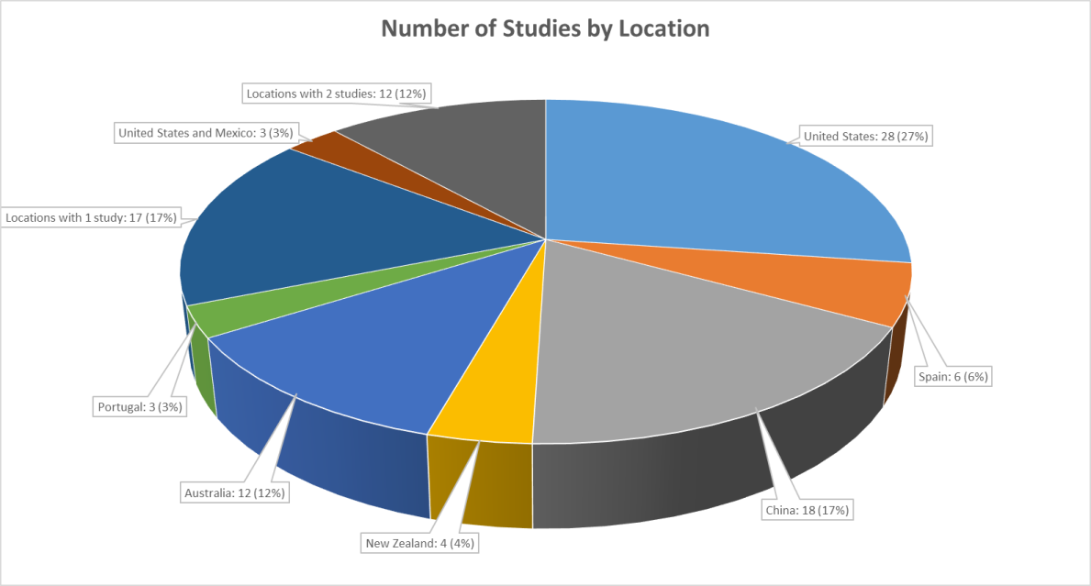

*Note:* There were six locations with two studies (namely, Belgium, England, Greece, Nepal, South Africa, and Switzerland); and 17 locations with one study (namely, Austria, Benin, Canada, Ethiopia, Germany, Iran, Ireland, Italy, Mozambique, Scotland, the Netherlands, Turkey and five multi-location studies (4, 6, 7, 7 and 15 country studies).

When studies were broken down into specific water resources, we also found a range of terms being used for the water systems (Figure 3). The most common terms were either river or river basin and watershed, which was to be expected from our search terms, while other terms included wetland, river delta, catchment, and estuary. It is important to note that the terms watershed, wetland, estuary, river, and river basin were used by researchers in many countries on many continents. Hence, we felt that we had located a good percentage of the relevant literature for our investigation.

**Figure 3: Various Water Resources**

## 3.2 Number of Specific Ecosystem Services

As stated previously, the Millennium Ecosystem Assessment classifies ecosystem services into four general categories and approximately 21 ecosystem services. While the four general categories were used commonly in the studies, the listing of 21 ecosystem services was not specifically followed. Instead, the researchers chose to use the specific ecosystem services that were more relevant to their own studies; that being said, these ecosystem services typically fell into one of the 21 ecosystem services. This could mean that one of the services in the Millennium Ecosystem Assessment (for example, fresh water) could be broken down into many specific services (for example, fresh river water for fish, fresh river water for invertebrates, fresh river water for humans, clean lake water for humans, clean lake water for fish).

Of the 69 studies that conducted an active investigation of one or more specific ecosystem services, it was determined that the number of ecosystem services focussed on in each study ranged from one through 34. The results reveal that more studies focus on five or fewer ecosystem services (55 percent) than 6 or more (45 percent). Only one considered 34 ecosystem services, while only two used the Millennium Ecosystem Assessment’s same list of 21 (Figure 4).

**Figure 4: Number of Ecosystem Services Considered in Each Study**

## 3.3 Ecosystem Service Terminology

The terminology for ecosystem services used in the various studies was found to be inconsistent. Rather than the 21 ecosystem services listed in the Millennium Ecosystem Assessment (Table 1), we found 217 ecosystem services in the reviewed articles, with a large majority of the 217 only being found in one study; as such, we will not list all of them here. Many of these ecosystem services could potentially be grouped together (for example, some researchers grouped research and education together, while others focussed only on research or education; some were more specific in their descriptions, looking at the biological control of pests and diseases, while others just discussed biological control). Some of the services were related, but not the same (for example, there were 16 water related terms, but they could not all be grouped together; some of these included water, water clarity, water smell, water filtration, water flow, and water flow regulation).

For comparison purposes, the 21 most commonly used ecosystem services terminology in the studies are listed in Table 4. The top three terms were: recreation (28 studies), food (20 studies), and climate regulation (18 studies). Other commonly used terms include: habitat, water supply, aesthetic values, erosion control, and water quality. When comparing the top 21 ecosystem services with the 21 ecosystem services in the Millennium Ecosystem Assessment, we find many similarities. However, due to the nature of our literature review, RCW related ecosystem services are more commonly used (Table 4). While most of the commonly used RCW ecosystem services fall into the provisioning and regulating services category, this can be deceptive, as the ecosystem service found in the most studies was recreation (28 studies), yet there were only three cultural services in the top 21 RCW ecosystem services (that is, aesthetic values, cultural values and recreation).

**Table 3: Ecosystem Services Located in the Literature Review**

**compared to the Millennium Ecosystem Assessment Ecosystem Service List**



## 3.4 Ecosystem Services Partnership Classification

As stated previously, the Ecosystem Services Partnership takes on an ecosystem services approach while focussing on thirteen thematic working groups. Consequently, the primary working groups from each study were determined and placed into the database. Every study fell into at least one of the 13 working groups or categories; however, there were studies that included up to seven working groups.

Three of those working groups found to be commonly applied in the literature were modelling ecosystem services (92 studies), mapping ecosystem services (81 studies), and ecosystem services monetary valuation (64 studies) (Figure 5). This is consistent with the findings of the Ecosystem Services Partnership (Ecosystem Services Partnership, 2014). It is worth noting that 51 studies applied all three working groups (that is, mapping, modelling, and economic values) in their investigation (that is, 40 ecosystem services specific studies). Of the 69 studies focussed on specific ecosystem services, 55 used a mapping approach, 63 used a modelling approach, and 50 used an economic monetary value approach. Hence, studies that are focussed on investigating specific ecosystem services are highly likely to conduct mapping, valuation, and/or modelling.

**Figure 5: Thematic Working Groups of the Ecosystem Services Partnership**

**Found Among the Reviewed Literature**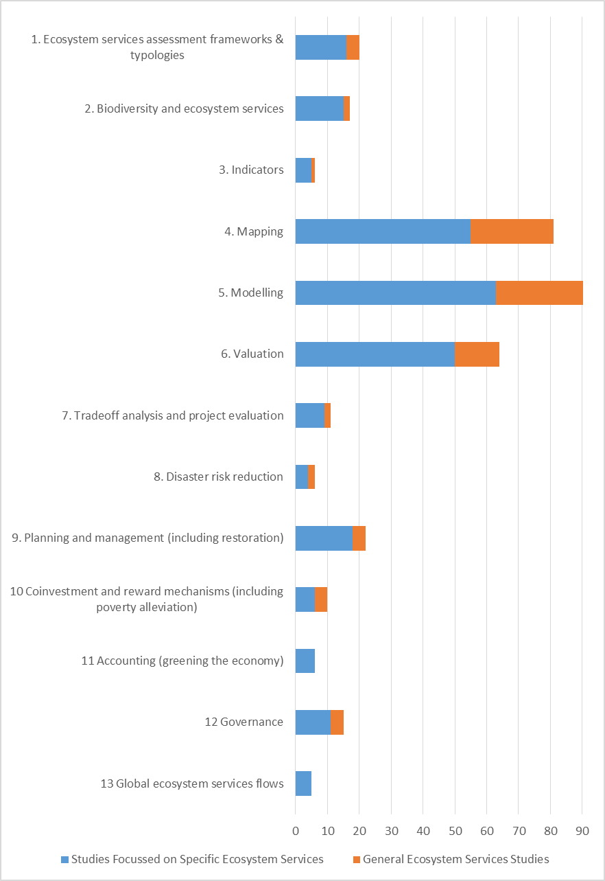

**4.0. Discussion**

RCWs are extremely important to all life on earth, as without water, life as we know it would not exist. Human society alone is extremely dependent on RCWs as part of the global water-energy-food nexus, as a large percentage of our water resources are directed to agriculture, given we depend on food to live (Hellegers *et al.* 2008 and Bennett *et al..* 2016). That being said, the costs of RCW management are continually increasing worldwide. In their 2016 article, Bennett *et al.* (2016) found that a minimum of $1 billion USD went towards watershed investment programs related to the water-energy-food nexus in 2013 alone. They also stated that the amount that is currently being spent on watershed investment is not matching our dependency of the water-energy-food nexus on healthy landscapes. Consequently, the sustainability of our RCW systems requires long-term RCW management schemes. Within these schemes is the importance of people, cities, regions, and countries working together, as RCWs are not bounded by artificial governing borders, but rather by geophysical characteristics.

In looking at RCWs across governing borders, our review located eight studies where more than one country was considered in the case study; only five of these were for RCWs that crossed country borders. The La Notte *et al.* (2015) case study covered all European river basins that drain into the Mediterranean Sea; this includes the Baltic Sea, North Sea, Celtic Sea, Northern Atlantic Ocean, Western Mediterranean Sea, Eastern Mediterranean Sea, Black Sea, Barentz Sea West, Norwegian Sea, Tuz Salt Lake, and Prespa Lake. The Bagstad *et al.* (2013) and Bagstad, Semmens and Winthrop (2013) studies examined the San Pedro River watershed in the United States and Mexico. Kaval (2011) focused her work on the Colorado River Basin, which is located in the United States and Mexico. And Becker, Helgeson and Katz (2014) investigated the Jordan River, located in Israel, Jordan, Syria, the West Bank, and Lebanon.

In looking at the map of the world in terms of areas where we found two or more relevant studies, we find that the map is very bare (Figure 6), especially when the majority of studies were conducted in the United States, China, and Australia. While this illustrates where the ecosystem service approach work is being used, it also illustrates that more work needs to be done in terms of ecosystem services worldwide and ecosystem service studies of RCWs that do not consider the geographical barriers.

**Figure 6: Countries with a Minimum of Two RCW Related Ecosystem Services Studies**

Highlighted in Red

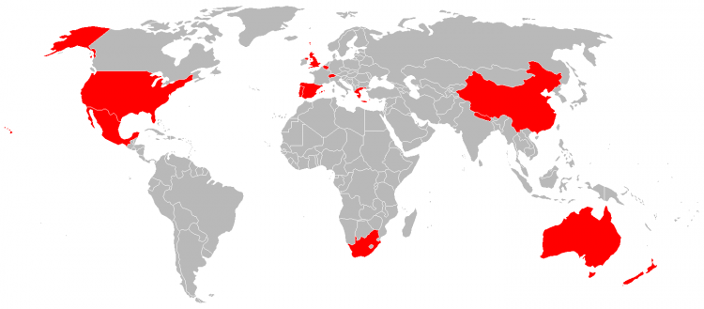

In our literature review, we found that the number of ecosystem service studies in relation to RCW’s has increased significantly since the first study we found in 1991. We also found the RCW ecosystem service literature to be very fragmented; results that agree with the findings of Abson *et al.* (2014).

More specifically, fragmentation, in our review, occurred in many ways. First, fragmentation occurred in the use of the ecosystem services, as some studies appeared to use the term ecosystem services as more of a buzz word, while others conducted in depth investigations directly related to specific ecosystem services. We therefore believe that the use of ecosystem services as an organizing framework to bridge natural capital and well-being is still developing.

Fragmentation also occurred in the terminology, as there was no strong consistency in the ecosystem services terminology. The four categories of ecosystem services described in the Millennium Ecosystem Assessment (2005) seemed to hold as broad categories across the literature reviewed. The 21 ecosystem services also hold, but more as general categories, rather than as specific services (for example, water regulation includes flood control and erosion control). Overall, 217 specific ecosystem services were located, where 21 ecosystem services were more commonly used than others. This was to be expected, as each study would focus on specific aspects that were relevant to their particular investigation. As an example, Qin, Yang and Yang (2014) conducted a study of China’s Yellow River Delta, mapping the distributions of biomass production, nutrient cycling, local climate regulation, and plant diversity. Morrison and MacDonald (2010) conducted an economic valuation of the environmental benefits of the Murray-Darling Basin in Australia and focussed on water-based recreation, native vegetation, native fish, colonial waterbird breeding, and waterbirds and other species. Wainger *et al.* (2013) looked at ecosystem service trade-offs in the implementation of the Chesapeake Bay total maximum daily load in the United States and investigated duck hunting, air quality, non-waterfowl hunting, carbon sequestration and reduced greenhouse gas emissions, brook trout habitat, and wetland water storage. Hence, ecosystem service studies need to be specific to the location and what is being investigated.

To achieve consistency in future work, it may be useful to define and adhere to the broad and general categories, while developing a protocol for making deviations to suit specific RCW challenges and focussing on the specifics of importance in a particular situation. In this way, the ecosystem services approach for RCW can be compatible at multiple scales and across landscapes and seascapes. The United Nations System for Environment and Economic Accounting (United Nations, 2014) is working on such guidelines from a top down perspective.

Fragmentation also occurred in the ecosystem services partnership themes usage. This was expected, as not all studies will focus on all 13 themes. That said, the use of valuation, mapping, and modelling was commonly applied.

It was not surprising to see valuation being used commonly, as one of the earlier ecosystem studies by Costanza *et al.* (1997), a study frequently cited in ecosystem services studies, focussed on placing monetary values on ecosystem services through the benefit transfer method. Nevertheless, this study was primarily undertaken as a conversation starter to introduce a broader value proposition, rather than as a focus on solely establishing exact monetary values to commodify all ecosystem services. Regardless, it has led to much valuation work, such as that of Johnson *et al.* (2012), who conducted a valuation and found that the quantification and valuation of ecosystem services can enhance policies and regulations and, if linked with payments or incentives, can properly reward private decisions that yield public benefits. They found that addressing uncertainty in ecosystem service valuation was critical for accurate assessment of trade-offs in land use (Johnson *et al.* 2012). Kaval (2011) believes that more complete ecosystem service valuations can improve the cost-effectiveness of fish and wildlife recovery policies, which would, in turn, improve the ecosystem service functions (and sustainability) of the watershed, as well as increase economic returns to the community (Kaval 2011).

It was also encouraging to see the mapping theme frequently used, as it is important to understand spatial distinctions in particular, because of their ability to deal with the multi-scale aspect of ecosystem services. In addition, with the rapid development of remote sensing and the use of Unmanned Aerial Vehicles (UAV), the potential for mapping capabilities of ecosystem services is expanding. Su et al. (2012) used mapping to assess the variation of ecosystem services and human activities in the Yanhe Watershed in China for grain production, soil conservation, water conservation, net primary productivity, carbon sequestration, and oxygen production. They found that strong trade-offs exist between regulating and provisioning ecosystem services.

Liu *et al.* (2013) modelled the production of multiple ecosystem services from forested and agricultural landscapes in the United States. They also conducted mapping that involved the illustration of trade-offs between crop yield and environmental flow, flood risk, nitrogen concentration, and phosphorus concentration.

One recurring theme in the work conducted in China was that of co-investment and reward mechanisms, specifically in evaluating payments for ecosystem services. One such study was conducted by the UNEP (2014) on Chongming Island, an eco-island. This report recommended strengthening the eco-compensation program through payments for ecosystem services and compensating for the loss of habitats and wetland ecosystems through habitat banking and/or the restoration of other degraded wetlands and habitats to ensure no net loss in biodiversity (UNEP, 2014). Qin *et al.* (2014) supported the calculation of ecological compensation payments for wetland damage by valuing the loss of ecosystem services and functions in monetary terms (Qin *et al.* 2014). Zheng *et al.* (2013), investigating the Paddy Land-to-Dry Land program (a payments for ecosystem services program), found that it generated benefits of improved water quantity and quality that far exceed the costs of reduced agricultural output.

The literature review also illustrates how an ecosystem services approach aims to make more visible the benefits people derive from ecosystems, which often complements ongoing attempts to protect and maintain (and increase) ecosystem areas (for example, wetland areas). As societal demand for ecosystem services and the restoration and enhancement of ecosystems is increasing, due to the continually increasing human population, a home-grown ecosystem services approach, as an organizing framework, can be further explored.

When considering an ecosystem services investigation, rather than suggesting only stakeholder or local citizen participation or science, we suggest a toolbox approach to iteratively design and use appropriate tools to reveal and design value propositions (van den Belt *et al.* 2013). The challenge then becomes the design of an interconnected toolbox that can be consistently and quickly used. Relevant and timely knowledge can be generated using data and information where available, while accepting there will always be gaps in the scientific evidence base. The ideal toolbox offers approaches across the spectrum of low to high decision stakes and uncertainty.

## 4.1. Example of a Modelling Toolbox

To illustrate what we mean by a ‘modelling toolbox’, we include an example from the Manawatū River (MR) watershed in New Zealand (van den Belt *et al.* 2011). The MR watershed (594 000 ha) is located on the North Island; approximately 200 000 people live in the MR watershed area. The land is intensively used for agriculture, particularly dairying. Historically, the steep hills in the area were forested, but the forest is now reduced to 20 percent of the original cover (Dymond *et al.* 2010). Wetlands have also been reduced, with 97 percent converted to other land use types (Dymond *et al.* 2010). The Māori, the indigenous peoples of New Zealand, have settled in the Manawatū area for centuries, but pakeha (people of European descent) and other non-indigenous people also live there.

The Integrated Freshwater Solutions (IFS) project researched collaborative decision support tools to connect local and regional freshwater management. This resulted in the development and testing of an ecosystem services modeling toolbox to support adaptive management (van den Belt, 2009) including:

1. **Mediated Modelling (MM).** MM refers to a process for building a model *with,* rather than *for,* stakeholders (van den Belt, 2004). MM was used to support the collaborative effort to better understand the underlying systems driving poor water quality, specifically those causing eutrophication, erosion and habitat destruction. System dynamics (using STELLA software) is an appropriate modelling approach for MM.[2] The strength of the MM process generally lies in the collaborative process (van den Belt *et al.* 2013); in this case, three 1-day workshops were conducted over 6 months. The generic overview of the MM model is illustrated in Figure 7. Particularly important is the closing of the feedback loop from the Action Plan and ball park levels of funding to the anticipated improvements in Natural Capital.

**Figure 7: Generic Overview of Interlinking Issues from an Ecosystem Services Perspective** Providing a Starting Point for a Stakeholder Dialogue

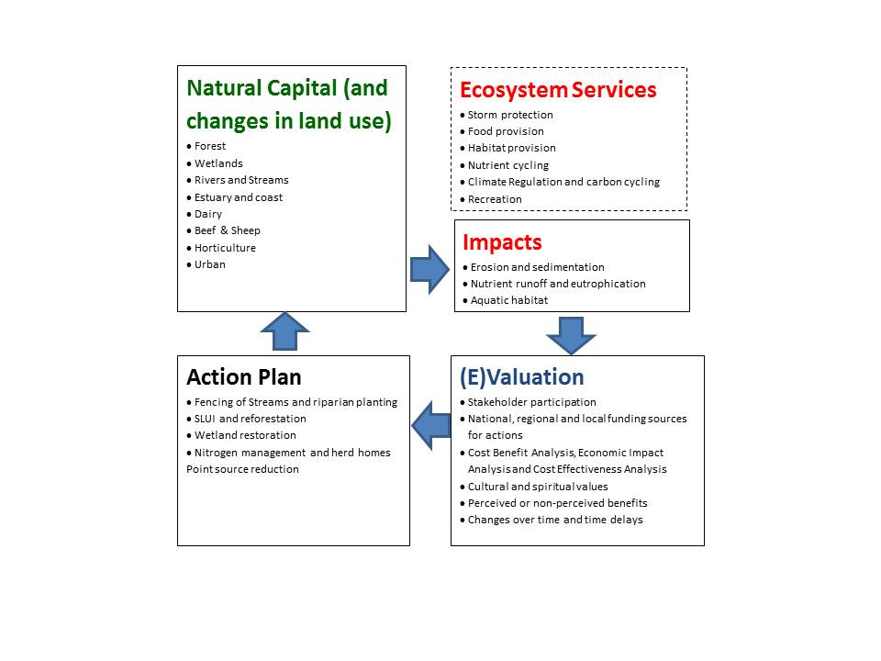

The MM scoping model is spatially homogeneous. An example of a scenario is the funding to reduce erosion by retiring land and planting trees as part of the Sustainable Land Use Initiative (SLUI). Figure 8 illustrates sediment loading in tons per year, when the impact of the SLUI is taken into account. Ecosystem services were briefly discussed in concept, but not readily taken up in the stakeholder dialogue.

2. A small **System Dynamics (SD)** model drew attention to an ‘investment trap’ in river management (van den Belt *et al.* 2013), using natural capital and ecosystem services framing in a teaching context.

3. The MM effort and SD model were subsequently translated and enhanced to develop a spatially explicit, dynamic **Multi-scale Integrated Model for Ecosystem Services** (MIMES) (Altman *et al.* 2014). Instead of stakeholders, MIMES involved scientists from different disciplines and research organizations. MIMES uses Simile software and links multiple databases in stacked arrays that allow for the bundling and trading off of ecosystem services over time and space. A generic overview of MIMES for the Manawatū watershed is shown in Figure 9.

**Figure 8: Mediated Modelling: Sediment Loading in Tons Per Year**

Taking the Impact of the Sustainable Land Use Initiative into Account

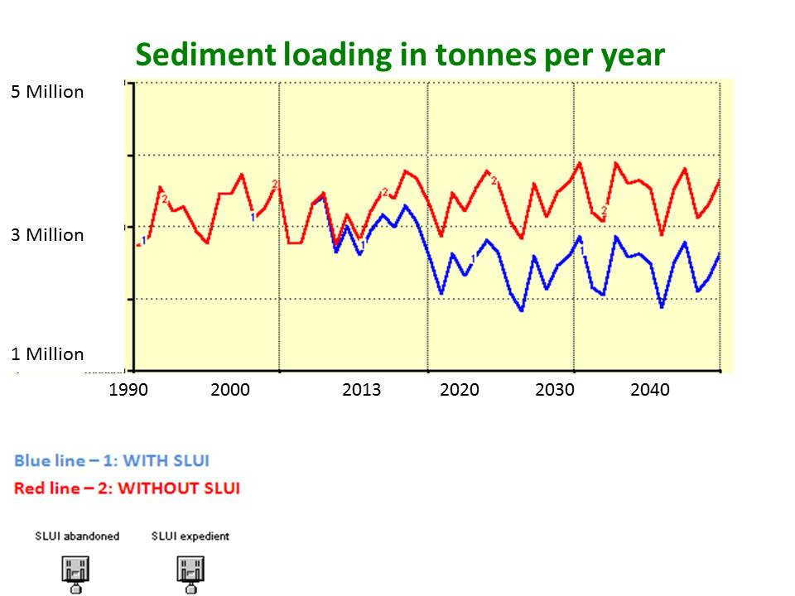

**Figure 9: Overview of MIMES (Multi-Scale Integrated Model for Ecosystem Services)** Manawatū, New Zealand

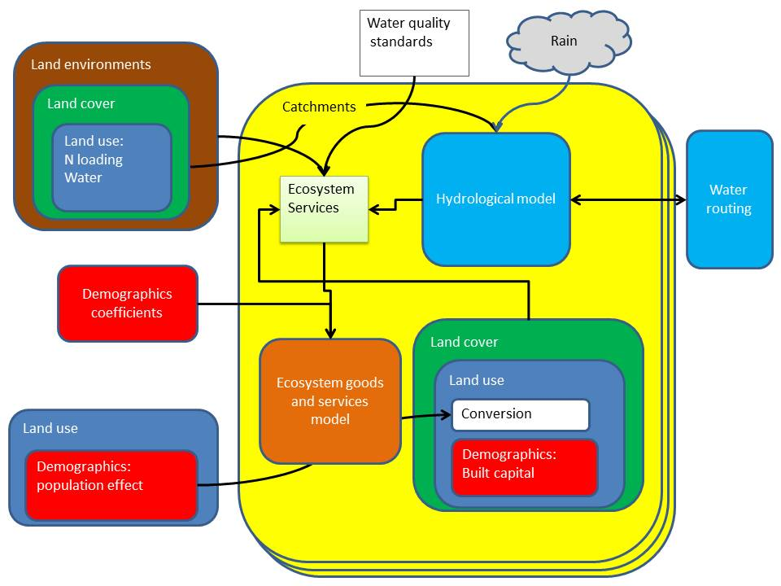

MIMES can be used to output scenarios, as shown in Figure 10. Here, erosion control (as undertaken, for example, by the SLUI programmer) is mapped to highlight the change in ‘hotspots’ over time and space (Crossman and Bryan 2009).[3] The progression of model development from MM to MIMES required a transition from interpreting stakeholder perceptions as a facilitated group to a more data-intense, specialist, modelling by the science community, which can use ‘demand profiles’ for various stakeholder perceptions.

**Figure 10: MIMES (Multi-Scale Integrated Model for Ecosystem Services)**

**Sediment Loading in Tons per Year**

**Taking the Impact of the Sustainable Land Use Initiative into Account**

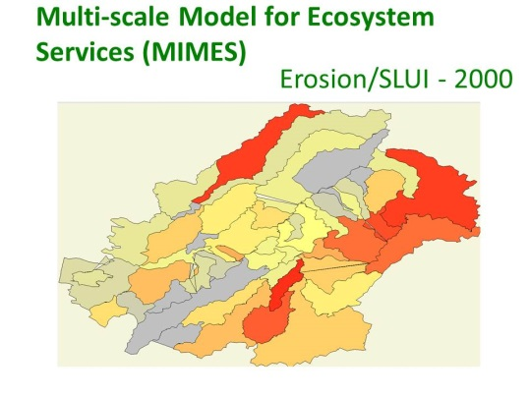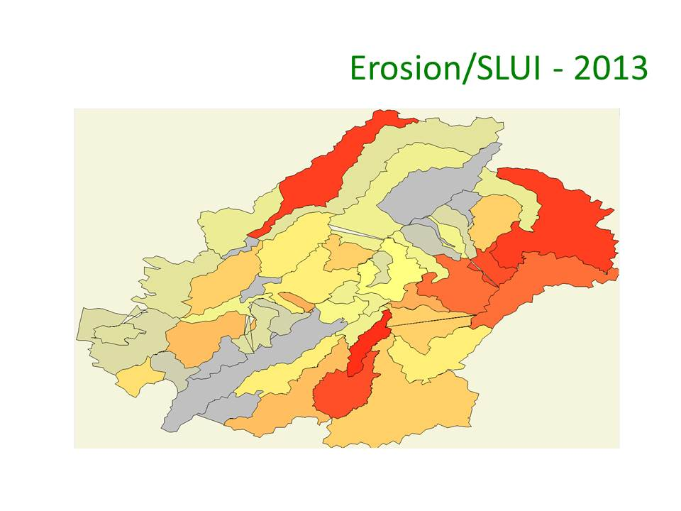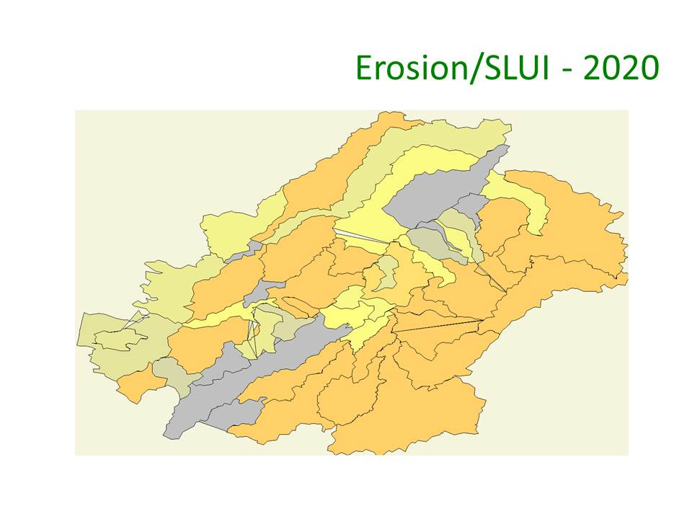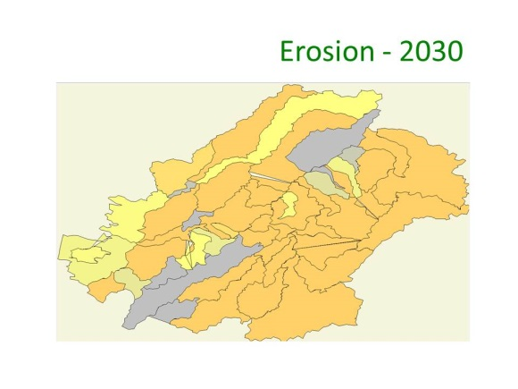

Figure 11 emphasizes the gap between the supply and demand of ecosystem services. The value (as opposed to price) of ecosystem services is based on whether there is an abundance or a shortage of ecosystem services over time and space, taking the perceptions of both market and non-market stakeholders into account (van den Belt and Blake 2014). Ecosystem services as an organizing framework was deliberately used in MIMES.

**Figure 11: Schematic Overview of the Supply of Ecosystem Services from Multiple Ecosystems and the Demand for Ecosystem Services from Market and Non-Market Sectors**

The arrows flow in the S(ame), O(pposite) or an unknown (?) direction.

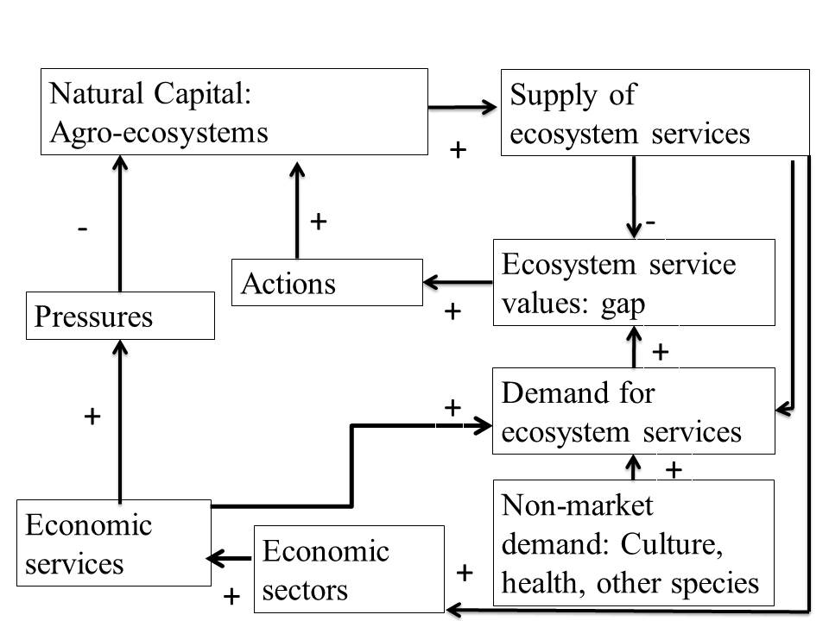

The toolbox approach allowed for a combination of (1) direct and indirect involvement of various stakeholders and scientists, (2) simulation of changes over time, and (3) spatial and non-spatial scenarios. It also allowed for a progression from scoping to research modelling, but did not reach the level of the ‘management model’ (Costanza and Ruth 1998). The modelling toolbox approach, in this case, included themes 1–10 listed in Table 2 based on the Ecosystem Services Partnership framework.

# **5.0 Conclusions**

Protecting, restoring and/or enhancing public and private RCW assets through RCW management is both important and increasingly expensive, if carried out with built capital. Hence, it is important to consider how investments in natural capital (e.g., the reforestation of steep hills; using floodplains and wetlands more effectively) are considered in long-term RCW planning. An ecosystem services approach considering the provisioning, regulating, supporting, and cultural ecosystem services provided may help make visible a multitude of connections and pathways to gather broad support for the transitioning towards long-term RCW management planning.

This investigation revealed an extensive amount of fragmentation in the currently available RCW ecosystem services literature. Of the 103 RCW publications reviewed, 67 percent focussed their investigation on specific ecosystem services, while the rest did not. This illustrates a lack of consistency in the use of an ecosystem services approach. Upon further investigation, 217 specific ecosystem services were evaluated in the studies; this result revealed a lack of consistency in the terminology of ecosystem services. Consequently, specific ecosystem services were categorized according to the Millennium Ecosystem Assessment categories. These results revealed that the most commonly studied RCW ecosystem service studies focussed on regulating services (nine ecosystem services, for example, pollination, carbon sequestration, water treatment, erosion control) and provisioning services (seven ecosystem services, for example, food, fresh water provision, fibre, raw materials, habitat). Fewer cultural (only three ecosystem services) and supporting services (only two ecosystem services) were a focus; hence, this may be something to consider in future RCW studies.

Another finding was that of the 13 Ecosystem Services Partnership themes, a majority of the 103 studies primarily focussed on mapping, modelling and/or valuation. Hence, there is a lack in the consistency of the use of the Ecosystem Services Partnership themes. That being said, we do believe that the use of mapping and modelling at multiple scales and resolutions is important, with a specific focus on spatially dynamic changes and trade-offs. While valuation remains important, it should be used with great care to avoid further commodification of ecosystems; we recommend the valuation toolbox to be expanded for inclusion of systems based tools. We also believe that the toolbox approach can be used to include most, if not all, of the Ecosystem Services Partnership themes.

Consequently, we recommend that future RCW ecosystem services research unnecessary fragmentation in terms of the use of ecosystem services, the terminology of ecosystem services and the use of the Ecosystem Services Partnership themes. In addition, we recommend future research to consider appropriate governance systems (for example, payments for ecosystem services), long term (sustainability) in RCW management, and that RCWs are not bounded by geographical borders. We conclude that there is room for an ecosystem services approach to reach its full potential as an organizing framework, in particular across regions/countries and at multiple levels of scale.

# **References**

Abson, D.J., von Wehrden, H., Baumgartner, S., Fischer, J., Hanspach, J., Hardtle, W., Heinrichs, H., Klein, A. M., Lang, D. J., Martens, P. and Walmsley, D. 2014. Ecosystem services as a boundary object for sustainability. *Ecological Economics*. 103: 29-37.

Altman, I., Boumans, R., Roman, J., Gopal, S., and Kaufman, L. 2014. An Ecosystem Accounting Framework for Marine Ecosystem-Based Management. In M. J. Fogarty and J. J. McCarthy (Eds.), *Marine Ecosystem-based Management* (Vol. 16): Harvard University Press.

Bagstad, K. J., Semmens, D. J., Waage, S., and Winthrop, R. 2013a. A comparative assessment of decision-support tools for ecosystem services quantification and valuation. *Ecosystem Services. 5*: e27-e39. doi: 10.1016/j.ecoser.2013.07.004

Bagstad, K. J., Semmens, D. J., and Winthrop, R. 2013b. Comparing approaches to spatially explicit ecosystem service modeling: A case study from the San Pedro River, Arizona. *Ecosystem Services, 5*, e40-50. doi: 10.1016/j.ecoser.2013.07.007

Bai, Y., Zheng, H., Ouyang, Z., Zhuang, C., and Jiang, B. 2013. Modeling hydrological ecosystem services and trade-offs: A case study in Baiyangdian watershed, China. *Environmental Earth Sciences, 70*(2), 709-718. doi: 10.1007/s12665-012-2154-5

Batker, D., de la Torre, I., Costanza, R., Swedeen, P., Day, J., Boumans, R., and Bagstad, K. 2010a. *Gaining ground: Wetlands, hurricanes and the economy - The value of restoring the Mississippi River Delta*. Earth Economics. 101 pages.

Batker, D., Kocian, M., McFaddan, J., and Schmidt, R. 2010b. *Valuing the Puget Sound Basin: Revealing Our Best Investments*. Earth Economics. 102 pages.

Becker, N., Helgeson, J., and Katz, D. 2014. Once there was a river: A benefit-cost analysis of rehabilitation of the Jordan River. *Regional Environmental Change, 14*(4), 1303-1314. doi: 10.1007/s10113-013-0578-4

Bennett, G., Cassin, J., and Carroll, N. 2016. Natural infrastructure investment and implications for the nexus: A global overview. *Ecosystem Services*. 17: 293-297.

Boerema, A., Schoelynck, J., Bal, K., Vrebos, D., Jacobs, S., Staes, J., and Meire, P. 2014. Economic valuation of ecosystem services, a case study for aquatic vegetation removal in the Nete catchment (Belgium). *Ecosystem Services, 7*: 46-56. doi: 10.1016/j.ecoser.2013.08.001

Boithias, L., Terrado, M., Corominas, L., Ziv, G., Kumar, V., Marques, M., Schuhmacher, M., and Acuna, V. 2016. Analysis of the uncertainty in the monetary valuation of ecosysterm services – A case study at the river basin scale. *Science of the Total Environment*. 543: 683-690.

Braat, L. C., and de Groot, R. 2012. The ecosystem services agenda: Bridging the worlds of natural science and economics, conservation and development, and public and private policy. *Ecosystem Services,* 1(1), 4-15.

Bryan, B. A., Higgins, A., Overton, I. C., Holland, K., Lester, R. E., King, D., Nolan, M., Hatton MacDonald, D., Connor, J. D., Bjornsson, T., and Kirby, M. 2013. Ecohydrological and socioeconomic integration for the operational management of environmental flows. *Ecological Applications, 23*(5): 999-1016. doi: 10.2307/23441602

Carpenter, S. R., Booth, E. G., Gillon, S. Kucharik, C. J., Loheide, S., Mase, A. S., Motew, M., Qiu, J., Rissman, A. R., Seifert, J., Soylu, E., Turner, M., and Wardropper, C. B. 2015. Plausible futures of a social-ecological system: Yahara watershed, Wisconsin, USA. *Ecology and Society.* 20(2): 17 pages.

Castro, A. J., Vaughn, C. C., Julian, J. P., and Garcia-Llorente, M. Social demand for ecosystem services and implications for watershed management*.* 2016. *Journal of the American Water Resources Association.* 52(1):209-221.

Chamberlain, J. F., and Miller, S. A. 2012. Policy incentives for switchgrass production using valuation of non-market ecosystem services. *Energy Policy.* 48:526-536.

doi: 10.1016/j.enpol.2012.05.057

Chen, W. Y., Aertsens, J., Liekens, I., Broekx, S., and De Nocker, L. 2014. Impact of perceived importance of ecosystem services and stated financial constraints on willingness to pay for riparian meadow restoration in Flanders (Belgium). *Environmental Management, 54*(2): 346-359.

Chong, J. 2012. Ecosystem services and water planning in the Murray-Darling Basin. *The Australasian Journal of Natural Resources Law and Policy. 15*(1): 17-41.

Costanza, R., d’Arge, R., deGroot, R., Farber, S., Grasso, M., Hannon, B., Limburg, K., Naeem, S., O’Neill, R. V., Paruelo, J., Raskin, R. G., Sutton, P., and van den Belt, M. 1997. The value of the world's ecosystem services and natural capital. *Nature. 387*(6630), 253-260.

doi: 10.1038/387253a0

Costanza, R., and Ruth, M. 1998. Dynamic systems modeling for scoping and consensus building. *Environmental Management, 22*, 183-195.

Crossman, N. D. and B. A. Bryan 2009. 'Identifying cost-effective hotspots for restoring natural capital and enhancing landscape multifunctionality.' Ecological Economics 68(3): 654-668.

CSIRO. 2012. *Assessment of the ecological and economic benefits of environmental water in the Murray-Darling Basin: The final report to the Murray-Darling Basin Authority from the CSIRO Multiple Benefits of the Basin Plan Project*. CSIRO Water for a Healthy Country National Research Flagship, Australia.

Daily, G. C. (Ed.). 1997. Chapter 1. Introduction: What are ecosystem services? *Nature's Services: Societal Depandence on Natural Ecosystems*. Washington DC: Island Press.

Doherty, E., Murphy, G., Hynes, S., and Buckley, C. 2014. Valuing ecosystem services across water bodies: Results from a discrete choice experiment. *Ecosystem Services. 7*: 89-97. doi: 10.1016/j.ecoser.2013.09.003

Dupras, J., Parcerisas, L., and Brenner, J. 2015. Using ecosystem services valuation to measure the economic impacts of land-use changes on the Spanish Mediterranean coast (El Maresme, 1850-2010). Regional Environmental Change. 1-14.

Dymond, J.R., H.D. Betts, and C.S. Schierlitz, 2010. An Erosion Model for Evaluating Regional Land-Use Scenarios. Environmental. Modelling and Software 25(3):289-298.

Ecosystem Services Partnership. 2014. Global Ecosystem Service Flows.

Retrieved from http://www.es-partnership.org/esp/84125/5/0/50

Elias, E., Laband, D., Dougherty, M., Lockaby, G., Srivastava, P., and Rodriguez, H. 2014. The public water supply protection value of forests:  A watershed-scale ecosystem services analysis based upon total organic carbon. *Open Journal of Ecology,* 4: 517-531.

Elsin, Y. K., Kramer, R. A., and Jenkins, W. A. 2010. Valuing drinking water provision as an ecosystem service in the Neuse River Basin. *Journal of Water Resources Planning and Management, 136*(4), 474-482. doi: 10.1061/(ASCE)WR.1943-5452.0000058

Fanaian, S., Graas, S., Jiang, Y., and van der Zaag, P. 2015. An ecological economic assessment of flow regimes in a hydropower dominated river basin: The case of the lower Zambezi River, Mozambique. *Science of The Total Environment, 505*: 464-473.

doi: http://dx.doi.org/10.1016/j.scitotenv.2014.10.033

Feng, X. Y., Luo, G. P., Li, C. F., Dai, L., and Lu, L. 2012. Dynamics of Ecosystem Service Value Caused by Land Use Changes in Manas River of Xinjiang, China. *International Journal of Environmental Research, 6*(2), 499-508.

Fu, B., Wang, Y. K., Xu, P., Yan, K., and Li, M. 2014. Value of ecosystem hydropower service and its impact on the payment for ecosystem services. *Science of The Total Environment, 472*: 338-346. doi: http://dx.doi.org/10.1016/j.scitotenv.2013.11.015

García-Llorente, M., Martín-López, B., Díaz, S., and Montes, C. 2011. Can ecosystem properties be fully translated into service values? An economic valuation of aquatic plant services. *Ecological Applications, 21*(8), 3083-3103. doi: 10.2307/41417113

Gilvear, D. J., Spray, C. J., and Casas-Mulet, R. 2013. River rehabilitation for the delivery of multiple ecosystem services at the river network scale. *Journal of Environmental Management, 126*: 30-43. doi: http://dx.doi.org/10.1016/j.jenvman.2013.03.026

Granek, E.F., S. Polasky, C. V. Kappel, D. M. Stoms, D. J. Reed, J. Primavera, E. W. Koch, C. Kennedy, L. A. Cramer, S. D. Hacker, G. M. E. Perillo, S. Aswani, B. Silliman, D. Bael, N. Muthiga, E. B. Barbier, E. Wolanski. 2010. Ecosystem services as a common language for coastal ecosystem-based management. *Conservation Biology*, 24: 207-216.

doi: DOI 10.1111/j.1523-1739.2009.01355.x

Grossmann, M. 2012. Economic value of the nutrient retention function of restored floodplain wetlands in the Elbe River basin. *Ecological Economics, 83*: 108-117. doi: http://dx.doi.org/10.1016/j.ecolecon.2012.03.008

Haas, J., and Ban, Y. 2014. Urban growth and environmental impacts in Jing-Jin-Ji, the Yangtze, River Delta and the Pearl River Delta. *International Journal of Applied Earth Observation and Geoinformation, 30*: 42-55. doi: http://dx.doi.org/10.1016/j.jag.2013.12.012

Haines-Young, R., and Potschin, M. 2010. *Proposal for a common international classification of ecosystem goods and services (CICES) for integrated environmental and economic accounting*. Report to the European Environment Agency.

Hearnshaw, E., Cullen, R., and Hughey, K. 2010. *Ecosystem services review of water projects*. Paper presented at the Australian Agricultural and Resource Economics Socie<https://us-mg6.mail.yahoo.com/neo/launch?.rand=fqvb8cqkknroo>ty Annual Conference.

Hearnshaw, E. J. S., Cullen, R., and Hughey, K. F. D. 2010. Ecosystem Services Review of Water Storage Projects in Canterbury:  The Opihi River Case: Environment Canterbury, New Zealand. 63 pages.

Hellegers, P., Zilberman, D., Steduto, P., and McCornick, P. 2008. Interactions between water, energy, food and environment: Evolving perspectives and policy issues. *Water Policy.* 10(S1):1-10.

Hoekstra, A. Y., Mekonnen, M. M., Chapagain, A. K., Mathews, R. E., and Richter, B. D. 2012. Global monthly water scarcity: Blue water footprints versus blue water availability. *Plos One, 7*(2).

Iniesta-Arandia, I., García-Llorente, M., Aguilera, P. A., Montes, C., and Martín-López, B. 2014. Socio-cultural valuation of ecosystem services: Uncovering the links between values, drivers of change, and human well-being. *Ecological Economics, 108:*36-48.

doi: 10.1016/j.ecolecon.2014.09.028

Isely, E. S., Steinman, A. D., Isely, P. N., and Parsell, M. A. 2014. Building partnerships to address conservation and management of western Michigan’s natural resources. *Freshwater Science, 33*(2): 679-685. doi: 10.1086/675933

Jenkins, W. A., Murray, B. C., Kramer, R. A., and Faulkner, S. P. 2010. Valuing ecosystem services from wetlands restoration in the Mississippi Alluvial Valley. *Ecological Economics, 69*(5):1051-1061. doi: http://dx.doi.org/10.1016/j.ecolecon.2009.11.022

Johnson, K. A., Polasky, S., Nelson, E., and Pennington, D. 2012. Uncertainty in ecosystem services valuation and implications for assessing land use trade-offs: An agricultural case study in the Minnesota River Basin. *Ecological Economics,* 79:71-79.

doi: http://dx.doi.org/10.1016/j.ecolecon.2012.04.020

Kaval, P. 2011. *Ecosystem service valuation of the Colorado River Basin:  A Literature Review and Assessment of the Total Economic Value of the Colorado River Basin*. The Nature Conservancy. 42 pages.

Kaval, P., and Baskaran, R. 2013. Key ideas and concepts from economics for understanding the roles and value of ecosystem services. In S. Wratten, H. Sandhu, R. Cullen and R. Costanza (Eds.), *ecosystem services in agricultural and urban landscapes* (pp. 28-42).

Kocian, M., Traughber, B., and Batker, D. 2012. *Valuing Nature's Benefits: An Ecological Economic Assessment of Iowa's Middle Cedar Watershed*. Earth Economics. Tacoma, WA.

Kozak, J., Lant, C., Shaikh, S., and Wang, G. 2011. The geography of ecosystem service value: The case of the Des Plaines and Cache River wetlands, Illinois. *Applied Geography, 31*(1): 303-311. doi: 10.1016/j.apgeog.2010.07.001

Kummu, M., Ward, P. J., De Moel, H., and Varis, O. 2010. Is physical water scarcity a new phenomenon? Global assessment of water shortage over the last two millennia. *Environmental Research Letters, 5*(3).

La Notte, A., Liquete, C., Grizzetti, B., Maes, J., Egoh, B. N., and Paracchini, M. L. 2015. An ecological-economic approach to the valuation of ecosystem services to support biodiversity policy. A case study for nitrogen retention by Mediterranean rivers and lakes. *Ecological Indicators,* 48:292-302. doi: http://dx.doi.org/10.1016/j.ecolind.2014.08.006

La Peyre, M., Furlong, J., Brown, L. A., Piazza, B. P., and Brown, K. 2014. Oyster reef restoration in the northern Gulf of Mexico: Extent, methods and outcomes. *Ocean and Coastal Management, 89:*20-28. doi: http://dx.doi.org/10.1016/j.ocecoaman.2013.12.002

Larson, S., Stoeckl, N., Neil, B., and Welters, R. 2013. Using resident perceptions of values associated with the Australian Tropical Rivers to identify policy and management priorities. *Ecological Economics,* 94: 9-18. doi: http://dx.doi.org/10.1016/j.ecolecon.2013.07.005

Lautenbach, S., Maes, J., Kattwinkel, M., Seppelt, R., Strauch, M., Scholz, M., Schulz-Zunkel, C., Volk, M. Weinert, J., and Dormann, C. F. 2012. Mapping water quality-related ecosystem services: Concepts and applications for nitrogen retention and pesticide risk reduction. *International Journal of Biodiversity Science, Ecosystems Services and Management, 8*(1-2):1-15. doi: http://www.tandfonline.com/doi/pdf/10.1080/21513732.2011.631940

Le Maitre, D. C., Kotzee, I. M., and O’Farrell, P. J. 2014. Impacts of land-cover change on the water flow regulation ecosystem service: Invasive alien plants, fire and their policy implications. *Land Use Policy,* 36:171-181. doi: http://dx.doi.org/10.1016/j.landusepol.2013.07.007

Li, X., Yu, X., Jiang, L., Li, W., Liu, Y., and Hou, X. 2014. How important are the wetlands in the middle-lower Yangtze River region: An ecosystem service valuation approach. *Ecosystem Services,* 10:54-60. doi: 10.1016/j.ecoser.2014.09.004

Liu, T., Merrill, N. H., Gold, A. J., Kellogg, D. Q., and Uchida, E. 2013. Modeling the Production of Multiple Ecosystem Services from Agricultural and Forest Landscapes in Rhode Island. *Agricultural and Resource Economics Review, 42*(1): 251-274.

doi: http://ageconsearch.umn.edu/handle/36551

Lu, Y., and He, T. 2014. Assessing the effects of regional payment for watershed services program on water quality using an intervention analysis model. *Science of the Total Environment,* 493: 1056-1064. doi: http://dx.doi.org/10.1016/j.scitotenv.2014.06.096

Melstrom, R. T., Lupi, F., Esselman, P. C., and Stevenson, R. J. 2015. Valuing recreational fishing quality at rivers and streams. *Water Resources Research*, 51:1-11. n/a-n/a.

doi: 10.1002/2014WR016152

Millennium Ecosystem Assessment. 2005. *Ecosystems and human well-being: Synthesis*. Washington, D.C.: Island Press. 155 pages.

Morrison, M., and MacDonald, D. H. 2010. *Economic valuation of environmental benefits in the Murray-Darling Basin*. Murray-Darling Basin Authority. 46 pages.

Morrison, M. D., Wheeler, S. A., and MacDonald, D. H. 2012. *Towards a more nuanced discussion of the net-benefits of sharing water in the Murray-Darling Basin*. 18 pages.

Myers, S. S., and Patz, J. A. 2009. Emerging threats to human health from global environmental change. *Annual Review of Environment and Resources, 34:* 223-252.

Nicosia, K., Daaram, S., Edelman, B., Gedrich, L., He, E., McNeilly, S., Shenoy, V., Velagapudi, A., Wu, W., Zhang, L., Barvalia, A., Bokka, V., Chan, B., Chiu, J., Dhulipalla, S., Hennandez, V., Jeon, J., Kanukollu, P., Kravets, P., Mantha, A., Miranda, C., Nigam, V., Patel, M., Praveen, S., Sang, T., Upadhyay, S., Varma, T., Xu, C., Yalamanchi, B., Zharova, M., Zheng, A., Verma, R., Vasslides, J., Manderson, J., Jordan, R., and Gray, S. 2014. Determining the willingness to pay for ecosystem service restoration in a degraded coastal watershed: A ninth grade investigation. *Ecological Economics,* 104:145-151.

doi: http://dx.doi.org/10.1016/j.ecolecon.2014.02.010

Pinto, R., Patrício, J., Neto, J. M., Salas, F., and Marques, J. C. 2010. Assessing estuarine quality under the ecosystem services scope: Ecological and socioeconomic aspects. *Ecological Complexity, 7*(3): 389-402. doi: http://dx.doi.org/10.1016/j.ecocom.2010.05.001

Pittock, J., and Lankford, B. A. 2010. Environmental water requirements: Demand management in an era of water scarcity. *Journal of Integrative Environmental Sciences, 7*(1), 75-93.

Qin, Y., Yang, Z., and Yang, W. 2014. Valuation of the loss of plant-related ecosystem services caused by water stress in the wetland of China’s Yellow River Delta. *Acta Ecologica Sinica, 34*(2):98-105. doi: <http://dx.doi.org/10.1016/j.chnaes.2013.06.003>

Raheem, N., Archambault, S., Arellano, E., Gonzales, M., Kopp, D., Rivera, J., Guldan, S., Boykin, K., Oldham, C., Valdez, A., Colt, S., Lamadrid, E., Wang, J., Price, J., Goldstein, J., Arnold, P., Martin, S., and Dingwell, E. 2015. A framework for assessing ecosystem services in acequia irrigation communities of the Upper Rio Grande watershed. WIREs Water. 18 pages.

Rockstrom, J., Steffen, W., Noone, K., Persson, A., Chapin, F. S., Lambin, E. F., Lenton, T. M., Scheffer, M., Folke, C., Schellnhuber, H. J., Nykvist, B., de Wit, C. A., Hughes, T., van der Leeuw, S., Rodhe, H., Sorlin, S., Snyder, P. K., Costanza, R., Svedin, U., Falkenmark, M., Karlberg, L., Corell, R. W., Febry, V. J., Hansen, J., Walker, B., Liverman, D., Richardson, K., Crutzen, P., and Foley, J. A. 2009. A safe operating space for humanity. *Nature, 461*(7263): 472-475. doi: Doi 10.1038/461472a

Russell, M., Rogers, J., Jordan, S., Dantin, D., Harvey, J., Nestlerode, J., and Alvarez, F. 2011. Prioritization of ecosystem services Research: Tampa Bay Demonstration Project. *Journal of Coastal Conservation, 15*(4):647-658. doi: 10.2307/41506555

Ryffel, A. N., Rid, W., and Grêt-Regamey, A. 2014. Land use trade-offs for flood protection: A choice experiment with visualizations. *Ecosystem Services,* 10:111-123. doi: http://dx.doi.org/10.1016/j.ecoser.2014.09.008

Sanchez-Canales, M., Lopez-Benito, A., Acuna, V., Ziv, G., Hamel, P., Chaplin-Kramer, R., and Elorza, F. J. 2015 . Sensitivity analysis of a sediment dynamics model applied in a Mediterranean river basin:  Global change and management implications. *Science of the Total Environment, 502:* 602-610.

Sawut, M., Eziz, M., and Tiyip, T. 2013. The effects of land-use change on ecosystem service value of desert oasis: A case study in ugan-kuqa river delta oasis, China. *Canadian Journal of Soil Science, 93*(1), 99-108. doi: 10.4141/CJSS2012-010

Si, J., Nasiri, F., Han, P., and Li, T. 2014. Variation in ecosystem service values in response to land use changes in Zhifanggou watershed of Loess plateau: A comparative study. *3(2*):1-10.

Su, C.-h., Fu, B.-J., He, C.-S., and Lu, Y.-H. 2012. Variation of ecosystem services and human activities:  A case study in the Yanhe Watershed of China. *Acta Oecologica,* 44:46-57.

Tao, Z., Yan, H., and Zhan, J. 2012. Economic Valuation of Forest Ecosystem Services in Heshui Watershed using Contingent Valuation Method. *Procedia Environmental Sciences,* 13:2445-2450. doi: http://dx.doi.org/10.1016/j.proenv.2012.01.233

TEEB (The Economics of Ecosystems and Biodiversity). 2010. *The Economics of Ecosystems and Biodiversity: Ecological and Economic Foundations.* Edited by Pushpam Kumar. Earthscan, London.

Tezer, A., Sen, O. L., Aksehirli, I., Cetin, N. I., and Onur, A. C. T. 2012. Integrated planning for the resilience of urban riverine ecosystems:  The Istanbul-Omerli Watershed case. *Ecohydrology and Hydrobiology, 12*(2), 153-163.

Tompkins, J-M., Hearnshaw, E., and Cullen, R. 2011. *Evaluating the sustainability of impounded river systems and the cost-effectiveness of dam projects:  An ecosystem services approach*. Paper presented at the 55th Annual AARecosystem services National Conference, Melbourne, Victoria, Australia. 37 pages.

UK (United Kingdom) National Ecosystem Assessment. (2011). The UK National Ecosystem Assessment: Synthesis of the Key Findings. UNEP-WCMC, Cambridge.

UNEP (United Nations Environment Programme). 2014. *Chongming Eco-island International Evaluation Report*. 106 pages.

United Nations. 2014. *System of Environmental-Economic Accounting 2012: Experimental Ecosystem Accounting*. European Commission, Organisation for Economic Co-operation and Development, World Bank Group. 198 pages.

van den Belt, M. 2004. *Mediated Modeling - a system dynamics approach to environmental consensus building*. Washington: Island Press.

van den Belt, M., 2009. Multi-scale Integrated Modeling for Sustainable Adaptive Systems, System Dynamics Society Conference, (three peer reviews) July 27 – 31, Albuquerque, New Mexico.

van den Belt, M., Boumans, R. and Ausseil, A. G. 2013 Toolkits for Valuing Natural Capital and Ecosystem Services Modelling. Annual International Ecosystem Services Partnership 26-30 August, Bali, Indonesia.

van den Belt, M. and Blake, D. 2014. Ecosystem services in New Zealand agro-ecosystems: A literature review. *Ecosystem Services, 9:*115-132. doi:

<http://dx.doi.org/10.1016/j.ecoser.2014.05.005>

van den Belt, M., Bowen, T., Slee, K., and Forgie, V. 2013. Flood Protection: Highlighting an Investment Trap Between Built and Natural Capital. *JAWRA (Journal of the American Water Resources Association), 49*(3), 681-692. doi: 10.1111/jawr.12063

van den Belt, M., and Cole, A. 2014. *Ecosystem goods and services in marine protected areas (MPAs)*. Wellington: Department of Conservation.

van den Belt, M., Forgie, V. E., Singh, R., and Schiele, H. C. 2011. *Mediated Modelling of Freshwater ecosystem services: A case study of the Manawatū Catchment* (Technical, Not reviewed). Palmerston North, New Zealand: Ecological Economics Research New Zealand.

van der Most, H., and Marchand, M. 2011. 11.08 - Management of the Sustainable Development of Deltas. In E. Wolanski and D. McLusky (Eds.), *Treatise on Estuarine and Coastal Science* (pp. 179-204). Waltham: Academic Press.

Van Houtven, G., Mansfield, C., Phaneuf, D. J., von Haefen, R., Milstead, B., Kenney, M. A., and Reckhow, K. H. 2014. Combining expert elicitation and stated preference methods to value ecosystem services from improved lake water quality. *Ecological Economics,* 99:40-52. doi: <http://dx.doi.org/10.1016/j.ecolecon.2013.12.018>

Vermaat, J. E., Wagtendonk, A. J., Brouwer, R., Sheremet, O., Ansink, E., Brockhoff, T., Plug, M., Hellsten, S., Aroviita, J., Tylec, L., Gielczewski, M., Kohut, L., Brabec, K., Haverkamp, J., Poppe, M., Bock, K., Coerssen, M., Segersten, J., and Hering, D. 2015. Assessing the societal benefits of river restoration using the ecosystem services approach. Hydrobiologia. 1-16.

Wainger, L. A., Van Houtven, G., Loomis, R., Messer, J., Beach, R., and Deerhake, M. 2013. Trade-offs among ecosystem services, Performance Certainty, and Cost-Efficiency in Implementation of the Chesapeake Bay Total Maximum Daily Load. *Agricultural and Resource Economics Review, 42*(1): 196-224. doi: http://ageconsearch.umn.edu/handle/36551

Wang, G., Fang, Q., Zhang, L., Chen, W., Chen, Z., and Hong, H. 2010. Valuing the effects of hydropower development on watershed ecosystem services: Case studies in the Jiulong River Watershed, Fujian Province, China. *Estuarine, Coastal and Shelf Science, 86*(3):363-368.

doi: http://dx.doi.org/10.1016/j.ecss.2009.03.022

Weber, M. A., Tidwell, V. C., and Thacher, J. A. 2010. Dynamic physical and economic modelling of riparian restoration options. *Environmental Modelling and Software, 25*(12):1825-1836.

doi: http://dx.doi.org/10.1016/j.envsoft.2010.05.017

Ye, S. Y., Laws, E. A., Costanza, R., and Brix, H. 2016. Ecosystem service value for the Common Reed Wetlands in the Liaohe Delta, Northeast China. Open Journal of Ecology, 6:129-137.

You, L., Li, Y. P., Huang, G. H., and Zhang, J. L. 2014. Modeling regional ecosystem development under uncertainty – A case study for New Binhai District of Tianjin. *Ecological Modelling, 288:*127-142. doi: http://dx.doi.org/10.1016/j.ecolmodel.2014.06.008

Zander, K. K., Garnett, S. T., and Straton, A. 2010. Trade-offs between development, culture and conservation – Willingness to pay for tropical river management among urban Australians. *Journal of Environmental Management, 91*(12):2519-2528.

doi: http://dx.doi.org/10.1016/j.jenvman.2010.07.012

Zander, K. K., and Straton, A. 2010. An economic assessment of the value of tropical river ecosystem services: Heterogeneous preferences among Aboriginal and non-Aboriginal Australians. *Ecological Economics, 69*(12):2417-2426.

doi: http://dx.doi.org/10.1016/j.ecolecon.2010.07.010

Zhao, J., Liu, Q., Lin, L., Lv, H., and Wang, Y. 2013. Assessing the comprehensive restoration of an urban river: An integrated application of contingent valuation in Shanghai, China. *Science of the Total Environment,* 458–460: 517-526.

doi: <http://dx.doi.org/10.1016/j.scitotenv.2013.04.042>

Zhao, M., Xv, T., Shi, H., Yao, L., Liu, B., and Lu, Q. 2015. Ecosystem service valuation of watershed restoration in the Shiyang River Basin under heterogeneous preferences. Journal of Resources and Ecology. 6(6):405-411.

Zheng, H., Robinson, B. E., Liang, Y.-C., Polasky, S., Ma, D.-C., Wang, F.-C., Ruckelshaus, M., Ouyang, Z.-Y., and Daily, G. C. 2013. Benefits, costs, and livelihood implications of a regional payment for ecosystem service program. *Proceedings of the National Academy of Sciences (PNAS), 110*(41):16681-16686.

# **Appendix A**

# **Studies by Country**



# **Appendix B**

# **Specific Ecosystem Service Articles**









1. It is also important to note that while not enough of a supply of (clean) water is a problem, too much water and flooding is also a problem.
2. A description of a scoping model detailing the context, process and content is available in van den Belt and Cole (2014).
3. No research funding available to fully validate and ground-proof the MIMES model.