**UNIVERSITY OF WAIKATO**

**Hamilton**

**New Zealand**

**Some Links between Sustainability and Well-Being**

**Mubashir Qasim**

**Working Paper in Economics 13/18**

October 2018

**Mubashir Qasim**

School of Accounting, Finance

and Economics

University of Waikato

Private Bag 3015

Hamilton

New Zealand, 3240

Email: mq21@students.waikato.ac.nz

## Abstract

Sustainability aims to ensure that people live their lives without compromising the well-being of future generations. Increasing well-being by providing more goods and services to consume is a sustainability challenge. There are two opposing schools of thought on the consumption of natural resources: strong sustainability and weak sustainability. Proponents of strong sustainability emphasize the preservation of natural capital in each period because they argue that it cannot be replaced with any other type of capital. By contrast, weak sustainability scholars argue that natural resource can be consumed to build other forms of capital in which case sustainability requires that the aggregated monetised value of all capital stocks is non-declining or preferably increasing over the time. In this paper, we propose to adopt a balanced approach instead of taking either of these extreme positions where critical natural capital (CNC) limits are defined by strong sustainability and, within that limit, substitutability between various types of capital is allowed for economic efficiency and growth in total wealth. In such frameworks, weak sustainability indicates the minimum sustainability requirement for an economy in which all types of capitals are substitutable under the limits of CNC.

**Keywords**

sustainable development

weak sustainability

strong sustainability

intergenerational well-being

**JEL Classifications**

I31,Q00,Q01, Q50, Q56

**Acknowledgements**

The New Zealand Marsden Fund supported this research, for which we are appreciative.

I would like to thank Les Oxley and Arthur Grimes for their valuable feedback, suggestions

and support through all the phases of this work.

## Preamble

The notion of sustainability revolves around a simple and historically well-established observation:  the requirement for humans to survive and thrive depends on the environment, either directly or indirectly (Marsh 1864). The environment delivers valuable services to nourish, support and sustain life, for example, breathable air, drinkable water and food. These environmental services are also required to increase the quality of life in different ways (Agarwala 2012, Ekins *et al.* 2003, Liu *et al.* 2007, Roberts *et al.* 2013). More efficient utilization of these services to satisfy human needs has been a driving force to advance knowledge (develop human capital) with respect to the use of renewable and non-renewable resources and building new materials from raw inputs (produced capital). Scarcity of natural resources has played a pivotal role in defining consumption and accumulating capital over time since continued growth requires the economy to operate below the environment’s carrying capacity and its ability to replenish itself. Therefore, in a broader sense, sustainable development (SD), regardless of the definition of sustainability, necessarily deals with the stocks of various types of capitals[1] and flows to and from these stocks[2].

Thus, having more of these stocks, and consuming more goods and services from flows based on them, can be taken to define human well-being over time. Eventually the alignment of sustainability and well-being (SaW) gives rise to a unified subject matter, sustainable well-being (SW). Separately each area seeks to inform policy makers to ultimately increase human well-being under a sustainability constraint. In doing so, well-being research can improve the clarity of the goal of sustainability processes, whilst sustainability can facilitate an inclusive increase in well-being enhanced by an understanding of how capital stocks evolve and how they can be allocated efficiently to deliver maximum inter-generational well-being.

In this paper, we will discuss the concept of sustainability or sustainable development in conjunction with human well-being as a unified subject matter, and highlight the missing links between them to develop a theoretical foundation for future empirical studies.

## 2. Sustainability Challenge

An increased demand for goods and services driven by increasing population, has been reducing the capacity of the planet to supply eco-system services essential to support life and thrive sustainably (Brander 2007, Pillarisetti 2005). For example, there are fewer forests than there were 100 years ago resulting in lower capacity of the planet to provide eco-system services to support life, for example, climate regulation, water filtration, soil re-generation and so on. Meanwhile, the rate at which we consume resources and generate waste is increasing rapidly as a consequence of population growth. Abuse of power and unequal distribution of wealth further exacerbate the problem (Alesina, Tella and MacCulloch 2004, Torras 2005, Verme 2011). Metaphorically, it is as if the society is passing through a funnel of declining opportunities, and pressure is increasing with the passage of time and we have less and less margin to manoeuvre as shown in Figure 1. (Lozano 2008, Ny *et al.* 2006).

Figure 1: Resource Funnel Sustainability Challenge

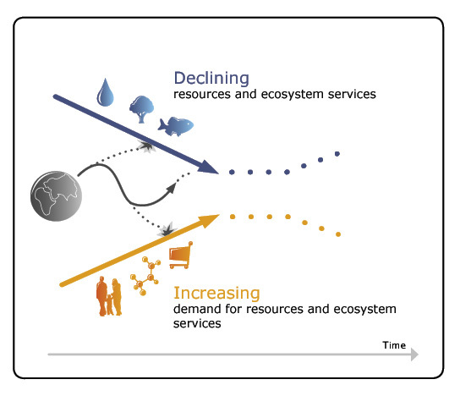

*Source:* <http://www.thenaturalstep.org/en/natural-step-funnel>

If government policies and societal structures do not mitigate unsustainable behaviours, finite natural resources represented by the walls of the funnel will function as constraints on socio-economic activities. It will expose governments, institutions, or actors that continue to practise such unsustainable actions, to a systematically higher risk of hitting these funnel walls which eventually will harm their economic activity. Furthermore, these behaviours can translate into higher costs for taxes, insurance, waste management, and so on consequently reducing the overall human well-being and this vicious cycle continues to exist (Broman, Holmberg and Robӧrt 2000, Ny *et al.* 2006).

It is worth noting that the Figure 1 represents an over simplified and pessimistic sustainability challenge by recognising the importance of natural capital only (in isolation from other types of capitals). The issues become increasingly complex when produced capital, social capital and human capital are brought into the analysis. These dimensions are discussed in detailed in section 5 and 6.

## Why Sustainability and Well-Being (SaW) Should Be Studied Together?

Sustainable development (SD) and human well-being have a brief and complex intellectual history. Optimal intergenerational human well-being is the foremost desired outcome of all SD endeavours; and increase in well-being of the present generation necessarily involves the utilization of resources for production and consumption[3] of good and services from the capital stocks of an economy. Managing these stocks rationally for sustained or increasing intertemporal consumption is the sustainability challenge. In other words, inflows and outflows of stocks directly contribute to income in the present and stocks are maintained to regulate these flows over the long-run. The relationship between stocks and flows of various type of capitals is illustrated in Figure 2.

Figure 2: Stocks and Flows

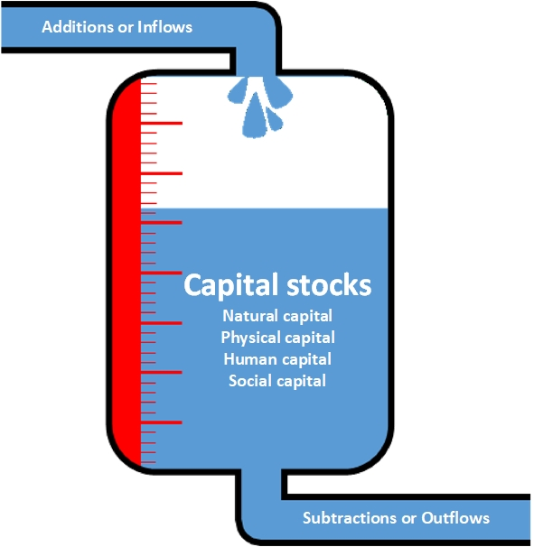

Source: Modified work of Christoph Roser (AllAboutLean.com)

c

However, the Industrial Revolution, driven by innovation and technological advancement, modified these fears of the Classical economists as modern machines and factories (produced capital) substituted for both unskilled labour and scarce land resources in the production process. Population increased accompanied by improvements in health via technological advancements. Later, elements associated with higher capabilities of labour (Sen 1985) through the so-called knowledge-based economy, have led to the substitution of skilled labour (which we call human capital) for all three of the previous types of capitals (i.e. natural capital, produced capital, and unskilled labour). Labour (skilled and unskilled) and physical capital are reproducible types of capital.

Similarly, some natural capital is reproducible (i.e. renewable capital such as forests). However, most natural capital is non-renewable such as minerals and energy resources. Concerns over the complete exhaustion of non-renewable natural capital are not new in resource economics. Jevons (1865) was likely the first notable economist to warn of the possible consequences of depleting a non-renewable natural capital resource (that is, coal) to meet the increasing energy demands of that time. However, with new technological advancements to meet energy demands from alternative energy resources (from renewable resources, for example, wind, solar and biomass) there is almost certainly more coal remaining in the ground than has ever been extracted.

From this discussion, it becomes clear that technological advancement plays a vital role in defining how basic types of capitals (land - natural capital), (unskilled) labour, human capital (skilled labour) and physical capital interact in the production of goods and services (for example, in a production function). It is also apparent how these interactions between various capitals have changed over time to contribute to current and future well-being from the consumption of goods and services. During the post-industrial revolution period, changes in the proportions of capitals used to create goods and services (and the utility to those that consume them) have occurred in response to changing relative prices, operating within some form of market.

Until quite recently, the size of these stocks of capitals (wealth) and the rates at which they change, have typically not concerned most governments or agents (exceptions include Jevons’ (1865) concern with coal; recognition of declining fish stocks in the North Sea, and latterly a popular belief in ‘peak oil’). Part of the reason might be the fact that the governments have been more interested in measuring the flows derived from the stocks (i.e. current income/expenditure) via the System of National Accounts (SNA). This includes changes in Gross Domestic Product (GDP[4]) or real GDP per capita (which takes population growth into account) which has sometimes been used as a proxy measure of well-being. Maximising changes (or reducing fluctuations) in these marketed flows of monetised values of goods and services has been advocated by many as ‘the goal’ of representative governments. Such measures could proxy for the utility received from these goods and services to some degree when non-market elements are excluded (Kuznets 1951, Stiglitz *et al.* 2010), but they fail to take account of non-market goods and services (which contribute to well-being) or changes in capital stocks (which are key to long-term sustainability). A narrow focus on GDP contradicts Adam Smith’s focus on the *Wealth of Nations* as opposed to the income of nations.

## Why are Sustainability and Well-Being Studied Independently?

Well-being and sustainability have generally been studied as independent subjects historically despite their intertwined nature. This has led to several gaps within SaW research (Helne and Hirvilammi 2015). As a result, despite SD being a catchword among policy makers for over four decades since the Brundtland Report (Bruntland *et al.* 1987), the actual progression towards a complete understanding of both sustainability and well-being is still in its infancy.

Questions around the contribution of economic development to human well-being has been a vital subject of the SaW debate for decades (Easterlin 1974, 2005, Easterlin *et al.* 2010, Grimes and Reinhardt 2015, Grimes *et al.* 2016, Qasim and Grimes 2018, Stevenson and Wolfers 2008, Stiglitz *et al.* 2010, Verme 2011). Contradicting arguments of the debate include varying definitions and measures of SaW (for example, measuring well-being in terms of economic welfare, job security, standards of living, personal happiness) and different interpretations from historical evidence. Whilst the debate on the relationship between economic development and well-being continues, there is general agreement that economic growth alone (as measured by GDP and other similar indicators) is not a perfect measure of well-being.

Both sustainability and well-being are seen as complex multi-dimensional notions for monitoring and evaluation. When it comes to assessing the performance of economies in terms of SaW, the majority of sustainability indicators fail to consider overall well-being (that is, Ecological Footprint, EF) and most well-being indicators ignore sustainability (that is, the Human Development Indicator, HDI) (Qasim 2017). Some indicators like the Index of Sustainable Economic Welfare (ISEW) and Genuine Progress Indicator (GPI) attempt to fully integrate SaW, at least in theory. However these indicators do not portray the richness of well-being dimensions and also miss particular aspects of sustainability, so do not present the whole picture (Neumayer 2007).

Part of the reason for this outcome is that historically, sustainability and well-being research have evolved as independent subjects. The roots of well-being are found mainly in the literature of philosophy, psychology, sociology, and medicine. In contrast, early SD research focused on the triple bottom-line, that is, economy, environment and society and thus predominantly emerged from interdisciplinary social sciences (Qasim 2017). In recent studies, the vitality of human well-being has been recognised as an outcome of SD. To this end, this paper presents key concepts, definitions, and developments in the fields of multidimensional SaW in relation to each other. We highlight the fundamental missing links between them and develop a case as to why SaW should be studied as a unified subject. The work will develop the foundations of the present project to link, and empirically assess, SaW in the following chapters.

## Sustainable Development

The phrase ‘Sustainable development’ (SD) (and its converse) is a concept with many possible meanings, interpretations, consequences, causes and solutions. It is sometimes interpreted as sustained growth, sustained positive change, or simply successful development (Lélé 1991). According to O’Riordan (1985) SD is a ‘contradiction in terms’. These differences in interpretations have both conceptual and semantic roots. For example, most people use the phrase sustainable development interchangeably for ecologically/environmentally sound development (Tolba 1984). Such an interpretation can be characterised by: (1) understanding sustainability as ecological/environmental sustainability or (2) conceptualising sustainability as a process which includes ecological/environmental sustainability as a component. Because of the broad, range of concepts and definitions around SD, it is imperative to attempt to consolidate SD theory to rigorously define what sustainability is, before attempting any meaningful empirical analysis.

### Brief Intellectual History of Sustainability

It is very hard to say when the phrase *‘sustainable development’* was first used. Historically, the roots of sustainability (in the context of sustainable development) are grounded in six independent but related strands of thought which predominantly emerged from three interconnected topics during the 1950s relating to: (1) population growth, (2) use of resources and (3) limits to growth. They six strands of thought are: (a) carrying capacity, (b) environment and resources, (c) biosphere, (d) no/slow growth, (e) eco-development, and (f) technological advancement. All of these strands of thought were well-established before the word *‘sustainable’* itself was used. The word *‘sustainability’* was used in 1972 in a British book, *Blueprint for Survival* in relation to the future of human society. In 1974, the word *‘sustainability’* was used in the United States to rationalise a ‘no growth’ economic development. *‘Sustainability’* was used in 1978 in the United Nations report to elaborate *‘ecodevelopment’*. By the end of the 1970s the term *‘Sustainability’* started to be widely used in technical reports and policy documents to explain a wide range of strands of thought (Kidd 1992).

The ‘overpopulation’ school of thought descends directly from the Malthusian notion of population growth proposed in *An Essay on the Principle of Population* by Robert Malthus in 1798 in which he focuses on population growth as an underlying cause of resource overuse and environmental degradation. His basic idea was that the population grows at a geometric rate, whereas food supply grows at an arithmetic rate leading to the occurrence of severe food shortage followed by starvation, deaths, and epidemics which eventually wipe out the surplus population and re-establishes equilibrium in society. Although global population continues to rise, and most sustainability models account for population growth, concerns over overpopulation have been retreating due to high incomes, low fertility rates (in some, but not all, countries), and technological advancements (Brander 2007).

Consideration of the use of resources mainly deals with concerns about environmental degradation (such as air and water pollution), and depletion of renewable (for example, forest) and non-renewable (for example, coal, oil, gas, minerals) natural resources. Sustainability models in two distinct (but overlapping) fields of economics i.e. environmental economics and resources economics, addresses natural capital in terms of *stocks and flows* for *wealth* accounting and *income* accounting. These concepts are discussed in detail later in the paper.

The *‘No growth’* philosophy emerged comprehensively and forcefully in the 1970s after the work Georgescu-Roegen (1971). In his book, *The Entropy Law and the Economic Process,* he emphasised that the steady-state[5] is inevitable for an economy following the fundamental laws of thermodynamics. In steady-state growth stage, by definition, the quantity of resources is constant and the inflow and outflow must balance (Ayres 1999). This was followed by the notion of *‘Limits to growth’* by (Meadows *et al.*1972).

Similar to Malthusian theory, Meadows *et al.* (1972) argues that the vital substance of the *‘Limits to growth’* approach is that the world is set for a collapse through population growth, depletion of natural resources, pollution, environmental degradation, or a combination of these, within a few decades. Results of their computer simulations showed that, if present growth trends remain unchanged, the planet will reach its limit in the next 100 years (that is, by 2072 since the book was first published) leading to a catastrophic future unless drastic actions, including cessation of economic growth, are taken. It is also worth noting that most of the natural resources included in their computer models (that is, coal, oil, gas) were predicted to be exhausted well before now (2018) nevertheless none of them have been, showing the falsity of the approach.

Following the above three topics and six strands of thought, the term ‘sustainability’ became widely used in resource economics, environmental economics, and in related policy documents, by late 1970s. Unfortunately, the term was used ambiguously (that is, in a variety of ways), which led to a significant semantic confusion (Brander 2007, Özdemir *et al.* 2011). However, it was somewhat agreed that the majority of sustainability approaches include environmental aspects in economic growth models by restricting the depletion of natural resources. The debates on the perception about the interactions between environmental health and economic growth and the extent to which natural capital could be allowed to be harvested in order to achieve higher quality of life led to the paradigms of ***weak sustainability*** and ***strong sustainability***. These are discussed in detail later in this paper.

The origins of SD were raised in 1930s in economics by (Hotelling 1931)[6] and in 1970s by (Dasgupta and Heal 1974, Solow 1974, Stiglitz 1980), which has been referred to as the ‘Dasgupta-Heal-Solow-Stiglitz (DHSS)’ approach in (Hamilton and Withagen 2007) and was expanded by (Pearce, Markandya and Barbier 1989)[7].

The modern concept of sustainability was emphasised and popularised in 1987 by the United Nation’s Brundtland Commission Report (Brundtland *et al.* 1987), *Our Common Future* which presented the concept of SD to the global community as a new paradigm for economic expansion, environmental sustainability and social viability. The Brundtland Commission 1987 Report defines sustainable development as:

*‘the development that meets the needs of the present without compromising the ability of future generations to meet their own needs.’*

It further argues that *‘the environment’* is where we live and *‘development’* is what we all do in order to improve our lives and these two are inseparable. SD according to Brundtland involves two key concepts:

(1) ‘The concept of ‘needs’, in particular, the essential needs of the world's poor, to which overriding priority should be given, and

(2) The idea of limitations imposed by the state of technology and social organization on the environment's ability to meet present and future needs.’

Later, in 1993, US President Clinton endorsed the idea of SD stating: ‘If we do not nurture our people and our planet through sustainable development, we will deepen conflict and waste the very wonders that make our efforts worth doing.’[8] In 2000, sustainable development became an integral part of the United Nations’ Millennium Development Goals (MDGs) and emerged as a shared vision of the governments around the world. Recently, sustainable development has been seen as a study of critical links between the allocation and distribution of a wide range of resources in order to ensure that our current actions are consistent with our future aims (UN, 2012).

*‘The long-term vision of the High-level Panel on Global Sustainability is to eradicate poverty, reduce inequality and make growth inclusive, and production and consumption more sustainable, while combating climate change and respecting a range of other planetary boundaries.’* (UN, 2012)Pg.10

In 2016, on the back of the success of the MDGs, 17 Sustainable Development Goals (SDGs), also known as ‘Global Goals’ have been introduced by the United Nation’s Development Programme which include new areas of development such as innovation, climate change, economic inequality, sustainable consumption, peace and justice, among other priorities. These goals, to be attained by 2013, have been adopted by the governments of some 170 countries (Griggs *et al.* 2013).

In a broader sense, positive sustainability in the literature is seen as study of: the dynamic optimality, intergenerational neutrality and interlinkages between the economy and the environment which puts social equity within and between countries at the core of SD. Although SD has been a visionary paradigm over the last several decades for governments, civil society, and businesses around the world, the concept itself remains elusive across disciplines and its implementation has proven hard (Drexhage and Murphy 2010, Lélé 1991, Quiggin 1997, Tisdell 1988, 1993). It is largely agreed that SD necessitates the convergence between its three pillars: (1) economic development, (2) social equity and (3) environmental protection. The differences and inconsistencies in conceptualizing SD are rooted in perceiving the overlaps between them.

For example, neoclassical economics typically evaluates policies based on their welfare outcome where welfare is sometimes equated with consumption (Safarzyńska 2013). Sustainability theories of neoclassic economics have been criticised by new and emerging disciplines in economics, environmental sustainability, and behavioural studies. For instance, sustainable consumption in neoclassical economics is built around the notion of market equilibrium, utility maximization and preferences which are inadequate to guide policy prescriptions in the presence of dynamic preferences, uncertainties and complex socio-economic interactions (Akerlof and Shiller 2010, van den Bergh and Kallis 2009, Binder and Witt 2011, Farmer and Foley 2009, Gowdy 2005, Ostrom 2008).

Others argue that ecological modernization concepts with an emphasis on efficiency and innovation cannot guarantee to meet Brundtland’s sustainability criteria. For instance, Lorek and Spangenberg (2014) argue that the concept of sustainability has been unfortunately weakened, misunderstood and misinterpreted by green economy/green growth theories since its formation. Nations are, therefore, hardly approaching it and current trends are moving in the opposite direction. These diverging arguments on sustainability and well-being are grounded in the varying arrangements of three pillars of sustainability (which are widely discussed in sustainability literature (Daly 1996, Ekins and Medhurst 2006, Ekins 2011, Elkington 1998, Jickling *et al.* 2011, Mulia, Behura and Kar, 2016) summarised in Figure 3.

Figure 3: Commonly Used Sustainability Models



A: The bullseye sustainability model  
B: The ‘Mickey Mouse’ sustainability model

C: Venn diagram sustainability model

*Source:* Figure compiled from multiple resources.

The 'bullseye' sustainability model on the left in Figure 3 recognises the economy as a subset of a society and both of these are entirely dependent on the environment. Economy exists within the society due to the fact that a significant proportion of society does not contribute to economic activity. In this model, society and the economy combined operate within the natural limits of the environment (for details see Daly (1996). This model has also been referred to as strong sustainability model (although it allows some degree of substitutability between natural capital and other forms of capital).

In the middle of Figure 3, Model B (the 'Mickey Mouse' model) focuses on the economy as the most important pillar of sustainability with society and the environment as minor side issues (Houck 2003, Mann 2018, SANZ 2009). It reflects anthropocentric behaviours where economic activities predominantly influence the environmental and social bottom-lines (Mulia, Behura and Kar 2016). Model C on the right (a Venn diagram or a standard triple bottom-line model) was proposed by (Elkington 1998) to illustrate the relationship between the three pillars of sustainability. Models B ignores the ultimate limits of Model A imposed by the environment (biosphere) on the economic and social pillars of sustainability and thus indicates a growth economy which make them weak sustainability models (Lozano 2008). By contrast, if the economy in model C is operating in the intersection area, then it is operating within the natural boundaries.

In the following section, we try to narrow down the definition of sustainable development leading to human-well-being in the field of economics by classifying and categorizing overlapping concepts.

### Sustainability Revisited in Modern Economics

Although modern economic models of sustainable development limit the scope of objectives, they maintain internal consistency. The economic approach to sustainability is based upon maximizing intertemporal welfare, where the constrained optimization problem includes system interlinkages and refrains from intertemporal discrimination. In other words, sustainability in an economic perspective rests on three pillars of inter-generational equity, interlinkages between environment and economy ‘environomy’ and dynamic optimization (Stavins, Wagner and Wagner 2003). Economists began with a modest specification of interlinkages, where production is taken as a function of natural resource extraction, capital and labour (which in some cases may be represented by a Cobb-Douglas production function).

According to Endress and Roumasset (1994), Endress *et al.*(2014) and Endress, Roumasset and Zhou (2005) adding intergenerational equity into the function results in two main rules for sustainable and optimal growth: (1) extract natural resources in accordance with the principle for **optimal resource management**; (2) **accumulate genuine savings** guided by the Ramsey condition for optimal savings and investment. Combination of these two principles provides a decomposition of the sum of natural capital and produced capital (used in the Genuine Savings measure for example) and an optimal consumption path. This optimal path is sustainable even in the absence of a sustainability constraint, which requires non-declining consumption over-time (Pezzey 1997) or non-declining intertemporal welfare (Arrow *et al.* 2004). Optimal consumption continually rises and approaches the Golden Rule level[9] (Endress and Roumasset 1994).

These models can be extended further by including externalities, such as pollution growth, greenhouse gas emissions, under the same optimality condition of the Ramsey equation and the Pearce equation (Endress, Roumasset and Zhou 2005, Endress *et al.*2014). Therefore, sustainable development does not require to abandon fundamental principles of economics as in the popularised approaches. Optimal growth theory, for sustainable development, only requires the combination of recognised economic principles (Endress, Roumasset and Zhou 2005). The debate between ecological modernisation and optimal growth has led to the categorisation of sustainability under strong sustainability and weak sustainability discussed in the following section.

### Types of Sustainability

The idea of sustainable development is tempting. It has evolved as a development catchword and become one of the key challenges of the century. The term itself, however, has resisted unanimously acceptance (Clark 2007, Dietz and Neumayer 2007, Sachs 2005). Though there is considerable political consensus on the notion of sustainability, the scientific consensus regarding the fundamental question ‘what to sustain?’ (Arrow *et al.* 2012, Dobson 1996, Robert, Parris and Leiserowitz, 2005, Stone, 2003) has still not been reached (Brand 2009). We must discriminate between a number of approaches in order to reach a substantive definition (Neumayer 2007). As mentioned earlier, in economics, one debate is over what sort of capitals ought to be preserved for current and future generations (Arrow *et al.* 2012, Costanza *et al.* 2007). At a conceptual level, this is the choice between strong sustainability and weak sustainability (Pezzey and Toman 2002), a classic dispute between Solow (1974) and Georgescu-Roegen (1971).

#### Strong Sustainabilit*y*

Strong sustainability is hard to define unambiguously, although it is based on the notion that views natural capital to a greater and lesser extent non-substitutable in the production processes. It defends the critical role of natural capital due to its unique contribution for sustenance and well-being (environment, eco-system services) and holds that it is non-substitutable with any other type of capital (for example, produced capital, social capital). Thus, all types of capitals should be independently maintained. In this paradigm, any development process which does not preserve natural capital is bound to lead towards an unsustainable growth path (Mulia, Behura and Kar 2016, Neumayer 2003). Strong sustainability aims at box D in Figure 4 where the quality of life is achieved without tapping into natural capital as the only sustainable solution. Whereas in weak sustainability, box C is also acceptable as long as net aggregate value in monetised terms of all types of capital is larger than the value of the degraded environment, or outputs are greater than inputs.

**Figure 4: Sustainability and Quality of Life (Human Well-Being)**

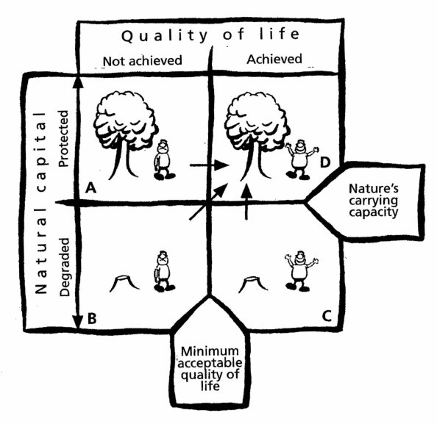

*Source:* Colorado College, <http://www.coloradocollege.edu/dept/ev/courses/footprint/Footprint.htm>

‘Very strong’ sustainability (backed by the Deep Ecology movement and supported by those who believe in the ‘right-to-life’ for all forms of life) implies that every element or sub-system of natural capital, all species, and physical stocks, must be preserved (Pearce and Atkinson 1995). Some have also included a ‘neo-Marxist’ political economy perspective in to the strong sustainability argument which opposes economic modernization theories and stresses the fundamental trade-offs between economic production and eco-system services. Under such scenarios, the solution lies in diverting sustainability policies from economic expansion towards ecological sustainability.

#### Weak Sustainability

The notion of weak sustainability emerged from the neo-classical economic strand of though (Pearce and Atkinson 1993). In this view it is assumed that any economic activity can be sustainable provided that the total output value (aggregated from the monetised value of all types of capitals) is greater than the input value used in the production processes. Thus, weak sustainability implies all types of capitals discussed earlier are interchangeable. Economic modernisation theory stemming from neo-classical economics, argues that the environmental degradation caused by economic growth can be compensated for with the development of other types of capitals (for example, human capital, produced capital). Skilled human capital and technological advancements, in the future, will not only help to reduce the environmental impacts more effectively, but also improve production efficiencies. Thus, the economic modernisation theory does not view a fundamental conflict between economic modernisation and utilisation if the environment over the long-run (Ayres *et al.* 1998, Dietz and Neumayer 2007).

The origins of weak sustainability are found in the 1970s (Neumayer 2007) when neoclassic models of economic growth were extended to account for non-renewable natural capital as a factor of production (Dasgupta and Heal 1974, Hartwick 1977, Solow 1974). These aggregate economic growth models account for the optimal use of income produced from the non-renewable resource extraction in order to establish a rule on how much of it to consume and how much should be invested in produced capital for future consumption. The key question posed with these models was whether the optimal growth is sustainable in the sense of non-declining well-being, which proved to be infeasible in a certain class of models which include a non-renewable resource as a factor of production. In these models, consumption declines to zero in the long-run as a result of saving for optimal growth (Solow 1974). It, therefore, becomes necessary to define rules for non-declining welfare over time based on the maintenance of natural capital, produced capital, human capital and social capital.

Hartwick (1977) developed a general rule a ‘rule of thumb’ that the rents produced from the depletion of non-renewable resource should be reinvested in the produced capital. This could be considered as a general rule of weak sustainability such that the rate of change of net capital investment, which includes gross investment in all types of capital, is measurable, and subtractable from depreciation or consumption, is not allowed to be negative (Hamilton 1994).

The Hartwick and Solow models impute renewable and non-renewable resources in a Cobb-Douglas production function which is characterised by a unitary and constant elasticity of substitution between all factors of production. In other words, it assumes that natural capital and produced capital are similar and substitutable. To validate this assumption, either of the following must hold: (1) natural resources are abundant or (2) the elasticity of substitution between natural capital and produced capital is equal to or great than unity; (3) technological advancement can boost productivity of natural capital at a higher rate than its depletion (Dietz and Neumayer 2007).

In order to measure weak sustainability, we need to enter the realm of green accounting. In other words, we have to associate economic values to the reduction in the quantity of natural capital and to environmental degradation, that is, the economic value of damage to natural capital quality. This enables planners to correctly understand if the natural capital losses are being compensated equivalently, or not. Commonly used measures of weak sustainability include environmentally-adjusted net product; genuine savings (GS); measures of resource depletion; measures of environmental degradation and the index of sustainable economic welfare (Asheim 1994, Dietz and Neumayer 2007, Pearce and Atkinson 1993, Quiggin 1997, Romero and Linares 2014).

#### Are Strong and Weak Sustainability Conflicting Paradigms?

To many, an unambiguous answer to this question is ‘yes’. According to (Pearce, Markandya and Barbier 1989), however, this is not the case. In *Blueprint for a Green Economy* they define SD as a situation where *well-being for a given population is not declining, or preferably is increasing over time* (Pearce, Markandya and Barbier 1989)*.* They suggest that such SD requires that each generation passes-on undiminished stocks of total capital to the future generation in order to meet intergenerational fairness and non-declining consumption over time. They emphasised the extent to which a decline in natural capital (for example, loss of forest) can be compensated for by increasing other forms of capital (for example, human capital, produced capital) leading to the following cases for intergenerational rule:

(1) SD requires non-declining total wealth (weak sustainability condition).

(2) SD requires non-declining natural wealth (strong sustainability condition).

They further explain the following reasons why we need to impose rules on the strong sustainability condition rather than the weak sustainability condition.

(a) Lack of sufficient substitutability

(b) Irreversibility

(c) Uncertainty and

(d) Intra-generational equity[10]

In weak sustainability[11], the natural capital stock is maintained as non-declining (in the long-run) slightly differently by compensating for the net value of environmental damages (Rule 1). When evaluated at the programme level, this value of net environmental damage should be zero or negative, either when discounted across multiple time periods or at each point in time as suggested by the Hartwick general rule. According to (Pearce, Markandya and Barbier 1989), this could be achieved by commissioning shadow projects which have the purpose of off-setting environmental damages from other projects in the programme. Such shadow projects might well yield negative NPVs when appraised in isolation, implying that there is a sustainability ‘price’ being paid by the economy, which is the marginal cost of the constraint of no positive environmental damage.

## Balanced Sustainability Approach

The debate between the proponents of weak sustainability and strong sustainability continues today. Although there are many possibilities for substitutions and major breakthroughs, strong sustainability might seems sensible to some, but it the concept undermines the role that technological advancement and skilled human capital can play particularly over the long-run (Ayres 1999 and Daly 1997).

Since strong sustainability is a more rigid concept, a number of rules have been suggested to operationalise it. Neumayer (2003) has identified two different school of thoughts. One requires that the value of natural capital is preserved under the assumption of unlimited substitutability (for weak sustainability) among different forms of capital. In the case of non-renewable natural resources, for instance, extraction should be compensated by the investment in renewable natural resource of the same or higher value. The second school of thought requires that a subset of total natural capital should be preserved in physical terms so that its functions remain intact. This is called ***critical natural capital***(CNC) (Brand 2009, Dietz and Neumayer 2007, Ekins *et al.* 2003, Neumayer 2003).

CNC is largely defined as ‘the minimum amount of natural capital which is required for important environmental functions and which cannot be substituted in the provision of these functions by any other form of capital’ (Douguet and O’Connor 2003, Ekins 2011, Ekins *et al.* 2003) and the maintenance of CNC is one of the key aspects of SD which is essential (Brand 2009, Ekins *et al.*  2003). According to Turner (1993), the constraint of critical natural capital is required to be maintained within bounds to be consistent with the ecosystem stability and resilience. Depletion of natural capital beyond a critical limit, results in irreversible loss (for example, extinction of an entire species) which could entail enormous costs due to its vital role for human well-being; and it could be highly unethical (Dietz and Neumayer 2007).

If the environmental limits are exceeded (that is, depletion of natural capital beyond CNC) weak sustainability also becomes indefensible (Arrow *et al.* 1995). Environmental conservatives have suggested that production processes have already exceeded earth’s carrying capacity resulting in ecological overshoot[12] (Wackernagel *et al.* 2002). According to their work, overshooting occurred around the 1980s and during the following two decades, until the late 1990s, when this amount reached 1.2 as show in Figure 5. Similarly, the National Footprint Accounts annual trends, published by Global Footprint Network shown in Figure 6, reveals that every coming year is bringing ‘overshoot day’ (in illustrative calendar date when consumption of resources for the year exceeds the planetary capacity to re-generate those resources and assimilate waste for that that year[13]) earlier than the previous year. This day fell on 2 August in 2017 see <https://www.overshootday.org/>); and at the current rates of consumption, we would need 1.7 earth like planets to off-set those footprints.

While recognising some concerns of the strong sustainability believers, proponents of weak sustainability emphasise total wealth which includes all other types of capital as well (Arrow *et al.* 2012, Ferreira, Hamilton and Vincent 2008, Greasley *et al.* 2014). As long as total wealth is increasing, societies are on a sustainable development path. For example, the Human Development Index (HDI) global mean (compiled by the UNDP as a broader measure for quality of life) has been increasing since the 1990’s as shown in Figure 7. This trend contradicts the rigid pessimism by overshoot theorists. If global population has been over consuming natural resources unsustainably for the last four decades, some of its adversities should have been reflected in the HDI trends. Dietz and Neumayer (2007) also criticised strong sustainability assumptions in EF frameworks of sustainability, for similar reasons[14].

Figure 5: Ecological Overshoot of the Economy

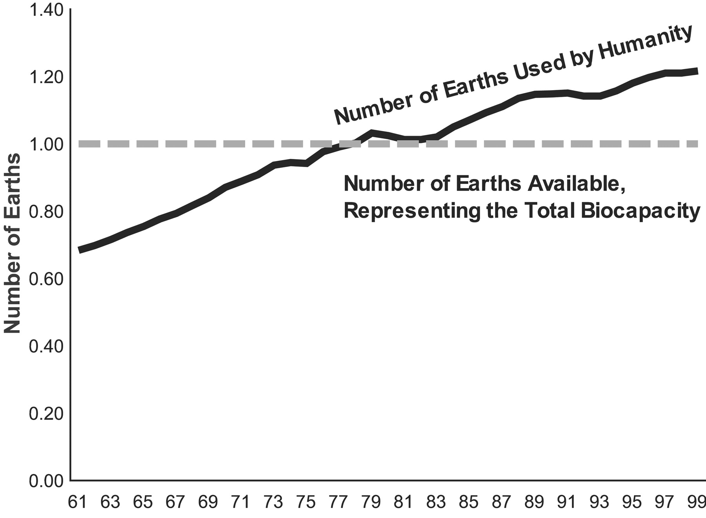

*Source:* (Wackernagel *et al.* 2002)

Figure 6: Annual Trends in Earth Overshoot Day

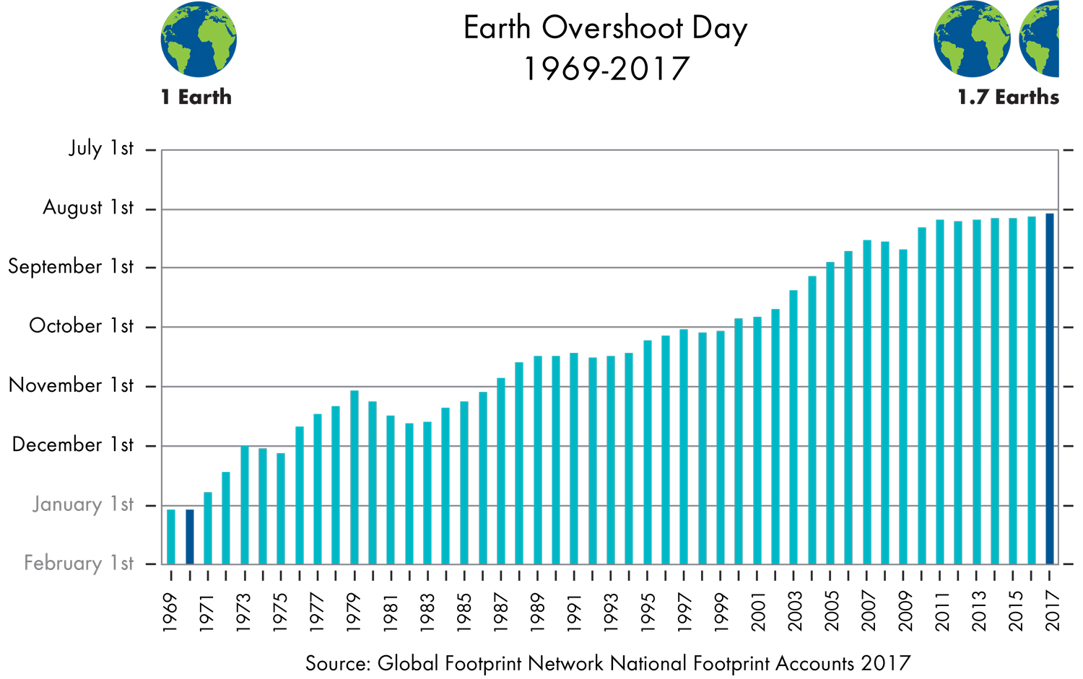

Figure 7: Tends in Global Mean HDI

*Source:* Plotted from the data at http://hdr.undp.org/en/data#

On the other hand, the key reason for which weak sustainability is criticised is that it overlooks CNC limits in unlimited substitution possibilities. This short-coming has been recognised as suggesting that the weak sustainability frameworks and their monitoring and evaluation indicators, should be consistent with protecting CNC (Dietz and Neumayer 2007).

Our argument is that taking either of these two extreme positions of weak sustainability’s infinite substitutability, or strong sustainability’s ecological superiority is unnecessary. Instead, adoption of a middle way between them is the most coherent approach. That is, some degree of substitutability between various types of capital should be allowed and ***renewable natural*** capital can be harvested below the CNC limit to develop other types of capital (Romero and Linares 2014). Our proposed concept is illustrated in Figure 8. The x-axis shows substitutability between natural capital and other types of capitals from 0 (no substitution) to 1 (perfect substitution); and natural capital utilisation is shown along the y-axis from O (state of fully preserved natural capital) to Z (state of fully consumed natural capital). In this figure, strong sustainability is shown as a corner solution in which any substitution between various capitals is not allowed and where natural capital is not consumed at all.

Figure 8: Balanced Sustainability Concept

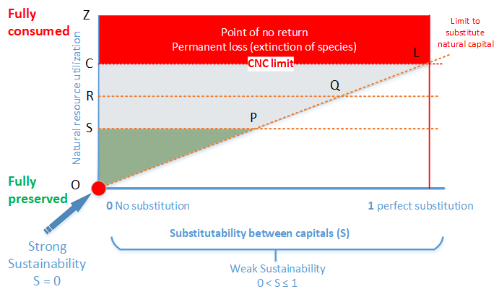

*Source:* Authors.

## 8. Conclusions

In this paper we reviewed some of the seminal sustainability literature, from the emergence of the concept itself and tracked its historical developments over time. We also shed some light on why human well-being, which is the foremost desirable outcome of all sustainability endeavours, has been excluded from most sustainability models. One of the key reasons is that the term ‘sustainability’ has been the focal debate between environmentalists, ecologists and economists. This is a debate of the substitutability between various types of capitals: natural capital; produced capital; human capital, a debate captured in terms of *‘strong sustainability’* and *‘weak sustainability’.*

Ecologically, strong sustainability models view natural capital as the fundamental layer on the top of which societies and economies are built. Due to its life supporting provisioning of natural capital, it cannot be substituted for with any other type of capital (for example, produced capital, human capital) in each period for intergenerational sustainability. Thus, under the strong sustainability development paradigm, all development policies should focus on developing human capital and produced capital, independently from natural capital.

Whereas, weak sustainability focuses on the total wealth of nations estimated from the monetised aggregates of all types of capitals over the long-run. It suggests that as long as total wealth is maintained, or preferably increasing over time, a country is on a sustainable development path. The key condition for weak sustainability models given by Hartwick’s ‘rule of thumb’ is that the depletion of natural capital can be compensated for with equivalent investment in produced capital and human capital. In future, higher production efficiencies from technological advancement (in produced capital) and rich human capital (skilled labour) will off-set any adverse environmental impacts.

Both of these approaches have been subject to criticism. For example, strong sustainability has been criticised for overlooking the resilience of natural capital and waste of unused natural capital through natural processes. Whereas, weak sustainability has been criticised for allowing infinite substitutability of natural capital with other types of capital. We argue, instead of adopting either of these extreme approaches, sustainability policies can be defined by adopting a balanced approach, where substitutability between various types of capitals is allowed for (as suggested in weak sustainability models) in order to build national wealth (in terms of all capitals) but – crucially – subject to CNC limits (to be consistent with strong sustainability conditions).

## 9. Future Directions

Sustainability is not a destination rather it is a process of continuous improvement. It cannot be confined to one single place in isolation neglecting the planet as a whole. Weak sustainability subject to CNC limits is the minimum SD criteria to meet for every part of the world to thrive as earthlings. In doing so, we need to broaden the focus of SD indicators to places at different scales – from regions, to countries, to continents (and oceans) and, ultimately, to the planet.

## References

Agarwala, M. (2012). *Inclusive Wealth Report 2012: Measuring Progress Toward Sustainability*. Cambridge University Press.

Akerlof, G. A. and Shiller, R. J. (2010). *Animal spirits: How human psychology drives the economy, and why it matters for global capitalism*. Princeton University Press.

Alesina, A., Tella, R. D. and MacCulloch, R. (2004). Inequality and happiness: are Europeans and Americans different? . *Journal of Public Economics* , *88*(9–10), 2009 – 2042.

doi:http://dx.doi.org/10.1016/j.jpubeco.2003.07.006

Arrow, K., Bolin, B., Costanza, R., Dasgupta, P., Folke, C., Holling, C. S., Jansson, B.-O., *et al.*  (1995). Economic growth, carrying capacity, and the environment . *Ecological Economics*, *15*(2), 91–95. doi:http://dx.doi.org/10.1016/0921-8009(95)00059-3

Arrow, K., Dasgupta, P., Goulder, L., Daily, G., Ehrlich, P., Heal, G., Levin, S., *et al.* (2004). Are We Consuming Too Much? *The Journal of Economic Perspectives*, *18*(3), pp. 147–172. American Economic Association. Retrieved from http://www.jstor.org/stable/3216811

Arrow, K. J., Dasgupta, P., Goulder, L. H., Mumford, K. J. and Oleson, K. (2012). Sustainability and the measurement of wealth. *Environment and Development Economics*, *17*(03), 317–353.

doi:10.1017/S1355770X12000137

Asheim, G. B. (1994). Net National Product as an Indicator of Sustainability. *The Scandinavian Journal of Economics*, *96*(2), 257–265. Retrieved from http://www.jstor.org/stable/3440603

Ayres, R. U. (1999). The second law, the fourth law, recycling and limits to growth . *Ecological Economics*, *29*(3), 473–483. doi:http://dx.doi.org/10.1016/S0921-8009(98)00098-6

Ayres, R. U., Van Den Bergh, J. C., Gowdy, J. M. and others. (1998). Weak versus Strong Sustainability. Tinbergen Institute (TI).

Van den Bergh, J. C. J. M. and Kallis, G. (2009). *Evolutionary policy*. Jena: Max-Planck-Inst. für Ökonomik. Retrieved from http://hdl.handle.net/10419/32650

Binder, M. and Witt, U. (2011). As innovations drive economic growth, do they also raise well-being? *Evolutionary Economics Group,*, (1105). Jena: Max-Planck-Inst. für Ökonomik. Retrieved from http://hdl.handle.net/10419/57557

Brand, F. (2009). Critical natural capital revisited: Ecological resilience and sustainable development . *Ecological Economics* , *68*(3), 605–612. doi:http://dx.doi.org/10.1016/j.ecolecon.2008.09.013

Brander, J. A. (2007). sustainability: Malthus revisited? *Canadian Journal of Economics/Revue canadienne d’économique*, *40*(1), 1–38.

Broman, G., Holmberg, J. and Robӧrt, K.-H. (2000). Simplicity without reduction: Thinking upstream towards the sustainable society. *Interfaces*, *30*(3), 13–25. INFORMS.

Brundtland, G., Khalid, M., Agnelli, S., Al-Athel, S., Chidzero, B., Fadika, L., Hauff, V., *et al.* (1987). Our Common Future. Oxford University Press, USA.

Bruntland, G. *et al.* (1987). Our common future: The world commission on environment and development. Oxford: Oxford University Press.

Chichilnisky, G., Heal, G. and Beltratti, A. (1995). The green golden rule. *Economics Letters*, *49*(2), 175–179.

Clark, W. C. (2007). Sustainability Science: A room of its own. *Proceedings of the National Academy of Sciences*, *104*(6), 1737–1738. doi:10.1073/pnas.0611291104

Costanza, R., Fisher, B., Ali, S., Beer, C., Bond, L., Boumans, R., Danigelis, N. L., et al. (2007). Quality of life: An approach integrating opportunities, human needs, and subjective well-being . *Ecological Economics* , *61*(2–3), 267 – 276. doi:http://dx.doi.org/10.1016/j.ecolecon.2006.02.023

Costello, A., Abbas, M., Allen, A., Ball, S., Bell, S., Bellamy, R., Friel, S., et al. (2009). Managing the health effects of climate change: lancet and University College London Institute for Global Health Commission. *The Lancet*, *373*(9676), 1693–1733. Elsevier.

Daly, H. (1977). Steady state economy. *San Francisco*.

Daly, H. E. (1996). *Beyond growth: the economics of sustainable development*. Beacon Press.

Daly, H. E. (1997). Georgescu-Roegen versus Solow/Stiglitz . *Ecological Economics*, *22*(3), 261–266. doi:http://dx.doi.org/10.1016/S0921-8009(97)00080-3

Dasgupta, P. and Heal, G. (1974). The Optimal Depletion of Exhaustible Resources. *The Review of Economic Studies*, *41*, pp. 3–28. Oxford University Press.

Dietz, S. and Neumayer, E. (2007). Weak and strong sustainability in the SEEA: Concepts and measurement. *Ecological Economics*, *61*(4), 617–626.

doi:http://dx.doi.org/10.1016/j.ecolecon.2006.09.007  
Dobson, A. (1996). Environment sustainabilities: An analysis and a typology. *Environmental Politics*, *5*(3), 401–428. doi:10.1080/09644019608414280

Douguet, J.-M. and O’Connor, M. (2003). Maintaining the integrity of the French terroir: a study of critical natural capital in its cultural context. *Ecological Economics*, *44*(2), 233–254. doi:https://doi.org/10.1016/S0921-8009(02)00276-8

Drexhage, J. and Murphy, D. (2010). Sustainable development: from Brundtland to Rio 2012. Background paper prepared for consideration by the High Level Panel on Global Sustainability at its first meeting 19 September 2010. New York New York United Nations 2010 Sep.

Easterlin, R. A. (1974). Does economic growth improve the human lot? Some empirical evidence. *Nations and Households in Economic Growth*, *89*, 89–125.

Easterlin, R. A. (2005). Feeding the illusion of growth and happiness: A reply to Hagerty and Veenhoven. *Social indicators research*, *74*(3), 429–443. Springer.

Easterlin, R. A., McVey, L. A., Switek, M., Sawangfa, O. and Zweig, J. S. (2010). The happiness–income paradox revisited. *Proceedings of the National Academy of Sciences*.

doi:10.1073/pnas.1015962107

Ekins, P. (2011). Environmental sustainability From environmental valuation to the sustainability gap. *Progress in Physical Geography*, *35*(5), 629–651. Sage London.

Ekins, P. and Medhurst, J. (2006). The European structural funds and sustainable development: A methodology and indicator framework for evaluation. *Evaluation*, *12*(4), 474–495. Sage London.

Ekins, P., Simon, S., Deutsch, L., Folke, C. and Groot, R. D. (2003). A framework for the practical application of the concepts of critical natural capital and strong sustainability . *Ecological Economics* , *44*(2–3), 165 – 185. doi:http://dx.doi.org/10.1016/S0921-8009(02)00272-0

Elkington, J. (1998). Partnerships from cannibals with forks: The triple bottom line of 21st-century business. *Environmental Quality Management*, *8*(1), 37–51.

Endress, L. H., Pongkijvorasin, S., Roumasset, J. and Wada, C. A. (2014). Intergenerational equity with individual impatience in a model of optimal and sustainable growth . *Resource and Energy Economics*, *36*(2), 620–635. doi:http://dx.doi.org/10.1016/j.reseneeco.2013.10.001

Endress, L. H. and Roumasset, J. A. (1994). Golden Rules for Sustainable Resource Management*. *Economic Record*, *70*(210), 267–277. Blackwell. doi:10.1111/j.1475-4932.1994.tb01847.x

Endress, L. H., Roumasset, J. A. and Zhou, T. (2005). Sustainable growth with environmental spillovers. *Journal of Economic Behavior and Organization*, *58*(4), 527–547.

doi:http://dx.doi.org/10.1016/j.jebo.2004.09.003

Farmer, J. D. and Foley, D. (2009). The economy needs agent-based modelling. *Nature*, *460*(7256), 685–686.

Ferreira, S., Hamilton, K. and Vincent, J. R. (2008). Comprehensive Wealth and Future Consumption: Accounting for Population Growth. *World Bank Economic Review*, *22*(2), 233–248.

doi:10.1093/wber/lhn008

Georgescu-Roegen, N. (1971). *The Entropy Law and the Economic Process*. Harvard University Press, Cambridge, MA.

Gowdy, J. (2005). Toward a new welfare economics for sustainability . *Ecological Economics*, *53*(2),

211 – 222. doi:http://dx.doi.org/10.1016/j.ecolecon.2004.08.007

Greasley, D., Hanley, N., Kunnas, J., McLaughlin, E., Oxley, L. and Warde, P. (2014). Testing genuine savings as a forward-looking indicator of future well-being over the (very) long-run. *Journal of Environmental Economics and Management*, *67*(2), 171 – 188.

doi:http://dx.doi.org/10.1016/j.jeem.2013.12.001

Greasley, D., McLaughlin, E., Hanley, N. and Oxley, L. (2017). Australia: a land of missed opportunities? *Environment and Development Economics*, *22*(6), 674–698. Cambridge University Press. doi:10.1017/S1355770X17000110

Griggs, D., Stafford-Smith, M., Gaffney, O., Rockstrӧm, J., Öhman, M. C., Shyamsundar, P., Steffen, W., *et al.*  (2013). Policy: Sustainable development goals for people and planet. *Nature*, *495*(7441), 305.

Grimes, A., Ormsby, J., Robinson, A. and Wong, S. Y. (2016). Subjective wellbeing impacts of national and subnational fiscal policies. *Motu Working Paper*, *3*(1), 43–69.

doi:10.18335/region.v3i1.121

Grimes, A. and Reinhardt, M. G. (2015). Relative income and subjective wellbeing: Intra-national and inter-national comparisons by settlement and country type. *Motu Working Paper*.

Hamilton, K. (1994). Green adjustments to GDP. *Resources Policy*, *20*(3), 155–168.

doi:http://dx.doi.org/10.1016/0301-4207(94)90048-5

Hamilton, K. and Withagen, C. (2007). Savings growth and the path of utility. *Canadian Journal of Economics*, *40*(2), 703–713. doi:10.1111/j.1365-2966.2007.00427.x

Hartwick, J. M. (1977). Intergenerational equity and the investing of rents from exhaustible resources. *American Economic Review*, *67*(5), 972–974.

Helne, T. and Hirvilammi, T. (2015). Wellbeing and Sustainability: A Relational Approach. *Sustainable Development*, *23*(3), 167–175. doi:10.1002/sd.1581

Hotelling, H. (1931). The economics of exhaustible resources. *Journal of Political Economy*, *39*(2), 137–175.

Houck, O. (2003). Introduction: Thinking About Tomorrow: Cuba’s’ Alternative Model’ for Sustainable Development. *Tulane Environmental Law Journal*, *16*, 521–532.

Jevons, W. S. (1865). *The coal question: An inquiry concerning the progress of the nation, and the probable exhaustion of the coal-mines*. Macmillan.

Jickling, B., Sauvé, L., Briere, L., Niblett, B. and Root, E. (2011). 5th world environmental education congress, 2009: A research project. *Canadian Journal of Environmental Education* *15*, 47–67.

Kidd, C. V. (1992). The evolution of sustainability. *Journal of Agricultural and Environmental Ethics*, *5*(1), 1–26.

Kuznets, S. (1951). Government product and national income. *Review of Income and Wealth*, *1*(1),   
178–244.

Lélé, S. M. (1991). Sustainable development: A critical review . *World Development*, *19*(6), 607 – 621. doi:http://dx.doi.org/10.1016/0305-750X(91)90197-P

Liu, J., Dietz, T., Carpenter, S. R., Alberti, M., Folke, C., Moran, E., Pell, A. N., *et al.* (2007). Complexity of coupled human and natural systems. *science*, *317*(5844), 1513–1516. American Association for the Advancement of Science.

Lorek, S. and Spangenberg, J. H. (2014). Sustainable consumption within a sustainable economy-beyond green growth and green economies. *Journal of Cleaner Production* , *63*, 33–44.

Lozano, R. (2008). Envisioning sustainability three-dimensionally. *Journal of cleaner production*, *16*(17), 1838–1846.

Mann, S. (2018). Visualising sustainability. Posted under *Computing for Sustainability. http://computingforsustainability. wordpress. com/2009/03/15/visualisingsustainability/*(accessed March 20, 2018).

Marsh, G. P. (1864). *Man and Nature: Or, Physical Geography as Modified by Human Action*. University of Washington Press.

Meadows, D. H., Goldsmith, E. I., Meadow, P. and others. (1972). *The limits to growth* (Vol. 381). Earth Island, London.

Mendelsohn, R., Dinar, A. and Williams, L. (2006). The distributional impact of climate change on rich and poor countries. *Environment and Development Economics*, *11*(2), 159–178.

Mulia, P., Behura, A. and Kar, S. (2016). Categorical Imperative in Defense of Strong Sustainability.

Neumayer, E. (2003). *Weak versus strong sustainability: exploring the limits of two opposing paradigms*. Edward Elgar.

Neumayer, E. (2007). Sustainability and well-being indicators. *Human Well-Being* (pp. 193–213). Springer.

Ny, H., MacDonald, J. P., Broman, G., Yamamoto, R. and Robért, K.-H. (2006). Sustainability constraints as system boundaries: an approach to making life-cycle management strategic. *Journal of Industrial Ecology*, *10*(1-2), 61–77.

O’Riordan, T. (1985). Research policy and review 6. Future directions for environmental policy. *Environment and Planning A*, *17*(11), 1431–1446. Sage London.

Ostrom, E. (2008). Institutions and the Environment. *Economic affairs*, *28*(3), 24–31.

Özdemir, E. D., Härdtlein, M., Jenssen, T., Zech, D. and Eltrop, L. (2011). A confusion of tongues or the art of aggregating indicators—Reflections on four projective methodologies on sustainability measurement. *Renewable and Sustainable Energy Reviews*, *15*(5), 2385–2396.

Parker, J. A. (1999). Spendthrift in America? On two decades of decline in the US saving rate. *NBER macroeconomics annual*, *14*, 317–370.

Pearce, D. and Atkinson, G. (1995). Measuring sustainable development (*Handbook of environmental economics)*. Oxford, Blackwell.

Pearce, D. W. and Atkinson, G. D. (1993). Capital Theory and the Measurement of Sustainable Development: An Indicator of Weak Sustainability. *Ecological Economics*, *8*(2), 103–108. doi:http://dx.doi.org/10.1016/0921-8009(93)90039-9

Pearce, D. W. and Turner, R. K. (1990). *Economics of natural resources and the environment*. JHU Press.

Pearce, Markandya, A. and Barbier, E. (1989). *Blueprint 1: for a green economy*. Routledge.

Pezzey, J. C. V. (1997). Sustainability constraints versus `optimality’ versus intertemporal concern, and axioms versus data. *Land Economics*, *73*(4), 448. Retrieved from

http://search.ebscohost.com/login.aspx?direct=trueanddb=bthandAN=40152andsite=ehost-live

Pezzey, J. and Toman, M. A. (2002). The economics of sustainability: a review of journal articles. Resources for the Future Washington, DC.

Phelps, E. (1961). The golden rule of accumulation: a fable for growthmen. *American Economic Review*, *51*(4), 638–643.

Pillarisetti, J. R. (2005). The World Bank’s ‘genuine savings’ measure and sustainability . *Ecological Economics* , *55*(4), 599–609. doi:http://dx.doi.org/10.1016/j.ecolecon.2005.01.018

Qasim, M. (2017). Sustainability and Wellbeing: A Scientometric and Bibliometric Review of the Literature. *Journal of Economic Surveys*, *31*(4), 1035–1061.

Qasim, M. and Grimes, A. (2018). Sustainable economic policy and well-being: The relationship between adjusted net savings and subjective well-being. *Motu Working Paper*, Motu Economic and Public Policy Research.

Quiggin, J. (1997). Discount rates and sustainability. *International Journal of Social Economics*, *24*(1/2/3), 65–90.

Robert, K. W., Parris, T. M. and Leiserowitz, A. A. (2005). What is Sustainable Development? Goals, Indicators, Values, and Practice. *Environment: Science and Policy for Sustainable Development*, *47*(3), 8–21.

Roberts, L., Brower, A., Kerr, G., Lambert, S., McWilliam, W., Moore, K., Quinn, J., et al. (2013). *A Good Life: How nature’s ecosystem services contribute to the wellbeing of New Zealand and New Zealanders*. Department of Conservation.

Romero, J. C. and Linares, P. (2014). Exergy as a global energy sustainability indicator. A review of the state of the art. *Renewable and Sustainable Energy Reviews*, *33*(0), 427–442.

doi:http://dx.doi.org/10.1016/j.rser.2014.02.012

Sachs, J. D. (2005). Challenges of sustainable development under globalisation. *International Journal of Development Issues*, *4*(2), 1–20.

Safarzyńska, K. (2013). Evolutionary-economic policies for sustainable consumption . *Ecological Economics*, *90*(0), 187–195. doi:http://dx.doi.org/10.1016/j.ecolecon.2013.03.020

SANZ. (2009). Strong sustainability for New Zealand: Principles and scenarios. *Sustainable Aotearoa New Zealand*.

Sen, A. (1985). Commodities and Capabilities. Elsevier, Oxford.

Solow, R. M. (1974). The Economics of Resources or the Resources of Economics.  *American Economic Review*, *64*(2), pp. 1–14. Retrieved from http://www.jstor.org/stable/1816009

Stavins, R. N., Wagner, A. F. and Wagner, G. (2003). Interpreting sustainability in economic terms: dynamic efficiency plus intergenerational equity. *Economics Letters*, *79*(3), 339–343. doi:http://dx.doi.org/10.1016/S0165-1765(03)00036-3

Stevenson, B. and Wolfers, J. (2008). *Economic growth and subjective well-being: reassessing the Easterlin paradox*.

Stiglitz, J. (1980). A neoclassical analysis of the economics of natural resource*s* (*Scarcity and Growth Reconsidered*). RFF and Johns Hopkins, Baltimore.

Stiglitz, J. E., Sen, A., Fitoussi, J.-P. *et al.* (2010). Report by the commission on the measurement of economic performance and social progress. *Paris: Commission on the Measurement of Economic Performance and Social Progress*.

Stone, M. P. (2003). Is Sustainability for Development Anthropologists? *Human Organization*, *62*, 93–99. Retrieved from http://sfaa.metapress.com/content/9CFAM6HD6E04YAC8

Tisdell, C. (1988). Sustainable development: differing perspectives of ecologists and economists, and relevance to LDCs. *World Development*, *16*(3), 373–384. doi:http://dx.doi.org/10.1016/0305-750X(88)90004-6

Tisdell, C. (1993). Project appraisal, the environment and sustainability for small islands . *World Developmen*t, *21*(2), 213 – 219. doi:http://dx.doi.org/10.1016/0305-750X(93)90016-3

Tolba, M. K. (1984). The premises for building a sustainable society. *Address to the World Commission on Environment and Development. Nairobi. Nairobi: United Nations Environment Programme*.

Torras, M. (2005). Ecological inequality in assessing well-being: Some applications. *Policy Sciences*, *38*(4), 205–224. Springer US. doi:10.1007/s11077-005-9003-2

Turner, R. K. (1993). Sustainability: principles and practice. *Sustainable environmental economics and management: Principles and practice*, 3–36. Belhaven Press: London, UK.

UN. (2012). Resilient Planet: a future worth choosing. The report of the United Nations Secretary-General’s High-level Panel on Global Sustainability United Nations New York, NY, USA.

Verme, P. (2011). Life Satisfaction And Income Inequality. *Review of Income and Wealth*, *57*(1), 111–127.doi:10.1111/j.1475-4991.2010.00420.x

Wackernagel, M., Schulz, N. B., Deumling, D., Linares, A. C., Jenkins, M., Kapos, V., Monfreda, C., *et al.* (2002). Tracking the ecological overshoot of the human economy. *Proceedings of the national Academy of Sciences*, *99*(14), 9266–9271.

1. Types of capital include natural capital, produced capital (or physical capital), social capital, and human capital. Wealth of a country is estimated by converting all these capital stocks in monetary terms (Greasley *et al.* 2017). In addition, national wealth estimates include Net International Investment Position (NIIP) of a country, that is, foreign assets less foreign liabilities (Ferreira, Hamilton, and Vincent 2008).
2. The flow of the stocks stems from the production and consumption of goods and services (income/expenditure) to satisfy individual needs.
3. Utilization of resources for production of intermediate goods is a sort of consumption; therefore, both of these terms will be referred to as consumption of resources hereafter.
4. GDP was ‘invented’ in the US in the 1930s and was acclaimed as a significant achievement. This new system of annual estimates of gross national product was used initially for wartime (WWII) planning and were seen as having the potential to identify where an economy is in terms of a business cycle and potentially for governments to smooth out peaks and troughs. GDP accounting was never seen as an indicator or instrument designed to foster long run (sustainable) economic development, but more as a tool to identify how the economy was changing over short periods of time in terms of monetised production, where positive annual changes in the growth rate were/are seen as a goal in their own right and as a metric for international benchmarking and measures of success. Importantly, one of the key founders of GDP accounting, Simon Kuznets did not see GDP as a goal to be maximized. See Kuznets (1951) for details.
5. Steady-state growth for an economy is one of the most fundamental critiques of traditional economics from a sustainability perspective. In his book, *Steady-State Economic Growth*, Daly (1977) argues that endless growth for an economy in physical production is not possible and it grows qualitatively rather than quantitatively beyond steady-state.
6. In his paper*,* ‘The economics of exhaustible resources’*,* Hotelling (1931) models ‘a non-renewable, exhaustible resources with completely known stock, where no new discoveries are possible, there are no alternatives, no recycling, private ownership and constant costs of extraction…’ and concludes that, ‘the price of the resource will increase at the interest rate over time.’

   Empirical results, on the contrary, have shown that prices for most depletable resources do not seem to follow ever increasing Hotelling price path ever over very long time-horizons. The key reasons for the empirical falsification appears to be that the restrictions assumed to create the Hotelling Rule do not all apply. Once these restrictions are eliminated or relaxed, the result can be either an increase or decrease in resource price over time.

   However, in a general sense the ‘Hotelling Rule’ is about the rationing role of prices in markets where price signals reflect scarcity of resources. Any attempts to influence prices for other issues, may mean that the rationing signals are distorted.
7. All of this work discussed in detail later in this chapter.
8. <http://www.state.gov/p/io/potusunga/207375.htm>
9. The golden rule is defined as the growth path which returns the highest indefinitely maintainable level of consumption per capita (Phelps 1961). It clearly contains the concept of sustainability implicitly, that is, the golden rule path is the sustainable development path (Chichilnisky, Heal and Beltratti 1995 and Parker 1999).
10. This is due to the reason that the poor are often more adversely affected by the degraded environment than the rich (Costello *et al.* 2009, Mendelsohn, Dinar and Williams 2006).
11. Pearce, Markandya and Barbier (1989) used terms weak sustainability and strong sustainability slightly differently. According to them, the former is the situation where the net environmental cost of implementing a portfolio of projects is zero or negative across projects in the portfolio over time. In the latter, they require this non-positive condition to hold for each single time period.
12. Ecological overshoot is one of the major concepts among the supporters of strong sustainability of the sustainability, this occurs when natural capital is harvested at a faster rate than it regenerates which could lead to depleting the stocks of natural capital (Wackernagel *et al.* 2002).
13.
14. This paragraph rests on the assumption that HDI a good measure of well-being. Other composite measures of well-being, such as the Legatum Prosperity Index and the OECD’s Better Life Index also show no sign of reduction in broadly measured well-being over time.