UNIVERSITY OF WAIKATO

Hamilton

New Zealand

Sustainability and Wellbeing:
A Text Analysis of New Zealand
Parliamentary Debates, Official Yearbooks
and Ministerial Documents

Mubashir Qasim

Working Paper in Economics 1/19
January 2019

Mubashir Qasim

School of Accounting, Finance
and Economics
University of Waikato
Private Bag 3015
Hamilton
New Zealand, 3240

Email: mq21@students.waikato.ac.nz

Abstract

Recent advances in natural language processing and semantic analysis methods are enabling scholars to analyse text extensively. These techniques have not only minimized the margins of error arising from missing data from a traditionally conducted discourse analysis but also permitted reproducibility of research results. In this paper, we use several text analysis methods to analyse the evolution of the terms ‘sustainability’ and ‘wellbeing’ (SaW) from parliamentary debates (Hansard), New Zealand Official Yearbooks (NZOYBs) and ministerial documents over 125 years. The term ‘welfare’ has existed in the NZOYBs and Hansard text since the start of our analysis (1893), with a steadily increasing trend until the mid-1980s. The term ‘wellbeing’ gained momentum in mid-1930s and has been linked strongly with ‘sustainability’ in the following decades. Our analysis re-emphasizes the importance of the Brundtland Report (‘Our Common Future’) which acted as a catalyst to the sustainable movement in late 1980s. ‘Sustainability’ and ‘wellbeing’ then began to appear in conjunction. Our analysis includes the finding that SaW differ significantly when political parties are considered.

Keywords
sustainable development
wellbeing
text analysis
resilience
parliamentary debates
Hansard

JEL Classifications
C80, I31, N00, Q01, Q56

Acknowledgements
Funding from the New Zealand Marsden Fund for this research is appreciated.
I would also like to thank Les Oxley and Arthur Grimes for their invaluable feedback, suggestions and support through all the phases of this work.

Introduction

Sustainability and Wellbeing (referred to henceforth as a unified subject matter descriptor, SaW) is an interdisciplinary, interrelated, and complex subject matter which underpins a wide range of socio-economic factors to attain an equitable quality of life intergenerationally without going past the planetary boundaries to replenish itself (Greasley et al. 2014, Qasim and Grimes 2018, Qasim, Oxley and McLaughlin 2018 and Qasim 2018). In generic economic terms, having more or consuming more goods and services is directly associated with higher levels of human wellbeing. On the other hand, everything we require to survive and thrive (for example breathable air, drinkable water and food) depends on the environment directly or indirectly including the production of these goods and services; and waste assimilation generated during the production, consumption and transportation processes (Marsh 1864). The notion of sustainability focuses on a straight forward and historically well-established fact that environmental services exploited to satisfy human needs should not exceed earth’s carrying capacity over the long-run. Such alignment of sustainability and human wellbeing (SaW) gives birth to a unified subject matter sustainable wellbeing (SaW).

Considerable effort has been made to consolidate a wide range of SaW definitions to set agreeable goals for governments, organizations and businesses since late 1980s. Nevertheless, this debate is yet to be concluded (Qasim 2017). For instance, researchers have used the word ‘sustainability’ to describe a wide range of environmental, social and economic issues; and word ‘wellbeing’ for mental, social, physical and psychological health related issues. Usage of these terms in a broad range of scenarios has led to one of the most interesting recent economic, social and political research streams within a burgeoning SaW literature. While politically ubiquitous, they can also be analytically ambiguous (Amsler 2009). Sustainability means different things to different people (Jickling 2001). Unlike academic scholars, law makers and government organizations tend to be reluctant to utilise unclear concepts and catchwords (like sustainability to avoid language disconnect). Instead, they would typically rather expect to have precise terms terminology when formulating specific policies or laws. Nowadays, it is also commonly believed among policy makers that some prefer to talk about ‘sustainability’ without using the actual word itself. In this paper, we tested to the extent to which these perceptions are factual in the context of New Zealand using an enormous text corpus of the literal words of truth.

In this study we analyse the presence of terms ‘sustainability’ and ‘wellbeing’ in New Zealand parliamentary debates and policy documents to address the key question of how and when we adopted ‘sustainability’ and ‘wellbeing’ in our language. We analysed text corpus of New Zealand parliamentary debates transcripts (Hansard) and NZ Official Year Books (NZOYBs) over a period of 125 years. These data are also combined with the text of annual reports from the Ministry of Business Innovation and Employment (MBIE), Ministry for the Environment (MFE), Ministry of Primary Industries (MPI) and NZ Treasury for the maximum periods available. For the text analysis we applied various text analysis methods including, normalised word frequencies per year, to extract the historic trends in the evolution of SaW terms and applied methods for example, bigram networks of highly correlated terms, to extract how they are linked. We further explain how these trends and networks are affected by the political party in power.

Our main results show that terms ‘welfare’ has a long history in New Zealand as it appeared from the very first year in our data, that is, 1893 with a steadily increasing trend until mid-1980s. After which the decline in the use of ‘welfare’ was off-set by sharply increasing trends in term ‘sustainability’. Our pre and post 1970 bigram network analysis shows the emergence of ‘sustainability’ in the context of sustainable development in the later part only. Reasons for these changes include change in political parties, global policies, and most importantly influence from sustainability research. We also observe a recent tendency to replace the word resilience for sustainability and comment on the usefulness or otherwise of this trend.

Background

The economy of New Zealand has evolved through several phases of economic development led by both different shades of government and individuals. There has not been any single solution to New Zealand’s economic problems and governments adopted often quite radical measures over the years. For instance, Vogel’s programme for public works, Prime Minister Muldoon’s ‘Think Big’ and tighter regulations, Finance Minister Douglas’s privatisation and deregulation, and Prime Minister Ardern’s reinvention of social policies and wellbeing centric budget. All of these changes have redefined notions of sustainability and wellbeing according to governments’ implicit or explicit objective functions. Without going into details at a granular level, this section aims to briefly discuss the historic evolution of the New Zealand economy by arranging time into five major stages of development (shown in Table 1) to help focus readers onto the varying contexts of the use of SaW terms. A detailed timeline of key events in the economic history of New Zealand is provided in the Appendix.

Table 1: Stages of New Zealand’s Economic Development
Stage | Period | Sustainability and Welfare (SaW) Focus
1 | 1860s–1914 | Liberal-focused economy mainly driven by individuals, farming, mining and quarrying of natural resources.
2 | 1915–1934 | Period of struggles through war, epidemic, and economic depression.
3 | 1935 –1966 | Big government with stronger central control of the economy, partial industrialisation, welfare state, social housing.
4 | 1966– 2016 | Neo-liberalism, privatisation, public enterprises sell-offs on a large scale, implementation of the NZ experiment.
5 | 2017- | Reinvention of social pand wellbeing-focused policies.

2.1. Stage 1: 1860s to 1914

The economic system of New Zealand was largely shaped by individuals’ desire to improve their personal wellbeing, since the mid-nineteenth century from the arrival of British settlers and immigrants from other parts of the world. However, the government also played a vital role in its liberal manners as a facilitator. Key focus of economic activity during this period was farming and the trade of cheap raw material from natural resources which was highly demanded in the world such as seals, whales, flax and trees. Mining and quarrying of natural resources became a major driver of the economy after the discovery of gold. While the farming sector was limited by access to land and wars over land in the 1860s. The Gold rush attracted more immigrants to New Zealand than did the any other commodity exploited before (Briggs 2003 and Hawke 1977).

The Gold rush was over by the 1870s and it was no longer a permanent economic activity. Agriculture once again dominated the exports from New Zealand where most went to Britain. Julius Vogel, the treasurer under the administration of William Fox (then prime minister of New Zealand), launched a massive drive for public works and immigration. Heavy borrowing from overseas was invested to develop better transport infrastructure particularly in settled dairying areas. It improved the access to many areas of the country and further accelerated pasture-based farming. The use of refrigeration in exports made it possible to export frozen meat, butter, and cheese by the 1890s. The country was able to produce these products at very competitive prices because of the year-round pastural farming and availability of grass. With soaring export prices from the mid-1890s, New Zealand was one of the highest GDP per capita countries in the world (Briggs 2003).

2.2. Stage 2: 1915 to 1934

The period between 1914 and 1934 was a miserable time of unique failure for the New Zealand economy. This period saw with unemployment rates, riots, repressive policies and falling incomes. Many of these crises were external in terms of origin and, thus, were out of control for New Zealanders. The country experienced various crises including people displaced during the first world war, loss of lives, and the epidemic of influenza in 1918. This was worsened by unprecedented unemployment rates, declines in real wages and rise in prices and government debt. The value of New Zealand exports fell by 40 percent following (and even preceding) the Wall Street crash in 1929. Average incomes per capita in real terms fell by about 20 percent in 1930 (Hawke 1977). In 1932, Britain retreated from the free trade ‘Ottawa Agreement’.

2.3. Stage 3: 1935 to 1966

New Zealand started to recover with a rise in exports as the US and Europe recovered from recessions. In 1935, The Labour Government was elected for the first time and country started to move towards a more state-controlled economy from individually controlled state with the government spending being an important instrument of economic policy. The Labour government implemented a comprehensive system of social security in 1938 and introduced family benefits in 1946 to financially support parents with limited incomes. Such welfare-oriented policies reflected a common expectation that the state could deliver ‘cradle-to-the-grave’ protection to its citizens against economic shocks (Condliffe 1960, Sutch 1942). This government was also determined to provide full-employment to the labour force and maintain it by insulating it from international shocks. Despite an ambitious government drive, full employment was not achieved until Second World War absorbed most of the labour force.

Moreover, the need for industrialisation became imminent as agriculture and farming could not provide enough jobs to accommodate the full labour force. Existing industries were promoted and new were established to create more jobs. As a result of a massive drive for nationalisation, the government had widespread ownership in education, health, banking, insurance, transport, energy and other utilities. Real GDP per capita grew at a much faster rate than before with the growth in manufacturing sector and with higher production efficiency. Value added products from pulp, paper, steel, and oil industries started to contribute to national exports, however primary products still accounted for most of the exports by the 1960s. New Zealand became one of the richest countries in OECD during this period in terms of real GDP per capita (Briggs 2003).

2.4. Stage 4: 1967 to 2016

Wool, one of the major export products from New Zealand started to lose its value due to, in part, competition with synthetic fibres. The price of wool collapsed, and the Wool Commission ended its role of buying and selling to stabilise the price. Britain joined the European Economic Community (EEC) in 1973 which imposed quota limits on New Zealand’s meat and dairy exports. This was followed by additional external shocks due to the sharply rising oil prices following Israel-Arab war in 1973 and in 1978 because of the revolution in Iran. Following these events, foreign debt rose from 11 percent of GDP in 1974 to 95 percent by 1984. Public debt increased from 5 percent to 32 percent of GDP and inflation rates remained in double digits during this period (Evans et al. 1996). New Zealand lost its place of being one of the richest OECD country in 1960s and became one of the poorest in 1990s.

Despite these shocks, interestingly, real GDP per capita continued to grow steadily because of slower (or even negative) population growth rate. The New Zealand dollar was widely believed to be overvalued during early 1980s and the country experienced a massive outflow of foreign exchange during the elections of 1984. This rapid outflow led to country’s worst foreign exchange crises as the central bank ceased the conversion of the New Zealand dollar into foreign currencies. This provoked a unique constitutional crisis for the new government. Following these crises New Zealand embarked on one of the most comprehensive and coherent economy-wide reforms between 1984 and 1996.

It is generally agreed that by the end of 1990s, the country emerged as a more liberal, diversified, and low inflation economy. With open and competitive markets in the 21st century, the economy stood out in international comparisons in terms of for example, ease of doing business. New Zealand became the first OECD country to maintain long-term fiscal surplus in recent years. Excluding the short periods of recessions, around 2008-09 global financial crises, the country managed to reduce unemployment levels to record lows (RBNZ, 2007).

2.5. Stage 5: 2017 Onwards

New Zealand was an early pioneer of welfare-oriented social policies ranging from women’s right to vote in 1893, supporting families with limited incomes, unemployment support, old and age benefits (Evans et al. 1996). The Labour Party formed a government in 2017 (although it wasn’t the largest party) with an agenda to re-invent social policies. The newly elected government appears committed to deliver high levels of wellbeing while ensuring maximum environmental sustainability. Some of the SaW policies include exclusive reporting against a range of indicators in future budgets and a 2019 budget which is being dubbed ‘the wellbeing budget’, which is being designed to focus on some SaW ideas that go beyond traditional economic performance measures. To create this budget, Treasury appears to be, rebranding its ‘Living Standard Framework’ (LSF) for more specific decision-making related to intergenerational wellbeing and for setting future priorities (Treasury, 2018a, 2018b).

Data and Methods

The text data used in this study have been extracted from multiple sources summarised in Table 2 and processed using a range of advanced text analysis methods discussed later in this section. Data analysis is conducted using the R programming language. There is plethora of R libraries to conduct end-to-end text analysis and plotting tools to report the results.

Table 2: Data Type, Sources and Coverage
Type | Coverage | Source
1. Parliamentary Debates | 1893 – 2017 | New Zealand Hansard database website  (and third-party websites)
2. NZ Official Yearbooks | 1893 – 2010 | Statistics New Zealand website;  Yearbook collection 1893–2012
3. NZ Treasury Annual Reports | 1999 – 2017 | The Treasury New Zealand website
4. MFE Annual Reports | 1999 – 2016 | Ministry for Environment (MFE) website
5. MPI Annual Reports | 2010/11 – 2015/16 | Ministry for Primary Industries (MPI) website
6. MBIE Annual Reports | 2012/13 – 2016/17 | Ministry of Business, Innovation and Employment (MBIE) website

Source URLs:
- https://www.parliament.nz/en/pb/hansard-debates/rhr/
- http://archive.stats.govt.nz/browse_for_stats/snapshots-of-nz/digital-yearbook-collection.aspx
- https://treasury.govt.nz/publications/corporate-documents/annual-reports
- http://www.mfe.govt.nz/publication-search
- https://www.mpi.govt.nz/about-us/corporate-publications/
- https://www.mbie.govt.nz/publications-research/publications
Hansard data contain records of what is said in the New Zealand parliament debates and individual speeches or statements delivered by the parliamentarians. Hansard data are available in three types of digital formats derived from various eras of publishing technologies. The first 402 volumes, from 1893 to 1987 (Volumes 80 through 482) are simple scans of original hardback copies from the University of California. These volumes are digitized by Google using optical character recognition (OCR) technology and are hosted on a third-party digital library called the HathiTrust. The second group of volumes, from 1987 to 2002 (volumes 483 through 605), are PDF files generated by word processing software. These volumes are available through a public Google drive folder. The third group of volumes from 2003 onwards are available in both HTML and PDF formats on the Hansard New Zealand website itself.

The New Zealand Official Yearbooks (NZOYBs) are considered as the comprehensive documents of the New Zealand economy from 1893 to 2012 from a statistical viewpoint. Annual NZOYBs were downloaded from Statistics NZ official website in HTML format (except 2010 version which is available in PDF format). Similarly, annual reports from the New Zealand Treasury and other Ministries noted in Table 2, were retrieved from their official websites in PDF format.

3.1. Data Pre-Processing
We transformed data from various formats to a standardized plain text format. It is necessary to pre-process the data before running any analysis on a text corpus, in order to eliminate a variety of possible errors in OCR generated data such as missing punctuation, uncertain separation of articles on the same page, meaningless combinations of words and letters from mathematical equations etc. Multi-stage data pre-processing was applied to reduce errors which involves the following steps:

- Isolate the comments and the source code identifiers.
- Remove special characters from the text (for example de-hyphenating) and spelling correction (such as ‘sustainably’ to ‘sustainable’ and ‘resilient’ to ‘resilience’).
- Split words based on common naming schemes.
- Convert all text into the lower case.
- Merge similar words for example sustainable and sustainability; welfare’s and welfare; happily, happiness, and happy; sustained, sustaining, and sustains.
After pre-processing, we filtered out everything from the text corpus except the desired SaW terms. These terms include: (1) All variants of ‘sustain’, such as sustainable, sustainability and sustained, to represent the sustainability part in our data; (2) Variants of ‘happ’, for example happy, happiness and happily, as a representation of wellbeing outcome and (3) ‘Wellbeing’ OR ‘wellbeing’ and ‘welfare’. An important worth noting fact is during certain periods words ‘sustainability’ or ‘sustainable’ were avoided in New Zealand policy documents due to its very vague definition and conflicting understanding. However, there is a common understanding that it was replaced with term ‘resilience’ during those periods. Therefore, we have also included the term ‘resilience’ in our corpus for analysis. We build text corpus by searching any text containing the following substrings: ‘sustain’ OR ‘resilience’ OR ‘resilient’ OR ‘wellbeing’ OR ‘welfare OR ‘happy’ OR ‘happy’. Some unwanted terms remaining in the cleaned text corpus (for example, ‘chappie’) were also dropped.

3.2. Trends of SaW Terms by Political Party

Our quest for knowledge began by analysing the trends of commonly used SaW terms in the text corpus using a slightly modified method adopted by Google Ngram. Google Books Ngram, plots the frequencies of text strings using a yearly count of n-grams found in sources printed over the period of more than 500 years between 1500 and 2008 in Google’s text corpora (Banerjee and Pedersen 2003, Goldstone and Underwood 2014, Gulordava and Baroni 2011, Lin et al. 2012 and Qasim 2017). In our analysis, we applied Equation (1) to calculate the normalised frequency of a term in a given year in order to extract annual trends of SaW terms:
$NTF_{i,y}=log⁡( \frac{W_{i}}{TWC_{y}})$ (1)

where $NTF_{y}$ represents the normalised frequency count of term $i$ in year $y$; $W_{i}$ is a selected SaW term and $TWC_{y}$ is the total word count in year $y$. For instance, let us suppose term ‘sustainability’ appears 44 times in the total word count of 181755 in the NZOYB of 2008, then the normalised frequency count of term ‘sustainability’ is 2.42e-04.

3.3. Bigram Analysis Networks

Bigram analysis is one of the commonly used and very powerful techniques, to conduct the relationship between words in a text corpus (Banerjee and Pedersen 2003, Feldman, Sanger and others 2007, Hall, Jurafsky and Manning 2008). We used the ‘tidytext’ library in R programming language to extract tokenized text by pairs of adjacent words. For example, from phrase ‘the definition of sustainable development is’ following bigrams can be extracted:
- the definition
- definition of
- of sustainable
- sustainable development
- development is
It is important to note that commonly used words in English such as ‘the’ or ‘of’ are dispensable and thus are excluded in text analysis. The R library ‘tidytext’ provides functionality to drop bigrams with a leading or trailing stopwords. It uses a built-in list of stopwords to identify them in the text corpus. In the above example, stopwords are underlined and any bigrams containing a stopwords is eliminated from the text dataset (that is, bigrams 1,2,3 and 5).

Results from the bigram analysis can be visualised using a Markov Chain model (Fabbrizzi et al. 2016, Feldman, Sanger and others 2007 and Lucas et al. 2015). In this model, an un-directional network graph consisted of nodes (terms) and edges (the relationship between terms) is constructed from three variables of bigram analysis:

- From: the source node an edge is coming from.
- To: the end node an edge is going towards
- Weight: a numeric value associated with each edge (that is, count of bigrams in either direction).

Finally, the resulting networks are plotted using two other R packages; ‘ggraph’ and ‘igraph’.

Results and Discussion

Use of the words ‘sustainability’, ‘wellbeing’, and other selected SaW terms included in NZOYBs, parliamentary debates and ministerial documents in our dataset, has changed significantly over time as shown in Figures 1 to 3. Similarly, the context in which these terms are used has also varied in different periods, as highlighted in bigram networks of correlated SaW terms in Figures 4 to 8. In this section, we will discuss key results in detail.

Figure 1: Log Normalized Count of SaW TermsiIn NZOYBs by Political Parties

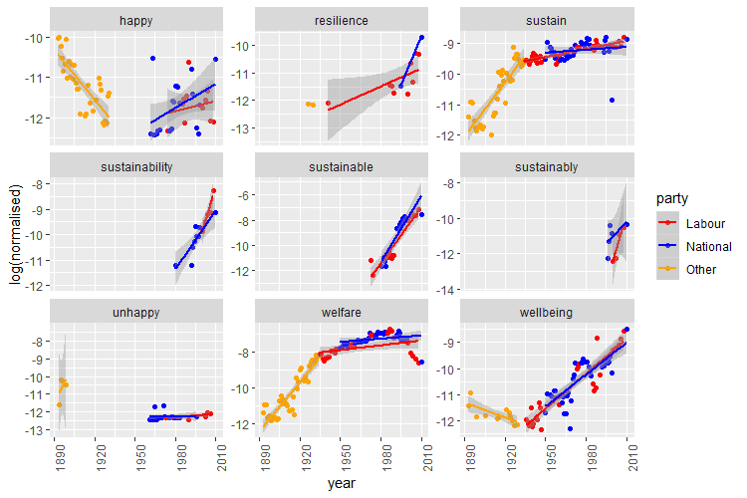
Figure 2: Log Normalized Count of SaW Terms in Parliamentary Debates by Political Party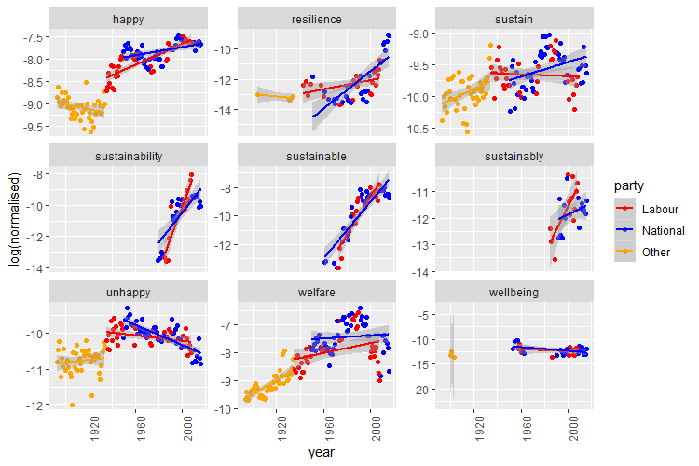

Figure 3: Log Normalized Count of SaW Terms in Ministerial Documents by Political Party
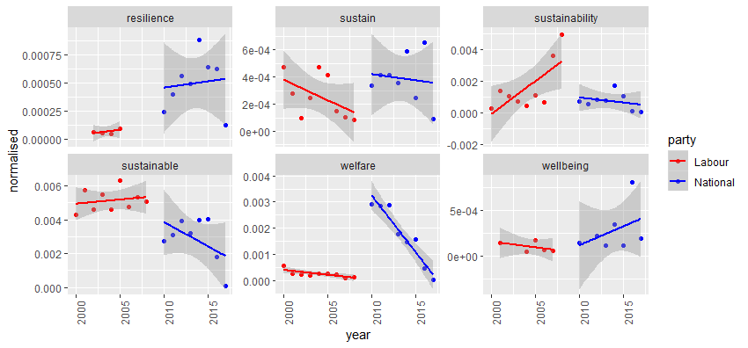
log(normalised)

4.1. Trend of SaW Terms

As shown in Figures 1 to 3, the terms ‘(un)happy’, ‘sustain’, ‘welfare’ and ‘wellbeing’ start to appear in the corpus from the first year of data (that is, 1893) in NZOYBs and Hansard. The terms, ‘happy and ‘unhappy’ have been used with fairly standard semantics, however with opposite trends. There is a decline in the use of the word ‘happy’ during the Liberal party regime until 1935, when the Labour government was first elected, after that, the trend is reversed. In contrast, the term ‘unhappy’ follows the exact opposite patterns in both periods (that is, before and after the Liberal government).

The term ‘sustain’ was used increasingly during the Liberal regime in both the NZOYBs and Hansard where the context was of maintaining certain levels of something for example ‘sustained yield’ or ‘sustained injuries’. The trend in the word count for the term ‘sustain’ continue to grow, however, at much slower rate since late 1930s. The term ‘welfare’ also exhibits a non-linear trend. Use of the word ‘welfare’ continues to grow from the first year in our data (1893) and reached its peak by the mid-1980s after which the trends started to decline. This is the period when sustainable development was gaining the attention of policy makers globally, for details see (Qasim 2017, 2018). During the late 1980s, after the Brundtland Commission’s report ‘Our Common Future’, sustainable development becomes a global agenda and the term ‘sustainability’ and its variants are commonly used in policy debates and documents (Qasim 2017). New Zealand also followed the same pattern which is reflected by the sharply increasing trends for words like ‘sustainability’, ‘sustainable’ and ‘sustainably’ in our results shown in Figure 1 and 2.

The term ‘resilience’ appeared in 1904 in parliamentary debates and in 1926 in the NZOYBs and has been used in a wide range of social and economic contexts with an overall increasing trend. For instance, in the sentences ‘Sarah Dowie: How does our economic resilience compare internationally?’, ‘I have immense faith in the resilience of human nature.’, ‘I am confident that it has resilience and the opportunity to take on any problem like this.’ etc.

The term ‘resilience’ is particularly important among the selected SaW terms because it seems to have been used as a replacement for the term ‘sustainability’ in recent years especially during the last National government period between 2008 and 2017. As identified in Figure 3, the term ‘sustainability’ exhibited an increasing trend during the Labour government period between 1999 and 2008. The number of uses then plummeted when the National government came into power and the trend continued to decline during the following years of their tenure. The term ‘resilience’, however, was identified as a replacement word in Ministerial documents as shown in Figure 3. This finding is consistent with the common understanding that the term ‘sustainability’ became less popular during the National government tenure because they felt it was poorly understood, ill-defined and had a vague agenda to follow. Helen Clark’s government was criticised by National’s for overusing the word ‘sustainability’ in their conversations (Herald, 2009). This is also highlighted by the steeper slope for ‘sustainability’ in Figures 1and 2 under a Labour Government.

Moving forward, the current Labour Government is committed to maximizing environmental sustainability, coupled with higher levels of wellbeing through social housing, poverty reduction, extensive tree plantings etc. One of their significant steps in this regard is the adoption of The Treasury’s ‘Living Standard Framework’ (LSF) for setting priorities, decision making, and monitoring progress related to intergenerational wellbeing. It is, therefore, plausible to expect sustainability and wellbeing would have much stronger connections in any discourse analysis for Labour government in future.

4.2. Network Analysis of SaW Terms Before and After 1970s

Figures 4 and 5 show the context in which SaW terms have been used before and after the 1970s using highly correlated bigram networks. During this time the notion of sustainable development had started to appear in United Nations’ documents and was being discussed by policy makers worldwide (Qasim 2018). In these networks of bigrams, each word is represented by a node and their link is illustrated by the edges linking two nodes. The thickness of the edge represents the degree of correlation between two terms, that is, thicker edge represents strong correlation.

Three standalone networks in Figure 4(2), show the bigram relationship over the period 1893 – 1970 in NZOYBs. They reveal that SaW terms were used semantically during this time. Where the term ‘sustain(ed)’ was used in a sense of maintaining the levels of something. for example, terms ‘sustain’ is highly correlated with words like ‘capital’, ‘rights’, ‘force’ and ‘trade’. Likewise, the term ‘sustained’ is also associated with words such as ‘forest’, ‘management’, ‘timber’ and ‘yield’. In addition, this is also linked with the term ‘welfare’ which is linked with words like ‘people’, ‘children’, ‘environment’ and ‘child’. Figure 5(2), illustrates the network diagrams from parliamentary debates over the same period and shows similar trends. The only difference, however, is that ‘welfare’ and ‘happy’ are not highly linked with terms like ‘sustain(ed)’. In other words, SaW relationships did not exist in the published source literature before the 1970s, which is consistent with the finding of Qasim (2017 2018).

In contrast, after 1970, we see a strong relationship between SaW terms in the context of sustainable development. As shown in Figure 4(1), there is high correlation between the terms ‘welfare’ and ‘sustainable’ and ‘sustainability’. The terms ‘sustainable’ or ‘sustainability’ are strongly linked with words like ‘rio’, ‘climate’ and ‘environment’ and ‘welfare’ is linked with words like ‘social’, ‘aged’ and ‘persons’. Figure 5(1) shows a similar pattern for parliamentary debates. However, the term ‘welfare’ dominates the network in the centre and terms ‘sustain(ed)’ and ‘sustainability’ are linked back to it through some other words. This pattern explains the fact that ‘welfare’ is more frequently used in parliamentary debates than in NZOYBs which is mainly a comprehensive snapshot of the New Zealand economy for a certain year.
Figure 4(1): Correlation Network of Frequently Occurring SaW Terms in NZOYBs

After 1970

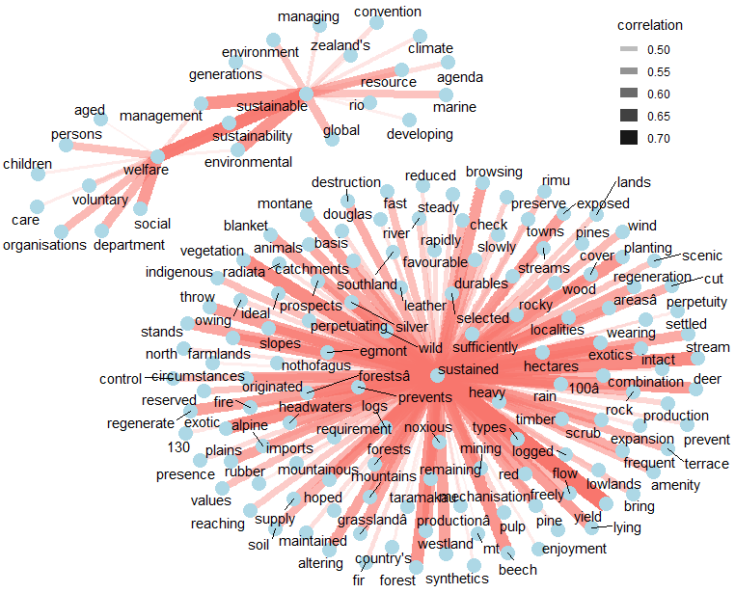

Figure 5(2): Correlation Network of Frequently Occurring SaW Terms in NZOYBs

1893-1970

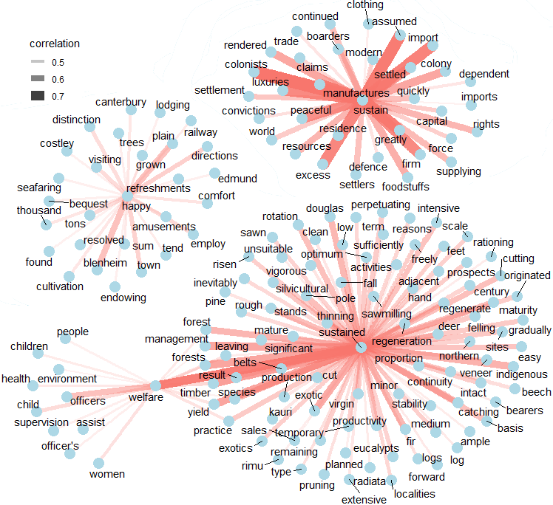
2

Figure 6(1): Correlation Network of Frequently Occurring SaW Terms
in Parliamentary Debates after 1970

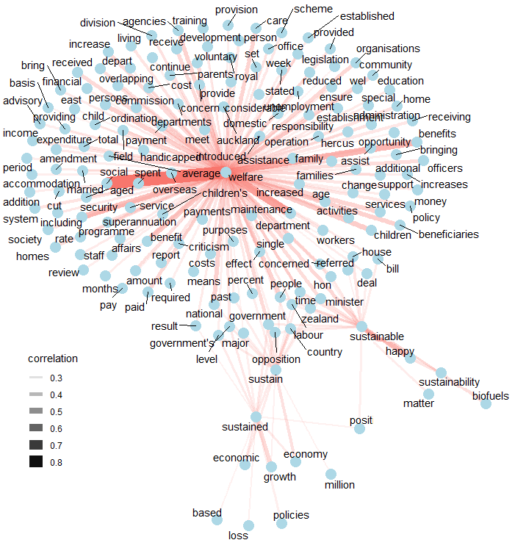

Figure 7(2): Correlation Network of Frequently Occurring Saw Terms
in Parliamentary Debates 1893-1970

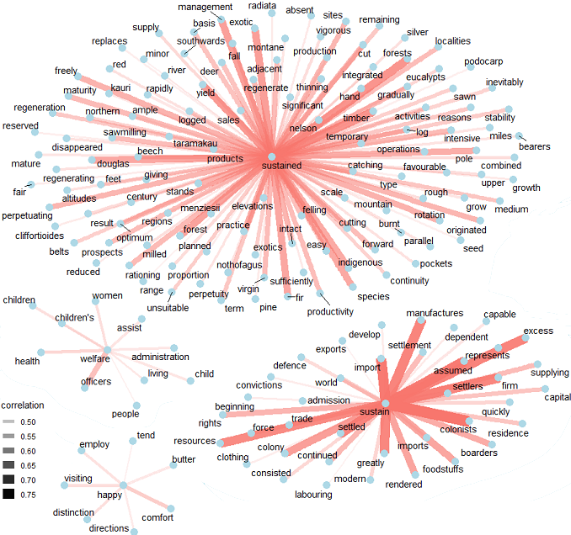

4.3. Network Analysis of SaW Terms by Political Party

If we turn our focus to analyse the network diagrams of highly correlated SaW terms by political party in three text corpuses; NZOYBs, Hansard, and Ministerial documents. In this analysis, we took subsets of NZYOBs and Hansard text corpuses starting from year 1935 when Labour was elected for the first time. Furthermore, text data for the Labour party includes the years when Labour was in power and is the same for the National party text data.

At first glance, we see a stronger and denser relationship between SaW terms in all three networks shown in Figures 6 to 8 for the Labour party; and these terms align with the notion of sustainable development. For example, in the Figure 6(1) network using the NZOYBs corpus, the terms ‘sustainable’ and ‘sustainability’ are linked with the words ‘development’, ‘environment’, ‘climate’ and ‘rio’ and the term ‘welfare’ is linked with ‘care’, ‘social’, ‘accommodation’ and ‘workers’. In contrast, we observe a weaker relationship between ‘sustainable’ and ‘welfare’ for the National government in Figure 6(2). It is also worth noting that the term ‘sustainable’ is linked with the words ‘managing’, ‘marine’, ‘resources’ and ‘fisheries’ for the National party. One might suggest that this relationship highlights the dominant focus of National’s supply side preference to deliver welfare. Furthermore, differences between highly connected words with SaW underpins the conflicting standpoints of political parties to articulate conceptually the same sustainability and wellbeing issues.

In the network diagrams for the NZOYBs, Figure 6(2), we observe a direct link between ‘sustainable’ or ‘sustainability’ and ‘welfare’ for both Labour and National party governments. There are two networks for each party; one linking ‘sustain’, ‘sustained’ with other frequently co-occurring words; and the second linking ‘sustainable’, ‘sustainability’ and ‘welfare’. One noticeable difference here is that the second network is denser and larger for Labour.

Similarly, Figure 7 shows a network of words linked with SaW terms and other co-occurring words in the corpus of Hansard data which differ markedly for both political parties. The key difference is, all SaW terms with other co-occurring words are linked in one single network for Labour. This suggests that sustainability and wellbeing have been viewed as a whole during Labour’s various tenures. This is also reflected in the current Labour government’s adoption of LSF as mentioned earlier. Whereas, standalone networks for ‘sustainability’ in Figure 7(2) suggest that during National governments, ‘sustainability’ and ‘welfare’ are considered as two independent issues and thus were discussed separately.

Figure 8(1): Correlation of Frequently Occurring SaW Terms in NZOYBs by Political Party

Labour Party

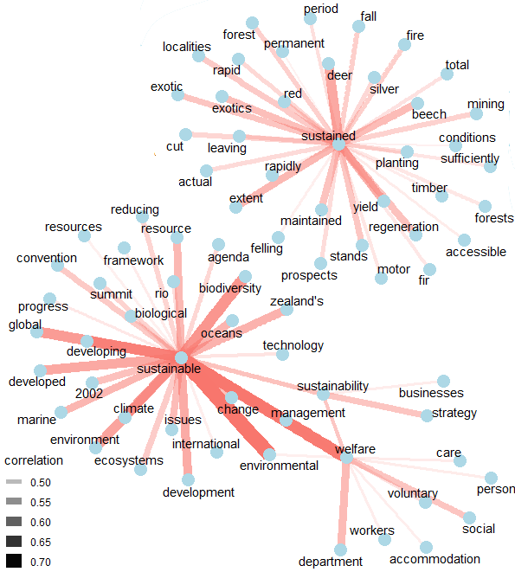

Figure 9(2): Correlation of Frequently Occurring SaW Terms In NZOYBs by Political Party

National Party

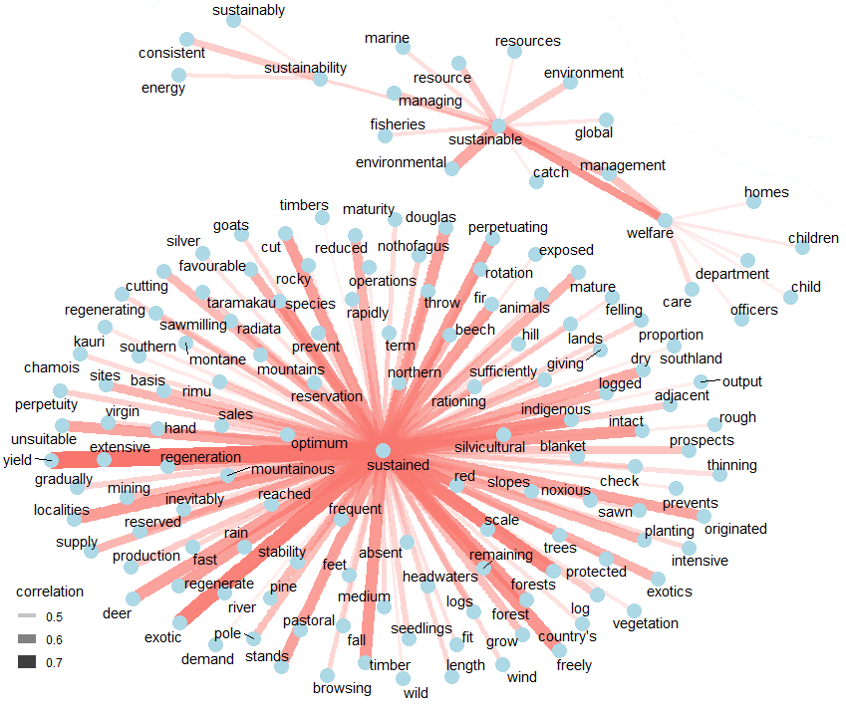

Figure 10(1): Correlation of Frequently Occurring SaW Terms
in Parliamentary Debates by Political Party

Labour Party

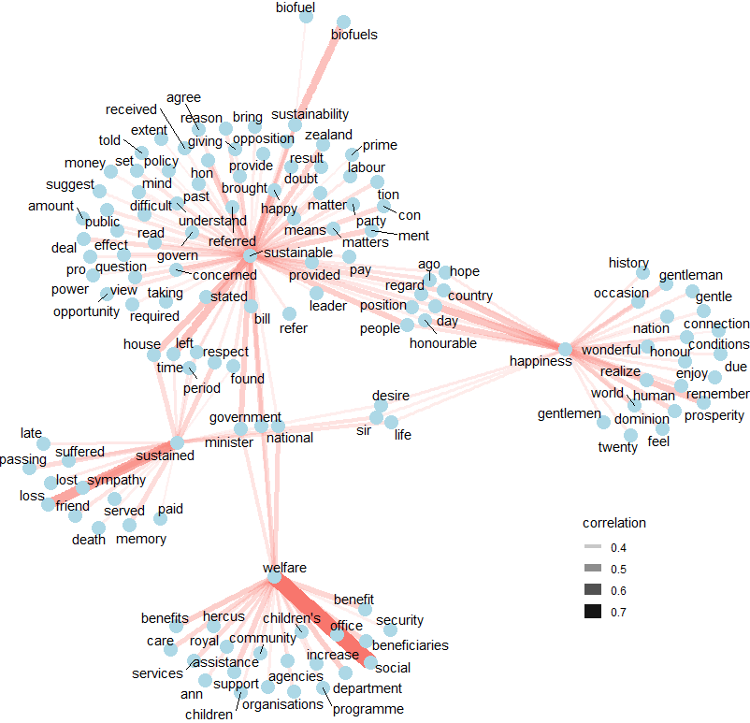

Figure 11(2): Correlation of Frequently Occurring SaW Terms
in Parliamentary Debates by Political Party

National Party

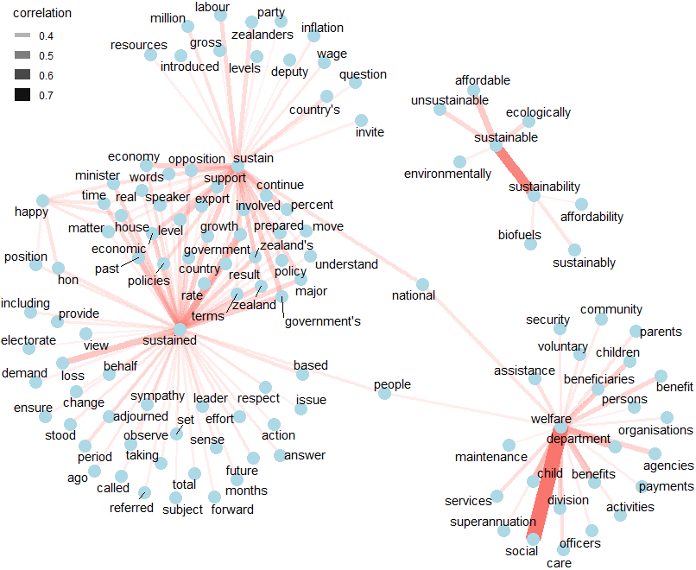

Finally, Ministerial document networks presented as Figure 8, show that SaW are presented together under both Labour and National Governments.

Figure 12(1): Correlation of Frequently Occurring SaW Terms
in Ministerial Documents by Political Party
Labour Party
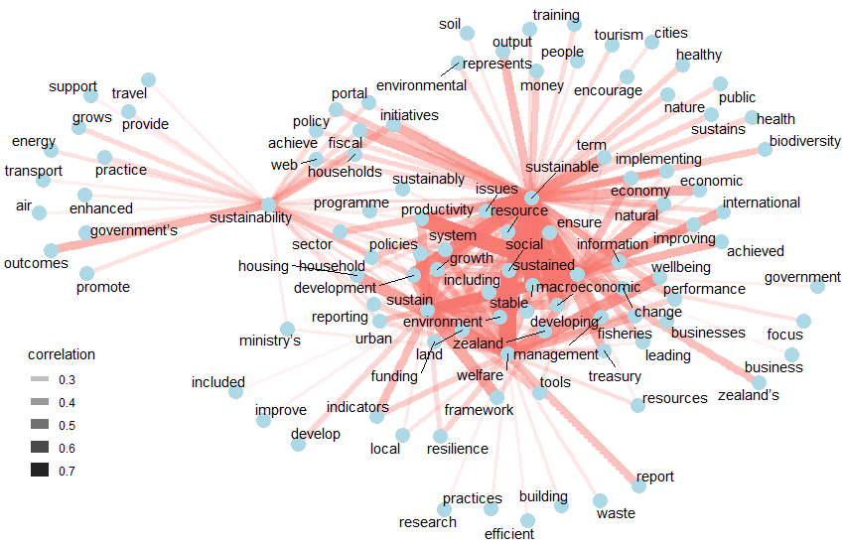
Figure 13(1): Correlation of Frequently Occurring SaW Terms
in Ministerial Documents by Political Party
National Party 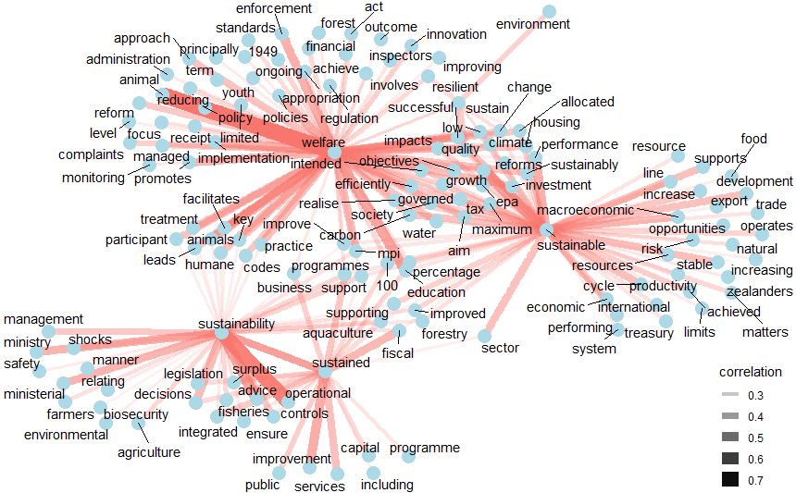

Conclusions
Sustainability and wellbeing are inter-related subjects often discussed in conjunction with each other in the literature (Qasim 2017, 2018). However, there has been very little investigation into how politicians articulate these issues and how these issues are reported in policy documents. This paper is an effort to fill this gap by conducting advanced corpus analysis including key SaW terms’ analysis, to identify their historic trends and to analyse their evolution using bigram network analysis to underpin how SaW terms are associated with each other. The global sustainable development movement following the Brundtland Commission’s Report affected SaW references in New Zealand.

Methodologically, this paper is one of the early studies in social science to make use of powerful text analysis methods to analysis enormous text data. Empirical analysis on text data using traditional methods mostly relies on data that are not observed directly, rather are quantified by historians or experts who analyse and interpret qualitative resources. Although this is generally accepted as a valid way of data transformation, such processes are driven by the expert-opinions and are inherently non-robust as it is almost impossible to replicate or match with the ground truth (Benoit et al. 2016).

Our key results highlight that the term ‘welfare’ has existed in the NZOYBs and Hasard data from 1893 (which is the first year in our dataset) with and increasing trend for almost a century. This mirrors the long history of social welfare-oriented policies in New Zealand. The terms ‘wellbeing’ and ‘sustain’ also stretch over the same period. The term ‘wellbeing’ gained momentum in the mid-1930s when the Labour government was first elected, after which it was used frequently in a wide range of social, and economic contexts. The term ‘sustain’ has also been used semantically to show maintained levels of something for example sustained yield.

Network analysis of correlated bigrams shows that ‘wellbeing’, ‘welfare’, ‘sustain’ were typically used independently before the 1970s. After the 1970s, the term ‘sustainability’ started to appear in the text corpus with a sharply rising trend. This is the time when sustainable development was entering the agenda of several governments around the world. Brundtland’s report catalysed this trend further. After that, the terms ‘sustainability’ and ‘wellbeing’ started to co-occur frequently as shown in our network analysis results. In terms of political parties, we see co-occurring words with SaW terms that differ significantly for the Labour party and the National party. Such differences highlight the apparent varying SaW perspectives of the ruling party. For example, the network density of a SaW network from the NZOYBS (Figure 6) is denser for the Labour party compared to that of the National party; and in the Hansard network (Figure 7) we observe a disconnect between ‘sustainability’ and ‘welfare’ networks for the National party whereas these are linked in the case of Labour. It shows that when National is in power, sustainability and wellbeing seem to be viewed as two separate issues and are typically not discussed together or one of the terms is simply neglected for any reason. In contrast, Labour appears to view SaW as a whole. This to some extent is also confirmed by their elevation of Treasury’s LSF for decision making.

Limitations of this Study
This work could have been improved significantly by performing some statistical analysis of the network such as degree of centrality, Modularity, Eigenvector centrality etc., if time was not a constraint. These networks could also have improved by diving them into smaller time intervals to get even more fine-grained results should time and resources have allowed.

References

Amsler, S.S. (2009). Embracing the politics of ambiguity: Towards a normative theory of ‘sustainability.’ Capitalism Nature Socialism, 20(2), 111–125.
Banerjee, S. and Pedersen, T. (2003). The design, implementation and use of the N-Gram statistics package. Computational Linguistics and Intelligent Text Processing, 370–381.
Benoit, K., Conway, D., Lauderdale, B.E., Laver, M. and Mikhaylov, S. (2016). Crowd-sourced text analysis: Reproducible and agile production of political data. American Political Science Review, 110(2), 278–295.
Briggs, P. (2003). Looking at the numbers. A view of New Zealand economic history. Wellington: NZIER.
Condliffe, J.B. (1960). The welfare state in New Zealand. Journal of Farm Economics, 42(3), 718–720. Retrieved from http://www.jstor.org/stable/1235423
Dalziel, P. (2002). New Zealand’s economic reforms: An assessment. Review of Political Economy, 14(1), 31–46.
Evans, L., Grimes, A., Wilkinson, B. and Teece, D. (1996). Economic reform in New Zealand 1984-95: The pursuit of efficiency. Journal of Economic Literature, 34(4), 1856–1902.
Fabbrizzi, S., Maggino, F., Marinelli, N., Menghini, S., Ricci, C. and Sacchelli, S. (2016). Sustainability and food: a text analysis of the scientific literature. Agriculture and agricultural science procedia, 8, 670–679.
Feldman, R., Sanger, J. et al. (2007). The text mining handbook: advanced approaches in analyzing unstructured data. Cambridge University Press.
Goldstone, A. and Underwood, T. (2014). The quiet transformations of literary studies: What thirteen thousand scholars could tell us. New Literary History, 45(3), 359–384.
Greasley, D., Hanley, N., Kunnas, J., McLaughlin, E., Oxley, L. and Warde, P. (2014). Testing genuine savings as a forward-looking indicator of future well-being over the (very) long-run. Journal of Environmental Economics and Management, 67(2), 171–188.
Gulordava, K. and Baroni, M. (2011). A distributional similarity approach to the detection of semantic change in the Google Books Ngram corpus. Proceedings of the GEMS 2011 Workshop on GEometrical Models of Natural Language Semantics (pp. 67–71).
Hall, D., Jurafsky, D. and Manning, C.D. (2008). Studying the history of ideas using topic models. Proceedings of the conference on empirical methods in natural language processing, 363–371.
Hawke, G.R. (1977). The evolution of the New Zealand economy. Auckland: Heinemann Educational.
Henderson, D. (1995). The revival of economic liberalism: Australia in an international perspective. Australian Economic Review, 28(1), 59–85.
Herald. (2009). Don’t say that ‘sustainability’ word. Retrieved 4 November 2018 from https://www.nzherald.co.nz/business/news/article.cfm?c_id=3andobjectid=10606288
Jickling, B. (2001). Environmental thought, the language of sustainability, and digital watches. Environmental Education Research, 7(2), 167–180.
Lin, Y., Michel, J.-B., Aiden, E. L., Orwant, J., Brockman, W. and Petrov, S. (2012). Syntactic annotations for the google books ngram corpus. Proceedings of the ACL 2012 system demonstrations, 169–174.
Lucas, C., Nielsen, R. A., Roberts, M. E., Stewart, B. M., Storer, A. and Tingley, D. (2015). Computer-assisted text analysis for comparative politics. Political Analysis, 23(2), 254–277.
Marsh, G. P. (1864). Man and Nature: Or, Physical Geography as Modified by Human Action. University of Washington Press.
Qasim, M. (2017). Sustainability and Wellbeing: A scientometric and bibliometric review of the literature. Journal of Economic Surveys, 31(4), 1035–1061.
Qasim, M. (2018). Some Links between Sustainability and Well-Being. Working Paper in Economics 13/18, Hamilton, New Zealand: University of Waikato.
Qasim, M. and Grimes, A. (2018). Sustainable economic policy and well-being: The relationship between adjusted net savings and subjective well-being. Motu Working Paper, Wellington, New Zealand: Motu Economic and Public Policy Research.
Qasim, M., Oxley, L. and McLaughlin, E. (2018). Genuine savings as a test of New Zealand weak sustainability. Environment, Development and Sustainability. doi:10.1007/s10668-018-0185-0
RBNZ. (2007). The Reserve Bank and New Zealand’s economic history. Reserve Bank of New Zealand.
Rheault, L., Beelen, K., Cochrane, C. and Hirst, G. (2016). Measuring emotion in parliamentary debates with automated textual analysis. PloS one, 11(12), e0168843.
Sutch, W. B. (1942). The quest for security in New Zealand, 1840 to 1966. Oxford University Press.
Treasury. (2018). Annual Report 2017/18 and Minister of Finance’s Reports on Non-Departmental Appropriations. The Treasury New Zealand.
Treasury. (2018). Budget at a Glance. The Treasury New Zealand.
Williams, F. (2016). Sustainability: lost in translation: from https://www.theguardian.com/sustainable-business/blog/articulating-sustainability-language-green-business.
Willis, R. (2017). Taming the Climate? Corpus analysis of politicians’ speech on climate change. Environmental Politics, 26(2), 212–231.

Appendix
Timeline of Major Economic Events
Year | Event
1891 | Liberal Government formed
1901 | Australian states form a federal government; New Zealand opts not to join
1907 | New Zealand constituted as a Dominion
1914–18 | First World War
1918 | Influenza epidemic
1922 | Meat Producers’ Board placed in control of meat exports
1929 | US share market crash
1932 | Ottawa agreement: Britain retreats from free trade
1935 | Labour Government elected
1936 | Reserve Bank nationalised
1938 | Social Security Act; import licensing introduced
1939–45 | Second World War
1946 | Family benefit introduced; Bank of New Zealand nationalised
1947 | Statute of Westminster adopted by Parliament
1948 | Economic Stabilisation Act
1949 | National Government elected
1950 | Legislative Council abolished
1951 | Waterfront dispute
1965 | New Zealand Australia Free Trade Agreement (NAFTA)
1967 | Robert Muldoon becomes Minister of Finance
1973 | Britain joins EEC; oil prices rise sharply following the Israeli-Arab war
1975 | Waitangi Tribunal established
1979 | Oil prices rise sharply following the revolution in Iran
1982 | - Comprehensive, freeze imposed on wages, prices, interest rate, and rents.  - Major tax cuts announced to support the program.
1983 | - Closer Economic Relations (CER) Agreement with Australia signed with an aim to allow free trade with Australia.  - Effective date for first stage of deregulation of land transport.  - Industrial Law Reform Bill, enabling voluntary unionism, is passed.
1984 | - Abolishment of Supplementary Minimum Price subsidy scheme for farming.  - Labour elected in the general election with 56 seats, and Sir Roger Douglas becomes Minister of Finance.  - Government announced program to remove all major export incentives and reduce import protection.  - Remaining interest rate controls abolished.  - Budget removes many subsidies and incentives.  - Abolition of exchange controls.
1985 | - New Zealand dollar floated funds outflow which largely deprived the banking system of reserves.  - Abolition of limits on foreign ownership in New Zealand financial institutions, advertising agencies, and fish processors.  - Major review of quality of state spending.  - Significant increase in minimum wage and family incentives.  - Lower tariffs to assist exporting farmers.
1986 | - Statement on Government Expenditure Reform.  - Comprehensive goods and services tax introduced at a uniform rate of 10 percent, the top personal income tax rate to be reduced from 66 percent to 48 percent.
1987 | - Share market crash  - First (partial) privatization to assist the Bank of New Zealand to raise capital  - Nine new state-owned enterprises formed.
1988 | - Flat tax and family income measures suspended.  - Reduction of the top personal income tax rate from 48 percent to 33.  - Further budget cuts expenditure to reduce national deficit.
1989 | - Corporate tax rate to rise from 28 percent to 33 percent.
1990 | - National wins general election with 67 seats.  - Complete free trade of goods with Australia under the 1983 CER agreement.  - ‘Economic and Social Initiative’ involving wide-ranging welfare benefit reforms.
1991 | - Employment Contracts Act  - Most benefits are cut.  - Further budget cuts spending.
1992 | - Health reforms take effect.
1993 | - Budget continues to move toward reducing expenditure and net public debt as a percentage of GDP and to move toward fiscal surpluses.  - Hung parliament with 50 seats of National, 45 of Labour, 2 of Alliance, and 2 of New Zealand First 2 in the 99-seat parliament.
1994 | - Moody’s Investor Services upgrades New Zealand government long-term overseas debt after a long time from AA3 to AA2.  - Fiscal Responsibility Act passed.  - Tariff reductions on key products.
1995 | - First Budget Policy Statement under the Fiscal Responsibility Act.
1998 | - Drought; Asian crisis.
2000 | Employment Relations Act; free trade agreement with Singapore
2001 | US-led global slowdown; Kiwi migrants to Australia need permanent entry status to qualify for welfare benefits
2002 | New Zealand GDP growth per capita overtakes OECD average
2007 | The threat of inflation pushes interest rates and the New Zealand dollar to a post-float high against the US dollar
2008 | New Zealand-China free trade agreement
2008-09 | Global Financial Crisis; Canterbury earthquakes
2011 | Rugby World Cup
2015 | TPP agreed
2017 | Labour wins general election 2017
2018 | Government redefined social policies; wellbeing budget
Sources: NZOYBs, Olssen and Stenson (1987), Dalton and Watters (1999), Briggs (2003), Evans et al. (1996).

Historically sustainability and well-being has evolved as independent but inter-related subjects. However, realization of the fact that the ultimate aim of all sustainability (or sustainable development) endeavours is to achieve higher quality of life for everyone equitably (for example, supporting the disadvantaged at higher priority) has turned them into a unified subject matter see Qasim (2017) and (Qasim 2018) for details.
‘Sustainability doesn’t mean anything real to consumers. Too often, it brings to mind technical issues or seemingly insurmountable environmental challenges’ Williams (2016).
See data section for data coverage of ministerial documents.
This is referred to as ‘Vogel Programme’. Vogel’s vision was to extensively develop the economy through immigration, public works and infrastructure development. Without going into the pros cons of the state controlled development from efficiency perspective, this programme, without a doubt was a prominent example of government led development in the 19th century in New Zealand (Hawke 1977).
One of the motivations to gain government control over the state was to insulate economy from the depressions caused by external shocks. Insulation, however, was a complex issue. It was considered mainly in the context of providing stable prices to the dairy farmers irrespective of export prices. In doing so, over ambitious policies of the Labour government led to the exchange crises and the economy was unable to finance imports.
EEC is now known as European Union (EU).
Henderson (1995), an OECD expert, views these reforms as called ‘one of the most notable episodes of liberalization that history has to offer.’ These reforms included massive drive for privatization restoring individuals’ control over the economy. This period is of reforms, therefore, is also referred to as the period of neo-liberalism in New Zealand. According to Evans et al. (1996) these series of supply side reforms successfully improved the performance of a poor economy however Dalziel (2002) argues this programme did not achieve the objectives expected from it.
https://www.budget.govt.nz/budget/2018/economic-fiscal-outlook/budget-2019-focus-on-wellbeing.htm accessed on 12th December 2019.
Theoretical foundation of the Treasury’s LSF is grounded in the principles Genuine Savings and weak sustainability (Qasim, Oxley and McLaughlin 2018). It mainly deals with maintaining four different capitals, that is, natural capita, social capital, human capita and physical and financial capital. Stocks of these capitals represent the total national wealth.
See the following papers as examples of for commonly used corpus analysis methods in political economics: Benoit et al. (2016), Lucas et al. (2015), Fabbrizzi et al. (2016), Rheault et al. (2016) and Willis (2017).
Historic Hansard volumes of New Zealand parliamentary debates from 1854 to 1987 are hosted on HathiTrust which can be accessed from the following url: https://babel.hathitrust.org/cgi/mb?a=listisandc=71329709
Updated working link to the google drive folders can be found on the Hansard website: https://www.parliament.nz/en/pb/hansard-debates/historical-hansard/
http://archive.stats.govt.nz/browse_for_stats/snapshots-of-nz/digital-yearbook-collection.aspx
In text analysis it is a common practise to use word stemming technique to automatically accommodate all variants of a word, for example, stem word for ‘running’ or ‘runs’ is ‘run’. For further examples see Lucas et al. (2015).
Parliamentary debates on Tuesday, 28 June 2016 (for inclusion in Volume 715).
Parliamentary debates V277 1947.
Parliamentary debates V430, 12th June to 8th July 1980.

