**UNIVERSITY OF WAIKATO**

**Hamilton**

**New Zealand**

**Designing Call Auction Institutions to Eliminate Price Bubbles:**

**Is English Dutch the Best?**

Cary Deck, Maroš Servátka and Steven Tucker

**Working Paper in Economics 04/19**

April 2019

*Corresponding Author*

**Steven Tucker**

School of Accounting, Finance and Economics

University of Waikato

Private Bag 3105

Hamilton 3240

NEW ZEALAND

Email: steven.tucker@waikato.ac.nz

**Cary Deck**

University of Alabama and Chapman University

Email: cdeck@cba.ua.edu

**Maroš Servátka**

Macquarie Graduate School of Management

*and*

University of Economics in Bratislava

Email: maros.servatka@mgsm.edu.au

**Abstract**

The bubble and burst pattern in asset market experiments is among the most replicable results in experimental economics. Numerous studies have searched for means to reduce this mispricing. Using controlled laboratory experiments, we compare mispricing in standard double auction markets to prices in two clock auctions. The double Dutch auction, shown to be more efficient than the double auction in commodity market experiments, does not eliminate bubbles. However, the English Dutch auction does yield prices reflective of underlying fundamentals and succeeds in taming bubbles even with inexperienced traders in the common declining fundamental value environment.

**Keywords**

asset markets

experimental economics

institutional design

**JEL Classification**

C91, D02, D14, G12

**Acknowledgements**

We wish to thank Mark DeSantis, David Porter, and Vernon Smith for helpful comments on this project. We are also very thankful to Miloš Fišar for his assistance with programming. We gratefully acknowledge financial support from Waikato Management School, University of Waikato.

**I. Introduction**

Ever since Smith, Suchanek, and Williams (1988) introduced what has become the canonical environment for studying asset prices in the laboratory, researchers have puzzled over how to eliminate the price bubbles that often occur in such settings. We ask if a market mechanism can be designed to eliminate bubbles in financial asset markets. A wealth of evidence from empirical studies including laboratory and field experiments clearly demonstrates that institutions matter. As defined by Smith (1982), institutions determine the set of actions available to economic agents, the incentives they face, and the information they have at the time of making their decisions. Thus, ‘institutions matter, because incentives and information matter’ (Smith 1994).

Because market outcomes can differ between institutions, it is plausible that the persistent overpricing observed in asset market experiments may be dampened or even eliminated when certain trading rules are implemented. This approach differs from attempts to reduce bubbles through eliminating confusion because those often rely heavily upon training traders with common experience and/or information that are specific to the characteristics of the underlying asset being traded, which is unlikely to be available in financial markets or outside of the laboratory in general. By contrast, implementation of an institutional solution requires no prior knowledge of the asset’s characteristics.

We study two alternative pricing rules, the double Dutch auction and the English Dutch auction and compare their performance with the continuous double auction, the standard-bearer when studying asset market bubbles. The double Dutch auction utilizes two pricing clocks: one clock with a falling price for the buyers and one with a rising price for sellers. As the buyers’ clock falls, buyers’ revealed demand increases as in a typical multi-unit Dutch clock auction. This demand revelation happens in conjunction with the sellers’ clock increasing to identify willing sellers and thus increase revealed supply. The English Dutch auction relies on a single clock that acts simultaneously as an English clock for buyers and a Dutch clock for sellers, operating in a way that as the clock price increases, revealed quantity demanded decreases while revealed quantity supplied increases. In the double Dutch auction, the buyers’ clock decreases and thus provides an incentive to over-reveal demand; but, in the English Dutch auction buyers face an increasing clock and thus have an incentive to under-reveal demand. The incentives to over- or under-reveal demand are a crucial distinguishing feature between the two institutions. However, both the double Dutch and the English Dutch auctions generate a uniform market-clearing price, which prevents intra-period speculation, similar to the call market experiments of Van Boening, Williams, and LaMaster (1993).

We replicate the standard bubble and burst pattern using the double auction. We find that the double Dutch markets lead to bubbles similar to those observed in the double auction experiments, just as the call markets of Van Boening, Williams, and LaMaster (1993) did. However, the English Dutch auction, which focuses a trader’s attention on their own willingness to buy or sell at various prices, eliminates bubbles. This results holds despite our use of inexperienced traders in a declining fundamental value environment with an increasing cash to asset ratio, all three of which are factors previously found to exacerbate overpricing.

**II. Background**

One of the most robust experimental results is the convergence to competitive equilibrium by the double auction market of Smith (1962). In such markets, buyers and sellers have assigned roles and cannot speculate via purchasing an asset in the hope of reselling it at a profit. In these markets, which Dickhaut, Lin, Porter and Smith (2012) refer to as reflecting conditions for commodities like ‘hamburgers and haircuts,’ traders quickly find the equilibrium and achieve high levels of efficiency. Thus, the double auction was an obvious institution for Smith, Suchanek and Williams (1988) to rely on when creating an experiment in which to study the causes of bubbles in financial markets where people can speculate across periods. To their surprise, overpricing appeared spontaneously, a result that has spawned a massive literature in economics and finance.

A major theme in the experimental asset market literature has been the search for means to eliminate mispricing. Short selling, buying on margin, pricing collars, futures markets have all been found to have only limited success in reducing mispricing (King, Smith, Williams, and Van Boening 1993; Haruvy and Noussair 2006; Porter and Smith 1995; Noussair, Tucker, and Xu 2016. See also Noussair and Tucker 2013 and Palan 2013 for surveys). Subject sophistication has also been questioned, but King, Smith, Williams and Van Boening (1993) found that professional traders also generated speculative bubbles (see also Weitzel, Huer, Huber, Kirchler, Lindner and Rose 2018).

Recently, Kirchler, Huber and Stöckl (2012) has suggested that the declining fundamental value and increasing cash to asset ratio of Smith, Suchanek, and Williams (1988) led to subject confusion coupled with extreme liquidity and is responsible for driving observed bubbles. Framing the asset as shares of a depletable gold mine, Kirchler, Huber and Stöckl (2012) reports that mispricing is substantially reduced. However, Cheung, Hedegaard, and Palan (2014) argues that public knowledge among subjects of common enhanced directions or framing techniques designed to reduce confusion may actually be harmonizing traders’ beliefs about the prices at which others will be willing to trade or their beliefs about the beliefs of others. This convergence of beliefs may in turn reduce speculative motives. Specifically, Cheung, Hedegaard, and Palan (2014) shows that markets in which all traders are given extensive training still generate bubbles unless the fact that all of the traders are undergoing such training is common knowledge.

Overall, the most reliable method of eliminating bubbles in the lab is experience. Smith, Suchanek, and Williams (1988) show that twice experienced traders generated prices close to fundamental value. They attribute this to the creation of common expectations. Hussam, Porter, and Smith (2008) shows that the experience must be common to the group as the introduction of new traders or a new environment can rekindle bubbles, although Duwenberg, Lindqvist, and Moore (2005) find that an influx of inexperienced traders may not lead to large bubbles.[1] This experience effect is consistent with both reduced confusion and a harmonization of beliefs.

However, financial markets are ever changing and therefore common experience in the specific setting is not a viable policy prescription for reducing bubbles outside the laboratory and neither is common knowledge of extensive training regarding fundamental value. Thus, it is important to look for alternative mechanisms, such as institutional rules, for reducing mispricing. Because of its success in many other settings, most of the research on asset markets has relied upon the double auction, but Dickhaut, Lin, Porter and Smith (2012) show that the mere ability to speculate reduces the efficiency of double auction markets. Therefore, we explore the ability of two alternative institutions to reduce asset mispricing. Other researchers have unsuccessfully pursued similar efforts. For example, Van Boening, Williams and LaMaster (1993) showed the familiar bubble and burst pattern in a declining fundamental value environment occurred when trading is organized by call markets. More recently, Bachestanian, Lugovskyy, Puzzello and Tucker (2014) compare double auction and call markets to those organized by a Tatonnement process. They report that bubbles persisted under the Tatonnement auction, although they were smaller than the bubbles observed under the other two institutions using standard measures.

One alternative institution, which we investigate in the lab, is the double Dutch auction introduced by McCabe, Rassenti, and Smith (1992). The double Dutch auction uses two Dutch clocks: one clock with a falling price for the buyers and one with a rising price for sellers. As the buyers clock falls and revealed demand increases, the sellers clock increases to identify sellers and thus increase revealed supply. In haircut and hamburger markets, McCabe, Rassenti and Smith (1992) demonstrate that the double Dutch auction actually outperforms the double auction leading to their titular question ‘Is Double Dutch the Best?’ Its prior success makes this an obvious institution to consider, but ultimately we find that the double Dutch is not best for financial assets when traders can speculate as it generates significant mispricing. This failure subsequently led us to test a third institution, the English Dutch auction. We find that the set of trading rules effectively eliminates mispricing and thus it may be best for asset markets, leading to our titular question.[2] The English Dutch auction relies on a single clock that simultaneously serves as an English clock to buyers and a Dutch clock to sellers. As the clock price increases, quantity demanded is reduced while quantity supplied is increased.[3]

The success of the English Dutch auction may be attributed to the institution providing incentives for buyers to under-reveal their demand. Price paths frequently observed in asset markets are characterized by an initial rise in prices that climb well above the fundamental value and eventually crash towards the end of the market. Thus, institutional features that encourage under-revealing of demand may be critical in dampening bubbles. In the English Dutch auction, the buyer clock is always rising, and thus the longer the clock runs, the worse prices are for buyers. Therefore, buyers have an incentive to stop the clock, under-revealing their demand. Conversely, the Double Dutch auction provides just the opposite incentives given that the clocks move in favour of the buyers, that is, clocks continually decrease in price, and thus provide incentives to over-reveal demand.

**III. The Experiment**

The experiment consisted of 15 sessions. Each session was comprised of either 8 or 9 subjects that were recruited from undergraduate courses at The University of Waikato via the ORSEE recruitment program (Greiner 2015).[4] Each subject participated in a single session and none had any experience with asset market experiments. The experiment was computerized and employed the Z-tree software package (Fischbacher 2007). Transactions were denominated in an experimental currency called ‘francs’ and converted to New Zealand dollars at the end of the experiment at a publicly known exchange rate.[5] Each session lasted about 90 minutes and subjects earned approximately 40 NZD on average.

Subject traders were initially endowed with 10 units of an asset and a cash balance of 10,000 francs. The assets had a finite life of 15 periods during which traders could exchange cash and assets with each other. At the end of each period a dividend payment was randomly determined for the asset and this amount was added to the cash balance of the asset’s owner. Dividends were drawn from a four-point distribution of 0, 8, 28, and 60 francs, each with equal probability. Thus, the expected value of the dividend payment in any period was 24 francs. The value of the dividend in a given period did not depend on the identity of the asset’s owner. Further, in each period the dividend was the same for every asset in the market. After the final dividend payment at the end of period 15 the asset was worthless. Therefore, the fundamental value of the asset at any point in the experiment equalled the expected value of 24 francs times the number of periods (or dividend payments) remaining in the market. This structure was common information among the traders. [6]

The experiment consisted of three between–subjects treatments with the trading institution as the treatment variable: *Double Auction* (*DA*)*, Double Dutch* (*DD*)and *English Dutch* (*ED*). In all treatments, subjects were allowed to buy and sell units of the asset as long as they had sufficient cash inventory to cover the purchase or sufficient asset inventory to make the sale. No short selling or borrowing was allowed. The inventories of cash and assets carried over from period to period such that for each subject, the cash balance and inventory of assets at the beginning of period *t*+1 were the same as those at the end of period *t*.[7]

In the DA treatment, the computerized continuous double auction trading rules were employed (see Smith 1962 and Plott and Gray 1990 for a description). Under the continuous double auction rules, each period of the market was opened for fixed period of 3 minutes. At any time within a period, subjects could submit a bid or an offer to the market. A bid (offer) specified a price at which a subject is willing to buy (sell) a unit of the asset. All bids and offers were displayed to all subjects on their computer screens. Any subject with sufficient funds (assets) could have accepted an outstanding offer to sell (bid to buy) at any time. Upon the acceptance of a bid or an offer, a transaction would have been completed and the asset and cash would be transferred between the transacting parties. Thus, in the parlance of stock market trading bids and offers represent limit orders whereas acceptances represent market orders.

In the DD treatment, we replicated the double Dutch trading institution introduced by McCabe *et al.* (1992). This institution uses two Dutch clocks, that is, a descending price Buyers’ Clock and an ascending price Sellers’ Clock. The clocks present tentative prices at which one could buy or sell, respectively. At the beginning of a period, the Sellers’ clock always starts at 0 francs. The Buyers’ Clock starts at 900 francs in the first period as this is the maximum possible total dividend payment for an asset (900 francs = 15 periods × 60 francs / period). In every subsequent period, the Buyers’ Clock starts at twice the market clearing price of the previous period.[8] Within a period, the clocks operate in an alternating fashion so that only one clock is active at any time. Traders indicate a willingness to trade at the clock price on the currently operating clock by stopping it. This action locks the trader into a transaction at a price that is at least as favourable as the clock price when the trader stopped the clock. A uniform market clearing price is determined when the two clocks cross. All transactions in the market occur at this crossing price.

Each period starts with the activation of one of the clocks. The clock that is activated first in a period alternates from period to period. An activated clock always starts with a 3 second countdown to allow subjects to ‘stop’ the clock and thus indicate a willingness to make multiple trades at a given price. If no subject stops the active clock within the 3 second countdown, the clock ticks until either a trader stops it (thus indicating a willingness to trade at that price) or the two clocks have the same price (in which case the market clearing price is determined and the market closes). As long as the two clock prices do not match, after a clock is stopped, one of the clocks is activated. More specifically, if there is excess demand in the market, then the Sellers’ Clock is activated to find a seller who can meet that demand. If there is excess supply in the market, then the Buyers’ Clock is activated.[9] If there is no excess supply or demand in the market after a trader stops an active clock, then the previously active clock starts once again. This procedure ensures that there is not a consistent upwards or downwards pressure on the market prices. In order to ensure multiple units of the asset may enter the market at a single same price, the clocks are always restarted at the price at which they were previously stopped.

An example may be useful. Suppose that in the first period the Buyer’ Clock starts at 900 and when the Buyers’ Clock falls to a price of 600 a trader stops it indicating that buyer is willing to buy a unit of the asset at 600. Because there is now excess demand, the Sellers’ Clock becomes active and starts ticking up. Suppose a trader stops this clock at 300, indicating the trader is willing to sell a unit of the asset at a price of 300. At this point the number of assets being bought and sold are equal, so the Sellers’ Clock continues to be active. During the 3 second countdown a trader stops the clock indicating a willingness to sell a unit at 300. Now there is excess supply so the Buyers’ Clock becomes active. Suppose the price of the Buyers’ Clock falls from 600 down to 400 where a trader stops it. The number of buyers and sellers is balanced so the Buyers’ Clock is activated. Suppose it falls until it reaches 300, the price of the inactive Sellers’ Clock. In this case, the market closes. The market clearing price is 300 and two units are exchanged among the traders who stopped the clocks.

The active clock always ticks in 1 franc increments, but the speed at which the clocks ticks is determined by the disparity between the current prices on the two clocks. If the difference in prices is greater than 200 francs, then the clock tick rate is 1 franc per 1/10th second. If the prices differ by less than 200 francs but more than 30 francs, then the clock tick rate is 1 franc per 1/5th second. If the two prices are less than 30 francs apart, then the tick rate is 1 franc per second.

In the English Dutch treatment, the institution consists of a single clock that simultaneously acts as English clock for buyers and a Dutch clock for sellers. The starting price in each period is zero. Prior to the start of the clock, traders are asked to specify the number of assets they would like to buy at a price of zero.[10] As a result, the excess demand at a price of 0 is determined. The clock, which represents a tentative price is then activated and begins to increase. At any point a trader can reduce the number of assets she wishes to purchase. Thus, the clock is an English auction for buyers who reduce their demand as prices increase. Once a trader has reduced her demand to zero, as the price continues to increase the trader can indicate a willingness to sell assets she owns at a price equal to or greater than the current clock price. For sellers, the clock functions like a Dutch auction as prices become more attractive. As traders begin reducing their quantity demanded and increasing their quantity supplied, the excess demand in the market is reduced. Once the excess demand equals zero, the clock stops, the market is closed and all positions are cleared at the final clock price. Thus, the English Dutch auction works by trying to eliminate excess demand.

Pragmatically, traders who have excess demand have a series of buttons on their screen that allow them to decrease their demand by one unit, five units, or all demanded units. The software also forces a trader to reduce demand based on the trader’s budget constraint (i.e. the trader must hold enough cash to purchase the number of units she is demanding at the current price). Once a trader’s demand reaches zero, the buttons on the screen are replaced by buttons allowing them to increase their supply by one unit, five units, or all (owned) units. The multiple unit changes mean that there may be instances where the market overshoots causing excess supply, in which case the market closes at that price and the surplus units are not traded (the additional units sold only apply to the last trader). The increment of the English Dutch clock is similar to that for the double Dutch in that the speed slows as the market closing nears.

The timing of events in each session proceeded as follows: (1) Subjects entered the computer lab and chose a computer terminal to use for the session. (2) Instructions for the asset market were distributed and subjects were allowed 15 minutes to read the instructions on their own (see appendix). (3) The experimenter provided a summary of the main features of the market and interface by reviewing a market screenshot that was projected at the front of the lab. (4) Subjects completed a short quiz on the dividend process (see appendix) with the experimenter reviewing the quiz answers and addressing any questions privately with each subject. (5) The trading market was conducted. (6) Upon completion of the market, subjects were privately paid their cash earnings for the session and dismissed from the experiment. [11]

**IV. Results**

The time series of average period prices by treatment and fundamental value are plotted in Figure 1. In the DA treatment, the average transaction prices exhibit a traditional price bubble pattern of initial prices relatively close to fundamental value, followed by a decoupling of prices from fundamental value as the bubble forms, and eventuating in prices crashing down to fundamental value in the last two periods. This figure is comparable to figures shown in many of the previously cited papers.

**Figure 1: Time Series of Market Prices**

|  |  |
| --- | --- |
| Average Price by Treatment | Double Auction |
| Double Dutch | English Dutch |

The DD treatment initially leads to higher prices than the DA treatment, with average prices above those of the DA for the first 6 periods. However, in the middle and latter portion of the trading horizon the DD has lower average prices. Casual inspection of Figure 1 suggests that while the DA leads to an inflating and then bursting bubble, the DD has a steady level of overpricing followed by a sudden collapse at the end of the trading horizon. By contrast, the ED treatment yields price that closely tracks fundamental value over the entire trading horizon.

To more precisely analyze differences in bubble formation between treatments, we calculate and comparethe two common standardized bubble measures used in the literature (see Stöckl *et al.* 2010). Relative Deviation (RD) is defined as $\frac{1}{T}\sum_{t=1}^{T}{({\overline{P}}_{t}-{FV}_{t})/\left|\overline{FV}\right|}$ where *T* denotes the total number of periods in the market, ${\overline{P}}_{t}$ is the average transaction price in period *t*, *FVt* is the fundamental value in period *t*, and $\overline{FV}$ is the average fundamental value over the trading horizon.[12] Relative Absolute Deviation (RAD) is defined as $\frac{1}{T}\sum_{t=1}^{T}{\left|({\overline{P}}_{t}-{FV}_{t})\right|/\left|\overline{FV}\right|}$. RD indicates the direction of departure from fundamental value, i.e. whether prices are above or below fundamental value on average. RAD is similar to RD except that the numerator takes the absolute value of the differences between prices and fundamental value. Thus, RD is a measure of overpricing while RAD is a measure of mispricing. The denominators for both calculations provide a normalization to facilitate comparisons with other asset market environments (i.e. different dividend structures and trading horizons).

The top portion of Table 1 shows the average value of the two bubble measures for each treatment. To determine whether these differences are significantly different, we conduct Mann-Whitney Rank Sum tests with an individual session as the unit of observation. The bottom part of Table 1 reports the z-scores and corresponding p-values in brackets for each pairwise test. The table confirms that, on average, ED has relatively small deviations from fundamental value and both lower overpricing and less mispricing than either DA and DD. From the table, nominally DA has the greatest mispricing and overpricing, but there is no statistically significant difference in bubble measures between DA and DD in our sample.

**Table 1: Comparison of Bubble Measures across Treatments**

|  |  |  |
| --- | --- | --- |
| Average Bubble Measures | RD | RAD |
| DA | 0.858 | 0.925 |
| DD | 0.526 | 0.595 |
| ED | 0.056 | 0.198 |
| Treatment Comparison | | |
| DA v DD | -0.94 [0.347] | -1.358 [0.175] |
| DA v ED | -2.611*** [0.009] | -2.611*** [0.009] |
| DD v ED | -1.776*  [0.076] | -1.776*  [0.076] |
| Treatment comparisons are z-scores of Mann-Whitney Rank Sum tests [p-values are given in brackets]. * and *** denote the 10% and 1% significance levels, respectively. The similarity in RAD and RD test statistics for comparing ED to the other institutions is due to the substantial upward bias in prices in the other institutions. | | |

**V. Discussion**

Starting with Smith, Suchanek and Williams (1988), the spontaneous presence of bubbles in asset markets with common information regarding fundamental value has been a puzzling and enduring behavioral pattern. Several studies have investigated various means of reducing or eliminating this mispricing, such as the margin trading, short selling, price collars, and the use of highly sophisticated traders, but to date the creation of common expectations either through repetition or training procedures has been the only reliable means to do so. However, these successful techniques are unlikely to be practical outside of the laboratory.

In this paper, we demonstrate that an alternative trading institution, the double Dutch auction, that has previously been shown to outperform the standard double auction in commodity markets does not reduce mispricing in asset markets. However, we do find evidence that a previously unexplored institution, the English Dutch auction, does lead to prices that closely track fundamental value in asset markets. This pattern holds despite our use of a declining fundamental value environment with an increasing cash to asset ratio, two factors that have been shown to contribute to bubble formation in previous studies. It also holds despite the absence of other features of naturally occurring markets generally believed to dampen bubbles such as short selling. That this institutional success even holds with naïve traders who lack experience or the benefit of replication is particularly impressive as that has been the most robust mechanism for eliminating mispricing in previous laboratory experiments. In sum, we believe our experimental results suggest an important avenue for future work research in asset pricing and offer a promising market design alternative for taming bubbles.

**References**

Baghestanian, S., V. Lugovskyy, D. Puzzello, and S. Tucker, (2014) Trading Institution in Experimental Asset Markets: Theory and Evidence. Working Paper, Indiana University.

Cheung, S., M. Hedegaard, and S. Palan, (2014) To see is to believe: Common expectations in experimental asset markets. *European Economic Review* 66, pp. 84-96.

Dickhaut, J., S. Lin, D. Porter, V. Smith, (2012) Commodity durability, trader specialization, and market performance. *Proceedings of the National Academy of Science* 109(5):  
1425–1430.

Dufwenberg, M., T. Lindqvist and E. Moore, (2005) Bubbles and experience: An experiment. *American Economic Review* 95(5):1731–1737.

Deck, C., D. Porter, and V. Smith, (2014) Double bubbles in assets markets with multiple generations. *Journal of Behavioral Finance* 15(2), pp. 79-88.

Fischbacher, U., (2007) z-tree: Zurich toolbox for ready-made economic experiments. *Experimental Economics* 10(2), pp. 171-178.

Frederick, S., (2005) Cognitive reflection and decision-making. *Journal of Economic Perspectives* 19(4), pp. 25–42.

Greiner, B. (2015). Subject pool recruitment procedures: organizing experiments with ORSEE. *Journal of the Economic Science Association, 1*(1), 114-125.

Haruvy, E. and C. Noussair (2006) The effect of short selling on bubbles and crashes in experimental spot asset markets. *Journal of Finance* 61 (3), pp. 1119-1157.

Hussam, R., D. Porter, and V. Smith, (2008) Thar she blows: Can bubbles be rekindled with experienced subjects? *American Economic Review* 98(3), pp. 924-37.

King, R., V. Smith, A. Williams, and M. Van Boening, (1993) The robustness of bubbles and crashes in experimental stock markets. In Richard H. Day & Ping Chen, eds., *Nonlinear Dynamics and Evolutionary Economics*. Oxford University Press.

Kirchler, M., J. Huber, and T. Stöckl, (2012) Thar she bursts: reducing confusion reduces bubbles? *American Economic Review* 102 (2), pp. 865-883

Lei, V., C. Noussair, and C. Plott, (2001) Nonspeculative bubbles in experimental asset markets: Lack of common knowledge of rationality vs. actual irrationality. *Econometrica* 69(4), pp. 831-59.

McCabe, K., S. Rassenti, and V. Smith, (1992) Designing call auction institutions: Is double Dutch the best? *The Economic Journal* 102, pp. 9-23.

Noussair, C., and S. Tucker, (2006) Futures markets and bubble formation in experimental asset markets? *Pacific Economic Review* 11 (2), pp. 167-184.

Noussair, C., and S. Tucker, (2013) ‘Experimental Research on Asset Pricing’, Journal of Economic Surveys 27(3), pages 554 - 569.

Noussair, C., S. Tucker, and Y. XU, (2016) Futures markets, cognitive ability, and mispricing in experimental asset markets, *Journal of Economic Behavior and Organization* 130, pp. 166-179.

Palan, S. (2013) A review of bubbles and crashes in experimental asset markets. *Journal of Economic Surveys* 27(3): 570–588.

Plott, C. and P. Gray (1990) The multiple unit double auction*. Journal of Economic Behavior and Organization* 13 (2), pp. 245-258.

Porter, D., and V. Smith, (1995) Futures contracting and dividend uncertainty in experimental asset markets*. Journal of Business* 68(4), pp. 509-41.

Smith, V., (1962) An experimental study of competitive market behavior. *Journal of Political Economy* 70:111–137.

Smith, V., G. Suchanek, and A. Williams, (1988) Bubbles, crashes and endogenous expectations in experimental spot asset markets. *Econometrica* 56(5):1119–1151.

Stöckl, T., J. Huber, and M. Kirchler, (2010) Bubble measures in experimental asset markets? *Experimental Economics* 13 (3), pp. 284-298.

Van Boening, M., A. Williams, and S. LaMaster, (1993) Price bubbles and crashes in experimental call markets. *Economic Letters* 41(2):179–185.

Weitzel, U., C. Huber, J. Huber, M. Kirchler, F. Lindner, J. Rose, (2018) Bubbles and financial professionals. working paper, University of Innsbruck.

**APPENDIX**

**General Instructions**

**Double Auction**

This experiment will consist of *fifteen* trading periods in which you will have the opportunity to buy and sell in a market. The currency used in the market is francs. All trading and earnings will be in terms of francs.

________ francs = 1 NZ dollar

Your francs will be converted to dollars at this rate, and you will be paid in dollars when you leave the lab today. The more francs you earn, the more dollars you earn.

In each period, you may buy and sell units of a good called X in a market. X can be considered an asset with a life of 15 periods, and your inventory of X carries over from one trading period to the next. Each unit of X in your inventory at the end of *each* trading period pays a dividend to you. The dividend paid on each unit is the same for every participant.

You will not know the exact value of the dividend per unit until the end of each trading period. The dividend is determined by chance at the end of each period by a random number generator. The dividend in each period has an equally likely chance of being 0, 8, 28, or 60. The information is provided in the table below.

|  |  |  |  |  |  |
| --- | --- | --- | --- | --- | --- |
| Dividend | → | 0 | 8 | 28 | 60 |
| Likelihood | → | 25% | 25% | 25% | 25% |

The average dividend per period for each unit of X is 24 francs. The dividend draws in each period are independent. That means that the likelihood of a particular dividend in a period is not affected by the dividend in previous periods.

**2. Your Earnings**

At the beginning of the experiment, you will be given […] francs in your Cash inventory. Your earnings for the entire experiment are equal to your Cash inventory at the end of period 15.

All dividends you receive are added to your Cash inventory.

All money spent on purchases is subtracted from your Cash inventory.

All money received from sales is added to your Cash inventory.

**Example of earnings from dividends**: if you have 6 units of X at the end of period 3 and the dividend draw is 8 francs (which has a 25% chance of occurring), then your dividend earnings for period 3 are equal to 6 units x 8 francs = 48 francs.

**3. Average Value Holding Table**

You can use your **AVERAGE HOLDING VALUE TABLE** (attached at the end of this document) to help you make decisions. It calculates the average amount of dividends you will receive if you keep a unit of X until the end of the experiment. It also describes how to calculate how much in future dividends you give up on average when you sell a share at any time. The following describes each of the columns in the table.

1. *Ending Period*: period 15 is the last trading period within the experiment, and thus the last period for which to receive a dividend payment. After the final dividend payment in period 15, each unit of X is worthless.

2. *Current Period*: the period during which the average holding value is being calculated. For example, in period 1, the numbers in the row corresponding to ‘Current Period 1’ are in effect.

3. *Number of Remaining Dividend Payments*: the number of times that a dividend can be received from the current period until the final period (period 15). That is, it indicates the number of random asset payment draws remaining in the lifetime of the asset. It is calculated by taking the total number of periods, 15, subtracting the current period number, and adding 1, because the dividend is also paid in the current period.

4. *Average Dividend Value per Period*: the average amount of each dividend. As we indicated earlier, the average dividend in each period is 24 francs per unit of X.

5. *Average Holding Value per Unit of Inventory*: the average value of holding a unit of X for the remainder of the experiment. That is, for each unit of X you hold in your inventory for the remainder of the experiment, you receive on average the amount listed in column 5. The number in Average Holding Value is calculated by multiplying the Number of Remaining Dividend Payments with the Average Dividend Payment per Period.

Please examine the table now and make sure you understand it. The following example may help in your understanding. Suppose for example that there are 7 periods remaining. Since the dividend paid on a unit of X has a 25% chance of being 0, a 25% chance of being 8, a 25% chance of being 28, and a 25% chance of being 60 in any period, the dividend is on average 24 per period for each unit of X. If you hold a unit of X for 7 periods, the total dividend paid on the unit over the 7 periods is on average 7*24 = 168.

**4. Market and Trading Rules**

At the beginning of the experiment, you will have an initial inventory of […] units of X and […] francs. The experiment consists of 15 periods. In each period, each participant will have an opportunity to buy and sell units of X. The following is an example of your bidding screen.

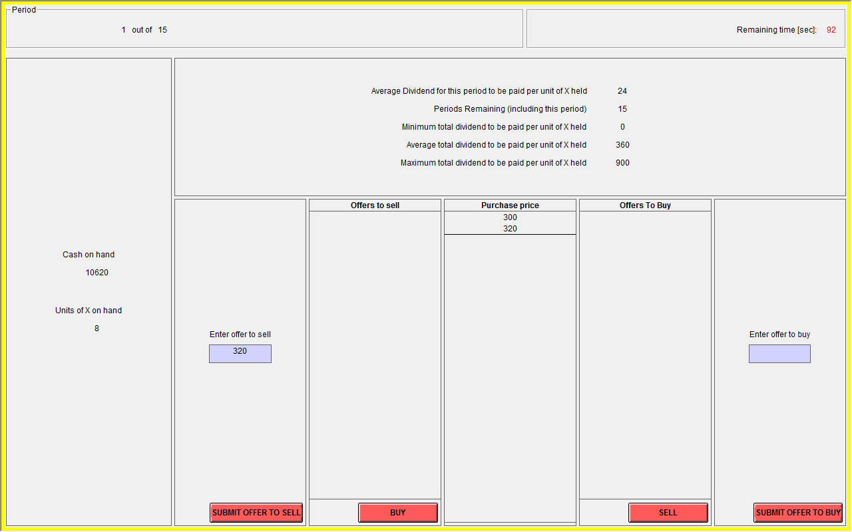

In the top right hand corner of the screen you see how much time is remaining in the current Period. In the top left hand corner of your screen you see the current Period and how many periods remaining. Your Cash on Hand and your inventory of X are in the left column.

If you would like to offer to sell a unit of X, use the text area entitled ‘Enter offer to sell’ in the second column. In that text area you can enter the price at which you are offering to sell a unit of X, and then select ‘SUBMIT OFFER TO SELL’.

As people submit offers to sell units of X, these offers will appear in the third column from the left, entitled ‘Offers To Sell’. The lowest ask price will always be on the bottom of that list and will, by default, be selected. You can select a different offer by clicking on it. If you select the ‘BUY’ button, you will buy one unit of X for the currently selected sell price.

When you buy a unit of X, your Cash on Hand decreases by the price of the purchase. When you sell a unit of X, your Cash on Hand increases by the price of the sale. You may make an offer to buy a unit by typing a price at which you are willing to purchase one unit of X in the text area ‘Enter offer to buy,’ and then pressing the red button labelled ‘SUBMIT OFFER TO BUY’. You can sell to the person who submitted the highest offer to buy if you click on ‘SELL’. In the middle column, labelled ‘Transaction Prices’, you can see the prices at which units of X have been bought and sold in this period.

**5. Recording Your Earnings**

At the end of each period, a summary screen will be provided to you (an example of the summary screen is illustrated below).

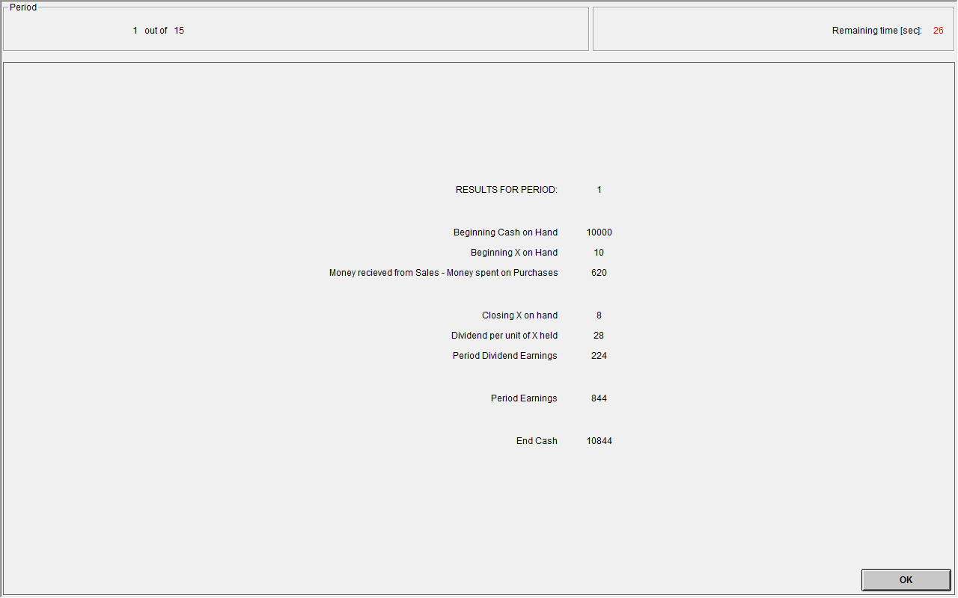

On your **PERIOD EARNINGS SHEET** please record the following information from the summary screen. At the beginning of period 1, record your cash on hand at the beginning of the period in column 2 in the row marked period 1. In column 3, record your earnings from sales minus expenditures on purchases for the period. Record your inventory of units at the end of the period in column 4 in the row marked period 1. Fill in the dividend of each unit in column 5. Record your dividend earnings for the period in column 6. In column 7, record your cash on hand at the end of the period. Record your cash on hand at the beginning of the period in column 8. Your earnings in each period equal the difference in your cash on hand at the end of the period minus the cash on hand at the beginning of the period. Record your period earnings in column 9. Repeat this procedure to obtain the period earnings of all periods.

END OF PERIOD CASH = BEGINNING OF PERIOD CASH + DIVIDEND PER UNIT * NUMBER OF UNITS IN INVENTORY AT THE END OF PERIOD+SALES -PURCHASES

PERIOD EARNINGS = END OF PERIOD CASH – BEGINNING OF PERIOD CASH

Subsequent periods should be recorded similarly. Your earnings for this experiment are given by the cash on hand at the end of period 15.

**Example of Period Earnings**

Suppose that in period 10 your BEGINNING OF PERIOD CASH is 3,000 francs and your INVENTORY at the beginning of period 10 is 7 units of X. If in period 10 you sell 2 units of X at a price of 200 francs and the dividend draw is 8 francs, then in period 10:

END OF PERIOD CASH = 3,000 + 2*200 = 3,400

INVENTORY (at the end of period 10) = 7 - 2 = 5

PERIOD DIVIDEND EARNINGS = DIVIDEND PER UNIT * NUMBER OF UNITS IN INVENTORY = 8 * 5 = 40.

PERIOD EARNINGS = END OF PERIOD CASH – BEGINNING OF PERIOD CASH + DIVIDEND PER UNIT * NUMBER OF UNITS IN INVENTORY AT THE END OF PERIOD = 3,400 – 3,000 + 8 * 5 = 440.

**6. Quiz[13]**

**Question 1:** Suppose that you purchase a unit of X in period 5.

1. What is the average dividend payment on the unit of X for period 5? _____
2. If you hold that unit of X till the end of the experiment (11 periods including the current period), what is the average total dividend paid on the unit of X? _____
3. What is the maximum possible dividend paid on the unit of X till the end of the experiment (11 periods including the current period)? _____

d. What is the minimum possible dividend paid on the unit of X till the end of the experiment (11 periods including the current period)? _____

**Question 2:** Suppose that you purchase a unit of X in period 15.

1. What is the average dividend payment on the unit of X for period 15? _____
2. If you hold that unit of X till the end of the experiment (1 period including the current period), what is the average total dividend paid on the unit of X? _____
3. What is the maximum possible dividend paid on the unit of X till the end of the experiment (1 period including the current period)? _____

d. What is the minimum possible dividend paid on the unit of X till the end of the experiment (1 period including the current period)? _____

**Question 3:** What is the value of the asset after the final dividend payment in period 15? ___

**Period Earnings Sheet**

|  |  |  |  |  |  |  |  |  |
| --- | --- | --- | --- | --- | --- | --- | --- | --- |
| (1)  PERIOD | (2)  BEGINNING CASH | (3)  + SALES  -PURCHASES | (4)  INVENTORY AT THE END OF PERIOD | (5)  DIVIDEND PER UNIT | (6)  PERIOD DIVIDEND EARNINGS | (7)  END  CASH | (8)  BEGINNING CASH | (9)  PERIOD EARNINGS |
| 1 | […] |  |  |  |  |  | […] |  |
| 2 |  |  |  |  |  |  |  |  |
| 3 |  |  |  |  |  |  |  |  |
| 4 |  |  |  |  |  |  |  |  |
| 5 |  |  |  |  |  |  |  |  |
| 6 |  |  |  |  |  |  |  |  |
| 7 |  |  |  |  |  |  |  |  |
| 8 |  |  |  |  |  |  |  |  |
| 10 |  |  |  |  |  |  |  |  |
| 11 |  |  |  |  |  |  |  |  |
| 12 |  |  |  |  |  |  |  |  |
| 13 |  |  |  |  |  |  |  |  |
| 14 |  |  |  |  |  |  |  |  |
| 15 |  |  |  |  |  |  |  |  |

**Average Holding Value Table**

|  |  |  |  |  |  |  |
| --- | --- | --- | --- | --- | --- | --- |
| Ending Period | Current Period (Before it Ends and a Dividend is Paid) | Number of Remaining Dividend Payments | * | Average Dividend Value Per Period | = | Average Holding Value Per Unit of Inventory |
| 15 | 1 | 15 | * | 24 | = | 360 |
| 15 | 2 | 14 | * | 24 | = | 333 |
| 15 | 3 | 13 | * | 24 | = | 312 |
| 15 | 4 | 12 | * | 24 | = | 288 |
| 15 | 5 | 11 | * | 24 | = | 264 |
| 15 | 6 | 10 | * | 24 | = | 240 |
| 15 | 7 | 9 | * | 24 | = | 216 |
| 15 | 8 | 8 | * | 24 | = | 192 |
| 15 | 9 | 7 | * | 24 | = | 168 |
| 15 | 10 | 6 | * | 24 | = | 144 |
| 15 | 11 | 5 | * | 24 | = | 120 |
| 15 | 12 | 4 | * | 24 | = | 96 |
| 15 | 13 | 3 | * | 24 | = | 72 |
| 15 | 14 | 2 | * | 24 | = | 48 |
| 15 | 15 | 1 | * | 24 | = | 24 |

**General Instructions**

**Double Dutch**

This experiment will consist of *fifteen* trading periods in which you will have the opportunity to buy and sell in a market. The currency used in the market is francs. All trading and earnings will be in terms of francs.

________ francs = 1 NZ dollar

Your francs will be converted to dollars at this rate, and you will be paid in dollars when you leave the lab today. The more francs you earn, the more dollars you earn.

In each period, you may buy and sell units of a good called X in a market. X can be considered an asset with a life of 15 periods, and your inventory of X carries over from one trading period to the next. Each unit of X in your inventory at the end of *each* trading period pays a dividend to you. The dividend paid on each unit is the same for every participant.

You will not know the exact value of the dividend per unit until the end of each trading period. The dividend is determined by chance at the end of each period by a random number generator. The dividend in each period has an equally likely chance of being 0, 8, 28, or 60. The information is provided in the table below.

|  |  |  |  |  |  |
| --- | --- | --- | --- | --- | --- |
| Dividend | → | 0 | 8 | 28 | 60 |
| Likelihood | → | 25% | 25% | 25% | 25% |

The average dividend per period for each unit of X is 24 francs.

The dividend draws in each period are independent. That means that the likelihood of a particular dividend in a period is not affected by the dividend in previous periods.

**2. Your Earnings**

At the beginning of the experiment, you will be given […] francs in your Cash inventory. Your earnings for the entire experiment are equal to your Cash inventory at the end of period 15.

All dividends you receive are added to your Cash inventory.

All money spent on purchases is subtracted from your Cash inventory.

All money received from sales is added to your Cash inventory.

**Example of earnings from dividends**

If you have 6 units of X at the end of period 3 and the dividend draw is 8 francs (which has a 25% chance of occurring), then your dividend earnings for period 3 are equal to 6 units x 8 francs = 48 francs.

**3. Average Value Holding Table**

You can use your **AVERAGE HOLDING VALUE TABLE[14]** to help you make decisions. It calculates the average amount of dividends you will receive if you keep a unit of X until the end of the experiment. It also describes how to calculate how much in future dividends you give up on average when you sell a share at any time. The following describes each of the columns in the table.

1. *Ending Period*: period 15 is the last trading period within the experiment, and thus the last period for which to receive a dividend payment. After the final dividend payment in period 15, each unit of X is worthless.

2. *Current Period*: the period during which the average holding value is being calculated. For example, in period 1, the numbers in the row corresponding to ‘Current Period 1’ are in effect.

3. *Number of Remaining Dividend Payments*: the number of times that a dividend can be received from the current period until the final period (period 15). That is, it indicates the number of random asset payment draws remaining in the lifetime of the asset. It is calculated by taking the total number of periods, 15, subtracting the current period number, and adding 1, because the dividend is also paid in the current period.

4. *Average Dividend Value per Period*: the average amount of each dividend. As we indicated earlier, the average dividend in each period is 24 francs per unit of X.

5. *Average Holding Value per Unit of Inventory*: the average value of holding a unit of X for the remainder of the experiment. That is, for each unit of X you hold in your inventory for the remainder of the experiment, you receive on average the amount listed in column 5. The number in Average Holding Value is calculated by multiplying the Number of Remaining Dividend Payments with the Average Dividend Payment per Period.

Please have a look at the table now and make sure you understand it. The following example may help in your understanding. Suppose for example that there are 7 periods remaining. Since the dividend paid on a unit of X has a 25% chance of being 0, a 25% chance of being 8, a 25% chance of being 28, and a 25% chance of being 60 in any period, the dividend is on average 24 per period for each unit of X. If you hold a unit of X for 7 periods, the total dividend paid on the unit over the 7 periods is on average 7*24 = 168.

**4. Market and Trading Rules**

At the beginning of the experiment, you will have an initial inventory of […] units of X and […] francs. The experiment consists of 15 periods. In each period, each participant will have an opportunity to buy and sell units of X. The following is an example of your bidding screen.

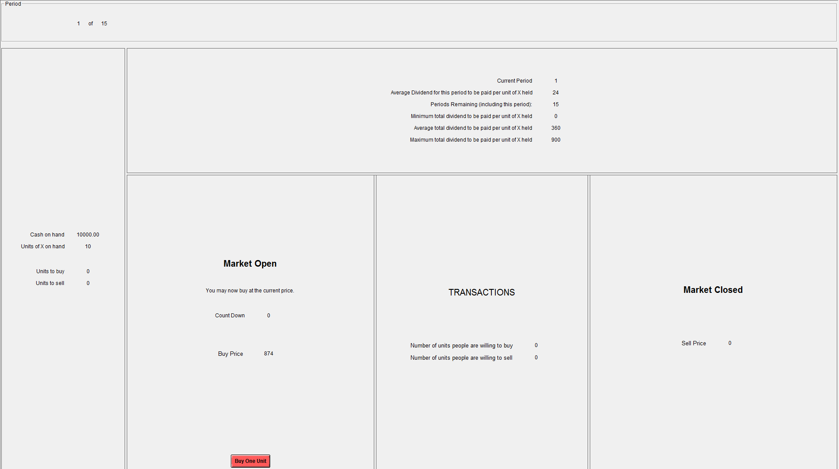

In the top left hand corner of your screen you see the current Period and how many periods remaining. Your Cash on Hand and your inventory of X are in the left column. On the left hand side of the screen, there is a box labelled ‘Buy Price’. The number in the box represents the price to buy one unit of X. Similarly, on the right hand side of the screen, there is a box labelled ‘Sell Price’. The number in the box represents the price to sell one unit of X. As you can see from the above example screen, the Buy Price is starts higher than the Sell Price. These price boxes will highlight alternately during the period. A highlighted box indicates the side of the market that is active. For example, you may only sell a unit of X when the Sell Price box is highlighted and vice versa for buying a unit of X.

When the period begins, one of the boxes will be highlighted indicating which side of the market is active and thus the type of transaction that is currently available and at what price. For example, suppose the Sell Price box is highlighted. If you are willing to sell a unit of X at the highlighted price, then click the SELL button. A three second countdown is given at the start of the period. The price will not change for these three seconds allowing you to easily click the SELL button if you want to sell at that price. After three seconds, the Sell Price will begin to rise rapidly. If the price reaches a point that you are willing to sell a unit of X, the click the SELL button. As soon as someone clicks their SELL button, then the sell side becomes inactive and the buy side becomes highlighted and active. The three second timer will begin. If no one clicks their BUY button during the first 3 seconds, then the price will begin to drop rapidly. If the price reaches a point that you are willing to buy a unit of X, then click the BUY button. This switching between sides of markets continues until the period ends.

The period will end when the Buy Price and the Sell Price are equal. If you had indicated that you are willing to buy or sell a unit of X by clicking the BUY or SELL button respectively during the period, then your transactions will be completed at the market ending price where the Buy Price equals the Sell Price.

* Note, when you click on the BUY (SELL) button for a given price during the period, you are indicating that you are willing to buy (sell) a unit of X at a price that is at least this favourable for you. That is, the price that you eventually pay (receive) may be lower (higher) than when you clicked the BUY (sell) button.

In the middle column, labelled ‘Transactions’, you can see the number of units of X that have been bought and sold in this period. The switching between the BUY side and SELL sides of the market depends upon how many units have been bought and sold. If the number of units bought equals the number of units sold, then the same side of the market starts again. If there are more units bought than units sold, then the SELL side starts. If there are more units sold than bought, then the BUY side starts.

If the Buy Price and the Sell Price are equal (and thus the period ends) and the number of units bought does not equal the number of units sold, then the last unit offered to buy/sell is not transacted.

**5. Recording your earnings**

At the end of each period, a summary screen will be provided to you (an example of the summary screen is illustrated below).



On your **PERIOD EARNINGS SHEET[15]** record the following information from the summary screen. At the beginning of period 1, record your cash on hand at the beginning of the period in column 2 in the row marked period 1. In column 3, record your earnings from sales minus expenditures on purchases for the period. Record your inventory of units at the end of the period in column 4 in the row marked period 1. Fill in the dividend of each unit in column 5. Record your dividend earnings for the period in column 6. In column 7, record your cash on hand at the end of the period. Record your cash on hand at the beginning of the period in column 8. Your earnings in each period equal the difference in your cash on hand at the end of the period minus the cash on hand at the beginning of the period. Record your period earnings in column 9. Repeat this procedure to obtain the period earnings of all periods.

END OF PERIOD CASH= BEGINNING OF PERIOD CASH + DIVIDEND PER UNIT * NUMBER OF UNITS IN INVENTORY AT THE END OF PERIOD+SALES -PURCHASES

PERIOD EARNINGS = END OF PERIOD CASH – BEGINNING OF PERIOD CASH

Subsequent periods should be recorded similarly. Your earnings for this experiment are given by the cash on hand at the end of period 15.

**Example of period earnings.** Suppose that in period 10 your BEGINNING OF PERIOD CASH is 3,000 francs and your INVENTORY at the beginning of period 10 is 7 units of X. If in period 10 you sell 2 units of X at a price of 200 francs and the dividend draw is 8 francs, then in period 10:

END OF PERIOD CASH = 3,000 + 2*200 = 3,400

INVENTORY (at the end of period 10) = 7 - 2 = 5

PERIOD DIVIDEND EARNINGS = DIVIDEND PER UNIT * NUMBER OF UNITS IN INVENTORY = 8 * 5 = 40.

PERIOD EARNINGS = END OF PERIOD CASH – BEGINNING OF PERIOD CASH + DIVIDEND PER UNIT * NUMBER OF UNITS IN INVENTORY AT THE END OF PERIOD = 3,400 – 3,000 + 8 * 5 = 440.

**General Instructions**

**English Dutch**

This experiment will consist of *fifteen* trading periods in which you will have the opportunity to buy and sell in a market. The currency used in the market is francs. All trading and earnings will be in terms of francs.

360 francs = 1 NZ dollar

Your francs will be converted to dollars at this rate, and you will be paid in dollars when you leave the lab today. The more francs you earn, the more dollars you earn.

In each period, you may buy or sell units of X in a market. X can be considered an asset with a life of 15 periods, and your inventory of X carries over from one trading period to the next. Each unit of X in your inventory at the end of *any* trading period pays a dividend to you. The dividend paid on each asset is the same for every participant that period.

No one will know the exact value of the dividend per unit until the end of each trading period. The dividend is determined by chance at the end of each period by a random number generator. The dividend in each period has an equally likely chance of being 0, 8, 28, or 60. The information is provided in the table below.

|  |  |  |  |  |  |
| --- | --- | --- | --- | --- | --- |
| Dividend | → | 0 | 8 | 28 | 60 |
| Likelihood | → | 25% | 25% | 25% | 25% |

The average dividend per period for each unit of X is 24 francs.

The likelihood of a particular dividend in a period is not affected by the dividend in previous periods.

**2. Your Earnings**

At the beginning of the experiment, you will be given 10,000 francs in your Cash inventory. Your earnings for the entire experiment are equal to your Cash inventory at the end of  
period 15.

All dividends you receive at the end of each period are added to your Cash inventory.

All money spent on purchases is subtracted from your Cash inventory.

All money received from sales is added to your Cash inventory.

**Example of earnings from dividends**

If you have 6 units of X at the end of period 3 and the dividend draw is 8 francs (which has a 25% chance of occurring), then your dividend earnings for period 3 are equal to 6 units x 8 francs = 48 francs.

**3. Average Value Holding Table**

You can use your **AVERAGE HOLDING VALUE TABLE[16]** to help you make decisions. It calculates the average amount of dividends you will receive if you keep a unit of X until the end of the experiment. It also describes how to calculate how much in future dividends you give up on average when you sell a unit of X at any time. The following describes each of the columns in the table.

1. *Ending Period*: Period 15 is the last trading period within the experiment, and thus the last period for which to receive a dividend payment. After the final dividend payment in period 15, each unit of X is worthless.

2. *Current Period*: The period during which the average holding value is being calculated. For example, in period 1, the numbers in the row corresponding to ‘Current Period 1’ are in effect.

3. *Number of Remaining Dividend Payments*:The number of times that a dividend can be received from the current period until the final period (period 15). That is, it indicates the number of random dividend payment draws outstanding in the remaining lifetime of the asset. It is calculated by taking the total number of periods, 15, subtracting the current period number, and adding 1, because a dividend is paid at the end of the current period.

4. *Average Dividend Value per Period*: The average amount of each dividend. As we indicated earlier, the average dividend in each period is 24 francs.

5. *Average Holding Value per Unit of Inventory*: The average value of holding a unit of X for the remainder of the experiment. That is, for each unit of X you hold in your inventory for the remainder of the experiment, you receive on average the amount listed in column 5. The number in Average Holding Value is calculated by multiplying the Number of Remaining Dividend Payments with the Average Dividend Payment per Period.

Please look at the table now and make sure you understand it. The following example may help in your understanding. Suppose for example that there are 7 periods remaining including the current period. Since the dividend paid on a unit of X has a 25% chance of being 0, a 25% chance of being 8, a 25% chance of being 28, and a 25% chance of being 60 in any period, the dividend is on average 24 per period for each unit of X. If you hold a unit of X for 7 periods, the total dividend paid on the unit over the 7 periods is on average 7*24 = 168.

**4. Market and Trading Rules**

At the beginning of the experiment, you will have an initial inventory of 10 units of X and 10,000 francs. The experiment will consist of 15 periods. In each period, each participant will have an opportunity to buy or sell units of X. The following is an example of your Initial Purchase Offer screen.

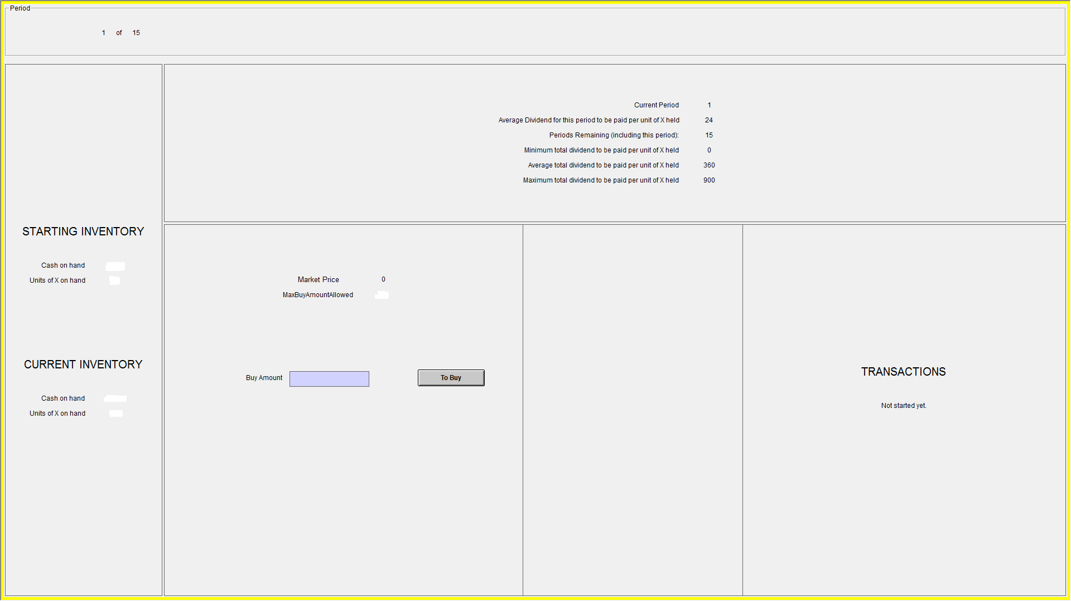

In the top left hand corner of your screen you see the current Period and how many periods are remaining. Your Cash on Hand and your inventory of X are in the left column. A summary of the information presented on your Average Holding Value Table is presented at the top center. In the middle of the screen, the ‘Market Price’ is listed, which represents the price to buy/sell a single unit. At the beginning of each period, the initially listed price is zero. On this Initial Purchase Offer screen, you must enter the amount of X you want to purchase at a zero price by entering a number between 0 and 90 in the box labeled ‘Buy Amount’ and click the ‘To Buy’ button. Once everyone has submitted their initial purchase quantity, the program will continue to your Bidding Screen. An example of this screen is listed below.

Once again, the period and Average Value Holding Table summary information are presented for you at the top of the screen and your Cash on Hand and inventory of X are in the left column. In the middle of the screen is the ‘Market Price’ which once again is initially listed as zero, the ‘Buy Amount’ which is the number of units you stated you want to purchase at a zero Price, and the ‘Sell Amount’ which is the number of units you want to sell at the listed Price (this is always zero at the beginning of a period). The right column presents the ‘Total to Buy’ which is the sum of all traders offers to buy at the listed Price and the ‘Total to Sell’ which is the sum of all traders offers to sell at the listed Price (because everyone starts with 0 units of X as their Sell Amount, this total is also always zero at the beginning of a period).

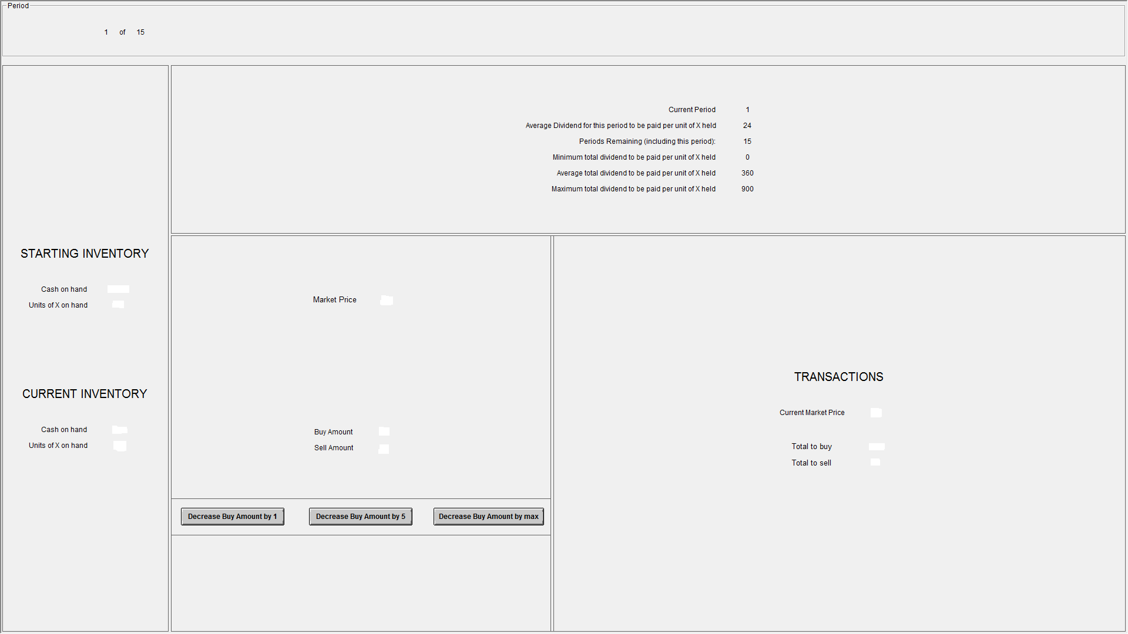

The program will have a three second countdown prior to the start of the period. Once the countdown is completed, the price will begin to increase. As the price increases, you will have the option to decrease the number of units you want to purchase by clicking one of the buttons on the bottom of the screen. Each time you click one of the buttons, the number of units you want to buy decreases by the amount listed on that button. If your Buy Amount reaches zero, a new set of buttons appear allowing you to increase the amount you want to sell.

The period ends when the sum of all traders' Buy Amount (presented on your screen as the Total to Buy) equals the sum of all traders' Sell Amount (similarly presented as the Total to Sell). The price listed when Total to Buy equals Total to Sell is the price for all units of X bought and sold in the period. That is, if you have any units of X listed in your Buy Amount, this is the price you must pay for each unit. Conversely, this is the price you will receive for each unit of X you have listed in your Sell Amount.

Note: The quantities of X listed in your Buy Amount or Sell Amount are commitments to buy or sell respectively. Because all units of X trade at the same price and the fact that the price continually increases throughout the period, the quantity you were willing to buy at a zero price listed in your Initial Purchase Offer becomes more expensive as the period progresses. You will be committed to purchasing these units unless you reduce the amount you want to buy by clicking one of the buttons at the bottom of the page. Conversely, if you click the buttons sufficiently to induce a positive amount to sell, i.e. your Sell Amount is greater than zero, then each unit to sell is a commitment and cannot be reduced.

There are two restrictions in the market.

1. You cannot buy more units of X than you can afford. That is, the listed Price multiplied by your Buy Amount cannot be more than the cash you have available. Because every unit of X trades at the same price, as the listed Price increases throughout the period, the amount of cash you need to be able to complete the purchase(s) you agreed to (as listed by your Buy Amount) also increases. This means that as the period progresses and the price continues to increase, you may not have enough money to purchase all the units listed in your Buy Amount. If this occurs, the computer will automatically reduce the units of X in your Buy Amount to ensure you can afford all listed purchases. To assist you in making your purchase/sell decisions, the computer will adjust your Cash on Hand based upon the number of units you have committed to purchase or sell and the listed Price.
2. You cannot sell more units of X than you have in your inventory. Therefore, if you commit to sell every unit of X you have, the sell buttons will become disabled.

Because of the way this market works, you cannot buy and sell units of X in a single period. Instead you will either be a net buyer of X, a net seller of X, or you will not trade any units of X. You could buy shares of X in one period and sell them in a different period or vice versa.

**5. Recording Your Earnings**

At the end of each period, a summary screen will be provided to you. Below is an example of how your earnings are calculated each period. In this example, period 5 has just been completed. This person had a Beginning X on Hand of 4 units, purchased 1 unit by spending 350 to having a Closing X on Hand of 5 units of X. The randomly selected dividend was 8 resulting in 5x8=40 in Received Dividend Earnings. Since the person started with 1450 Beginning Cash on Hand, had a Change in Cash from Sales and Purchase of -350 (=0 Cash Received from Sales – 350 Cash Spent on Purchases) and had 40 Received Dividend Earnings, this person has a Closing Cash on Hand of 1140. Since the Number of Remaining Periods in which dividends will be paid is 10, the Average Holding Value per Unit is 240. As this person has a Closing X on Hand of 5, the Average Holding Value of X on Hand is 5x240=1200. Therefore, if this person made no further trades, on average she would earn 1140 + 1200=2340 in the experiment.

**RESULTS AFTER PERIOD 5**

**(10 Periods Remain)**

**Beginning X on Hand** 4

Units of X Purchased +1

Units of X Sold -0

**Closing X on Hand…………………………………..**5 → 5

Dividend per unit of X Held x8

**Received Dividend Earnings………………………………** 40 → **40**

**Beginning Cash on Hand +1450**

Cash Received from Sales +0

Cash Spent on Purchases -350

**Change in Cash from Sales and Purchases………..**-350 → **-350**

**Closing Cash on Hand……………………………………………………….1140** →

Average Dividend Payment per Period 24

Number of Periods Remaining x10

**Average Holding Value per Unit…………………………** 240 → **240**

Closing X on Hand (from line 4 above) **x5**

**Average Holding Value of X on Hand……………………….…………..1200** →

**Average Profit with No Further Trading 2340**

On your **PERIOD EARNINGS SHEET[17]** record the following information from the summary screen after each period. For the completed period, record your Beginning Cash on Hand in column 2. In column 3, record your Change in Cash from Sales and Purchases (this is your earnings from sales minus expenditures on purchases for the period). Record your inventory of units at the end of the period in column 4 labeled Closing X on Hand. Fill in the Dividend per Unit of X Held in column 5. Record your Received Dividend Earnings for the period in column 6. In column 7, record your Closing Cash on Hand (this is your Beginning Cash on Hand + Change in Cash from Sales and Purchases + Received Dividend Earnings). In column 8, record your Average Holding Value of X on Hand.

Since all units of X have already paid the dividend for the period that was just completed, the Average Holding Value of X on Hand is the average dividend payment of 24 francs per period times the number of dividend payments remaining, so it is one less than the number shown on the Average Holding Value Table because that table assumes the dividend for the period has not yet been paid. In column 9, record your Average Profit with No Further Trading (which is your Closing Cash on Hand plus the Average Holding Value of X on Hand). Your earnings for this experiment are given by the Closing Cash on Hand at the end of period 15 because the Average Holding Value of X on Hand is 0 after the last dividend payment has been made.

1. Deck, Porter and Smith (2014) find that introducing new traders over the course of an asset’s life can cause bubbles to rekindle within a market.
2. Of course, there may be other institutions that are even more effective at reducing mispricing in asset markets. So the English Dutch auction may not be best in a global sense, but it is the best among the institutions that have been tested in the laboratory.
3. In addition to the double Dutch auction, McCabe, Rassenti and Smith (1992) introduce the Dutch English auction, as well as a double English auction, but do not mention the English Dutch auction although its structure is obvious given their work.
4. All the sessions of Double Dutch and English Dutch treatments consisted of 9 subjects. The baseline double auction treatment consisted of eight subjects in each session as the double auction sessions were originally designed to be part of a different study.
5. The exchange rate ranged from 360 to 550 francs to 1 NZD depending upon the treatment due to expected differences in timeframes to complete sessions.
6. This is the same dividend distribution used in numerous asset market studies, for example, Smith   
   *et al*. (1988), King *et al.* (1993), Porter and Smith (1995), Lei *et al.* (2001), Haruvy and Noussair (2006), Noussair and Tucker (2006) and Hussam *et al.* (2008).
7. Any dividends received at the end of period *t* were added to the cash balances to be carried over to period *t*+1. Thus, the environment had an increasing cash to asset ratio providing a tough test of an institution.
8. The starting prices may well be important parameters for these markets. To the degree that our choices may bias behavior one would expect to observe prices holding constant from period to period since the closing price in the previous period is the average of the starting prices in the next period. Because of the leeway in parameter selection, the double Dutch and the English Dutch auctions are really classes of institutions. The same is true of the double auction as the market designer has several options including the openness of the bid book or the requirement of an improvement rule.
9. Since the subjects are limited to single unit contracts, the maximum excess supply/demand in the market at any time is a single unit.
10. As explained in the instructions, each subject was endowed with 10 units of the asset, and thus the total number of assets available in the market was 10 times the number of traders. The maximum number of assets a subject is allowed to buy at the initial price of zero is constrained to available outstanding number of assets in the market, i.e. total number of assets in the market minus number of assets currently in the subject’s inventory. If a trader does not want to purchase any units in the following period, they can enter a zero quantity.
11. As part of a separate project, participants in this study and other studies being conducted at the same lab were incentivised to answer the three standard cognitive reflection task (CRT) questions of Frederick (2005) after the experiment.  We do not analyse the data here in part because we believe that this procedure and the correct answers became known among the subject pool participants over time.  As mentioned previously, the English Dutch auction was implemented after the initial Double Dutch and Double Auction were completed.  The average CRT score increased from 1.38 out of 3 for the first two treatments to 2.24 out of 3 for the last one. The former number is in line with those reported in other studies conducted at similar institutions and consistent historically with data collected in the same lab, whereas the latter greatly exceeds the extreme scores reported elsewhere such as the student sample from MIT which scored 2.18 out of 3 as reported by Frederick (2005). However, even if the CRT scores are accurate, we do not believe this drives the treatment effects we report in the next section. The justification for this belief is that the correlation between CRT and either measure of bubble size that we report is small and insignificant within each treatment. That is, we have no evidence that higher average CRT scores lead to better performance within a treatment, something that should be true if performance is driven CRT. Further, for the one English Dutch session that had a more typical average CRT score (1.55 out of 3), its bubble measures are lower than the bubble measures for the (5 of 10) sessions in other treatments which had average the same or higher CRT scores. Again, this suggests market performance is not driven by the cognitive reflection of the subjects.
12. DD and ED are uniform price auctions and thus the market-clearing price is necessarily the average transaction price.
13. This quiz was conducted in each session. In some sessions, the quiz was hand-run within the instruction packet and others the quiz was computerized via zTree.
14. Average Holding Value Tables are identical across treatments and thus refer to Double Action instructions.
15. Period Earnings Sheets are identical across treatments and thus refer to Double Action instructions.
16. Average Holding Value Tables are identical across treatments and thus refer to Double Action instructions.
17. Period Earnings Sheets are identical across treatments and thus refer to Double Action instructions.