UNIVERSITY OF WAIKATO
Hamilton
New Zealand

Civil War and International Migration from Nepal:

Evidence from a Spatial Durbin Model

Hari Sharma and John Gibson

Working Paper in Economics 6/19

June 2019

Corresponding Author
Hari Sharma
School of Accounting, Finance and Economics
University of Waikato
Private Bag 3105
Hamilton
New Zealand, 3240
Email: hps5@students.waikato.ac.nz

John Gibson
School of Accounting, Finance and Economics
University of Waikato
Private Bag 3105
Hamilton
New Zealand, 3240

Tel: +64 (7) 838 4289

Email: jkgibson@waikato.ac.nz

Abstract

A growing literature studies microeconomic effects of war on human capital formation and labour market activity. A common research design is to relate spatially aggregated data on conflict rates at the first or second sub-national level to more spatially disaggregated survey data on outcomes of interest. Several studies focus on Nepal’s civil war, that ran for a decade from 1996, and use conflict-related deaths in Nepal’s 75 districts (the second sub-national level). Variation in the conflict-related death rate within Nepal’s districts is more than three times higher than the variation between districts. Consequently, using district-level conflict data creates a measurement error on the right-hand side of regression models, making the conflict seem more widespread, and biases econometric estimates of conflict impacts. Prior studies also ignore spatial spillovers, where local conflict may affect outcomes not only locally but also in surrounding areas. To deal with these biases, we use measures of conflict intensity for Nepal’s 3982 localities in a spatial Durbin model of the change in emigration rates between the 2001 and 2011. We distinguish emigration to India, which is informal and long-standing, from emigration to other countries that is a recent development for Nepal and requires formal recruitment and visa processes. Higher local conflict intensity is associated with slower local growth in the emigration rate between 2001 and 2011. It is mainly indirect impacts, based on the spatial lags, which matter and it is emigration to destinations other than India that was deterred by the conflict. The estimated impacts would be substantially distorted if conflict intensity was measured at the more aggregated, district-level, as in the existing literature.

Keywords
aggregation, conflict, emigration, spatial Durbin model, Nepal

JEL Codes
C21, D74, F22, O15

Acknowledgements
We are grateful to Geua Boe-Gibson for producing the maps and
to helpful suggestions from audiences at KU Leuven and the SEAI and NZAE Conferences.

1. Introduction

A growing literature studies microeconomic effects of war on human capital formation and labour market activity. A recent review by Verwimp et al. (2019) notes that an objective of this literature is to study ‘ways in which individuals, households, and communities, behave, adapt, make decisions and live in conflict-affected contexts’ (p.1). A typical research design is to relate spatially aggregated data on conflict rates at the first or second sub-national level to more spatially disaggregated survey data on outcomes of interest. For example, studies of Nepal’s civil war, that ran for a decade from 1996, use conflict-related deaths in 75 districts (the second sub-national level) as predictors of internal displacement rates (Adhikari 2012), and of survey measures of female employment (Menon and Van der Meulen Rodgers 2015), schooling attainment (Pivovarova and Swee 2015), and international migration (Shrestha 2017). Elsewhere, Chamarbagwala and Morán (2011) use civil war victimization data for Guatemala’s 22 departamentos (the first sub-national level) to predict individual-level human capital formation, while Kountchou et al. (2019) use conflict data for 53 districts in Chad in a model of child health and nutrition for 20,000 children in 650 DHS survey clusters.

A problem with this research design is that the vector of data on conflict indicators is implicitly ‘stretched’ to line it up with the more disaggregated outcome measures, causing an econometric bias. The local conflict rate may be quite different to the district-level conflict rate, so using district-level data creates mean-reverting measurement error; the fatality rate in areas with no (or few) fatalities is overstated by using fatality rates for more aggregated areas, while it is understated for localities with higher fatality rates than the district average. With mean-reverting errors, regression coefficients can be either attenuated or exaggerated (Gibson et al. 2015), unlike the usual problem of attenuation bias when there are random errors in right-hand side variables. Intuitively, by suppressing intra-district spatial heterogeneity, there appears to be less variation in conflict rates (than actually was so at the local level), and so to best fit the outcome data the regression coefficients on district-level data are amplified.

For example, the variation in total deaths and in the death rate within districts during Nepal’s civil war was more than three times higher than the variation between districts. This within-district variation is ignored by existing studies. The smoothing of the apparent conflict intensity, in excessively aggregated data, makes the conflict seem more widespread; while all but two (of 75) districts had some fatalities, only about half of the 3982 localities had any conflict-related fatalities. This pattern is also likely to occur elsewhere because civil wars in developing countries are often spatially concentrated conflicts (Verwimp et al. 2019).

To overcome these weaknesses in the literature, we measure conflict intensity for Nepal’s 3982 localities (formally, VDCs or Village Development Committees, once known as panchayats). The average district is just under 2000 km² (about the area of Mauritius), while the average VDC is just 36 km² and so it provides a far more spatially detailed unit of analysis than in prior research. We use a spatial Durbin model that allows indirect effects of the conflict in one locality to affect outcomes in (all) other localities. This deals with another problem in the existing literature, of not allowing for spatial spillovers, where local conflict may affect outcomes not only in that particular area but also in surrounding areas.

The particular outcome we focus on is emigration, because labour export is a key feature of Nepal’s economy, with two million Nepalese working abroad sending almost US$7 billion in annual remittances (equivalent to 29% of GDP, the third highest rate in the world). The existing literature suggests that conflict intensity increased emigration from Nepal (Shrestha 2017). More generally, the idea that conflict is an important push factor in international migration is widespread in the literature (for example, Naude 2008).

We test if the local intensity of Nepal’s civil war, measured at the VDC level, affected the growth in emigration rates, both in the same localities and elsewhere. We use conflict death rates from 2002 to 2004, which was when fighting was heaviest, with two-thirds of the total 15,000 deaths occurring in those three years. However, our results would be largely the same if we used data on the full decade of conflict-related deaths. We separate emigration to India, which is low-cost, informal, and has occurred for decades, from emigration to other countries, where formal (and costly) recruitment and visa processing (in Kathmandu) is required, and which has been a recent large-scale development for Nepal.

Our migration data are from Nepal’s 2001 and 2011 census of population, which asks about members of households who are overseas. If an entire household moved abroad it will not be in our data, although the same limitation is present in the survey data used in other studies. The peak conflict period occurred between the two censuses, which limits use of panel data methods that relate contemporaneous conflict to contemporaneous emigration, where VDC-level fixed effects could be used to deal with omitted heterogeneity. We could use a long lag to link the 2011 census to the peak conflict period but the lag lengths would be ad hoc and a similar lag for the 2001 census would be before the conflict started so baseline death rates would be zero. Instead, we use long differences, with our outcome measures the change in the emigration rates for each VDC between 2001 and 2011. Control variables from the census are also in long differences, while our main variable of interest is the conflict intensity at the peak of the fighting, from 2002-04. The census does not have any measures of local economic growth, so to measure one type of push factor (lack of local urban growth) we use satellite observation of night-time lights for each VDC, following the same protocols as used by a recent study of urban economic growth in India (Gibson et al. 2017).

We find that an increase in conflict intensity, by one death per thousand population at the peak of the conflict (2002-04), is associated with slower growth in the emigration rate between 2001 and 2011. Specifically, the emigration rate rose by 3.9 persons per thousand less (equivalent to ten percent of the mean increase) than it would have in the absence of the conflict. This effect is predominantly though the indirect channels that operate via the spatial lags in the conflict rate and in the emigration rate. When we disaggregate the change in emigration rates into the part which is due to emigration to India and that due to emigration elsewhere, it is for the non-India destinations that the conflict intensity has a statistically significant effect in depressing the rate of increase in emigration.

A different picture emerges if we measure conflict intensity at the district level, as in prior studies for Nepal. Using these more spatially aggregated data there would seem to be a large and statistically significant direct effect of higher conflict intensity (of one death per thousand) increasing the emigration rate by eight persons per thousand overall and by eleven persons per thousand to India. These direct effects are offset by even larger negative indirect effects, so that the total effect of one more death per thousand appears as a suppression of the 2001 to 2011 increase in the emigration rate by about eight persons per thousand (with similar magnitudes, but not precision, of the effects for India and for the other destinations). These total effects are up to four times larger than when the conflict intensity is measured at the VDC level. These results suggest that the existing literature, which has relied on district level measures of conflict intensity, may have biased estimates of the micro economic effects of the war because the micro-level spatial heterogeneity in the conflict intensity is ignored.

Our findings also imply that people in VDCs that experienced the highest intensity of localized conflict may still be suffering at least one after-effect of the war. It is likely that remittance income in these areas is lower than it is elsewhere, since they did not participate as much in the huge growth in work-related emigration that the rest of Nepal experienced between 2001 and 2011. If this is the case, it is even more important to correctly diagnose the local consequences of the conflict. Extant studies that wrongly suggest positive effects of local conflict intensity on emigration could lead one to predict that these areas will have a higher expected remittance income (from what seems to be a higher emigration rate), which might be expected to help offset some of the conflict-related losses. In fact, it is likely that remittance income grew less in these conflict-affected areas than elsewhere because the conflict had a mildly suppressing effect on the growth in emigration.

The remainder of the paper is structured as follows: Section 2 provides the context for our study; Section 3 discusses the data and our econometric model; Section 4 contains the results, and Section 5 concludes.

2. Context
2.1 Emigration from Nepal
Nepal has a long history of work-related migration, especially to its southern neighbour. This includes British Army recruitment of hill Nepali during World War II and recruitment of Gurkha regiments by India to fight in the Indo-China and Indo-Pakistan wars. An open border treaty in 1950 made India an attractive and low-cost destination to escape domestic unemployment. Thus, emigration for employment emerged as a major household activity (Sapkota 2013). For example, the third Nepal Living Standards Survey showed that one-third of households in 2010 had at least one member working abroad; mostly amongst the 15 to 59 age group. This emigration opportunity was especially used by households in the western and mid-western regions of Nepal, which have poor land productivity, high poverty and food insecurity, and poor infrastructure. These two regions accounted for 36% and 48% of the emigrants in India according to the censuses in 2001 and 2011 (CBS, 2001, 2011).

In recent years the demand for workers in the Middle East created a new opportunity for emigrants from Nepal. Beginning in 1993/94, when 3,605 people obtained a permit to move for foreign employment in the Middle East, demand for this type of permit-based emigration (as opposed to the informal migration to India) rose strongly, such that there was a seven-fold increase (to annual recruitment of 28,000 workers) in just six years. However, the major period of increase, which also saw a spreading out to ASEAN countries like Malaysia, and to richer labour-scarce countries like Korea, came in the decade from 2001. Between the population censuses in 2001 and 2011 Nepal’s emigration rate more than doubled, to be over seven percent in 2011. This was due almost entirely to emigration to destinations other than India, as seen in Figure 1 which shows the mean and the 25th and 75th percentiles of the VDC-level emigration rate in each census. The mean emigration rate to India hardly changed, going from 28 to 30 per thousand from 2001 to 2011; for destinations elsewhere it rose from 7 to 43 per thousand. This sharp rise in emigration to places other than India more than doubled Nepal’s overall emigration rate. In over one-quarter of localities the emigration rate now exceeds ten percent (shown by the grey capped bar). Emigrants provide at least US$7 billion in annual remittances (equivalent to 29% of GDP, the third highest rate in the world) and probably more, since most remittances from India are undocumented.

Figure 1: Average Emigration Rates from Nepal 2001 and 2011
Bars Show Inter-Quartile Range

In terms of where these emigrants came from, Figure 2 maps the emigration rates in 2001. Given that three-quarters of all emigrants were in India in that year, the map for all destinations (panel a) is much like the map for where emigrants to India came from (panel b). The concentration of emigrant-source areas in the western and mid-western regions is apparent. In contrast, even though they were numerically far fewer in 2001, the emigrants going to locations other than India (shown in panel c of Figure 2) were predominantly from the central and eastern regions of Nepal. One cause of these spatial patterns is that people from relatively poor areas tend to emigrate to India as a low cost option due to their lack of wherewithal to finance emigration to elsewhere, like the Middle East, that offers higher returns. Roughly speaking, it takes from US$2,000-US$10,000 to emigrate to a non-India destination, in addition to the commuting cost to Kathmandu in order to obtain a passport and get a permit from the Ministry of Labour and Employment. The nearby central region is more developed, so people from there have many advantages in partaking in non-India emigration, including lower commuting cost for getting the needed documents, high literacy rates, and access to financial institutions to help fund the up-front costs of recruitment and visa charges.

The change in emigration rates between 2001 and 2011, at the VDC-level, is shown in Figure 3. The first panel shows emigration to all countries, the second panel is for emigration to India, and the third is for other Asian destinations and the Middle East. These maps show the spatial distribution of the outcome variables that our econometric models focus on. One feature that is apparent from panel (a) is that almost all parts of Nepal experienced higher emigration rates over this decade; less than ten percent of VDCs had no rise in emigration rates (shown by the hatched areas in the map). It is also clear that there is a lot of variation within districts; the standard deviation for within-district variation is twice as large as for between-district variation and the intra-district correlation in the change in emigration rates is only 0.21. This suggests that it is important to conduct analyses at a disaggregated level.

The second panel in Figure 3 shows the change in the emigration rate to India. Almost one-half of all VDCs, which cover more than half of Nepal’s area, had a fall in the rate of emigration to India. Conversely, the areas of increased emigration to India were along the northern border, in the very far west and a scattering of VDCs in the mid-western regions. When we consider the emigration to other Asian and Middle Eastern destinations (panel c), western areas of Nepal are some of the lowest participants, being in the lowest category of increase (shown by the tan colour) or even having decreasing rates. In contrast, the richer central and eastern areas were the major source of increase in emigration rates to non-India destinations, although with considerable heterogeneity within districts.

Figure 2: Emigration Rate to (a) all countries, (b) India (c) other Asia and Middle East at VDC level, 2001 Census

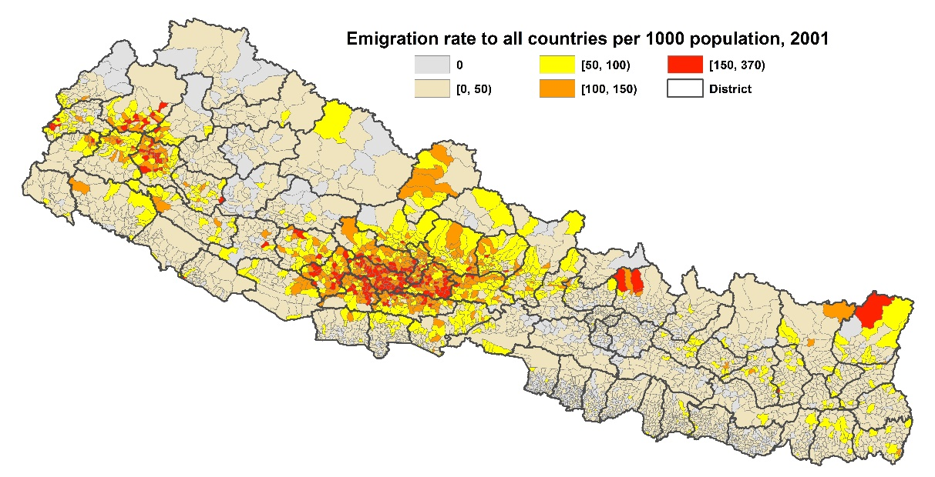
(a)
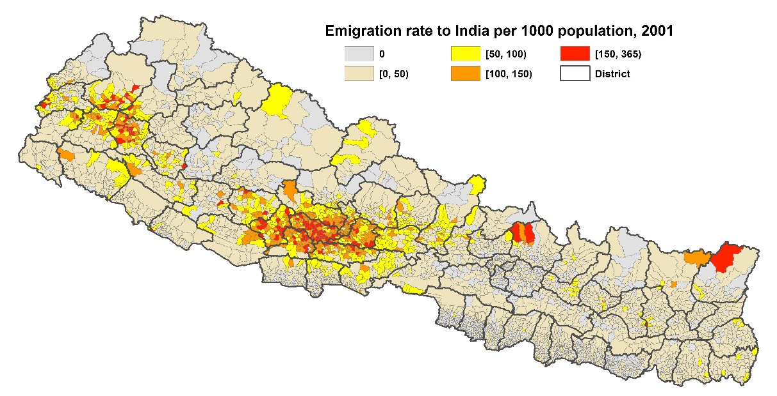
(b)
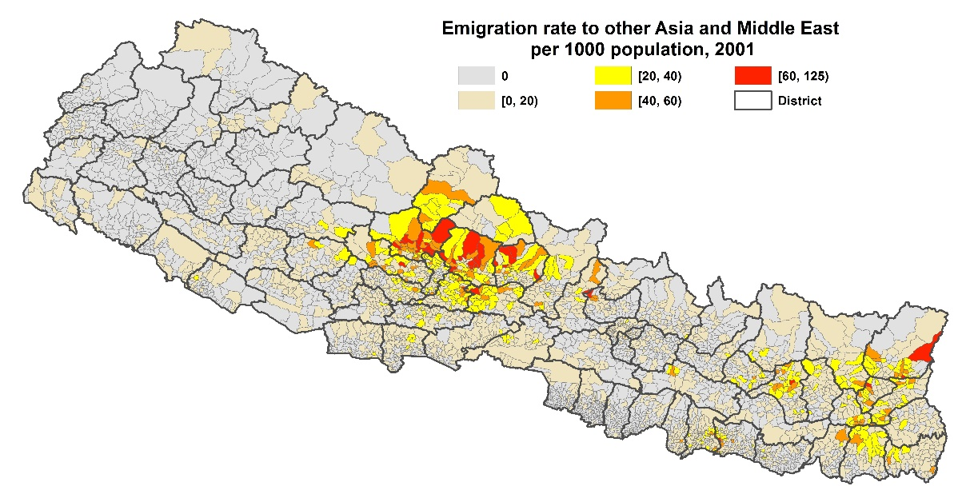
(c)
Source: Author’s calculations from Census extract data

Figure 3: Change in Emigration Rate at VDC level between 2001 and 2011 to
(a) all countries, (b) India (c) other Asia and Middle East

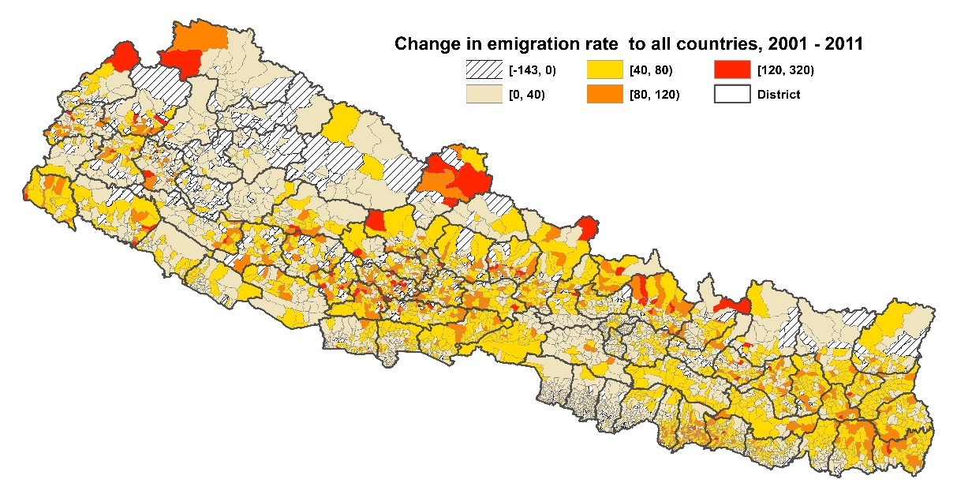
(a)
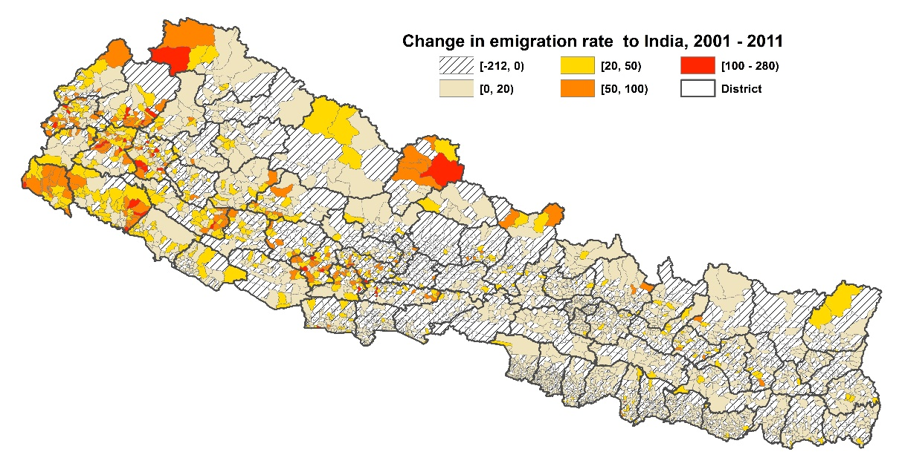
(b)
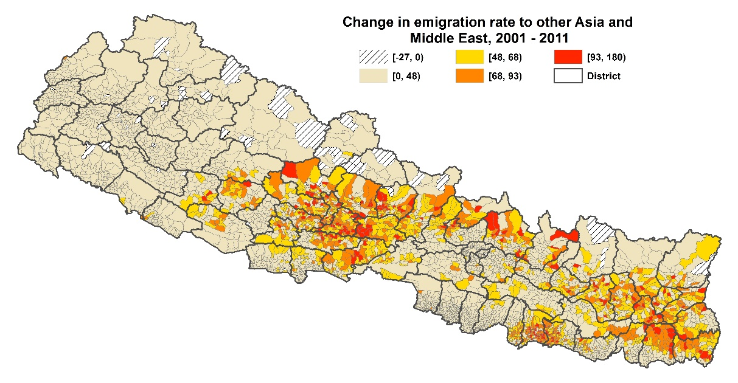
(c)
Source: Author’s calculations from Census extract data
2.2 Nepal’s Civil War

In 1996, the Communist Party of Nepal (CPM-Maoist) formally declared war against the state with the aim of abolishing the constitutional monarchy and establishing communist rule. In the early stage, the conflict was restricted to the poorest and underdeveloped regions in the far west and mid-western regions of Nepal. The Maoists benefited from the remoteness, and the dense forest and mountains, which favoured guerrilla tactics for their occasional attacks on police posts and on private firms and banks. Chronic poverty in these regions also helped to draw in support of some locals, especially because the Maoists seized land from the landlords and let poorer farmers cultivate it. While the police retaliated against these attacks (including claims of torturing people they believed were militants), there was no involvement by the army. Over five years of mainly localized fighting, which slowly grew in intensity, approximately 2000 people had been killed in total (Figure 4).

Figure 4: Annual Conflict-Related Deaths During Civil War in Nepal

Source: Informal Sector Service Center (INSEC), Nepal.

The war took an unexpected turn to more generalized and intensive conflict, after the killing in June 2001 of King Birendra and his family, murdered by the then crown prince, who subsequently committed suicide. The new King, Gyanendra Shah mobilised the army to deal with the insurgents, after on-going peace talks broke down in late 2001. Consequently, the conflict spread rapidly and became more intense, with over 4000 deaths in 2002, and more than 2000 deaths per year in 2003 and 2004 (Figure 4). In total, two-thirds of all conflict deaths occurred in this three-year period. During this period the Maoists had some control in at least 35 of the 75 districts (Pivovarova and Swee 2015), with a parallel government (Libois 2016). In 2005, the Maoists called for a unilateral ceasefire so as to join peace talks with other major political parties. Later in 2006, an uprising of the Nepali population against the King brought an end to the monarchy. By then, a peace agreement signed with all political parties led to the end of the decade-long conflict and by the time of elections in 2008 the political party based on the Maoists won close to half of the seats.

The data in Figure 4 are from the Informal Sector Service Centre (INSEC), a NGO in Kathmandu who monitored human rights violations by Maoist and government forces from February 1996 to December 2006. Their data are considered the most reliable source on the conflict intensity during the civil war (Libois 2016, Valente 2013). For each death and disappearance (equated to death if they were never located) in INSEC’s district-level dataset we disaggregated to VDC level by using the report of where the victimization event occurred. These data cover the army, police, insurgents, and civilians who may be killed in cross-fire, by landmines, and so on. Of the 15,021 deaths covered in the INSEC data (Joshi and Pyakurel 2015), we could identify the VDC where the death occurred in over 97 percent of cases, for 14,595 victims. As far as we know, this is the first research to use the location of deaths at this spatially detailed level, with all previous studies using the district-level conflict data.

The location of deaths during the 2002-04 peak in the conflict is mapped in Figure 5a. The conflict was often very localized, and almost half of all VDCs (n=1954) had no deaths recorded. In contrast, just two of 75 districts (that is, 3% of the total) had no conflict-related deaths. Thus, the spatially aggregated data make the conflict appear more widespread. At the other end of the distribution, just 13 VDCs had 50 or more deaths and 29 had 30 or more deaths (that is, averaging ten deaths per year). Variance decompositions also show that district-level analysis may mislead; the standard deviation (SD) in the number of deaths is 7.1 within districts and only 2.0 between districts. In other words, there is more than three times as much variability within a district as between districts. This also shows up in the low value (0.08) of the intra-district correlation in deaths (Figure 5a).

In Figure 5b we consider death rates rather than deaths, since Nepal’s population is unequally distributed over space (and the Maoists initially established in low density areas). Using death rates tilts conflict intensity slightly to the west, but it remains the case that the standard deviation in death rates within districts is three times as large as between districts so a district level analysis is likely to mislead because it understates the spatial heterogeneity. We illustrate this effect in Figure 5c, which takes the same death rate data as in Figure 5b but averages it to district level before mapping; the conflict appears to be far more widespread, both in the west and also in the north east. Our econometric analysis in Section IV shows that this spreading effect causes bias in models that estimate impacts of the conflict.

Figure 5: Spatial Variation in Conflict Intensity:
(a) Deaths (b) Death Rates (c) Smoothed by District
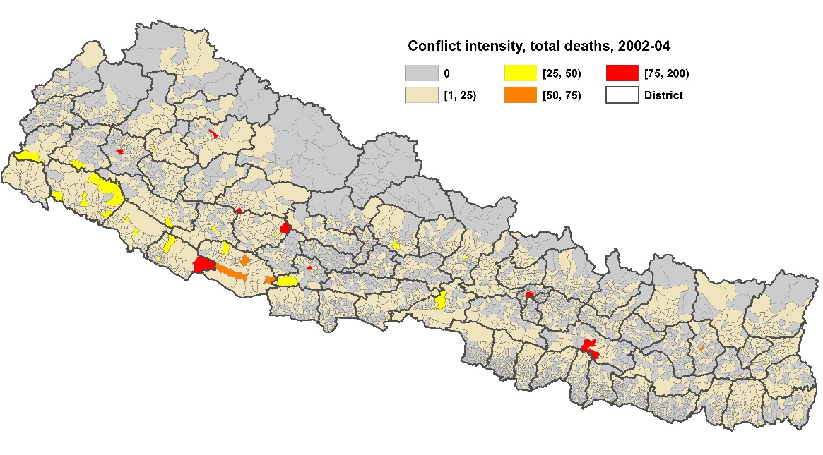
(a)
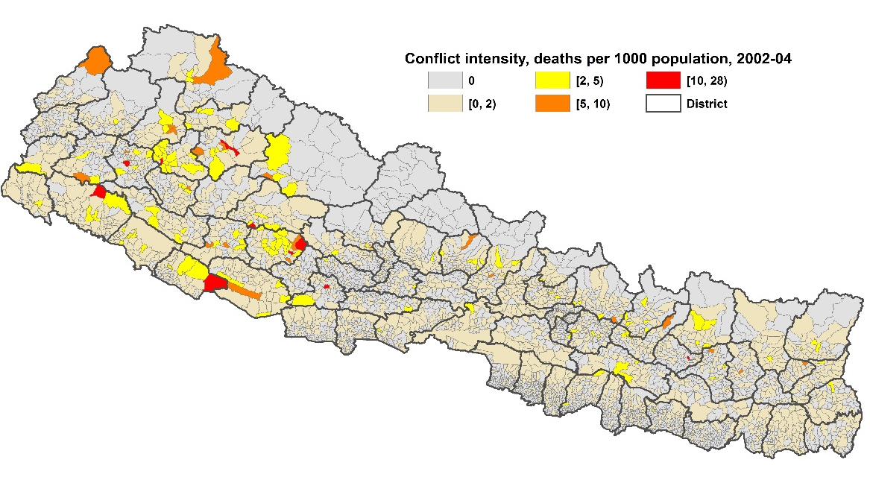
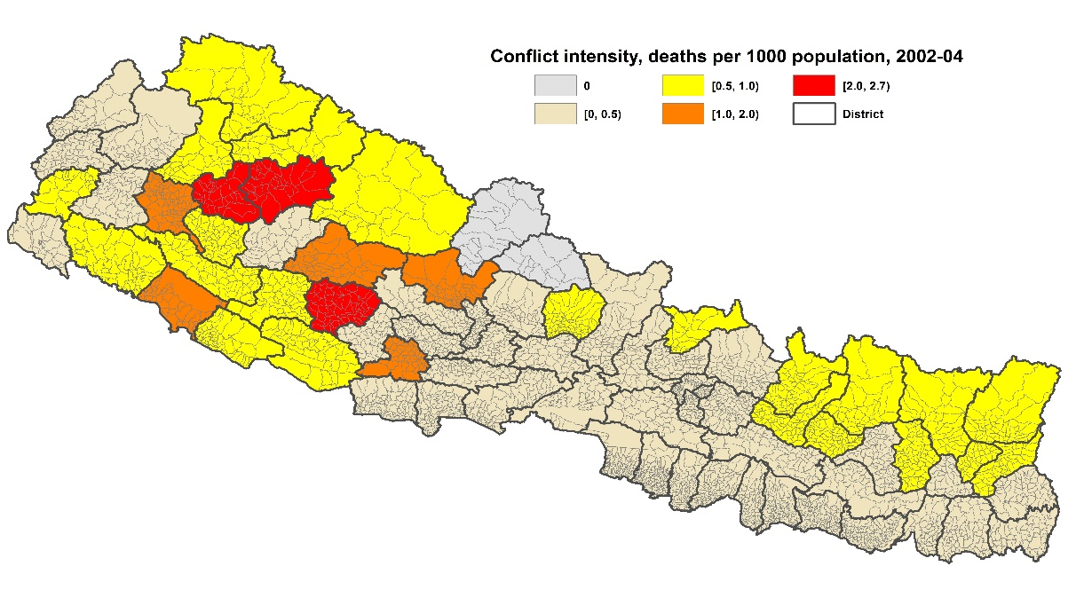
SD within Districts = 1.2
SD between Districts = 0.4
ρ _{intra-District} = 0.10
(c)
3. Data and Methods

In addition to conflict data from INSEC described above, our main data sources are the tenth and eleventh national population and housing censuses from 2001 and 2011. Nepal does not give microdata access to the full census but the Central Bureau of Statistics (CBS) provided extracts with complete records for over one-tenth of households, covering all VDCs. Census questions on household members working abroad provide our measures of emigration, and we express these as rates using the extract-level population for each VDC in each census. We also use census data on literacy rates and educational attainment, and on age structure.

The census does not provide a measure of local urban growth, the lack of which may be a push factor for emigration. We therefore measured disaggregated urban growth using night time lights as detected by satellite, taking a three year average for 1999-2001 and for 2009-11 to smooth over short-term fluctuations. These night lights data are best thought of as measuring urban growth because it takes 800-times more light than a typical incandescent bulb in order to be detected from space with the sensors on the Defence Meteorological Satellite Program (DMSP) satellites. We further rule out the measurement of rural economic activity by setting luminosity thresholds to distinguish urban and rural areas, where these thresholds match those recently used for a study of how urban development in India affects rural areas (Gibson, et al, 2017). Thus, changes in night time lights between 2001 and 2011 are more likely to be a proxy cause of emigration, rather than a result (e.g. as might occur if subsequent remittances enabled rural dwellers to electrify their dwelling).

Table 1 has complete definitions and descriptive statistics for all of the variables that we use. The analysis is mostly cast in terms of long differences between 2001 and 2011 and so some of the environmental and infrastructural factors that may affect emigration rates can be ignored if they are fixed in the medium term. However, we do include a dummy variable for whether a VDC borders India (which is true for 7.6% of them) based on a GIS analysis. We also use the baseline emigration rates from the 2001 census which should capture other (relatively time-invariant) factors that make particular localities more or less prone to having high emigration. Our objective in using these various control variables is so that the intensity of the conflict (which, recall, took an unexpected turn after the death of the King in 2001) is not acting as a proxy for some omitted local factors.

Table 1: Variable Definition and Descriptive Statistics (N=3982)

 |  | Mean |  | Std Dev |  | Minimum | Maximum
Δ VDC level emigration rate to all countries (emigrants per 1000 population) |  | 39.351 |  | 37.589 |  | -143.128 |  | 318.253
Δ VDC level emigration rate to India (emigrants per 1000 population) |  | 0.289 |  | 29.365 |  | -212.253 |  | 280.411
Δ VDC level emigration rate to other Asia and Middle East (per 1000 population) |  | 37.01 |  | 30.184 |  | -26.805 |  | 180.328
VDC conflict Intensity (Deaths per 1000 population at peak period (2002-2004) of conflict) |  | 0.446 |  | 1.267 |  | 0 |  | 27.746
District conflict Intensity (Deaths per 1000 population at peak period (2002-2004) of conflict) |  | 0.463 |  | 0.442 |  | 0 |  | 2.706
Δ share of working age (15-59) population to total population |  | 0.014 |  | 0.0475 |  | -0.304 |  | 0.215
Δ literacy rate (share of individuals in the VDC who are literate) |  | 0.173 |  | 0.086 |  | -0.37 |  | 0.551
Δ share of individuals aged 15-59 with schooling to grade ≥ 8 |  | 0.102 |  | 0.12 |  | -0.611 |  | 0.717
Δ local urban activity (proxied by night light digital number (DN) | luminosity ˃20%) |  | -0.001 |  | 1.648 |  | -17.913 |  | 19.25
VDC borders India (=1, otherwise zero) |  | 0.076 |  | 0.265 |  | 0 |  | 1
VDC level emigration rate to all countries, 2001 (emigrants per 1000 population) |  | 41.539 |  | 49.12 |  | 0 |  | 370.69
VDC level emigration rate to India, 2001 (emigrants per 1000 population) |  | 34.01 |  | 45.949 |  | 0 |  | 362.069
VDC level emigration rate to other Asia and Middle East, 2001 (per 1000 population) |  | 6.893 |  | 12.623 |  | 0 |  | 121.827
Source
Author calculations from census extracts, from INSEC data on the conflict, and from DMSP night lights.
Note
All variables that are measured as change (denoted by Δ) are for the change from 2001 to 2011.

The Econometric Model
The N-vector of long differences in VDC-level emigration rates is denoted ${∆M}_{i},$ the conflict intensity variables are denoted $C_{i},$ there are five control variables in the matrix $X_{i}$ (the change in the working age population share, the change in the literacy rate and in the share of working age individuals with grade 8 schooling or above, the change in local urban activity as proxied by night lights, and a dummy for whether the VDC borders India), and the lagged VDC-level emigration rate from 2001 is $M_{i}^{t=2001}$. Our spatial Durbin model (SDM) is:

$${∆M}_{i}=δ{W∆M}_{i}+{β_{1}C}_{i}+{β_{2}WC}_{i}+{β_{3}X}_{1i}+{β_{4}WX}_{1i}+⋯+{β_{11}X}_{5i}$$
$+{β_{12}WX}_{5i}+{β_{13}M}_{i}^{t=2001}+{β_{14}WM}_{i}^{t=2001}+v_{i}$ (1)

Here the spatial weighting matrix W describes the structure of spatial relationships between each VDC. The W matrix has zeros along the main diagonal, given that no VDC is its own neighbor, while the off diagonals are set to unity for immediate neighbors (using Queen contiguity weights) and zero otherwise. This model allows for changes in an explanatory variable in a particular VDC to not only affect the change in the emigration rate in that VDC, but also in the surrounding areas. The parameters to estimate are $δ$ and $β_{1},…,β_{14},$ while $v_{i}$ is a random error term which the generalized spatial two-stage least squares estimator (Kelejian and Prucha 1999, Drukker et al. 2013) that we use allows to be heteroscedastic.

The spatial Durbin model is a general model that nests several alternatives, such as the spatial autoregressive model, where only the dependent variable is spatially lagged, the spatial error model, where only the errors are spatially lagged, and aspatial models such as OLS, where there are no spatial lags for any variables. The SDM gives unbiased coefficient estimates even if the true data-generation process is a spatial autoregressive model or a spatial error model, but the reverse is not true given that it involves omitting relevant variables. Thus, the SDM provides a good general basis for testing the effects of conflict on emigration.

A feature of the SDM is that the total effect of changes in an independent variable—such as in conflict intensity—may be quite different to what is shown by ${\hat{β}}_{1}$ since a local change in the emigration rate may affect the emigration rates of neighbours, which, in turn, affects the emigration rate of their neighbours, including the original locality. In addition to these effects that operate through the spatial lag of the dependent variable, the lags on the independent variables also mean that local changes can affect outcomes elsewhere. These spillover and feedback effects let us decompose effects of conflict on emigration into direct and indirect components. To see how, note first that equation (1) can also be written in matrix notation (where the five control variables in the X matrix, and all of the subscripts, are suppressed for reasons of expositional simplicity, and I is the identity matrix) as:

$∆M={\left(I-δW\right)}^{-1}\left(β_{1}C+β_{2}WC\right)+{\left(I-δW\right)}^{-1}v$ (2)

Following Elhorst (2012), the partial derivatives can then be written as:

$\frac{∂∆M}{∂C}={\left(I-δW\right)}^{-1}\left(β_{1}I_{N}+β_{2}W\right)$ (3)

The total marginal effect of conflict intensity on the inter-censual change in the emigration rate, $∆M$ includes both direct and indirect effects, and these will vary across VDCs as a result of spatial feedbacks. The estimator that we use follows LeSage and Pace (2009) in reporting a single direct effect, that averages the diagonal elements of the matrix in (3), and a single indirect effect, that averages the row sums of the non-diagonal elements of that matrix. Note that indirect effects of conflict arise not only from the neighbours of a VDC, when $β_{2}0$ but also from (potentially) all VDCs through spatial autocorrelation when $δ≠0$.

The indirect effects are important for two reasons. First, while the conflict was highly localized, as the maps in panel A and B of Figure 5 show, the impact on emigration may be felt more widely, depending on the strength of the $δ$ and $β_{2}$ coefficients. Seen in this light, one problem with previous research using district-level conflict rates, effectively spreading the conflict over space (as seen in panel C of Figure 5), is that it lacks an explicit framework like equation (3) that lets the data dictate the degree of spreading. In our estimates, the marginal effects (direct, indirect, and total) are computed for each of the 3982 VDCs, allowing for the possibility that in some cases there will be a lot of spreading of the effects and in others there will be little. This variation will depend on the underlying geography, population density, transport infrastructure, and so forth.

The second reason that these indirect effects may matter is that the two different emigration channels available to Nepalese – informal to India and formal to elsewhere – have quite different spatial transactions costs. A person could go to India from the VDC where they live, and the free border lets them choose amongst a multitude of routes, so that their journey was not disrupted by conflict (or the risk, thereof). However, to emigrate elsewhere an aspiring migrant first had to go to Kathmandu to get a passport and to be recruited and undergo formal visa processing. This requirement to reach a particular place, rather than to simply cross anywhere along a border, limits the set of routes available. Moreover, there were often lengthy delays in this process, so repeated trips to Kathmandu may have been necessary, and this extra travel meant that there was more potential to be disrupted (or to be deterred) by outbreaks of localized conflict than was the case for emigration to India.

4. Results

The results of estimating equation (1) are reported in Table 2. There are six sets of results, with separate equations for the change in the emigration rate to all countries, to India, and to other Asian and Middle East destinations (corresponding to the maps of the dependent variables in panels (a), (b), and (c) of Figure 3). The last three columns of results in Table 2 show what happens when the VDC-level death rate variable is replaced with a district-level death rate (which is mapped in Figure 5c). The comparison between the results in the first three and last three columns in Table 2 may be informative about biases in the prior literature, which usually related spatially disaggregated data on outcomes to the (smoothed) data on conflict indicators by using district average death rates.

The results suggest an increase in conflict intensity, by one death per thousand, would directly reduce growth in the emigration rate for non-India destinations by -0.45 persons per thousand (statistically significant at p<0.06). The same effect, for the all-destinations emigration change, is almost the same but is imprecisely estimated, while conflict intensity appears to have no effect on the VDC-level change in the emigration rate to India. This differing effect of conflict supports the disaggregation of the emigration outflows into the low-cost, informal, channel to India, and the higher cost, more formal and more recent channel to other destinations.

The coefficients with respect to the spatially weighted average of the conflict intensity in neighbouring VDCs are larger, at between −0.6 and −3.6. For example, for a VDC where the weighted average death rate amongst its neighbours was one person per thousand higher, the 2001 to 2011 increase in the all-destination emigration rate from the surrounded VDC would be 3.6 persons per thousand lower, and this effect is statistically significant at the p<0.01 level. The spatial lag of the change in the emigration rate is always statistically significant at p<0.01 for all three outcomes. Given that the $δ$ and $β_{2}$ coefficients are statistically significant, local conflict will have spatial spillover effects on the change in emigration rates, and these are calculated using equation (3) and presented later.

Table 2: Spatial Durbin Models for Change in the VDC Emigration Rate Between 2001 and 2011, With Different Spatial Granularity of Conflict Data
 | Conflict Intensity Measured At VDC Level |  |  |  | Conflict Intensity Measured at District Level
Emigration to: | All Countries | India | Otherª |  |  | All Countries |  | India |  | Otherª
Conflict intensity (Death rate at peak (2002-04) | -0.483 | -0.011 | -0.445 |  |  | 8.643 |  | 11.510 |  | 4.877
 | (0.91) | (0.03) | (1.90)* |  |  | (2.58)*** |  | (4.67)*** |  | (2.48)**
Δ share of working age (15-59) | -31.834 | -38.119 | -13.709 |  |  | -33.117 |  | -36.533 |  | -13.771
 | (2.29)** | (3.91)*** | (1.47) |  |  | (2.39)** |  | (3.80)*** |  | (1.49)
Δ literacy rate | -9.488 | 3.453 | 7.929 |  |  | -11.315 |  | -0.054 |  | 7.414
 | (1.29) | (0.67) | (1.90)* |  |  | (1.54) |  | (0.01) |  | (1.78)*
Δ share of 15-59 schooled to grade ≥ 8 | -0.985 | 1.296 | 7.095 |  |  | -1.393 |  | -0.253 |  | 7.024
 | (0.20) | (0.36) | (2.21)** |  |  | (0.28) |  | (0.07) |  | (2.17)**
Δ local urban activity (night lights DN) | -0.584 | -0.266 | -0.142 |  |  | -0.610 |  | -0.287 |  | -0.160
 | (1.73)* | (1.48) | (0.66) |  |  | (1.84)* |  | (1.61) |  | (0.74)
VDC borders India | -3.029 | 3.558 | -2.012 |  |  | -2.974 |  | 3.418 |  | -2.011
 | (1.20) | (2.17)** | (1.32) |  |  | (1.19) |  | (2.10)** |  | (1.33)
VDC level emigration rate, 2001 | -0.370 | -0.499 | -0.086 |  |  | -0.374 |  | -0.505 |  | -0.090
 | (12.41)*** | (16.09)*** | (1.51) |  |  | (12.48)*** |  | (16.49)*** |  | (1.60)*
W × Conflict intensity | -3.563 | -1.259 | -0.637 |  |  | -18.419 |  | -15.400 |  | -11.237
 | (3.14)*** | (1.39) | (1.01) |  |  | (4.48)*** |  | (4.70)*** |  | (4.42)***
W × Δ share of working age (15-59) | 190.341 | -14.093 | 129.084 |  |  | 170.322 |  | -12.648 |  | 113.444
 | (7.08)*** | (0.58) | (6.72)*** |  |  | (6.17)*** |  | (0.51) |  | (5.94)***
W × Δ literacy rate | -114.502 | -60.024 | -87.956 |  |  | -95.099 |  | -42.828 |  | -71.005
 | (8.96)*** | (6.71)*** | (11.26)*** |  |  | (7.09)*** |  | (4.58)*** |  | (8.19)***
W × Δ share of 15-59 schooled to grade ≥ 8 | -58.544 | -19.489 | -36.554 |  |  | -47.084 |  | -12.842 |  | -27.397
 | (4.81)*** | (2.19)** | (5.09)*** |  |  | (3.73)*** |  | (1.35) |  | (3.70)***
W × Δ local urban activity (night lights DN) | -0.088 | 0.497 | -0.681 |  |  | 0.300 |  | 0.519 |  | -0.544
 | (0.12) | (1.35) | (1.33) |  |  | (0.41) |  | (1.39) |  | (1.05)
W × VDC borders India | -17.668 | -3.760 | -13.639 |  |  | -18.341 |  | -3.263 |  | -14.644
 | (3.10)*** | (1.04) | (3.58)*** |  |  | (3.24)*** |  | (0.90) |  | (3.85)***
W × VDC level emigration rate, 2001 | 0.558 | 0.600 | 0.801 |  |  | 0.570 |  | 0.611 |  | 0.851
 | (13.75)*** | (14.72)*** | (7.70)*** |  |  | (13.96)*** |  | (15.11)*** |  | (8.07)***
Spatial lag of change in emigration rate (δ) | 0.183 | 0.911 | 0.588 |  |  | 0.195 |  | 0.932 |  | 0.581
 | (2.84)*** | (9.76)*** | (11.54)*** |  |  | (2.84)*** |  | (10.08)*** |  | (10.80)***
Pseudo-R² | 0.1513 | 0.1211 | 0.2935 |  |  | 0.1542 |  | 0.1247 |  | 0.303
Wald test for model (Chi-squared, 13 df) | 422.79 | 487.63 | 2065.32 |  |  | 452.00 |  | 516.13 |  | 2147.66
Notes: Estimates are from generalized spatial two-stage least squares with heteroscedastic errors. N=3982 VDCs. Variables measured in changes (shown by Δ) are for the change from 2001 to 2011. ªOther is other Asia and Middle East.

Before turning to the estimates of direct, indirect, and total effects, we comment on two other aspects of the results in Table 2. First, several control variables show significant effects, particularly the change in the working age share of the total population (which rose on average by 1.4 percentage points but with a wide range across VDCs). Improvements in the level of human capital, in terms of the change in the literacy rate (which rose 17 points over the decade) and in the share of working age individuals with at least eight years of schooling (a share which rose by one-tenth over the decade) generally depress the rate of increase in the emigration rate, especially with the spatially lagged terms. This suggests that emigration is especially a vent for surplus unskilled labour from Nepal. There is less rise in the emigration rate in VDCs that had faster urban economic growth (as proxied by night lights) but with imprecisely estimated coefficients. For a VDC on the border with India there was a bigger rise in the emigration rate to India, by almost four persons per thousand, but the spatial lag of the same effect is negative and so it is only after the equation (3) estimates are computed that a clear picture of the total effect will be available.

The temporal lag of the emigration rate for a VDC has significant negative effects on the growth in emigration from that VDC, for emigration to India and to all destinations, but this effect is not apparent for the more formal emigration to other Asian and Middle East destinations. The negative coefficients could suggest a convergence process, with VDCs that had historically low emigration rates having a faster rate of change, to catch up to the leaders. However, this effect is complicated because there are positive and precisely estimated coefficients on all of the spatial lags of the 2001 emigration rates. So the total average effect will depend on the VDC-by-VDC calculations of equation (3).

It is also the case that regressions without the temporal lag of the emigration rate, which are reported in Appendix Tables A1, A2, and A3, show generally similar patterns for coefficients to what is seen in Table 2. These appendix tables also show what the results are like if the total conflict rate, based on deaths per thousand from 1996 to 2006, is used instead of the death rate at the peak of the conflict, and these sensitivity analysis results also are similar to the main results. The appendix tables also report a parallel set of aspatial OLS results that omit the spatial lags, although the data are not consistent with the parametric restrictions that OLS models need.

The last thing to note in the Table 2 results is what the last three columns show, using the district-level conflict data. By comparing with results in the first three columns, it is clear that using conflict data at a more spatially aggregated level makes a big difference, most likely because this entails a mean-reverting measurement error in the key right-hand side variable. An increase by one death per thousand in a district would seem to directly increase the emigration rate from that district by between five and 12 persons per thousand, being larger for emigration to India than to elsewhere and all of these effects are statistically significant at the p<0.01 level. The direction of the effect is the opposite of what the VDC-level conflict data show, although the interpretation is complicated because the spatial lags of the district-level conflict rates are all significantly negative and so the total effects will reflect this offsetting influence. It is apparent, however, that smoothing the conflict data (as seen in comparing Figures 5b and 5c) and carrying out the analysis at a more spatially aggregated level has a potentially large effect on econometric estimates. This effect of aggregation could skew the interpretations of how Nepal’s civil conflict affected the change in emigration (and perhaps skew the interpretation for impacts on other microeconomic outcomes).

The direct, indirect and total impacts of changes in the independent variables on the outcomes are reported in Table 3. As noted above, we report the average impacts; the extent to which conflict intensity in a particular VDC impacts on the change in the emigration rate in another VDC depends partly on how many degrees of separation there are, in terms of the number of neighbours of neighbours needed to transmit the spillover effects over space and so the averages are a convenient way to deal with the multitude of marginal effects that could be presented. When we use the VDC-level conflict rate, we find that an increase in conflict intensity, by one death per thousand population at the peak of the conflict (2002-04), is associated with slower growth in the emigration rate between 2001 and 2011. The impacts for direct, indirect, and total effects are always negatively signed, for all three outcome variables, although they are never statistically significant for the change in emigration to India. Once again, it appears that the constraints on growth of the informal and low-cost emigration to India differ from the constraints (such as deterrence effects of conflict) on growth of emigration to other destinations. These effects in Table 3 are statistically significant for two out of three of the direct, indirect, and total impacts for both all-destinations emigration and for the other Asia and Middle East emigration.

In terms of the magnitudes of these impacts, for all-destination emigration a death rate of one per thousand at the peak of the conflict (2002-04) suppresses the rise in the emigration rate between 2001 and 2011 (which rose 40 per thousand on average) by 3.9 persons per thousand. In percentage terms, this is a ten percent smaller rise than would be predicted in the absence of the conflict-related deaths. This effect operates predominantly though the indirect channels, where the impacts are up to six times larger than the direct impacts. When we disaggregate the change in emigration rates into emigration to India and emigration to other Asia and the Middle East, it is only for the non-India destinations that the conflict intensity has a statistically significant effect in depressing the rate of increase in emigration.

Table 3: Estimated Direct, Indirect and Total Impacts, Averaging Over All 3982 VDCs
 | Change in Emigration Rate to All Countries |  |  |  |  |  | Change in Emigration rate to India |  |  |  |  |  | Change in Emigration rate to otherª
 | VDC Conflict |  |  | District Conflict |  |  | VDC Conflict |  |  | District Conflict |  |  | VDC Conflict |  |  | District Conflict
Direct Effect | dy/dx | t-stat |  | dy/dx | t-stat |  | dy/dx | t-stat |  | dy/dx | t-stat |  | dy/dx | t-stat |  | dy/dx | t-stat
Conflict Intensity | -0.557 | 1.07 |  | 8.282 | 2.55** |  | -0.221 | 0.48 |  | 10.581 | 4.51*** |  | -0.519 | 2.23** |  | 4.199 | 2.25**
Δ Share of Working age (15-59) | -28.055 | 2.06** |  | -29.508 | 2.17** |  | -47.193 | 4.64*** |  | -45.818 | 4.43*** |  | -3.746 | 0.42 |  | -5.258 | 0.58
Δ literacy rate | -11.868 | 1..66* |  | -13.458 | 1.88* |  | -7.119 | 0.96 |  | -8.451 | 1.17 |  | 1.072 | 0.25 |  | 2.030 | 0.47
Δ Share of 15-59 schooled to grade ≥8 | -2.187 | 0.44 |  | -2.436 | 0.49 |  | -2.107 | 0.47 |  | -2.853 | 0.62 |  | 4.429 | 1.33 |  | 5.142 | 1.54
Δ local urban activity (night lights DN) | -0.584 | 1.79* |  | -0.606 | 1.89* |  | -0.219 | 1.38 |  | -0.237 | 1.50 |  | -0.205 | 1.03 |  | -0.211 | 1.06
VDC borders India | -3.402 | 1.38 |  | -3.391 | 1.39 |  | 3.462 | 2.02** |  | 3.403 | 1.99** |  | -3.232 | 2.26** |  | -3.287 | 2.31**
VDC level emigration rate, 2001 | -0.360 | 12.33*** |  | -0.363 | 12.46*** |  | -0.472 | 15.65*** |  | -0.477 | 16.03*** |  | -0.024 | 0.44 |  | -0.026 | 0.48
Indirect Effect
Conflict Intensity | -3.348 | 3.33*** |  | -15.879 | 4.61*** |  | -4.483 | 1.29 |  | -18.765 | 2.22** |  | -1.350 | 1.53 |  | -12.538 | 5.18***
Δ Share of Working age (15-59) | 169.234 | 7.79*** |  | 152.036 | 6.69*** |  | -175.254 | 1.84* |  | -187.620 | 1.58 |  | 182.940 | 9.00*** |  | 157.302 | 7.55***
Δ literacy rate | -106.600 | 6.84*** |  | -90.294 | 5.74*** |  | -204.200 | 1.87* |  | -171.850 | 1.51 |  | -125.910 | 6.80*** |  | -99.500 | 5.56***
Δ Share of 15-59 schooled to grade ≥8 | -53.857 | 4.80*** |  | -43.942 | 3.75*** |  | -65.733 | 1.58 |  | -52.536 | 1.15 |  | -48.947 | 4.57*** |  | -34.784 | 3.18***
Δ local urban activity (night lights DN) | -0.017 | 0.03 |  | 0.167 | 0.26 |  | 0.914 | 0.99 |  | 1.012 | 0.94 |  | -1.156 | 1.77* |  | -0.951 | 1.45
VDC borders India | -16.711 | 3.30*** |  | -17.558 | 3.46*** |  | -1.862 | 0.16 |  | 0.311 | 0.03 |  | -22.408 | 4.37*** |  | -23.587 | 4.71***
VDC level emigration rate, 2001 | 0.449 | 13.86*** |  | 0.461 | 14.05*** |  | 0.521 | 4.59*** |  | 0.564 | 3.57*** |  | 1.135 | 11.02*** |  | 1.191 | 11.73***
Total Effect
Conflict Intensity | -3.906 | 3.93*** |  | -7.600 | 4.55*** |  | -4.704 | 1.28 |  | -8.185 | 0.99 |  | -1.877 | 2.02** |  | -8.339 | 4.87***
Δ Share of Working age (15-59) | 141.179 | 6.55*** |  | 122.528 | 5.37*** |  | -222.454 | 2.26** |  | -233.440 | 1.90* |  | 179.193 | 8.51*** |  | 152.044 | 6.99***
Δ literacy rate | -118.470 | 7.19*** |  | -103.752 | 6.24*** |  | -211.329 | 1.84* |  | -180.299 | 1.52 |  | -124.837 | 6.22*** |  | -97.470 | 5.03***
Δ Share of 15-59 schooled to grade ≥8 | -56.044 | 4.54*** |  | -46.378 | 3.58*** |  | -67.841 | 1.53 |  | -55.389 | 1.13 |  | -44.518 | 3.69*** |  | -29.643 | 2.41**
Δ local urban activity (night lights DN) | -0.601 | 1.26 |  | -0.440 | 0.91 |  | 0.695 | 0.78 |  | 0.775 | 0.74 |  | -1.361 | 2.22** |  | -1.162 | 1.90*
VDC borders India | -20.113 | 4.63*** |  | -20.949 | 4.79*** |  | 1.600 | 0.13 |  | 3.091 | 0.24 |  | -25.641 | 5.15*** |  | -26.874 | 5.53***
VDC level emigration rate, 2001 | 0.089 | 4.89*** |  | 0.099 | 5.26*** |  | 0.049 | 0.46 |  | 0.086 | 0.58 |  | 1.111 | 11.38*** |  | 1.165 | 12.23***
Notes: dy/dx denotes marginal effect, which is derived from SDM. t-statistics with heteroscedastic errors, ***, **, * denote statistical significance at 1%, 5%, or 10%. N=3982 VDCs. ª Other is other Asia and Middle East

In contrast, if the district-level conflict rates are used, a direct effect of conflict is seeming to increase emigration appears. Specifically, higher conflict intensity (of one death per thousand) would seem to directly increase the emigration rate by eight persons per thousand for all-destinations emigration, and by eleven persons per thousand to India. However, these direct effects are offset by even larger negative indirect effects, so that the total effect of one more death per thousand appears as a suppression of the 2001 to 2011 increase in the emigration rate of between 4.6 persons per thousand for emigration to India and 8.2 persons per thousand for emigration to other Asia and the Middle East. These total effects are up to four times larger than those that are estimated when the conflict intensity is measured at the VDC level. This overstatement is most likely due to the mean-reverting measurement error that results from using conflict data that are too spatially aggregated, compared to using the VDC-level conflict data.

5. Conclusions

In this paper, we show that research into the microeconomic effects of civil conflict may be distorted if conflict data are overly aggregated. A common research design in this literature is to match census or survey data on microeconomic outcomes (especially for human capital indicators) to data on conflict intensity that is reported at a more spatially aggregated level. Typically the conflict data is reported for the first or second sub-national level even though there may be more finely-grained locations listed in the original field reports on instances of conflict-related deaths.

We show in this paper that using much more finely-grained location data on conflict intensity can matter a lot to the results found from microeconomic studies of conflict. In the civil war in Nepal, the conflict was mostly very localized, with almost half of localities suffering no conflict-related deaths and with much greater variation in death rates within districts than between districts. Yet if district-level conflict data are used, as in prior studies, the conflict appears much more generalized, with only three percent of districts not affected. The spatially aggregated death rates have a mean-reverting measurement error, to the extent that the behaviour of individuals living in conflict is most affected by nearby conflict.

When we use the finely grained data, a greater intensity of conflict during Nepal’s civil war is associated with a slight depressing effect on the growth in emigration, equivalent to about ten percent of the growth that occurred from 2001 to 2011. However, if we use more aggregated conflict data, as in the previous studies, the conflict appears to have far larger effects – both indirectly and directly. We can only speculate if this bias would occur in studies of other microeconomic outcomes in Nepal. However, the general problem of using conflict data that are reported at an overly-aggregated spatial level, which makes the conflict appear much more widespread than it truly is and creates a mean-reverting error, may undermine the contribution that empirical studies of conflict can make.

In the specific context of Nepal, the importance of distinguishing between low-cost, informal, and higher cost, formal, emigration is also highlighted. The growth in informal emigration to India does not appear to have been deterred by spatial variation in conflict intensity. Given the free mobility across the India-Nepal border, an emigrant could leave their home area and travel to an employment destination in India via multiple routes in order to avoid conflict hotspots. The same flexibility was not available for accessing emigration to the Middle East and other destinations that required an expensive (and sometimes lengthy) process of obtaining a passport, a visa, and being recruited. This process may have entailed repeated trips to Kathmandu and conflict either in the home locality or in localities on the way to Kathmandu could deter some potential emigrants. The different costs and location of these two emigration channels induce spatial differences in patterns of supply and according to the results of the spatial Durbin model there appears to be more conflict-related disruption of the higher-cost (and higher-return) emigration channel.

References

Adhikari, P. (2012). The plight of the forgotten ones: Civil war and forced migration. International Studies Quarterly, 56(3), 590-606.
Central Bureau of Statistics [CBS] (2001). National Population Census 2001, Report on Nepal’s Tenth Census. Government of Nepal. Kathmandu.
Central Bureau of Statistics [CBS] (2011). National Population and Housing Census 2011, National Report. Government of Nepal. Kathmandu.
Chamarbagwala, R., & Morán, H. E. (2011). The human capital consequences of civil war: Evidence from Guatemala. Journal of Development Economics, 94(1), 41-61.
Do, Q. T., & Iyer, L. (2010). Geography, poverty and conflict in Nepal. Journal of Peace Research, 47(6), 735-748.
Drukker, D. M., Prucha, I. R., & Raciborski, R. (2013). Maximum likelihood and generalized spatial two-stage least-squares estimators for a spatial-autoregressive model with spatial-autoregressive disturbances. Stata Journal, 13(2), 221-241.
Elhorst, J. Paul (2012) Dynamic spatial panels: models, methods, and inferences. Journal of Geographic Systems 14: 5–28.
Gibson, J., Beegle, K., De Weerdt, J., & Friedman, J. (2015). What does variation in survey design reveal about the nature of measurement errors in household consumption? Oxford Bulletin of Economics and Statistics, 77(3), 466-474.
Gibson, J., Datt, G., Murgai, R., & Ravallion, M. (2017). For India’s rural poor, growing towns matter more than growing cities. World Development, 98(1), 413-429.
Joshi, M., & Pyakurel, S. R. (2015). Individual-Level Data on the Victims of Nepal’s Civil War, 1996‒2006: A New Dataset. International Interactions, 41(3), 601-619.
Kelejian, H. H., & Prucha, I. R. (1999). A generalized moments estimator for the autoregressive parameter in a spatial model. International Economic Review, 40(2), 509-533.
Kountchou, A., Sonne, S., & Gadom, G. (2019). The Local Impact of Armed Conflict on Children’s Nutrition and Health Outcomes: Evidence from Chad. Paper presented at the CSAE Conference, University of Oxford.
LeSage, J., & Pace, R.K. (2009). Introduction to Spatial Econometrics Chapman and Hall and CRC Press, Boca Raton.
Libois, F. (2016). Households in Times of War: Adaptation Strategies during the Nepal Civil War. Working Paper No. 1603. University of Namur, Department of Economics.
Menon, N., & Van der Meulen Rodgers, Y. (2015). War and women’s work: Evidence from the conflict in Nepal. Journal of Conflict Resolution, 59(1), 51-73.
Naudé, W. (2008). Conflict, disasters, and no jobs: Reasons for international migration from Sub-Saharan Africa. UNU-WIDER, Research Paper No. 2008/85.
Pivovarova, M., & Swee, E. L. (2015). Quantifying the microeconomic effects of war using panel data: Evidence from Nepal. World Development, 66(1), 308-321.
Sapkota, C. (2013). Remittances in Nepal: boon or bane? The Journal of Development Studies, 49(10), 1316-1331.
Shrestha, M. (2017). Push and pull: A study of international migration from Nepal. Policy Research Working Paper No. 7965, The World Bank, Washington DC.
Valente, C. (2013). Education and civil conflict in Nepal. The World Bank Economic Review, 28(2), 354-383.
Verwimp, P., Justino, P., & Brück, T. (2019). The microeconomics of violent conflict. Journal of Development Economics (forthcoming).

.
Appendix Table 1a: Regression Models for the Change in the Emigration Rate (to All Countries) Between 2001 and 2011, at VDC Level, Nepal
 | Spatial Durbin Models |  |  |  |  | Ordinary Least Squares Models
 | During Peak (2002-04) |  | Entire War (1996-08) |  |  | During Peak (2002-04) |  | Entire War (1996-08)
Conflict intensity | -0.483 | 0.369 | -0.194 | 0.295 |  | -0.796 | -0.754 | -0.757 | -0.728
 | (0.91) | (0.80) | (0.52) | (0.91) |  | (1.70)* | (1.61)* | (2.34)** | (2.24)**
Δ share of working age (15-59) | -31.834 | -47.665 | -32.689 | -49.074 |  | 34.678 | 33.372 | 33.561 | 32.264
 | (2.29)** | (3.25)*** | (2.35)** | (3.35)*** |  | (2.74)*** | (2.64)*** | (2.65)*** | (2.55)**
Δ literacy rate | -9.488 | -9.687 | -9.447 | -9.524 |  | -37.527 | -37.034 | -37.132 | -36.643
 | (1.29) | (1.27) | (1.29) | (1.25) |  | (5.40)*** | (5.33)*** | (5.34)*** | (5.27)***
Δ share of 15-59 schooled to grade ≥ 8 | -0.985 | -6.163 | -0.979 | -6.100 |  | -15.376 | -16.601 | -15.067 | -16.31
 | (0.20) | (1.21) | (0.20) | (1.19) |  | (3.03)*** | (3.29)*** | (2.97)*** | (3.23)***
Δ local urban activity (night lights DN) | -0.584 | -0.609 | -0.58 | -0.606 |  | -0.803 | -0.786 | -0.803 | -0.786
 | (1.73)* | (1.82)* | (1.73)* | (1.82)* |  | (2.24)** | (2.19)** | (2.24)** | (2.19)**
VDC borders India | -3.029 | -2.208 | -3.002 | -2.159 |  | -9.74 | -9.094 | -9.84 | -9.186
 | (1.20) | (0.89) | (1.19) | (0.87) |  | (4.43)*** | (4.07)*** | (4.37)*** | (4.11)***
Emigration rate to all countries, 2001 | -0.370 |  | -0.370 |  |  | -0.031 |  | -0.031
 | (12.41)*** |  | (12.42)*** |  |  | (2.56)** |  | (2.59)***
W × Conflict intensity | -3.563 | -3.749 | -2.020 | -2.205
 | (3.14)*** | (3.32)*** | (2.64)*** | (2.93)***
W × Δ share of working age (15-59) | 190.341 | 171.657 | 188.364 | 170.182
 | (7.08)*** | (6.58)*** | (6.99)*** | (6.53)***
W × Δ literacy rate | -114.502 | -80.003 | -115.147 | -80.723
 | (8.96)*** | (6.30)*** | (8.98)*** | (6.32)***
W × Δ share of 15-59 schooled to grade ≥ 8 | -58.544 | -23.829 | -58.57 | -23.964
 | (4.81)*** | (2.03)** | (4.78)*** | (2.03)**
W × Δ local urban activity (night lights DN) | -0.088 | 0.010 | -0.059 | 0.080
 | (0.12) | (0.13) | (0.08) | (0.11)
W × VDC borders India | -17.668 | -17.653 | -17.935 | -17.905
 | (3.10)*** | (3.25)*** | (3.16)*** | (3.29)***
W × Emigration rate to all countries, 2001 | 0.558 |  | 0.556
 | (13.75)*** |  | (13.69)***
Spatial lag of change in emigration rate (δ) | 0.183 | 0.433 | 0.183 | 0.434
 | (2.84)*** | (6.87)*** | (2.82)*** | (6.85)***
(Pseudo-)R2 | 0.1513 | 0.053 | 0.150 | 0.052 |  | 0.017 | 0.016 | 0.018 | 0.016
Wald test for model (Chi-squared) | 422.79 | 299.80 | 418.46 | 299.46 |  | 69.90 | 63.18 | 72.45 | 65.70
Notes: t-statistics from heteroscedasticity-robust standard errors in ( ), ***, **, * denote statistical significance at 1%, 5%, or 10%. N=3982. Wald-tests have 13[12] degrees of freedom for SDM and 7[6] for OLS, with smaller value in [ ] for models without the temporal lag of the emigration rate. The spatial weights matrix, W uses first-order Queen contiguity.
Appendix Table 1b: Regression Models for the Change in the Emigration Rate to India Between 2001 and 2011, at VDC Level, Nepal
 | Spatial Durbin Models |  |  |  |  | Ordinary Least Squares Models
 | During Peak (2002-04) |  | Entire War (1996-08) |  |  | During Peak (2002-04) |  | Entire War (1996-08)
Conflict intensity | -0.011 | 1.022 | 0.062 | 0.662 |  | 0.173 | 0.387 | 0.075 | 0.058
 | (0.03) | (2.84)*** | (0.23) | (2.73)*** |  | (0.49) | (1.06) | (0.31) | (0.23)
Δ share of working age (15-59) | -38.119 | -41.341 | -38.323 | -42.524 |  | -80.257 | -81.97 | -80.916 | -82.191
 | (3.91)*** | (3.68)*** | (3.95)*** | (3.80)*** |  | (8.42)*** | (8.30)*** | (8.47)*** | (8.35)***
Δ literacy rate | 3.453 | -3.832 | 3.414 | -3.76 |  | 9.885 | 8.932 | 10.068 | 9.084
 | (0.67) | (0.64) | (0.66) | (0.63) |  | (1.89)* | (1.65)* | (1.92)* | (1.68)
Δ share of 15-59 schooled to grade ≥ 8 | 1.296 | -8.876 | 1.310 | -8.852 |  | -1.970 | -7.987 | -1.793 | -7.834
 | (0.36) | (2.21)** | (0.36) | (2.20)** |  | (0.51) | (2.03)** | (0.47) | (1.99)**
Δ local urban activity (night lights DN) | -0.266 | -0.315 | -0.264 | -0.314 |  | -0.138 | -0.069 | -0.137 | -0.068
 | (1.48) | (1.41) | (1.47) | (1.41) |  | (0.51) | (0.25) | (0.51) | (0.24)
VDC borders India | 3.558 | 2.25 | 3.572 | 2.28 |  | 3.906 | 6.285 | 3.856 | 6.246
 | (2.17)** | (1.23) | (2.18)** | (1.24) |  | (2.31)** | (3.61)*** | (2.28)** | (3.59)***
Emigration rate to India, 2001 | -0.499 |  | 0.500 |  |  | -0.156 |  | -0.157
 | (16.09)*** |  | (16.19)*** |  |  | (15.96)*** |  | (15.99)***
W × Conflict intensity | -1.259 | -2.287 | -0.777 | -1.317
 | (1.39) | (2.28)** | (1.36) | (2.02)**
W × Δ share of working age (15-59) | -14.093 | 32.075 | -12.646 | 33.262
 | (0.58) | (1.34) | (0.52) | (1.39)
W × Δ literacy rate | -60.024 | -9.455 | -60.861 | -10.065
 | (6.71)*** | (0.95) | (6.74)*** | (1.00)
W × Δ share of 15-59 schooled to grade ≥ 8 | -19.489 | 7.268 | -19.309 | 6.977
 | (2.19)** | (0.72) | (2.14)** | (0.68)
W × Δ local urban activity (night lights DN) | 0.497 | 0.376 | 0.482 | 0.369
 | (1.35) | (0.75) | (1.30) | (0.73)
W × VDC borders India | -3.76 | -2.021 | -4.087 | -2.081
 | (1.04) | (0.47) | (1.14) | (0.49)
W × Emigration rate to India, 2001 | 0.600 |  | 0.601
 | (14.72)*** |  | (14.72)***
Spatial lag of change in emigration rate (δ) | 0.911 | 1.131 | 0.927 | 1.130
 | (9.76)*** | (10.06)*** | (10.10)*** | (10.14)***
(Pseudo-)R2 | 0.1211 | 0.0047 | 0.1163 | 0.0017 |  | 0.084 | 0.025 | 0.084 | 0.025
Wald test for model (Chi-squared) | 487.63 | 253.16 | 494.55 | 255.94 |  | 363.23 | 101.88 | 363.02 | 100.80
Notes: t-statistics from heteroscedasticity-robust standard errors in ( ), ***, **, * denote statistical significance at 1%, 5%, or 10%. N=3982. Wald-tests have 13[12] degrees of freedom for SDM and 7[6] for OLS, with smaller value in [ ] for models without the temporal lag of the emigration rate. The spatial weights matrix, W uses first-order Queen contiguity.

Appendix Table 1c: Regression Models for Change in the Emigration Rate to Other Asia and the Middle East Between 2001 and 2011, at VDC Level, Nepal
 | Spatial Durbin Models |  |  |  |  | Ordinary Least Squares Models
 | During Peak (2002-04) |  | Entire War (1996-08) |  |  | During Peak (2002-04) |  | Entire War (1996-08)
Conflict intensity | -0.445 | -0.443 | -0.227 | -0.248 |  | -1.189 | -1.212 | -0.731 | -0.82
 | (1.90)* | (1.96)* | (1.33) | (1.50) |  | (3.40)*** | (3.28)*** | (3.02)*** | (3.21)***
Δ share of working age (15-59) | -13.709 | -17.930 | -13.461 | -17.799 |  | 76.269 | 97.844 | 76.136 | 97.385
 | (1.47) | (1.90)* | (1.45) | (1.89)* |  | (8.04)*** | (9.82)*** | (8.02)*** | (9.76)***
Δ literacy rate | 7.929 | 4.155 | 7.584 | 4.033 |  | -19.85 | -34.386 | -19.728 | -34.15
 | (1.90)* | (0.98) | (1.81)* | (0.96) |  | (3.80)*** | (6.28)*** | (3.77)*** | (6.63)***
Δ share of 15-59 schooled to grade ≥ 8 | 7.095 | 7.020 | 6.929 | 6.952 |  | -6.978 | -5.923 | -6.917 | -5.791
 | (2.21)** | (2.23)** | (2.15)** | (2.21)** |  | (1.85)* | (1.49) | (1.83)* | (1.45)
Δ local urban activity (night lights DN) | -0.142 | -0.166 | -0.139 | -0.165 |  | -0.732 | -0.785 | -0.734 | -0.786
 | (0.66) | (0.79) | (0.65) | (0.79) |  | (2.74)*** | (2.78)*** | (2.74)*** | (2.78)***
VDC borders India | -2.012 | -2.164 | -2.032 | -2.154 |  | -9.890 | -13.675 | -9.927 | -13.709
 | (1.32) | (1.43) | (1.33) | (1.42) |  | (5.90)*** | (7.76)*** | (5.91)*** | (7.78)***
Emigration rate to India, 2001 | -0.086 |  | -0.086 |  |  | 0.768 |  | 0.767
 | (1.51) |  | (1.53) |  |  | (21.55)*** |  | (21.50)***
W × Conflict intensity | -0.637 | -0.206 | 0.176 | 0.264
 | (1.01) | (0.34) | (0.44) | (0.68)
W × Δ share of working age (15-59) | 129.084 | 125.221 | 130.965 | 125.076
 | (6.72)*** | (7.05)*** | (6.76)*** | (7.02)***
W × Δ literacy rate | -87.956 | -103.633 | -90.166 | -105.305
 | (11.26)*** | (14.60)*** | (11.60)*** | (14.86)***
W × Δ share of 15-59 schooled to grade ≥ 8 | -36.554 | -26.346 | -37.751 | -27.236
 | (5.09)*** | (3.78)*** | (5.24)*** | (3.91)***
W × Δ local urban activity (night lights DN) | -0.681 | -0.509 | -0.698 | -0.513
 | (1.33) | (1.01) | (1.37) | (1.03)
W × VDC borders India | -13.639 | -16.297 | -13.286 | -15.962
 | (3.58)*** | (4.25)*** | (3.47)*** | (4.15)***
W × Emigration rate to India, 2001 | (0.801) |  | 0.799
 | (7.70)*** |  | (7.67)***
Spatial lag of change in emigration rate (δ) | 0.588 | 0.738 | 0.590 | 0.743
 | (11.54)*** | (22.77)*** | (11.50)*** | (22.98)***
(Pseudo-)R2 | 0.2935 | 0.1476 | 0.2922 | 0.1465 |  | 0.1515 | 0.0524 | 0.1510 | 0.0522
Wald test for model (Chi-squared) | 2065.32 | 2084.4 | 2044.17 | 2084.52 |  | 709.80 | 219.60 | 706.93 | 219.12
Notes: t-statistics from heteroscedasticity-robust standard errors in ( ), ***, **, * denote statistical significance at 1%, 5%, or 10%. N=3982. Wald-tests have 13[12] degrees of freedom for SDM and 7[6] for OLS, with smaller value in [ ] for models without the temporal lag of the emigration rate. The spatial weights matrix, W uses first-order Queen contiguity.

Do and Iyer (2010) use district-level data to study geographic and poverty-related causes of the conflict.
For expressing the conflict intensity as rates per thousand population we use the full population counts for each VDC from the 2001 census, since we do not need household-level data for that purpose.
For an excellent overview of the spatial Durbin model see Elhorst (2012).
For example, the spatial autoregressive model can be derived from our SDM by imposing the restrictions that $β_{2}=β_{4}=β_{6}=β_{8}=β_{10}=β_{12}=β_{14}=0.$ The spatial error model can be derived by imposing a common factor (COMFAC) restriction.
The models reported in the table also allow tests of the nesting restrictions to derive some of the other models from the SDM. For example, for the all-destinations model, the restrictions to derive the spatial autoregressive model are rejected with a chi-squared test statistic of 320, those to derive the spatial error model are likewise rejected (chi-squared=305) and those to nest an OLS model are even more strongly rejected (chi-squared=332).
Elhorst (2012) distinguishes local indirect effects as those associated with and global indirect effects as those associated with As noted earlier, we follow LeSage and Pace (2009) in defining direct effects as ‘own region effects’, that is, the effect of a change in a covariate in VDC i on the dependent variable in i averaged over all VDCs, whereas the total effect is the effect of the same change in the covariate in all VDCs on the dependent variable in VDC i averaged over all VDCs. The indirect effect is then simply the difference between the total and direct effect.
This conclusion also holds if we control for travel time or travel distance from each VDC to Kathmandu, either directly or interacted with the conflict variables. Such estimates are only approximate, because some VDCs lack road access, so we had to calculate travel time and distance (using Google Maps) to the nearest point on the road network. The effect of conflict intensity, when measured at the district level, is still much larger than the effect when measured at the VDC level, even with these additional control variables.

