UNIVERSITY OF WAIKATO
Hamilton
New Zealand

A veil of ignorance: uncertain and ambiguous individual productivity supports stable contributions to a public good

Zack Dorner, Steven Tucker and Gazi Hassan

Working Paper in Economics 1/21

March 2020

Corresponding Author
Zack Dorner
School of Accounting Finance and Economics
Te Raupapa – Waikato Management School
University of Waikato
Private Bag 3105
Hamilton
New Zealand, 3240

Email: zack.dorner@waikato.ac.nz

Steven Tucker
School of Accounting Finance and Economics
Te Raupapa – Waikato Management School
University of Waikato

Email: steven.tucker@waikato.ac.nz

Gazi Hassan
School of Accounting Finance and Economics
Te Raupapa – Waikato Management School
University of Waikato

Email: gazi.hassan@waikato.ac.nz

Abstract
The linear public goods game with a voluntary contribution mechanism (VCM) has a large literature providing many insights for the field. Recent papers have investigated impacts on contributions of heterogeneity, risk and ambiguity in marginal per capita return (MPCR) from the public good. We investigate a neglected, but highly relevant set up. In our experiment, the voluntary contribution of one individual to the public good may be more/less productive than another, and this productivity may be uncertain or ambiguous. We have four treatments: HOMOGENOUS (all members of the fixed groups of four are of equal productivity), CERTAIN (two high productivity, two low, but randomly switching in future periods), UNCERTAIN (each subject has a 50-50 lottery of being high or low productivity) and AMBIGUOUS (each subject has an unknown probability of being high or low). High productivity subjects contribute more in the CERTAIN treatment. We find contribution levels are stable in the three treatments over the 10 periods, whereas contributions in the HOMOGENOUS control decline as per the standard finding in a public goods game. These results suggest a natural veil of ignorance about current or future individual productivity, and a social norm of the highly productive contributing more, support a more stable level of contributions over time. Our results are relevant to many field examples, such as contributing to the public good by wearing a face mask in a pandemic, given it is uncertain/ambiguous whether the wearer is contagious (high productivity) or not (low productivity).

JEL Classification
C92, D62, D63, D64, H41.

Keywords
ambiguity
heterogeneous productivity
public goods game
social norms
uncertainty
voluntary contribution mechanism

Acknowledgment
We acknowledge the participants in various seminars for their generous comments on the paper, including those at the School of Accounting, Finance and Economics at the University of Waikato, the Department of Economics at the University of Otago; participants of the Australia New Zealand Workshop in Experimental Economics in 2019; and the Australasian Agricultural and Resource Economics Society Conference in 2020. We particularly acknowledge the more extensive feedback provided at these events by Ronald Peeters, Marie Claire Villeval and Bertil Tungodden. We thank Te Raupapa – Waikato Management School for providing funding.
1. Introduction

Among the essential features of this situation is that no one knows … his fortune in the distribution of natural assets and abilities … The principles of justice are chosen behind a veil of ignorance.

-John Rawls, A theory of justice (1971)

Many public goods are subject to uncertain, possibly even ambiguous, and heterogeneous productivity in contributions. A stark example is mask wearing during the Covid-19 pandemic, where the probability of acquiring or spreading Covid-19 is ambiguous. As we are all familiar, the purpose of wearing a mask is not only to protect oneself from acquiring the virus from others, but more importantly, to protect others nearby on the chance the wearer is currently contagious. Hence, we highlight two motivations why someone might contribute to the public good by wearing a mask. First, there is a non-zero probability they are contagious. Second, they may recognize the importance of reinforcing the social norm of mask wearing, in the hope others will wear a mask. In John Rawls’ A theory of justice, he argues that individuals should determine what a just society looks like under “a veil of ignorance” about their ultimate position in that society, and their natural assets and abilities. Under this veil, Rawls essentially proposes that individuals will have an increased social orientation. In this paper we ask whether a natural occurring veil of ignorance, caused by uncertainty or ambiguity around each individual’s own productivity, could help support a social norm around contributing to a public good. Or, might the veil of ignorance lead to reduced contributions?

The example of mask wearing has the elements of voluntary contribution to public goods we investigate in this paper. The productivity of each individual’s contribution to the public good by mask wearing is heterogeneous: high (the person is contagious and has stopped spreading it to others) or low (the person is not contagious anyway). The chance of a high or low productivity level of their contribution on any given day is also uncertain (subject to a known probability distribution) or ambiguous (subject to an unknown probability).

There are numerous other examples of public goods characterized by uncertain or ambiguous heterogeneity in productivity of contributions. Farmers contributing to the public good of water quality by reducing nitrogen leaching do not know how much of a difference their contributions are making, due to scientific uncertainty (or even ambiguity) about complex groundwater hydrology and random processes such as weather (Collins et al., 2017; Julian et al., 2017; Gooday et al., 2014). When an individual voluntarily participates in research, such as by filling out a survey, they do not know how valuable their contribution will be or even if their responses will ultimately be used in the final analysis. Workers contribute to group projects with both heterogeneous productivity and uncertainty/ambiguity on the extent that their individual contribution will determine the project’s success. And, individuals contribute in kind to charities and community groups with uncertain/ambiguous and heterogeneous results to the public good. As represented by all these examples, it is reasonable to expect that there may be heterogeneity and uncertainty or ambiguity in productivity of contributions within many of the scenarios in life that can be described by a public goods game.

We investigate the impact of uncertain and ambiguous heterogeneity in productivity on contributions to public goods by building on a standard linear laboratory public goods experiment with a voluntary contribution mechanism (VCM) (Isaac et al., 1984). This public goods game has become a workhorse for investigating public goods in the field (Chaudhuri, 2011; Ledyard, 1995). Our experimental design includes characteristics of public goods that are readily present in the field but rarely and incompletely studied in the lab. Hence, it is important to investigate whether these features change the robust findings of this large body of work. Our paper draws on two strands of the public goods literature that have yet to be brought together. First, there is a small literature on heterogeneous productivity, but the widespread applicability of this type of public good in the field has not been broadly acknowledged. Second, there is an emerging set of studies investigating uncertainty and ambiguity in the marginal returns from a public good, but as far as we are aware, these studies do not consider heterogeneity in productivity.

There are several papers that directly address heterogeneous contribution productivity relative to homogeneity, but with certainty on productivity and returns from the public good. Closest to our paper is Tan (2008), from whose basic experimental design and parameterization we build. They find contributions decrease with heterogeneous productivity, compared with homogenous. However, subjects are fixed in equal sized groups as high or low productivity throughout their experiments, whereas we randomly vary each subject’s productivity levels between each period of the game. Using an alternative design, Kölle (2015) finds the opposite, that heterogeneity in productivity increases contributions. Their heterogeneous productivity treatment assigns one of the players a productivity level threefold higher than the other two players in the group. A confounding effect of this design is that the marginal per capita return (here forward MPCR) is also increased with the treatment variable of heterogeneous productivity. A well-known result in the public good literature is that MPCR and contribution levels are highly correlated (Ledyard, 1995). Tan’s (2008) and our design avoids this confounder by keeping the average productivity and MPCR constant between treatments.

Another paper addressing productivity heterogeneity on the public good with certainty is Fellner, Iida, Kröger, and Seki (2011). In their design they exclude individuals from benefiting from their own contribution so that their contribution costs do not vary between high and low productivity types. Like Kölle (2015), they find contributions increase with productivity heterogeneity. We choose to follow Tan’s (2008) design rather than Fellner et al. (2011) as public goods by their nature have non-excludable benefits.

Fisher, Isaac, Schatzberg, & Walker (1995) and Palfrey and Prisbrey (1997) achieve differences in productivity (“investment costs”) between subjects through varying the private return to keeping the endowment. This approach varies endowments and investment costs of each subject simultaneously, while maintaining the same average MPCR for each subject from the public good. They both find investment costs for the public good are a strong determinant of contribution level, even in heterogeneous groups. Palfrey and Prisbrey (1997) term this warm glow contribution, with little evidence for altruistic contributions as they vary the group MPCR. In our design, we keep endowments homogenous as there is evidence that heterogeneous endowments will impact contribution levels (Brekke et al., 2017; Buckley & Croson, 2006; Colasante & Russo, 2017; Zelmer, 2003). Our research interest is uncertain and ambiguous heterogeneous productivity for contributions to the public good, rather than endowment differences.

A number of papers look at the effect on contribution levels of uncertainty or ambiguity on the MPCR at the group or individual level. These papers either find a reduction in contributions, moving from certainty to uncertainty or ambiguity in the MPCR of the public good (Fischbacher et al., 2014; Freundt & Lange, 2019; Gangadharan & Nemes, 2009; Stoddard, 2015), or no change in contributions (Björk et al., 2016; Boulu-Reshef et al., 2017; Butera et al., 2020; Levati & Morone, 2013; Théroude & Zylbersztejn, 2020). The designs of these papers do not consider uncertainty or ambiguity in terms of individual productivity of contributions. In one set of these papers, the MPCR is the same for all group members and subject to uncertainty (Stoddard, 2015), ambiguity (Butera et al., 2020) or uncertainty and ambiguity (Björk et al., 2016; Gangadharan & Nemes, 2009; Levati & Morone, 2013). In second set of these papers, the MPCR on the public good is subject to uncertainty at the individual level (Boulu-Reshef et al., 2017; Fischbacher et al., 2014; Freundt & Lange, 2019; Théroude & Zylbersztejn, 2020). Our set up has similarities and differences with the two. All subjects earn the same from the public good, as in the former case, while putting uncertainty or ambiguity at the individual level in terms of the return from their public good contribution to themselves and others. Given the range of design choices and findings, we cannot draw more from this literature other than a suggestion that uncertainty will either have a negative or neutral effect on contribution levels on average.

Our paper adds to the literature by testing whether heterogeneity in productivity on the public good alters contribution levels, with increasing levels of a “veil of ignorance” over subjects’ own productivity. First, we test heterogeneous productivity, with certainty over current productivity of contribution to the public good, but uncertainty about productivity in future periods. We compare it to a control treatment of homogenous productivity. We then add uncertainty over current individual productivity. Finally, we add ambiguity over current productivity. Thus, our paper provides insights into whether and how heterogeneous and risky productivity affects voluntary contributions to a public good.

2. Experimental design

The experiment consisted of fifteen sessions conducted in the Waikato Experimental Economics Laboratory at the University of Waikato, Hamilton, New Zealand. A total of 220 subjects were recruited university wide via the ORSEE recruitment program (Greiner, 2015). Some subjects may have participated in previous experiments, but none had any experience with the voluntary contributions mechanism. Each subject only participated in a single session of the study. The currency used in the experiment for decisions was ECU (experimental currency units) and a subject’s final accumulation of ECU was converted to NZD via the predetermined and publicly known conversion rate of 11 ECU to $1. Sessions lasted an average of 90 minutes and subjects earned NZ$38.44 on average. The experiment was computerized using the z-Tree software platform (Fishbacher, 2007).

In each session, subjects were randomly allocated to four-person groups that interacted for 10 periods. It was common knowledge that each period would be an identical play of the game and the group assignments remained the same for the entire session. All interaction took place via the computer terminals and thus, subjects could not be associated with their decisions by their counterparts at any time.

Table 1 Description of treatments.
Treatment | MPCR for own contribution | Allocation of own MPCR | Knowledge of own MPCR | Fixed group size | Number of periods
HOMOGENOUS | 0.6 | All the same | Always 0.6 | 4 | 10
CERTAIN | 0.3 or 0.6 | Two high, two low | Known at start of period | 4 | 10
UNCERTAIN | 0.3 or 0.6 | 0.5 chance of high/low | Determined at end of period | 4 | 10
AMBIGUOUS | 0.3 or 0.6 | Unknown chance of high/low | Determined at end of period | 4 | 10

The experiment consists of four treatments in which we vary the contribution productivity and productivity knowledge within the framework of the linear public goods game. A summary of the treatments is presented in Table 1. The instructions for the AMBIGUOUS treatment are provided in the appendix; the instructions between treatments were written to be as similar as possible. Instructions were summarized by the experimenter, and all subjects had to pass a quiz before the experiment began. At the beginning of each period across all treatments, each subject was endowed with 20 ECU. Subjects were required to simultaneously decide the portion of this endowment to allocate to the group account.

In our control treatment, HOMOGENOUS, the contribution productivity was the same for all group members and the productivity levels of each group member was known to all. For every ECU contributed to the group account, each member of the group received 0.6 ECU. Each ECU not contributed to the group account was kept for themselves. Therefore, subject i's earnings in a period equaled

${ECU}_{i}^{HOMOGENOUS}=20-c_{i}+0.6\sum_{j=1}^{4}{c_{j}}$ (1)

where c_{i} is the contribution of subject i to the group account. Thus, the marginal per-capita return of an ECU contributed to the project was 0.6 ECU. It is easy to see from the earnings equations of each treatment that subject i’s earnings are maximized at c_{i} = 0. More specifically, the dominant strategy in a one-stage game is to contribute zero to the group account since every ECU the subject keeps for themselves earns 0.4 ECU more than if that ECU was contributed to the group. If the game is finitely repeated and the number of repetitions is common knowledge, the only subgame perfect equilibrium of the game is for all subjects to contribute zero in each period. However, the social optimum is for subjects to contribute their entire endowment in each period.

In the CERTAIN treatment, we introduce heterogeneous productivity by, in each period, randomly allocating two subjects to an MPCR = 0.9 and the remaining two subjects an MPCR = 0.3. The random draw was conducted via a random number generator for the z-Tree program. The distribution of MPCR was common knowledge and the individual MPCR was known prior to making contribution decisions in each period. However, individual MPCR in future periods was unknown. The earnings of subject i in a period equaled

${ECU}_{i}^{CERTAIN}=20-c_{i}+0.3\sum_{j=1}^{2}{c_{j}}+0.9\sum_{k=1}^{2}{c_{k}}$. (2)

Given the half the subjects were high, and the other half had a low MPCR, the mean MPCR = 0.6, which is the same as the control. Therefore, once again, the only subgame perfect equilibrium of the game is for subjects to contribute zero in each period.

In the UNCERTAIN treatment, we have both heterogeneous and uncertain productivity levels. Each group member has a 50% chance of a high or low MPCR, which is not known by the subjects prior to making their contribution decisions. A random draw, procedures discussed below, was conducted at the end of each period to inform each subject of their individual productivity level and calculate earnings for the period. The earnings of subject i in a period equaled
${ECU}_{i}^{UNCERTAIN}=20-c_{i}+\left(0.5\right)\left(0.3\right)\sum_{j=1}^{4}{c_{j}}+\left(0.5\right)\left(0.9\right)\sum_{k=1}^{4}{c_{k}}.$ (3)

Once again, the expected MPCR = 0.6. The only subgame perfect equilibrium of the game is for subjects to contribute zero in each period.

Our last treatment, AMBIGUOUS, is identical to the UNCERTAIN treatment except subjects do not know the probability of being either a high or low MPCR. The earnings of subject i in a period equaled

${ECU}_{i}^{AMBIGUOUS}=20-c_{i}+p\left(0.3\right)\sum_{j=1}^{4}{c_{j}}+\left(1-p\right)\left(0.9\right)\sum_{k=1}^{4}{c_{k}}$. (4)

where p is the probability of a low MPCR, thus providing an expected MPCR of $0.3≤MPCR≤0.9.$ As is the case for all other treatments, the only subgame perfect equilibrium of the game is for subjects to contribute zero in each period.

Table 2 Distribution of colors A/B of the balloons in AMBGUITY TREATMENT by period.
Period | 1 | 2 | 3 | 4 | 5 | 6 | 7 | 8 | 9 | 10
Distribution | 94/6 | 95/5 | 91/9 | 63/37 | 84/16 | 77/23 | 81/19 | 75/25 | 68/32 | 56/44

To randomly allocate the MPCR in the UNCERTAIN and AMBIGUOUS treatments, we followed the procedures Sutter et al. (2013), and applied them to the public goods game set up in a similar manner to Björk et al. (2016). In the UNCERTAIN treatment, an opaque bag was filled with 50 uninflated balloons of one color and 50 balloons of another color. This distribution was made common knowledge to the subjects. In the AMBIGUOUS treatment, ten opaque bags (one corresponding to each of the ten periods of the VCM game) contained randomly determined distributions of two different colored balloons. The distribution of balloons for each period are illustrated in Table 2. These distributions were unknown to the subjects. At the beginning of each period, subjects were asked to choose one of the two different colors of balloons available, before deciding their contribution level. After the subjects’ made their decisions in the VCM game within a given period, the experimenter drew a balloon from the bag corresponding to that period for each group member, replacing the drawn balloon and mixing the bag vigorously between draws. If the balloon color drawn matched the decision color of the subject, then the productivity level for that group member was 0.9. If the balloon color drawn did not match, then the productivity level was 0.3. By allowing subjects to choose their own decision color, it was made common knowledge that the experimenters could not trick the subjects or bias the outcome (Charness et al., 2013, Pulford, 2009, Sutter et al., 2013).

In addition to participating in a VCM game, subjects also completed two sets of 40 choice problems to elicit risk and ambiguity preferences where they needed to decide between a certain or uncertain option. This experimental design and procedures closely follows Sutter et al. (2013). The payoff for the certain option in both the risk and ambiguity tasks increased in increments of 50 cents from $0.50 to $10 across the 20 questions. For the 20 questions associated with risk attitudes, the risky payoff was either $0 or $10 with a 50% probability for each. For the second 20 questions associated with ambiguity, the ambiguous payoff was either $0 or $10 with unknown probabilities. To determine the payoffs associated with risky/ambiguous choices, balloons were once again drawn from opaque bags. The bag used for the risky choice questions was filled with a known distribution of 50 balloons of one color and 50 balloons of another color. The bag for the ambiguity choice questions was filled with 100 balloons comprised of two different colors with an unknown distribution. Prior to the start of these tasks, subjects were asked to choose between the two possible balloon colors in the bags. If the balloon color drawn from a bag matched the decision color, then the payoff was $10. If the drawn balloon color did not match, then the payoff was $0. Even though subjects made 40 decisions, only one of the payoffs was realized via draw from a bingo cage.

Figure 1 Mean group contribution by treatment and period.
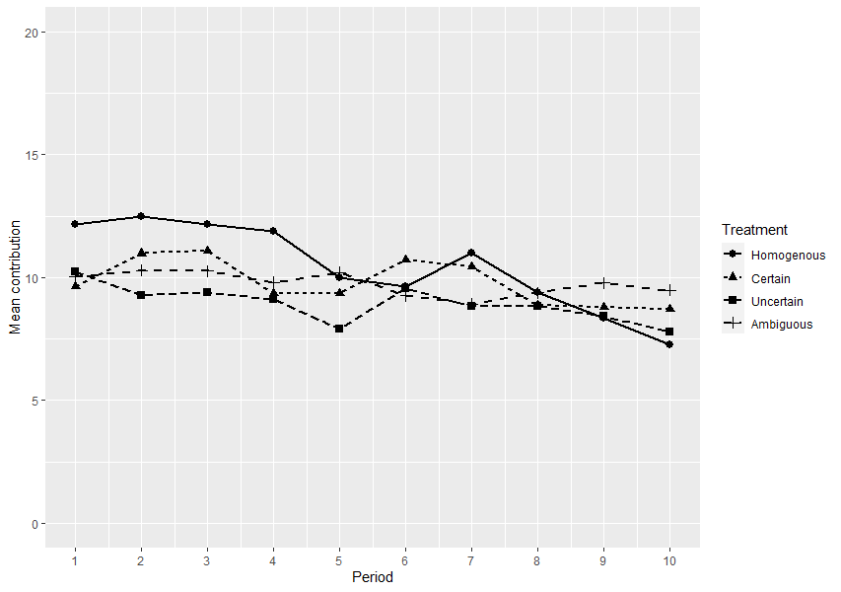

3. Results

The mean group contribution by treatment and period is presented in Figure 1. Overall, the contribution levels are closely aligned between treatments. HOMOGENOUS group mean contribution starts at 12.2 in period 1, declining to 7.3 in period 10 in the typical pattern of a public goods game with VCM. While the other treatments are similar, their slopes are flatter. They all start at a contribution level of around 10, and finish in period 10 above HOMOGENOUS.

We test for differences between the treatment groups in Tables 1 and 2. In Table 3, we conservatively test for differences in treatments, by averaging at the group level, across all periods. None of the differences are significant using the nonparametric Mann-Whitney U test, comparing the treatments to HOMOGENOUS, which acts as our control.

Table 3 Mean group contribution by treatment, at the group level, tested using the nonparametric Mann-Whitney U test.
 | Mean contribution | Difference with HOMOGENOUS | p-value | Obs.
HOMOGENOUS | 10.44 |  |  | 14
CERTAIN | 9.78 | -0.65 | 0.646 | 14
UNCERTAIN | 8.94 | -1.50 | 0.120 | 13
AMBIGUOUS | 9.74 | -0.70 | 0.701 | 14

In Table 4, we test for differences in individual contributions in each period between treatments using a linear model estimated by OLS. In column (1) we test each treatment group against the control (HOMOGENOUS). The model uses a set up common in the public goods game literature, with a Period variable (1 to 10) and additional dummies for periods 9 and 10 when defection may begin to occur (Kent, 2020). We bootstrap our standard errors to conservatively take into account the complex error structure of the data (with potential correlations across individuals, periods and groups). Hence, this is a robust model to test for treatment differences. We find UNCERTAIN is significantly lower than HOMOGENOUS at the 99% level, whereas the other two treatments are not different from HOMOGENOUS.

Result 1: Uncertainty reduces mean contributions. There are no differences in mean contributions between CERTAIN, AMBIGUOUS and HOMOGENOUS.

In column (2) of Table 4 we test for differences in contribution levels of the individuals within the certain treatment, by their level of productivity on their contribution to the public good. The two main variables in the model are low productivity and high productivity, relative to the HOMOGENOUS case which has moderate productivity half way between high and low. Low productivity is negative and highly statistically significant and high productivity is positive and highly statistically significant.

Hence, while on average there is no difference between CERTAIN (heterogeneous) and HOMOGENOUS, individuals in CERTAIN are altering their contribution, depending on whether they are high or low productivity. These adjustments equal out on average to be the same average contribution as the constant productivity level in HOMOGENOUS, and thus the observed no significant differences.

Result 2: Contributions are positively related to known productivity.

Table 3 Pooled linear model of individual period contributions, estimated by OLS.
 | (1) | (2) | (3) | (4)
 | Contribution | Contribution | Contribution  Periods 1-5 | Contribution  Periods 6-10
CERTAIN | -0.6536 |  | -1.6643*** | 0.3571
 | (0.4536) |  | (0.6414) | (0.6686)
UNCERTAIN | -1.5010*** |  | -2.5511*** | -0.4508
 | (0.4754) |  | (0.6573) | (0.6847)
AMBIGUOUS | -0.6964 |  | -1.6214** | 0.2286
 | (0.4459) |  | (0.6330) | (0.6495)
CERTAIN low |  | -4.1446***
 |  | (0.4952)
CERTAIN high |  | 2.8375***
 |  | (0.5367)
Period | -0.2156*** | -0.2692** | -0.3000* | -0.3914**
 | (0.0764) | (0.1050) | (0.1563) | (0.1726)
Period 9 | -0.2071 | -0.7851
 | (0.6515) | (0.8778)
Period 10 | -0.5188 | -1.0962
 | (0.7179) | (0.9452)
Constant | 11.6958*** | 12.1064*** | 12.6357*** | 12.2702***
 | (0.4703) | (0.5864) | (0.6499) | (1.4540)
Individuals | 220 | 112 | 220 | 220
Observations | 2,200 | 1,120 | 1,100 | 1,100
Adj. $R^{2}$ | 0.0115 | 0.1184 | 0.0148 | 0.0031
Notes: (Bootstrapped std. errs, 1000 reps). Column (2) drops UNCERTAIN and AMBIGUOUS treatment groups.

Next, we look at differences by treatment for the first half of the periods (column 3, Table 4) and last half (column 4). For periods 1-5, we find the treatment groups contribute significantly less than the control (HOMOGENOUS) at the 95% or 99% levels. However, for periods 6-10, these differences disappear. This finding aligns with the data shown in Figure 1. It seems the contributions of the three treatments start lower than the control (at around 10, or 50% of possible contribution level) and proceed in a relatively flat manner. The control however starts at around 12 (60% contribution) and declines over time.

In Table 5, we investigate these aforementioned dynamics, and potential other drivers of contribution levels. We run a separate pooled linear model for each treatment group, with bootstrapped standard errors. We test for a declining contribution level by period, impact of risk/ambiguity aversion on contributions, and whether the MPCR being low in period $t-1$ impacted contributions in period $t$. All variables included in the model are dummy variables except for Period.

Table 4 Pooled linear models estimated using OLS, separated by treatment group, testing for drivers of contributions.
 | (1) | (2) | (3) | (4)
 | HOMOGENOUS | CERTAIN | UNCERTAIN | AMBIGUOUS
Period | -0.5052** | -0.2423 | -0.0510 | -0.2479
 | (0.2234) | (0.1753) | (0.2075) | (0.1686)
Period 9 | -0.4315 | -0.2763 | -0.3803 | 1.0427
 | (1.4819) | (1.2356) | (1.5123) | (1.2579)
Period 10 | -1.5097 | -0.0302 | -0.9002 | 1.2605
 | (1.6833) | (1.3580) | (1.6735) | (1.3820)
Risk averse | 0.4915 | 1.0176 | -1.5885** | 2.7031***
 | (0.9632) | (0.6706) | (0.6731) | (0.7192)
Amb averse | 2.3237 | 0.0872 | 4.6192*** | 3.7460***
 | (1.7604) | (0.7745) | (1.0595) | (0.7425)
MPCR low t-1 |  | 0.7998 | 1.0995 | -0.8540
 |  | (0.6378) | (0.7620) | (0.6147)
CERTAIN low |  | -6.6914***
 |  | (0.6276)
Constant | 13.2622*** | 13.8980*** | 8.3480*** | 8.8935***
 | (1.1930) | (1.0639) | (1.2110) | (0.9696)
Individuals | 48 | 53 | 48 | 52
Observations | 432 | 477 | 432 | 468
Adj. $R^{2}$ | 0.0368 | 0.2061 | 0.0388 | 0.1281
Notes: (Bootstrapped std. errs, 1000 reps). Observations dropped for period 1, and for individuals who chose dominated choices for the final risk and ambiguity questions. This had little impact on the results.

In column (1) of Table 5 we see the control (HOMOGENOUS) treatment. Only period is significant (95% level), with contributions declining. Contributions are lower in periods 9 and 10, but not statistically. In the three treatment groups (columns 2 to 4), we see contributions are declining over the periods, but not statistically significantly.

Result 3: Contributions do not decline over the periods in CERTAIN, AMBIGUOUS and HOMOGENOUS.

Next, we look at the effect of risk and ambiguity aversion. We include a dummy variable for both risk aversion and ambiguity aversion, in each of the models in Table 5. These dummies are only significant in the uncertainty and ambiguity treatments, at the 95 or 99% levels.

Result 4: Risk aversion has no effect on contributions in HOMOGENOUS and CERTAIN, decreases contributions in UNCERTAIN, and increases contributions in the AMBIGUITY.

Result 5: Ambiguity aversion has no effect on contributions in the HOMOGENOUS and CERTAIN, and increases contributions in UNCERTAIN and AMBIGUITY.

Finally, we look at whether the MPCR being low in period $t-1$ impacted contributions in period $t$. Across the three treatments in columns (2) to (4), this does not have a statistically significant impact on contribution levels. Note we include the certain, low MPCR control for the certain treatment in column (2), which again is shown to have a very significant impact on contribution level, as per Result 2.

Result 6: MPCR in the prior period has no impact on contributions.

4. Discussion and conclusion

We find the standard pattern of declining contributions breaks down when heterogeneity, and uncertainty or ambiguity, is added to each individual’s productivity on their contributions to the public good (individual MPCR). Subjects are initially more hesitant in their contributions, contributing less than the case where productivity is homogenous. However, this lower initial contribution level ends up establishing a more stable equilibrium level of contributions that do not decline over time. Thus, natural uncertainty or ambiguity over an individual’s productivity in their contributions to a public good may help establish a more stable social norm.

Result 2, which reports a positive correlation between contributions and known productivity, is important for understanding our findings. In CERTAIN, two subjects in each group in each period are assigned low productivity and two high. Subjects are informed of their own productivity level before contributions are made. When subjects are assigned low, they contribute less, and when they are high, they contribute more. This result is significant in terms of the difference between contributions between high and low productivity (around 7 units, or around 70% of mean contributions) and is highly statistically significant. However, we see the mean contributions being stable across all 10 periods.

In the certain treatment we replicate Tan’s (2008) T2 treatment, with one key difference. In Tan’s (2008) design, subjects keep their low or high productivity level for the full set of periods, whereas in our design subjects are randomly reassigned their productivity level in each period. In contrast to our results, Tan (2008) finds a low and declining contribution level across periods. Hence, it seems the uncertainty over future productivity levels in our certain treatment is pivotal for maintaining a stable social norm of contributions. We conjecture that this finding is due to the veil of ignorance about productivity levels in future periods, due to the contrast in findings between our paper and Tan (2008), and our one key design difference. However, this needs more research to understand.

We test this finding further in our uncertainty treatment. Now, each subject does not know their productivity level before contributing, rather they know they have a 50-50 chance of being high or low. Again, this uncertainty has the effect of producing a stable equilibrium in contributions. Finally, we make the probabilities over productivity level ambiguous, which may be the most realistic representation for many real-world public goods, and again we find a stable level of contributions.

We do find a role for risk and ambiguity preferences in the level of contribution in the uncertain ambiguous treatments. A priori, there is no clear prediction on the direction of the effect of risk aversion or ambiguity aversion on contributions. The impact of these preferences on contributions will depend on whether risk/ambiguity averse subjects are more concerned with their own payoff, or their ultimate level of contribution to the group payoff.

We find risk averse subjects contribute less in the uncertain treatment, but more in the ambiguous treatment. Ambiguity averse subjects contribute more in both treatments. Hence, we find risk and ambiguity preferences do have a role in contribution decisions when productivity levels are unknown, and determined probabilistically.

In this paper, we focus on an important but heretofore neglected dimension of public goods – heterogeneous and uncertain or ambiguous levels of individual productivity over contribution. We have shown, using a linear VCM public goods game, that this source of natural uncertainty or ambiguity actually changes the dynamics of the contributions themselves. Hence, in real world settings, social norms may be partially determined by a veil of ignorance over how much of a difference each individual is actually making to the public good.

References
Björk, L., Kocher, M., Martinsson, P., & Khanh, P. N. (2016). Cooperation under risk and ambiguity (Working Papers in Economics No. 683). University of Gothenburg.
Boulu-Reshef, B., Brott, S. H., & Zylbersztejn, A. (2017). Does Uncertainty Deter Provision of Public Goods? Revue Économique, 68(5), 785. https://doi.org/10.3917/reco.pr3.0087
Brekke, K. A., Konow, J., & Nyborg, K. (2017). Framing in a threshold public goods experiment with heterogeneous endowments. Journal of Economic Behavior & Organization, 138, 99–110. https://doi.org/10.1016/j.jebo.2017.04.006
Brick, K., & Visser, M. (2010). Meeting a national emission reduction target in an experimental setting. Climate Policy, 10(5), 543–559. https://doi.org/10.3763/cpol.2010.0106
Buckley, E., & Croson, R. (2006). Income and wealth heterogeneity in the voluntary provision of linear public goods. Journal of Public Economics, 90(4–5), 935–955. https://doi.org/10.1016/j.jpubeco.2005.06.002
Butera, L., Grossman, P. J., Houser, D., List, J. A., & Villeval, M. C. (2020). A new mechanism to alleviate the crises of confidence in science-with an application to the public goods game (Working Paper 26801; p. 58). National Bureau of Economic Research.
Charness, G., Gneezy, U., & Imas, A. (2013). Experimental Methods: Eliciting risk preferences. Journal of Economic Behavior & Organization, 87, 43–51. https://doi.org/10.1016/j.jebo.2012.12.023
Chaudhuri, A. (2011). Sustaining cooperation in laboratory public goods experiments: A selective survey of the literature. Experimental Economics, 14(1), 47–83. https://doi.org/10.1007/s10683-010-9257-1
Colasante, A., & Russo, A. (2017). Voting for the distribution rule in a Public Good Game with heterogeneous endowments. Journal of Economic Interaction and Coordination, 12(3), 443–467. https://doi.org/10.1007/s11403-016-0172-1
Collins, S., Singh, R., Rivas, A., Palmer, A., Horne, D., Manderson, A., Roygard, J., & Matthews, A. (2017). Transport and potential attenuation of nitrogen in shallow groundwaters in the lower Rangitikei catchment, New Zealand. Journal of Contaminant Hydrology, 206, 55–66. https://doi.org/10.1016/j.jconhyd.2017.10.002
Fellner, G., Iida, Y., Kröger, S., & Seki, E. (2011). Heterogeneous productivity in voluntary public good provision: An experimental analysis. http://papers.ssrn.com/sol3/papers.cfm?abstract_id=1790667
Fischbacher, U. (2007). z-Tree: Zurich Toolbox for Ready-made Economic Experiments. Experimental Economics, 10(2), 171–178. https://doi.org/10.1007/s10683-006-9159-4
Fischbacher, U., Schudy, S., & Teyssier, S. (2014). Heterogeneous reactions to heterogeneity in returns from public goods. Social Choice and Welfare, 43(1), 195–217. https://doi.org/10.1007/s00355-013-0763-x
Fisher, J., Isaac, R. M., Schatzberg, J. W., & Walker, J. M. (1995). Heterogenous demand for public goods: Behavior in the voluntary contributions mechanism. Public Choice, 85(3–4), 249–266. https://doi.org/10.1007/BF01048198
Freundt, J., & Lange, A. (2019). On the Impact of Risky Private and Public Returns in the Private Provision of Public Goods-The Case of Social Investments (CESifo Working Paper no. 7458; p. 35).
Gangadharan, L., & Nemes, V. (2009). Experimental analysis of risk and uncertainty in provisioning private and public goods. Economic Inquiry, 47(1), 146–164. https://doi.org/10.1111/j.1465-7295.2007.00118.x
Gooday, R. D., Anthony, S. G., Chadwick, D. R., Newell-Price, P., Harris, D., Duethmann, D., Fish, R., Collins, A. L., & Winter, M. (2014). Modelling the cost-effectiveness of mitigation methods for multiple pollutants at farm scale. Science of The Total Environment, 468–469, 1198–1209. https://doi.org/10.1016/j.scitotenv.2013.04.078
Greiner, B. (2015). Subject Pool Recruitment Procedures: Organizing experiments with ORSEE. Journal of the Economic Science Association, 1(1), 114–125. https://doi.org/10.1007/s40881-015-0004-4
Hartig, B., Irlenbusch, B., & Kölle, F. (2015). Conditioning on what? Heterogeneous contributions and conditional cooperation. Journal of Behavioral and Experimental Economics, 55, 48–64. https://doi.org/10.1016/j.socec.2015.01.001
Isaac, R. M., Walker, J. M., & Thomas, S. H. (1984). Divergent evidence on free riding: An experimental examination of possible explanations. Public Choice, 43(2), 113–149. https://doi.org/10.1007/BF00140829
Julian, J. P., de Beurs, K. M., Owsley, B., Davies-Colley, R. J., & Ausseil, A.-G. E. (2017). River water quality changes in New Zealand over 26 years: Response to land use intensity. Hydrology and Earth System Sciences, 21(2), 1149–1171. https://doi.org/10.5194/hess-21-1149-2017
Kent, D. (2020). Comparing alternative estimation methods of a public goods game. Journal of the Economic Science Association, 6(2), 156–167. https://doi.org/10.1007/s40881-020-00092-3
Kölle, F. (2015). Heterogeneity and cooperation: The role of capability and valuation on public goods provision. Journal of Economic Behavior & Organization, 109, 120–134. https://doi.org/10.1016/j.jebo.2014.11.009
Ledyard, J. O. (1995). Public Goods: A Survey of Experimental Research. In J. H. Kagel & A. E. Roth (Eds.), The Handbook of Experimental Economics (pp. 111–194). Princeton University Press.
Levati, M. V., & Morone, A. (2013). Voluntary Contributions with Risky and Uncertain Marginal Returns: The Importance of the Parameter Values: Voluntary Contributions with Risky and Uncertain Marginal Returns. Journal of Public Economic Theory, 15(5), 736–744. https://doi.org/10.1111/jpet.12043
Noussair, C. N., & Tan, F. (2011). Voting on Punishment Systems within a Heterogeneous Group. Journal of Public Economic Theory, 13(5), 661–693. https://doi.org/10.1111/j.1467-9779.2011.01516.x
Palfrey, T. R., & Prisbrey, J. E. (1997). Anomalous behavior in public goods experiments: How much and why? The American Economic Review, 87(5), 829–846.
Pulford, B. D. (2009). Short article: Is luck on my side? Optimism, pessimism, and ambiguity aversion. Quarterly Journal of Experimental Psychology, 62(6), 1079–1087. https://doi.org/10.1080/17470210802592113
Stoddard, B. V. (2015). Probabilistic Production of a Public Good. Economics Bulletin, 35(1), 37–52.
Tan, F. (2008). Punishment in a Linear Public Good Game with Productivity Heterogeneity. De Economist, 156(3), 269–293. https://doi.org/10.1007/s10645-008-9094-1
Théroude, V., & Zylbersztejn, A. (2020). Cooperation in a risky world. Journal of Public Economic Theory, 22(2), 388–407. https://doi.org/10.1111/jpet.12366
Zelmer, J. (2003). Linear Public Goods Experiments: A Meta-Analysis. Experimental Economics, 6, 299–310.

Appendix

General instructions

You are now taking part in an economic experiment. If you read the following instructions carefully, you can, depending on your decisions and the decisions of others, earn a considerable amount of money. It is therefore very important that you read these instructions with care.

The instructions we have distributed to you are solely for your private information. It is prohibited to communicate with the other participants during the experiment. Should you have any questions please ask us. If you violate this rule, we shall have to exclude you from the experiment and from all payments.

You will learn neither during nor after the experiment, with whom you interact in the experiment. The other participants will neither during nor after the experiment learn how much you earn. Your decisions will be anonymous.

During the experiment your entire earnings will be calculated in ECU (Experimental Currency Units). At the end of the experiment the total amount of ECU you have earned will be converted to dollars at the following rate:

11 ECU=$1

At the end of the experiment your entire earnings from the experiment will be immediately paid to you in cash.

The experiment consists of two parts. You will receive instructions for each part after the previous part has ended. The two parts are independent of each other.

Instructions for Part I of the experiment

This part of the experiment will consist of 10 periods. Participants are divided into groups of four and the pairings of these groups will be same for all periods. You will therefore be in a group with the same three other participants for each of the 10 periods.

At the beginning of each period, each participant receives 20 ECU. In the following we call this your endowment. Your task is to decide how to allocate your endowment between a group account and a private account. More specifically, you have to decide how many ECU to contribute to the group account by choosing a number between 0 and 20. Each ECU that you do not put into the group account will automatically be allocated to your private account. After choosing your contribution you must press the ok button. Once you have done this, your decision can no longer be revised.

Your income from the private account:

You will earn one ECU for each ECU you allocate to your private account. For example, if you decide not to contribute anything to the group account, then all 20 ECU will be allocated into your private account (and therefore do not put anything into the group account), your income will amount to exactly 20 ECU from your private account. If you allocate 6 ECU into your private account, then your income from this account will be 6 ECU. No one except you earns something from your private account.

Your income from the group account:

Each group member will profit equally from the amount you put into the group account. Similarly, you will also get a payoff from the other group members’ contribution into the group account. Each group members’ individual income from the group account depends on the productivity of each group members’ contribution. More specifically, the contribution to the group account of each group member will be multiplied by a productivity multiplier that can be either 0.3 or 0.9. Therefore, your income from the group account is each group member’s contribution multiplied by either 0.3 or 0.9.

The following example may help your understanding. The values used in the following example are completely hypothetical, and thus please do not infer anything from them.

Suppose you contributed 10 ECU, group member 2 contributed 5 ECU, group member 3 contributed 15 ECU and group member 4 contributed 0 ECU. Also suppose that group members 1 through 4 have the following multipliers respectively: 0.9, 0.3, 0.3, and 0.9. Then you and all other group members each earn 0.9x10 + 0.3x5 + 0.3x15 + 0.9x0 = 15 ECU from the group account.

Your total income for a period

Your total income in a period is the sum of your income from your private account and the group account.
How to determine each group member’s multiplier

The value of each group member’s multiplier is determine by a random draw. There is an unknown chance that the multiplier is 0.3 and an unknown chance that it is 0.9.
At the beginning of each period, you will choose one of two colors. Your choice of color will determine your multiplier for the period.

There are 10 opaque bags that are filled with exactly 100 balloons labelled Period 1, Period 2, …, Period 10. The balloons in each bag consist of two colors. A research assistant has randomly drawn 100 balloons for each bag from a bigger bag that has far more than 100 balloons of each color. Thus, you do not know how many balloons of each color are in the bags. At the end of each period, a balloon will be randomly drawn from the appropriate bag (bag “Period 1” after period 1, bag “Period 2” after period 2, and so on) for each group member (each time returning the balloon to the bag). If the color of the balloon drawn matches the color chosen at the beginning of the period, then the multiplier for that group member is 0.9. If the color does not match, then the multiplier is 0.3. However, you will NOT be told your assigned multiplier until the end of the period. Therefore, you must make your contribution decision without knowing your assigned multiplier or your group member’s assigned multipliers.

You are allowed to inspect that opaque bags at the end of the experiment.

Decision Screen

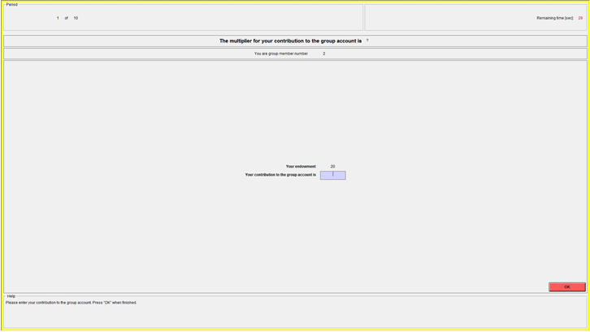
The decision screen, which you see in every period, looks like this:

As described above, your sole decision in each period is to decide how much of your endowment you want to contribute to the group account. The remaining portion of your endowment will be allocated to your private account. Please make sure to click the OK button upon completing your decision. Once you’ve clicked the OK button, your decision cannot be revised.

At the end of every period, each participant receives feedback on the results of the period, including your assigned multiplier, your contribution to the group account, the group’s total contribution to the group account, and your earnings for the period.

You will have one practice period to allow you to become comfortable with interactions via the decision screen. The earnings from the practice period will NOT count towards your overall earnings for the experiment.

To check your understanding of the experiment, please answer the following.

Recall that the value of each group member’s multiplier is determine by a random draw from opaque bags with exactly 100 balloons of two different colors. The distribution of the colors is unknown to you. Each group members’ multiplier will either be 0.3 or 0.9, but you do not know the chance for either multiplier occurring.

Note, when making your contribution decision for the period, you will not know your multiplier value.

For the following questions, suppose that group members 1 through 4 have the following multipliers respectively: 0.3, 0.9, 0.3 and 0.9.

- Suppose each group member has an endowment of 20 ECU. Nobody (including yourself) contributes any ECU to the group account. How high is:

- Your income for the period? _________
- The income of the other group members for the period? _________

- Suppose each group member has an endowment of 20 ECU. You contribute 20 ECU to the group account. All other group members contribute 20 ECU to the group account. What is:

a) Your income for the period? _________
b) The income of the other group members for the period? _________

- Suppose each group member has an endowment of 20 ECU. Suppose Group member #2 contributes 10, #3 contributes 20 and #4 contributes 0.

- What is your income if you contribute 0 ECU to the group account? _________
- What is your income if you contribute 15 ECU to the group account? _________

[SECOND SET OF INSTRUCTIONS, HANDED OUT ON COMPLETION OF PART 1]
General Instructions for Parts 2 and 3
Now that part 1 of the experiment is finished, we will move on to parts 2 and 3.
At the beginning of Part 2, you will be asked to choose a color (Red or Blue). This will assist in determining the random aspect of your earnings for the rest of the experiment.
In parts 2 and 3, you are not matched with any other person, i.e. your earnings are not dependent upon anyone else’s decisions.
In parts 2 and 3, you will make a total of 40 more decisions (20 decisions in each part). However, only one of those 40 decisions will be randomly selected to count towards your overall earnings. After completing decisions in both parts 2 and 3, a bingo cage with 40 balls, one corresponding to each of the 40 decisions, will be used to randomly decide which of the 40 decisions will be realized for payment.

Specific Instructions for Part 2
You will have to make 20 decisions where you choose between two alternatives. Once you have completed all 20 decisions, please click the OK button. You can revise your decisions as much as you like until you click the OK button, after which all 20 decisions are finalized.
The 20 decisions concern a Bag A. Bag A is filled with 100 balloons. Exactly 50 balloons are red and 50 balloons are blue. In the 20 decisions, you will have to decide whether you want to bet on the draw from the bag (Option X) or take an increasing amount of money for sure (independent of the balloon draw) (Option Y).
If one of the 20 decisions from Part 2 is payoff-relevant (selected from the random bingo cage roll), then a balloon will be randomly drawn from the opaque Bag A. If you have chosen Option X for the randomly determined decision problem and the balloon color drawn matches the color you selected at the beginning of Part 2, then you receive $10. However, if you have chosen Option X and the balloon draw does not match your choice of color, then you receive $0. If you have chosen Option Y, then you receive the corresponding payoff for sure, regardless of the color drawn from Bag A.
Below is an example of your decision screen for Part 2.
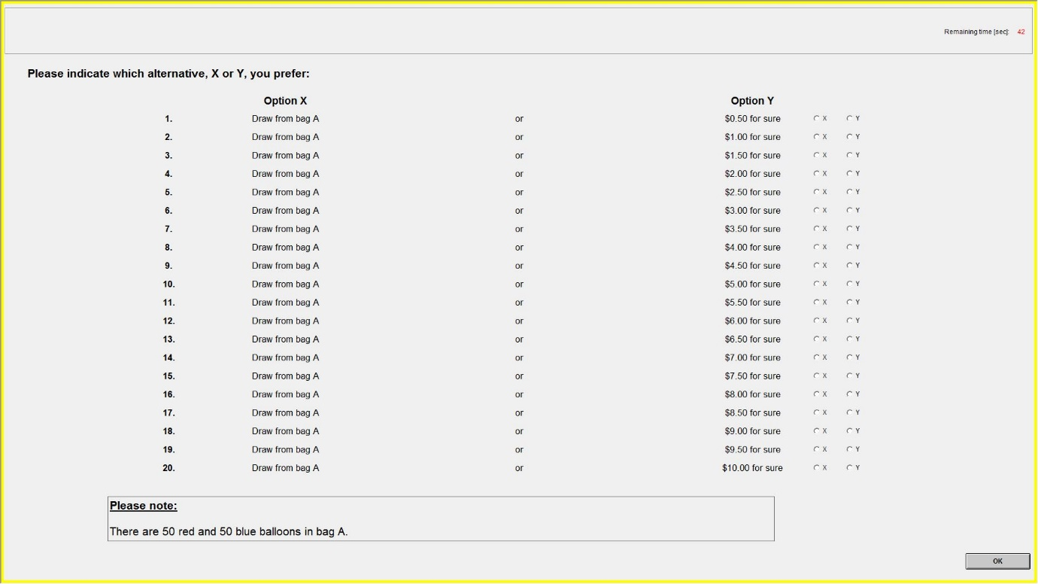

Specific Instructions for Part 3
The 20 decisions in Part 3 concern Bag B. Bag B is filled with 100 balloons. The balloons are either red or blue. The distribution of the colors is unknown to you. A research assistant has randomly drawn 100 balloons bag from a bigger bag that has far more than 100 balloons of each color. Thus, you do not know how many of the 100 balloons are red or blue. In the 20 decisions, you will have to decide whether you want to bet on the draw from the bag (Option X) or take an increasing amount of money for sure (independent of the balloon draw) (Option Y).
If one of the 20 decisions from Part 3 is payoff-relevant (selected from the random bingo cage roll), then a balloon will be randomly drawn from the opaque Bag B. If you have chosen Option X for the randomly determined decision problem and the balloon color drawn matches the color you selected at the beginning of Part 2, then you receive $10. However, if you have chosen Option X and the balloon draw does not match your choice of color, then you receive $0. If you have chosen Option Y, then you receive the corresponding payoff for sure, regardless of the color drawn from Bag B.
Below is an example of your decision screen for Part 3.
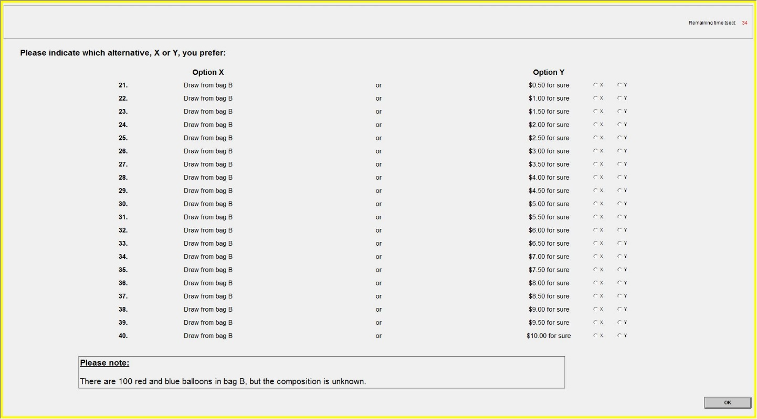

There is inconsistent use of the term “uncertain” in the literature, hence we define it here as per our usage in this paper.
Papers that have heterogeneous productivity on contributions to the public good, but no comparison with homogenous productivity include Brick and Visser (2010) and Noussair and Tan (2011).
We randomly rotated between 8 colors across periods to avoid any correlation between rounds and subjects in terms of color choice.
It was announced at the beginning of each session that all the opaque bags were to be made available for inspection upon completion of the experiment. No subject took up the offer.
Each session conducted consisted of multiple groups of four subjects. Each subject within a group was randomly assigned an identifier, e.g. subject 1, …, subject 4. To reduce the time required to randomly allocate productivity levels to subjects, a single balloon draw was used to determine the productivity level for subjects with the same identifier. Therefore, in each period, only four balloon draws were made.
We were concerned about potential multicollinearity with risk and ambiguity aversion, however the variables only have a Spearman’s r of 0.41.

