UNIVERSITY OF WAIKATO

Hamilton
New Zealand

Rising Immigration and Falling Native-Born Home Ownership:
A Spatial Econometric Analysis for New Zealand
Chao Li, John Gibson and Geua Boe-Gibson

Working Paper in Economics 3/21
March 2021
Chao Li
University of Auckland

Corresponding Author

John Gibson
School of Accounting, Finance
and Economics
University of Waikato
Private Bag 3105
Hamilton, 3240
New Zealand

Tel: +64 (7) 838 4289
Email: jkgibson@waikato.ac.nz

Geua Boe-Gibson
School of Accounting, Finance
and Economics
University of Waikato

Abstract

In the last two decades the foreign-born share of New Zealand’s population has risen far faster than in other rich countries, raising questions about impacts on the native-born population. We apply spatial econometric models to a three-wave panel of 1851 census area units to examine impacts of higher foreign-born population shares on home ownership rates for the native-born. A standard deviation higher foreign-born share is associated with a one-sixth of a standard deviation lower ownership rate for the native-born. Much of the impact is indirect, with higher foreign-born shares in one area spilling over into lower native-born ownership rates elsewhere.

Keywords
immigration
home ownership
spatial spillovers
New Zealand
JEL Classification
J61
R31

Acknowledgements
Access to the data used in this study was provided by Statistics New Zealand under conditions designed to give effect to the security and confidentiality provisions of the Statistics Act 1975. The results presented in this study are the work of the authors, not Statistics New Zealand or individual data suppliers.

I. Introduction
In the last two decades the foreign-born share of New Zealand’s population has risen faster than in other rich countries. Figure 1 shows foreign-born shares from New Zealand’s four most recent census years: 2001, 2006, 2013 and 2018. Over this period, the foreign-born share went from 18% to 26%—a proportionate increase of 44%. In contrast, the proportionate increase in the foreign-born share in Australia was only 26%, with the gap between Australia and New Zealand in the foreign-born share almost halving over these 17 years. In other small OECD countries there is no rise in the foreign-born share if one restricts attention to those with less than four million population, or else there are rises of just one-fifth (one-eighth) if considering countries with less than six million (ten million) population. Across all three definitions of small OECD countries, by 2018 New Zealand had double or more than double the share of foreign-born population than is found in the typical small OECD country.

This rise in immigration shows up in uneven ways within New Zealand, as some areas saw far bigger rises in the foreign-born share than others. For example, in South Waikato the share rose only 5% (from 0.125 to 0.131) between 2001 and 2013 while in the similarly rural Ashburton District the foreign-born share more than doubled. In absolute terms, in parts of Auckland the foreign-born share rose by 12 percentage points or more from 2001 to 2013 but in 15 Territorial Authorities outside of Auckland it rose by two percentage points or less. The change in foreign-born shares from the 2001 to 2013 censuses, and resulting shares in 2013, are mapped in Figure 2. For clearer display the maps use data at Territorial Authority (TA) level (and local boards for Auckland) but there is also considerable variation in foreign-born shares below that level; in area unit data the within-TA variation is almost four-fifths of the between-TA variation in 2013, with the within-share rising since 2001.
Figure 2: Changes in (a), and levels of (b), foreign-born shares of the population, by Territorial Authority and Local Board
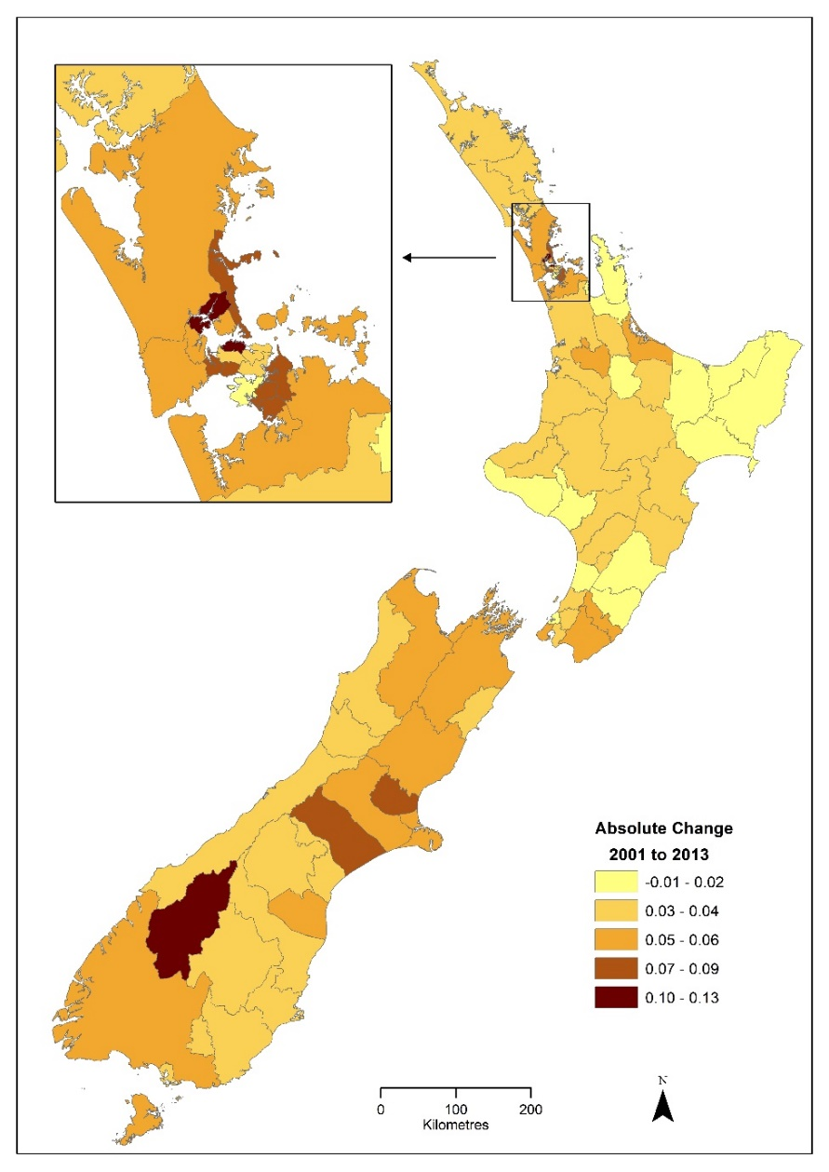  (a) | 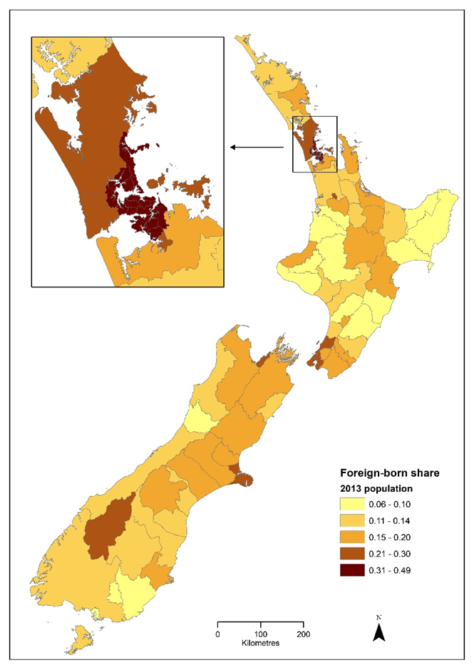
(b)

This variation provides an opportunity to estimate some impacts of the foreign-born on outcomes for the native-born. If changes in the foreign-born share were uniform it would be harder to disentangle impacts from other (aggregate) changes over time. The outcome we focus on is the native-born home ownership rate, which fell as the foreign-born share rose. A feature of our analysis is use of spatial econometric models, to allow for any spillovers where effects of a higher foreign-born share in one place spread into neighbouring areas.

In contrast to our study, prior studies in New Zealand look especially at immigration effects on house prices. For example, Hyslop et al (2019) link census data from 1986, 2001, 2006 and 2013 to house price data (and rents and building consents) and find the immigrant share of the local (usually TA or ward level) population unrelated to house prices. An earlier review of impacts of net international migration on housing markets has similar conclusions (Cochrane and Poot, 2016). There are good reasons for prior studies to look at house prices, as there are concerns that price rises due to exuberance may add systemic risk to the financial sector (Pavlidis et al, 2021) while at the micro level reduced affordability hinders reallocation of workers into more productive areas (Nunns, 2021). Yet some public concern about house prices likely is from feared effects on home ownership and so it is useful to directly examine immigration impacts on home ownership. Also, politicians are clear in espousing for home ownership while shrouding comments about house prices in ambiguity, as supporting higher prices seems callous to the plight of first-home buyers but calling for prices to fall may upset owner-occupiers. If New Zealand has pursued an expanded immigration program that proves incompatible with higher home ownership rates it is helpful to point out this contradiction.

II. Data and Methods
We used unit record data from the 2001, 2006 and 2013 Census in the Statistics New Zealand Datalab (2018 Census data were not available when the project started). Our interest is in the home ownership rate of native-born adults. A household can be comprised of both native-born and foreign-born individuals, so Dwelling Form questions, where one person answers on behalf of the whole dwelling, are less suitable for our purposes. Also, Dwelling Form questions rely on potentially less reliable proxy reporting. In contrast, the Individual Form that we use links one-to-one to nativity status and has a direct answer (from everyone aged 15 and above) to the question: “do you yourself own, or partly own, the dwelling that you usually live in” with wording of this question unchanged across the three censuses.

We aggregated the individual ownership reports to rates at the area unit level, for a balanced panel of 1851 area units. These met a criteria of having a population of at least 30 in each of the three censuses. This was to ensure that rates were not calculated from very small denominators. We use area units rather than the far more aggregated Territorial Authority level to allow a full range of spatial effects to be observed. Furthermore, if spatial data are overly aggregated it can cause mean-reverting errors (Sharma and Gibson, 2020).

We begin with an aspatial panel model, with fixed effects for area units and years, and observations initially treated as independent. The native-born home ownership rate and the share of the foreign-born in the population of an area unit are both standardized so regression coefficients can be interpreted as standard deviation changes. The native-born ownership rate in area i in year t is ${NHO}_{it}$, the foreign-born share is ${FB}_{it}$ the $μ_{i}$ are time-invariant fixed effects for each area unit, the $ϑ_{t}$ are year fixed effects, and $e_{it}$ is a random error:
${NHO}_{it}={β_{1}FB}_{it}+μ_{i}+ϑ_{t}+e_{it}$ (1)
Panel models such as equation (1) are typically used to deal with omitted heterogeneity; here affecting both ownership rates and the foreign-born share. For example, if migrants settle in densely populated areas due to perceived productivity advantages and if the native-born tend to rent in such areas because security of tenure from ownership may matter less where many alternative dwellings are nearby, then omitting density could bias ${\hat{β}}_{OLS}$ as an estimator of the causal effect. However, to the extent that density variation across space hardly changes in the short-run, as it is due to geology, topography and the history of a particular area, then $μ_{i}$ fixed effects can mitigate this omitted variable bias. Likewise, time fixed effects can control for any temporal factors that may correlate with ownership rates (including any reporting effects from changes in how census questions are interpreted) and with immigration.

However, for housing studies there are reasons to doubt the independence assumption in equation (1), where changes in the foreign-born share in the ith area unit only affect NHO there. Instead, shocks in one area may spill into other areas. For example, investor demand for houses may be higher not only with more renters in a certain area unit but also in nearby areas, as commuting hardly changes for a renter moving from nearby area units. In contrast, an area unit surrounded mostly by owner-occupiers may be less attractive to investors as the supply of nearby potential tenants is lower. So in this example a spillover is through the dependent variable. Alternatively, if immigrants establish a beachhead in a particular area and then spread out, there may be spillovers through the independent variable.

Spatial econometric methods let us estimate the effects of these spillovers, where all possible interactions between areas are summarized into a $N×N$spatial weights matrix, W. Our contiguity matrix has values of one for neighbours and zero otherwise, with a diagonal of zeros as an area unit cannot neighbour itself. The average area unit has five neighbours. The spatial weights matrix allows for spatial lags, which are averages over neighbouring units. The most general model is a spatial autoregressive model with spatial autoregressive errors (SARAR), allowing spatially lagged dependent variables, independent variables and errors.
${NHO}_{it}={WNHO}_{it}+{β_{1}FB}_{it}+{β_{2}WFB}_{it}+μ_{i}+ϑ_{t}+{ρWu}_{it}+e_{it}$ (2)
This model lets outcome changes in a given area affect contemporaneous outcomes in other areas (via the autoregressive spatial lag of the dependent variable, if $≠0$). It lets changes in independent variables affect not only own-area outcomes but also outcomes in neighbouring areas (if $β_{2}≠0)$. The ${ρWu}_{it}$ term allows for spatial autocorrelation, where the errors for an area unit are correlated (ρ) with a weighted average of the errors from surrounding area units. Equation (2) nests a spatial Durbin model if $ρ=0,$ a spatial auto-regressive model (aka spatial lag model) where only the dependent variable is spatially lagged if $β_{2}=ρ=0$, a spatial error model where only the errors are spatially lagged (if λ$=β_{2}=0)$, and aspatial models, such as equation (1), that have no spatial lags (if ${=β}_{2}=ρ=0)$.

An important feature of spatial econometric models is that lags of either the outcome variable or the independent variable (but not the errors) mean that total effects of changes in an independent variable—e.g. a higher foreign-born share—may be quite different to what the regression coefficient shows. Thus, while ${\hat{β}}_{1}$ is the object of interest in aspatial models like equation (1), with spatial models ${\hat{β}}_{1}$ does not capture the total effect of changes in the foreign-born share if there are any spillovers. A useful decomposition relies on rewriting equation (2) in matrix notation (for simplicity, subscripts are dropped and fixed effects and error terms combine in v because the errors do not affect this decomposition) as:
$NHO={\left(I-W\right)}^{-1}\left(FBβ_{1}+WFBβ_{2}\right)+{\left(I-W\right)}^{-1}v$ (3)
Following Elhorst (2012), the $N×N$matrix of partial derivatives can be written (noting that diagonal elements of W are zero) as:
$$\frac{∂NHO}{{∂FB}_{k}}={\left(I-W\right)}^{-1}\left(β_{1k}I_{N}+β_{2k}W\right) (4)$$
where FB_{k} is the foreign-born share in area unit k. The total marginal effect of the foreign-born share on the native-born ownership rate has direct and indirect components that vary over space. The estimator that we use follows LeSage and Pace (2009) in reporting a single direct effect, that averages the diagonal elements of the matrix in (4) and a single indirect effect that averages the row sums of the non-diagonal elements of that matrix. Indirect effects arise not just from adjacent area units, if $β_{2k}≠0,$ but also from (potentially) all areas through the spatial autoregressive effect if $≠0$. Thus, there can be both local and global spillovers and when these are accounted for, averages from the matrix of derivatives ${∂NHO}/{{∂FB}_{k}}$ may be quite different to the direct impact effect, ${\hat{β}}_{1}$.
III. Results
The results from estimating equations (1) and (2) are reported in Table 1. For aspatial models, a standard deviation higher foreign-born share is associated with 0.12 of a standard deviation lower native-born home ownership rate. Controlling for time-varying attributes of the native-born, such as their age and employment, does not alter the size of the effect of the foreign-born share on the ownership rate (nor the statistical significance, which is p<0.01 in all cases). Notably, time-invariant features of each area unit and spatially-invariant features of each time period are controlled for in these results and so various threats to interpreting the coefficients in causal terms can be countered.

The results in columns (1) and (5) of Table 1 follow usual practice of (implicitly if not explicitly) imposing an independence assumption. The results in the remaining columns relax this assumption in various ways: letting outcomes in one area just affect outcomes in other areas (in columns (2) and (6)); letting changes in both outcomes and in the foreign-born share in one area spill over into other areas (columns (3) and (7)); and most generally, allowing the outcomes, the covariates and the errors in each area to be affected by values of these same variables in other areas (columns (4) and (8)). In all cases, spatial lags of the dependent variable have precisely estimated coefficients (p<0.01), spatial lags of the foreign-born share have less precisely estimated coefficients in the spatial Durbin model but become highly precise once spatial lags of the errors are included in the SARAR model, and the hypothesis that spatial effects can be excluded from the models is always rejected. In other words, at least for studies of the housing market conducted at the area unit level, it seems important to allow for spatial spillovers, even with spatial fixed effects included.

The coefficients on the foreign-born share steadily diminish in magnitude as various spatial lags are added in Table 1 but it would be incorrect to conclude that this variable is becoming less important as specifications imposing fewer assumptions are used. Instead, for situations where either $≠0$ (so there are global spillovers) or $β_{2}≠0$ (so there are local spillovers) the value of ${\hat{β}}_{1}$ is no longer sufficient for showing the full impact of changes in the foreign-born share. Instead the full $N×N$ matrix of partial derivatives has to be calculated and these results can then be conveniently summarized in terms of average direct, average indirect and average total effects, following LeSage and Pace (2009).

Table 1: Effects of the Foreign-Born Share on the Native-Born Home Ownership Rate: Evidence From the 2001, 2006 and 2013 Censuses
 | Aspatial | Spatial Lag | Spatial Durbin | SARAR | Aspatial | Spatial Lag | Spatial Durbin | SARAR
 | (1) | (2) | (3) | (4) | (5) | (6) | (7) | (8)
Foreign-born share | ˗0.117*** | ˗0.075*** | -0.059*** | -0.048** | ˗0.115*** | ˗0.075*** | -0.062*** | -0.051***
 | (0.019) | (0.018) | (0.020) | (0.019) | (0.018) | (0.018) | (0.019) | (0.019)
Average ageª |  |  |  |  | 0.043*** | 0.041*** | 0.041*** | 0.037***
 |  |  |  |  | (0.003) | (0.003) | (0.003) | (0.003)
Share employedª |  |  |  |  | 1.084*** | 0.957*** | 0.931*** | 0.833***
 |  |  |  |  | (0.148) | (0.142) | (0.143) | (0.142)
Spatial Lags
Native-born ownership rate |  | 0.063*** | 0.062*** | -0.097*** |  | 0.061*** | 0.060*** | -0.092***
 |  | (0.004) | (0.004) | (0.007) |  | (0.004) | (0.004) | (0.007)
Foreign-born share |  |  | -0.009* | -0.038*** |  |  | -0.008* | -0.039***
 |  |  | (0.005) | (0.008) |  |  | (0.005) | (0.007)
Residuals |  |  |  | 0.121*** |  |  |  | 0.119***
 |  |  |  | (0.003) |  |  |  | (0.003)
Year fixed effects | Yes | Yes | Yes | Yes | Yes | Yes | Yes | Yes
Area unit fixed effects | Yes | Yes | Yes | Yes | Yes | Yes | Yes | Yes
(Pseudo-)R² | 0.088 | 0.086 | 0.091 | 0.081 | 0.338 | 0.345 | 0.331 | 0.213
All covariates = 0 | 44.52*** | 414.12*** | 416.68*** | 288.29*** | 66.38*** | 618.51*** | 620.32*** | 483.38***
Spatial effects = 0 |  | 268.34*** | 270.88*** | 1946.77*** |  | 257.32*** | 259.11*** | 1863.29***
Notes: Native-born home ownership rate and foreign-born share are in standardized form. N=1851 census area units, each observed three times. Clustered standard errors in ( ), with ***, **, * denoting statistical significance at p<0.01, p<0.05, and p<0.10. Spatial lags are based on an un-normalized first-order contiguity weight matrix. For aspatial models, the overall R² is reported, while for other models it is the squared correlation between the predictions and the dependent variable. SARAR stands for spatial autoregressive model with spatial autoregressive errors.
ª For the native-born population in each area unit.

Table 2: Average Direct, Indirect and Total Impacts of Foreign-Born Share on the Native-Born Home Ownership Rate from Spatial Econometric Models
 | Models without time-varying controls |  |  |  | Models with time-varying controls
 | Spatial Lag | Spatial Durbin | SARAR |  | Spatial Lag | Spatial Durbin | SARAR
Average direct impacts | -0.077*** | -0.064*** | -0.033* |  | -0.077*** | -0.067*** | -0.036*
 | (0.018) | (0.020) | (0.020) |  | (0.018) | (0.019) | (0.019)
Average indirect impacts | -0.039*** | -0.104*** | -0.113*** |  | -0.037*** | -0.091*** | -0.119***
 | (0.010) | (0.036) | (0.025) |  | (0.009) | (0.035) | (0.025)
Average total impacts | -0.115*** | -0.168*** | -0.146*** |  | -0.114*** | -0.158*** | -0.155***
 | (0.027) | (0.039) | (0.028) |  | (0.026) | (0.038) | (0.028)
Notes: Impacts are in standard deviation terms, ***, **, * denote statistical significance at p<0.01, p<0.05, and p<0.10.

The results of this decomposition, which relies on equation (4), are shown in Table 2. Starting with the average total impact, this ranges from ˗0.11 to ˗0.17 and is always precisely estimated (p<0.01). The lowest values of the average total impact come from the spatial lag models, where they are about the same as what the aspatial models show. However, with the spatial Durbin model and the SARAR model, total impacts are about 50% larger than what is suggested by an aspatial model like equation (1). The statistical significance of spatial lags on the foreign-born share and on the errors imply that the spatial lag models rely on restrictions that are inconsistent with the data. Thus, it is these larger values of the total effects, which we estimate as approximately ˗0.16, that should be thought of as closer to the truth. These averages of the total impacts imply that a standard deviation higher foreign-born share is associated with a one-sixth of a standard deviation lower ownership rate for the native-born.

The reason that spatial models show a larger impact of the foreign-born share than do the aspatial models is because much of the impact is indirect and the aspatial models cannot estimate indirect impacts. For example, a local change in the foreign-born share will affect the native-born ownership rate in that same area unit, in turn affecting the ownership rates in nearby area units, then in turn affecting the ownership rates of their neighbours (including the original area unit). In addition to these spillover and feedback affects operating through the dependent variable, given that $β_{2}≠0$ there also will be spillovers that come through the independent variables whereby a higher foreign-born share in nearby area units is associated with lower native-born ownership rates in the k^{th} area unit.

More research is needed to see if indirect effects are as important at different spatial scales. It could be that spillovers internalize for large spatial units like a Territorial Authority. In order to examine a key result estimated mostly at the TA level without spatial econometric models, we augmented the models in Table 1 with (log) population for each area unit—the Hyslop et al (2019) finding is that population growth puts pressure on house prices while the composition of the local population, in terms of native-born or foreign-born, does not matter. In contrast, we find even after controlling for (log) population, total impacts of the foreign-born share on native-born ownership rates are about the same, at ˗0.14 (p<0.01), as before even allowing for the negative effect of population growth on the native ownership rate. However, the indirect component of the impacts of the foreign-born share is increased when population is also included as a covariate and this effect (if it also operates via house prices) would be less easy to observe with the aspatial models used by Hyslop et al (2019).

IV. Conclusions
New Zealand recently experienced a surge in immigration but with much unevenness over space. We calculate native-born home ownership rates from three censuses to relate to foreign-born population shares, for a panel of 1851 area units. A standard deviation higher foreign-born share is associated with a one-sixth standard deviation lower ownership rate for the native-born. Spatial econometric models show that much of this impact is through nearby areas rather than just coming from the own-area so an important methodological contribution is to illustrate the value of allowing for spatial spillovers when studying housing. In terms of policy, the results suggest that New Zealand may have pursued incompatible goals (given self-imposed constraints on urban land supply) of immigration-driven population growth and increasing native-born home ownership.

References
Cochrane, William and Jacques Poot (2016) Past research on the impact of international migration on house prices: Implications for Auckland. Mimeo University of Waikato.
Drukker, David, Ingmar Prucha and Rafal Raciborski (2013) Maximum likelihood and generalized spatial two-stage least-squares estimators for a spatial-autoregressive model with spatial-autoregressive disturbances. Stata Journal 13(2): 221-241.
Elhorst, J. Paul (2012) Dynamic spatial panels: models, methods, and inferences. Journal of Geographic Systems 14(1): 5–28.
Hyslop, Dean, Trinh Le, David Maré and Steven Stillman (2019) Housing markets and migration: Evidence from New Zealand. Working Paper No. 19-14, Motu Economic and Public Policy Research.
Lee, Lung-Fei and Jihai Yu (2010) Estimation of spatial autoregressive panel data models with fixed effects. Journal of Econometrics 154(1): 165–185.
LeSage, James and Robert Kelley Pace (2009) Introduction to Spatial Econometrics Chapman and Hall and CRC Press, Boca Raton.
Nunns, Peter (2021) The causes and economic consequences of rising regional housing prices in New Zealand. New Zealand Economic Papers 55(1): 66-.
Pavlidis, Efthymios, Ivan Paya and Alexandros Skouralis (2021) House prices, (un)affordability and systemic risk. New Zealand Economic Papers 55(1): 105-123.
Sharma, Hari and John Gibson (2020) Mean-reverting errors and spatially aggregated conflict data: Impacts of civil war on international migration from Nepal. Mimeo, University of Waikato.

Figure 1 uses OECD series 5a368e1b-en and d434f82b-en. Not all countries have data in years with NZ censuses; to ensure averages for each year in Figure 1 are for the same group of countries, LUX, IRL, SVK and CHE are excluded. The three OECD groups in Figure 1 have 5, 8, and 10 members.
For example, in their 2020 election manifesto the Labour Party support progressive home ownership. For several examples of politicians bobbing and weaving to avoid answering questions about whether they want house prices to fall see: https://www.stuff.co.nz/business/opinion-analysis/300205858/the-brutal-catch22-politics-of-trying-to-move-to-affordable-housing
The Dwelling Form set of questions have also become much more complex over time as Statistics New Zealand grapples with implications of increased use of family trusts. A careful discussion of these issues is in the Retirement Policy Research Centre Pension Briefing 2013-4.
Only 0.07% of the population in 2013 lived in area units we omitted due to this restriction.
Area units are aggregations of adjacent meshblocks with coterminous boundaries. In urban areas an area unit is often a collection of city blocks, while in rural areas they typically correspond to localities or communities.
This is estimated by quasi-maximum likelihood (Lee and Yu, 2010), using the Drukker et al (2013) estimator.
Coefficient values for spatial lag terms can be altered by using different normalizations of the spatial weights matrix but the standard errors scale in proportion so statistical significance is unchanged. Moreover, non-lagged parts of the model, and the impacts given by equation (4), are invariant to the spatial weights normalization.

