UNIVERSITY OF WAIKATO

Hamilton
New Zealand

How effective are sanctions on North Korea?
Popular DMSP night-lights data may bias evaluations due to blurring and poor- low-light detection

Working Paper in Economics 6/22
Revised November 2022

John Gibson
School of Accounting, Finance and Economics
University of Waikato
Private Bag 3105
Hamilton, 3240
New Zealand

Tel: +64 (7) 838 4289
Email: jkgibson@waikato.ac.nz

Bonggeun Kim
Department of Economics
Seoul National University
South Korea
Geua Boe-Gibson
School of Accounting, Finance and Economics
University of Waikato

Abstract
The effect of sanctions on economic activity in targeted countries is increasingly studied with satellite-detected night-lights data because conventional economic activity data for such countries are either unavailable or untrustworthy. Many studies use data from the Defense Meteorological Satellite Program (DMSP), designed for observing clouds for short-term weather forecasts rather than for long-run observation of economic activity on earth. The DMSP data are flawed by blurring, and bottom-coding due to poor low-light detection. These errors may bias evaluation of sanction effectiveness. To show this we use a difference-in-differences analysis of impacts on night-lights of the shutdown of the Kaesong Industrial Zone in North Korea, which South Korea closed in 2016 in response to North Korea’s nuclear tests. We estimate impacts of about 50% declines in luminosity, depending on the choice of comparison region, and these effects are always precisely estimated if data from the accurate Visible Infrared Imaging Radiometer Suite (VIIRS) on the Suomi-NPP satellite are used. Yet with the more widely used DMSP data, apparent impacts are imprecisely estimated and are far smaller. A decomposition suggests much of the attenuation in estimated treatment effects if DMSP data are used comes from false zeroes, which are also likely to matter to evaluations in other poorly lit places.

Keywords:
DMSP
mean-reverting error
night lights
sanctions
VIIRS
North Korea

JEL Classification:
C80, F51, O11

Acknowledgements

Financial support from Marsden Fund project UOW1901 is acknowledged.

1. Introduction
The imposition of sanctions on Russia following the Ukraine invasion in February 2022 is the latest attempt by the international community to alter behaviour of countries whose actions may violate international norms. Several studies estimate economic impacts of sanctions but face a fundamental difficulty; countries under sanction are unlikely to have trustworthy data available for researchers, especially if such data would show that the sanctions are helping to weaken their economy. In response, a popular recent approach relies on remote sensing data, especially of satellite-detected night-lights. These data cover all countries and should be free from manipulation. Some recent studies of impacts of sanctions imposed on North Korea (Lee, 2018; Son & Cho, 2021; Kim et al, 2021) and Iran (Arbatli & Gomtsyan, 2021; Farzanegan & Fischer, 2021) are good examples of this use of satellite-detected night-lights.
An important measurement issue with undesirable econometric implications does not seem to be considered in this recent literature. Most studies use the Defense Meteorological Satellite Program (DMSP) data, which involves repurposing information originally collected for cloud detection for short-term Air Force weather forecasts. While the seminal study by Henderson et al (2012) showed that DMSP data can also be used to make long-run observations of economic activity on earth, the framework used in that seminal study only required measurement errors in DMSP data to be independent of errors in reported GDP. Independence mattered because an optimally weighted mix of the two types of data was used to proxy for true but unknown economic activity. In contrast, the studies estimating impacts of sanctions use the DMSP data directly as a proxy for economic activity and so the measurement errors in these data can cause an econometric bias that may distort conclusions about the effectiveness of sanctions.
The DMSP data are used on the left-hand side of econometric models in the studies evaluating sanctions, so it requires non-classical measurement errors if there is to be bias in the estimated regression coefficients. The first source of such errors is false zeroes, due to the poor low-light detection capability of DMSP sensors. Given the original purpose of detecting clouds, the sensor needs little amplification when cloud tops are visible in moonlight during half of the lunar cycle, so lights on earth that are not very brightly lit often go undetected. For example, Chen & Nordhaus (2015) study 1°×1° grid cells over Africa, each having 10,000 to 100,000 people and all having anthropomorphic lights according to other data sources, yet in the DMSP data over one-half of these cells are recording as having zero light. Top-coding is a more widely discussed problem in DMSP data (Bluhm & Krause, 2022) but bottom-coding from false zeroes (Abrahams et al, 2018) matters more for poorly-lit areas. Non-classical measurement errors also result from blurring, where night-lights are attributed to places from which light is not emitted. Blurring is an inherent feature of DMSP sensors and data management (Elvidge et al, 2013; Tuttle et al, 2013) and it causes mean-reverting measurement errors (Gibson, 2021).
To provide evidence on the econometric bias caused by these DMSP measurement issues we use a difference-in-differences analysis of the impacts on night-lights of a particular sanction on North Korea: the shutdown of the Kaesong Industrial Zone in February 2016 in response to North Korea’s nuclear tests. This joint venture with South Korea operated about 10 km north of the DMZ, with over 50,000 North Korean workers employed in factories operated by South Korean companies. We estimate that luminosity in the district where the Industrial Zone was located fell by around 50%, as the impact of this sanction. These effects are always precisely estimated if data from the accurate Visible Infrared Imaging Radiometer Suite (VIIRS) of instruments on the Suomi-NPP satellite are used. Yet if we use the more popular DMSP data for the same years, the same spatial units, and the same sanctions event, the apparent impacts are imprecisely estimated and are much smaller. In other words, with the data source used in several recent studies of sanctions we get smaller estimated impacts, compared to what the more accurate data show, even though the more accurate data are used far less frequently in the literature that relies on satellite-detected night-lights to study sanctions impacts.
These results suggest it would be useful to reexamine some of the recently published findings on the impacts of sanctions. If the measurement error bias that we demonstrate here holds more widely then it is possible that effectiveness of sanctions in weakening the economy of targeted countries may have been understated because studies have used satellite-detected night-lights data that are affected by non-classical measurement errors. Importantly, our results should not be affected by sanctions evasion measures because we know the sanction we study was fully implemented, in the sense that all South Korean enterprises shut their activities in Kaesong. In contrast, studies that focus on trade sanctions (e.g. Lee, 2018; Kim et al, 2021) face the difficulty that North Korea has sanctions evasion strategies like falsification of documents and covert ship-to-ship transfers of cargo at sea. Consequently, trade sanctions may appear ineffective either because measurement errors in the night-lights data understate the impacts, or because sanctions actually are partly ineffective due to North Korea’s evasions. In contrast, with the Kaesong closure, we have a ‘ground-truth’ event as a benchmark for examining the nature of the measurement errors in the data used to evaluate the impact of this event.
We also go beyond showing a bias in the difference-in-differences analysis when the DMSP data are used, by examining the source of the understated impacts. By decomposing the change in results when VIIRS data are used instead of DMSP data it seems that much of the attenuation in estimated treatment effects if DMSP data are used comes from false zeroes. Applied studies using DMSP data—in general, rather than specifically for studying the impacts of sanctions—use various ad hoc methods for dealing with apparently unlit observations. A common tactic is to use transformations such as taking the logarithm of $\left(y+0.01\right)$, or some other small constant added to the data (Gibson et al, 2020). Based on the results here, and on more general concerns about how ad hoc transformations may bias estimated elasticities (Bellemare & Wichman, 2020), finding better solutions for bottom-coded DMSP false zeroes would be valuable.
The rest of the paper is set out as follows: Section 2 provides details on the context, Section 3 discusses the data and econometric methods, Section 4 has the results and Section 5 concludes.

2. Context: Sanctions on North Korea
2.1 Previous Evidence on Impacts of the Sanctions
Over the last two decades the international community has responded to North Korea’s nuclear testing program by imposing several waves of sanctions. After North Korea’s first reported nuclear test in October 2006 the UN Security Council unanimously adopted Resolution 1718 that banned various imports and exports to North Korea, and froze assets and banned travel by participants in the nuclear program. However, China did not participate in these sanctions and China’s trade with North Korea appears to have increased to offset some of the loss of trade with other countries. Further UN sanctions were imposed in 2009 following North Korea’s second nuclear test and additional sanctions were put in place by South Korea in 2010 after an attack by North Korea on a South Korean navy vessel.
An evaluation of the impact of these sanctions up until 2013 used annual DMSP night-lights data for a micro-grid overlaid on the map of North Korea, where cell sizes for the grid were about 2.6 km² (Lee, 2018). According to the results of this study, while sanctions seemed to have little overall effect on luminosity, some redistribution of economic activity to the regions of North Korea more linked to trade with China was detected. One concern with results of this study is that the cell size for the grid is far smaller than the ground footprint of DMSP pixels, which is 25 km² at nadir and may be up to 60 km² away from the nadir (Elvidge et al, 2013). Thus, the luminosity values attributed to particular cells in the Lee (2018) study are likely to be affected by lights from nearby cells. This blurring of the observations will create a form of mean-reverting measurement error that biases regression coefficients towards zero, varying with the strength of the mean-reversion in the left-hand side variable (Gibson, 2021).
A more aggregated approach with night-lights data is used by Son & Cho (2021), based on the growth in night-lights for 25 major cities in North Korea. A range of new sanctions imposed in 2016, which notably included China as one of the countries limiting trade with North Korea, appears to have decreased the growth in night-lights, particularly in cities where coal mining is important. Notably, coal was included in the list of banned North Korean exports under two UN resolutions (#2270 in March 2016 and # 2371 in August 2017) and prior to then coal had been North Korea’s largest export, contributing about one-third of total export revenues (Kim et al, 2021). The study by Son & Cho (2021) used a time-series of night-lights data that spliced records from the two data sources: DMSP and VIIRS. However, there was no allowance for the quite different measurement error properties of the two data sources (with a mean-reverting error in the DMSP data there is no simple adjustment factor to ‘line up’ the two data sources because the error will vary with the true, but unknown, level of luminosity). Moreover, splicing together these two data sources to give a longer time-series (the DMSP time-series previously ended in 2013) is no longer needed because the DMSP time-series was recently extended through to 2019 (Ghosh et al, 2021).
Another study of the impacts of various layers of sanctions on North Korea is Kim et al (2021), who use night-lights data aggregated to the second sub-national level (this corresponds to counties for rural areas and districts within urban areas). This study uses VIIRS data rather than DMSP data, because the focus is on sanctions imposed in 2016 and 2017, near the middle of the 2014-19 time-series that is used (VIIRS became operational in 2012). The sanctions on exports and intermediate inputs were found to cause declines in luminosity, while product-level market price data suggest that North Korea faced significant price increases for imports of sanctioned products. This study also attempted to distinguish between the effects of different waves of sanctions. The layering of various sanctions over time, and of the countries adhering to them, with China eventually joining with other countries in imposing sanctions, points to the difficulty of the empirical task in trying to estimate impacts of the sanctions. Sanctions may not seem to have much overall impact, as Lee (2018) found, either because the luminosity data have measurement errors that attenuate estimated impacts or because North Korea successfully evades sanctions that are not applied in an immediate and complete manner. So it requires a different type of sanctions event to use as a benchmark for learning about the nature of the measurement errors in the luminosity data used to evaluate impacts of the sanctions.
2.2 North Korea’s Administrative Geography
A basic overview of the administrative geography may help readers to interpret the difference-in-differences results of the sanctions event studied below. At the first sub-national level, North Korea has nine provinces and four special municipalities that are centrally-controlled rather than under a province. Each of these centrally-controlled municipalities is called a “city” but this is an administrative term rather than a functional description, with low-density rural areas also within these municipalities. One of these centrally-controlled municipalities is “Kaesong City”, which is on the border with South Korea and is about 50 km northwest of Seoul. At the second sub-national level, North Korea is divided into 186 areas, which are named as districts within the four centrally controlled municipalities and usually are named as counties in the more rural areas.
The Kaesong Industrial Zone is located in Panmun District of Kaesong City (Figure 1). The only other district in Kaesong City is Kaepyong District. So one set of difference-in-differences results involves comparing luminosity trends in Panmun and Kaepyong districts, where the treatment (closure of the industrial zone) occurred sufficiently early in 2016 (on February 10) that we can use annual data from 2016 onwards as the post-treatment period, and values from 2015 and earlier as the pre-treatment period. While Kaepyong District is physically closest to the treated unit two other candidates for control group membership are more distant but are similar in other dimensions by also having special economic zone status: Rason and Sinuiju. These two cities have economic activity that is linked closely to China, and they are more market oriented than other parts of North Korea. Examples of these links include China’s domestic shipments of coal from the mines in northeast China going via sea from Rason to Shanghai and other coastal destinations in China, and the use of Sinuiju as a site for entrepôt trade (both legal and illegal) across the Yalu river into China.
Figure 1: Administrative Areas of North Korea
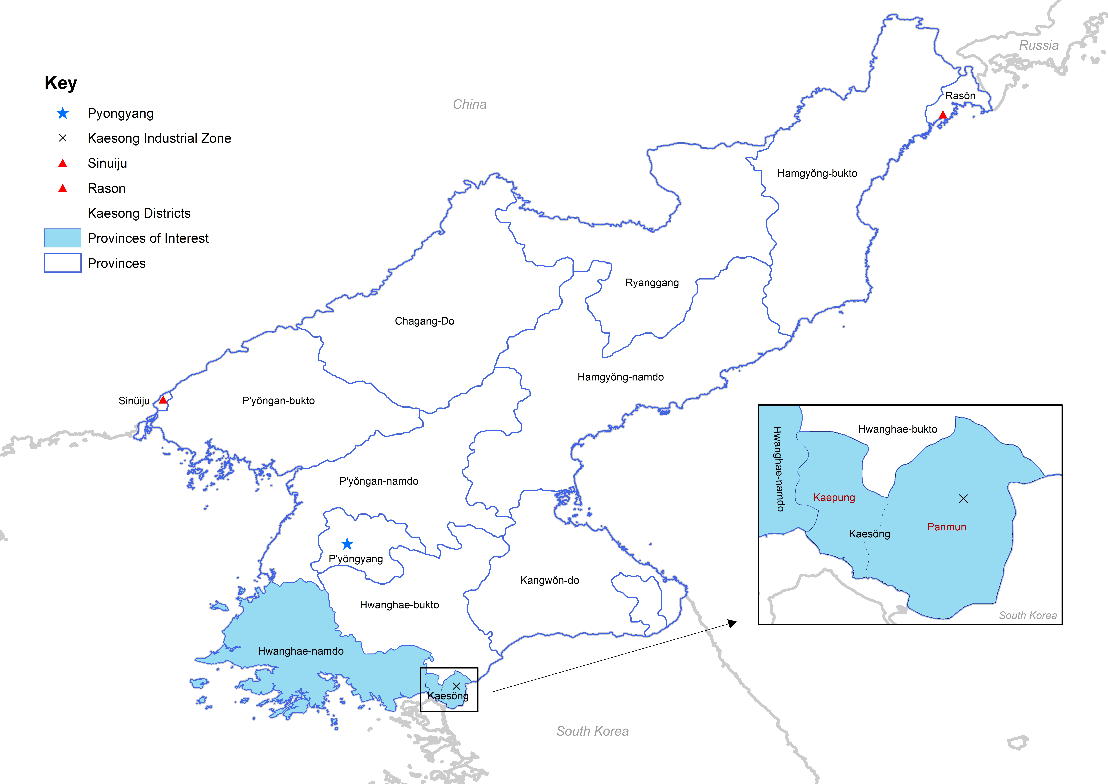
There is no guarantee that the impacts of the closure of the Kaesong Industrial Zone will be confined to Panmun District, so we also present difference-in-differences results at a more spatially aggregated level, using Kaesong City as the treated unit. The reason for this broader treatment unit is that employment at Kaesong Industrial Zone was equivalent to one-sixth of the entire population of Kaesong City so impacts beyond the Panmun District are quite likely. If Kaesong City is used as the treated unit, the neighbouring province, Hwanghae-namdo (South Hwanghae) is a natural comparison unit. Going further out, we also use all of North Korea outside of Kaesong City as a potential comparison group. In contrast to using Sinuiju and Rason as comparison groups, which are spatial units that are somewhat urbanized and illuminated, using an entire province like Hwanghae-namdo or even more so for using other parts of North Korea as comparison groups brings the very low levels of lighting in these areas into consideration, to see how the problem of false zeroes affects results.

3. Data and Econometric Methods
We use two sources of night-lights data: DMSP stable lights annual composites and VIIRS Day-Night Band (DNB) version 2.1 (V2.1 VNL) masked average radiance annual composites. Key references with details on how these annual composites are formed are Baugh et al (2010) and Ghosh et al (2021) for DMSP and Elvidge et al (2017, 2021) for VIIRS.
The DMSP data are 6-bit digital numbers (DN) ranging from 0 to 63 (with lower values for less brightly lit areas), that are reported for each 30 arc-second output pixel (which is roughly 0.9×0.7 km at the latitude of North Korea). Importantly, the output pixel size is far smaller than the spatial resolution of what the sensor can detect, where this coarse resolution of the sensor is due to effects of geolocation errors, to the aggregation of pixels to save on limited data storage and to the expansion of the footprint from viewing the earth at an angle away from the nadir (Elvidge et al, 2013; Tuttle et al, 2013; Abrahams et al, 2018). In the annual composites, ‘stable’ simply means that ephemeral lights, from sources such as fires and gas flaring, are removed before the annual composite is built up from nightly images. An alternative meaning of ‘stable’, in terms of temporal consistency, does not apply as there is no in-built calibration of the DMSP data to adjust for the constant changes in sensor amplification (that are made without any record kept, where the amplification changes are so that cloud-tops can be viewed with similar brightness across the light and dark part of the lunar cycle). Consequently, it is best to think of the DN value as a relative measure of brightness, because the same DN value in different years could correspond to different radiance values (Doll, 2008). While there are radiance-calibrated DMSP data (Elvidge et al, 1999), these are only available in certain years, and not since 2010, and so are not available for assessing the impact of the sanction of closing the Kaesong Industrial Zone in 2016.
The V2.1 VNL annual composites are produced from monthly cloud-free radiance averages, with initial filtering by remote sensing specialists (Elvidge et al, 2021) to remove extraneous features, such as fires and aurora, before a further set of outlier removal procedures are used to isolate lit grid cells from background. The data are in units of nano Watts per square centimeter per steradian (nW/cm²/sr) reported on a 15 arc-second output grid (equivalent to 0.47×0.38km at the latitude of North Korea). Unlike DMSP data, there are no blurring issues with V2.1 VNL data, with the sensor compensating for the change in ground footprint size as the earth is viewed at an angle and with no data storage constraints causing pixels to be aggregated. Moreover, the VIIRS DNB sensor can detect lights on earth in a far wider range of lighting conditions, that covers seven orders of magnitude from minimum luminosity to maximum luminosity while the DMSP sensor covers only two orders of magnitude (Gibson et al, 2020).
The inherent blurring in the DMSP images is illustrated in Figure 2, which compares the VIIRS annual composite for 2015 with the DMSP annual composite for the same year. The choice of year is deliberate, to show the situation immediately prior to the Kaesong Industrial Zone being shut down from early February 2016. In the VIIRS image the Kaesong Industrial Zone is shown as a distinct location of lights with unlit space between there and the border with South Korea (the overall far greater luminosity level in South Korea is also clearly apparent). In the VIIRS image there are 75 illuminated pixels in the Kaesong Industrial Zone, which covers an area of about 14 km² (equivalent to the combined area of 20 soccer fields).
Figure 2: Illustrating Blurring in the DMSP Images: Kaesong Industrial Zone in 2015
VIIRS DNB 2015 Annual Composite | DMSP Stable Lights 2015 Annual Composite
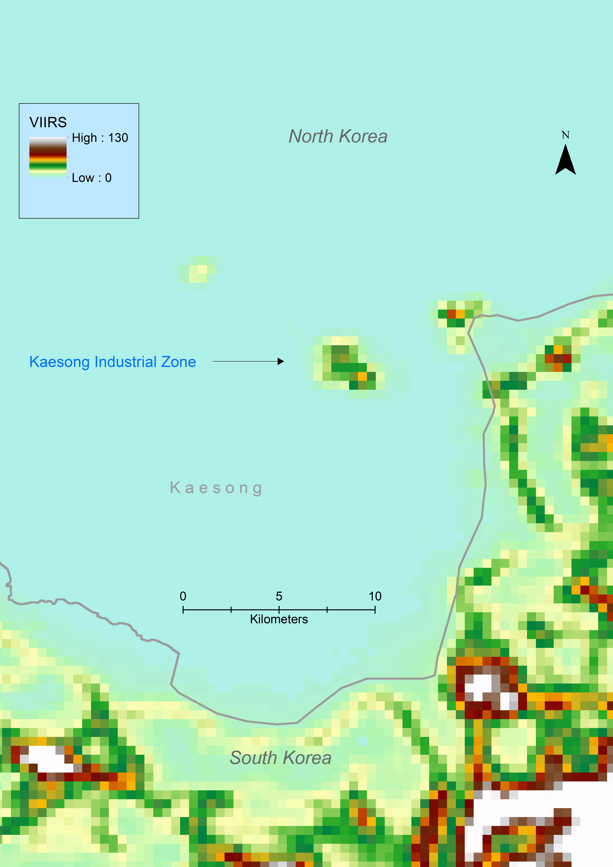 | 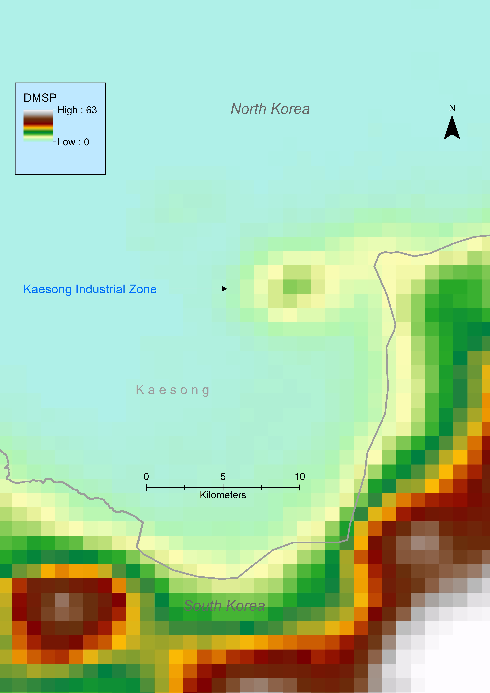
In the DMSP image the illuminated area from the Kaesong Industrial Zone appears far larger, at almost 90 km² (so over 6-times as large as what VIIRS shows). Moreover, lit area seems to extend all the way to the border with South Korea and so luminosity is attributed to unlit places (such as between the border and the Kaesong Industrial Zone), which is a common failing of the DMSP data. The blurring shown in Figure 2 suggests that results using DMSP data for micro-grids, such as the grid used by Lee (2018), may have some biases because the blurring causes a mean-reverting error which has been shown in other settings to cause econometric bias in results estimated with DMSP data (Gibson, 2021; Gibson & Boe-Gibson, 2021).
It is unclear from Figure 2 whether blurring of DMSP data is sufficient to cause bias when the spatial units are counties and districts rather than a micro-grid. In other words, even though the Kaesong Industrial Zone appears much bigger in the DMSP image in Figure 2, due to unlit areas being attributed some light from elsewhere (which causes an upwards reversion towards the mean) the scale of the map does not let us examine whether the overstatement of illuminated area is large enough to also spill over district boundaries. One sign that the bias does occur at this larger spatial scale comes from comparing quantiles of the two districts in Kaesong City because of the big gap between them in terms of luminosity. With both VIIRS and DMSP, Panmun is at the 99th percentile of the luminosity distribution (for all 186 areas in North Korea at the second sub-national level, averaged from 2012 to 2019). However, with VIIRS data Kaepyong is at the 29th percentile while it is at the 79th percentile in the DMSP data. In other words, much of the gap in luminosity between the two districts in Kaesong City is obscured with DMSP data. This may be due to Kaepyong’s rank in the luminosity distribution being inflated if blurred images attribute to it some of the lights coming from Panmun District.
Another way to examine this question is to decompose variance in luminosity into between- and within-area components, because blurring is expected to reduce the share of within-area variation. With DMSP the partial R² values for between-province and within-province components are 0.167 and 0.090, so there seems to be almost twice as much variation in economic activity between the provinces compared to the variation within provinces. Yet with the VIIRS data the two components are much more equal, with partial R² values of 0.129 and 0.120 for between and within components. In other words, the DMSP data seem to suppress within-province variation, making the constituent districts within a province appear more alike. This mean-reversion caused by blurring should attenuate econometric estimates of difference-in-differences results when a treatment like the shutting down of the Kaesong Industrial Zone is heavily concentrated in one district, given that differences between that district and the other parts of the same province will be blurred with DMSP data.
The other relevant flaw in the DMSP data, of false zeroes, is harder to show on a map. Instead, to illustrate this flaw we aggregated the night-lights data for 2015 to the district/county level (the second sub-national level) and compared distributions of the DMSP and VIIRS data. Of the 186 spatial units, 56% of them (n=105) appear to be entirely unlit in the DMSP annual composite for 2015. However, the VIIRS composite for the same year shows that over 60% of these 105 apparently unlit second-level units actually did have positive levels of luminosity. In other words, false zeroes made up more than one-half of the apparently (according to DMSP data) unlit counties and districts in 2015. This is somewhat higher than the rate found in a different setting (and using larger spatial units) by Chen & Nordhaus (2015). Across all years, the fraction of false zeroes in areas that DMSP indicated as unlit ranged from 62% to 84%, and averaged 77%. These false zeroes provide another form of non-classical measurement error (in addition to the mean-reverting error due to the blurring of the DMSP images) which could bias regression coefficients even when night-lights data are the left-hand side variable.
The basis of the econometric models is shown graphically in Figure 3, which has a comparison of trends in luminosity over time in Panmun District (where the Kaesong Industrial Zone was based) and in the rest of North Korea. The luminosity level in Panmun was much higher than in other parts of North Korea, especially prior to the closure of the Industrial Zone, so the chart is based on movements relative to the 2012 baseline in each place. In the econometric model, this same effect of adjusting for pre-treatment differences in the levels of the outcome variable is dealt with by using dummy variables for the treated unit(s).
Figure 3: Trends in Luminosity in Panmun and the Rest of North Korea
Pre-treatment
Post-treatment
In the years before the closure of the industrial zone, average luminosity in Panmun was 83% of the baseline value and this average then dropped to 49% of the baseline in the years after the closure of the industrial zone. This single difference, of a drop of about 34% based on the before and after comparison, is only a valid estimate of the impact of the sanction if everything elsewhere in North Korea stayed the same. In fact, there was some growth in luminosity in other parts of North Korea, even with the various layers of sanctions imposed. First, it helps to know that in 2015, immediately prior to the closure of the industrial zone, that the luminosity in Panmun was 0.71 of the baseline value, and this rate of decline was almost the same as for the rest of North Korea and for the neighbouring Kaepyong District (both at 0.69 of baseline). In other words, luminosity in the potential control groups had declined with the same trend as that experienced by Panmun, prior to the closure of the industrial zone, and this similarity helps to interpret the post-closure trend for those control groups as a useful guide to what might have happened in Panmun if the industrial zone had not closed.
In the rest of North Korea (that is, outside of Panmun) luminosity was able to return to slightly above baseline values by 2017, notwithstanding the various sanctions in place (Figure 3). The post-treatment years have 13% higher luminosity than the pre-treatment years for the rest of North Korea, and so combining a fall in luminosity in Panmun after closure of the industrial zone with a rise in luminosity in the rest of North Korea gives a difference-in-difference estimate of the impact of the sanction as a 47% fall in luminosity in Panmun (relative to the baseline). If instead of the rest of North Korea we use just Kaepyong as the control group, the post-treatment versus pre-treatment difference was 12%, and so rather than a decline of about one-third, as shown with a single difference approach, the difference-in-difference impact is a 46% fall in luminosity in Panmun, reflecting the reduced economic activity post-closure.
Although Figure 3 does not show it, so as to avoid clutter, movements in the DMSP DN values imply quite different impacts of closing the Kaesong Industrial Zone. Rather than a difference-in-difference estimate of luminosity falling 46% due to the sanction, as the VIIRS data show (using Kaepyong as the control group), the DMSP data suggest that luminosity in Panmun fell by less than it did in Kaepyong, implying a positive impact of closing the industrial zone.
In order to explore these differences more formally we use the following econometric model: ${ln\left(luminosity\right)}_{it}=β_{0}+β_{1}D_{i}+β_{2}T_{t}+β_{3}\left(D_{i}×T_{t}\right)+ε_{it}$ (1)
where the “luminosity” left-hand side variable is either the V2.1 VNL masked average radiance or the DMSP digital number. The spatial dummy variable $D_{i}=1$ for the treated unit and 0 for other areas. The treated unit is usually chosen to be Panmun District but we also use more spatially aggregated data and in that case set Kaesong City as the treated unit. The temporal dummy variable $T_{t}$ has a value of 1 for the post-sanction period (2016 onwards) and 0 for the pre-sanction period. The key coefficient estimate of interest is ${\hat{β}}_{3}$, which subtracts the change in the sample mean of the control group before and after the sanction from the change in the mean of the treatment group before and after the sanction, or in other words provides an estimate of the following double-difference: ${{(\overline{y}}_{T=1}-{\overline{y}}_{T=0})}_{D=1}-{{(\overline{y}}_{T=1}-{\overline{y}}_{T=0})}_{D=0}$.
The difference-in-differences results from the graphical approach in Figure 3 correspond to the type of values derived from the ${\hat{β}}_{3}$ estimates (with a logarithmic dependent variable and dummy variable regressors we use the Van Garderen & Shah (2002) estimator to calculate exact percentages and their standard errors). Our interest is in seeing how these results differ when the blurred and bottom-coded DMSP data are used instead of the more accurate VIIRS data.

4. Econometric Results
When we use VIIRS data to estimate equation (1) for getting difference-in-differences impacts of closing the Kaesong Industrial Zone, we estimate 45–64% declines in luminosity, depending on choice of comparison region (Table 1). The largest impacts are if using Rason City as the comparison region (a 64% decline in luminosity in Panmun District relative to the control group) and the smallest from using Sinuiju City (a 45% impact on Panmun). The average impact, across the five different control group regions used in Table 1, is a 52% decline in the luminosity of Panmun District after closure of the Kaesong Industrial zone compared to what would have been expected from temporal changes in other parts of North Korea.
Table 1: Using VIIRS Data to Estimate Difference-in-Differences Impacts on Luminosity of Closing the Kaesong Industrial Zone: Panmun District as the Treated Area with Various Control Groups
 | ------------------------ Control Group ------------------------
 | Kaepyong District | Rason (Special City) | Sinuiju  City | Hwanghae-namdo | Rest of North  Korea
Constant, $\left(β_{0}\right)$ | 2.238*** | 6.150*** | 7.903*** | 7.257*** | 10.116***
 | (0.197) | (0.116) | (0.044) | (0.090) | (0.104)
Treated group (D), $\left(β_{1}\right)$ | 5.275*** | 1.363*** | −0.390*** | 0.256** | −2.603***
 | (0.212) | (0.140) | (0.089) | (0.119) | (0.130)
Sanction period (T), $\left(β_{2}\right)$ | 0.109 | 0.465 | 0.050 | 0.141 | 0.127
 | (0.281) | (0.184) | (0.073) | (0.124) | (0.135)
Treated × Sanction, $\left(β_{3}\right)$ | −0.646** | −1.001*** | −0.586*** | −0.677*** | −0.663***
 | (0.296) | (0.206) | (0.118) | (0.155) | (0.164)
D-in-D percentage impact | −49.8% | −64.0% | −44.7% | −49.8% | −49.1%
(Standard error of impact) | (14.5) | (7.3) | (6.5) | (7.7) | (8.3)
Note: Each column represents a separate estimate of equation (1), using VIIRS V2.1 VNL masked average radiance annual composites from 2012-19, with samples varying according to the control group used in columns (1) to (5). Robust standard errors in ( ), with the ***, **, * representing statistical significance at the 1%, 5% and 10% levels. The percentage impact values and their standard errors are derived from the estimates for $β_{3}$ in the table, using the approximate unbiased variance estimator of van Garderen and Shah (2002).
The difference-in-differences estimates of the impacts, based on ${\hat{β}}_{3},$ are surrounded by small standard errors (on average, the robust standard errors are just one-quarter of the absolute value of the coefficient, with a range from about one-fifth to one-half). In other words, the impact of this particular sanction is fairly precisely estimated, even though there are not many annual observations before and after the event that we study.
We also get similar results if we study the impacts of closing the Kaesong Industrial Zone using a more spatially aggregated treatment group. Specifically, the results in Table 2 use Kaesong City as the treated unit. This aggregates Panmun District, where the industrial zone was located, and Kaepyong District which is the other sub-unit of Kaesong City, to allow for spillovers. Such spillovers are possible, given that the total employment in the industrial zone was equivalent to one-sixth of the entire population – rather than just of the working age population, which is not available to us – of Kaesong City. With the industrial zone workforce being such a large fraction of Kaesong City population, some workers may have resided in the Kaepyong District, creating second-round impacts on luminosity there due to the closure.
Table 2: Using VIIRS Data to Estimate Difference-in-Differences Impacts on Luminosity of Closing the Kaesong Industrial Zone: Kaesong City as the Treated Area with Various Control Groups
 | -------------------- Control Group --------------------
 |  | Rason (Special City) | Sinuiju  City | Hwanghae-namdo | Rest of North  Korea
Constant, $\left(β_{0}\right)$ |  | 6.150*** | 7.903*** | 7.257*** | 10.115***
 |  | (0.116) | (0.044) | (0.090) | (0.104)
Treated group (D), $\left(β_{1}\right)$ |  | 1.368*** | −0.385*** | 0.261** | −2.597***
 |  | (0.140) | (0.089) | (0.119) | (0.130)
Sanction period (T), $\left(β_{2}\right)$ |  | 0.465** | 0.050 | 0.141 | 0.127
 |  | (0.184) | (0.073) | (0.124) | (0.135)
Treated × Sanction, $\left(β_{3}\right)$ |  | −0.996*** | −0.581*** | −0.672*** | −0.657***
 |  | (0.206) | (0.117) | (0.155) | (0.163)
D-in-D percentage impact |  | −63.8% | −44.4% | −49.5% | −48.9%
(Standard error of impact) |  | (7.4) | (6.5) | (7.8) | (8.3)
Notes: See Table 1.
The difference-in-differences estimates show that over the four different control group regions used in Table 2 there is an average 52% decline (ranging from -44% to -64%) in the luminosity of Kaesong City following the closure of the industrial zone, compared to what would have been expected from movements in luminosity in other parts of North Korea. This estimated treatment impact is similar to the average of the estimates in Table 1, so allowing for potential spillovers by using more spatially aggregated data does not alter the apparent effectiveness of the sanction in this example. Likewise, using the more spatially aggregated treated unit does not cause much change in the precision of the difference-in-difference effects compared to the results in Table 1. Specifically, the difference-in-difference percentage impact effects remain statistically significant at the 1% level.
4.1 Results Using DMSP Data
In contrast to the precisely estimated impacts with the VIIRS data, which were reported in Table 1 and Table 2, if the DMSP data are used for the same years and the same treatment and control groups, the apparent impacts on economic activity of closing the Kaesong Industrial Zone are smaller and are imprecisely estimated. The results in Table 3 show that the estimated impacts of this sanction, when using the DMSP data, range from +23% to -68%. Across the five estimates in Table 3, the DMSP data suggest, on average, a 33% decline in luminosity in Panmun District relative to what would be expected from the changes over time in other parts of North Korea. This average is just three-fifths of the average impact in Table 1 estimated using VIIRS data with the same specification for the same spatial units and with the same time period. Moreover, only one of the five estimates of ${\hat{β}}_{3}$ in Table 3 is statistically significant (and only at the 10% level) when using the DMSP data, whereas four estimates of ${\hat{β}}_{3}$ in Table 1 were statistically significant at the 1% level and one was significant at the 5% level, when using the VIIRS data. In other words, if an evaluation relied on DMSP data, conclusions about the impact of this sanction on North Korea are likely to be distorted because of the underestimation and imprecision of the difference-in-differences impacts.
Table 3: Using DMSP Data to Estimate Difference-in-Differences Impacts on Luminosity of Closing the Kaesong Industrial Zone: Panmun District as the Treated Area with Various Control Groups
 | ------------------------ Control Group ------------------------
 | Kaepyong District | Rason (Special City) | Sinuiju  City | Hwanghae-namdo | Rest of North  Korea
Constant, $\left(β_{0}\right)$ | 6.543*** | 7.145*** | 8.940*** | 7.834*** | 11.252***
 | (0.523) | (0.234) | (0.138) | (0.393) | (0.239)
Treated group (D), $\left(β_{1}\right)$ | 2.595*** | 1.993*** | 0.198 | 1.304** | −2.115***
 | (0.601) | (0.377) | (0.326) | (0.492) | (0.380)
Sanction period (T), $\left(β_{2}\right)$ | −1.285** | −0.027 | −0.294* | −0.554 | −0.356
 | (0.579) | (0.258) | (0.143) | (0.413) | (0.245)
Treated × Sanction, $\left(β_{3}\right)$ | 0.427 | −0.830* | −0.564 | −0.303 | −0.502
 | (0.659) | (0.406) | (0.345) | (0.519) | (0.398)
D-in-D percentage impact | 23.4% | −59.9% | −46.4% | −35.5% | −44.1%
(Standard error of impact) | (73.2) | (15.7) | (18.0) | (31.3) | (21.4)
Note: Each column represents a separate estimate of equation (1), using DMSP stable lights annual composites from 2012-19, with samples varying according to the control group used in columns (1) to (5). Other notes, see Table 1.
A consideration of the measurement error properties of DMSP data may help explain why the impact estimates in Table 3 are only about one-half as large as the VIIRS-based estimates were in Table 1. Consider a regression model:$y=α+βx+u,$ where y is an outcome variable, the independent variable is x, the response coefficient is β, and there is a pure random error, u. The outcome variable has an observed value $y^{*}$ that is related to the true value by:
$y^{*}=θ+λy+v$ (2)
The textbook case of classical measurement error makes the assumptions that $θ=0, λ=1$ and $E\left(v\right)=cov\left(y,v\right)=cov\left(x,v\right)=cov\left(u,v\right)=0,$ so that just white noise is added to the true value. However, existing evidence on measurement errors in DMSP data is inconsistent with these textbook assumptions. Specifically, these studies treat VIIRS data as the true value, y and the DMSP data as the mis-measured variable, $y^{*}$ in order to empirically estimate equation (2). With pixel-level data for urban areas that are predominantly in developing countries, Alimi et al (2022) estimate $\hat{λ}=0.3.$ A higher estimate, of $\hat{λ}=0.7,$ comes from regional data for Europe at the NUTS2 level (Gibson, 2021); this level of aggregation uses provinces in some countries and groupings of counties in others (with a mean population of 1.4 million per spatial unit). When we use the second sub-national level data for North Korea to estimate equation (2) we get $\hat{λ}=0.40 \left(±0.05\right).$ That our estimate is between these two prior estimates is consistent with our use of a level of spatial aggregation that lies between the spatial aggregation levels used in these two prior studies because at least one source of the mean-reverting error is blurring of the DMSP images, and the blurring problem is relatively larger the smaller the spatial units.
With the textbook case of classical measurement error, the $\hat{β}$ is not biased if the mis-measured variable is on the left-hand side of a regression. However, when the errors are mean-reverting, $0<λ<1,$ which is the situation for DMSP data, the estimator of the response coefficient is biased if the error-ridden dependent variable is used. Specifically, the estimator is:
$β_{y^{*}x}=\frac{cov\left(y^{*}, x\right)}{var\left(x\right)}=\frac{cov\left(λα+λβx+λu-v,x\right)}{var\left(x\right)}=λβ$ (3)
In other words, with mean-reverting errors in the DMSP data, the difference-in-differences estimator of equation (1), for the impact of closing the Kaesong Industrial Zone, is expected to be attenuated in some proportion to the estimated mean-reversion parameter $\hat{λ}$ (the effect will be an approximation because of the presence of other covariates in equation (1) whereas the equation (3) result is based on a regression with no other covariates). The attenuated size of the average impacts calculated from the DMSP data in Table 3, when compared to the Table 1 results using VIIRS data, are consistent with what equation (3) shows. Specifically, with DMSP data as the outcome measure the difference-in-differences estimates gave impacts that are only about one-half as large as the impacts estimated with the more accurate data.
4.2 Effects of Different Treatments for False Zeros
The mean-reverting errors in the DMSP data that are causing attenuation of the impact estimates from the difference-in-differences regressions have at least two sources. One is the blurring of the DMSP images, which was shown visually in Figure 2. Another factor is the false zeros, where dimly lit areas are wrongly assessed by DMSP data as being totally unlit. The comparisons reported in Section 3 suggest that over one-half of the occurrences of zeros in the DMSP data for the second sub-national level of North Korea are false, because the VIIRS data show positive levels of luminosity in these same areas in the same year. We illustrate the impact of false zeros using Hwanghae-namdo and the rest of North Korea as the control groups because the other control groups (such as Rason and Sinuiju) are more urbanized; false zeros are likely to matter more for dimly-lit areas rather than for built-up urban areas.
The results for the difference-in-differences estimator, ${\hat{β}}_{3}$ of using various approaches to deal with zeros in the DMSP data are shown in Table 4. The first two rows of the table reproduce the coefficients reported in Table 1 using VIIRS data, and the coefficients reported in Table 3 using DMSP data. We are interested in whether approaches for dealing with zeros in DMSP data move the coefficients from their Table 3 values to being closer to the Table 1 values, which we view as a movement closer to the truth given the greater accuracy of the VIIRS data. Two approaches to zeros in DMSP data are used: (a) false zeros are replaced by the corresponding VIIRS values (which, by definition, are non-zero if the DMSP data are a false zero), (b) false zeros are given an ad hoc transformation, of adding 0.01 so that logarithms can be taken. This sort of ad hoc transformation is common; for example, the sanctions study by Lee (2018) added 0.01 to all DMSP values before they were logarithmically transformed, in order to get around the problem of the logarithm of zero being undefined.
Table 4: Effect on Estimates of the Key Difference-in-Differences Parameter, $\left(β_{3}\right)$ of Different Approaches to Dealing With Zeros in DMSP Data
 |  |  |  | Control Group
 |  |  |  | Hwanghae-namdo | Rest of North  Korea
Baseline results
1. Using VIIRS data for all observations (copied from Table 1) |  |  |  | −0.677*** | −0.663***
 |  |  |  | (0.155) | (0.164)
2. Using DMSP data for all observations (copied from Table 3) |  |  |  | −0.303 | −0.502
 |  |  |  | (0.519) | (0.398)
Treatment of zeros in DMSP data
3. Replacing false zeros in DMSP data with VIIRS values |  |  |  | −0.671 | −0.566*
 |  |  |  | (0.446) | (0.300)
4. Replacing false zeros in DMSP data with 0.01 prior to taking logs |  |  |  | −0.304 | −0.502
 |  |  |  | (0.519) | (0.398)
Note: Each cell has results of a separate estimate of equation (1), with the $β_{0}, β_{1}, and β_{2}$coefficient estimates not reported. The treated unit is Panmun District, and the control groups are noted in the column headings. Other notes, see Table 1.
False zeros in DMSP data are a large contributor to the mean-reverting errors that attenuate difference-in-differences estimates of the impacts of closing the Kaesong Industrial Zone. Over 35% of DMSP observations are for areas (and years) that seem to be completely unlit when in fact in those same times and places the VIIRS data show that they are illuminated. If these false zeros are replaced by the more accurate VIIRS value, the estimated mean-reversion parameter from equation (2), $\hat{λ}$, rises from 0.40 (±0.05) to 0.91 (±0.02). Thus adjusted data should have less attenuation in the difference-in-differences estimator of the sanction impacts (according to equation (3)). The results in row (3) of Table 4 bear this out; about 70% of the gap between the row (1) and row (2) values—that is, the smaller apparent impact of closing the industrial zone when using DMSP data rather than VIIRS data—is removed by replacing the false zeros with the VIIRS data. Of course this treatment is not possible if a study relies totally on the DMSP data, which has typically been the case in the literature estimating impacts of sanctions.
If we follow the common practice of adding a small constant, such as 0.01, to the data prior to creating the logarithm of the DMSP values, almost none of the gap between the row (1) and row (2) values is closed. Specifically, applying this ad hoc transformation to the false zeros hardly changes the difference-in-difference coefficients from what is reported in Table 3 with this adjustment not applied. Thus, based on the exercises reported in Table 4, finding better solutions for the issue of bottom-coded false zeros when DMSP data are used for evaluations in poorly illuminated places would be valuable.

5. Conclusions
In this paper we have used two different data sources to study a particular sanction on North Korea, the closure of the Kaesong Industrial Zone in early 2016. The widely used DMSP night-time lights data provide estimates of the impact of this sanction which are far smaller, and are generally imprecise, than what is revealed by the more accurate VIIRS data. The understated impact of the sanction when DMSP data are used is due to two main issues: (a) mean-reverting errors, which are likely due to blurring caused by poor spatial resolution of the DMSP sensor and by limited on-board data storage that result in pixel aggregation, and (b) false zeros, which are due to the poor low-light detection capability, recalling that the original objective of DMSP was to observe clouds and little amplification of the sensor is needed for this purpose during the brightly lit part of the lunar cycle. While previous studies have noted that DMSP data have some measurement errors, the implications of these errors for popular econometric models such as the difference-in-differences estimator have not been highlighted. To the extent that the patterns that we find hold more generally, conclusions about the impact of sanctions that have relied upon DMSP data may need to be revisited because it is likely that the impacts have been understated due to the mean-reverting measurement errors in DMSP data.

References
Abrahams, Alexei, Christopher Oram and Nancy Lozano-Gracia (2018) Deblurring DMSP night-time lights: A new method using Gaussian filters and frequencies of illumination. Remote Sensing of Environment 210(1): 242-258.
Arbatli, Cemal Eren, and David Gomtsyan (2021) Sectarian aid, sanctions and subnational development. European Economic Review 139(1): 103891.
Baugh, Kimberly, Christopher Elvidge, Tilottama Ghosh, and Daniel Ziskin (2010) Development of a 2009 stable lights product using DMSP-OLS data. Proceedings of the Asia-Pacific Advanced Network 30(1): 114.
Bellemare, Marc, and Casey Wichman (2020) Elasticities and the inverse hyperbolic sine transformation. Oxford Bulletin of Economics and Statistics 82(1): 50-61.
Bluhm, Richard, and Melanie Krause (2022) Top lights - bright cities and their contribution to economic development. Journal of Development Economics 157(1): 102880.
Chen, Xi, and William Nordhaus (2015) A test of the new VIIRS lights data set: Population and economic output in Africa. Remote Sensing 7(4): 4937-4947.
Ditzen, Jan, Yiannis Karavias, and Joakim Westerlund (2021) Xtbreak: Estimating and testing for structural breaks in Stata. https://janditzen.github.io/xtbreak/
Doll, Christopher (2008) CIESIN Thematic Guide to Night-time Light Remote Sensing and its Applications. Center for International Earth Science Information Network, Columbia University, New York.
Elvidge, Christopher, Kimberly Baugh, John Dietz, Theodore Bland, Paul Sutton, and Herbert Kroehl (1999) Radiance calibration of DMSP-OLS low-light imaging data of human settlements. Remote Sensing of Environment 68(1): 77-88.
Elvidge, Christopher, Kimberly Baugh, Mikhail Zhizhin, and Feng-Chi Hsu (2013) Why VIIRS data are superior to DMSP for mapping night time lights. Proceedings of the Asia-Pacific Advanced Network 35(1): 62-69.
Elvidge, Christopher, Kimberly Baugh, Mikhail Zhizhin, Feng Chi Hsu, and Tilottama Ghosh (2017) VIIRS night-time lights. International Journal of Remote Sensing 38(21): 5860-5879.
Elvidge, Christopher, Mikhail Zhizhin, Tilottama Ghosh, Feng-Chi Hsu, and Jay Taneja (2021) Annual time series of global VIIRS nighttime lights derived from monthly averages: 2012 to 2019. Remote Sensing 13(5): 922
Falchi, Fabio, and Pierantonio Cinzano (1998) Maps of artificial sky brightness and upward emission in Italy from DMSP measurements. arXiv preprint astro-ph/9811234.
Farzanegan, Mohammad Reza, and Sven Fischer (2021) Lifting of international sanctions and the shadow economy in Iran-A view from outer space. Remote Sensing 13(14): 4620.
Ghosh, Tilottama, Kimberly Baugh, Christopher Elvidge, Mikhail Zhizhin, Alexey Poyda, and Feng-Chi Hsu (2021) Extending the DMSP nighttime lights time series beyond 2013. Remote Sensing 13(24): 5004.
Gibson, John (2021) Better night lights data, for longer. Oxford Bulletin of Economics and Statistics 83(3): 770-791.
Gibson, John, and Geua Boe-Gibson (2021) Nighttime lights and county-level economic activity in the United States: 2001 to 2019. Remote Sensing 13(14): 2741.
Gibson, John, Susan Olivia and Geua Boe-Gibson (2020) Night lights in economics: Sources and uses. Journal of Economic Surveys 34(5): 955-980.
Gibson, John, Susan Olivia, Geua Boe-Gibson and Chao Li (2021) Which night lights data should we use in economics, and where? Journal of Development Economics 149(1): 102602.
Henderson, Vernon, Adam Storeygard, and David Weil (2012) Measuring economic growth from outer space. American Economic Review 102(2): 994-1028.
Kim, Jihee, Kyoochul Kim, Sangyoon Park, and Chang Sun (2021) The economic costs of trade sanctions: Evidence from North Korea. Mimeo http://jiheekim.net/files/paper_NorthKorea.pdf
Lee, Yong Suk (2018) International isolation and regional inequality: Evidence from sanctions on North Korea Journal of Urban Economics 103(1): 34-51.
Miller, Steven, Stephen Mills, Christopher Elvidge, Daniel Lindsey, Thomas Lee and Jeffrey Hawkins (2012) Suomi satellite brings to light a unique frontier of nighttime environmental sensing capabilities. Proceedings of the National Academy of Sciences 109(39): 15706-15711.
Son, Sung Hyun and Joonmo Cho (2021) Are economic sanctions against North Korea effective? Assessing nighttime light in 25 major cities. Pacific Affairs 94(3): 464-492.
Tuttle, Benjamin, Sharolyn Anderson, Paul Sutton, Christopher Elvidge, and Kim Baugh (2013) It used to be dark here. Photogrammetric Engineering & Remote Sensing 79(3): 287-297.
van Garderen, Kees and Chandra Shah (2002) Exact interpretation of dummy variables in semilogarithmic equations. The Econometrics Journal 5(1): 149-159.
Vuong, Quang (1989) Likelihood ratio tests for model selection and non-nested hypotheses. Econometrica 57(2): 307-333.
Zhang, Xiaoxuan and John Gibson (2022) Using multi-source nighttime lights data to proxy for county-level economic activity in China from 2012 to 2019. Remote Sensing 14(5): 1282.

Address for correspondence: jkgibson@waikato.ac.nz, Department of Economics, University of Waikato, Private Bag 3105, Hamilton 3240, New Zealand.
A growing empirical literature shows VIIRS data are far more accurate than DMSP data. Early discussion of the theoretical superiority of VIIRS over DMSP for studying night-lights includes Miller et al (2012) and Elvidge et al (2013); this second reference notes that VIIRS data are up to 45-times more accurate than DMSP data. More recently, empirical comparisons with non-nested tests show that models using VIIRS data provide results that are closer to the truth than are models using DMSP data (Gibson, 2021; Zhang & Gibson, 2022).
A Google Scholar search on 11 March 2022 for “DMSP” and “sanctions” returned 458 results, while a similar search for “VIIRS” and “sanctions” returned only 138 results. Likewise, using IDEAS/RePEc we found more than twice as many articles using DMSP than using VIIRS, attesting to the comparative popularity of DMSP data in this literature.
The ground footprint expands away from the nadir because of the angle of viewing the earth. Although DMSP has a 3000 km wide swath, only data from the central 1500 km of the swath are used to form annual composites because further out towards the extremes the ground footprint grows to be four-times as large as at the nadir (Falchi and Cinzano, 1998). Thus, at swath extremities the ground footprint covers approximately 100 km² and all light from that area is wrongly attributed to the pixel at the centre of the footprint (Abrahams et al, 2018).
This is equivalent to the situation in China, where Chongqing is one of four centrally-controlled municipalities and this “city” covers as area as large as Austria, and only a small part of it is densely built-up urban area.
Monthly lights data are available but are not cleaned and processed to the same extent as annual composites and there are often missing observations due to the impacts of stray light in some seasons (Gibson, 2021).
The DMSP data are available from: https://eogdata.mines.edu/products/dmsp/#download and the VIIRS data from https://eogdata.mines.edu/nighttime_light/annual/v21/. The DMSP data are from satellite F18 for 2012-13 and from F15 from 2014 onwards. There are different observation times for these two satellites with F18 having a late evening (ca. 10pm) observation time and F15 an early morning (ca. 3.30am) observation time (while the observation time of VIIRS is in the middle, at ca. 1.30am). We used a test for known break-points due to Ditzen et al (2021), to see if the change in the time of observing earth for the two DMSP satellites affected the difference-in-differences results and it did not. We also compared the proportion of unlit observations at the second sub-national level for North Korea according to F18 (0.48) and to F15 (0.50), with no significant difference due to the change in observation time apparent. In terms of VIIRS, comparisons between the various data products described by Elvidge et al (2021) show that the masked average radiance annual composite that we use here provides the best proxy (amongst the various VIIRS data products) for economic activity, using a panel of United States county-level and state-level GDP as a benchmark (Gibson & Boe-Gibson, 2021).
Examples from elsewhere also show that DMSP overstates lit area by 6-fold or more (Gibson et al, 2020) due to the inherent blurring of the images.
A test for parallel trends in the pre-treatment 2012-15 period does not reject (p<0.54) the null of no difference in the luminosity trends for Panmun and the rest of North Korea.
Support for the assumption that the VIIRS data can be used as the true value comes from Vuong (1989) tests that show that models using VIIRS data provide results that are closer to the truth than are models using DMSP data (Gibson, 2021; Zhang & Gibson, 2022).
The mean population per second sub-national unit in North Korea is approximately 0.14 million—one-tenth of the mean for the spatial units used in the study for Europe but far higher than the mean population per pixel for the Alimi et al (2022) study, corresponding to an intermediate level of spatial aggregation used here.
We did not consider using Kaepyong District as a control group for this exercise because with the DMSP data the coefficient switches from negative to positive—implausibly implying that luminosity in Panmun rose after the closure of the industrial zone. This switch in sign makes it harder to interpret any closing of the gap between difference-in-difference coefficients estimated with DMSP data compared to those estimated with VIIRS data.
This type of ad hoc transformation is common in the economics literature using DMSP data. In the review by Gibson et al (2020), almost 40% of studies with DMSP night lights data on the left-hand side of regressions added a small constant to the data before creating the logarithms.

