UNIVERSITY OF WAIKATO
Hamilton
New Zealand

The Role of Communication in Asset Market Experiments

Carol Luengo, Steven Tucker, Yilong Xu, Frank Scrimgeour and Kun Zhang

Working Paper in Economics 5/26

Revised August 2026

Corresponding Author

Steven Tucker

Waikato Management School
University of Waikato
Private Bag 3105
Hamilton, 3240
New Zealand

Email: steven.tucker@waikato.ac.nz

Carol Luengo and Frank Scrimgeour

Waikato Management School
University of Waikato

Yilong Xu
Utrecht School of Economics
Utrecht University

Kun Zhang
Business School
University of Jinan

Abstract
This study investigates the effect of continuous, free-form communication among traders on mispricing in experimental asset markets. We compare three fundamental value regimes: a constant fundamental value without interest, a decreasing fundamental value, and a constant fundamental value generated by dividends and interest on cash. Evidence indicates that the constant fundamental value with interest environment is the one that participants find hardest to understand. Communication's impact is examined by allowing participants to engage in unrestricted text chat during market trading sessions. We hypothesized that the benefits of communication, such as reducing confusion, correcting misconceptions, and promoting common beliefs, would be larger in market environments that traders find harder to understand. We find a marginal reduction in mispricing only in the environment participants found hardest to understand. Overall, communication has, at best, a marginal effect on pricing efficiency, and only in the most demanding of the three environments.

Keywords
communication
asset market experiment
mispricing

JEL codes
C90
C91
G12

Acknowledgement
We gratefully acknowledge the financial support of the University of Waikato. Carol Luengo acknowledges the support from the scholarship funded by the Agencia Nacional de Investigación y Desarrollo (ANID) / Beca de Doctorado en el Extranjero Becas Chile / 2022 - 72220236.

- Introduction
Communication between asset market traders beyond that of direct market participation has increased over recent decades with advances in information technology. Professional messaging services such as Bloomberg Instant Messaging, Symphony, and Thomson Reuters Eikon Messenger have become an integral tool for institutional traders. These tools allow traders to exchange ideas and research, submit trade inquiries, discuss pricing and news, and send indications of interest. Social trading platforms and online forums such as StockTwits, TradingView, and Reddit’s r/WallStreetBets are commonly used by retail traders to communicate and connect to one another. Even though communication among traders is so well integrated within market activity, the impact that communication has on market efficiency is not clear.
In this paper, we study the impact of continuous free-form communication on mispricing across three types of long-lived assets. To do so, we use pre-registered laboratory experimental asset markets (https://aspredicted.org/pxn3-tv9s.pdf). Ethical approval for this study was obtained from the Waikato Management School Ethics Committee on 27 March 2023. Experiments allow us to separate the effects of the market pricing mechanism from the social impacts of communication. We have complete control over both the intrinsic valuation of the asset via various fundamental value processes and the ability of traders to communicate. Our chat is anonymous, is not linked to market activity, and does not persist beyond a single market. Our results therefore speak to what free-form talk alone can accomplish, and are best read as a lower bound on the effect of communication in settings where senders can be evaluated and identified.
The three assets differ in how their payoff structures determine fundamental value. The first asset has zero expected dividends and a terminal buyout value, which gives it a constant fundamental value, as in Noussair et al. (2001). The second asset pays positive expected dividends and has no terminal value, so its fundamental value declines over the market horizon, as in Smith et al. (1988). The third asset has positive expected dividends, a terminal buyout value, and interest on cash holdings, which together generate a constant fundamental value, as in Holt et al. (2017). The corresponding market environments also differ in the cash transfer, loan, and interest rules used to keep the C/A ratio comparable across treatments. These differences across markets may lead participants to find some market environments more difficult to understand than others. This variation allows us to study whether the effect of communication depends on market difficulty. As we show below, participants found the third market environment the most difficult to understand.
On the one hand, communication may mitigate mispricing by allowing for more easily discernible messages than solely the information presented within trading activity. More specifically, richer text messages may allow for social learning (Shiller, 1984), i.e., some traders may want to teach others about what they believe is the right thing to do based on their own understanding of the market. Effective communication networks may also enable traders to correct misconceptions or speculative beliefs that contribute to asset mispricing, reducing informational asymmetries and speculative bubbles (Shiller, 2000; Engelberg and Parsons, 2011; Tucker and Xu, 2024a, 2024b). The reduction of confusion, the establishment of common knowledge of rationality across traders, and the opportunity to learn about market sentiments all point in the direction that communication may improve pricing efficiency (Antweiler and Frank, 2004; Tetlock, 2007; Angeletos and La'O, 2013). Therefore, communication among traders may play a pivotal role in reducing persistent mispricing and contribute positively to overall market efficiency.
On the other hand, communication may also impair market efficiency by facilitating the spread of unintentional misinformation arising from confusion, or intentional misinformation intended to support speculative capital gains, which may lead to sustained mispricing (Shiller, 2000; Hirshleifer and Teoh, 2009; Guler et al., 2025; Tucker and Xu, 2024b). Communication may also encourage herding, trend-following behavior, and overconfidence, amplifying existing positive or negative sentiment, and reinforcing investors’ pre-existing beliefs via confirmation bias. Its effects on price discovery are not yet clear, especially in the absence of counterfactuals where the traders are not allowed to chat.
In other economic settings, communication has been shown to improve efficiency and welfare: for instance, bargaining games (e.g., Agranov and Tergiman, 2014; Bolton et al., 2003; Bradfield and Kagel, 2015), coordination games (e.g., Cooper et al., 1992; Charness, 2000; Charness and Grosskopf, 2004; Charness and Rabin, 2005; Charness and Dufwenberg, 2006; Brandts and Cooper, 2007; Brandts et al., 2016; Charness and Ellman, 2016) and social dilemmas (e.g., Isaac and Walker, 1988; Ledyard, 1995; Chaudhuri, 2011; Oprea et al., 2014).
Despite this potential, evidence on communication in asset markets is surprisingly thin. Oechssler et al. (2011) study the impact of communication and insider information in a multi-asset market experiment. Their markets consisted of five different assets with constant fundamental values. Communication was free-form and public, so that all messages were visible to all traders. It was permitted only before the start of each period, with no chat before period one. They find that communication reduces mispricing relative to when communication is not allowed. Corgnet et al. (2024) study the effect of communication on market efficiency in short-lived asset market experiments (Plott and Sunder, 1982, 1988). They conduct a series of markets in which traders have the opportunity to send private messages to a subset or public messages to all other traders prior to the start of each period. The set of messages was pre-fabricated and associated with a signal of their private information. They find that simple, pre-market communication allows for private information to be conveyed more effectively, especially when traders’ reputations are at stake.
To our knowledge, there are two studies utilizing long-lived asset market designs that are prone to the bubble and crash phenomenon (Smith et al., 1988). Hargreaves Heap and Zizzo (2011) allow for free-form communication via an online anonymous chat “room” that is available continuously across the market. All discussions within the chat room were visible to all traders and thus public information. They do not find evidence that communication reduces mispricing. Steiger and Pelster (2020) provide two different means of one-on-one private communication as treatment conditions. The first is the ability to send a simple, private message in the form of a social media type “like” on a trader’s market activity. The second is the ability to communicate face-to-face within a large auditorium. When a communication condition is in effect, traders can use that form of communication continuously across the market session. They find that both forms of communication increase mispricing, with face-to-face communication generating larger bubbles than the social media type interactions.
The effect of communication may depend on the difficulty of the market environment. When the payoff process and associated cash flow rules are harder to understand, traders are more likely to make mistakes, remain confused about the market environment, and fail to share common beliefs about rational pricing. This concern is consistent with the in Smith et al. (1988), Lei et al. (2001), Oechssler (2010), Kirchler et al. (2012), and Bosch-Rosa et al. (2018). In more difficult market environments, communication may be more valuable because traders can explain the relevant rules, correct misconceptions, and make pricing logic more salient to others. These considerations motivate the conjecture that communication reduces mispricing more when the market environment is more difficult for participants to understand. We did not pre-specify a difficulty ranking across our three environments. The ranking reported in Section 3.1 is established from the auxiliary survey described in Section 2.3, so difficulty serves as an interpretive lens on our results.
Our results show that the market environment participants found most difficult to understand also generated the greatest mispricing. In that environment, communication is associated with lower mispricing, but we find little evidence that it reduces mispricing in the other two environments. Overall, communication has only modest effects on market outcomes. We then use a large language model to classify the content of trader communication. The chat analysis provides little evidence of a broad channel through which communication systematically reduces mispricing. In the market environment where communication is associated with lower mispricing, teaching statements are associated with lower mispricing only in markets where mispricing is already relatively low.
The results contribute to the literature in three ways. First, we provide a systematic study of free-form communication in long-lived asset markets across three commonly used market environments. Second, we examine whether the effect of communication differs across market environments that hold the initial C/A ratio constant, but differ in the payoff process, cash transfers, loans, and interest rules that participants must understand. We do not use these comparisons to identify the separate effect of any one feature. Instead, we relate the pattern of results to participants’ perceived and demonstrated difficulty in understanding the environments. Third, we contribute to the emerging literature on the use of large language models to classify communication in experiments.
The rest of the paper is organized as follows. Section 2 describes the experimental design, procedures, and auxiliary survey used to assess how difficult participants found the asset market environments. Section 3 presents the results. It begins with evidence on market difficulty, followed by the effect of communication on mispricing and the analysis of trader communication. Section 4 concludes.

2. Experimental Design
2.1 Experimental Markets and Treatments
In each session, eight participants traded an asset called X with a life of 15 periods in an open-book continuous double auction (Smith, 1962; Plott and Gray, 1990). The experiment was computerized using the z-Tree software package (Fischbacher, 2007). Each subject received an endowment of experimental currency, called francs, together with 10 units of asset X. Cash balances and asset inventories carried over from one trading period to the next.
At the end of each trading period, each asset paid a dividend drawn randomly and independently from a known four-point distribution, with each outcome equally likely. Therefore, the expected value of the dividend payment could be calculated for each period. The value of the dividend did not depend on the owner of the asset, and in each period, all assets in the market paid the same dividend. The dividend payments were added to the cash balance of the asset’s owner. Francs were converted to Chinese Yuan at the end of the experiment at a predetermined, publicly known exchange rate.
The experiment consisted of two treatment variables, communication and asset market environment. In the communication treatment (C), participants either traded in the standard no communication environment (NC) or in an environment with free form text chat available throughout the market. Chat messages were visible to all participants in the market. Each participant was assigned an anonymous chat ID, which allowed messages to be tracked over time but did not link messages to market activity. Market activity was also presented anonymously. The chat box was cleared at the start of each new period. The asset market environment treatment consisted of three conditions: Downward (D), Constant without Interest (CNI), and Constant with Interest (CI). The treatments are summarized in Table 1.

Table 1. Treatment summary by communication condition and asset market environment
Treatment | Communication | Initial Cash | Cash Transfer Loan | Interest | Assets | Dividend Distribution | Periods | Initial  C/A ratio | Markets
C-D | Yes | 10,000 | No | No | 10 | 0,8,28,60 | 15 | 2.78 | 12
C-CNI | Yes | 5,333 | Yes | No | 10 | -10, -5,1,14 | 15 | 2.78 | 12
C-CI | Yes | 5,333 | Yes | Yes | 10 | 0,8,28,60 | 15 | 2.78 | 12
NC-D | No | 10,000 | No | No | 10 | 0,8,28,60 | 15 | 2.78 | 12
NC-CNI | No | 5,333 | Yes | No | 10 | -10, -5,1,14 | 15 | 2.78 | 12
NC-CI | No | 5,333 | Yes | Yes | 10 | 0,8,28,60 | 15 | 2.78 | 12
Note. Each treatment contains 12 independent markets. The initial C/A ratio is the ratio of initial cash to the initial fundamental value of the total asset endowment in the market. The ratio is held constant across all treatments.
Downward condition: The Downward condition follows the seminal Smith et al. (1988) paradigm. Traders in this condition were initially endowed with 10 units of the asset and 10000 francs. Dividends were drawn from a four-point distribution of 0, 8, 28, or 60 francs at the end of each trading period with an equal chance. Therefore, the expected value of the dividend per asset was 24 francs in any period. Dividends provided the only return on the asset, and after the final dividend payment at the end of period 15, the assets were worthless. Thus, the fundamental value of the asset in any period was calculated as the expected dividend value of 24 francs times the number of payments remaining in the market. That is, the fundamental value decreased from 360 francs in period 1 to 24 francs in period 15. Given the fundamental value and initial endowments of cash and asset units, the C/A ratio (Caginalp et al., 1998) at the start of period 1 was equal to 2.78 and climbed in expectation to 55.67 in period 15.
Constant without Interest condition: The Constant without Interest condition follows Noussair et al. (2001). Traders in this condition were initially endowed with 10 units of the asset and 5,333 francs. Dividends were drawn at the end of each period from a four-point distribution of -10, -5, 1, and 14 francs, with each outcome equally likely. The expected dividend was therefore zero francs per asset in each period. At the end of Period 15, each unit of the asset paid a terminal buyout value of 192 francs. The fundamental value was therefore 192 francs in every period. Because the expected dividend was zero, expected cash balances did not change through dividend payments. To keep the C/A ratio comparable to the Downward condition, traders received cash injections at the end of each period according to a predetermined schedule. These injections were loans, and participants repaid the sum of the injections at the end of the experiment.
We include the Constant without Interest condition because prior research suggests that constant fundamental value environments are among the least likely settings in this literature to generate large bubbles. Kirchler et al. (2012) find greater mispricing in declining fundamental value markets than in constant fundamental value markets, and Stöckl et al. (2015) report efficient pricing in markets with constant fundamental values and overvaluation in markets with decreasing fundamental values. Noussair and Tucker (2016) replicate the constant fundamental value results of Kirchler et al. (2012) for the cash levels used in that study, but also show that high cash holdings early in the life of the asset can generate overpricing and bubbles even when fundamental value is constant. The Constant without Interest condition therefore provides a useful benchmark in which there may be less expected room for communication to improve pricing. If communication helps traders coordinate on prices close to fundamental value, its effect should be limited in this environment. If communication instead introduces non-fundamental considerations or supports speculative beliefs, it may increase mispricing even in a market environment where large deviations from fundamental value are less expected.
Constant with Interest condition: The Constant with Interest condition follows Smith et al. (2014) and Holt et al. (2017). Traders in this condition were initially endowed with 10 units of the asset and 5,333 francs. Dividends were drawn at the end of each period from a four-point distribution of 0, 8, 28, and 60 francs, with each outcome equally likely. The expected dividend was therefore 24 francs per asset in each period. At the end of Period 15, each unit of the asset paid a terminal buyout value of 192 francs. In addition, each franc in a trader’s cash inventory earned interest at a fixed rate of 12.5 percent at the end of each period before dividends were paid. Given the dividend distribution, terminal buyout value, and interest rate, the fundamental value was 192 francs in every period. To keep the C/A ratio comparable to the Downward condition, traders received cash injections at the end of each period according to a predetermined schedule. These injections were loans. Participants repaid the sum of the injections, including accrued interest at 12.5 percent, at the end of the experiment.
The instructions for each market environment described the asset payoff process and the rules determining cash balances, loans, and interest where applicable. They did not suggest any relationship between fundamental value and transaction prices.
2.2 Experimental Procedure
The experiment consisted of 72 markets, 12 for each treatment, conducted at the Economics and Management Experimental Centre at Hebei University of Economics and Business in China. Eight of the twelve NC-D markets were run in 2019 as part of a separate study. The remaining 64 markets were run between June 2023 and April 2024. A total of 576 students, recruited university-wide via ORSEE (Greiner, 2015), took part in the study. Each subject only participated in a single session of this study, and none had previous experience with asset market experiments. Each session lasted no more than 2 hours, and participants earned 41.6 Yuan on average.
Each session followed the same procedures. At the start of the experiment, the experimenter explained the instructions and checked that participants understood the main features of the market. Participants then completed a questionnaire that included demographic questions, the Cognitive Reflection Test (CRT) (Frederick, 2005), the Financial Literacy Test (FinLit) (Van Rooij et al., 2011), and a short quiz on the basic features of the asset market. Once all participants completed the questionnaire and quiz, the asset market began. At the beginning of periods 1, 5, 10, and 15, participants forecast the average transaction price in the upcoming period and the holding value of the asset, defined as the expected value of dividends and terminal payments still to be received from one unit of the asset. Participants were informed that they would be paid based on the accuracy of these forecasts, according to the schedule in Table 2. After the asset market ended, participants completed a post experiment comprehension survey on the fundamental value process.

Table 2: Forecasting Payment Schedule
Accuracy | Payment
Within 10% of actual average price or average holding value | 300 francs
Within 25% of actual average price or average holding value | 120 francs
Within 50% of actual average price or average holding value | 60 francs

2.3 Auxiliary Survey on Understanding of the Asset Market Environment
To assess how difficult participants found the three asset market environments, we conducted an auxiliary survey experiment with 184 students using a within-subject design. These participants were not part of the market experiment. In the survey, participants first read the instructions for CI, CNI, and D in random order. The instructions described the asset payoff process and the associated cash flow rules, including dividends, terminal value, cash transfers, loans, and interest where applicable. Participants were informed that they would not participate in the market experiment as traders but would answer a series of questions based on the instructions.
After participants read the three sets of instructions, they rated the difficulty of each condition on a 7-point Likert scale, ranging from very easy to very difficult. They then answered a valuation question for each condition. Specifically, they were asked to determine the indifference value between selling a unit of the asset in Period 11 and holding it until the end of the experiment. Participants received feedback on whether each answer was correct, but the correct answers were not revealed.
After completing the valuation task, participants again rated the difficulty of each condition using the same 7-point scale. We also elicited incentivized beliefs about how difficult other participants would find each condition, following Houser and Xiao (2011). Participants received an additional payment of 15 Yuan for each judgment that matched the modal response among the other participants in the survey.
Finally, participants answered a set of treatment-specific comprehension questions designed to measure their understanding of the asset payoff process, including dividends, terminal value, cash transfers, and interest payments where applicable. The full set of survey questions is provided in the Appendix 1.2. The show-up fee was 5 Yuan, and participants could earn additional payments based on the accuracy of their responses. Average earnings in the auxiliary survey were 51.5 Yuan.
3. Results
3.1 Difficulty of the Asset Market Environments
We first examine whether participants found the three asset market environments equally difficult to understand. This evidence is useful for interpreting whether communication has different effects when the payoff and cash flow rules are harder for participants to understand.
Subjective evidence
We begin with participants’ subjective difficulty ratings from the auxiliary survey, reported in Table 3. Before answering any valuation questions, participants rated the Downward (D) condition as the least difficult, with an average rating of 3.84 on the 7-point scale. The corresponding ratings were 4.17 for Constant with Interest (CI) and 4.23 for Constant without Interest (CNI). The difference between D and each of the other two conditions is statistically significant using Wilcoxon signed-rank tests, with p-values less than 0.01. The difference between CI and CNI is not statistically significant.
The ratings changed after participants answered the Period 11 valuation question. At that point, participants rated CI as the most difficult condition, with an average rating of 5.22. This rating is significantly higher than the ratings for CNI and D, with p-values less than 0.01 using Wilcoxon signed-rank tests. The same pattern appears in participants’ incentivized beliefs about others. Participants believed that others would also find CI to be the most difficult condition. CNI and D did not differ significantly from one another, while both were rated as significantly less difficult than CI.
Table 3. Difficulty ratings by asset market environment
Treatment | Initial rating | Post valuation rating | Belief about others
CI | 4.17 (1.30) | 5.22 (1.19) | 5.10 (1.20)
CNI | 4.23 (1.29) | 4.65 (1.48) | 4.52 (1.39)
D | 3.84 (1.12) | 4.66 (1.37) | 4.45 (1.44)
Note: standard deviations are reported in parentheses.
Objective evidence
We next consider objective evidence on participants’ understanding of the three asset market environments. This evidence comes from the auxiliary survey and the main market experiment. In the auxiliary survey, we use responses to the Period 11 valuation question and the treatment specific comprehension questions. In the main market experiment, we use traders’ forecasts of the holding value of the asset. For the holding value forecasts, we define correct answers as being within 10 percent of the fundamental value, since this was the threshold for the highest level of accuracy in the payment schedule.
Performance on the Period 11 valuation task provides the clearest objective evidence that participants had more difficulty understanding CI than the other two asset market environments. Only 8.7 percent of participants answered correctly in CI, compared with 47.8 percent in CNI and 39.7 percent in D. The differences between CI and each of the other two environments are significant, with McNemar p-values below 0.001. The difference between CNI and D is not statistically significant. Table 4 reports these pairwise comparisons of correct responses on the Period 11 valuation task.
Table 4. Period 11 valuation accuracy by asset market environment
Comparison | X correct | Y correct | McNemar p-value
CI vs. CNI | 8.7% | 47.8% | p < 0.001
CI vs. D | 8.7% | 39.7% | p < 0.001
CNI vs D | 47.8% | 39.7% | p = 0.111

We next examine performance on the treatment specific comprehension questions from the auxiliary survey. Table 5 reports the average number of correct answers out of seven questions for each asset market environment. Participants answered fewer questions correctly in CI and D than in CNI. The difference between CI and CNI is statistically significant, with a Wilcoxon signed-rank test p-value of 0.018. This result provides additional evidence that participants had more difficulty understanding CI than CNI, although it does not provide a clear ranking between CI and D.

Table 5. Instruction comprehension scores by asset market environment
Treatment | Mean correct answers | Standard Deviation
CI | 5.29 | 1.90
CNI | 5.50 | 1.83
D | 5.21 | 1.60

The similarity between CNI and D on this measure should be interpreted in light of the design. Prior constant fundamental value markets are often relatively simple because the fundamental value is stable and participants do not need to track cash transfers or loan repayment. In our CNI environment, the constant fundamental value process is paired with predetermined cash injections that are treated as loans. These transfers are included to keep the C/A ratio comparable to the D condition, but they also add rules that participants must understand. Thus, the CNI difficulty measures do not imply that a simple constant value asset is as difficult as the D environment. Rather, they indicate that our CNI market environment, which includes cash injections and loan repayment, was similar in difficulty to D on this measure.
We also use the holding value forecasts from the main market experiment as an additional measure of whether traders could apply the relevant market rules. These forecasts were elicited at the beginning of periods 1, 5, 10, and 15. We focus on the first period forecast because it is made before participants observe market prices. The share of correct first period forecasts is lower in CI than in CNI and D, with p values below 0.01 using Pearson's Chi-squared test. The difference between CNI and D is not statistically significant. Table 6 reports forecast accuracy by asset market environment and period.
Table 6. Holding value forecast accuracy by treatment and pairwise comparison
Panel A. Share of correct holding value forecasts
Treatment | N | Period 1 | Period 5 | Period 10 | Period 15
CI | 192 | 13% | 15% | 14% | 26%
D | 192 | 27% | 25% | 17% | 33%
CNI | 192 | 28% | 27% | 24% | 33%
Panel B. Pairwise tests
Comparison | Period 1 | Period 5 | Period 10 | Period 15
CI vs. CNI | *** | *** | ***
CI vs. D | *** | **
CNI vs. D |  |  | *
Note: Panel A reports the share of forecasts within 10 percent of the fundamental value. Panel B reports pairwise tests of differences in forecast accuracy across treatments. ***, **, and * indicate significance at the 1%, 5%, and 10% levels.
Taken together, the evidence points to CI as the environment participants found most difficult, though not uniformly. The difficulty ratings collected after the valuation task, the incentivized beliefs about others, the Period 11 valuation accuracy, and the first period holding value forecasts all rank CI as the most difficult. Two measures do not. Before participants attempted any valuation, CI and CNI were rated as similarly difficult, and on the instruction comprehension questions in Table 5 CI scores above D. The ranking therefore emerges most clearly once participants have attempted to value the asset. The evidence also does not provide a consistent ranking between CNI and D. We therefore use CI as the asset market environment that participants found most difficult in the market analysis that follows.
3.2 Communication and mispricing
We first examine the effect of communication on transaction prices. Figure 1 plots treatment average prices separately for CI, CNI, and D. Hollow markers show markets with communication (C), while solid markers show markets without communication (NC). In CI, average prices are lower when communication is allowed than when it is not, although average prices remain above the fundamental value for the entirety of the market. This provides initial evidence that communication may reduce mispricing in the market environment that participants found most difficult to understand. In CNI and D, the price paths with and without communication are closely aligned. These figures provide little visual evidence that communication reduces mispricing in the other two market environments. Figures A.1- A.6 show the average transaction prices for each market by treatment.

Figure 1. Treatment average transaction prices
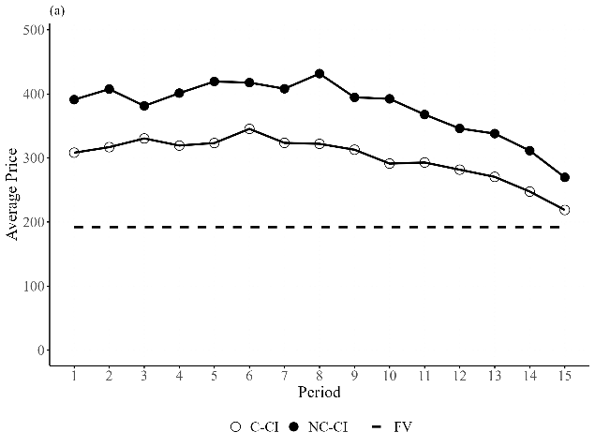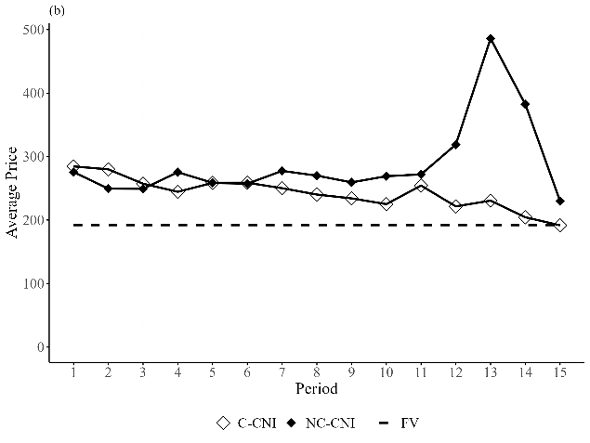
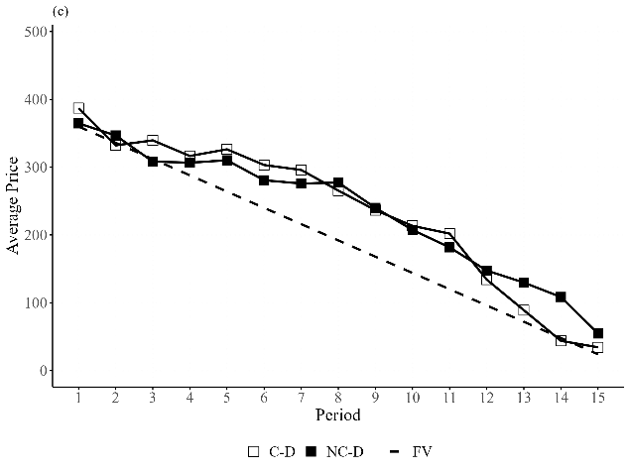
Next, we use standard mispricing measures in the literature to formally compare the degree of overpricing. These include Relative Absolute Deviation (RAD), Geometric Absolute Deviation (GAD), Relative Deviation (RD), Geometric Deviation (GD), Intra-/Inter-period volatility, and Turnover (Van Boening et al., 1993; Stöckl et al., 2010; Powell, 2016). Specifically, RAD measures how closely prices track fundamental value. It is defined as $RAD=\{\sum_{t}{|P_{t}-FV_{t} |}/(\sum_{t}{(FV_{t})}/T) \}/T$, where $FV_{t}$ is the fundamental value in period t (for assets with a flat fundamental value, this term is a constant value of 192), the term $P_{t}$ denotes the average price in period $t$, and T is the total number of periods. The measure RD is defined as $RD=\{\sum_{t}{(P_{t}-FV_{t})}/(\sum_{t}{(FV_{t})}/T) \}/T$, which indicates whether prices are on average above (RD > 0) or below (RD < 0) fundamental values. GAD is defined as $GAD=\exp\left\{\frac{1}{T}\sum_{t}{\left|\ln\left(\frac{P_{t}}{FV_{t}}\right)\right|}\right\}-1.$ GD is calculated as $GD=Π_{t}{\left(\frac{P_{t}}{FV_{t}}\right)}^{1/T}-1.$The interpretation of GAD and GD is the same as RAD and RD, but these measures satisfy numeraire independence.
We also measure how volatile prices are within a given period. This is known as the intra-period price volatility. It measures price volatility by using all log-returns of all market prices within a period. The intra-period volatility of returns is defined as $\sum_{t=1}^{T}{\frac{1}{T}}\sqrt{\frac{1}{N_{t}}\sum_{j=1}^{N_{t}}{{\left(R_{t,j}-{\overline{R}}_{t}\right)}^{2}}}$, where $R_{t,j}=\ln{P_{t,j}-\ln{P_{t,j-1}}}$, ${\overline{R}}_{t}$ is the average log returns in period $t$ and $N_{t}$ is the total number of transactions in each period. The inter-period volatility measure is introduced by Noussair et al. (2016) where it is defined as $\sum_{t=2}^{T}{\left|\left(P_{t}-FV_{t}\right)-\left(P_{t-1}-FV_{t-1}\right)\right|}/(T-1)$, and T is the total number of periods. Finally, Turnover is the total number of units traded over the life of the asset, normalized by the total stock of units in the market. It is defined as $(\sum_{t}{q_{t}})/TSU$, where $q_{t}$ is the quantity of units of the asset exchanged in period t, and TSU denotes the total stock of units. It measures how many times each unit of the asset changed hands over the life of the market.
Table 7 reports the average value of each mispricing measure by treatment. Within each asset market environment, we compare markets with communication to markets without communication. In the CI environment, communication is associated with lower absolute mispricing. Average RAD and GAD are about 100 percent of fundamental value without communication and about 60 percent with communication, although these differences are only marginally significant. These comparisons are not adjusted for multiple testing: we report seven measures in each of three environments, and the CI differences reach only the 10 percent level. Turnover is also higher in C-CI than in NC-CI, at 4.27 against 2.25, a difference that is significant at the 10 percent level and suggests that communication increased trading activity. This points to an alternative reading of the CI result. If communication mainly raises participation, prices may move toward fundamental value without any transmission of understanding between traders, and our design cannot separate that channel from the content of what traders say. In the CNI environment, communication does not significantly reduce mispricing, although volatility within periods is lower at the 10 percent level. In D, communication does not reduce mispricing, volatility, or turnover, and the point estimates for RAD and GAD are in fact higher with communication than without, although the differences are not significant.
Result 1: Communication has modest effects on mispricing. The only evidence of a reduction is in CI, the market environment participants found most difficult to understand.

Table 7. Average Mispricing Measures
Treatment | RAD | RD | GAD | GD | Inter-period volatility | Intra-period volatility | Turnover
C-CI | 0.59 (0.49) | 0.56 (0.51) | 0.55 (0.45) | 0.52 (0.49) | 26.40  (13.07) | 0.25  (0.17) | 4.27  (2.99)
NC-CI | 1.00 (0.54)* | 0.97 (0.60) | 0.95 (0.52)* | 0.91 (0.59) | 40.36  (28.42) | 0.28  (0.14) | 2.25 (1.09)*
C-CNI | 0.39 (0.41) | 0.26  (0.5) | 0.47 (0.57) | 0.24 (0.47) | 26.54  (30.77) | 0.22  (0.19) | 2.72  (1.59)
NC-CNI | 0.60 (0.78) | 0.50  (0.85) | 0.48  (0.5) | 0.35 (0.58) | 62.26 (120.78) | 0.44  (0.33)* | 3.21  (0.91)
C-D | 0.49 (0.34) | 0.22 (0.54) | 0.68 (0.51) | 0.16 (0.54) | 36.20  (17.89) | 0.32  (0.13) | 2.58  (1.33)
NC-D | 0.35 (0.34) | 0.23 (0.42) | 0.51 (0.42) | 0.32 (0.54) | 27.67  (17.3) | 0.39  (0.22) | 3.03  (1.8)
Notes: Each entry shows the average value of the corresponding measure, with its standard deviations reported in parentheses. ** and * indicate significant differences between the communication and no communication treatments within each asset market environment at the 5% and 10% levels, respectively, using a Mann-Whitney U test.
We also compare mispricing across the three asset market environments, pooling communication and no communication markets within each environment. This comparison is informative because the treatments were designed to hold the initial C/A ratio constant across environments. Mispricing is greater in CI than in CNI. The differences in RAD, RD, GAD, and GD are significant at the 5 percent level, while volatility and turnover do not differ significantly. Mispricing is also greater in CI than in D. The differences in RD and GD are significant at the 1 percent level, the difference in RAD is significant at the 5 percent level, and the difference in intra-period volatility is significant at the 10 percent level, while GAD, inter-period volatility and turnover do not differ significantly. We find little evidence of a difference in mispricing between CNI and D. Tables A.2 and A.3 report the corresponding mispricing measures and statistical tests.
These comparisons should be interpreted as comparisons across asset market environments, not as tests of the separate effect of any single market feature. The environments differ in the payoff process and in the associated cash transfer, loan, and interest rules that participants must understand. Our design holds the initial C/A ratio constant across environments, but it does not separately identify which element of the market environment accounts for the differences in mispricing across CI, CNI, and D. Our interpretation is that these market features may matter in part because they make some environments more difficult for participants to understand, as indicated by the auxiliary survey and forecast evidence.
Result 2: Mispricing is greater in CI than in the other two market environments. We find little evidence of a difference in mispricing between CNI and D.
3.3 Chat Classification and Content Analysis
Our experiment enables continuous conversation among traders throughout the market. We separate the conversations by trading period and divide each period into three stages. The first stage corresponds to when participants made their market predictions, which only occurred at the beginning of periods 1, 5, 10, and 15. The second stage corresponds to when the market was open for trading activity. The third stage corresponds to when the summary screens were presented.
The messages were classified using OpenAI’s GPT-5.5 think model via the OpenAI API. To avoid introducing translation errors, we analyzed the messages in their original language, Chinese. Because participants often use internet slang and abbreviations in text communication, the model was provided with a dictionary of commonly used Chinese internet slang to facilitate classification.
The chat messages were classified into eight substantive categories, with a ninth category, Other, used for messages that did not fit any of the substantive categories. The categories were developed in three steps. First, two authors of the paper independently reviewed the chat messages and prepared initial category lists. Second, the authors compared and merged their lists to create a common set of categories. Third, the proposed categories and the chat messages were provided to the model to assess whether any relevant categories were missing or whether any categories should be modified. The final categories used for classification and analysis are reported in Table 8.

Table 8: Categories
Category | Description | Examples
Confusion | Statements exhibiting confusion by traders | The loans make me confused.
Teaching | Teaching Statement | Assets can generate dividends.
Strategy | Discussing a strategy | I will not sell if the price is less than 365.
Overvalued | Pointing out that the asset is overvalued | I think the price is too high.
Undervalued | Pointing out that the asset is undervalued. | Buy price should be higher.
Positive | Positive emotional sentiment | This is hilarious.
Negative | Negative emotional sentiment | I give up.
Performance | Revealing or asking about performance, holdings, cash, profits, losses, or rank in the market | I lost so much money.
Other | Unclassified messages

Message classification using AI was conducted separately for each treatment. Within each treatment, the model was asked to determine whether each message belonged to each of the eight categories, allowing messages to belong to more than one category at a time. To provide context, all messages from a market corresponding to one stage of a period were sent in a single, sequentially ordered batch to be processed by the model. For example, all messages from a specific market sent during the trading stage of Period 1 were provided in a single batch, and the model classified each message in that batch individually. The same procedure was repeated for each stage and period until all messages were classified. We repeated the full classification procedure five times. A message was assigned to a category only if it was classified in that category in at least three of the five runs. If a message was not assigned to any of the eight substantive categories, it was classified as Other.
Because the substantive categories are not mutually exclusive, a message could be assigned to more than one category. After applying this procedure, 25.1 percent of messages were assigned to more than one substantive category, and 15.8 percent were not assigned to any substantive category.
We designed the prompts to provide the model with clear classification instructions and examples. Following Brown et al. (2020) and Celebi and Penczynski (2024), we used an n-shot prompt in which the model was given a small number of input and output examples before classifying the remaining messages. Each prompt defined the relevant category, provided examples of messages that did and did not belong to the category, and instructed the model to classify each message separately. An example prompt is provided in the Appendix 2.2.
Figure 2. Frequency of communication categories by treatment
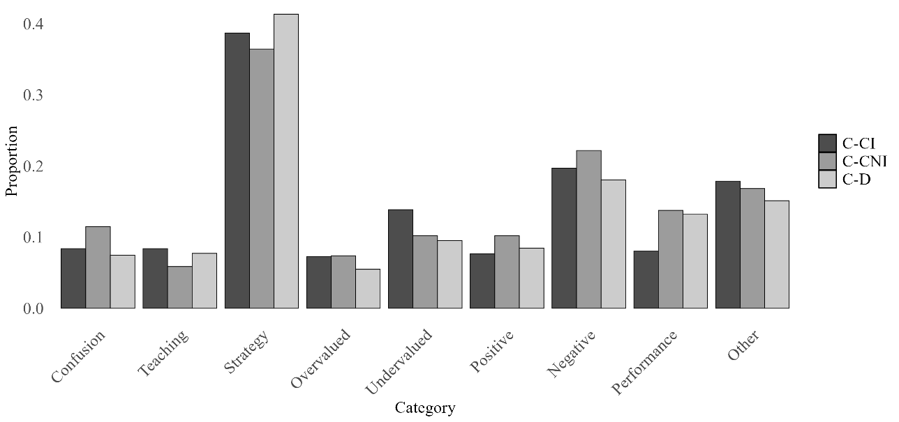
Table 9. Chi-squared test of Homogeneity by category
Category | P-value | P-Bonferroni | P- Benjamini-Hochberg
Confusion | 0.036** | 0.287 | 0.182
Teaching | 0.379 | 1 | 0.433
Strategy | 0.18 | 1 | 0.288
Overvalued | 0.232 | 1 | 0.31
Undervalued | 0.090* | 0.72 | 0.24
Positive | 0.451 | 1 | 0.451
Negative | 0.166 | 1 | 0.288
Performance | 0.046** | 0.364 | 0.182

We next examine whether the content of communication differs across the three communication treatments. Figure 2 reports the distribution of chat categories by treatment. The x axis shows the category, and the y axis shows the proportion of messages assigned to that category. Because messages can be assigned to more than one category, the proportions do not sum to one across categories. Table 9 reports chi-squared tests of homogeneity for each category across Communication Constant with Interest (C-CI), Communication Constant without Interest (C-CNI), and Communication Downward (C-D). The unadjusted tests indicate differences across treatments for Confusion, Undervalued, and Performance. Table 10 reports pairwise Fisher exact tests for these categories. The pairwise comparisons show that Confusion is higher in C-CNI than in C-D, Undervalued is higher in C-CI than in C-D, and Performance is lower in C-CI than in both C-CNI and C-D. Reviewing the messages classified as Confusion suggests that 26.7percent of confused statements in C-CNI refer to the asset itself, compared to 8.9 percent of statements about transfers and loans. However, the two types of confusion differ in nature. Messages about loans focus on how the loan works, whereas comments about the asset focus on price behavior. The pairwise differences remain significant at the 10 percent level after applying the Benjamini and Hochberg correction.
Table 10. Pairwise Fisher's exact test (2x2)
Category | Comparison | P-value | P-Bonferroni | P- Benjamini-Hochberg
Confusion | C-CI vs C-CNI | 0.24200 | 1.000 | 0.363
Confusion | C-CI vs C-D | 0.62200 | 1.000 | 0.741
Confusion | C-CNI vs C-D | 0.014** | 0.123 | 0.076*
Undervalued | C-CI vs C-CNI | 0.17800 | 1.000 | 0.320
Undervalued | C-CI vs C-D | 0.039** | 0.352 | 0.088*
Undervalued | C-CNI vs C-D | 0.70300 | 1.000 | 0.741
Performance | C-CI vs C-CNI | 0.025** | 0.229 | 0.076*
Performance | C-CI vs C-D | 0.017** | 0.154 | 0.076*
Performance | C-CNI vs C-D | 0.7410 | 1.000 | 0.741

Result 3: The distribution of chat categories differs across communication treatments. The main differences are in Confusion, Performance, and Undervalued. After applying the Benjamini and Hochberg correction, the relevant pairwise differences remain significant at the 10 percent level.

Figure 3: Distribution of communication categories in C-CI
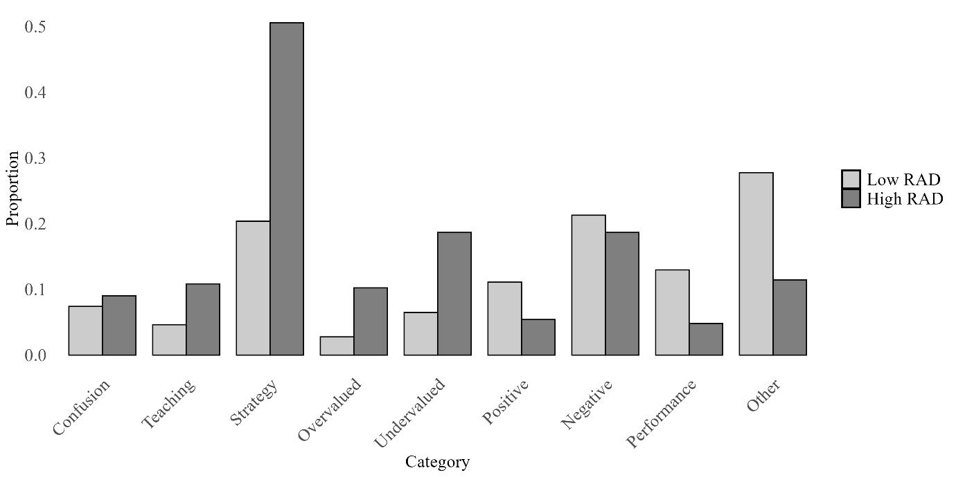
Note: Proportions are calculated at the message level as the percentage of messages within each Treatment-RAD group that contain a given category. Messages can belong to multiple categories, so proportions do not sum to one across all categories.
We next focus on C-CI. This is the communication treatment in the market environment that participants found most difficult to understand, and it is also the only treatment in which communication is associated with lower mispricing. We divide the C-CI markets into higher and lower mispricing groups using the median RAD of 0.29. Markets 1, 3, 5, 8, 10, and 12 are classified as high RAD markets. The remaining C-CI markets are classified as low RAD markets. Figure 3 reports the distribution of chat categories within C-CI by RAD group, and Table 11 reports the corresponding Fisher exact tests. In unadjusted tests, the differences between high and low RAD markets are significant at the 1 percent level for Strategy and Undervalued, at the 5 percent level for Overvalued and Performance, and at the 10 percent level for Teaching. Strategy and Undervalued remain significant after the Bonferroni correction, and Overvalued and Performance also remain significant after the Benjamini and Hochberg correction.

Table 11. Chat categories in high RAD and low RAD C-CI markets
Category | Avg. Proportion |  | P-Value | P-Bonferroni | P-Benjamini-Hochberg
Category | High RADs | Low  RADs | P-Value | P-Bonferroni | P-Benjamini-Hochberg
Confusion | 0.090 | 0.074 | 0.824 | 1.000 | 0.824
Teaching | 0.108 | 0.046 | 0.078* | 0.622 | 0.124
Strategy | 0.506 | 0.204 | 0.000*** | 0.000*** | 0.000***
Overvalued | 0.102 | 0.028 | 0.030** | 0.240 | 0.060*
Undervalued | 0.187 | 0.065 | 0.004*** | 0.033** | 0.016**
Positive | 0.054 | 0.111 | 0.104 | 0.834 | 0.139
Negative | 0.187 | 0.213 | 0.642 | 1.000 | 0.734
Performance | 0.048 | 0.130 | 0.022** | 0.173 | 0.058*
Note: Average proportions are calculated at the message level within each RAD group. Messages can be assigned to more than one category, so proportions do not sum to one across categories. Fisher's exact tests compare the share of messages assigned to each category in high RAD and low RAD C-CI markets. Adjusted p-values are reported using Bonferroni and Benjamini and Hochberg corrections.
*p < 0.10, **p < 0.05, ***p < 0.01, Fisher's exact tests.
We next estimate dynamic random-effects panel regressions to examine the relationship between chat content and mispricing within C-CI. The dependent variable is RAD in a given period. The explanatory variables in model 1 are the proportions of messages in the same period classified as Strategy and Performance, together with a Disagreement dummy. These are the categories that differed between high RAD and low RAD markets in Table 11 after the Benjamini and Hochberg correction. Disagreement equals 1 when the proportions of both Overvalued and Undervalued messages are positive in a given period, so that some traders consider the asset overvalued while others consider it undervalued. Overvalued and Undervalued therefore enter the regression through Disagreement rather than separately. In Model 2, we also include Teaching because it is also marginally significant without multiple testing corrections. Table 12 reports the results in explaining the degree of mispricing measured in RAD.
The main results are the following. First, we see that Disagreement is positively associated with mispricing. This suggests that openly discussing disagreements over asset values reveals heterogeneity in beliefs and opportunities for speculative gains, consistent with the evidence on bubble formation in Tucker and Xu (2024b). Second, we find that Teaching is negatively associated with RAD, though only marginally significant. Conditional on lagged RAD and period controls, periods with a higher share of teaching statements have lower mispricing. Other coefficients and their lagged terms do not predict mispricing, suggesting that the effect of communication is modest.
Table 12. Explaining RAD in C-CI markets
 | RAD | RAD
 | (1) | (2)
Teaching |  | -0.261*
 |  | (0.143)
L.Teaching |  | -0.115
 |  | (0.166)
Strategy | -0.031 | -0.010
 | (0.057) | (0.059)
L.Strategy | -0.004 | 0.007
 | (0.045) | (0.049)
Disagreement | 0.108** | 0.111***
 | (0.050) | (0.043)
L.Disagreement | -0.058 | -0.049
 | (0.105) | (0.060)
Performance | -0.024 | 0.013
 | (0.067) | (0.060)
L.Performance | 0.028 | 0.038
 | (0.054) | (0.046)
L.RAD | 0.925*** | 0.933***
 | (0.017) | (0.014)
Period control | Yes | Yes
Observations | 154 | 154
$$R^{2}$$ | 0.881 | 0.885
Adjusted $R^{2}$ | 0.875 | 0.877
F Statistic | 1,075.512*** | 1,100.759***
Note: The dependent variable in the random-effects models is the period-level RAD. The explanatory variables are the proportions of messages in each category over the same period, and a disagreement dummy that equals 1 when both Overvalued and Undervalued are positive in a given period. One C-CI market is excluded from these regressions because no messages were sent in it, which leaves 11 markets and 154 market-period observations. Robust standard errors clustered at the market level are reported in parentheses. *p < 0.1, **p < 0.05, ***p < 0.01.

Result 4. In C-CI, communicating disagreements is associated with higher mispricing, and teaching communication is modestly associated with lower mispricing.

4. Discussion and Conclusion
We set out to study the impact of continuous free-form communication on mispricing in experimental asset markets, considering how difficult participants find the market environment in which the asset is traded. Communication has shown to be an effective instrument in improving coordination (e.g., Cooper et al., 1992; Charness, 2000; Charness and Grosskopf, 2004; Charness and Rabin, 2005; Charness and Dufwenberg, 2006; Brandts and Cooper, 2007; Brandts et al., 2016; Charness and Ellman, 2016) and to resolve social dilemmas (e.g., Isaac and Walker, 1988; Ledyard, 1995; Chaudhuri, 2011; Oprea et al., 2014). Given this backdrop, one might expect that communication can also improve the efficiency of the market for its potential to facilitate information exchange, reduce confusion, and establish common knowledge of rationality.
Our experimental findings, however, temper such expectations. Our results show that communication only marginally reduces mispricing in the market environment that participants find most difficult to understand (Constant with Interest) and that we find no evidence of an effect on mispricing in the two environments participants found easier to understand (Downward and Constant without Interest). The content analysis using large language models reveals that, in the C-CI treatment, disagreement about asset value is positively associated with mispricing. This suggests that openly discussing disagreements about asset value may reveal heterogeneity in beliefs and opportunities for speculative profits, which is consistent with evidence on bubble formation reported by Tucker and Xu (2024b).
A limitation of the design is that the comparisons across CI, CNI, and D do not identify the separate effect of any one market feature. The results instead show how communication performs across commonly used asset market environments that differ in the payoff process and in the associated rules participants must understand.
Our primary contribution is a systematic test of free-form continuous communication across three canonical asset market environments, holding the initial C/A ratio constant. Despite arguments that communication should reduce trader confusion, align market expectations, and mitigate speculative bubbles, our experimental findings indicate only modest effects of communication overall. There is a marginal reduction in the Constant with Interest environment. That pattern is consistent with communication mattering more where the environment is harder to understand.
The result seems to be at odds with the findings of Oechssler et al. (2011) and Corgnet et al. (2024) at first glance. Both papers find that communication improves market efficiency in their settings. However, a closer look at the studies reveals at least two important differences. First, insiders are present in both studies, and communication appears to temper other traders' expectations about insider trading. This is a salient benefit that is absent in our design. The deeper point is that in both settings some traders hold information that others do not, so communication has something to aggregate. In our markets, information is symmetric, and the fundamental value is computable from the instructions alone. There is no private signal for talk to transmit, apart from correcting misunderstanding, which may be the simplest account of why we find so little effect. It is also consistent with the one environment in which communication is associated with lower mispricing being the one where the required computation is hardest, so that correct reasoning is in effect privately held by whichever traders have managed it. Second, both studies adopt pre-market communication, whereas ours allows continuous communication throughout the market. This continuous format may sustain speculative dialogue as the market unfolds, highlighting potential side effects of continuous free-form interaction. Moreover, Oechssler et al. (2011)’s market is also quite complex, with five different assets trading concurrently. As in Oechssler et al. (2011), what benefits we observe are concentrated in the more demanding market environment, although their markets are demanding in a different sense, requiring traders to follow five assets at once rather than to understand a single complex payoff process.
Our findings open several promising avenues for future research. First, given the contextual sensitivity observed in the effects of communication, future studies could systematically examine how different communication formats (e.g., pre-market versus continuous, structured versus free-form, public versus private) influence market dynamics. Second, exploring the interaction between communication and the presence of informational asymmetries, such as insider trading or differential information endowment, could offer deeper insights into the robustness of communication's stabilizing effects. Relatedly, future studies could examine whether communication operates differently for long-lived and short-lived assets, and in particular whether traders discuss different topics because long-lived assets admit a wider range of speculative strategies. Other factors such as reputation, trust, and historical context may also significantly alter interaction dynamics and are worth exploring. Understanding precisely when, why, and how communication impacts market outcomes is not only informative to theory on communication but also to market regulations.
References
Agranov, M., and Tergiman, C. (2014). Communication in multilateral bargaining. Journal of Public Economics, 118, 75-85. https://doi.org/10.1016/j.jpubeco.2014.06.006
Angeletos, G.-M., and La'O, J. (2013). Sentiments. Econometrica, 81(2), 739-779. https://doi.org/10.3982/ecta10008
Antweiler, W., and Frank, M. Z. (2004). Is all that talk just noise? The information content of internet stock message boards. The Journal of Finance, 59(3), 1259–1294. https://doi.org/10.1111/j.1540-6261.2004.00662.x
Bolton, G. E., Chatterjee, K., and McGinn, K. L. (2003). How communication links influence coalition bargaining: A laboratory investigation. Management Science, 49(5), 583-598. https://doi.org/10.1287/mnsc.49.5.583.15148
Bosch-Rosa, C., Meissner, T., and Bosch-Domènech, A. (2018). Cognitive bubbles. Experimental Economics, 21(1), 132-153. https://doi.org/10.1007/s10683-017-9529-0
Bradfield, A. J., and Kagel, J. H. (2015). Legislative bargaining with teams. Games and Economic Behavior, 93, 117-127. https://doi.org/10.1016/j.geb.2015.08.001
Brandts, J., and Cooper, D. J. (2007). It's what you say, not what you pay: An experimental study of manager-employee relationships in overcoming coordination failure. Journal of the European Economic Association, 5(6), 1223-1268. https://doi.org/10.1162/jeea.2007.5.6.1223
Brandts, J., Ellman, M., and Charness, G. (2016). Let’s talk: How communication affects contract design. Journal of the European Economic Association, 14(4), 943-974. https://doi.org/10.1111/jeea.12157
Brown, T., Mann, B., Ryder, N., Subbiah, M., Kaplan, J. D., Dhariwal, P., Neelakantan, A., Shyam, P., Sastry, G., Askell, A., Agarwal, S., Herbert-Voss, A., Krueger, G., Henighan, T., Child, R., Ramesh, A., Ziegler, D., Wu, J., Winter, C., . . . Amodei, D. (2020). Language models are few-shot learners. Advances in Neural Information Processing Systems, 33, 1877–1901. https://doi.org/10.48550/arXiv.2005.14165
Caginalp, G., Porter, D., and Smith, V. (1998). Initial cash/asset ratio and asset prices: An experimental study. Proceedings of the National Academy of Sciences, 95(2), 756–761. https://doi.org/10.1073/pnas.95.2.756
Celebi, C., and Penczynski, S. (2024). Using large language models for text classification in experimental economics (Working Paper No. 24-01). University of East Anglia, Centre for Behavioural and Experimental Social Science (CBESS). https://ideas.repec.org/p/uea/wcbess/24-01.html
Charness, G. (2000). Self‐serving cheap talk: A test of Aumann’s conjecture. Games and Economic Behavior, 33(2), 177–194. https://doi.org/10.1006/game.1999.0776
Charness, G., and Dufwenberg, M. (2006). Promises and partnership. Econometrica, 74(6), 1579–1601. https://doi.org/10.1111/j.1468-0262.2006.00719.x
Charness, G., and Ellman, M. (2016). Choosing and not choosing with and without communication: Experimental results on contract design and selection. Journal of Institutional and Theoretical Economics, 172(1), 142-157. https://doi.org/10.1628/093245616X14500948554153
Charness, G., and Grosskopf, B. (2004). What makes cheap talk effective? Experimental evidence. Economics Letters, 83(3), 383-389. https://doi.org/10.1016/j.econlet.2003.12.007
Charness, G., and Rabin, M. (2005). Expressed preferences and behavior in experimental games. Games and Economic Behavior, 53(2), 151-169. https://doi.org/10.1016/j.geb.2004.09.010
Chaudhuri, A. (2011). Sustaining cooperation in laboratory public goods experiments: A selective survey of the literature. Experimental Economics, 14(1), 47-83. https://doi.org/10.1007/s10683-010-9257-1
Cooper, R., DeJong, D., Forsythe, R., and Ross, T. (1992). Communication in coordination games. The Quarterly Journal of Economics, 107(2), 739–771. https://doi.org/10.2307/2118488
Corgnet, B., DeSantis, M., and Porter, D. (2024). Let’s chat... When communication promotes efficiency in experimental asset markets. Management Science, 70(10), 6550–6568. https://doi.org/10.1287/mnsc.2023.4967
Deck, C., Servátka, M., and Tucker, S. (2020). Designing call auction institutions to eliminate price bubbles: Is English Dutch the best? American Economic Review: Insights, 2(2), 225–236. https://doi.org/10.1257/aeri.20190244
Ding, S., Lugovskyy, V., Puzzello, D., Tucker, S., and Williams, A. (2018). Cash versus extra-credit incentives in experimental asset markets. Journal of Economic Behavior and Organization, 150, 19–27. https://doi.org/10.1016/j.jebo.2018.03.014
Engelberg, J. E., and Parsons, C. A. (2011). The causal impact of media in financial markets. The Journal of Finance, 66(1), 67-97. https://doi.org/10.1111/j.1540-6261.2010.01626.x
Fischbacher, U. (2007). z-Tree: Zurich toolbox for ready-made economic experiments. Experimental Economics, 10(2), 171–178. https://doi.org/10.1007/s10683-006-9159-4
Frederick, S. (2005). Cognitive reflection and decision making. Journal of Economic Perspectives, 19(4), 25-42. https://doi.org/10.1257/089533005775196732
Greiner, B. (2015). Subject pool recruitment procedures: Organizing experiments with ORSEE. Journal of the Economic Science Association, 1(1), 114–125. https://doi.org/10.1007/s40881-015-0004-4
Guler, B., Lugovskyy, V., Puzzello, D., and Tucker, S. (2025). Trading institutions in experimental asset markets: Theory and evidence. European Economic Review, 180, 105148. https://doi.org/10.1016/j.euroecorev.2025.105148
Hargreaves Heap, S., and Zizzo, D. J. (2011). Emotions and chat in a financial markets experiment (Discussion Paper). Social Science Research Network. https://doi.org/10.2139/ssrn.1783462
Haruvy, E., and Noussair, C. N. (2006). The effect of short selling on bubbles and crashes in experimental spot asset markets. The Journal of Finance, 61(3), 1119–1157. https://doi.org/10.1111/j.1540-6261.2006.00868.x
Hirshleifer, D., and Teoh, S. H. (2009). Thought and behavior contagion in capital markets. In T. Hens and K. R. Schenk-Hoppé (Eds.), Handbook of financial markets: Dynamics and evolution (pp. 1–56). North-Holland. https://doi.org/10.1016/B978-012374258-2.50005-1
Holt, C. A., Porzio, M., and Song, M. Y. (2017). Price bubbles, gender, and expectations in experimental asset markets. European Economic Review, 100, 72-94. https://doi.org/10.1016/j.euroecorev.2017.05.005
Houser, D., and Xiao, E. (2011). Classification of natural language messages using a coordination game. Experimental Economics, 14(1), 1-14. https://doi.org/10.1007/s10683-010-9254-4
Hussam, R. N., Porter, D., and Smith, V. L. (2008). Thar she blows: Can bubbles be rekindled with experienced subjects? American Economic Review, 98(3), 924–937. https://doi.org/10.1257/aer.98.3.924
Isaac, R. M., and Walker, J. M. (1988). Communication and free riding behavior: The voluntary contribution mechanism. Economic Inquiry, 26(4), 585–608. https://doi.org/10.1111/j.1465-7295.1988.tb01519.x
King, R. R., Smith, V. L., Williams, A. W., and Van Boening, M. V. (1993). The robustness of bubbles and crashes in experimental stock markets. In R. H. Day and P. Chen (Eds.), Nonlinear dynamics and evolutionary economics (pp. 183–200). Oxford University Press.
Kirchler, M., Huber, J., and Stöckl, T. (2012). Thar she bursts: Reducing confusion reduces bubbles. American Economic Review, 102(2), 865–883. https://doi.org/10.1257/aer.102.2.865
Ledyard, J. (1995). Public goods: A survey of experimental research. In J. H. Kagel and A. E. Roth (Eds.), The Handbook of Experimental Economics (pp. 111-194). Princeton University Press. https://doi.org/10.2307/j.ctvzsmff5.6
Lei, V., Noussair, C. N., and Plott, C. R. (2001). Nonspeculative bubbles in experimental asset markets: Lack of common knowledge of rationality vs. actual irrationality. Econometrica, 69(4), 831–859. https://doi.org/10.1111/1468-0262.00222
Lugovskyy, V., Puzzello, D., Tucker, S., and Williams, A. (2014). Asset-holdings caps and bubbles in experimental asset markets. Journal of Economic Behavior and Organization, 107(B), 781–797. https://doi.org/10.1016/j.jebo.2014.04.021
Noussair, C., Robin, S., and Ruffieux, B. (2001). Price bubbles in laboratory asset markets with constant fundamental values. Experimental Economics, 4(1), 87–105. https://doi.org/10.1023/A:1011445522861
Noussair, C., and Tucker, S. (2006). Futures markets and bubble formation in experimental asset markets. Pacific Economic Review, 11(2), 167–184. https://doi.org/10.1111/j.1468-0106.2006.00308.x
Noussair, C. N., and Tucker, S. (2016). Cash inflows and bubbles in asset markets with constant fundamental values. Economic Inquiry, 54(3), 1596-1606. https://doi.org/10.1111/ecin.12320
Noussair, C. N., Tucker, S., and Xu, Y. (2016). Futures markets, cognitive ability, and mispricing in experimental asset markets. Journal of Economic Behavior and Organization, 130, 166–179. https://doi.org/10.1016/j.jebo.2016.07.010
Oechssler, J. (2010). Searching beyond the lamppost: Let’s focus on economically relevant questions. Journal of Economic Behavior and Organization, 73(1), 65-67. https://doi.org/10.1016/j.jebo.2008.10.017
Oechssler, J., Schmidt, C., and Schnedler, W. (2011). On the ingredients for bubble formation: Informed traders and communication. Journal of Economic Dynamics and Control, 35(11), 1831-1851. https://doi.org/10.1016/j.jedc.2011.05.009
Oprea, R., Charness, G., and Friedman, D. (2014). Continuous time and communication in a public-goods experiment. Journal of Economic Behavior and Organization, 108, 212–223. https://doi.org/10.1016/j.jebo.2014.09.012
Plott, C. R., and Gray, P. (1990). The multiple unit double auction. Journal of Economic Behavior and Organization, 13(2), 245–258. https://doi.org/10.1016/0167-2681(90)90089-V
Plott, C. R., and Sunder, S. (1982). Efficiency of experimental security markets with insider information: An application of rational-expectations models. Journal of Political Economy, 90(4), 663-698. https://doi.org/10.1086/261084
Plott, C. R., and Sunder, S. (1988). Rational expectations and the aggregation of diverse information in laboratory security markets. Econometrica, 56(5), 1085-1118. https://doi.org/10.2307/1911360
Porter, D. P., and Smith, V. L. (1995). Futures contracting and dividend uncertainty in experimental asset markets. The Journal of Business, 68(4), 509–541. https://doi.org/10.1086/296675
Powell, O. (2016). Numeraire independence and the measurement of mispricing in experimental asset markets. Journal of Behavioral and Experimental Finance, 9, 56-62. https://doi.org/10.1016/j.jbef.2015.11.002
Shiller, R. (1984). Stock Prices and Social Dynamics. Brookings Papers on Economic Activity, 1984(2), 457-510. https://doi.org/10.2307/2534436
Shiller, R. J. (2000). Irrational exuberance. Princeton University Press.
Smith, A., Lohrenz, T., King, J., Montague, P. R., and Camerer, C. F. (2014). Irrational exuberance and neural crash warning signals during endogenous experimental market bubbles. Proceedings of the National Academy of Sciences, 111(29), 10503-10508. https://doi.org/10.1073/pnas.1318416111
Smith, V. L. (1962). An experimental study of competitive market behavior. Journal of Political Economy, 70(2), 111–137. https://doi.org/10.1086/258609
Smith, V. L., Suchanek, G. L., and Williams, A. W. (1988). Bubbles, crashes, and endogenous expectations in experimental spot asset markets. Econometrica, 56(5), 1119–1151. https://doi.org/10.2307/1911361
Steiger, S., and Pelster, M. (2020). Social interactions and asset pricing bubbles. Journal of Economic Behavior and Organization, 179, 503-522. https://doi.org/10.1016/j.jebo.2020.09.020
Stöckl, T., Huber, J., and Kirchler, M. (2010). Bubble measures in experimental asset markets. Experimental Economics, 13(3), 284-298. https://doi.org/10.1007/s10683-010-9241-9
Stöckl, T., Huber, J., and Kirchler, M. (2015). Multi-period experimental asset markets with distinct fundamental value regimes. Experimental Economics, 18(2), 314–334. https://doi.org/10.1007/s10683-014-9404-1
Tetlock, P. C. (2007). Giving content to investor sentiment: The role of media in the stock market. The Journal of Finance, 62(3), 1139–1168. https://doi.org/10.1111/j.1540-6261.2007.01232.x
Tucker, S., and Xu, Y. (2024a). Nonspeculative bubbles revisited. Journal of Behavioral and Experimental Finance, 42, 100925. https://doi.org/10.1016/j.jbef.2024.100925
Tucker, S., and Xu, Y. (2024b). Motivations to speculate are the driving forces in experimental asset market bubbles. Working paper.
Van Boening, M. V., Williams, A. W., and LaMaster, S. (1993). Price bubbles and crashes in experimental call markets. Economics Letters, 41(2), 179-185. https://doi.org/10.1016/0165-1765(93)90194-H
Van Rooij, M., Lusardi, A., and Alessie, R. (2011). Financial literacy and stock market participation. Journal of Financial Economics, 101(2), 449-472. https://doi.org/10.1016/j.jfineco.2011.03.006

Appendix
Appendix 1. Experimental Instructions and Survey Questions
1.1. Experimental Instructions
1.1.1. Experiment Instructions for Constant FV without Interest Condition
(Communication Treatment Condition text in red)
1. General Instructions

This is an experiment in the economics of market decision-making. The instructions are simple and if you follow them carefully and make good decisions, you might earn a considerable amount of money, which will be paid to you in cash at the end of the experiment. The experiment will consist of 15 trading periods in which you will have the opportunity to buy and sell in a market. Throughout the experiment, you will always have the opportunity to chat with other traders via a chat box. The currency used in the market is francs. All trading and earnings will be in terms of francs.

_______ francs = 1 Yuan (RMB)

Your francs will be converted to RMB at this rate, and you will be paid in RMB when you leave the lab today. The more francs you earn, the more RMB you earn.

In each period, you may buy and sell units of a good called X. X can be considered an asset with a life of 15 periods, and your inventory of X carries over from one trading period to the next. Each Unit of asset X has a buyback value of 192 francs. That is, at the end of period 15 each unit of the asset in your inventory will be bought back by the experimenter at a price of 192 francs.

2. Dividends

Each unit of X in your inventory at the end of each trading period pays a dividend to you. The dividend paid on each unit is the same for every participant. The dividend at the end of each period was determined by chance by a random number generator. The dividend in each period has an equally likely chance of being -10, -5, 1, or 14. The information is provided in the table below.

Dividend | → | -10 | -5 | 1 | 14
Likelihood | → | 25% | 25% | 25% | 25%

The average dividend per period for each unit of X is 0 francs.

The dividend draws in each period are independent. That means that the likelihood of a particular dividend in a period is not affected by the dividend in previous periods.

3. Your Earnings

At the beginning of the experiment, you will be given 5,333 francs in your Cash inventory and 10 Units of Asset. At the start of each period, a transfer of francs will occur that affects your Cash inventory. The table below presents the amounts of francs to be transferred at the start of each period. These transfers are considered as loans and the sum of these transfers must be paid back at the end of the experiment. That is, 101,547 francs will be subtracted from your Cash inventory at the end of the experiment.

Period | Franc Transfer
1 | 0
2 | 518
3 | 598
4 | 698
5 | 824
6 | 989
7 | 1209
8 | 1511
9 | 1943
10 | 2590
11 | 3627
12 | 5440
13 | 9067
14 | 18133
15 | 54400

All cash transfers received at the beginning of each period are added to your Cash inventory.

All dividends you receive are added to your Cash inventory.

All money spent on purchases is subtracted from your Cash inventory.

All money received from sales is added to your Cash inventory.

Your earnings for participation in the market are equal to your Cash inventory at the end of period 15 plus the value of asset buyback at the end of the market (192 francs per unit of asset), plus earnings from forecasting (explained below), minus 101,547 francs.

Example of earnings from dividends: if you have 6 units of X at the end of period 3 and the dividend draw is 1 francs (which has a 25% chance of occurring), then your dividend earnings for period 3 are equal to 6 units x 1 francs = 6 francs.

4. Market and Trading Rules

The market consists of 8 subjects. Each trader gets an initial endowment of 10 assets and a working capital of 5,333 francs. The experiment will consist of 15 periods. Each period will last 3 minutes. In each period, you will see a computer screen like the one shown below. You can use the interface to buy and sell units of X. On your computer screen, you can see the Cash and Number of units of X you have available.

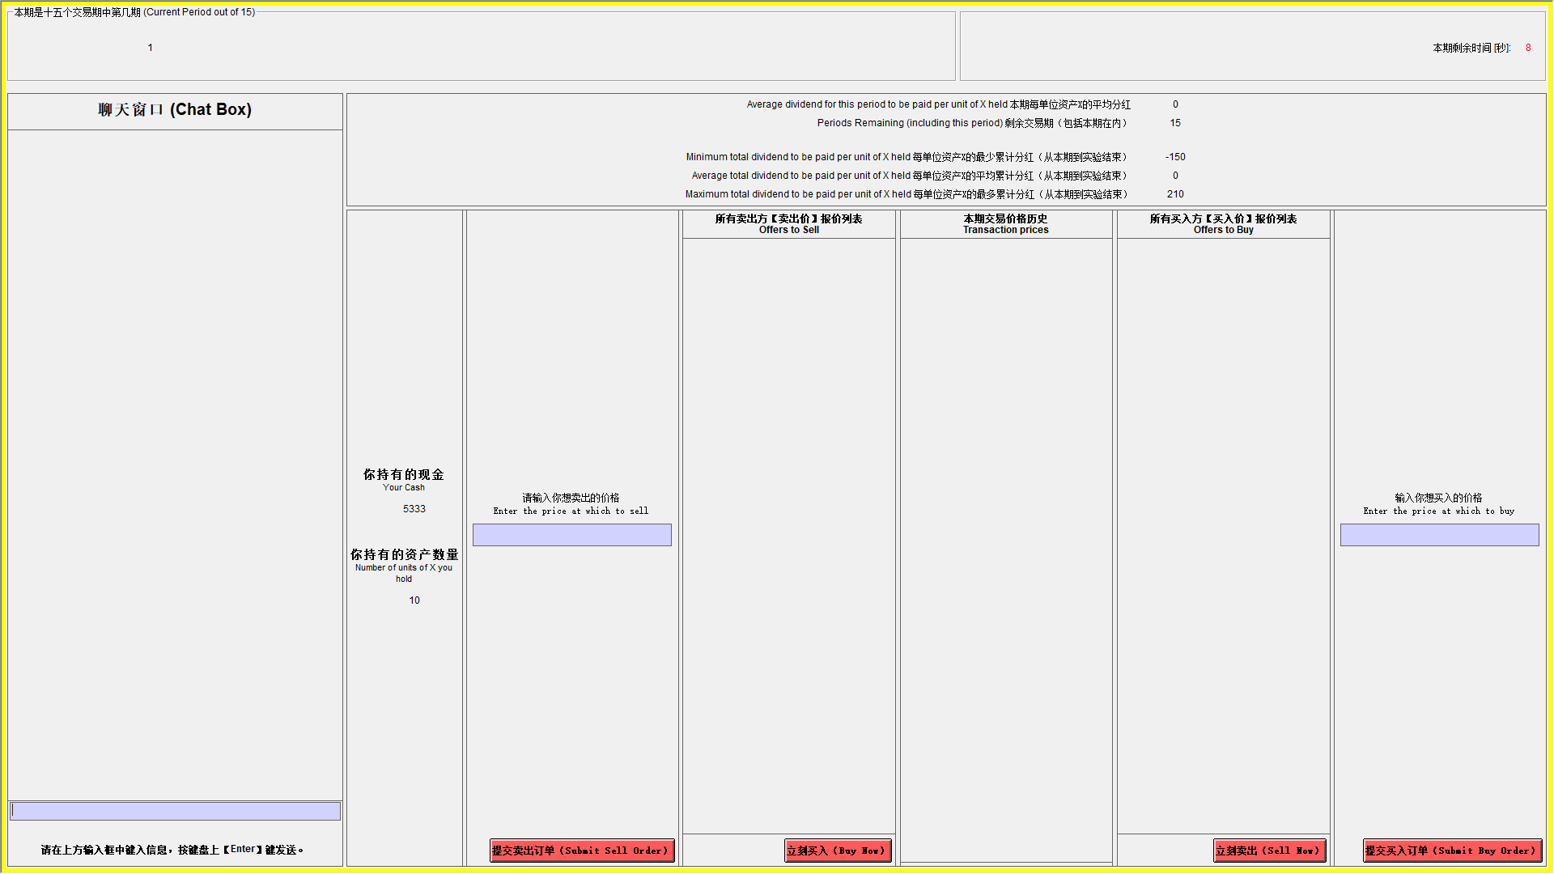

In a trading period, if you wish to purchase a unit of X you can send in a buy order by typing the amount you are willing to pay for a unit of good X in the box marked “Enter the price at which to buy” and by pressing the corresponding button. Similarly, if you wish to sell units of X, you can send in a sell order by typing the amount you are willing to sell a unit of X for in the box marked “Enter the price at which to sell” and by pressing the corresponding button. The “Offers to Buy” column shows a list of all the offers traders have made to purchase a single unit of the asset. The list is in descending order so that the highest price is at the top.

Press the “Sell” button if you would like to sell a unit of good X for the highlighted amount in the “Offers to Buy” column. The “Offers to Sell” column shows a list of all the offers traders have made to sell a single unit of the asset. The list is in ascending order so that the lowest price is at the top. Press the “Buy” button if you would like to buy a unit of good X for the highlighted amount in the “Offers to Sell” column. Note that you cannot accept your own buy or sell orders.

The “Transaction prices” column shows all the prices at which a unit of X has been bought or sold in the current period. Your offers to sell are limited by your available inventory of X (i.e., you cannot sell more units than you have), and your offers to buy are limited by your available cash on hand and the price (i.e., you cannot buy more than you can afford).
Examples of how the market works.
The numbers used in the examples are for illustrative purposes.
Example 1. Suppose that in period 9 four traders participate in the market and:
- Trader 1 submits an offer to buy at 60
- Trader 2 submits an offer to buy at 20
- Trader 3 submits an offer to sell at 10
- Trader 4 submits an offer to sell at 40
The sale prices will be ordered in ascending order in the “Offers to Sell” column so that the lowest price is at the top. The first participant who presses the button “Buy” will buy the unit at the price of 10, if this price is highlighted in the “Offers to Sell” column. The purchase prices will be ordered in descending order in the “Offers to Buy” so that the highest price is at the top. The first participant who presses the button “Sell” will sell at the price of 60, if this price is highlighted in the “Offers to Buy” column.
Example 2. Suppose that in Spot Market period 9 four traders participate in the market and:
- Trader 1 submits an offer to buy at 810
- Trader 2 submits an offer to buy at 800
- Trader 3 submits an offer to sell at 700
- Trader 4 submits an offer to sell at 720
The sale prices will be ordered in ascending order in the “Offers to Sell” column so that the lowest price is at the top. The first participant who presses the button “Buy” will buy the unit at the price of 700, if this price is highlighted in the “Offers to Sell” column. The purchase prices will be ordered in descending order in the “Offers to Buy” so that the highest price is at the top. The first participant who presses the button “Sell” will sell at the price of 810, if this price is highlighted in the “Offers to Buy” column.
5. Forecasting Average Transactions Price and Holding Values

At the beginning of periods 1, 5, 10, 15, you will be asked to make the following two forecasts:

- Forecast Average Transaction Price: submit a price that forecasts the average of all transaction prices of X in that period.
- Forecast the Indifference Price: Irrespective of the prices you see in the market, what is the price in this period such that the expected earnings are the same between selling the asset and holding the asset till the end of the experiment.
You will be paid for the accuracy of your forecasts.
The money you receive for each of your forecast will be calculated in the following manner:

Accuracy | Your Earnings
Within 10% of actual average price or average holding value | 50 francs
Within 25% of actual average price or average holding value | 20 francs
Within 50% of actual average price or average holding value | 10 francs

5. Record your earnings

At the end of each period, a summary screen will be provided to you.

END OF PERIOD CASH = BEGINNING OF PERIOD CASH+ CASH TRANSFERS + SALES – PURCHASES + DIVIDEND PER UNIT * NUMBER OF UNITS IN INVENTORY AT THE END OF PERIOD

PERIOD EARNINGS = END OF PERIOD CASH – BEGINNING OF PERIOD CASH
Subsequent periods should be recorded similarly.

Your earnings for this experiment are given by the cash on hand at the end of period 15 plus any earnings from forecasts plus earnings from asset buyback minus 101,547 francs (total of loan cash transfers).

Example of period earnings. Suppose that in period 10 your BEGINNING CASH ON HAND is 1,500 francs and your INVENTORY at the beginning of period 10 is 7 units of X. If in period 10 you sell 2 units of X at a price of 200 francs and the dividend draw is -10 francs, then in period 10:

SALES= 2*200=400
CLOSING X ON HAND = 7- 2 = 5
PERIOD DIVIDEND EARNINGS = DIVIDEND PAYMENT PER UNIT * CLOSING X ON HAND = -10 * 5 = -50.
END CASH = 1,500 - 50 + 400 = 1,850
PERIOD EARNINGS = END CASH – BEGINNING CASH ON HAND = 1,850 – 1,500 = 350.

1.1.2. Experiment Instructions for Downward FV Condition
(Communication Treatment Condition text in red)
1. General Instructions

This is an experiment in the economics of market decision-making. The instructions are simple and if you follow them carefully and make good decisions, you might earn a considerable amount of money, which will be paid to you in cash at the end of the experiment. The experiment will consist of 15 trading periods in which you will have the opportunity to buy and sell in a market. Throughout the experiment, you will always have the opportunity to chat with other traders via a chat box. The currency used in the market is francs. All trading and earnings will be in terms of francs.

_____ francs = 1 RMB

Your francs will be converted to RMB at this rate, and you will be paid in RMB when you leave the lab today. The more francs you earn, the more RMB you earn.

In each period, you may buy and sell units of a good called X. X can be considered an asset with a life of 15 periods, and your inventory of X carries over from one trading period to the next.

2. Dividends

Each unit of X in your inventory at the end of each trading period pays a dividend to you. The dividend paid on each unit is the same for every participant. The dividend at the end of each period was determined by chance by a random number generator. The dividend in each period has an equally likely chance of being 0, 8, 28, or 60. The information is provided in the table below.

Dividend | → | 0 | 8 | 28 | 60
Likelihood | → | 25% | 25% | 25% | 25%

The average dividend per period for each unit of X is 24 francs.

The dividend draws in each period are independent. That means that the likelihood of a particular dividend in a period is not affected by the dividend in previous periods.

3. Your Earnings

At the beginning of the experiment, you will be given 10,000 francs in your Cash inventory and 10 Units of Asset. Your earnings for participation in the market are equal to your Cash inventory at the end of period 15.

All dividends you receive are added to your Cash inventory.

All money spent on purchases is subtracted from your Cash inventory.

All money received from sales is added to your Cash inventory.
Example of earnings from dividends: if you have 6 units of X at the end of period 3 and the dividend draw is 8 francs (which has a 25% chance of occurring), then your dividend earnings for period 3 are equal to 6 units x 8 francs = 48 francs.

Example of the cumulative average dividends: Suppose for example that you are in period 9 (there are 7 periods remaining). Since the dividend paid on a unit of X has a 25% chance of being 0, a 25% chance of being 8, a 25% chance of being 28, and a 25% chance of being 60 in any period, the dividend is on average 24 per period for each unit of X. If you hold a unit of X for 7 periods, the total dividend paid on the unit over the 7 periods is on average 7*24 = 168.

4. Market and Trading Rules

The market consists of 8 subjects. Each trader gets an initial endowment of 10 units of X and 10,000 francs. The experiment will consist of 15 periods. Each period will last 3 minutes. In each period, you will see a computer screen like the one shown below. You can use the interface to buy and sell units of X. On your computer screen, you can see the Cash and Number of units of X you have available.

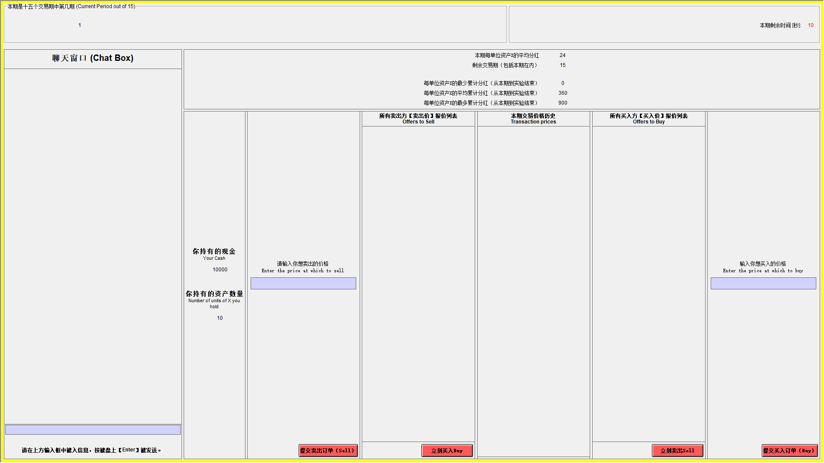

In a trading period, if you wish to purchase a unit of X you can send in a buy order by typing the amount you are willing to pay for a unit of good X in the box marked “Enter the price at which to buy” and by pressing the corresponding button. Similarly, if you wish to sell units of X, you can send in a sell order by typing the amount you are willing to sell a unit of X for in the box marked “Enter the price at which to sell” and by pressing the corresponding button. The “Offers to Buy” column shows a list of all the offers traders have made to purchase a single unit of the asset. The list is in descending order so that the highest price is at the top.

Press the “Sell” button if you would like to sell a unit of good X for the highlighted amount in the “Offers to Buy” column. The “Offers to Sell” column shows a list of all the offers traders have made to sell a single unit of the asset. The list is in ascending order so that the lowest price is at the top. Press the “Buy” button if you would like to buy a unit of good X for the highlighted amount in the “Offers to Sell” column. Note that you cannot accept your own buy or sell orders.

The “Transaction prices” column shows all the prices at which a unit of X has been bought or sold in the current period. Your offers to sell are limited by your available inventory of X (i.e., you cannot sell more units than you have), and your offers to buy are limited by your available cash on hand and the price (i.e., you cannot buy more than you can afford).

Examples of how the market works.
The numbers used in the examples are for illustrative purposes.
Example 1. Suppose that in period 9 four traders participate in the market and:
- Trader 1 submits an offer to buy at 60
- Trader 2 submits an offer to buy at 20
- Trader 3 submits an offer to sell at 10
- Trader 4 submits an offer to sell at 40
The sale prices will be ordered in ascending order in the “Offers to Sell” column so that the lowest price is at the top. The first participant who presses the button “Buy” will buy the unit at the price of 10, if this price is highlighted in the “Offers to Sell” column. The purchase prices will be ordered in descending order in the “Offers to Buy” so that the highest price is at the top. The first participant who presses the button “Sell” will sell at the price of 60, if this price is highlighted in the “Offers to Buy” column.
Example 2. Suppose that in Spot Market period 9 four traders participate in the market and:
- Trader 1 submits an offer to buy at 810
- Trader 2 submits an offer to buy at 800
- Trader 3 submits an offer to sell at 700
- Trader 4 submits an offer to sell at 720
The sale prices will be ordered in ascending order in the “Offers to Sell” column so that the lowest price is at the top. The first participant who presses the button “Buy” will buy the unit at the price of 700, if this price is highlighted in the “Offers to Sell” column. The purchase prices will be ordered in descending order in the “Offers to Buy” so that the highest price is at the top. The first participant who presses the button “Sell” will sell at the price of 810, if this price is highlighted in the “Offers to Buy” column.
5. Forecasting Average Transactions Price and Holding Values
At the beginning of periods 1, 5, 10, 15, you will be asked to make the following two forecasts:

- Forecast Average Transaction Price: submit a price that forecasts the average of all transaction prices of X in that period.
- Forecast the Indifference Price: Irrespective of the prices you see in the market, what is the price in this period such that the expected earnings are the same between selling the asset and holding the asset till the end of the experiment.

You will be paid for the accuracy of your forecasts.
The money you receive for each of your forecast will be calculated in the following manner:

Accuracy | Your Earnings
Within 10% of actual average price or average holding value | 100 francs
Within 25% of actual average price or average holding value | 40 francs
Within 50% of actual average price or average holding value | 20 francs

6. Record your earnings

At the end of each period, a summary screen will be provided to you.

END OF PERIOD CASH = BEGINNING OF PERIOD CASH + DIVIDEND PER UNIT * NUMBER OF UNITS IN INVENTORY AT THE END OF PERIOD + SALES - PURCHASES

PERIOD EARNINGS = END OF PERIOD CASH – BEGINNING OF PERIOD CASH

Subsequent periods should be recorded similarly.

Your earnings for this experiment are given by the cash on hand at the end of period 15 plus any earnings from forecasts.

Example of period earnings. Suppose that in period 10 your BEGINNING CASH ON HAND is 1,500 francs and your INVENTORY at the beginning of period 10 is 7 units of X. If in period 10 you sell 2 units of X at a price of 200 francs and the dividend draw is 8 francs, then in period 10:

SALES= 2*200=400
CLOSING X ON HAND = 7- 2 = 5
PERIOD DIVIDEND EARNINGS = DIVIDEND PAYMENT PER UNIT * CLOSING X ON HAND = 8 * 5 = 40.
END CASH = 1,500 +40+ 2*200 = 1,940
PERIOD EARNINGS = END CASH – BEGINNING CASH ON HAND = 1,940 – 1,500 = 440.

1.1.3. Experiment Instructions for Constant with Interest Condition
(Communication Treatment Condition text in red)
1. General Instructions

This is an experiment in the economics of market decision-making. The instructions are simple and if you follow them carefully and make good decisions, you might earn a considerable amount of money, which will be paid to you in cash at the end of the experiment. The experiment will consist of 15 trading periods in which you will have the opportunity to buy and sell in a market. Throughout the experiment, you will always have the opportunity to chat with other traders via a chat box. The currency used in the market is francs. All trading and earnings will be in terms of francs.

______ francs = 1 Yuan (RMB)

Your francs will be converted to RMB at this rate, and you will be paid in RMB when you leave the lab today. The more francs you earn, the more RMB you earn.

In each period, you may buy and sell units of a good called X. X can be considered an asset with a life of 15 periods, and your inventory of X carries over from one trading period to the next. Each Unit of asset X has a buyback value of 192 francs. That is, at the end of period 15 each unit of the asset in your inventory will be bought back by the experimenter at a price of 192 francs.

2. Dividends and Interest

Each unit of X in your inventory at the end of each trading period pays a dividend to you. The dividend paid on each unit is the same for every participant. The dividend at the end of each period was determined by chance by a random number generator. The dividend in each period has an equally likely chance of being 0, 8, 28, or 60. The information is provided in the table below.

Dividend | → | 0 | 8 | 28 | 60
Likelihood | → | 25% | 25% | 25% | 25%

The average dividend per period for each unit of X is 24 francs.

The dividend draws in each period are independent. That means that the likelihood of a particular dividend in a period is not affected by the dividend in previous periods.

Each franc in retained your Cash inventory at the end of a period (prior to dividend payment) will earn interest at a fixed rate of 12.5%.

Note, the dividend payments are drawn randomly, whereas interest rate is fixed in advance. Another difference is that interest is paid on each franc not used to purchase shares, whereas dividends are paid on each share, the price of which is determined in the trading process, as explained next.
3. Your Earnings

At the beginning of the experiment, you will be given 5,333 francs in your Cash inventory and 10 Units of Asset. At the start of each period, a transfer of francs will occur that affects your Cash inventory. The table below presents the amounts of francs to be transferred at the start of each period. Note, in periods 2 through 7, these transfers will be negative, i.e. the amount listed in column 2 will be subtracted from your Cash inventory at the start of these periods. These transfers are considered as loans and the sum of these transfers, including interest received on these transfers across all periods of the market (at 12.5%), must be paid back at the end of the experiment. That is, 79,955 francs will be subtracted from your Cash inventory at the end of the experiment.

Period | Franc Transfer
1 | 0
2 | -389
3 | -373
4 | -349
5 | -309
6 | -247
7 | -151
8 | 0
9 | 242
10 | 648
11 | 1360
12 | 2720
13 | 5667
14 | 13600
15 | 47600

All cash transfers received at the beginning of each period are added to your Cash inventory.

All dividends you receive are added to your Cash inventory.

All interest payments are added to your Cash inventory.

All money spent on purchases is subtracted from your Cash inventory.

All money received from sales is added to your Cash inventory.

Your earnings for participation in the market are equal to your Cash inventory at the end of period 15 plus the value of asset buyback at the end of the market (192 francs per unit of asset) plus earnings from forecasting (explained below) minus 79,955 francs.

Example of earnings from dividends: if you have 6 units of X at the end of period 3 and the dividend draw is 28 francs (which has a 25% chance of occurring), then your dividend earnings for period 3 are equal to 6 units x 28 francs = 168 francs.
Example of earnings from interest: suppose you have 15,000 francs at the end of a period (prior to the dividend payment). Since the interest rate is 12.5%, your earnings from cash holdings are 0.125 x 15,000 francs = 1,875 francs.

Example of the cumulative average dividends: For this example, we do not take interest payments into account. Suppose for example that there are 9 periods remaining. Since the dividend paid on a unit of X has a 25% chance of being 0, a 25% chance of being 8, a 25% chance of being 28, and a 25% chance of being 60 in any period, the dividend is on average 24 per period for each unit of X. If you hold a unit of X for 7 periods, the total dividend paid on the unit over the 7 periods is on average 7*24 = 168.

4. Market and Trading Rules

The market consists of 8 subjects. Each trader gets an initial endowment of 10 assets and a working capital of 5,333 francs. The experiment will consist of 15 periods. Each period will last 3 minutes. In each period, you will see a computer screen like the one shown below. You can use the interface to buy and sell units of X. On your computer screen, you can see the Cash and Number of units of X you have available.

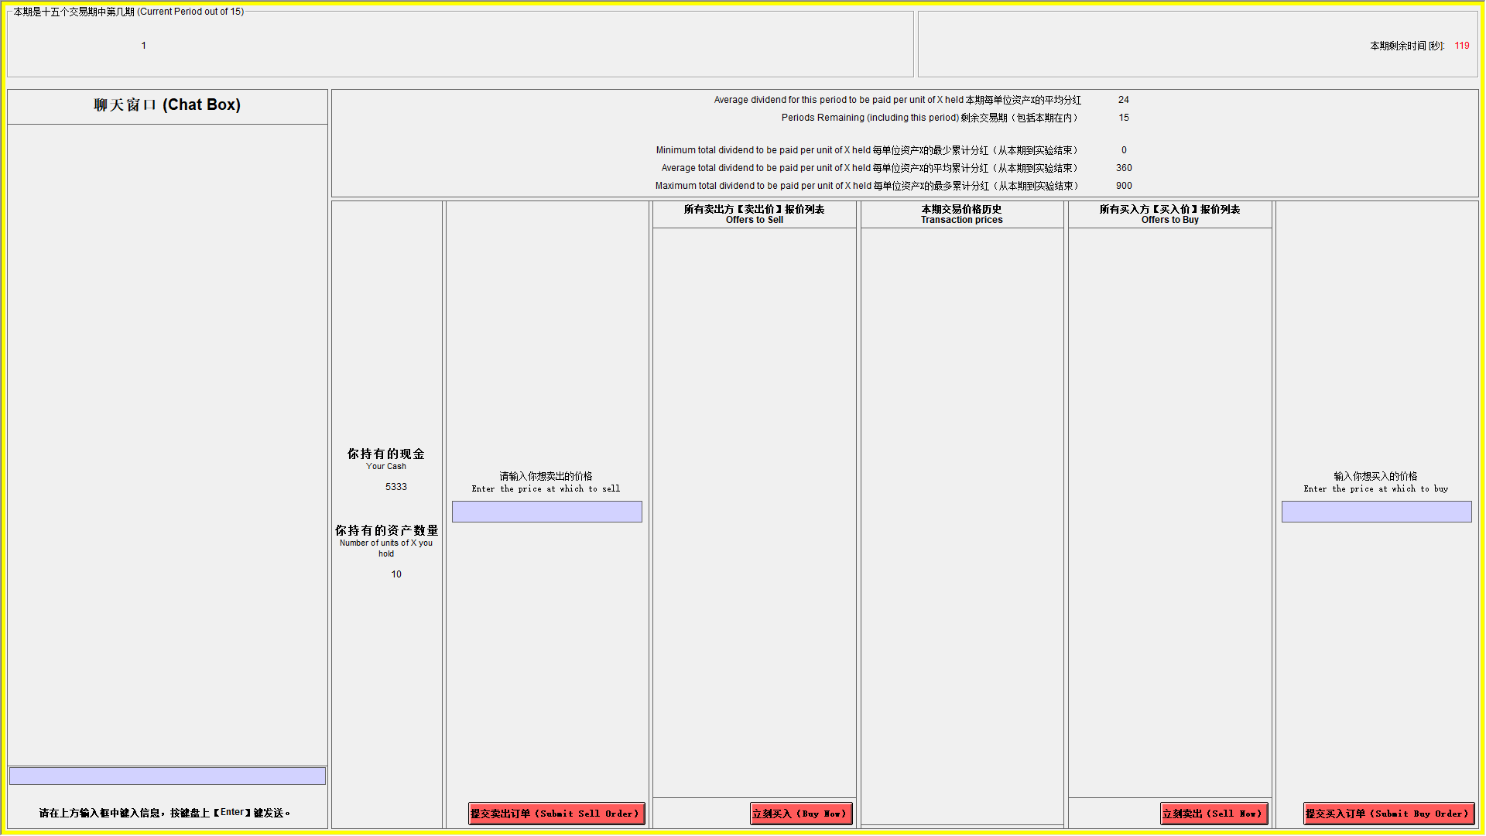

In a trading period, if you wish to purchase a unit of X you can send in a buy order by typing the amount you are willing to pay for a unit of good X in the box marked “Enter the price at which to buy” and by pressing the corresponding button. Similarly, if you wish to sell units of X, you can send in a sell order by typing the amount you are willing to sell a unit of X for in the box marked “Enter the price at which to sell” and by pressing the corresponding button. The “Offers to Buy” column shows a list of all the offers traders have made to purchase a single unit of the asset. The list is in descending order so that the highest price is at the top.

Press the “Sell” button if you would like to sell a unit of good X for the highlighted amount in the “Offers to Buy” column. The “Offers to Sell” column shows a list of all the offers traders have made to sell a single unit of the asset. The list is in ascending order so that the lowest price is at the top. Press the “Buy” button if you would like to buy a unit of good X for the highlighted amount in the “Offers to Sell” column. Note that you cannot accept your own buy or sell orders.

The “Transaction prices” column shows all the prices at which a unit of X has been bought or sold in the current period. Your offers to sell are limited by your available inventory of X (i.e., you cannot sell more units than you have), and your offers to buy are limited by your available cash on hand and the price (i.e., you cannot buy more than you can afford).
Examples of how the market works.
The numbers used in the examples are for illustrative purposes.
Example 1. Suppose that in period 9 four traders participate in the market and:
- Trader 1 submits an offer to buy at 60
- Trader 2 submits an offer to buy at 20
- Trader 3 submits an offer to sell at 10
- Trader 4 submits an offer to sell at 40
The sale prices will be ordered in ascending order in the “Offers to Sell” column so that the lowest price is at the top. The first participant who presses the button “Buy” will buy the unit at the price of 10, if this price is highlighted in the “Offers to Sell” column. The purchase prices will be ordered in descending order in the “Offers to Buy” so that the highest price is at the top. The first participant who presses the button “Sell” will sell at the price of 60, if this price is highlighted in the “Offers to Buy” column.
Example 2. Suppose that in Spot Market period 9 four traders participate in the market and:
- Trader 1 submits an offer to buy at 810
- Trader 2 submits an offer to buy at 800
- Trader 3 submits an offer to sell at 700
- Trader 4 submits an offer to sell at 720
The sale prices will be ordered in ascending order in the “Offers to Sell” column so that the lowest price is at the top. The first participant who presses the button “Buy” will buy the unit at the price of 700, if this price is highlighted in the “Offers to Sell” column. The purchase prices will be ordered in descending order in the “Offers to Buy” so that the highest price is at the top. The first participant who presses the button “Sell” will sell at the price of 810, if this price is highlighted in the “Offers to Buy” column.
5. Forecasting Average Transactions Price and Holding Values

At the beginning of periods 1, 5, 10, 15, you will be asked to make the following two forecasts:

- Forecast Average Transaction Price: Submit a price that forecasts the average of all transaction prices of X in this period.
- Forecast the Indifference Price: Irrespective of the prices you see in the market, what is the price in this period such that the expected earnings are the same between selling the asset and holding the asset till the end of the experiment.
You will be paid for the accuracy of your forecasts.
The money you receive for each of your forecast will be calculated in the following manner:

Accuracy | Your Earnings
Within 10% of actual average price or average holding value | 300 francs
Within 25% of actual average price or average holding value | 120 francs
Within 50% of actual average price or average holding value | 60 francs

6. Record your earnings

At the end of each period, a summary screen will be provided to you.

END OF PERIOD CASH = BEGINNING OF PERIOD CASH + CASH TRANSFERS + SALES - PURCHASES + INTEREST PAYMENTS + DIVIDEND PER UNIT * NUMBER OF UNITS IN INVENTORY AT THE END OF PERIOD

PERIOD EARNINGS = END OF PERIOD CASH – BEGINNING OF PERIOD CASH

Subsequent periods should be recorded similarly.

Your earnings for this experiment are given by the cash on hand at the end of period 15 plus any earnings from forecasts plus earnings from asset buyback minus 79,955 francs (total of loan cash transfers).

Example of period earnings. Suppose that in period 10 your BEGINNING CASH ON HAND is 1,500 francs and your INVENTORY at the beginning of period 10 is 7 units of X. If in period 10 you sell 2 units of X at a price of 200 francs and the dividend draw is 8 francs, then in period 10:

SALES= 2*200=400
CLOSING X ON HAND = 7- 2 = 5
PERIOD DIVIDEND EARNINGS = DIVIDEND PAYMENT PER UNIT * CLOSING X ON HAND = 8 * 5 = 40.
PERIOD INTEREST EARNING = (1,500 + 400) * 0.125 = 237.5
END CASH = 1,500 + 40 + 400 + 237.5= 2,177.5
PERIOD EARNINGS = END CASH – BEGINNING CASH ON HAND = 2,177.5– 1,500 = 677.5.

1.2 Survey questions
First Task:
Please find the first three questions below.
For the following three questions, please state how difficult you find each of the three experiments (A, B and C) in the scales presented below.
- How difficult is experiment A to you?
Very easy O O O O O O O Very difficult
- How difficult is experiment B to you?
Very easy O O O O O O O Very difficult
- How difficult is experiment C to you?
Very easy O O O O O O O Very difficult
Suppose you are currently in the 11th trading period. Including this period, there are 5 periods remaining until the end of the market. What price would you accept to sell one unit of the asset such that the financial gain from selling the asset is equal to the average financial gains if you were to instead hold the asset and collect remaining dividend payments until the end of the market. When calculating this price, please consider possible interest income and dividend income.
- What is the price in experiment A? (1 attempt, without revealing the answer but with feedback for right and wrong)
- What is the price in experiment B? (1 attempt, without revealing the answer but with feedback for right and wrong)
- What is the price in experiment C? (1 attempt, without revealing the answer but with feedback for right and wrong)
Constant with Interest: 192
Constant without Interest: 192
Downward: 24*5 =120
Once again, please state how difficult you find each of the three experiments (A, B and C) in the scales presented below.
- How difficult is experiment A to you?
Very easy O O O O O O O Very difficult
- How difficult is experiment B to you?
Very easy O O O O O O O Very difficult
- How difficult is experiment C to you?
Very easy O O O O O O O Very difficult
For the following three questions, please predict how you think others find the experiments in terms of the level of difficulty. For each of the three experiments, please choose a difficultly level (Very Easy to Very Difficult) in the scales presented below. Other respondents are asked to make the same judgments for the three different experiments (A, B and C) by answering the questions below.
You will be paid upon the accuracy of your prediction. If your judgment matches the most popular judgment (the answer that appears most often) of all other participants in the study, then you will receive an additional payment of 15 Yuan per question. Therefore, you will have the opportunity to earn an additional 45 Yuan for this portion of the survey.
- How difficult do you think others find experiment A?
Very easy O O O O O O O Very difficult
- How difficult do you think others find experiment B?
Very easy O O O O O O O Very difficult
- How difficult do you think others find experiment C?
Very easy O O O O O O O Very difficult
Second Task:
- Suppose that you purchased a unit of X in period 9, if you hold that unit of X till the end of the experiment (7 periods left including the current period), what is the average total dividend paid on the unit of X?
- Constant with Interest: 7*24 = 168
- Constant without Interest: 0
- Downward: 7*24 = 168
- Suppose that you purchased a unit of X in period 9, what is the maximum possible dividend paid on the unit of X till the end of the experiment (7 periods left including the current period)?
- Constant with Interest: 7*60 = 420
- Constant without Interest: 14*7 = 98
- Downward: 7*60 = 420
- Suppose that you purchased a unit of X in period 9, what is the minimum possible dividend paid on the unit of X till the end of the experiment (7 periods left including the current period)?
- Constant with Interest: 7*0 = 0
- Constant without Interest: -10*7 = -70
- Downward: 7*0 = 0
- What is the value of the asset after the final dividend payment in period 15?
- Constant with Interest:192
- Constant without Interest:192
- Downward: 0
- Do you receive any earnings each period for simply holding cash?
- Constant with Interest: Yes
- Constant without Interest: No
- Downward: No
- If so, how much per franc in your cash inventory? (write 0 if you think there will be no interest payment).
- Constant with Interest: 0.125 on every franc.
- Constant without Interest: 0
- Downward: 0
- If you had 1000 ECUs in your Cash inventory at the end of period 14, how much would you earn in interest on the 1000 ECUs for that period?
- Constant with Interest: 1000 * 0.125 = 125 ECUs
- Constant without Interest: 0
- (Downward) If you had 1000 ECUs in your Cash inventory at the end of period 14, how much in total would you earn in interest on the 1000 ECUs for the remainder of the market?
- Downward: 0

Appendix 2. Additional Results and Prompt
2.1. Additional Figures and Tables
Figure A.1: Average transaction prices in C-CI by market
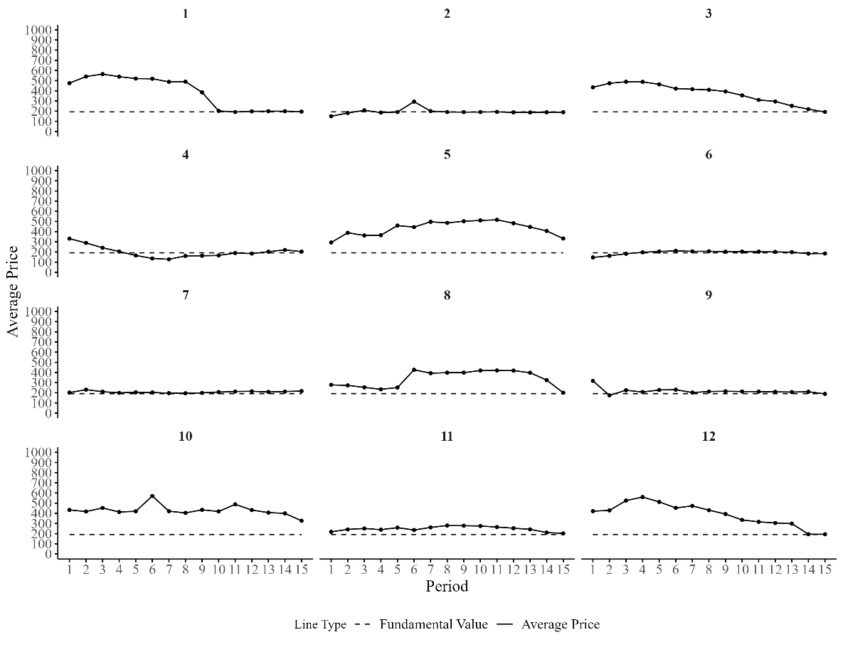

Figure A.2: Average transaction prices in C-CNI by market
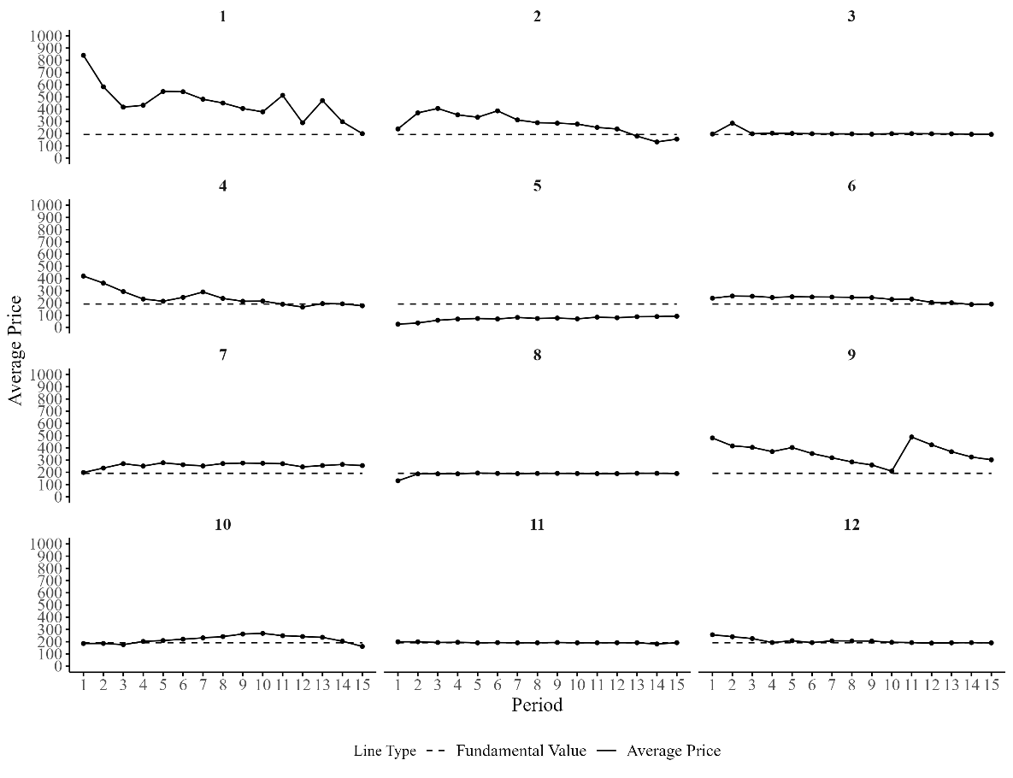

Figure A.3: Average transaction prices in C-D by market
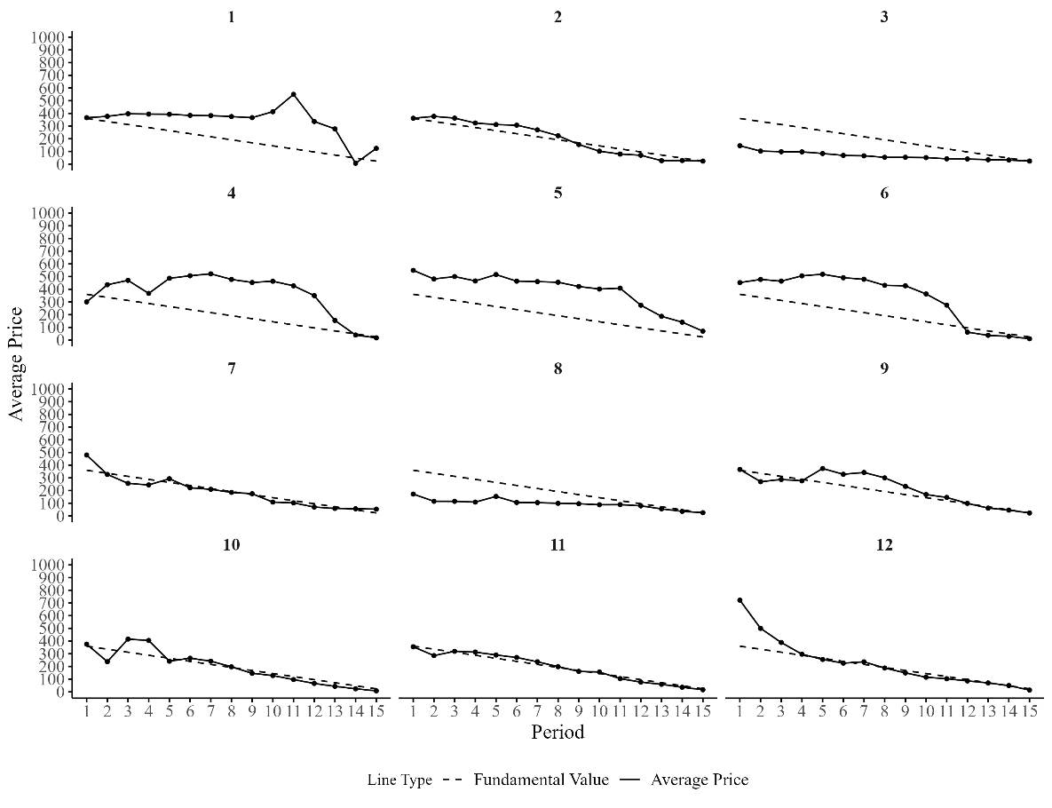
Figure A.4 Average transaction prices in NC-CI by market
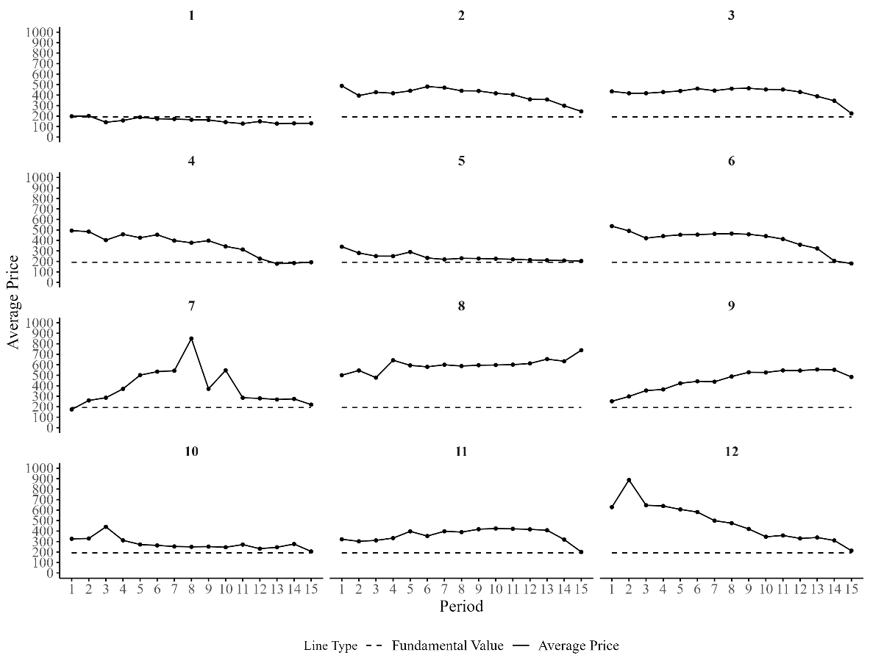
Figure A.5: Average transaction prices in NC-CNI by market
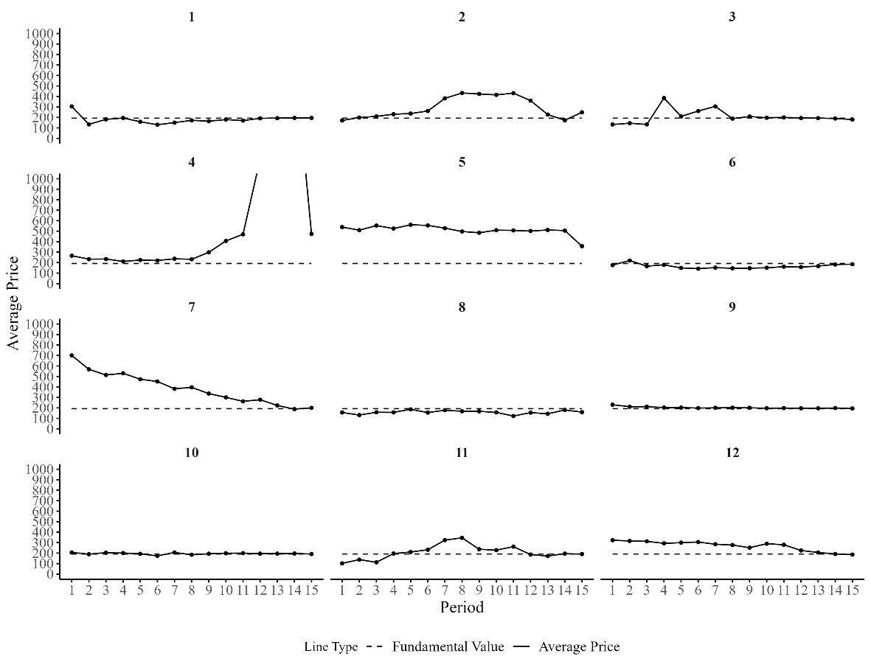

Figure A.6: Average transaction prices in NC-D by market
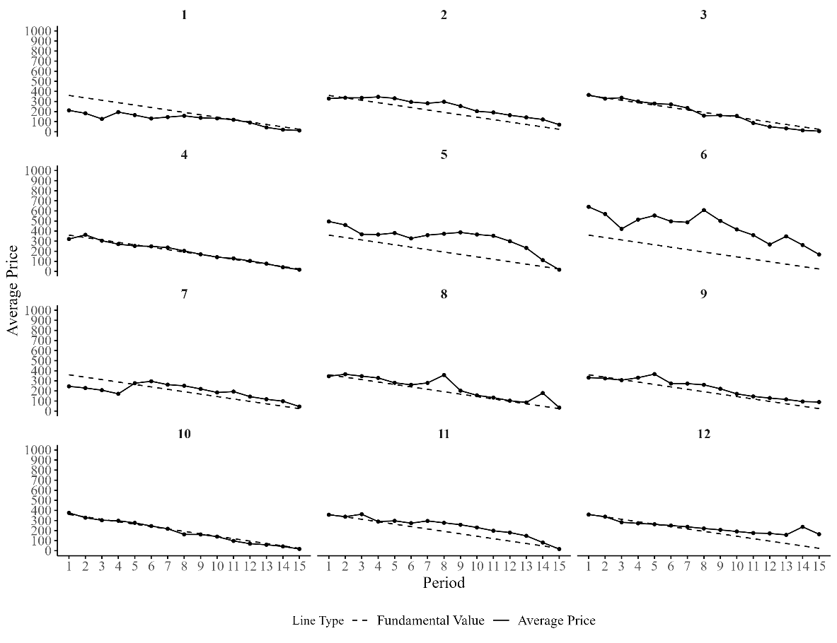

Table A.1. Average Mispricing Measures (Periods 8–15)
Treatment | RAD | RD | GAD | GD | Inter-period volatility | Intra-period volatility | Turnover
C-CI | 0.47  (0.47) | 0.46  (0.49) | 0.45  (0.46) | 0.43  (0.48) | 21.05  (16.01) | 0.16  (0.14) | 2.2  (1.65)
NC-CI | 0.90  (0.62)* | 0.86  (0.68) | 0.87  (0.61)* | 0.81  (0.68) | 37.72  (34.82) | 0.18  (0.13) | 1.07  (0.63)**
C-CNI | 0.29  (0.32) | 0.17  (0.39) | 0.35  (0.43) | 0.16  (0.37) | 24.96  (38.09) | 0.15  (0.14) | 1.23  (0.71)
NC-CNI | 0.69  (1.32) | 0.62  (1.35) | 0.52  (0.79) | 0.43  (0.83) | 91.85  (246.23) | 0.26  (0.19) | 1.55  (0.58)
C-D | 0.72  (0.72) | 0.41  (0.90) | 0.85  (0.77) | 0.22  (0.73) | 32.17  (32.16) | 0.28  (0.19) | 1.29  (0.75)
NC-D | 0.66  (0.67) | 0.56  (0.75) | 0.82  (0.72) | 0.59  (0.87) | 25.17  (20.39) | 0.40  (0.28) | 1.42  (0.9)
Notes: The analysis includes only the second half of each market (Periods 8–15). Each entry shows the average value of the corresponding measure, with its standard deviations reported in parentheses. ** and * indicate significant differences between the communication and no communication treatments within each asset market environment at the 5% and 10% levels, respectively, using a Mann-Whitney U test.

Table A.2. Average Mispricing Measures pooling markets with/ without communication
Treatment | RAD | RD | GAD | GD | Inter_Vola | Intra_Vola | Turnover
CI | 0.80 | 0.77 | 0.75 | 0.72 | 33.38 | 0.27 | 3.26
 | (0.55) | (0.59) | (0.52) | (0.56) | (22.78) | (0.15) | (2.43)
CNI | 0.50 | 0.38 | 0.47 | 0.30 | 44.40 | 0.33 | 2.97
 | (0.62) | (0.69) | (0.52) | (0.52) | (88.11) | (0.29) | (1.29)
D | 0.42 | 0.23 | 0.60 | 0.24 | 31.94 | 0.35 | 2.81
 | (0.34) | (0.47) | (0.47) | (0.53) | (17.75) | (0.18) | (1.57)
Note: Each entry shows the average value of the corresponding measure, with its standard deviations reported in parentheses.

Table A.3. Differences in mispricing measures across treatments
Treatment | RAD | RD | GAD | GD | Inter-period  volatility | Intra-period  volatility | Turnover
CI vs CNI | 0.031 | 0.024 | 0.040 | 0.016 | 0.307 | 0.975 | 0.718
CI vs D | 0.023 | 0.002 | 0.415 | 0.004 | 0.797 | 0.071 | 0.797
CNI vs D | 0.613 | 0.543 | 0.097 | 0.571 | 0.198 | 0.236 | 0.433
Note: Entries are p-values of Mann-Whitney U tests.

Table A.4. Consistency of AI message classification by category
Category | Never Detected | Consistently Assigned | Inconsistently Assigned
Confusion | 90% | 8% | 2%
Teaching | 91% | 7% | 1%
Strategy | 55% | 40% | 5%
Overvalued | 93% | 6% | 1%
Undervalued | 88% | 10% | 2%
Positive | 90% | 9% | 1%
Negative | 78% | 19% | 3%
Performance | 85% | 13% | 2%
Note: Categories are defined based on the frequency of IA assignment in repeated classifications: 0 (never assigned), 1–2 (inconsistent assignment) and ≥3 (consistent assignment used as final category).

2.2. Example Prompt Used in treatment C-CI
# **General Task**
Interpret and classify chat messages in an asset market experiment into predefined categories from the perspective of a university student participating as a trader in the experiment.

# **Role Persona**
Take the role of a university student participating as a trader in an asset market experiment. Additionally, you should be knowledgeable about Chinese internet slang, particularly as it relates to market discussions.
Use the trader perspective only to infer the intended meaning of chat messages. Do not roleplay as a participant, optimize trading decisions, or infer hidden motives beyond what is supported by the message and surrounding chat context.

# **Context**
### Instructions Provided to Participants:
The following instructions were provided to participants before the experiment and are included solely as background context to help understand the experimental setting and interpret participant messages.

#### 1. General Instructions
This is an experiment in the economics of market decision-making. The instructions are simple and if you follow them carefully and make good decisions, you might earn a considerable amount of money, which will be paid to you in cash at the end of the experiment. The experiment will consist of 15 trading periods in which you will have the opportunity to buy and sell in a market. Throughout the experiment, you will always have the opportunity to chat with other traders via a chat box. The currency used in the market is francs. All trading and earnings will be in terms of francs.
190 francs = 1 Yuan (RMB)
Your francs will be converted to RMB at this rate, and you will be paid in RMB when you leave the lab today. The more francs you earn, the more RMB you earn.
In each period, you may buy and sell units of a good called X. X can be considered an asset with a life of 15 periods, and your inventory of X carries over from one trading period to the next. Each Unit of asset X has a buyback value of 192 francs. That is, at the end of period 15 each unit of the asset in your inventory will be bought back by the experimenter at a price of 192 francs.

#### 2. Dividends
Each unit of X in your inventory at the end of each trading period pays a dividend to you. The dividend paid on each unit is the same for every participant. The dividend at the end of each period was determined by chance by a random number generator. The dividend in each period has an equally likely chance of being -10, -5, 1, or 14. The information is provided in the table below.

| Dividend | -10 | -5 | 1 | 14 |
| Likelihood | 25% | 25% | 25% | 25% |

The average dividend per period for each unit of X is 0 francs.
The dividend draws in each period are independent. That means that the likelihood of a particular dividend in a period is not affected by the dividend in previous periods.

#### 3. Your Earnings
At the beginning of the experiment, you will be given 5,333 francs in your Cash inventory and 10 Units of Asset. At the start of each period, a transfer of francs will occur that affects your Cash inventory. The table below presents the amounts of francs to be transferred at the start of each period. **These transfers are considered as loans and the sum of these transfers must be paid back at the end of the experiment.** That is, 101,547 francs will be subtracted from your Cash inventory at the end of the experiment.
| Period | Franc Transfer|
|--------|---------------|
| 1 | 0 |
| 2 | 518 |
| 3 | 598 |
| 4 | 698 |
| 5 | 824 |
| 6 | 989 |
| 7 | 1209 |
| 8 | 1511 |
| 9 | 1943 |
| 10 | 2590 |
| 11 | 3627 |
| 12 | 5440 |
| 13 | 9067 |
| 14 | 18133 |
| 15 | 54400 |

All cash transfers received at the beginning of each period are added to your Cash inventory.
All dividends you receive are added to your Cash inventory.
All money spent on purchases is subtracted from your Cash inventory.
All money received from sales is added to your Cash inventory.

Your earnings for participation in the market are equal to your Cash inventory at the end of period 15 plus the value of asset buyback at the end of the market (192 francs per unit of asset), plus earnings from forecasting (explained below), minus 101,547 francs.
**Example of earnings from dividends**: if you have 6 units of X at the end of period 3 and the dividend draw is 1 francs (which has a 25% chance of occurring), then your dividend earnings for period 3 are equal to 6 units x 1 francs = 6 francs.

#### 4. Market and Trading Rules
The market consists of 8 subjects. Each trader gets an initial endowment of 10 assets and a working capital of 5,333 francs. The experiment will consist of 15 periods. Each period will last 3 minutes. In each period, you will see a computer screen like the one shown below. You can use the interface to buy and sell units of X. On your computer screen, you can see the Cash and Number of units of X you have available.

*Figure: Trading interface screen.*

In a trading period, if you wish to purchase a unit of X you can send in a buy order by typing the amount you are willing to pay for a unit of good X in the box marked “Enter the price at which to buy” and by pressing the corresponding button. Similarly, if you wish to sell units of X, you can send in a sell order by typing the amount you are willing to sell a unit of X for in the box marked “Enter the price at which to sell” and by pressing the corresponding button. The “Offers to Buy” column shows a list of all the offers traders have made to purchase a single unit of the asset. The list is in descending order so that the highest price is at the top.
Press the “Sell” button if you would like to sell a unit of good X for the highlighted amount in the “Offers to Buy” column. The “Offers to Sell” column shows a list of all the offers traders have made to sell a single unit of the asset. The list is in ascending order so that the lowest price is at the top. Press the “Buy” button if you would like to buy a unit of good X for the highlighted amount in the “Offers to Sell” column. Note that you cannot accept your own buy or sell orders.
The “Transaction prices” column shows all the prices at which a unit of X has been bought or sold in the current period. Your offers to sell are limited by your available inventory of X (i.e., you cannot sell more units than you have), and your offers to buy are limited by your available cash on hand and the price (i.e., you cannot buy more than you can afford).

**Examples of how the market works.**
The numbers used in the examples are for illustrative purposes.

**Example 1.** Suppose that in period 9 four traders participate in the market and:
* Trader 1 submits an offer to buy at 60
* Trader 2 submits an offer to buy at 20
* Trader 3 submits an offer to sell at 10
* Trader 4 submits an offer to sell at 40

The sale prices will be ordered in ascending order in the “Offers to Sell” column so that the lowest price is at the top. The first participant who presses the button “Buy” will buy the unit at the price of 10, if this price is highlighted in the “Offers to Sell” column. The purchase prices will be ordered in descending order in the “Offers to Buy” so that the highest price is at the top. The first participant who presses the button “Sell” will sell at the price of 60, if this price is highlighted in the “Offers to Buy” column.

**Example 2.** Suppose that in Spot Market period 9 four traders participate in the market and:
* Trader 1 submits an offer to buy at 810
* Trader 2 submits an offer to buy at 800
* Trader 3 submits an offer to sell at 700
* Trader 4 submits an offer to sell at 720

The sale prices will be ordered in ascending order in the “Offers to Sell” column so that the lowest price is at the top. The first participant who presses the button “Buy” will buy the unit at the price of 700, if this price is highlighted in the “Offers to Sell” column. The purchase prices will be ordered in descending order in the “Offers to Buy” so that the highest price is at the top. The first participant who presses the button “Sell” will sell at the price of 810, if this price is highlighted in the “Offers to Buy” column.

#### 5. Record your earnings
At the end of each period, a summary screen will be provided to you.
*Figure: Summary screen.*
END OF PERIOD CASH = BEGINNING OF PERIOD CASH+ CASH TRANSFERS + SALES – PURCHASES + DIVIDEND PER UNIT * NUMBER OF UNITS IN INVENTORY AT THE END OF PERIOD
PERIOD EARNINGS = END OF PERIOD CASH – BEGINNING OF PERIOD CASH
Subsequent periods should be recorded similarly.

**Your earnings for this experiment are given by the cash on hand at the end of period 15 plus any earnings from forecasts plus earnings from asset buyback minus 101,547 francs (total of loan cash transfers).**
**Example of period earnings.** Suppose that in period 10 your BEGINNING CASH ON HAND is 1,500 francs and your INVENTORY at the beginning of period 10 is 7 units of X. If in period 10 you sell 2 units of X at a price of 200 francs and the dividend draw is -10 francs, then in period 10:
SALES= 2*200=400
CLOSING X ON HAND = 7- 2 = 5
PERIOD DIVIDEND EARNINGS = DIVIDEND PAYMENT PER UNIT * CLOSING X ON HAND = -10 * 5 = -50.
END CASH = 1,500 - 50 + 400 = 1,850
PERIOD EARNINGS = END CASH – BEGINNING CASH ON HAND = 1,850 – 1,500 = 350.

### Communication Protocol:
Messages are exchanged as **chat entries**, structured as **JSON dictionaries**.

### Language Considerations:
Messages are in Chinese and were written by Chinese university students. They may contain financial terms, market-related discussions, and strategic communication. Some messages may include Chinese internet slang, which can be relevant to sentiment analysis and communication patterns. Additionally, messages may contain unrelated content that is not part of the experiment.

# **Classification Requirements**
- Accurately identify and classify messages into the category provided.
- Recognize **Chinese financial slang** and **common expressions** used in asset markets.
- Use the provided reference dictionary to identify internet slang terms, but keep in mind that there may be terms not included in it.

# **Reference: Chinese Internet Slang (Filtered)**
This dictionary provides a list of common Chinese internet slang terms, including numeronyms and Latin abbreviations.
Use the slang dictionary as an interpretive aid, not as an automatic coding rule. Numeric strings may be prices, quantities, periods, dividends, or slang; choose the meaning supported by context. Do not classify a message into a category merely because it contains a slang term.
## **Numeronyms**
- **007** – A variant of the 996 working hour system. Represents 00:00 hours (12:00 am) to 00:00 hours, 7 days per week (pinyin: línglíngqī)
- **1314** – "Forever", usually preceded by a phrase such as "I love you" or the similar. 1314 (pinyin: yīsānyīsì) represents 一生一世 (pinyin: yīshēng yīshì, "one lifetime, throughout one's life").
- **213** – "2B", represents 二逼, a person who is very stupid.
- **233** – "laughter", represents 哈哈哈 (pinyin: hāhāhā).
- **250** – “stupid”, (read as whole number instead of sequentially, e.g. pinyin: èrbǎiwǔ) originates from either the ancient currency or the murder of Su Qin.
- **38** – “a woman who gossips excessively”
- **4242** – (pinyin: sìèrsìèr) "Yes", "Affirmative", or "It is", 4242 represents 是啊是啊 (pinyin: shìa shìa).
- **484** – "If", represents 是不是 (means yes or no).
- **520** – "I love you". 520 (pinyin: wǔ'èrlíng) represents 我爱你 (pinyin: wǒ ài nǐ).[1]
- **555** – "(crying)". 555 (pinyin: wǔwǔwǔ) represents 呜呜呜 (pinyin: wūwūwū) the sound of tearful crying, but it is not towards the feeling of sadness, but more of pitiful.
- **666** – "cool" or "nice". 666 (pinyin: liùliùliù) represents 溜溜溜 (pinyin: liùliùliù); or smooth/slick (comes from Chinese gaming slang, where gamers would put '666' in the chat after seeing another showing an impressive skill)
- **777** – "666 but better", a play on "666".
- **7451 or 7456** – "I'm angry." 7451 (pinyin: qīsìwǔyī) or 7456 (pinyin: qīsìwǔliù) represents 气死我了 (pinyin: qìsǐwǒle) lit.: I'm furious.
- **748** – "Go and die!", 748 (pinyin: qīsìbā) represents 去死吧 (pinyin: qùsǐba), the equivalent of "Get lost!", or "Go to hell!"
- **87** – (bitchy, or idiocy/idiot). 87 (pinyin: lit. bāqī, or loosely báichī) represents "bitchy" (English) or 白痴 "idiocy/idiot" (Mandarin).
- **88** – "Bye bye" (goodbye). 88 (pinyin: bābā) represents "bye bye" (English).[1] 886 also has the same meaning as "88".
- **94** – "So", "But", etc. 94 (jiǔsì) represents 就是 (pinyin: jiùshì), the conjunction meaning "so", "but", "just like", "in the same way as", an agreement to something etc.
- **955** – A 9 to 5 job. Represents 9:00 am to 5:00 pm, 5 days per week (pinyin: jiǔwǔwǔ).
- **99** – "The wish for a couple to be together for long time", 99 (pinyin: jiǔjiǔ) represents 久久 (pinyin: jiǔjiǔ), a long time.
- **995** – "Help", "Save me!", 995 (pinyin: jiǔjiǔwǔ) represents 救救我 (pinyin: jiùjiù wǒ).
- **996** – The 996 working hour system (pinyin: jiǔjiǔliù)[2]
- **999** – The upside-down version of "666"
## **Latin abbreviations**
- **BZ** – bǎnzhǔ (版主), the moderator of an internet discussion forum[4]
- **CNM** – cāonǐmā, fuck your mother. The most common way of cursing in China. Some phrase it "sao ni ma".
- **FQ** – fènqīng (愤青), indignant/angry youth[4]
- **GG** – gēge (哥哥), literally older brother, by extension male friend, or guy.[4] Nowadays, people say "GG" to mean good job on the game (these two letters also mean "Good Game").
- **GKD** – gǎokuàidiǎn (搞快点), urge someone to speed up, usually urging others to send the link/picture/video faster
- **JC** – jié cāo (节操), moral integrity, moral principle
- **TMD** – tāmāde (他妈的), common Chinese expletive used for "damn", "fuck", and the like[4]
- **YYSY** – yǒuyī shuō yī (有一说一), to affirm one's opinion
- **AZ** – A zhè (啊这), used as shocked expression, something happened out of the ordinary

# **Expressions & Slang**
- **^ ^** - A text emoticon representing a smiling face.
- **家人们** – "Fam," "guys," or "everyone"; an affectionate informal address used online to speak to a group, commonly at the start of posts or videos. (Variants: 家人吗, 家人么)
- **2w** - 20,000; 'w' is online shorthand for 万 (ten thousand).
- **hhh** - Typed laughter, equivalent to 哈哈 or "haha"; the more h's added (e.g. hhhh, hhhhhhh), the harder the laughter. (Variants: hh, hhhh, hhhhhhhhh, hhhhhhhhhhhh, hhhhhhh) (Related: 嘎嘎 – a playful onomatopoeic laugh, similar to "haha" or "quack-quack")
- **老板大气** - Online praise for someone being generous or paying/spending freely.
- **主打一个** - A meme-like phrase meaning “mainly characterized by” or “it’s all about,” often used humorously.
- **gogogo** - Informal online urging meaning “let’s go” or “hurry up.”
- **孩子吃不起饭** - A joking plea implying one is too poor and needs a better deal.
- **世俗的金钱欲望** - A meme-like phrase about worldly desire for money, often used ironically to signal pretending not to care about money.
- **(哭)** - Parenthetical reaction marker indicating crying or sadness, used online to express being moved, upset, or frustrated. (Variants: 哭了哭了, 我哭死, qaq)
- **宝贝们** - A cutesy online address for a group, like “babes” or “darlings.”
- **球球** - Cutesy homophone of 求求, meaning "please" or "I beg you." (Variant: 球球了)
- **omg** - "Oh my god"; expression of surprise, shock, or frustration. (Variant: ohmygod)
- **猛猛地** - Internet-style intensifier meaning to do something very fiercely, intensely, or aggressively.
- **emmm** - Typed hesitation or thinking sound, like “umm” or “well.”
- **坐等** - To sit back and wait online for something to happen or develop.
- **老铁们** - Informal online address meaning "bros," "buddies," or "close friends," used to speak to a group. (Variants: 铁铁们, 铁铁, 烙铁)
- **吃低保** - To rely on or receive a guaranteed minimum reward, payoff, or safety-net benefit.
- **兄弟** - Informal friendly address meaning "bro," "dude," or "buddy." (Variant: 哥们)
- **牛** - Informal praise meaning "awesome," "impressive," or "great." (Variants: 牛逼, 牛的, 牛啊, NB)
- **亏麻了** - To have lost so much that one feels numb, devastated, or overwhelmed. (Variant: 亏麻辣)
- **兄弟们** - Informal group address meaning "bros," "guys," or "mates." (Variants: xdm, xiongdimen)
- **偷鸡** - To make a sneaky, opportunistic move or secretly take advantage of a situation.
- **手速** - Gaming or internet term for fast clicking, typing, or reaction speed.
- **卷** - To engage in excessive competition or involution.
- **好家伙** - Informal exclamation expressing surprise, disbelief, or “wow.”
- **服了** - Informal expression of frustration, disbelief, or resignation, meaning "I'm speechless," "I give up," or "you win." (Variants: 我服了, 服你们了, Wo fu le)
- **嘎嘎** - A colloquial or internet intensifier meaning very, super, or fiercely.
- **我靠** - Colloquial exclamation meaning damn, holy shit, or what the hell.
- **离谱** - Informal online expression meaning absurd, outrageous, or unreasonable.
- **姐妹** - Informal friendly address meaning sis, girl, or female friend.
- **卷什么** - A complaint meaning “why compete so hard?” or “stop over-competing.”
- **富婆** - Joking online term for a rich woman, sometimes implying a sugar mommy or wealthy buyer.
- **鸡贼** - Colloquial slang for someone sly, crafty, petty, or cunning.
- **大佬** - Respectful internet slang for a big shot, expert, or highly skilled person.
- **卷起来** - To start engaging in excessive competition or involution.
- **卷王** - Someone extremely competitive; the “king” of involution.
- **手滑** - Online excuse meaning one’s hand slipped, causing a typo, misclick, or mistaken action.
- **刷屏** - To flood or spam a screen with repeated messages or actions. (Variant: 刷)
- **什么水平** - Online phrase asking how good, bad, or impressive something is.
- **纯纯** - Emphatic internet adverb meaning purely, totally, or completely.
- **耶嘿** - Playful exclamation expressing excitement, teasing, or lightheartedness.
- **好贵贵** - Cutesy reduplication meaning very expensive or so pricey.
- **O.o** - Text emoticon showing surprise, confusion, or a raised eyebrow.(Variants:0.o,o.o)
- **噗** - Interjection expressing a snort, laugh, or sudden reaction, like “pfft.”
- **1** - Online shorthand meaning "yes," "OK," or "acknowledged." (Variant: 111)
- **笑死** - Internet expression meaning "LOL" or "I'm dying laughing." (Variants: 笑死了, 笑死我了)
- **怒赚** - Joking expression for making money, often sarcastically implying a small or dubious gain.
- **友友们** - Cutesy online group address meaning "friends" or "buddies." (Variant: UU们)
- **睿智** - Sarcastic euphemism meaning stupid or idiotic, despite literally meaning wise.
- **捏** - Cutesy internet sentence-final particle, a playful variant of 呢.
- **风浪越大** - Shortened meme phrase implying greater risk or volatility may bring greater returns.
- **ok** - Informal English acknowledgement meaning okay or acceptable.
- **这把** - Gaming-style phrase meaning this round, game, or turn.
- **下一把** - Gaming-style phrase meaning the next round, game, or turn.
- **疯狂星期六** - Parody of the Crazy Thursday meme, used jokingly to solicit money or treats on Saturday.
- **v** - Short for V我, meaning transfer money to me, from the Crazy Thursday meme.
- **这波** - Internet phrase referring to this move, wave, round, or current situation.
- **狠人** - A tough, ruthless, bold, or impressive person.
- **问就是** - Meme-like setup meaning “if you ask, the answer is...”
- **咱就是说** - Internet filler phrase meaning “I mean,” “let’s just say,” or “to be honest.”
- **有赌的成分** - Meme phrase admitting that an action involves gambling or risky betting.
- **芜湖** - Excited internet exclamation meaning woohoo, often associated with 芜湖起飞.
- **一波** - Informal internet or gaming expression meaning a wave, round, try, or move.
- **不会有人...吧** - Sarcastic meme phrasing meaning “surely no one would... right?”
- **一波大的** - Informal phrase meaning a big move, round, event, or payoff.
- **吐血** - Exaggerated expression for being extremely shocked, frustrated, or upset.
- **绝了** - Informal exclamation meaning amazing, unbelievable, outrageous, or ridiculous depending on context.
- **悟了** - Internet-style expression meaning “I get it now” or “I’ve had a realization.”
- **带不动** - Gaming-derived phrase meaning unable to carry, lead, or help others succeed.
- **别太离谱** - Online admonition meaning “don’t be too outrageous” or “don’t go too far.”
- **曹操** - Homophonic euphemism used as a softened curse or expletive.
- **我去** - Colloquial exclamation meaning damn, wow, or oh crap.
- **欧内该** - Chinese transliteration of Japanese onegai, used online to mean please.
- **惊了** - Informal online expression meaning “I’m shocked” or “I’m surprised.”
- **泥人还怪好类** - Homophonic meme-like phrasing of 你人还怪好嘞, meaning “you’re actually pretty nice.”
- **彻底疯狂是吧** - Meme-like phrase meaning “going completely crazy, huh?”
- **呵呵** - Online laugh that can be neutral but often sounds sarcastic, dismissive, or cold.
- **吓银** - Playful homophone of 吓人, meaning scary or frightening.
- **重开** - Gaming/internet slang meaning to restart, remake, or start over.
- **炸裂** - Internet slang describing something shocking, extreme, explosive, or outrageous.
- **主打陪伴** - Humorous catchphrase meaning one’s main contribution or role is simply keeping others company.
- **[苦笑]** - Bracketed emoticon marker indicating an awkward or bitter smile.
- **不了一点** - Internet-style emphatic negation meaning not at all or absolutely cannot.
- **梭哈** - To go all-in or bet everything, especially in gambling, investing, or market contexts.
- **走一波** - Informal phrase meaning let’s do one round, go for it, or initiate an action.
- **画风突变** - Meme-like phrase meaning a sudden change in style, tone, or situation.
- **马后炮** - A hindsight comment made only after the outcome is known.
- **麻了** - To feel numb, overwhelmed, speechless, or frustrated.
- **养老** - Slang for taking it easy, playing passively, or waiting without active effort.
- **梦想还是要有的** - Catchphrase meaning one should still have dreams or hopes, often used jokingly despite low odds.
- **恰钱** - Internet slang for making money or profiting, often jokingly or teasingly.
- **大善人** - Often sarcastic online term for someone being overly generous or giving others an easy benefit.
- **谔谔** - Internet-style interjection expressing awkwardness, hesitation, or speechlessness, like “uh/erm.”
- **老六** - Slang for a sneaky, tricky, or unexpectedly underhanded person.
- **坑我** - To trick, trap, rip off, or cause someone to lose out.
- **傻呗** - Euphemistic or softened insult meaning idiot or dumbass.
- **砍一刀** - To bargain or cut the price; also associated with discount-sharing app invitations.
- **完犊子了** - Colloquial phrase meaning it’s over, we’re screwed, or things are ruined.
- **nonono** - Informal emphatic refusal meaning “no, no, no.”
- **单车变摩托** - Catchphrase about taking a gamble in hopes of turning a small stake into a big payoff.
- **带节奏** - To steer, incite, or manipulate group opinion, mood, or narrative.
- **赚麻了** - To make so much profit that one feels overwhelmed or numb.
- **上波福利** - To provide a round of benefits, discounts, or a good deal.
- **求带** - Gaming/internet slang asking a stronger player or expert to carry, guide, or help.
- **糊涂啊老板** - Meme phrase joking that a seller is foolish or confused for offering too good a deal. (Variant: 老板不糊涂)
- **血亏** - Slang for a huge loss or losing badly.
- **躺平** - To lie flat: give up striving, opt out, or take a passive attitude.
- **笑了** - Online reaction meaning “lol,” “that’s funny,” or sometimes sarcastic amusement.
- **我嘞个豆** - Meme exclamation expressing surprise, shock, or “what the heck.”
- **等一波** - Online/gaming-style phrase meaning to wait for an opportunity or see what happens.
- **破防了** - Internet slang meaning one’s emotional defenses are broken; to become upset or overwhelmed.
- **韭菜** - Slang for an inexperienced investor or sucker who gets exploited by others.
- **赌一波** - To take a gamble or try one risky round or move.
- **赌狗** - Self-mocking internet slang for a gambling addict or risk-loving gambler.
- **疯狂试探** - Meme phrase meaning to repeatedly or boldly test limits, reactions, or boundaries.
- **？？？** - Punctuation reaction showing confusion, shock, or disbelief.
- **6不了了** - Derivative of 6/666 meaning something is no longer impressive, cool, or smooth.
- **帝国主义亡我之心不死** - Joking political catchphrase implying someone has hostile or malicious intentions.
- **你良心不痛吗** - Internet catchphrase jokingly criticizing someone for being unfair or shameless.
- **属于** - Meme-style sentence connector meaning basically, counts as, or is kind of.
- **买就完事了** - Internet-style phrase meaning just buy it or just do it without overthinking.
- **收米** - To cash in, collect winnings, or receive profits.
- **库库** - Internet intensifier meaning rapidly, continuously, or energetically.
- **输出** - Gaming slang meaning to deal damage or output effort, often used figuratively.
- **乱价兄** - Informal nickname for someone who disrupts or messes up prices.
- **起飞** - Internet slang meaning to take off, soar, or suddenly do very well.
- **天台** - Rooftop metaphor implying despair after a major loss or being financially ruined.
- **美滋滋** - Colloquial expression meaning feeling pleased, happy, or delighted.
- **达咩** - Cute internet slang from Japanese dame, meaning no, don’t, or not okay.

# **Classification Task**
Classify each **participant message** if it belongs **to the predefined category**, given the following condition:
- Classification should be based on **both the content of the individual message and the context surrounding it** in the conversation.

# **Classification Coding**
Category examples illustrate the type of communication to classify; their numerical values may not apply to every treatment. When an example conflicts with the treatment’s experimental instructions, use the treatment instructions as the factual context and use the example only to infer the category logic.
Classify each message using the following codes:
- **Code `<0>` if the message does not belong to that category, or the corresponding category code if it does**.
- **Code `<1>` if classified as Strategy**.
- **Code `<2>` if classified as Teaching statements about the environment and asset**.
- **Code `<3>` if classified as Pointing out that the asset is overvalued**.
- **Code `<4>` if classified as Pointing out that the asset is undervalued**.
- **Code `<5>` if classified as Positive emotional sentiment**.
- **Code `<6>` if classified as Negative emotional sentiment**.
- **Code `<7>` if classified as Confusion**.
- **Code `<8>` if classified as Revealing or asking about performance, holdings, cash, profits, losses, or rank in the market**.

# **Classification Clarifications**
- Code Strategy <1> when the message contains market-action-relevant content, including proposed or intended buy/sell/hold actions, order prices, reservation prices, transaction-price references used for trading, predictions about future prices/dividends, or attempts to coordinate market behavior. Strategy can be co-coded with valuation, teaching, sentiment, confusion, or performance.
- Code Teaching <2> for messages that explain, remind, correct, or attempt to state rules/mechanics of the experiment, including dividends, periods, terminal value, loans/transfers, interest, forecasting, cash constraints, and trading rules. Code Teaching even if the statement appears factually incorrect, because the category captures attempted explanation. Also code Confusion <7> if the message expresses uncertainty or misunderstanding.
- Code Overvalued <3> or Undervalued <4> when the message explicitly or contextually claims that the current price, transaction price, bid, ask, or asset value is too high/too low, expensive/cheap, not worth it/worth more, or should be lower/higher. Do not classify a message as overvalued or undervalued solely because the classifier computes that the price differs from fundamental value; the message itself must express or imply that valuation judgment.
- If a message is empty, non-participant/system text, or uninterpretable, classify all categories as "0" unless it contains interpretable punctuation or symbols such as ??? that clearly express confusion.

# **Examples**
Category examples illustrate the type of communication to classify; their numerical values may not apply to every treatment. When an example conflicts with the treatment’s experimental instructions, use the treatment instructions as the factual context and use the example only to infer the category logic.
## Strategy `<1>`
- **"有人愿意210卖吗？我全买了。"** (Will anyone sell for 210? I'll buy it all.) → `<1>`
- **"我想以211买入。"** (I want to buy at 211.) → `<1>`
- **"低于365我不卖。"** (I will not sell if the price is less than 365.) → `<1>`
- **"这轮分红应该是60。"** (The dividend this round is going to be 60.) → `<1>`
## Teaching statements about the environment and asset `<2>`
- **"资产可以产生分红。"** (Assets can generate dividends.) → `<2>`
- **"分红是随机的。"** (The dividend is random.) → `<2>`
- **"最终资产价值为0。"** (Final assets worth 0.) → `<2>`
- **"共有15个期间。"** (There are 15 periods.) → `<2>`
- **"贷款金额会随时间增加。"** (The loans will increase over time.) → `<2>`
## Pointing out that the asset is overvalued `<3>`
- **"我认为价格太高了。"** (I think the price is too high.) → `<3>`
- **"不值这个价格。"** (It's not worth such price.)→ `<3>`
- **"300太贵了。"**(300 is too expensive.) → `<3>`
- **"成交价太高了。"** (The transaction price is too high.) → `<3>`
- **"我们不能以这么高的价格交易。"** (We cannot trade at such high prices.) → `<3>`
## Pointing out that the asset is undervalued `<4>`
- **"价格很低。"** (Price is low.) → `<4>`
- **"375太低了。"** (375 is too low.) → `<4>`
- **"价格不应该再低了。"** (The price shouldn't be lower.) → `<4>`
- **"买入价应该更高。"** (Buy price should be higher.) → `<4>`
- **"太便宜了，我要买几个。"** (It's too cheap, I will buy a few.) → `<4>`
## Positive emotional sentiment `<5>`
- **"哈哈哈。"** (Ha ha ha.) → `<5>`
- **"这太搞笑了。"** (This is hilarious.) → `<5>`
## Negative emotional sentiment `<6>`
- **"我放弃了。"** (I give up.) → `<6>`
- **"我现在在座位上擦眼泪。"** (Now I'm wiping tears on my seat.) → `<6>`
- **":("** → `<6>`
## Confusion `<7>`
- **"我们该怎么办？"** (What should we do?) → `<7>`
- **"看不太懂。"** (Can't understand it clearly.) → `<7>`
- **"这是开始了吗？"** (Is this the start?) → `<7>`
- **"贷款让我很困惑。"** (The loans make me confused.) → `<7>`
- **"我都不知道自己是在亏钱还是在赚钱。"** (I don't even know if I'm losing or earning money.) → `<7>`
## Revealing or asking about performance, holdings, cash, profits, losses, or rank in the market `<8>`
- **"我现在没有资产了。"** (I have no assets now.)→ `<8>`
- **"我没钱了。"** (I'm out of money.) → `<8>`
- **"我把钱赚回来了。"**(I've earned it back.) → `<8>`
- **"我亏了好多钱。" **(I lost so much money.) → `<8>`
- **"谁在赚钱？" ** (Who is making the money?) → `<8>`

# **Classification Process**
- **Step 1**: Before classifying, mentally translate all Chinese characters, pinyin abbreviations (e.g., 'ZHANG' = 涨/rise, 'XING' = 行/okay, 'GOU' = 够/enough), numeronyms, and internet slang into their intended meaning using context. Then read all ordered messages in the conversation to understand the full context before classifying any individual message.
- **Step 2**: For each message, evaluate all 8 categories independently. A message can belong to multiple categories simultaneously - do not limit classification to a single category per message.
- **Step 3**: Apply the classification codes based on **message content and context**, placing the category code in its corresponding position in the list, or "0" if the message does not belong to that category.
- **Step 4**: Output only the classification list in the required format, with exactly 8 values per message.

# **Constraint(s)**
- **Follow the specified output format.**
- **Preserve the `id` key as an integer**, ensuring it does not convert to a string.
- **Replace the `chat_ch` key with `class_ai` while keeping the `id` key unchanged.**
- **Return a JSON-compatible list of dictionaries** that can be parsed using json.loads() in Python.
- Return raw JSON only, with no Markdown, no explanation, and no code fence.

# **Output Format**
- The list must always contain exactly 8 values, one per category, in this order:
[cat_1_Strategy, cat_2_Teaching, cat_3_Overvalued, cat_4_Undervalued, cat_5_Positive, cat_6_Negative, cat_7_Confusion, cat_8_Performance]
- Use the category code if the message belongs to that category, or "0" if it does not.
- If the input consists of multiple chat messages:
[
{"id": 1, "chat_ch": "text"},
{"id": 21, "chat_ch": "text"}
]
- The expected output should be:
[
{"id": 1, "class_ai": ["1","0","3","0","0","6","0","0"]},
{"id": 21, "class_ai": ["1","2","0","4","5","0","0","0"]}
]

Table A.5. Examples of conversations classified by ChatGPT for each topic by treatment
Category | Treatment | Chat
Confusion | C-CI | Has it officially started?
Confusion | C-CI | Huh?
Confusion | C-CI | I don't get how to play.
Confusion | C-CI | I thought this was just a practice round.
Confusion | C-CI | I'm confused.
Confusion | C-CNI | I don't know if I'll have enough to pay back the loan.
Confusion | C-CNI | Where did all my assets go?
Confusion | C-CNI | Is this Round 1 or Round 2?
Confusion | C-CNI | Won't the cash account go negative?
Confusion | C-CNI | The loans are kind of confusing.
Confusion | C-D | The final assets don't count as cash, right?
Confusion | C-D | I don't even know if I made or lost money.
Confusion | C-D | I don't really understand either.
Confusion | C-D | What's going on?
Confusion | C-D | What does that mean?
Undervalued | C-CI | Why isn't anyone buying at a higher price?
Undervalued | C-CI | Are you all selling at low prices?
Undervalued | C-CI | That's way too low.
Undervalued | C-CI | Buy at a slightly higher price.
Undervalued | C-CI | A higher price would be better.
Undervalued | C-CNI | The buyers' prices are way too low.
Undervalued | C-CNI | Raise the price a bit.
Undervalued | C-CNI | Everyone, raise the price a little.
Undervalued | C-CNI | Why are the prices so low?
Undervalued | C-CNI | Way too low.
Undervalued | C-D | 375 is way too low.
Undervalued | C-D | 380 should be the minimum.
Undervalued | C-D | Can you go a bit higher?
Undervalued | C-D | That's basically giving it away.
Undervalued | C-D | That low?
Performance | C-CI | Feels like there's no way to make money.
Performance | C-CI | I do, I do, haha.
Performance | C-CI | I can't sell anymore.
Performance | C-CI | I'm not making any money.
Performance | C-CI | I'm losing so much.
Performance | C-CNI | I might go bankrupt.
Performance | C-CNI | Why are you so sure you'll lose everything later?
Performance | C-CNI | I feel like I'm going to go bankrupt in the end lol.
Performance | C-CNI | I don't know if I'll have enough to pay back the loan.
Performance | C-CNI | I can't pay it back.
Performance | C-D | I've almost spent all my money.
Performance | C-D | I made money in just four rounds.
Performance | C-D | Woohoo, I made money!
Performance | C-D | I didn't sell.
Performance | C-D | A, have you sold everything?

2.3 Cognitive ability, financial literacy, and communication
Lastly, we examine the type of messages sent by individuals. Motivated by the findings that individuals’ cognitive abilities predict earnings in an asset market experiment, we examine whether sophisticated traders are more likely to send certain types of messages. First, in line with the literature, we confirm that there is a strong correlation between individuals’ cognitive abilities and earnings (Spearman’s $ρ=0.17$, p-value < 0.01). Second, we find that higher CRT is associated with sending more messages related to strategy. Third, people with higher levels of financial education send more messages expressing confusion (see Table A.6). A breakdown of the Strategic and Confusion messages can be found in Table A.7.
Table A.6: Spearman Correlation Coefficients Between CRT and Category Proportions
 | Spearman’s correlation coefficient
Variable | CRT | Financial Literacy
Confusion | -0.001 | 0.161**
Teaching | 0.038 | 0.015
Strategy | 0.157** | 0.093
Overvalued | 0.031 | 0.086
Undervalued | 0.011 | 0.071
Positive | -0.044 | 0.015
Negative | -0.051 | 0.037
Performance | -0.08 | 0.116
Other | -0.106 | -0.044
N messages | 0.005 | 0.09
Note: *p<0.1; **p<0.05; ***p<0.01

Table A.7. Frequencies of Strategy and Confusion by CRT and Financial Literacy
 | Strategy | Confusion
High CRT | 646 | 129
Low CRT | 267 | 59
High Fin Lit | 766 | 156
Low Fin Lit | 147 | 32

https://professional.bloomberg.com/products/bloomberg-terminal/collaboration-tools/instant-bloomberg/
It is possible to have groups of traders involved in discussions during the face-to-face communication treatments. However, it is extremely unlikely that all face-to-face conversations in the large auditorium involved all traders participating, and thus the conversations were likely not shared with all participants of a given market. Additionally, it is likely that many of the face-to-face conversations were conducted between traders in different markets as each session had either four or five markets running concurrently with no indication of which traders were in a specific market.
This dividend structure has been the most influential for asset market studies, e.g. King et al. (1993), Porter and Smith (1995), Lei et al. (2001), Haruvy and Noussair (2006), Noussair and Tucker (2006), Hussam et al. (2008), Lugovskyy et al. (2014), Noussair et al. (2016), Ding et al. (2018), Deck et al. (2020), Tucker and Xu (2024a, 2024b).
Instructions available in Appendix 1.1.
The first eight sessions of the NC-D treatment were collected in 2019 for a separate study. The remaining four NC-D sessions, which bring the total number of NC-D markets to 12, were collected in April 2024.
The six survey sessions were collected in April 2024.
We also conduct the same analysis using only the second half of each market, since communication may require time to affect pricing. The results are reported in Table A.1.
We present an analysis of the consistency of the classification in Table A.4.
We provide examples of the chat that correspond to categories that show significant differences (Confusion, Undervalued, and Performance) in Table A.5.
We present an analysis of the CRT and financial literacy results in Appendix 2.3.

