UNIVERSITY OF WAIKATO

Hamilton
New Zealand

The Role of Communication in Asset Market Experiments

Carol Luengo, Steven Tucker, Yilong Xu and Kun Zhang

Working Paper in Economics 4/25

April, 2025

Carol Luengo  School of Accounting, Finance  and Economics  University of Waikato  Private Bag 3105  Hamilton  NEW ZEALAND, 3240  cl376@students.waikato.ac.nz | Steven Tucker  School of Accounting, Finance  and Economics  University of Waikato  Private Bag 3105  Hamilton  NEW ZEALAND, 3240  Email: steven.tucker.nz@gmail.com
Yilong Xu  Utrecht School of Economics  Utrecht University, The Netherlands  Email: y.xu3@uu.nl | Kun Zhang  Business School, University of Jinan  Shizhong District, Jinan, Jinan  China, 250004  Kunzhang_uk@163.com

Abstract

This study investigates the effect of continuous, free-form communication among traders on mispricing in experimental asset markets. Using laboratory experiments, we compare three asset types with varying complexity regarding their payoff structures: a simple constant fundamental value, a moderately complex decreasing fundamental value, and a highly complex constant fundamental value with dividends and interest. Communication's impact is examined by allowing participants to engage in unrestricted text chat during market trading sessions. We hypothesize that the potential benefits of communication—such as reducing confusion, correcting misconceptions, and promoting common beliefs—would be more pronounced in more complex asset markets. However, results indicate that communication's effects are generally modest, with only a slight reduction in mispricing observed in the most complex asset scenario. Content analysis employing large language models reveals significant differences in the communication topics discussed, particularly highlighting strategy-related conversations in highly mispriced markets. Despite expectations that communication could substantially improve market efficiency, our findings suggest limited effectiveness, contingent upon the nature and complexity of the asset traded. This research contributes to understanding how trader communication influences asset pricing dynamics and extends insights into the institutional factors impacting market efficiency.

JEL Classification

C90, C91, G12

Keywords

communication
experimental asset markets
mispricing

Acknowledgment

We gratefully acknowledge financial support from Waikato Management School, University of Waikato. The study has received human ethics approval from the Waikato Management School Human Ethics Committee.

- Introduction
Communication between asset market traders beyond that of direct market participation has increased in past decades thanks to the recent IT advancement. Professional messaging services such as Bloomberg Instant Messaging, Symphony, and Thomson Reuters Eikon Messenger have become an integral tool for institutional traders. The communication mechanisms allow traders to exchange ideas and research, submit trade inquiries, discuss pricing or news, send indications of interest, etc. Social trading platforms and online forums such as StockTwits, TradingView and Reddit’s r/WallStreetBets are commonly used by retail traders to communicate and connect to one another. Even though communication among traders is so well integrated within market activity, the impact that communication has on market efficiency is not clear.
On the one hand, communication may mitigate mispricing by allowing for more easily discernible messages than solely the information presented within trading activity. More specifically, richer text messages may allow for social learning (Shiller, 1984), i.e., some traders may want to teach others about what they believe is the right thing to do based on their own understanding of the market. Effective communication networks may also enable traders to correct misconceptions or speculative beliefs that contribute to asset mispricing, reducing informational asymmetries and speculative bubbles (Shiller, 2000; Engelberg & Parsons, 2011; Tucker and Xu, 2024a; Tucker and Xu, 2024b). The reduction of confusion, the establishment of common knowledge of rationality across traders, and the opportunity to learn about market sentiments all point in the direction that communication may improve pricing efficiency (Antweiler & Frank, 2004; Tetlock, 2007; Angeletos and La'o, 2013). Therefore, communication among traders may play a pivotal role in reducing persistent mispricing and contribute positively to overall market efficiency.
On the other hand, communication may also impair market efficiency by facilitating the spread of unintentional misinformation based upon confusion and/or intentional misinformation to support capital gains via speculative motives, which may lead to sustained mispricing (Shiller, 2000; Hirshleifer & Teoh, 2009; Guler et al., 2021; Tucker and Xu, 2024b). Communication may also encourage herding and trending following behaviors and overconfidence, amplifying existing positive or negative sentiment, and reinforcing investors’ pre-existing beliefs via confirmation bias. Its effects on price discovery are not yet clear, especially in the absence of counterfactuals where the traders are not allowed to chat.
In other economic settings, communication has shown to be an effective instrument in improving efficiency and welfare: for instance, bargaining games (e.g., Agranov and Tergiman, 2014; Bolton et al., 2003; Bradfield and Kagel, 2015), coordination games (e.g., Cooper et al., 1992; Charness, 2000; Charness and Grosskopf, 2004; Charness and Rabin, 2005; Charness and Dufwenberg, 2006; Brandts and Cooper, 2007; Brandts et al., 2015; Charness and Ellman 2016) and social dilemma (e.g., Isaac and Walker, 1988; Ledyard, 1995; Chaudhuri, 2011; Oprea et al., 2014).
Given the potential benefit of communication in asset markets, there exist surprisingly few studies. Oechssler et al. (2011) study the impact of communication and insider information in a multi-asset market experiment. Their markets consist of five different assets with constant fundamental values. Communication is free-form and public information, that is, all messages are viewable by all traders. Communication was only allowed prior to the start of each period with no chat prior to period one. They find that communication reduces mispricing relative to when communication is not allowed. Corgnet et al. (2024) study the effect of communication on market efficiency in short-lived asset market experiments (Plott and Sunder, 1982, 1988). They conduct a series of markets in which traders have the opportunity to send private messages to a subset or public messages to all other traders prior to the start of each period. The set of messages was pre-fabricated and associated with a signal of their private information. They find that simple, pre-market communication allows for private information to be conveyed more effectively, especially when traders’ reputations are at stake.
To our knowledge, there are two studies utilizing long-lived asset market designs that are prone to the bubble and crash phenomenon (Smith et al., 1988). Heap et al. (2011) allow for free-form communication via an online anonymous chat “room” that is available continuously across the market. All discussions within the chat room were visible to all traders and thus public information. They do not find evidence that communication reduces mispricing. Steiger and Pelster (2020) provide two different means of one-on-one private communication as treatment conditions. The first is the ability to send a simple, private message in the form of a social media type “like” on a trader’s market activity. The second is the ability to communicate face-to-face within a large auditorium. When a communication condition is in effect, traders can use that form of communication continuously across the market session. They find that all forms of communication produce mispricing with face-to-face communication providing larger bubbles than the simple social media type interactions.
In this paper, we add to the existing literature by studying the impact of continuous free-form communication on mispricing across three types of long-lived assets. To do so, we use pre-registered laboratory experimental asset markets (https://aspredicted.org/pxn3-tv9s.pdf). Experiments allow us to separate the effects of the market pricing mechanism from social impacts of communication. We have complete control over both the intrinsic valuation of the asset via various fundamental value processes and the ability of traders to communicate.
The three types of assets vary in terms of their payoff structures and, thus, complexity. The first, and least complex, is an asset that does not generate any intermediate payoffs in expectation, and thus provides a constant fundamental value equal to its terminal buyout value (e.g. Noussair et al., 2001). The second type is of moderate complexity with expected positive dividend payments each period generating a downward sloping fundamental value (e.g. Smith et al., 1988). Lastly, the third and most complex type has a constant fundamental value that is generated by expected positive dividend payments and interest on cash holding each period (e.g. Holt et al., 2017).
It is conceivable that the effect of communication may vary across different complex environments. The more complex the calculation of the fundamental process, the more likely the existence of mistakes (Lei et al., 2001), confusion (Oechssler, 2010; Kirchler et al., 2012; and Bosch-Rosa et al., 2018), and the lack of common knowledge of rationality (Smith et al., 1988). Thus, the more complex the environment, the greater the potential for the positive aspects of communication to play a role, e.g., teaching, correcting misconceptions, establishing common beliefs, etc. Therefore, we hypothesized that the effect of communication on reducing mispricing would be more pronounced when the asset’s intrinsic value is more complex.
Our results show that mispricing is greatest when the asset's value is relatively complex. However, the effect of communication is modest at best with marginal impacts on mispricing only in the most complex environments. We use a large language model (LLM) to conduct content analysis on the chat in order to investigate what aspects of chat may contribute to these modest effects. Since not all markets with communication exhibit low mispricing, we examine which communication topics are associated with lower mispricing by comparing markets with high and low mispricing. We find a significant difference only in the topic of strategy: in the most complex treatment, participants made more strategic statements in markets with high mispricing than in those with low mispricing. When pooling all the data, only statements related to asset undervaluation differ significantly between high and low mispricing markets.
The results contribute to the literature in three ways. First, we are the first to systematically study the effect of free-form communication on price discovery across three prevailing asset designs. Second, as we carefully control a number of features across markets and thus make assets with different complexities comparable, we contribute to the literature analyzing the relationship between institutions and market efficiency. Third, we contribute to the emerging literature on the use of large language models to classify the content of communication.
The paper is organized as follows. Section 2 details the experiment design and procedures. We also discuss how an LLM may contribute to the understanding of traders’ communication. The results are presented in section 3, and section 4 concludes the paper.

2. Experimental Design

2.1 Experimental Markets and Treatments

In each session, eight participants had the opportunity to trade an asset called X with a life of 15 periods in an open-book continuous double auction (Smith, 1962; Plott and Gray, 1990). The experiment was computerized using the z-Tree software package (Fischbacher, 2007). Each subject received an endowment of experimental currency, called francs, together with 10 units of asset X. Cash balances and inventories of the asset can be carried over from one trading period to the next.
At the end of each trading period, each asset paid an uncertain dividend that was randomly, independently drawn from a known four-point distribution with equal probability. Therefore, the expected value of the dividend payment could be calculated for each period. The value of the dividend did not depend on the owner of the asset, and in each period, all assets in the market paid the same dividend. The dividend payments were added to the cash balance of the asset’s owner. Francs were converted to Chinese Yuan at the end of the experiment at a predetermined, publicly known exchange rate.
The experiment consisted of two treatment variables, Communication and Fundamental Value Regime. For the treatment variable communication, we provided the participants either the traditional no-communication environment or the option to engage in free-form text chat throughout the entirety of the market that was visible to all participants. Each chatter was assigned an anonymous ID number to allow for the tracking of comments over time, but the ID was not linked to market activity, which was presented anonymously. The chat box was cleared at the start of the following period. The treatment variable Fundamental Value Regime consisted of three conditions: Downward (D), Constant (C), and Constant with Interest (CI).

Table 1: Treatment Summary

Treatment | Communication | Initial Cash | Loan | Interest | Assets | Dividend | Periods | Initial  C/A ratio | # of Obs
CD | Yes | 10,000 | No | No | 10 | 0,8,28,60 | 15 | 2.78 | 12
CC | Yes | 5,333 | Yes | No | 10 | -10, -5,1,14 | 15 | 2.78 | 12
CI | Yes | 5,333 | Yes | Yes | 10 | 0,8,28,60 | 15 | 2.78 | 12
NCD | No | 10,000 | No | No | 10 | 0,8,28,60 | 15 | 2.78 | 12
NCC | No | 5,333 | Yes | No | 10 | -10, -5,1,14 | 15 | 2.78 | 12
NCI | No | 5,333 | Yes | Yes | 10 | 0,8,28,60 | 15 | 2.78 | 12

Downward FV condition: The Downward condition follows the seminal Smith et al. (1988) paradigm. Traders in this condition were initially endowed with 10 units of the asset and 10000 francs. Dividends were drawn from a four-point distribution of 0, 8, 28, or 60 francs at the end of each trading period with an equal chance. Therefore, the expected value of the dividend per asset was 24 francs in any period. Dividends provided the only return on the asset, and after the final dividend payment at the end of period 15, the assets were worthless. Thus, the fundamental value of the asset in any period was calculated as the expected dividend value of 24 francs times the number of payments remaining in the market. That is, the fundamental value across periods was decreasing from 360 francs in period 1 to 24 francs in period 15. Given the fundamental value and initial endowments of cash and asset units, the C/A ratio (Caginalp et al., 1998) at the start of period 1 was equal to 2.77 and climbed in expectation to 55.67 in period 15.
Constant FV condition: The Constant fundamental value condition builds upon Noussair et al. (2001). Traders’ initial endowments were 5333 francs and 10 units of the asset. The dividends’ distribution was -10, -5, 1, and 14, each occurring with an equal chance, and thus the expected value of the dividend was 0 francs in each period. At the end of period 15, each unit of the asset paid the owner 192 francs (a buyout value). Therefore, the fundamental value was equal to 192 francs in each period, providing a constant fundamental value trajectory across the market horizon. Given the expected dividend payment of zero each period, there is no expected change in the cash balances from period to period. To match the C/A ratio of the Downward treatment condition, cash injections were made into each trader’s cash inventory at the end of each period. The cash injections for each period are presented in Table 2. The cash injections were a loan, and thus the sum of all injections was required to be paid back at the end of the experiment.
Constant FV and Interest condition: This design is based on Smith et al. (2014) and Holt et al. (2017). Traders’ initial endowments were 5333 francs and 10 units of the asset. The dividends’ distribution was 0, 8, 28, and 60 with an equal chance, and thus the expected value of the dividend was 24 francs in each period. At the end of period 15, each unit of the asset paid the owner 192 francs. Moreover, each franc in their Cash inventory at the end of a period (prior to dividend payment) earned interest at a fixed rate of 12.5%. According to the net present value formula, a discount rate of 12.5% can precisely ensure that the value of each asset was equal to 192 in each period, thus providing a constant fundamental value trajectory across the market horizon. To match the C/A ratio of the Downward treatment condition, cash injections were made into each trader’s cash inventory at the end of each period. The cash injections for each period are presented in Table 2. The cash injections were a loan, and thus the sum of all injections (including interest at the rate of 12.5%) was required to be paid back at the end of the experiment.
The instructions associated with each treatment condition described the fundamental value process in detail, but there was no suggestion of a relationship between fundamental value and prices.

Table 2: Cash Injections in Each Period across Treatments

Period | Downward | Constant | Constant Interest
1 | 0 | 0 | 0
2 | 0 | 518 | -389
3 | 0 | 598 | -373
4 | 0 | 698 | -349
5 | 0 | 824 | -309
6 | 0 | 989 | -247
7 | 0 | 1209 | -151
8 | 0 | 1511 | 0
9 | 0 | 1943 | 242
10 | 0 | 2590 | 648
11 | 0 | 3627 | 1360
12 | 0 | 5440 | 2720
13 | 0 | 9067 | 5667
14 | 0 | 18133 | 13600
15 | 0 | 54400 | 47600

2.2 Experimental Procedure

The experiment consisted of 72 markets, 12 for each treatment, conducted at the Economics and Management Experimental Centre at Hebei University of Economics and Business in China from June 2023 to April 2024. A total of 576 participants participated in the study, who were recruited university-wide via the ORSEE recruitment program (Greiner, 2015). Each subject only participated in a single session of this study, and none had previous experience with asset market experiments. Each trading period was 2 minutes in duration for markets without communication and 3 minutes for markets with communication. Each session lasted no more than 2 hours, and participants earned 41.6 Yuan on average.
A session proceeded as follows: At the start of the experiment, the experimenter explained the experiment instructions and ensured that all participants had a good understanding of the experiment. The experiment is divided into the following steps. First, participants were asked to fill out a questionnaire, including personal demographic information, Cognitive Reflection Test [CRT] (Frederick, 2005), and Financial Literacy Test [FinLit] (Van Rooij et al., 2011), and short quiz to ensure all participants understand the basic features of the asset market. Once all participants completed the questionnaire and quiz, the experimental asset market began. In addition, at the beginning of periods 1, 5, 10, and 15, participants were asked to predict the average price of all transaction prices for asset X in the following period and the indifference price, i.e., the price at which the expected profits are the same between selling the asset and holding it until the end of the experiment regardless of market prices. Participants were informed that they would be paid based on the accuracy of their forecasts (See Table 3). After the asset market ends, there is a post-experiment comprehension survey to test how well participants know the fundamental value process.

Table 3: Forecasting Payment Schedule

Accuracy | Earnings
Within 10% of actual average price or average holding value | 300 francs
Within 25% of actual average price or average holding value | 120 francs
Within 50% of actual average price or average holding value | 60 francs

2.3 Chat Classification by AI
Our experiment allows for continuous conversation between traders throughout the entirety of the market. For analysis purposes, we divide the market into different stages associated with the different decision-making/information sections of the market. The first stage corresponds to when participants made their market predictions, which only occurred at the beginning of periods 1, 5, 10, and 15. The second stage corresponds to when the market was open for trading activity. The third stage corresponds to when the summary screens were presented.
The messages sent in each of the three stages of the experiment were classified using a Large Language Model (LLM). Specifically, the model used for this classification was OpenAI's o3-mini model, and it was carried out using OpenAI’s API. We used the most advanced reasoning model available to the public at the time of the study (March 2025). The messages were classified in their original language (Chinese) in order to prevent the potential issue of “lost in translation”. Since it is common for people to use internet slang and abbreviations when communicating via text, the AI ​​was provided with a dictionary of commonly used and culturally based Chinese internet slang to facilitate its understanding.
The chat messages were classified into eight categories with a ninth category of “Other” for those messages that could not be classified into any of the initial eight. The categories were determined in the following way. First, two authors of the papers (ST and YX) independently and manually reviewed the chat messages to formulate a list of categories. They then compared and merged the two lists to create a mutually agreed-upon list. These categories, along with all the chat messages, were presented to ChatGPT and asked whether any categories were missing or whether it had suggestions to modify the categories. The final nine categories used for classification and analysis are presented in Table 4.

Table 4: Categories
Category | Description
Confusion | Statements exhibiting confusion by traders
Negative | Negative emotional sentiment
Other | Unclassified messages
Overvalued | Pointing out that the asset is overvalued
Performance | Revealing their own performance in the market
Positive | Positive emotional sentiment
Strategy | Discussing a strategy
Teaching | Teaching Statement
Undervalued | Pointing out that the asset is undervalued.

The AI ​​classification process consisted of two steps. In the first, the AI ​​had to determine whether a given message belonged to a specific category. To facilitate understanding, we sent messages to the AI ​​in batches corresponding to a specific stage of a market period, ordered sequentially to contextualize each message. We grouped the messages within the same period, separating them by stages, since traders initially had to focus on different tasks, and therefore, the communication topics could be different. We asked the AI ​​to focus on one message at a time to determine whether it belonged to the specified category. For example, we provided AI with all of the messages that took place during the trading stage of period 1 in one batch and asked AI to read all the messages and then classify each message one by one. Once classified, the next batch to be classified in the same category includes the messages made in the first period when the summary screens were presented. Once all the message batches for a specific category were analyzed, the process was repeated with the next category, and repeated until all eight categories were completed. If a message did not fit any of the eight categories, it was considered as "Other".
Upon completion of step one, 32% of the messages were categorized into more than one topic. The second step aimed to reclassify the messages so that each message was allocated to only one category. AI was presented with the original batches, including the categories assigned in step one, and instructed to reclassify any messages with more than one category into the most appropriate category.
In order to get the LLM to categorize the messages properly, we first needed to establish proper prompts. Prompts allow you to direct the response of an LLM language model using natural language to express complex ideas. However, if the instructions are not defined correctly or lack context, they can lead to ambiguities. The effectiveness of the prompt depends on the clarity and contextual relevance of the prompt as well as the model's ability to interpret the instructions (Celebi and Penczynski, 2024).
More specifically, the prompt used is of the n-shot type (Brown et al., 2020), whose structure we adapted from Celebi and Penczynski (2024). An n-shot prompt is a process that demonstrates the execution of a task using a small number of input-output pairs, where the input serves as the question and the output as the answer. In the classification task, the term n indicates the number of examples provided in the prompt (Celebi and Penczynski, 2024). An example of the prompt we used to address these issues is found in the appendix.

3. Results

3.1 Communication and mispricing

We first discuss the effect of communication on pricing. Figure 1 plots the treatment average transaction prices across all treatments: Constant with Interest, Constant, and Decreasing. The hollow markers on the price trajectories indicate treatments that allow communication, while solid markers represent treatments without communication. Panel (a) shows that the treatment average prices in Communication Constant with Interest (CCI) are consistently lower when

Figure 1. Treatment average transaction prices
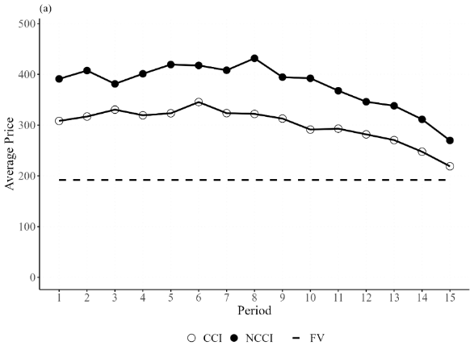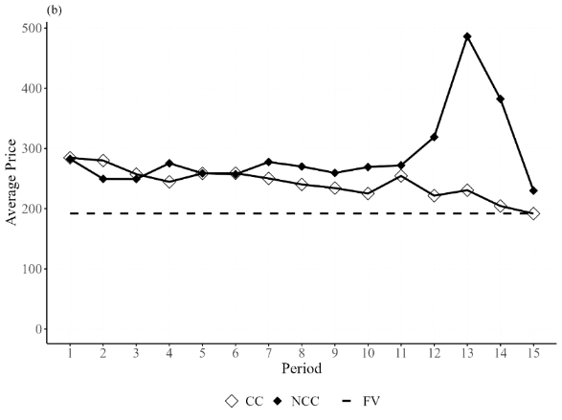
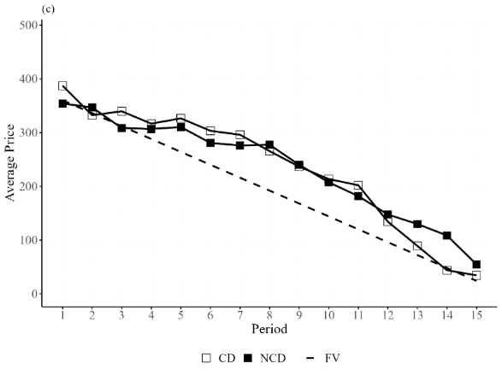

communication is allowed, offering some indicative evidence that communication slightly mitigates mispricing when the fundamental value process is relatively more complex. However, prices are consistently above the fundamental value of 192, even with the possibility of communication. In treatments where the asset has a flat but relatively simple fundamental value process (treatments CC and NCC) or a declining and moderately complex fundamental value process (CD and NCD), we see that prices are mostly above fundamental values during a market session, and there is no evidence that communication mitigates mispricing --- the price trajectories are intertwined with each other. In all treatments, we see that prices tend to crash towards the fundamental value in the last three periods.
Next, we employ commonly used mispricing measures in the literature to formally compare the degree of overpricing. These include Relative Absolute Deviation (RAD), Geometric Absolute Deviation (GAD), Relative Deviation (RD), Geometric Deviation (GD), Intra-/Inter-period volatility, and Turnover (Van Boening et al., 1993; Stöckl et al., 2010; Powell, 2016). Specifically, RAD measures how closely prices track fundamental value. It is defined as RAD = {$\sum_{t}{|P_{t}-FV_{t} |}/(\sum_{t}{(FV_{t})}/T) \}/T$, where $FV_{t}$ is the fundamental value in period t (for assets with a flat fundamental value, this term is a constant value of 192), the term $P_{t}$ denotes the average price in period $t$, and T is the total number of periods. The measure RD is defined as $RD=\{\sum_{t}{(P_{t}-FV_{t})}/(\sum_{t}{(FV_{t})}/T) \}/T$, which indicates whether prices are on average above (RD > 0) or below (RD < 0) fundamental values. GAD is defined as $GAD=\exp\left\{\frac{1}{T}\sum_{t}{\left|\ln\left(\frac{P_{t}}{FV_{t}}\right)\right|}\right\}-1.$ GD is calculated as $GD=Π_{t}{\left(\frac{P_{t}}{FV_{t}}\right)}^{1/T}-1.$The interpretation of GAD and GD is the same as RAD and RD, but these measures satisfy numeraire independence.
We also measure how volatile prices are within a given period. This is known as the intra-period price volatility. It measures price volatility by using all log-returns of all market prices within a period. The intra-period volatility or the returns is defined as $\sum_{t=1}^{T}{\frac{1}{T}}\sqrt{\frac{1}{N_{t}}\sum_{j=1}^{N_{t}}{{\left(R_{t,j}-{\overline{R}}_{t}\right)}^{2}}}$, where $R_{t,j}=\ln{P_{t,j}-\ln{P_{t,j-1}}}$, ${\overline{R}}_{t}$ is the average log returns in period $t$ and $N_{t}$ is the total number of transactions in each period. The inter-period volatility measure is introduced by Noussair et al. (2016) where it is defined as $\sum_{t=2}^{T}{\left|\left(P_{t}-FV_{t}\right)-\left(P_{t-1}-FV_{t-1}\right)\right|}/(T-1)$, and T is the total number of periods. Finally, Turnover is the total number of transactions in a market session, normalized by the total units of the asset available in the market. It is defined as $(\sum_{t}{q_{t}})/TSU$, where $q_{t}$ is the quantity of units of the asset exchanged in period t and TSU denotes the total stock of units. In other words, it is the total number of transactions over the life of the asset, normalized by the total stock of units in the market. It measures how many times each share of the asset has changed hands in the market.
Table 5 summarizes the values of the mispricing measures by treatment. The upper panel is the constant fundamental value regime with interest (CCI and NCCI), the middle panel is the constant fundamental value regime without interest (CC and NCC), and the lower panel is the decreasing fundamental value regime (CD and NCD). Under each fundamental value regime, we test whether communication has a significant influence on mispricing or not. First, comparing treatments CCI and NCCI, we find that communication seems to have some marginal dampening effect on mispricing. In particular, the average degree of absolute mispricing is about 100% relative to the fundamental values (RAD and GAD) in the absence of communication (NCCI), whereas the same statistics are about 60% on average with communication. However, the effect is only borderline significant. Interestingly, turnover is larger in CCI than in NCCI, which means that people are more active in making transactions when communication is possible, though the effect is also marginally significant. The values of other mispricing measures are also smaller with communication than without, comparing CC and NCC, but the differences are insignificant. Second, we find that under the constant fundamental value regime without interest (CC vs. NCC), communication does not influence the degree of mispricing, except that the volatility appears lower, albeit at the 10% level. Third, communication does not reduce mispricing, volatilities, or turnover under the decreasing fundamental value regime (CD vs. NCD).

Table 5. Average Mispricing Measures

Treatment | RAD | RD | GAD | GD | Inter_Vola | Intra_Vola | Turnover
CCI | 0.59 (0.49) | 0.56 (0.51) | 0.55 (0.45) | 0.52 (0.49) | 26.40 (13.07) | 0.25  (0.17) | 4.27 (2.99)
NCCI | 1.00 (0.54)* | 0.97 (0.60) | 0.95 (0.52)* | 0.91 (0.59) | 40.36 (28.42) | 0.28  (0.14) | 2.25 (1.09)*
CC | 0.39 (0.41) | 0.26  (0.5) | 0.47 (0.57) | 0.24 (0.47) | 26.54 (30.77) | 0.22  (0.19) | 2.72 (1.59)
NCC | 0.61 (0.78) | 0.51  (0.84) | 0.48  (0.5) | 0.36 (0.58) | 62.43 (120.72) | 0.45  (0.33)* | 3.25 (0.90)
CD | 0.49 (0.34) | 0.22 (0.54) | 0.68 (0.51) | 0.16 (0.54) | 36.20 (17.89) | 0.32  (0.13) | 2.58 (1.33)
NCD | 0.34 (0.33) | 0.23 (0.41) | 0.51 (0.41) | 0.31 (0.53) | 28.19 (17.78) | 0.40  (0.22) | 3.21  (1.8)
Notes: Each entry shows the average value of the corresponding measure, with its standard deviations reported in parentheses. ** and * indicate significant differences in the measures of mispricing between the communication and the no communication treatments under different fundamental value regimes at the 5% and 10% levels, respectively, Mann-Whitney U test.

Result 1: Communication generally has modest effects on mispricing. It mitigates mispricing only when the asset’s fundamental value is relatively complex (treatment Constant with Interest).

Another helpful aspect to examine is whether bubbles differ across the three fundamental value schemes. These three schemes, Constant with Interest, Constant, and Decreasing, are comparable in our experiment because we have controlled for the cash-to-asset ratio among these treatments. When comparing Constant with Interest and Constant without Interest (pooling markets with or without communication), we find that price levels and mispricing tend to be higher in Complex than in Easy. The differences in RAD, RD, GAD, and GD between the two schemes are significant at the 5% level, though there is no difference in Volatility and Turnover. We also find greater mispricing in Complex than in the Downward-sloping treatment. For RD and GD, the difference is significant at the 1% level; for RAD and Intra_Vola, this is significant at the 5% level. There is virtually no difference between the Downward-sloping and Easy treatments regarding mispricing. For details of the mispricing measures and the corresponding tests, please refer to Tables A1 and A2 in the Appendix.

Result 2: We find greater mispricing when the asset's fundamental value process is relatively complex (treatment Constant with Interest) than in other Fundamental Value Regimes (Constant and Decline).

3.2 Content analysis of the chats

Figure 2. Frequency of communication categories by treatment

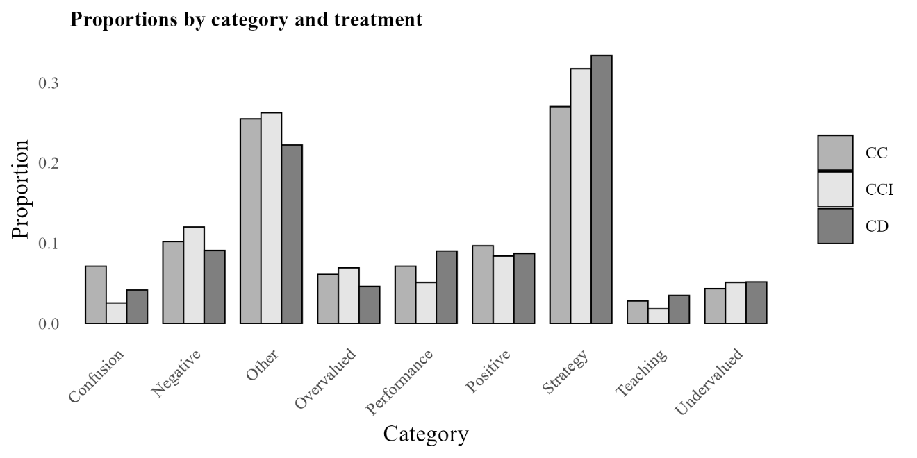

In this section, we turn to content analysis. As discussed in the methodology section, we have categorized the messages into nine categories. In Figure 2, we present the distribution of the categories by treatment. The x-axis shows the category, and the y-axis shows the proportion of chats in each category. The chi-squared test of homogeneity (see also Figure A7) suggests that the distributions of the chat categories differ across these three treatments (p-value = 0.02). There seem to be disproportionately more strategy discussions in CD than in the other two treatments, CC and CCI. Pair-wise Fisher's Exact tests (CD vs. CCI and CD vs. CC) indeed suggest that there are proportionally more chats about strategy in CD than in CC (p-value = 0.02), but there is no difference between CD and CCI. We have made pairwise comparisons
Table 6. Pairwise Fisher's exact test (2x2)

 | Category | Comparison | P-value | P-Bonferroni
 | Confusion | CCI vs CC | 0.008*** | 0.197
 | Confusion | CCI vs CD | 0.241 | 1
 | Confusion | CC vs CD | 0.017** | 0.409
 | Negative | CCI vs CC | 0.453 | 1
 | Negative | CCI vs CD | 0.147 | 1
 | Negative | CC vs CD | 0.498 | 1
 | Overvalued | CCI vs CC | 0.749 | 1
 | Overvalued | CCI vs CD | 0.13 | 1
 | Overvalued | CC vs CD | 0.24 | 1
 | Performance | CCI vs CC | 0.333 | 1
 | Performance | CCI vs CD | 0.034** | 0.811
 | Performance | CC vs CD | 0.27 | 1
 | Positive | CCI vs CC | 0.588 | 1
 | Positive | CCI vs CD | 1 | 1
 | Positive | CC vs CD | 0.553 | 1
Strategy |  | CCI vs CC | 0.194 | 1
Strategy |  | CCI vs CD | 0.627 | 1
Strategy |  | CC vs CD | 0.016** | 0.380
 | Teaching | CCI vs CC | 0.455 | 1
 | Teaching | CCI vs CD | 0.195 | 1
 | Teaching | CC vs CD | 0.639 | 1
 | Undervalued | CCI vs CC | 0.71 | 1
 | Undervalued | CCI vs CD | 1 | 1
 | Undervalued | CC vs CD | 0.605 | 1
using Fisher’s Exact test for other categories, and we find that CC has significantly more confused statements than CD and CCI (p-values < 0.05 and 0.01, respectively). We have analyzed the content about confusion, and we find that people are confused about the transfers (the loan that can be used as working capital) instead of the asset itself in CC. There are also proportionally more chats regarding their performance in the market in CD than CCI (p-value = 0.03). However, there is no significant difference across the treatments once we adjust for multiple testing (Bonferroni), see Table 6.

Result 3: Although the distribution of chat categories differs across treatments, suggesting that the communication topic is treatment-dependent, no significant differences were found in individual topics after adjusting for multiple testing using the Bonferroni correction.

Figure 3: Distribution of communication categories in CCI
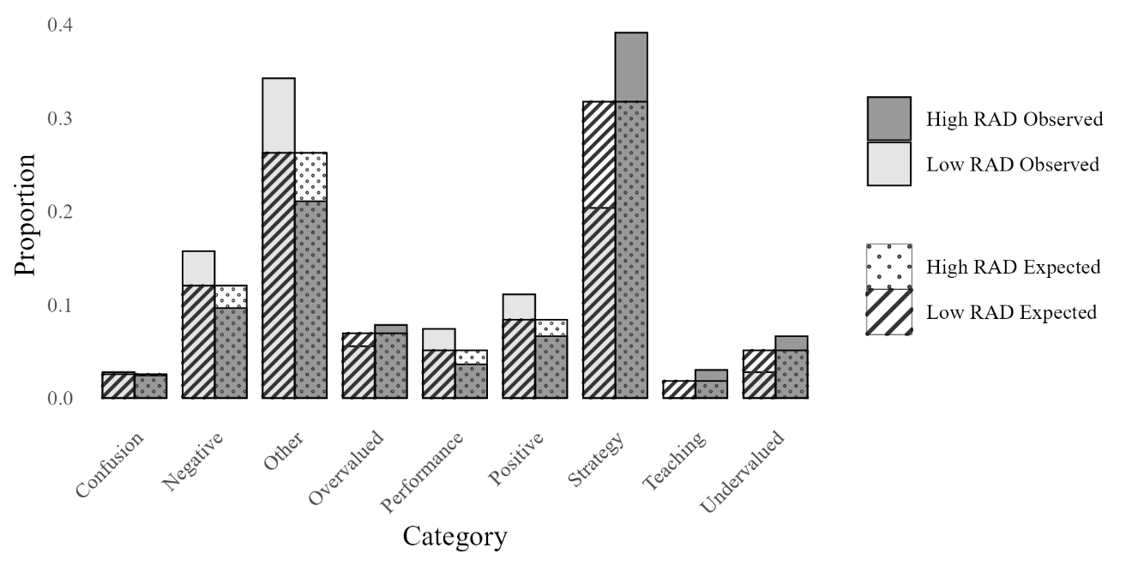
Note: The expected proportions shown here correspond to a null hypothesis of equal frequencies (i.e., each category is equally likely). These expected values were used in a chi-square test to compare against the observed proportions.

Having seen the overall distribution of chat topics, we now focus on the content of chats in treatment CCI, as it is the only treatment where communication has some beneficial effects. To this end, we separately consider CCI markets with higher and lower mispricing. This way, we can determine whether mispricing is mitigated in some CCI markets because traders discuss different topics with one another. We deem a market to exhibit higher mispricing if its RAD exceeds the median RAD of 0.29 in CCI, corresponding to markets 1, 3, 5, 8, 10, and 12. The other markets in CCI are considered to exhibit low mispricing. Figure 3 illustrates the distribution of chat categories within CCI, comparing markets with an RAD above the median to those below. Although the chi-squared test of homogeneity indicates a significant difference in the distribution of chat topics with a p-value < 0.01, zooming in on the individual category does not reveal any significant difference at the 5% level (Fisher’s Exact test), except for the strategy statement, see Table 7.
More specifically, 20.4% of messages (n = 22) talk about strategy in markets where RAD is low, while approximately 39.2% of the messages (n = 65) talk about strategy when RAD is high. The LLM-assisted content analysis shows some similarities in the strategies traders discuss when RAD is high and when it is low. First, in both groups, traders discuss setting specific price thresholds for trade execution. Second, they communicate about maximizing profits. Some traders express a desire to buy at lower prices, while others emphasize selling at higher prices to profit from price differences (capital gains). There are also distinct differences. In scenarios of high mispricing, traders focus on more aggressive strategies that rapidly adjust to market conditions. They also actively encourage market momentum with phrases like 'go go go' to exploit capital gains opportunities. In contrast, when mispricing is low, strategies are more conservative, and there are more inquiries about others’ cash and holdings, more debates about appropriate prices, and discussions of earning profits through safer avenues like interest earnings, which did not occur in high RAD markets. The conversations in low mispricing markets imply a more stable and conservative approach.

Table 7. Breakdown of chat topics in High and Low RAD groups in CCI

Variable | Avg. Proportion High RAD | Avg. Proportion  Low RAD | P value
Confusion | 0.018 | 0.044 | 1
Negative | 0.051 | 0.086 | 1
Overvalued | 0.166 | 0.072 | 1
Performance | 0.039 | 0.050 | 1
Positive | 0.105 | 0.228 | 1
Strategy | 0.375 | 0.179 | 0.011**
Teaching | 0.049 | 0.000 | 1
Undervalued | 0.054 | 0.033 | 1
Note: Fisher's exact test p-values adjusted for multiple testing (Bonferroni).

Table 8. Explaining RAD in CCI

 | (1) | (2) | (3)
 | RAD | RAD | RAD
Strategy | -0.056 | -0.087* | -0.091*
 | (0.115) | (0.048) | (0.047)
Period | -0.027 | -0.027 | -0.027
 | (0.017) | (0.017) | (0.017)
Strategy * High RAD |  | 0.074 | 0.037
 |  | (0.187) | (0.196)
Constant | 0.776*** | 0.775*** | 0.753***
 | (0.220) | (0.220) | (0.214)
Observations | 165 | 165 | 165
Controls | No | No | Yes
R² | 0.108 | 0.103 | 0.179
Adjusted R² | 0.097 | 0.087 | 0.126
F Statistic | 19.637*** | 18.530*** | 33.664***
Note: *p<0.1; **p<0.05; ***p<0.01, robust standard errors clustering at the market level are reported in parentheses. Controls include proportions of eight topics (except for Other) in a given period.

Next, we conduct a panel regression to examine the effect of discussing strategies. To this end, we regress the mispricing measure RAD for a given period on the proportion of chats about strategy within the same period, see Table 8. In model (1), we find that the share of chats on strategy has a negative but insignificant effect on mispricing when we do not distinguish high and low RAD markets. As the content analysis above suggests that traders talk about different strategies in high and low RAD markets, we also look into the interaction effect in model (2). Here, we find that the share of conversations on strategy marginally reduces mispricing in low RAD markets (because the strategies are less speculative) but increases mispricing in high RAD markets, though insignificantly so. The effect remains consistent when the proportions of other communication topics are included as controls in model (3).

Result 4. In treatment CCI, where communication reduces mispricing, there is a greater proportion of communications about strategy in markets where mispricing is high than when it is low. Content analysis suggests that strategic discussions are less speculative, less inclined to promote momentum chasing, and more oriented toward alternative ways of earning money—such as collecting interest payments—compared to discussions in markets with higher mispricing.

3.3 Pooling the treatments

Next, we pool all treatments together to increase the statistical power and examine the effect of chat contents on mispricing. Similar to previous analyses, we divided the data into two groups by using the median of RAD. We then contrast these two groups to investigate which category of communications potentially influences prices. Thus, markets are in the high RAD group if their RAD exceeds 0.29 (the median RAD of all markets with communication, pooling all treatments). Table 9 summarizes our division, and the corresponding price trajectories of these markets can be found in Figures A1 to A6 in the Appendix.
Table 9. Market IDs with High or Low RAD by Treatment

 | CCI | CD | CC
High RAD | 1,3,5,8,10,12 | 1,3,4,5,6,8 | 1,2,4,5,7,9
Low RAD | 2,4,6,7,9,11 | 2,7,9,10,11,12 | 3,6,8,10,11,12

First, we conduct a chi-squared test of homogeneity to examine whether the distribution of chat categories depends on whether the markets exhibit bubbles. The test result is presented in Figure 4, which shows both the expected and observed proportions. The p-value for the chi-squared test is smaller than 0.01, suggesting that communication topic distribution depends on RAD levels. Thus, the topics of interest differ significantly between markets with high RADs and those with low RADs. Second, when zooming in on individual chat categories, we find that in markets with high RADs, there is a significantly higher proportion of topics highlighting the undervaluation of the asset (see Table 10). However, it is not the case that those conversations highlighting undervaluation in the high RADs markets took place when the prices were actually low. Instead, people in high RADs are generally more vocal about assets being undervalued; see Table 11 for more details. This is likely to explain why RADs are high in those markets.
Figure 4: Observed vs. Expected Counts: Markets with high or low RAD
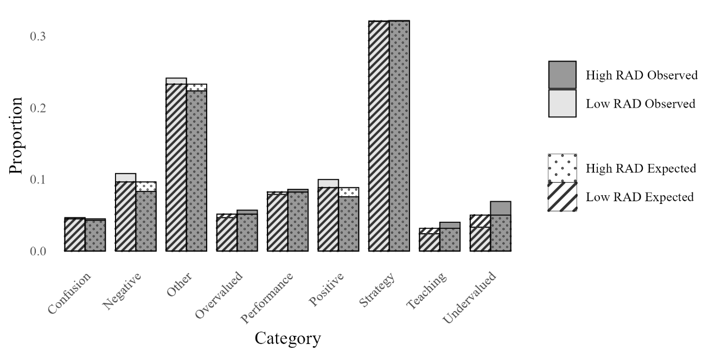
Note: The expected proportions shown here correspond to a null hypothesis of equal frequencies (i.e., each category is equally likely). These expected values were used in a chi-square test to compare against the observed proportions.

Table 10. Breakdown of chat topics in High and Low RAD groups for all treatments

Variable | Avg. Proportion High RADs | Avg. Proportion Low RADs | P-value
Confusion | 0.045 | 0.085 | 1
Negative | 0.069 | 0.093 | 0.370
Overvalued | 0.106 | 0.048 | 1
Performance | 0.053 | 0.052 | 1
Positive | 0.082 | 0.157 | 0.366
Strategy | 0.338 | 0.236 | 1
Teaching | 0.040 | 0.011 | 0.248
Undervalued | 0.064 | 0.023 | 0.001
Note: Fisher's exact test p-values are adjusted for multiple testing using the Bonferroni correction.

Table 11. When do people chat about assets being undervalued

 |  |  | Undervalued
RAD | RD | N messages | Frequency | Proportion
Low | Positive | 642 | 16 | 0.025
Low | Negative | 559 | 24 | 0.043
High | Positive | 781 | 54 | 0.069
High | Negative | 288 | 20 | 0.069
Note: A positive (negative) RD means that prices are too high (low) compared to the fundamentals.

Result 5: The distributions of chat differ between markets that exhibit high mispricing and markets that do not. The difference can be attributed to greater proportions of discussion about the undervaluation of the asset in markets with high RADs.

Next, we examine the impact of each chat category on RAD using random-effects panel regressions and present the results in Table 12. First, we test the effect of each topic without distinguishing whether the chat took place in high or low RAD markets, see model (1). The results show that none of the chat categories has any effect on mispricing. However, as we will show next, this is because communications typically have the opposite effect in markets with high and low RAD. Second, we separately investigate the effects of four communication topics that are shown to be different in Table 10 with adjusted p-values not equal to 1. These categories are Negative, Positive, Teaching, and Undervaluation. We also added one more category to the analysis, Strategy, despite not being significant in Table 10. This is because it is the largest chat category, and it has been shown to be relevant for treatment CCI. The results can be found in models (2) to (6). We can see that these communication topics reduce mispricing in markets with a low RAD, and either have no effect or increase mispricing in markets with a high RAD. However, the R-squared values are very low. In Model (7), we include all chat categories and their interaction with the high RAD market dummy. The result further confirms our finding.

Result 6: Communications may be associated with lower mispricing in markets with below median RAD. In markets with above median RAD, communications either have no effect or positive effects. Overall, the effects of communication are weak, as evident by the R-squares.

In the Appendix, we also do the same analysis for the authors’ own topic categorizations, and the results are qualitatively the same, see Tables A5.

Table 12. Explaining RAD

 |  | (1) | (2) | (3) | (4) | (5) | (6) | (7)
 |  | RAD | RAD | RAD | RAD | RAD | RAD | RAD
Confusion |  | 0.004 |  |  |  |  |  | -0.155**
 |  | (0.072) |  |  |  |  |  | (0.068)
Negative |  | 0.002 | -0.156*** |  |  |  |  | -0.180***
 |  | (0.080) | (0.043) |  |  |  |  | (0.044)
Overvalued |  | 0.310 |  |  |  |  |  | -0.023
 |  | (0.244) |  |  |  |  |  | (0.083)
Performance |  | 0.509 |  |  |  |  |  | -0.013
 |  | (0.340) |  |  |  |  |  | (0.214)
Positive |  | -0.066 |  | -0.130** |  |  |  | -0.182***
 |  | (0.057) |  | (0.055) |  |  |  | (0.068)
Strategy |  | -0.016 |  |  | -0.122*** |  |  | -0.134***
 |  | (0.084) |  |  | (0.032) |  |  | (0.035)
Teaching |  | -0.130 |  |  |  | -0.156 |  | -0.272***
 |  | (0.165) |  |  |  | (0.133) |  | (0.103)
Undervalued |  | -0.091 |  |  |  |  | -0.248*** | -0.304***
 |  | (0.131) |  |  |  |  | (0.058) | (0.066)
Confusion*High RAD |  |  |  |  |  |  |  | 0.378**
 |  |  |  |  |  |  |  | (0.161)
Negative*High RAD |  |  | 0.381** |  |  |  |  | 0.430**
 |  |  | (0.182) |  |  |  |  | (0.200)
Overvalued*High RAD |  |  |  |  |  |  |  | 0.545
 |  |  |  |  |  |  |  | (0.342)
Performance*High RAD |  |  |  |  |  |  |  | 1.280
 |  |  |  |  |  |  |  | (0.794)
Positive*High RAD |  |  |  | 0.171 |  |  |  | 0.217*
 |  |  |  | (0.124) |  |  |  | (0.130)
Strategy*High RAD |  |  |  |  | 0.182 |  |  | 0.259**
 |  |  |  |  | (0.132) |  |  | (0.126)
Teaching*High RAD |  |  |  |  |  | 0.036 |  | 0.217
 |  |  |  |  |  | (0.213) |  | (0.159)
Undervalued*High RAD |  |  |  |  |  |  | 0.165 | 0.392**
 |  |  |  |  |  |  | (0.182) | (0.174)
CC |  | -0.161 | -0.163 | -0.162 | -0.163 | -0.164 | -0.166 | -0.164
 |  | (0.181) | (0.177) | (0.179) | (0.177) | (0.181) | (0.181) | (0.160)
CD |  | 0.010 | 0.021 | 0.026 | 0.032 | 0.026 | 0.026 | 0.018
 |  | (0.194) | (0.187) | (0.189) | (0.184) | (0.192) | (0.190) | (0.156)
Period |  | -0.006 | -0.006 | -0.006 | -0.006 | -0.006 | -0.006 | -0.007
 |  | (0.010) | (0.011) | (0.011) | (0.011) | (0.011) | (0.011) | (0.010)
Constant |  | 0.587*** | 0.596*** | 0.598*** | 0.599*** | 0.597*** | 0.601*** | 0.580***
 |  | (0.167) | (0.172) | (0.174) | (0.173) | (0.175) | (0.177) | (0.156)
Observations |  | 525 | 525 | 525 | 525 | 525 | 525 | 525
R2 |  | 0.028 | 0.011 | 0.008 | 0.011 | 0.007 | 0.008 | 0.067
F Statistic |  | 14.762 | 5.709 | 4.141 | 6.020 | 3.552 | 4.262 | 36.382***
 | Note: *p<0.1; **p<0.05; ***p<0.01, robust standard errors clustering at the market level are reported in parentheses.
3.4 Cognitive ability, financial literacy, and communication

Lastly, we examine the type of messages sent by individuals. Motivated by the findings that individuals’ cognitive abilities predict earnings in an asset market experiment, we examine whether sophisticated traders are more likely to send certain types of messages. First, in line with the literature, we confirm that there is a strong correlation between individuals’ cognitive abilities and earnings (Spearman’s $ρ=0.13$, p-value < 0.01). Second, we find that higher CRT is associated with sending more messages related to strategy. Third, individuals with higher financial literacy are also sending out more strategic messages, and they are also sending more messages associated with negative sentiment in the market (see Table 13). A breakdown of the strategic messages and messages of negative sentiment can be found in Table 14.

Table 13: Spearman Correlation Coefficients Between CRT and Category Proportions

 | Spearman’s correlation coefficient
Variable | CRT | Financial Literacy
Confusion | -0.024 | 0.076
Negative Sentiment | 0.039 | 0.119**
Other | 0.010 | 0.018
Overvalued | 0.011 | -0.015
Performance | -0.031 | 0.041
Positive Sentiment | -0.050 | 0.011
Strategy | 0.136** | 0.141**
Teaching | 0.021 | 0.076
Undervalued | -0.029 | 0.084
N messages | 0.040 | 0.086
Note: *p<0.1; **p<0.05; ***p<0.01

Table 14. Frequencies of Strategy and Negative Sentiment by CRT and Financial Literacy

 | Strategy | Negative Sentiment
High CRT | 521 | 142
Low CRT | 208 | 77
High Fin Lit | 598 | 192
Low Fin Lit | 131 | 27

Content analysis shows some similarities between the high and low CRT groups. For instance, they both try to buy low and sell high. However, high CRT traders exhibit more proactive, aggressive strategies aimed at market control. In contrast, the low CRT group emphasizes liquidity monitoring and trade timing, particularly regarding end-of-period liquidation strategies. Similarly, highly financially literate traders also discuss more complex strategies to maintain high prices and split orders to minimize market impacts, while low financially literate traders discuss a more straightforward strategy centered on order execution. A detailed summary by LLM can be found in Table A7 in the Appendix.

Result 7: Individuals with higher cognitive ability (proxied by CRT) and higher financial literacy are associated with sending our more strategic messages. Individuals with higher financial literacy also send more messages expressing negative market sentiment.

4. Discussion and Conclusion
We set out to study the impact of continuous free-form communication on mispricing in experimental asset markets, considering the varying complexity of the asset’s fundamental value. Communication has shown to be an effective instrument in improving coordination (e.g., Cooper et al., 1992; Charness, 2000; Charness and Grosskopf, 2004; Charness and Rabin, 2005; Charness and Dufwenberg, 2006; Brandts and Cooper, 2007; Brandts et al., 2015; Charness and Ellman 2016) and resolving social dilemma (e.g., Isaac and Walker, 1988; Ledyard, 1995; Chaudhuri, 2011; Oprea et al., 2014). Given this backdrop, one might expect that communication can also improve the efficiency of the market for its potential to facilitate information exchange, reduce confusion, and establish common knowledge of rationality.
Our experimental findings, however, temper such expectations. Our results show that communication only modestly reduces mispricing within the most complex asset markets (Constant with Interest) and has no impact on mispricing in simpler asset valuation scenarios (Downward and Constant). The content analysis using large language models reveals that in complex asset markets with high mispricing, strategic discussions predominantly focus on aggressive trading strategies to exploit price momentum, potentially exacerbating speculative behavior. Conversely, markets exhibiting lower mispricing are associated with more conservative and less speculative strategic conversations, indicating a stabilizing role of communication under certain conditions. When pooling all treatments together, we find that communications may be associated with lower mispricing in markets with below median RAD. In markets with above median RAD, communications either have no effect or positive effects.
Our primary contribution is a systematic examination of how communication interacts with asset complexity to influence market efficiency. Despite arguments supporting significant potential benefits of communication, such as reducing trader confusion, aligning market expectations, and mitigating speculative bubbles, our experimental findings indicate only modest effects of communication overall.
The result seems to be at odds with the findings of Oechssler et al. (2011) and Corgnet et al. (2024) at first glance. Both papers find that communication improves market efficiency in their settings. However, a closer look at the studies reveals at least two important differences. One is that insiders are present in both studies, and communication seems to curb the expectations of insider trading. This is a salient benefit that is absent in our design. Second, both studies adopt pre-market communication, whereas ours allows a more realistic, continuous communication throughout the market periods. This continuous format may unintentionally support dynamic speculative dialogue, highlighting potential side effects of continuous free-form interaction. Moreover, Oechssler et al. (2011)’s market is also quite complex, with five different assets trading concurrently. Echoing Oechssler et al. (2011), we also observe that communication's benefits emerge more prominently in complex asset markets.
Our findings open several promising avenues for future research. First, given the contextual sensitivity observed in the effects of communication, future studies could systematically examine how different communication formats (e.g., pre-market versus continuous, structured versus free-form, public versus private) influence market dynamics. Second, exploring the interaction between communication and the presence of informational asymmetries, such as insider trading or differential information endowment, could offer deeper insights into the robustness of communication's stabilizing effects. Relatedly, future studies may also explore whether communication works better with long-lived assets, instead of short-lived ones. Importantly, do traders discuss different topics because long-lived assets allow traders to formulate more speculative strategies than short-lived assets? Other factors such as reputation, trust, and historical context may also significantly alter interaction dynamics and are worth exploring. Understanding precisely when, why, and how communication impacts market outcomes is not only informative to theory on communication but also to market regulations.
REFERENCES
Agranov, M., & Tergiman, C. (2014). Communication in multilateral bargaining. Journal of Public Economics, 118, 75-85.
Angeletos, G. M., & La'o, J. (2013). Sentiments. Econometrica, 81(2), 739-779.
Antweiler, W., & Frank, M. Z. (2004). Is all that talk just noise? The information content of internet stock message boards. The Journal of Finance, 59(3), 1259–1294.
Bolton, G. E., Chatterjee, K., & McGinn, K. L. (2003). How communication links influence coalition bargaining: A laboratory investigation. Management Science, 49(5), 583-598.
Bosch-Rosa, C., Meissner, T., & Bosch-Domènech, A. (2018). Cognitive bubbles. Experimental Economics, 21(1), 132-153. https://doi.org/10.1007/s10683-017-9529-0
Bradfield, A. J., & Kagel, J. H. (2015). Legislative bargaining with teams. Games and economic behavior, 93, 117-127.
Brandts, J., & Cooper, D. J. (2007). It's What You Say, Not What You Pay: An Experimental Study of Manager-Employee Relationships in Overcoming Coordination Failure. Journal of the European Economic Association, 5(6), 1223-1268. https://doi.org/10.1162/jeea.2007.5.6.1223
Brandts, J., Ellman, M., & Charness, G. (2015). Let’s Talk: How Communication Affects Contract Design. Journal of the European Economic Association, 14(4), 943-974. https://doi.org/10.1111/jeea.12157
Brown, T., Mann, B., Ryder, N., Subbiah, M., Kaplan, J. D., Dhariwal, P., Neelakantan, A., Shyam, P., Sastry, G., & Askell, A. (2020). Language models are few-shot learners. Advances in Neural Information Processing Systems, 33, 1877–1901.
Caginalp, G., Porter, D., & Smith, V. (1998). Initial cash/asset ratio and asset prices: An experimental study. Proceedings of the National Academy of Sciences, 95(2), 756–761.
Celebi, C., & Penczynski, S. (2024). Using large language models for text classification in experimental economics (Working Paper No. 24-01). University of East Anglia, Centre for Behavioural and Experimental Social Science (CBESS). https://ideas.repec.org/p/uea/wcbess/24-01.html
Charness, G. (2000). Self‐serving cheap talk and credibility: A test of Aumann’s conjecture. Games and Economic Behavior, 33(2), 177–194.
Charness, G., & Dufwenberg, M. (2006). Promises and partnership. Econometrica, 74(6), 1579–1601.
Charness, G., & Ellman, M. (2016). Choosing and not choosing with and without communication: Experimental results on contract design and selection. Journal of Institutional and Theoretical Economics (JITE)/Zeitschrift für die gesamte Staatswissenschaft, 142-157.
Charness, G., & Grosskopf, B. (2004). What makes cheap talk effective? Experimental evidence. Economics Letters, 83(3), 383-389.
Charness, G., & Rabin, M. (2005). Expressed preferences and behavior in experimental games. Games and economic behavior, 53(2), 151-169.
Chaudhuri, A. (2011). Sustaining cooperation in laboratory public goods experiments: a selective survey of the literature. Experimental economics, 14(1), 47-83.
Cooper, R., DeJong, D., Forsythe, R., & Ross, T. (1992). Communication in coordination games. The Quarterly Journal of Economics, 107(2), 739–771.
Corgnet, B., DeSantis, M., & Porter, D. (2024). Let’s chat... When communication promotes efficiency in experimental asset markets. Management Science, 70(10), 6550–6568.
Deck, C., Sevatka, M., & Tucker, S. (2020). Designing call auction institutions to eliminate price bubbles: Is English Dutch the best? American Economic Review Insights, 2(2), 225–236.
Ding, S., Lugovskyy, V., Puzzello, D., Tucker, S., & Williams, A. (2018). Cash vs extra-credit incentive in experimental asset markets. Journal of Economic Behavior & Organization, 150, 19–27.
Engelberg, J. E., & Parsons, C. A. (2011). The causal impact of media in financial markets. the Journal of Finance, 66(1), 67-97.
Fischbacher, U. (2007). z-Tree: Zurich toolbox for ready-made economic experiments. Experimental Economics, 10(2), 171–178.
Frederick, S. (2005). Cognitive reflection and decision making. Journal of Economic perspectives, 19(4), 25-42.
Greiner, B. (2015). Subject pool recruitment procedures: Organizing experiments with ORSEE. Journal of the Economic Science Association, 1(1), 114–125.
Guler, B., Lugovskyy, V., Puzzello, D., & Tucker, S. (2021). Trading institutions in experimental asset markets: Theory and evidence (Working Papers in Economics No. 21/15). University of Waikato.
Haruvy, E., & Noussair, C. N. (2006). The effect of short selling on bubbles and crashes in experimental spot asset markets. The Journal of Finance, 61(3), 1119–1157. https://doi.org/10.1111/j.1540-6261.2006.00868.x
Heap, H., Shaun, P., & Zizzo, D. (2011). Emotions and chat in a financial markets experiment (Discussion Paper). Social Science Research Network.
Hirshleifer, D., & Teoh, S. H. (2009). Thought and behavior contagion in capital markets. In T. Hens & K. R. Schenk-Hoppé (Eds.), Handbook of financial markets: Dynamics and evolution (pp. 1–46). Elsevier.
Holt, C. A., Porzio, M., & Song, M. Y. (2017). Price bubbles, gender, and expectations in experimental asset markets. European Economic Review, 100, 72-94.
Hussam, R. N., Porter, D., & Smith, V. L. (2008). Thar she blows: Can bubbles be rekindled with experienced participants? American Economic Review, 98(3), 924–937. https://doi.org/10.1257/aer.98.3.924
Isaac, R., & Walker, J. (1988). Communication and free riding behavior: The voluntary contributions mechanism. Economic Inquiry, 26(4), 585–608.
King, R. R., Smith, V. L., Williams, A. W., & Van Boening, M. V. (1993). The robustness of bubbles and crashes in experimental stock markets. In R. H. Day & P. Chen (Eds.), Nonlinear dynamics and evolutionary economics (pp. 183–200). Oxford University Press.
Kirchler, M., Huber, J., & Stöckl, T. (2012). Thar She Bursts: Reducing Confusion Reduces Bubbles. American Economic Review, 102(2), 865–883. https://doi.org/10.1257/aer.102.2.865
Ledyard, J. (1995), "Public Goods: A Survey of Experimental" in Kagel and Roth ed. Handbook of Experimental Economics: Princeton University Press.
Lei, V., Noussair, C. N., & Plott, C. R. (2001). Nonspeculative bubbles in experimental asset markets: Lack of common knowledge of rationality vs. actual irrationality. Econometrica, 69(4), 831–859.
Lugovskyy, V., Puzzello, D., Tucker, S., & Williams, A. (2014). Asset-holdings caps and bubbles in experimental asset markets. Journal of Economic Behavior & Organization, 107(B), 781–797.
Noussair, C. N., Robin, S., & Ruffieux, B. (2001). Price bubbles in laboratory asset markets with constant fundamental values. Experimental Economics, 4(1), 87–105.
Noussair, C., & Tucker, S. (2006). Futures markets and bubble formation in experimental asset markets. Pacific Economic Review, 11(2), 167–184. https://doi.org/10.1111/j.1468-0106.2006.00308.x
Noussair, C. N., Tucker, S., & Xu, Y. (2016). Futures markets, cognitive ability, and mispricing in experimental asset markets. Journal of Economic Behavior & Organization, 130, 166–179.
Oechssler, J. (2010). Searching beyond the lamppost: Let’s focus on economically relevant questions. Journal of economic behavior & organization, 73(1), 65-67.
Oechssler, J., Schmidt, C., & Schnedler, W. (2011). On the ingredients for bubble formation: informed traders and communication. Journal of Economic Dynamics and Control, 35(11), 1831-1851.
Oprea, R., Charness, G., & Friedman, D. (2014). Continuous time and communication in a public-goods experiment. Journal of Economic Behavior & Organization, 108, 212–223.
Plott, C. R., & Gray, P. (1990). The multiple unit double auction. Journal of Economic Behavior and Organization, 13(2), 245–258.
Plott, C. R., & Sunder, S. (1982). Efficiency of experimental security markets with insider information: An application of rational-expectations models. Journal of political economy, 90(4), 663-698.
Plott, C. R., & Sunder, S. (1988). Rational expectations and the aggregation of diverse information in laboratory security markets. Econometrica: Journal of the Econometric Society, 1085-1118.
Porter, D. P., & Smith, V. L. (1995). Futures contracting and dividend uncertainty in experimental asset markets. The Journal of Business, 68(4), 509–541.
Powell, O. (2016). Numeraire independence and the measurement of mispricing in experimental asset markets. Journal of Behavioral and Experimental Finance, 9, 56-62. https://doi.org/10.1016/j.jbef.2015.11.002
Shiller, R. (1984). Stock Prices and Social Dynamics. Brookings Papers on Economic Activity, 457-498. https://doi.org/10.2307/2534436
Shiller, R. J. (2000). Irrational exuberance. Princeton University Press.
Smith, A., Lohrenz, T., King, J., Montague, P. R., & Camerer, C. F. (2014). Irrational exuberance and neural crash warning signals during endogenous experimental market bubbles. Proceedings of the National Academy of Sciences, 111(29), 10503-10508.
Smith, V. L. (1962). An experimental study of competitive market behavior. Journal of Political Economy, 70(2), 111–137.
Smith, V. L., Suchanek, G. L., & Williams, A. W. (1988). Bubbles, crashes, and endogenous expectations in experimental spot asset markets. Econometrica, 56(5), 1119–1151.
Steiger, S., & Pelster, M. (2020). Social interactions and asset pricing bubbles. Journal of Economic Behavior & Organization, 179, 503-522.
Stöckl, T., Huber, J., & Kirchler, M. (2010). Bubble measures in experimental asset markets. Experimental Economics, 13(3), 284-298. https://doi.org/10.1007/s10683-010-9241-9
Tetlock, P. C. (2007). Giving content to investor sentiment: The role of media in the stock market. The Journal of Finance, 62(3), 1139–1168.
Tucker, S., & Xu, Y. (2024a). Nonspeculative bubbles revisited. Journal of Behavioral and Experimental Finance, 42, 100925.
Tucker, S., & Xu, Y. (2024b). Motivations to speculate are the driving forces in experimental asset market bubbles (No. 24/02).
Van Boening, M. V., Williams, A. W., & LaMaster, S. (1993). Price bubbles and crashes in experimental call markets. Economics Letters, 41(2), 179-185. https://doi.org/10.1016/0165-1765(93)90194-H
Van Rooij, M., Lusardi, A., & Alessie, R. (2011). Financial literacy and stock market participation. Journal of Financial economics, 101(2), 449-472.

APPENDIX

Experiment Instructions for Constant FV Condition
(Communication Treatment Condition text in red)

1. General Instructions

This is an experiment in the economics of market decision-making. The instructions are simple and if you follow them carefully and make good decisions, you might earn a considerable amount of money, which will be paid to you in cash at the end of the experiment. The experiment will consist of 15 trading periods in which you will have the opportunity to buy and sell in a market. Throughout the experiment, you will always have the opportunity to chat with other traders via a chat box. The currency used in the market is francs. All trading and earnings will be in terms of francs.

_______ francs = 1 Yuan (RMB)

Your francs will be converted to RMB at this rate, and you will be paid in RMB when you leave the lab today. The more francs you earn, the more RMB you earn.

In each period, you may buy and sell units of a good called X. X can be considered an asset with a life of 15 periods, and your inventory of X carries over from one trading period to the next. Each Unit of asset X has a buyback value of 192 francs. That is, at the end of period 15 each unit of the asset in your inventory will be bought back by the experimenter at a price of 192 francs.

2. Dividends

Each unit of X in your inventory at the end of each trading period pays a dividend to you. The dividend paid on each unit is the same for every participant. The dividend at the end of each period was determined by chance by a random number generator. The dividend in each period has an equally likely chance of being -10, -5, 1, or 14. The information is provided in the table below.

Dividend | → | -10 | -5 | 1 | 14
Likelihood | → | 25% | 25% | 25% | 25%

The average dividend per period for each unit of X is 0 francs.

The dividend draws in each period are independent. That means that the likelihood of a particular dividend in a period is not affected by the dividend in previous periods.

3. Your Earnings

At the beginning of the experiment, you will be given 5,333 francs in your Cash inventory and 10 Units of Asset. At the start of each period, a transfer of francs will occur that affects your Cash inventory. The table below presents the amounts of francs to be transferred at the start of each period. These transfers are considered as loans and the sum of these transfers must be paid back at the end of the experiment. That is, 101,547 francs will be subtracted from your Cash inventory at the end of the experiment.

Period | Franc Transfer
1 | 0
2 | 518
3 | 598
4 | 698
5 | 824
6 | 989
7 | 1209
8 | 1511
9 | 1943
10 | 2590
11 | 3627
12 | 5440
13 | 9067
14 | 18133
15 | 54400

All cash transfers received at the beginning of each period are added to your Cash inventory.

All dividends you receive are added to your Cash inventory.

All money spent on purchases is subtracted from your Cash inventory.

All money received from sales is added to your Cash inventory.

Your earnings for participation in the market are equal to your Cash inventory at the end of period 15 plus the value of asset buyback at the end of the market (192 francs per unit of asset), plus earnings from forecasting (explained below), minus 101,547 francs.

Example of earnings from dividends: if you have 6 units of X at the end of period 3 and the dividend draw is 1 francs (which has a 25% chance of occurring), then your dividend earnings for period 3 are equal to 6 units x 1 francs = 6 francs.

4. Market and Trading Rules

The market consists of 8 subjects. Each trader gets an initial endowment of 10 assets and a working capital of 5,333 francs. The experiment will consist of 15 periods. Each period will last 3 minutes. In each period, you will see a computer screen like the one shown below. You can use the interface to buy and sell units of X. On your computer screen, you can see the Cash and Number of units of X you have available.

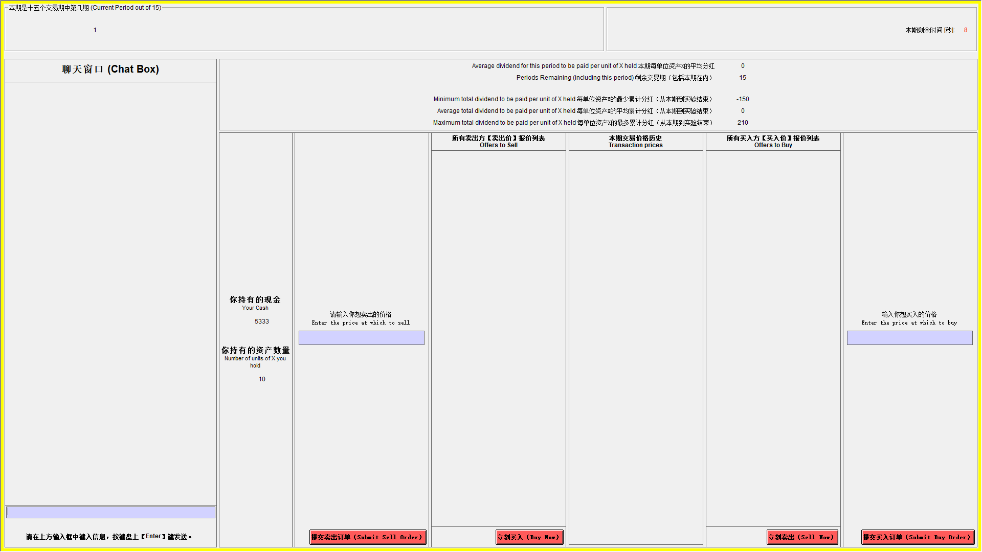

In a trading period, if you wish to purchase a unit of X you can send in a buy order by typing the amount you are willing to pay for a unit of good X in the box marked “Enter the price at which to buy” and by pressing the corresponding button. Similarly, if you wish to sell units of X, you can send in a sell order by typing the amount you are willing to sell a unit of X for in the box marked “Enter the price at which to sell” and by pressing the corresponding button. The “Offers to Buy” column shows a list of all the offers traders have made to purchase a single unit of the asset. The list is in descending order so that the highest price is at the top.

Press the “Sell” button if you would like to sell a unit of good X for the highlighted amount in the “Offers to Buy” column. The “Offers to Sell” column shows a list of all the offers traders have made to sell a single unit of the asset. The list is in ascending order so that the lowest price is at the top. Press the “Buy” button if you would like to buy a unit of good X for the highlighted amount in the “Offers to Sell” column. Note that you cannot accept your own buy or sell orders.

The “Transaction prices” column shows all the prices at which a unit of X has been bought or sold in the current period. Your offers to sell are limited by your available inventory of X (i.e., you cannot sell more units than you have), and your offers to buy are limited by your available cash on hand and the price (i.e., you cannot buy more than you can afford).
Examples of how the market works.
The numbers used in the examples are for illustrative purposes.
Example 1. Suppose that in period 9 four traders participate in the market and:
- Trader 1 submits an offer to buy at 60
- Trader 2 submits an offer to buy at 20
- Trader 3 submits an offer to sell at 10
- Trader 4 submits an offer to sell at 40
The sale prices will be ordered in ascending order in the “Offers to Sell” column so that the lowest price is at the top. The first participant who presses the button “Buy” will buy the unit at the price of 10, if this price is highlighted in the “Offers to Sell” column. The purchase prices will be ordered in descending order in the “Offers to Buy” so that the highest price is at the top. The first participant who presses the button “Sell” will sell at the price of 60, if this price is highlighted in the “Offers to Buy” column.
Example 2. Suppose that in Spot Market period 9 four traders participate in the market and:
- Trader 1 submits an offer to buy at 810
- Trader 2 submits an offer to buy at 800
- Trader 3 submits an offer to sell at 700
- Trader 4 submits an offer to sell at 720
The sale prices will be ordered in ascending order in the “Offers to Sell” column so that the lowest price is at the top. The first participant who presses the button “Buy” will buy the unit at the price of 700, if this price is highlighted in the “Offers to Sell” column. The purchase prices will be ordered in descending order in the “Offers to Buy” so that the highest price is at the top. The first participant who presses the button “Sell” will sell at the price of 810, if this price is highlighted in the “Offers to Buy” column.
5. Forecasting Average Transactions Price and Holding Values

At the beginning of periods 1, 5, 10, 15, you will be asked to make the following two forecasts:

- Forecast Average Transaction Price: submit a price that forecasts the average of all transaction prices of X in that period.
- Forecast the Indifference Price: Irrespective of the prices you see in the market, what is the price in this period such that the expected earnings are the same between selling the asset and holding the asset till the end of the experiment.
You will be paid for the accuracy of your forecasts.
The money you receive for each of your forecast will be calculated in the following manner:

Accuracy | Your Earnings
Within 10% of actual average price or average holding value | 50 francs
Within 25% of actual average price or average holding value | 20 francs
Within 50% of actual average price or average holding value | 10 francs

5. Record your earnings

At the end of each period, a summary screen will be provided to you.

END OF PERIOD CASH = BEGINNING OF PERIOD CASH+ CASH TRANSFERS + SALES – PURCHASES + DIVIDEND PER UNIT * NUMBER OF UNITS IN INVENTORY AT THE END OF PERIOD

PERIOD EARNINGS = END OF PERIOD CASH – BEGINNING OF PERIOD CASH
Subsequent periods should be recorded similarly.

Your earnings for this experiment are given by the cash on hand at the end of period 15 plus any earnings from forecasts plus earnings from asset buyback minus 101,547 francs (total of loan cash transfers).

Example of period earnings. Suppose that in period 10 your BEGINNING CASH ON HAND is 1,500 francs and your INVENTORY at the beginning of period 10 is 7 units of X. If in period 10 you sell 2 units of X at a price of 200 francs and the dividend draw is -10 francs, then in period 10:

SALES= 2*200=400
CLOSING X ON HAND = 7- 2 = 5
PERIOD DIVIDEND EARNINGS = DIVIDEND PAYMENT PER UNIT * CLOSING X ON HAND = -10 * 5 = -50.
END CASH = 1,500 - 50 + 400 = 1,850
PERIOD EARNINGS = END CASH – BEGINNING CASH ON HAND = 1,850 – 1,500 = 350.

Experiment Instructions for Downward FV Condition
(Communication Treatment Condition text in red)

1. General Instructions

This is an experiment in the economics of market decision-making. The instructions are simple and if you follow them carefully and make good decisions, you might earn a considerable amount of money, which will be paid to you in cash at the end of the experiment. The experiment will consist of 15 trading periods in which you will have the opportunity to buy and sell in a market. Throughout the experiment, you will always have the opportunity to chat with other traders via a chat box. The currency used in the market is francs. All trading and earnings will be in terms of francs.

_____ francs = 1 RMB

Your francs will be converted to dollars at this rate, and you will be paid in dollars when you leave the lab today. The more francs you earn, the more dollars you earn.

In each period, you may buy and sell units of a good called X. X can be considered an asset with a life of 15 periods, and your inventory of X carries over from one trading period to the next.

2. Dividends

Each unit of X in your inventory at the end of each trading period pays a dividend to you. The dividend paid on each unit is the same for every participant. The dividend at the end of each period was determined by chance by a random number generator. The dividend in each period has an equally likely chance of being 0, 8, 28, or 60. The information is provided in the table below.

Dividend | → | 0 | 8 | 28 | 60
Likelihood | → | 25% | 25% | 25% | 25%

The average dividend per period for each unit of X is 24 francs.

The dividend draws in each period are independent. That means that the likelihood of a particular dividend in a period is not affected by the dividend in previous periods.

3. Your Earnings

At the beginning of the experiment, you will be given 10,000 francs in your Cash inventory and 10 Units of Asset. Your earnings for participation in the market are equal to your Cash inventory at the end of period 15.

All dividends you receive are added to your Cash inventory.

All money spent on purchases is subtracted from your Cash inventory.

All money received from sales is added to your Cash inventory.
Example of earnings from dividends: if you have 6 units of X at the end of period 3 and the dividend draw is 8 francs (which has a 25% chance of occurring), then your dividend earnings for period 3 are equal to 6 units x 8 francs = 48 francs.

Example of the cumulative average dividends: Suppose for example that you are in period 9 (there are 7 periods remaining). Since the dividend paid on a unit of X has a 25% chance of being 0, a 25% chance of being 8, a 25% chance of being 28, and a 25% chance of being 60 in any period, the dividend is on average 24 per period for each unit of X. If you hold a unit of X for 7 periods, the total dividend paid on the unit over the 7 periods is on average 7*24 = 168.

4. Market and Trading Rules

The market consists of 8 subjects. Each trader gets an initial endowment of 10 units of X and 10,000 francs. The experiment will consist of 15 periods. Each period will last 3 minutes. In each period, you will see a computer screen like the one shown below. You can use the interface to buy and sell units of X. On your computer screen, you can see the Cash and Number of units of X you have available.

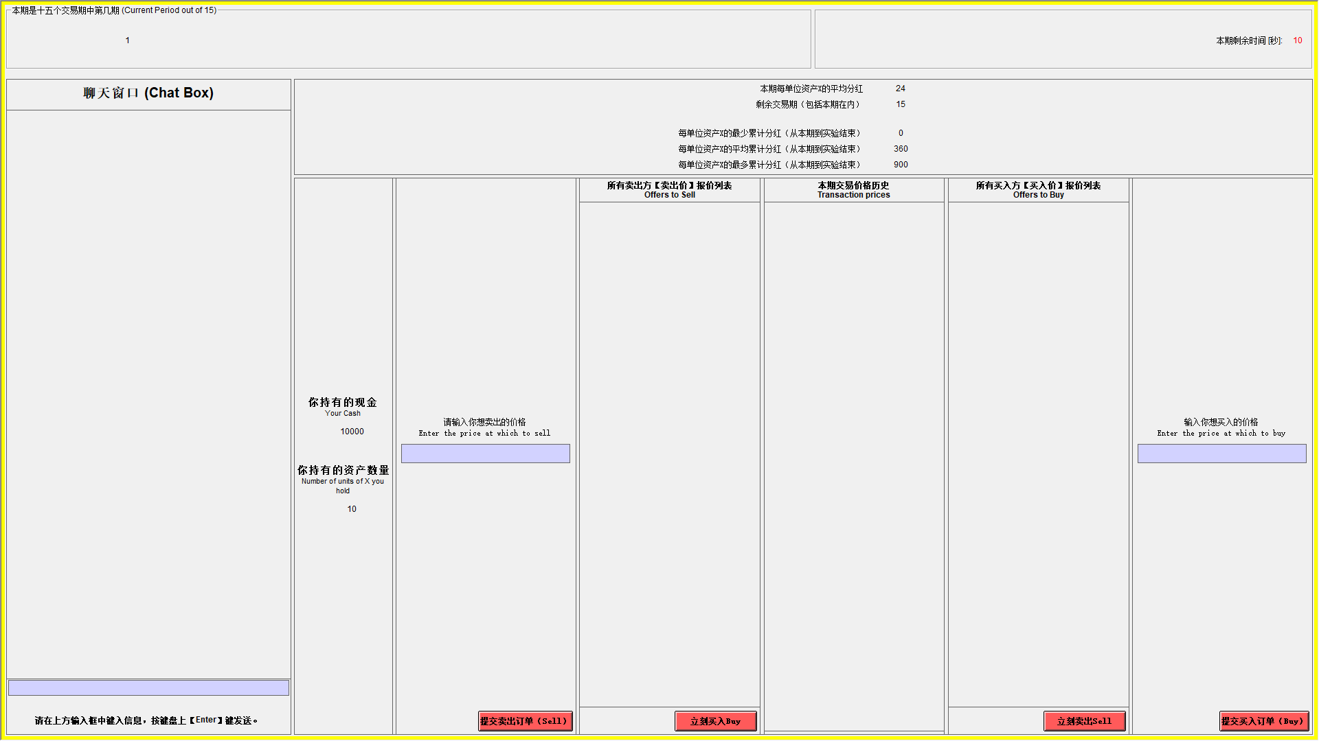

In a trading period, if you wish to purchase a unit of X you can send in a buy order by typing the amount you are willing to pay for a unit of good X in the box marked “Enter the price at which to buy” and by pressing the corresponding button. Similarly, if you wish to sell units of X, you can send in a sell order by typing the amount you are willing to sell a unit of X for in the box marked “Enter the price at which to sell” and by pressing the corresponding button. The “Offers to Buy” column shows a list of all the offers traders have made to purchase a single unit of the asset. The list is in descending order so that the highest price is at the top.

Press the “Sell” button if you would like to sell a unit of good X for the highlighted amount in the “Offers to Buy” column. The “Offers to Sell” column shows a list of all the offers traders have made to sell a single unit of the asset. The list is in ascending order so that the lowest price is at the top. Press the “Buy” button if you would like to buy a unit of good X for the highlighted amount in the “Offers to Sell” column. Note that you cannot accept your own buy or sell orders.

The “Transaction prices” column shows all the prices at which a unit of X has been bought or sold in the current period. Your offers to sell are limited by your available inventory of X (i.e., you cannot sell more units than you have), and your offers to buy are limited by your available cash on hand and the price (i.e., you cannot buy more than you can afford).

Examples of how the market works.
The numbers used in the examples are for illustrative purposes.
Example 1. Suppose that in period 9 four traders participate in the market and:
- Trader 1 submits an offer to buy at 60
- Trader 2 submits an offer to buy at 20
- Trader 3 submits an offer to sell at 10
- Trader 4 submits an offer to sell at 40
The sale prices will be ordered in ascending order in the “Offers to Sell” column so that the lowest price is at the top. The first participant who presses the button “Buy” will buy the unit at the price of 10, if this price is highlighted in the “Offers to Sell” column. The purchase prices will be ordered in descending order in the “Offers to Buy” so that the highest price is at the top. The first participant who presses the button “Sell” will sell at the price of 60, if this price is highlighted in the “Offers to Buy” column.
Example 2. Suppose that in Spot Market period 9 four traders participate in the market and:
- Trader 1 submits an offer to buy at 810
- Trader 2 submits an offer to buy at 800
- Trader 3 submits an offer to sell at 700
- Trader 4 submits an offer to sell at 720
The sale prices will be ordered in ascending order in the “Offers to Sell” column so that the lowest price is at the top. The first participant who presses the button “Buy” will buy the unit at the price of 700, if this price is highlighted in the “Offers to Sell” column. The purchase prices will be ordered in descending order in the “Offers to Buy” so that the highest price is at the top. The first participant who presses the button “Sell” will sell at the price of 810, if this price is highlighted in the “Offers to Buy” column.
5. Forecasting Average Transactions Price and Holding Values
At the beginning of periods 1, 5, 10, 15, you will be asked to make the following two forecasts:

- Forecast Average Transaction Price: submit a price that forecasts the average of all transaction prices of X in that period.
- Forecast the Indifference Price: Irrespective of the prices you see in the market, what is the price in this period such that the expected earnings are the same between selling the asset and holding the asset till the end of the experiment.

You will be paid for the accuracy of your forecasts.
The money you receive for each of your forecast will be calculated in the following manner:

Accuracy | Your Earnings
Within 10% of actual average price or average holding value | 100 francs
Within 25% of actual average price or average holding value | 40 francs
Within 50% of actual average price or average holding value | 20 francs

6. Record your earnings

At the end of each period, a summary screen will be provided to you.

END OF PERIOD CASH = BEGINNING OF PERIOD CASH + DIVIDEND PER UNIT * NUMBER OF UNITS IN INVENTORY AT THE END OF PERIOD + SALES - PURCHASES

PERIOD EARNINGS = END OF PERIOD CASH – BEGINNING OF PERIOD CASH

Subsequent periods should be recorded similarly.

Your earnings for this experiment are given by the cash on hand at the end of period 15 plus any earnings from forecasts.

Example of period earnings. Suppose that in period 10 your BEGINNING CASH ON HAND is 1,500 francs and your INVENTORY at the beginning of period 10 is 7 units of X. If in period 10 you sell 2 units of X at a price of 200 francs and the dividend draw is 8 francs, then in period 10:

SALES= 2*200=400
CLOSING X ON HAND = 7- 2 = 5
PERIOD DIVIDEND EARNINGS = DIVIDEND PAYMENT PER UNIT * CLOSING X ON HAND = 8 * 5 = 40.
END CASH = 1,500 +40+ 2*200 = 1,940
PERIOD EARNINGS = END CASH – BEGINNING CASH ON HAND = 1,940 – 1,500 = 440.

Experiment Instructions for Constant FV and Interest Condition
(Communication Treatment Condition text in red)

1. General Instructions

This is an experiment in the economics of market decision-making. The instructions are simple and if you follow them carefully and make good decisions, you might earn a considerable amount of money, which will be paid to you in cash at the end of the experiment. The experiment will consist of 15 trading periods in which you will have the opportunity to buy and sell in a market. Throughout the experiment, you will always have the opportunity to chat with other traders via a chat box. The currency used in the market is francs. All trading and earnings will be in terms of francs.

______ francs = 1 Yuan (RMB)

Your francs will be converted to RMB at this rate, and you will be paid in RMB when you leave the lab today. The more francs you earn, the more RMB you earn.

In each period, you may buy and sell units of a good called X. X can be considered an asset with a life of 15 periods, and your inventory of X carries over from one trading period to the next. Each Unit of asset X has a buyback value of 192 francs. That is, at the end of period 15 each unit of the asset in your inventory will be bought back by the experimenter at a price of 192 francs.

2. Dividends and Interest

Each unit of X in your inventory at the end of each trading period pays a dividend to you. The dividend paid on each unit is the same for every participant. The dividend at the end of each period was determined by chance by a random number generator. The dividend in each period has an equally likely chance of being 0, 8, 28, or 60. The information is provided in the table below.

Dividend | → | 0 | 8 | 28 | 60
Likelihood | → | 25% | 25% | 25% | 25%

The average dividend per period for each unit of X is 24 francs.

The dividend draws in each period are independent. That means that the likelihood of a particular dividend in a period is not affected by the dividend in previous periods.

Each franc in retained your Cash inventory at the end of a period (prior to dividend payment) will earn interest at a fixed rate of 12.5%.

Note, the dividend payments are drawn randomly, whereas interest rate is fixed in advance. Another difference is that interest is paid on each franc not used to purchase shares, whereas dividends are paid on each share, the price of which is determined in the trading process, as explained next.
3. Your Earnings

At the beginning of the experiment, you will be given 5,333 francs in your Cash inventory and 10 Units of Asset. At the start of each period, a transfer of francs will occur that affects your Cash inventory. The table below presents the amounts of francs to be transferred at the start of each period. Note, in periods 2 through 7, these transfers will be negative, i.e. the amount listed in column 2 will be subtracted from your Cash inventory at the start of these periods. These transfers are considered as loans and the sum of these transfers, including interest received on these transfers across all periods of the market (at 12.5%), must be paid back at the end of the experiment. That is, 79,955 francs will be subtracted from your Cash inventory at the end of the experiment.

Period | Franc Transfer
1 | 0
2 | -389
3 | -373
4 | -349
5 | -309
6 | -247
7 | -151
8 | 0
9 | 242
10 | 648
11 | 1360
12 | 2720
13 | 5667
14 | 13600
15 | 47600

All cash transfers received at the beginning of each period are added to your Cash inventory.

All dividends you receive are added to your Cash inventory.

All interest payments are added to your Cash inventory.

All money spent on purchases is subtracted from your Cash inventory.

All money received from sales is added to your Cash inventory.

Your earnings for participation in the market are equal to your Cash inventory at the end of period 15 plus the value of asset buyback at the end of the market (192 francs per unit of asset) plus earnings from forecasting (explained below) minus 79,955 francs.

Example of earnings from dividends: if you have 6 units of X at the end of period 3 and the dividend draw is 28 francs (which has a 25% chance of occurring), then your dividend earnings for period 3 are equal to 6 units x 28 francs = 168 francs.
Example of earnings from interest: suppose you have 15,000 francs at the end of a period (prior to the dividend payment). Since the interest rate is 12.5%, your earnings from cash holdings are 0.125 x 15,000 francs = 1,875 francs.

Example of the cumulative average dividends: For this example, we do not take interest payments into account. Suppose for example that there are 9 periods remaining. Since the dividend paid on a unit of X has a 25% chance of being 0, a 25% chance of being 8, a 25% chance of being 28, and a 25% chance of being 60 in any period, the dividend is on average 24 per period for each unit of X. If you hold a unit of X for 7 periods, the total dividend paid on the unit over the 7 periods is on average 7*24 = 168.

4. Market and Trading Rules

The market consists of 8 subjects. Each trader gets an initial endowment of 10 assets and a working capital of 5,333 francs. The experiment will consist of 15 periods. Each period will last 3 minutes. In each period, you will see a computer screen like the one shown below. You can use the interface to buy and sell units of X. On your computer screen, you can see the Cash and Number of units of X you have available.

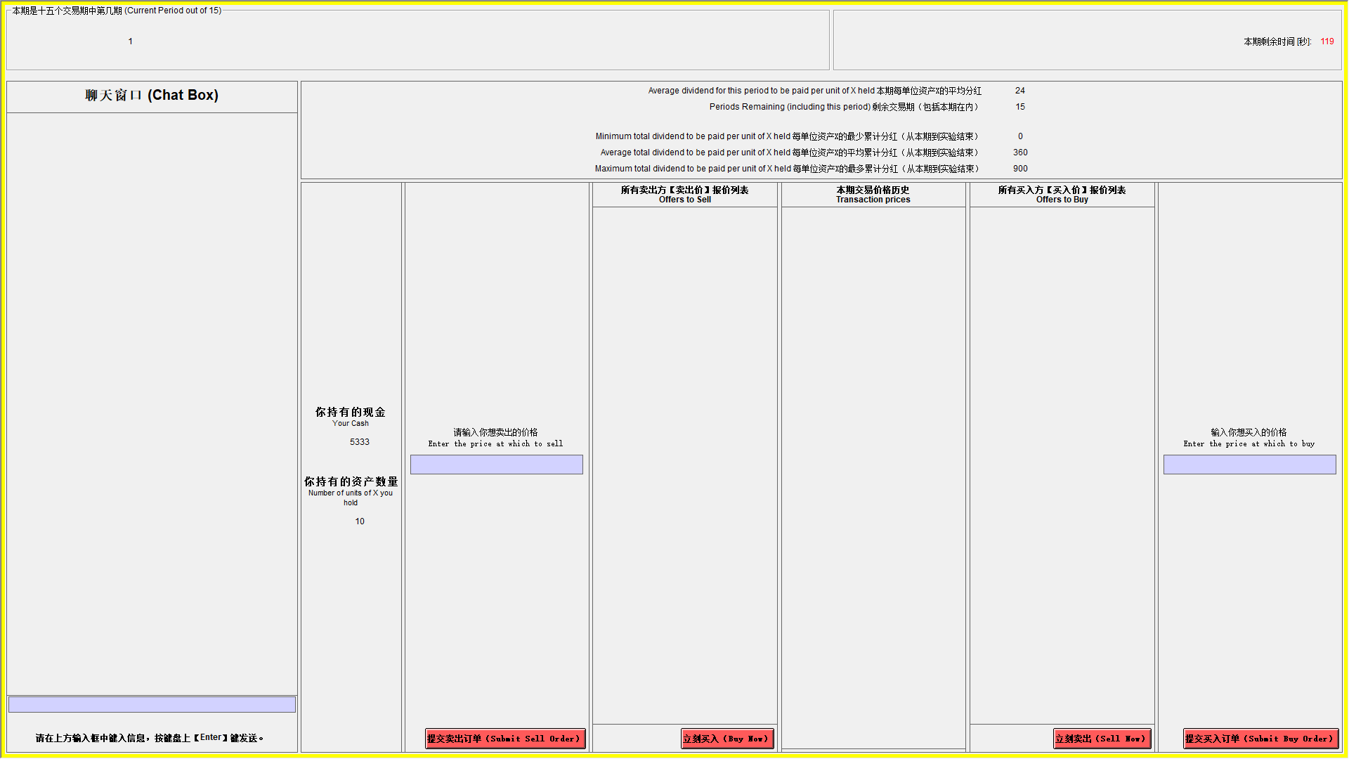

In a trading period, if you wish to purchase a unit of X you can send in a buy order by typing the amount you are willing to pay for a unit of good X in the box marked “Enter the price at which to buy” and by pressing the corresponding button. Similarly, if you wish to sell units of X, you can send in a sell order by typing the amount you are willing to sell a unit of X for in the box marked “Enter the price at which to sell” and by pressing the corresponding button. The “Offers to Buy” column shows a list of all the offers traders have made to purchase a single unit of the asset. The list is in descending order so that the highest price is at the top.

Press the “Sell” button if you would like to sell a unit of good X for the highlighted amount in the “Offers to Buy” column. The “Offers to Sell” column shows a list of all the offers traders have made to sell a single unit of the asset. The list is in ascending order so that the lowest price is at the top. Press the “Buy” button if you would like to buy a unit of good X for the highlighted amount in the “Offers to Sell” column. Note that you cannot accept your own buy or sell orders.

The “Transaction prices” column shows all the prices at which a unit of X has been bought or sold in the current period. Your offers to sell are limited by your available inventory of X (i.e., you cannot sell more units than you have), and your offers to buy are limited by your available cash on hand and the price (i.e., you cannot buy more than you can afford).
Examples of how the market works.
The numbers used in the examples are for illustrative purposes.
Example 1. Suppose that in period 9 four traders participate in the market and:
- Trader 1 submits an offer to buy at 60
- Trader 2 submits an offer to buy at 20
- Trader 3 submits an offer to sell at 10
- Trader 4 submits an offer to sell at 40
The sale prices will be ordered in ascending order in the “Offers to Sell” column so that the lowest price is at the top. The first participant who presses the button “Buy” will buy the unit at the price of 10, if this price is highlighted in the “Offers to Sell” column. The purchase prices will be ordered in descending order in the “Offers to Buy” so that the highest price is at the top. The first participant who presses the button “Sell” will sell at the price of 60, if this price is highlighted in the “Offers to Buy” column.
Example 2. Suppose that in Spot Market period 9 four traders participate in the market and:
- Trader 1 submits an offer to buy at 810
- Trader 2 submits an offer to buy at 800
- Trader 3 submits an offer to sell at 700
- Trader 4 submits an offer to sell at 720
The sale prices will be ordered in ascending order in the “Offers to Sell” column so that the lowest price is at the top. The first participant who presses the button “Buy” will buy the unit at the price of 700, if this price is highlighted in the “Offers to Sell” column. The purchase prices will be ordered in descending order in the “Offers to Buy” so that the highest price is at the top. The first participant who presses the button “Sell” will sell at the price of 810, if this price is highlighted in the “Offers to Buy” column.
5. Forecasting Average Transactions Price and Holding Values

At the beginning of periods 1, 5, 10, 15, you will be asked to make the following two forecasts:

- Forecast Average Transaction Price: Submit a price that forecasts the average of all transaction prices of X in this period.
- Forecast the Indifference Price: Irrespective of the prices you see in the market, what is the price in this period such that the expected earnings are the same between selling the asset and holding the asset till the end of the experiment.
You will be paid for the accuracy of your forecasts.
The money you receive for each of your forecast will be calculated in the following manner:

Accuracy | Your Earnings
Within 10% of actual average price or average holding value | 300 francs
Within 25% of actual average price or average holding value | 120 francs
Within 50% of actual average price or average holding value | 60 francs

6. Record your earnings

At the end of each period, a summary screen will be provided to you.

END OF PERIOD CASH = BEGINNING OF PERIOD CASH + CASH TRANSFERS + SALES - PURCHASES + INTEREST PAYMENTS + DIVIDEND PER UNIT * NUMBER OF UNITS IN INVENTORY AT THE END OF PERIOD

PERIOD EARNINGS = END OF PERIOD CASH – BEGINNING OF PERIOD CASH

Subsequent periods should be recorded similarly.

Your earnings for this experiment are given by the cash on hand at the end of period 15 plus any earnings from forecasts plus earnings from asset buyback minus 79,955 francs (total of loan cash transfers).

Example of period earnings. Suppose that in period 10 your BEGINNING CASH ON HAND is 1,500 francs and your INVENTORY at the beginning of period 10 is 7 units of X. If in period 10 you sell 2 units of X at a price of 200 francs and the dividend draw is 8 francs, then in period 10:

SALES= 2*200=400
CLOSING X ON HAND = 7- 2 = 5
PERIOD DIVIDEND EARNINGS = DIVIDEND PAYMENT PER UNIT * CLOSING X ON HAND = 8 * 5 = 40.
PERIOD INTEREST EARNING = (1,500 + 400) * 0.125 = 237.5
END CASH = 1,500 + 40 + 400 + 237.5= 2,177.5
PERIOD EARNINGS = END CASH – BEGINNING CASH ON HAND = 2,177.5– 1,500 = 677.5.

Prompt treatment CCI part I
# **General Task**
Interpret and classify chat messages in an asset market experiment into predefined categories from the perspective of a university student participating as a trader in the experiment.
# **Role Persona**
Take the role of a university student participating as a trader in an asset market experiment. Additionally, you should be knowledgeable about Chinese internet slang, particularly as it relates to market discussions.
# **Context**
### Summary of Experiment Instructions:
- **Market Decision Experiment**: Participants take part in a 15-period market, where they can buy and sell units of an asset called X. Each period lasts 3 minutes, and traders can communicate through a chat box. Each market involves 8 participants.
- **Currency**: The market currency is francs, with a conversion rate of 1030 francs = 1 Yuan (RMB).
- **Asset**: Asset X lasts for 15 periods and carries over between periods.
- **Buyback**: At the end of period 15, each unit of asset X in your inventory will be repurchased by the experimenter for 192 francs.
- **Dividends**: Each unit of X generates a random dividend of 0, 8, 28 or 60 francs at the end of each period, with a 25% probability for each.
- **Expected Dividend**: The average dividend per unit is 24 francs per period.
- **Interest payment**: Each franc in your Cash inventory at the end of a period (before dividend payment) will earn interest at a fixed rate of 12.5%.
- **Initial Endowment**: 5333 francs and 10 units of X.
- **Loan**: At the start of each period, a transfer of francs will affect your Cash inventory. In periods 2-7, these transfers will be negative, and from periods 8 to 15, the transfer will be either zero or positive. These transfers are considered as a loan with interest. The total amount, including 12.5% interest, must be repaid at the end of the experiment, with 79,955 francs deducted from your Cash inventory.
- **Earnings**: Cash inventory at the end of period 15 plus the value of asset buyback at the end of the market (192 francs per unit of asset), plus earnings from forecasting minus 79,955 francs (total sum of loans received across the 15 periods).
- **Market Rules**: Transactions occur when buy and sell orders match, following a double auction trading mechanism.
- **Restrictions**: Trades are limited by available cash or inventory, and participants cannot accept their own buy or sell orders.
- **Market Example**: If the lowest ask price is 10 and someone buys, the transaction is executed at that price.
- **End of period cash (formula)**: END CASH = BEGINNING CASH + CASH TRANSFERS + SALES - PURCHASES + INTEREST + DIVIDENDS.
- **End of period cash example**: In period 10, with 1,500 francs in cash and 7 units of X , with 648 francs transferred, selling 2 units at 200 francs, receiving a dividend of 8 francs per unit, and earning 12.5% interest, the final cash is 2,906.5 francs.
### Communication Protocol:
Messages are exchanged as **chat entries**, structured as **JSON dictionaries**.
### Language Considerations:
Messages are in Chinese and were written by Chinese university students. They may contain financial terms, market-related discussions, and strategic communication. Some messages may include Chinese internet slang, which can be relevant to sentiment analysis and communication patterns. Additionally, messages may contain unrelated content that is not part of the experiment.
# **Classification Requirements**
- Accurately identify and classify messages into the category provided.
- Recognize **Chinese financial slang** and **common expressions** used in asset markets.
- Use the provided reference dictionary to identify internet slang terms, but keep in mind that there may be terms not included in it.
# **Reference: Chinese Internet Slang (Filtered)**
This dictionary provides a list of common Chinese internet slang terms, including numeronyms and Latin abbreviations.
## **Numeronyms**
- **007** – A variant of the 996 working hour system. Represents 00:00 hours (12:00 am) to 00:00 hours, 7 days per week (pinyin: línglíngqī)
- **1314** – "Forever", usually preceded by a phrase such as "I love you" or the similar. 1314 (pinyin: yīsānyīsì) represents 一生一世 (pinyin: yīshēng yīshì, "one lifetime, throughout one's life").
- **213** – "2B", represents 二逼, a person who is very stupid.
- **233** – "laughter", represents 哈哈哈 (pinyin: hāhāhā).
- **205** – “stupid”, (read as whole number instead of sequentially, e.g. pinyin: èrbǎiwǔ) originates from either the ancient currency or the murder of Su Qin.
- **38** – “a woman who gossips excessively”
- **4242** – (pinyin: sìèrsìèr) "Yes", "Affirmative", or "It is", 4242 represents 是啊是啊 (pinyin: shìa shìa).
- **484** – "If", represents 是不是 (means yes or no).
- **520** – "I love you". 520 (pinyin: wǔ'èrlíng) represents 我爱你 (pinyin: wǒ ài nǐ).
- **555** – "(crying)". 555 (pinyin: wǔwǔwǔ) represents 呜呜呜 (pinyin: wūwūwū) the sound of tearful crying, but it is not towards the feeling of sadness, but more of pitiful.
- **666** – "cool" or "nice". 666 (pinyin: liùliùliù) represents 溜溜溜 (pinyin: liùliùliù); or smooth/slick (comes from Chinese gaming slang, where gamers would put '666' in the chat after seeing another showing an impressive skill)
- **777** – "666 but better", a play on "666".
- **7451 or 7456** – "I'm angry." 7451 (pinyin: qīsìwǔyī) or 7456 (pinyin: qīsìwǔliù) represents 气死我了 (pinyin: qìsǐwǒle) lit.: I'm furious.
- **748** – "Go and die!", 748 (pinyin: qīsìbā) represents 去死吧 (pinyin: qùsǐba), the equivalent of "Get lost!", or "Go to hell!"
- **87** – (bitchy, or idiocy/idiot). 87 (pinyin: lit. bāqī, or loosely báichī) represents "bitchy" (English) or 白痴 "idiocy/idiot" (Mandarin).
- **88** – "Bye bye" (goodbye). 88 (pinyin: bābā) represents "bye bye" (English). 886 also has the same meaning as "88".
- **94** – "So", "But", etc. 94 (jiǔsì) represents 就是 (pinyin: jiùshì), the conjunction meaning "so", "but", "just like", "in the same way as", an agreement to something etc.
- **955** – A 9 to 5 job. Represents 9:00 am to 5:00 pm, 5 days per week (pinyin: jiǔwǔwǔ).
- **99** – "The wish for a couple to be together for long time", 99 (pinyin: jiǔjiǔ) represents 久久 (pinyin: jiǔjiǔ), a long time.
- **995** – "Help", "Save me!", 995 (pinyin: jiǔjiǔwǔ) represents 救救我 (pinyin: jiùjiù wǒ).
- **996** – The 996 working hour system (pinyin: jiǔjiǔliù)
- **999** – The upside-down version of "666"
## **Latin abbreviations**
- **BZ** – bǎnzhǔ (版主), the moderator of an internet discussion forum
- **CNM** – cāonǐmā, fuck your mother. The most common way of cursing in China. Some phrase it "sao ni ma".
- **FQ** – fènqīng (愤青), indignant/angry youth
- **GG** – gēge (哥哥), literally older brother, by extension male friend, or guy. Nowadays, people say "GG" to mean good job on the game (these two letters also mean "Good Game").
- **GKD** – gǎokuàidiǎn (搞快点), urge someone to speed up, usually urging others to send the link/picture/video faster
- **JC** – jié cāo (节操), moral integrity, moral principle
- **TMD** – tāmāde (他妈的), common Chinese expletive used for "damn", "fuck", and the like
- **YYSY** – yǒuyī shuō yī (有一说一), to affirm one's opinion
- **AZ** – A zhè (啊这), used as shocked expression, something happened out of the ordinary

# **Classification Task**
Classify each **participant message** if it belongs **to the predefined category**, given the following condition:
- Classification should be based on **both the content of the individual message and the context surrounding it** in the conversation.
# **Classification Coding**
Classify each message using the following codes:
- **Code `<1>`if classified as Strategy**.
- **Code `<0>` if not classified as 1**.

# **Examples**
- **"The last price was 200."** → `<1>` (Strategy)
- **"Will anyone sell for 210? I'll buy it all"** → `<1>` (Strategy)
- **"I want to buy at 211."** → `<1>` (Strategy)
- **"I will not sell if the price is less than 365"** → `<1>` (Strategy)
- **"The dividend this round is going to be 60."** → `<1>` (Strategy)

# **Classification Process**
- **Step 1**: Read all **ordered messages** in the conversation before classifying each message to understand its context.
- **Step 2**: Apply the classification codes based on **message content and context**.
- **Step 3**: Output only the classification code in the required format.

# **Constraint(s)**
- **Follow the specified output format.**
- **Preserve the `id` key as an integer**, ensuring it does not convert to a string.
- **Replace the `chat_ch` key with `class_ai` while keeping the `id` key unchanged.**
- **Return a JSON-compatible list of dictionaries** that can be parsed using json.loads() in Python.

# **Output Format**
- If the input consists of multiple chat messages:
[
{"id": 1, "chat_ch": "text"},
{"id": 21, "chat_ch": "text"}
]
- The expected output should be:
[
{"id": 1, "class_ai": "1"},
{"id": 21, "class_ai": "0"}
]

Figure A1: Average transaction prices in CC by market
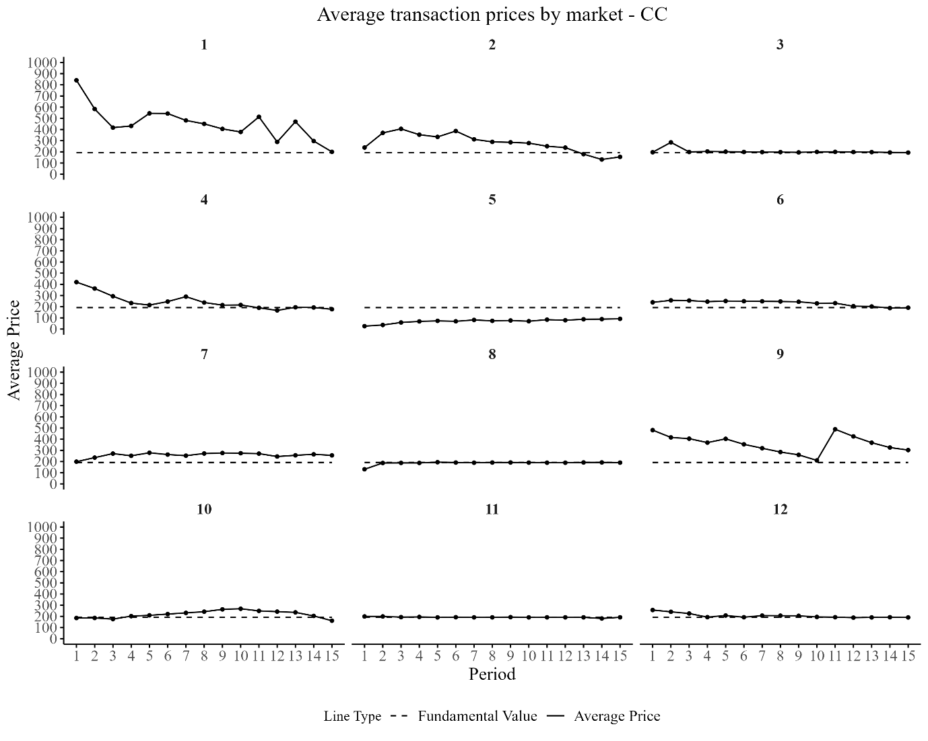
Figure A2: Average transaction prices in CCI by market
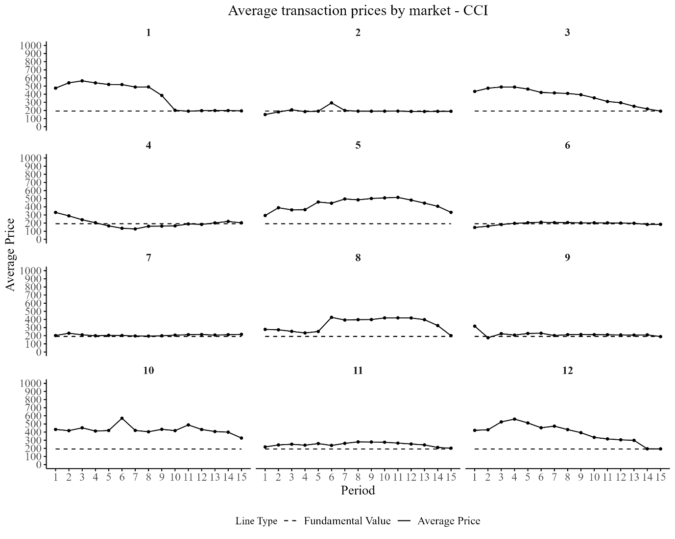

Figure A3: Average transaction prices in CD by market
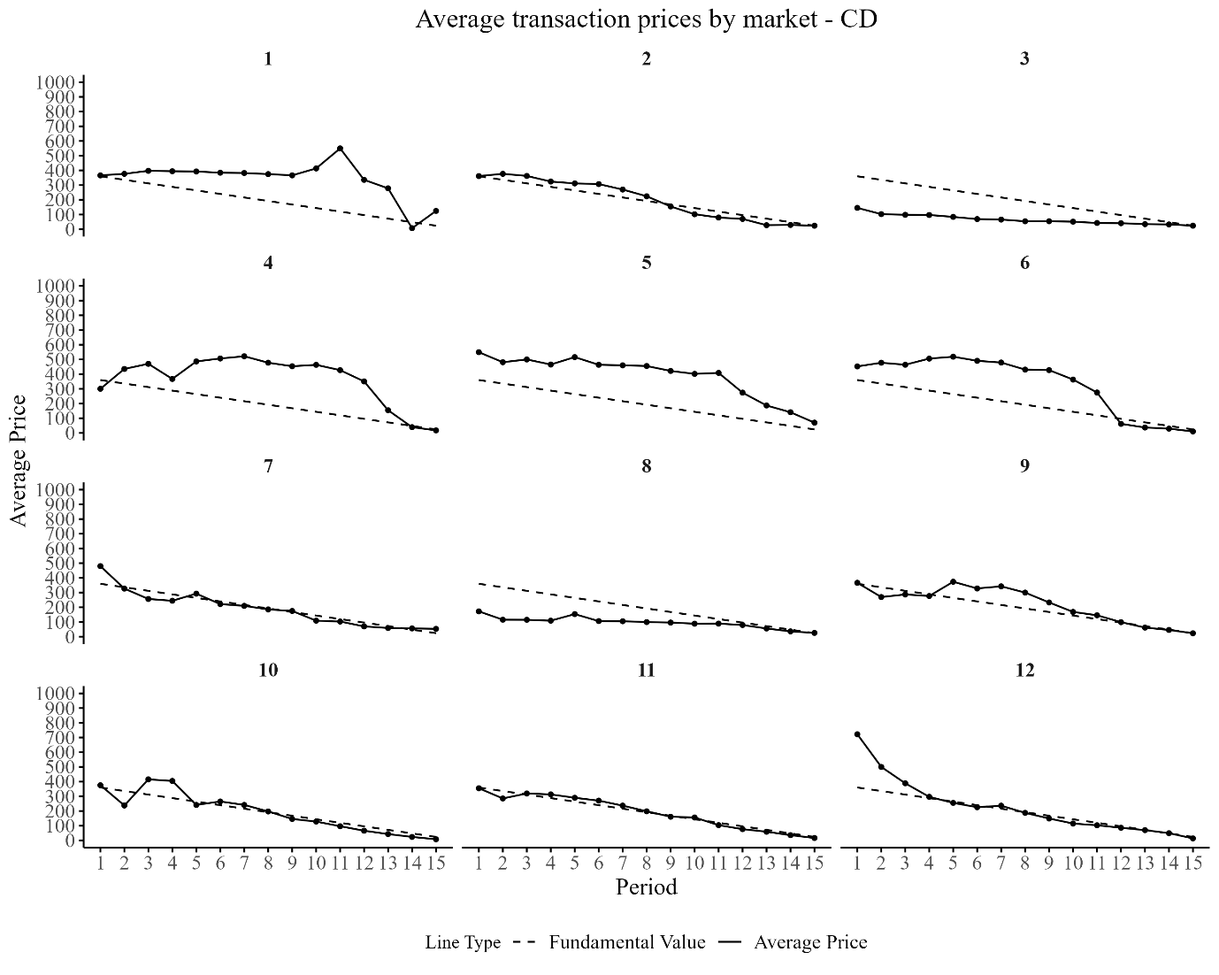
Figure A4 Average transaction prices in NCCI by market
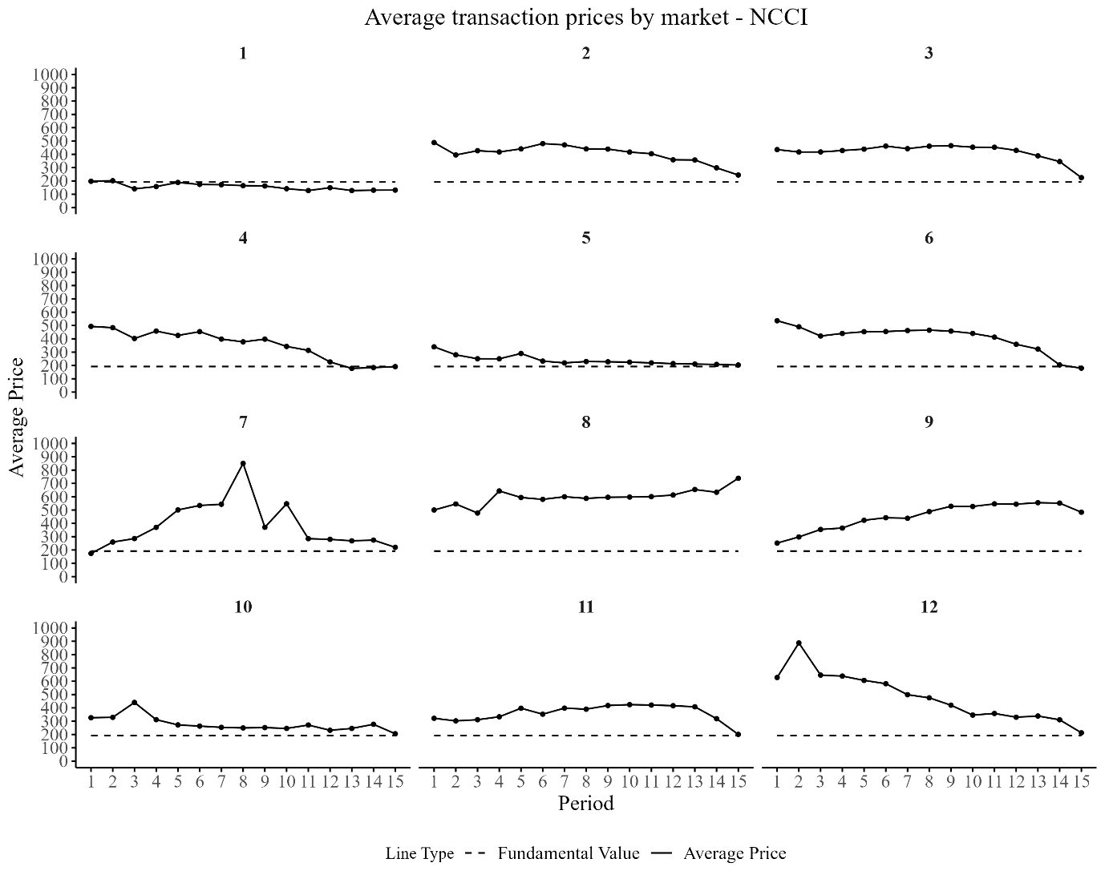

Figure A5: Average transaction prices in NCC by market
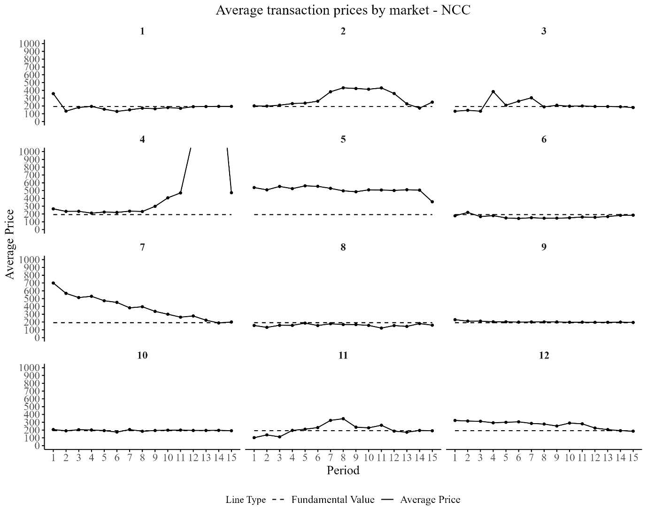
Figure A6: Average transaction prices in NCD by market
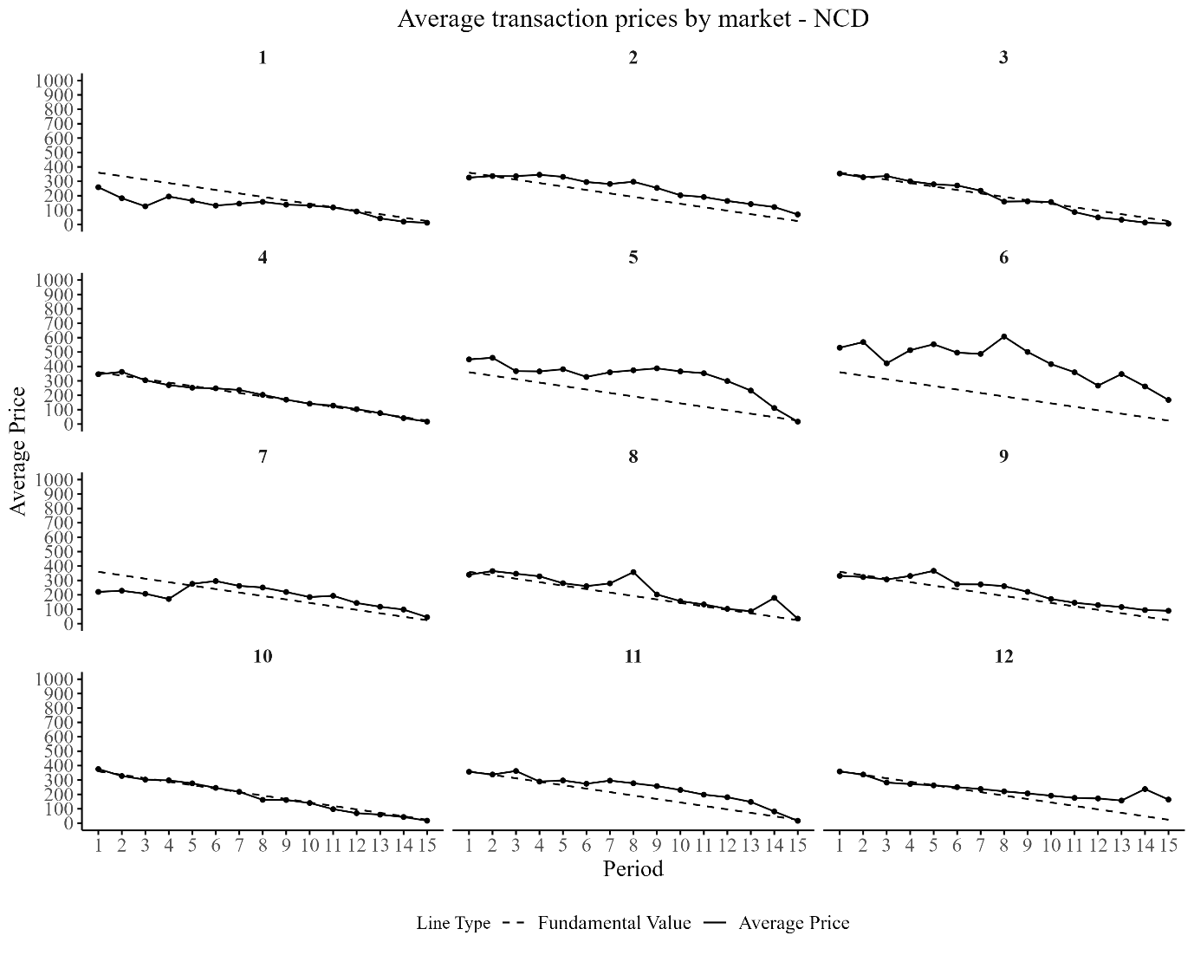

Figure A7: Comparison of observed and expected proportions by treatment
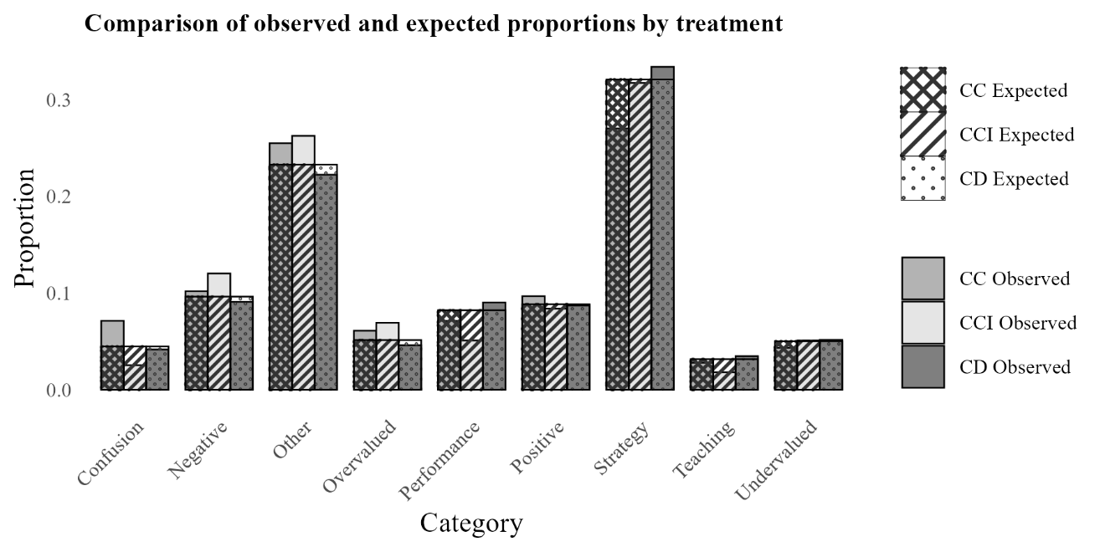

Table A1. Average Mispricing Measures pooling markets with/ without communication
Treatment | RAD | RD | GAD | GD | Inter_Vola | Intra_Vola | Turnover
CI | 0.80 | 0.77 | 0.75 | 0.72 | 33.38 | 0.27 | 3.26
 | (0.55) | (0.58) | (0.52) | (0.56) | (22.78) | (0.15) | (2.43)
C | 0.50 | 0.38 | 0.47 | 0.30 | 44.49 | 0.33 | 2.98
 | (0.62) | (0.69) | (0.52) | (0.52) | (88.08) | (0.29) | (1.30)
D | 0.42 | 0.22 | 0.60 | 0.24 | 32.19 | 0.36 | 2.90
 | (0.34) | (0.46) | (0.46) | (0.53) | (17.92) | (0.18) | (1.58)
Note: Each entry shows the average value of the corresponding measure, with its standard deviations reported in parentheses.

Table A2. Differences in mispricing measures across treatments
Treatment | RAD | RD | GAD | GD | Inter_Vola | Intra_Vola | Turnover
CI vs C | 0.032 | 0.023 | 0.039 | 0.015 | 0.331 | 0.992 | 0.703
CI vs D | 0.022 | 0.001 | 0.407 | 0.004 | 0.911 | 0.059 | 0.975
C vs D | 0.646 | 0.546 | 0.093 | 0.574 | 0.192 | 0.23 | 0.665
Note: entries are p-values of Mann-Whitney U tests.

Table A3. Explaining RAD in CC and CD
 | CC |  | CD
 | (1) | (2) | (3) | (4)
 | RAD | RAD | RAD | RAD
Confusion |  | 0.043 |  | -0.501***
 |  | (0.074) |  | (0.179)
Negative |  |  |  | -1.139**
 |  |  |  | (0.492)
Overvalued |  | 0.104***
 |  | (0.023)
Performance |  | 0.515
 |  | (0.408)
Positive |  | -0.067 |  | -0.487**
 |  | (0.078) |  | (0.199)
Strategy | -0.090*** | -0.072*** | -0.210 | -0.283
 | (0.032) | (0.019) | (0.138) | (0.176)
Undervalued |  |  |  | -0.357
 |  |  |  | (0.220)
Confusion*High RAD |  |  |  | 0.851***
 |  |  |  | (0.281)
Negative*High RAD |  |  |  | 2.113***
 |  |  |  | (0.543)
Overvalued*High RAD |  | 1.194***
 |  | (0.396)
Positive*High RAD |  | 0.368** |  | 0.692
 |  | (0.154) |  | (0.760)
Strategy*High RAD | 0.104* | 0.139*** | 0.606* | 1.003***
 | (0.057) | (0.043) | (0.312) | (0.154)
Undervalued*High RAD |  |  |  | 1.143***
 |  |  |  | (0.302)
Period | -0.028*** | -0.023*** | 0.036* | 0.040*
 | (0.011) | (0.008) | (0.021) | (0.021)
Constant | 0.613*** | 0.521*** | 0.265*** | 0.211***
 | (0.191) | (0.146) | (0.077) | (0.078)
Observations | 180 | 180 | 180 | 180
R2 | 0.162 | 0.399 | 0.104 | 0.332
Adjusted R2 | 0.148 | 0.367 | 0.088 | 0.288
F Statistic | 34.071*** | 112.926*** | 20.329*** | 83.332***
Note: *p<0.1; **p<0.05; ***p<0.01, robust standard errors clustering at the market level are reported in parentheses.

The authors’ categorizations
In an earlier version of the paper, two authors (ST and YX) manually and independently categorized all chat messages. The categories are mostly the same as ChatGPT’s version, with a few exceptions. Here is the list of categories used in this analysis.

Category | Description
Confusion | Statements exhibiting confusion by traders
Dividends | Any discussions that involve dividends (most chats are about predicting/ speculating on future dividends).
Market | Objectively what the market is doing
Other | Unclassified messages
Performance | Performance in the market
Statement | Statement of price
Strategy | Discussing a strategy
Teaching | Teaching Statement
Valuation | Pointing out overvaluation or undervaluation of the asset.

The Chi-squared test of homogeneity suggests that the distribution of chat topics is highly dependent on Treatment (p < 0.0001). Zooming into the individual categories reveals that there is the least discussion (speculation) of dividends in CCI than in the other two treatments.

Figure A8. Distribution of Authors’ categorizations
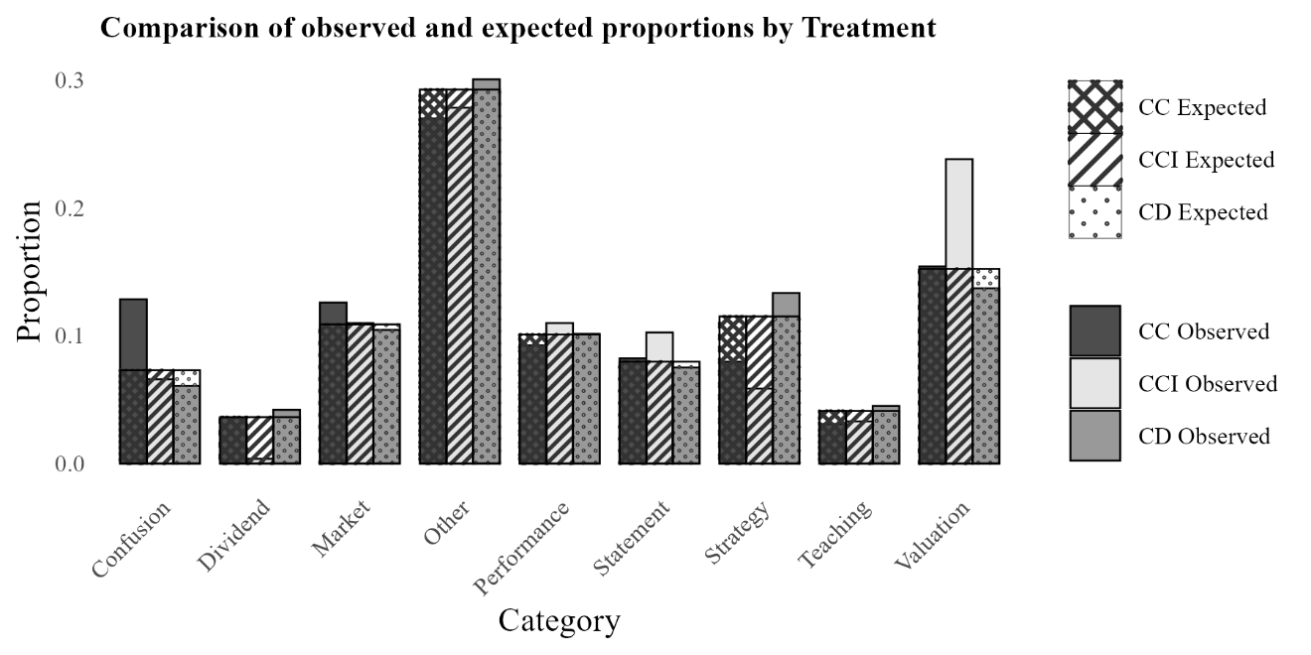
Note: The expected proportions shown here correspond to a null hypothesis of equal frequencies (i.e., each category is equally likely). These expected values were used in a chi-square test to compare against the observed proportions.

Table A4. Fisher's exact test (pairwise comparisons)
Category | Comparison | P-value | P-value Bonferroni
Confusion | CCI vs CC | 0.009 | 0.217
Confusion | CCI vs CD | 0.684 | 1
Confusion | CC vs CD | 0.000 | 0.000
Dividend | CCI vs CC | 0.006 | 0.144
Dividend | CCI vs CD | 0.000 | 0.009
Dividend | CC vs CD | 0.774 | 1
Market | CCI vs CC | 0.625 | 1
Market | CCI vs CD | 0.750 | 1
Market | CC vs CD | 0.273 | 1
Performance | CCI vs CC | 0.353 | 1
Performance | CCI vs CD | 0.665 | 1
Performance | CC vs CD | 0.505 | 1
Statement | CCI vs CC | 0.491 | 1
Statement | CCI vs CD | 0.176 | 1
Statement | CC vs CD | 0.521 | 1
Strategy | CCI vs CC | 0.357 | 1
Strategy | CCI vs CD | 0.000 | 0.007
Strategy | CC vs CD | 0.004 | 0.102
Teaching | CCI vs CC | 1.000 | 1
Teaching | CCI vs CD | 0.424 | 1
Teaching | CC vs CD | 0.261 | 1
Valuation | CCI vs CC | 0.009 | 0.208
Valuation | CCI vs CD | 0.000 | 0.001
Valuation | CC vs CD | 0.369 | 1

Table A5. Explaining RAD (previous categorization)
 | (1) | (2) | (3) | (4) | (5) | (6) | (7) | (8) | (9)
 | RAD | RAD | RAD | RAD | RAD | RAD | RAD | RAD | RAD
Confusion | -0.099 |  |  |  |  |  |  |  | -0.138*
 | (0.083) |  |  |  |  |  |  |  | (0.072)
Dividend |  | 0.287 |  |  |  |  |  |  | 0.214
 |  | (0.382) |  |  |  |  |  |  | (0.367)
Market |  |  | -0.132*** |  |  |  |  |  | -0.146***
 |  |  | (0.048) |  |  |  |  |  | (0.050)
Performance |  |  |  | 0.015 |  |  |  |  | 0.0003
 |  |  |  | (0.069) |  |  |  |  | (0.071)
Statement |  |  |  |  | -0.043 |  |  |  | -0.064
 |  |  |  |  | (0.051) |  |  |  | (0.051)
Strategy |  |  |  |  |  | -0.049 |  |  | -0.076
 |  |  |  |  |  | (0.073) |  |  | (0.064)
Teaching |  |  |  |  |  |  | 0.004 |  | -0.027
 |  |  |  |  |  |  | (0.256) |  | (0.229)
Valuation |  |  |  |  |  |  |  | -0.099* | -0.070
 |  |  |  |  |  |  |  | (0.053) | (0.047)
Confusion*High RAD | 0.222 |  |  |  |  |  |  |  | 0.308*
 | (0.172) |  |  |  |  |  |  |  | (0.159)
Dividend*High RAD |  | -0.128 |  |  |  |  |  |  | -0.025
 |  | (0.395) |  |  |  |  |  |  | (0.379)
Market*High RAD |  |  | 0.679*** |  |  |  |  |  | 0.730***
 |  |  | (0.142) |  |  |  |  |  | (0.161)
Performance*High RAD |  |  |  | 0.652 |  |  |  |  | 0.696
 |  |  |  | (0.531) |  |  |  |  | (0.534)
Statement*High RAD |  |  |  |  | -0.309 |  |  |  | -0.185
 |  |  |  |  | (0.232) |  |  |  | (0.228)
Strategy*High RAD |  |  |  |  |  | 0.433* |  |  | 0.527*
 |  |  |  |  |  | (0.254) |  |  | (0.279)
Teaching*High RAD |  |  |  |  |  |  | -0.396 |  | -0.230
 |  |  |  |  |  |  | (0.340) |  | (0.320)
Valuation*High RAD |  |  |  |  |  |  |  | 0.347** | 0.296**
 |  |  |  |  |  |  |  | (0.153) | (0.144)
CC | -0.162 | -0.166 | -0.162 | -0.166 | -0.173 | -0.168 | -0.167 | -0.166 | -0.178
 | (0.179) | (0.180) | (0.175) | (0.178) | (0.186) | (0.179) | (0.182) | (0.173) | (0.166)
CD | 0.023 | 0.014 | 0.012 | 0.010 | 0.014 | 0.014 | 0.024 | 0.014 | -0.025
 | (0.188) | (0.195) | (0.182) | (0.184) | (0.196) | (0.187) | (0.193) | (0.179) | (0.164)
Period | -0.006 | -0.006 | -0.007 | -0.006 | -0.005 | -0.006 | -0.005 | -0.004 | -0.006
 | (0.011) | (0.011) | (0.011) | (0.011) | (0.011) | (0.011) | (0.011) | (0.011) | (0.011)
Constant | 0.595*** | 0.597** | 0.598*** | * 0.593*** | 0.607*** | 0.596*** | 0.598*** | 0.570*** | 0.579***
 | (0.175) | (0.176) | (0.172) | (0.175) | (0.175) | (0.173) | (0.175) | (0.168) | (0.163)
Observations | 525 | 525 | 525 | 525 | 525 | 525 | 525 | 525 | 525
R2 | 0.008 | 0.007 | 0.024 | 0.018 | 0.020 | 0.014 | 0.011 | 0.022 | 0.072
Adjusted R2 | -0.002 | -0.002 | 0.014 | 0.008 | 0.011 | 0.005 | 0.001 | 0.013 | 0.038
F Statistic | 4.167 | 3.704 | 12.579** | 9.481* | 10.753* | 7.535 | 5.746 | 11.848** | 39.444***
Note: *p<0.1; **p<0.05; ***p<0.01, robust standard errors clustering at the market level are reported in parentheses.

Table A6. Examples of conversations classified by ChatGPT for each topic by treatment
Category | Treatment | Chat
Strategy | CCI | - How much is it now?
 |  | - How about 260?
 |  | - if you pay 300, I will sell to you
 |  | - Not buying?
 |  | - Why no one buy even at 210???
 |  | - Anyone buying at 190? I'll sell if there's an offer.
 |  | - The lowest bid for buying is 500.
 |  | - Raise the price, please
 |  | - Anyone selling at 500?
 |  | - Who is selling at 500?
 | CC | - Waiting for a seller with a price below 200.
 |  | - offer at 150, I'll buy.
 |  | - At least 500.
 |  | - Can't everyone just add 500?
 |  | - At 150, I'll definitely buy.
 |  | - Why is someone still selling at 180?
 |  | - Anyone selling at 181?
 |  | - I'll buy at 180.
 |  | - Anyone want to buy at 350?
 |  | - Buy more, earn more.
 | CD | - I'll buy at 390.
 |  | - I'll take all at 10.
 |  | - I'll buy at 10.
 |  | - Does Anyone want to sell at 350?
 |  | - I will buy at 330.
 |  | - I'll take at 300.
 |  | - I'll buy if you sell.
 |  | - Win-win cooperation is everyone driving up the stock prices.
 |  | - Any cooperative ways to win together?
 |  | - Hurry up and sell.
Confusion | CCI | - Why can't I buy with my order? (Crying)
 |  | - Why do prices go higher?
 |  | - Has it officially started?
 |  | - There is a loan, so the tokens will be deducted in the end right?
 |  | - Has it started?
 |  | - I don't understand this.
 | CC | - This is the first round, right?
 |  | - Does more market activity mean more dividends?
 |  | - Is our game play correct?
 |  | - Will our cash account go into the negatives?
 |  | - Will we really be able to earn 100,000 in the end?
 |  | - The loans make me confused
 |  | - Can't understand it clearly.
 |  | - Don't know if it's enough to repay the loan.
 |  | - Which round is it now?
 |  | - Hard to figure out.
 | CD | - Is this the beginning?
 |  | - Can't understand at all.
 |  | - I don't really understand.
 |  | - What's going on?
 |  | - How many periods have passed?
 |  | - I have a question.
 |  | - I don't understand.
 |  | - Why are the dividends 0 for these two periods?
 |  | - why this period's dividend is less than before?
 |  | - Is this the start?
Performance | CCI | - I have too few assets.
 |  | - It's sold out.
 |  | - I don't have any X anymore.
 |  | - I'm out of assets again.
 |  | - I have less than 10,000 now.
 |  | - Around a million or so.
 |  | - Only 20,000.
 |  | - The sellers are really bold.
 |  | - Losing money every day.
 |  | - I failed at stock trading.
 | CC | - Definitely going bankrupt.
 |  | - I feel like I'm going to go bankrupt in the end, hhhh.
 |  | - Not much cash on hand.
 |  | - All my cash is from loans.
 |  | - Can't afford to pay it back.
 |  | - Running out of money .
 |  | - I'm really out of money.
 |  | - All gone.
 |  | - Just enough to pay it back.
 |  | - Just enough to pay off the loan.
 | CD | - Earning dividends.
 |  | - I bought a lot.
 |  | - Almost no cash on hand.
 |  | - Making big profits.
 |  | - Really out of money.
 |  | - I have 40 assets.
 |  | - Losing money.
 |  | - I have no assets.
 |  | - No money left.
 |  | - I'm out of money.

Table A7. Examples of strategies discussed by traders with high/low CRT and financial knowledge
Strategy | Chat
High CRT | - if you pay 300, I will sell to you
 | - Anyone buying at 190? I'll sell if there's an offer.
 | - Anyone selling at 500?
 | - I think we can raise the buying price to around 200.
 | - The smaller the buying and selling spread, the less profit space. It is recommended not to sell below 196.
 | - At 150, I'll definitely buy.
 | - I want to buy at 211.
 | - I will Buy at 380.
 | - Don't lower price.
 | - I have to buy stocks back.
Low CRT | - How about 260?
 | - Let's raise the price over 500
 | - I'll monopolize it.
 | - Can't everyone just add 500?
 | - Selling cheap.
 | - How about 250?
 | - Can Someone sell at 200.
 | - Sell it to me for 200
 | - Don't lower the selling price, okay?
 | - Selling cheaply.
High Fin | - I want to buy at a low price.
 | - Will someone sell at 210? I'll buy it all.
 | - Who is selling at 500?
 | - I'll take it at 400.
 | - The selling price should be lowered.
 | - I have the feeling that we are buying high and selling low
 | - Don't cut the price
 | - I will Buy at 380.
 | - Minimum price is 390.
 | - Raise the price a bit more.
Low Fin | - I sell for 280, anyone want it?
 | - Buying at 220 or not?
 | - If you want to buy, offer a higher price.
 | - I can offer you one, but the price is 266.
 | - I want to buy at 211.
 | - I'll take at 300.
 | - Anyone buying at 300?
 | - How about 250?
 | - Sell it to me for 200
 | - Offer a higher buy price.

Instant Bloomberg (IB) | Bloomberg Professional Services
It is possible to have groups of traders involved in discussions during the face-to-face communication treatments. However, it is extremely unlikely that all face-to-face conversations in the large auditorium involved all traders participating, and thus the conversations were likely not shared with all participants of a given market. Additionally, it is likely that many of the face-to-face conversations were conducted between traders in different markets as each session had either four or five markets running concurrently with no indication of which traders were in a specific market.
This dividend structure has been the most influential for asset market studies, e.g. King et al. (1993), Porter and Smith (1995), Lei, Noussair, and Plott (2001), Haruvy and Noussair (2006), Noussair and Tucker (2006), Hussam, Porter, and Smith (2008), Lugovskyy et al. (2014), Noussair et al. (2016), Ding et al. (2018), Deck et al. (2020), Tucker and Xu (2024a, 2024b).
Instructions available in Appendix.
The first 8 sessions of the baseline treatment was collected in 2019 for a separate study. The last 4 baseline sessions (to bring the total number of baseline observations to 12) were collected in April 2024. The experiment has been pre-registered: https://aspredicted.org/pxn3-tv9s.pdf
We have also conducted sub-sample analysis by focusing on only the second half of the market because it may take some time before the communication takes effect, the results are largely the same.
We provide examples of the chat that correspond to categories that show significant differences (Confusion, Performance, and Strategy) in Table A6 in the Appendix.
A similar analysis has been conducted for treatment CC and CD, see Table A3 in the Appendix.

