UNIVERSITY OF WAIKATO

Hamilton
New Zealand

The Changing Effect of Energy and Rice Prices and Remittances on Overall Inflation in Emerging Markets: Evidence from the Philippines
Harold Glenn A. Valera, Mark J. Holmes and Vic K. Delloro

Department of Economics
Working Paper in Economics 5/25
May 2025
Corresponding Author
Harold Glenn A. Valera
BSP Research Academy
Bangko Sentral ng Pilipinas
Malate 1004, Manila
Philippines
Email: ValeraHA@bsp.gov.ph

Mark J. Holmes
School of Accounting, Finance and Economics
University of Waikato
Hamilton, 3240
New Zealand
Email: holmesmj@waikato.ac.nz

Vic K. Delloro
Bangko Sentral ng Pilipinas
Malate 1004, Manila
Philippines
Email: vicdelloro@bsp.gov.ph

Abstract

In this paper, we address the challenge of using aggregate data to study the effects of fuel and rice prices on overall inflation in emerging markets. Our quantile regression analysis using the Philippines' province-level monthly data from 1996 to 2024 finds a strong impact during periods of higher inflation. Indeed, this impact is verified in Indonesia, Thailand, and India. We also find that inflation targeting and rice tariffication reduce such an impact and that high-poverty and rice-deficit areas exhibit a higher fall in rice inflation effect post-tariffication. In addition, the impact of remittances on Philippine inflation is nonlinear, while it is asymmetric for the other three countries.

Key words
CPI inflation
energy and rice prices
remittances
quantile regression
panel data
emerging markets

JEL Classification
C33
E43

Acknowledgements
We would like to express our gratitude to Calla Weimer from the American Committee on Asian Economic Studies and participants at the BSP Research Huddle in April 2024 and the Philippine Economic Society's 62nd Annual Meeting and Conference session on "Central Banking in the Post-pandemic Era: New Trends in Inflation, Financial Stability, and External Factors" in November 2024 for their valuable insights and suggestions. The authors also thank the BSP Department of Economic Statistics for providing the Consumer Expectations Survey microdata. We also thank Shirley Mustafa of the Food and Agriculture Organization's Trade and Market Division for helpful comments on organizing sub-national data on rice prices for Indonesia and Thailand. We also thank Jessie G. Esquivel from the BSP Research Academy for his excellent assistance in gathering and organizing data and visualization.

Disclaimer: This paper presents a draft research output and is disseminated for discussion purposes. Comments are welcome and may be sent to the corresponding author's email address. The views expressed in this discussion paper are those of the author/s and do not represent the official position of the Bangko Sentral ng Pilipinas.
1. Introduction

How sensitive is the inflationary impact of food and energy prices to different inflation states is perhaps one of the most pressing questions in the recent periods of the global inflation surge. Evaluating inflation drivers and their sensitivity to varying conditions is complicated by bias from endogenous policy and omission of regional heterogeneity when using aggregate data. Fitzgerald et al. (2024) argued that such bias blurs the true relationship in the aggregate data if a central bank reacts to shocks to meet an inflation target. Despite extensive literature showing that monetary policy is a key driver of macro-level inflation, the mechanisms for regional dynamics of this linkage are unclear. This paper sheds new light on these mechanisms by focusing on the role of province-level data on fuel and rice prices in the Philippines. This analysis is particularly pertinent when provinces experience an increase in overall inflation.

For the first time, this paper shows that rising fuel and rice inflation has a more significant impact during periods of high overall inflation. Still, this effect is significantly mitigated by inflation targeting and rice tariffication. After tariffication, a significant drop in the effect of rice price inflation was observed in high-poverty and rice-deficit areas, which were identified using large, nationally representative data.

The analysis is based on unique monthly provincial panel data from 1996– 2024. The paper offers four key contributions. First, we used the fixed effects quantile regression approach that Machado and Silva (2019) proposed to estimate overall inflation's conditional quantiles. Unlike most studies on a country's regions, we applied this framework to a panel setting to capture state-dependent price heterogeneity. This allows us to interpret our results in the context of price-setting behavior theories, such as Taylor's (2000) notion that firms pass on costs during times of high inflation and the insights from Golosov and Lucas (2007) that firms prioritize price adjustments in high-inflation periods despite reluctance to change prices frequently.

The second contribution is that we draw policy connections to inflation targeting in 2002 and rice tariffication in 2019. Inflation targeting can reduce the fuel price shock-induced inflation. The switch from quantitative restriction on rice imports to tariff only could help lower inflation via the decline in rice prices due to the increase in private sector rice import quantities.

The third contribution is the comparison using panel data from Indonesia, India, and Thailand. This offers insights into how rice prices influence inflation in traditional rice importers like the Philippines and Indonesia relative to large exporters like India and Thailand. We also employ a proxy for monthly sub-national remittance data to align with prior studies on Philippine inflation (Lartey, 2016; Valera, Balié & Magrini, 2022) and to analyze better the mechanism that the real wealth boost from remittances induces consumption spending and inflation.

Finally, we compare the effects of rice and fuel prices on inflation before and after rice tariffication, focusing on provinces with varying rice self-sufficiency and poverty levels. Using a nationally representative dataset and Deaton's (1989) net benefit ratio to estimate household rice production and consumption at the provincial level, we aim to support the idea that food and fuel prices affect household inflation expectations due to their salience (Binder, 2018; Coibion & Gorodnichenko, 2015). This is tested through a simple correlation analysis of provincial inflation expectations and rice or fuel prices using quarterly consumer expectations survey data.

With this contribution in mind, we focus on the Philippines for three main reasons. First, the elevated inflation in recent years was unique for the country relative to its Asian peers due to the dominance of supply shock. Second, the country is a net energy importer, and so the rising global prices triggered by recent events surrounding geopolitical tensions have raised domestic inflation. Third, rice is a key concern as the Philippines is also a net food importer.

The remainder of the paper is structured as follows: Motivating literature is discussed in Section 2. Section 3 presents the methodology and data. Empirical evidence on the impact of rice and fuel prices and remittances on inflation is presented in Section 4. Section 5 concludes.

2. Literature review
Our paper is related to three strands of research. The first literature examines the state-dependent effects of oil and food prices on domestic inflation. In terms of theories, our starting point is motivated by a rich literature that uses insights about price-setting behavior in different inflation environments. The theories suggested by Golosov and Lucas (2007), Costain and Nakov (2011), and Devereux and Siu (2007) connected with the theoretical interpretations we provide for our findings.

On the matter of technique, our work connects to the literature that applies the quantile regression framework. Recent examples include Ge and Sun (2024), and Iddrisu and Alagidede (2020, 2021). Most of these studies focused on analyzing national-level overall inflation. Iddrisu and Alagidede (2020) and Ge and Sun (2024) examined the impact of monetary policy and oil prices on overall inflation. Iddrisu and Alagidede (2021) analyzed the impact of monetary policy on inflation for individual provinces in Ghana. Our main departure from those studies is the analysis of the effects of rice and fuel prices on provincial overall inflation using a panel quantile regression. Recent studies also used a quantile-based method but focused on cross-country analysis of inflation at risk (Banerjee et al., 2024; López-Salido & Loria, 2024).

The second strand of literature includes works in monetary policy that investigate the effects of inflation targeting on inflation. For instance, Sethi and Mishra (2024) examined the effects of inflation targeting on 24 Asian economies and found that such a policy regime reduces inflation's level and volatility, especially during the Global Financial Crisis. Hwang and Zhu (2024) found that while inflation targeting helps to shorten the duration of inflation that exceeds the upper limit of the inflation target caused by oil price shocks, it does not significantly reduce the level or volatility of inflation. Relative to these papers, we examine the consequences of both the monetary policy shift to inflation targeting and change in food policy through the implementation of the rice tariffication policy. This is the first paper that explains the overall inflation differential across provinces and considers its dynamics under those two policy regimes.

The third strand of literature we contribute to is related to regional inflation analysis. A recent example is Fitzgerald et al. (2024) who used city- and state-level data to identify the structural relationship between the US unemployment and inflation. A particularly closely related paper to ours is Valera, Balié, and Magrini (2022), who analyzed regional monthly inflation dynamics in the Philippines using a panel vector auto-regression model from 2007 to 2019. They found that the effect of rice prices on inflation is more significant than that of fuel prices and remittances. In Ghana, Iddrisu and Alagidede (2021) used a quantile method and find that restrictive monetary policy delivers stability in prices in some provinces, but prices in other locations are destabilizing. We contribute to the existing literature by presenting regional drivers of overall inflation in the Philippines and in other selected emerging markets in Asia.

3. Methodology and data
The main objective of this section is to outline the fixed effects quantile regression methodology. Next, we document three distinct datasets. The first is sub-national level data on overall inflation and its drivers in the Philippines and other Asian countries for international comparison. The second is provincial remittance proxy data based on publicly available overseas workers' and national-level surveys. The third is provincial data on net benefit ratio. This latter dataset, estimated from a nationally representative household survey data and microsimulation, enable us to report results across different provinces based on their rice self-sufficiency levels.

3.1 Estimation methodology
In this section, we begin with a reduced-form model of an economy's inflation process that is determined by a commodity price as stated in equation (1). If this equation treats price homogeneity for all economic agents in different parts of such an economy, we obtain:

$$π_{t}=α+β{Δc}_{t}+{λπ}_{t-1}+ε_{t},$$

where $π_{t}$ denotes domestic overall inflation, ${Δc}_{t}$ is the percentage change in our commodity price variables and $ε_{t}$ is the residual. The reduced-form representation of the relationship in equation (1) follows Gerlach and Stuart (2024).

Considering evidence regarding the importance of price frictions that can potentially display in an economy comprised of a continuum of geographically separated regions (e.g., Fitzgerald et al., 2024), the estimation considers a panel of provinces that face the same monetary policy and food policy. We also account for varying sensitivities of the effect of rising commodity prices on inflation during different inflation states. This leads us to use the following fixed effects quantile regression of Machado and Silva (2019) on the Philippine provincial inflation data:

$$π_{i,t,m}=α_{i,τ}+β_{1,τ}{Δc}_{i,t,m}^{rc}+β_{2,τ}{Δc}_{i,t,m}^{fu}+\sum_{k=1}^{n}{λ_{τ,k}π_{i,t,m-k}}+γ_{t}+δ_{i}+ε_{τ,i,t,m}$$

where $π_{i,t,m}$ is monthly year-on-year change in the general consumer price index (CPI). The subscripts i, t, and m denote province, year, and month, respectively. On the right-hand side, ${Δc}_{i,t,m}^{rc}$ and ${Δc}_{i,t,m}^{fu}$ are monthly year-on-year changes in rice and fuel prices, respectively; $α_{i,τ}$, $β_{1,τ}$, $β_{2,τ}$ and $λ_{τ,k}$ are the parameters to be estimated; $γ_{t}$ is year dummies; $δ_{i}$ controls for time-invariant province-idiosyncratic error components; $ε_{τ,i,t,m}$ is the error term which assumes that its conditional expectations over each quantile are zero, and k is the number of lags.

Furthermore, the estimation includes the impact of remittances to allow comparison with a prior study of the Philippine regional inflation dynamics (e.g., Valera, Balié & Magrini, 2022). Lags of changes in rice prices, fuel prices, and remittances are also added because these are informative as to the evaluation of their long-run effect on overall inflation.

Our main fixed effects quantile regression is specified as follows:

$$π_{i,t,m}=α_{i,τ}+β_{1,τ}{Δc}_{i,t,m}^{rc}+β_{2,τ}{Δc}_{i,t,m}^{fu}+β_{3,τ}{Δc}_{i,t,m}^{re}+\sum_{k=1}^{n}{λ_{τ,k}π_{i,t,m-k}}+\sum_{k=1}^{n}{θ_{β_{j},τ,k}}Z_{i,t,m-k}+γ_{t}+δ_{i}+ε_{τ,i,t,m}$$

where the additional explanatory variable ${Δc}_{i,t,m}^{re}$ is monthly year-on-year change in remittances; $Z_{i,t}$ is composed of controls such as the lagged values of rice prices, fuel prices, and remittances, and subscript j refers to $β$ coefficients for the commodity price and remittance variables.

In addition to estimating equation (3) on the entire sample, we perform the same estimation while restricting the sample to before and after (i) monetary policy shift to inflation targeting and (ii) rice tariffication. Doing so enables us to further our understanding of their consequences and association with poverty and rice self-sufficiency. For all results, we estimated coefficients for nine quantiles τ: the 10-, 20-, 30-, 40-, 50-, 60-, 70-, 80-, and 90-% quantiles. We used province clusters with 1,000 bootstrap replications to calculate confidence intervals.

It is worth mentioning that estimating equation (3) using the moment-based approach of Machado and Silva (2019) has the advantage of controlling for unobserved unit heterogeneity in which the individual effects are allowed to affect the entire distribution rather than just shifting its location (Zhang & Malikov, 2022). The ability of this approach to account for individual effects and handle endogeneity issues ensures more robust estimations (Lee, Yuan & Lee, 2023). Yet the endogeneity issue could still arise because of reverse causality, whereby overall inflation could influence rice or fuel prices. In the vein of Choi et al. (2018), we rely on the lagged overall inflation and rice or fuel price variables to reduce reverse causality concerns.

Another identification issue that needs to be discussed before estimating equation (3) is the omitted variables that may correlate with inflation and the explanatory variables. In this, we follow first the argument of Molyneux et al. (2022) for the inclusion of time-fixed effects, such as the vector $γ_{t}$ in equation (3). Adding year fixed-effects controls for factors common to all provinces on a given year, such as global commodity price shocks affecting both domestic prices and inflation or government policies beyond the ones under review, including taxes and subsidies. To further reduce concerns about omitted variables, we re-estimate equation (3) in our robustness analysis by including the Thailand 5% broken rice export prices to capture the impact of global commodity price shocks. In the above regression, each of the $β$ coefficients measures the short-run impact of the three drivers under study. With these coefficients at hand and the corresponding coefficients of their lagged values $θ_{β_{j},τ,k}$, the long-run effect of each driver can be computed for each quantile $τ$:

$LRE=\frac{β_{k}+\left(\sum_{k=1}^{n}{θ_{β_{j},τ,k}}\right)}{1-\left(\sum_{k=1}^{n}{λ_{τ,k}} \right)}$.

In equation (4), the estimated long-run effect is an essential metric for assessing the extent to which the impact effect from each driver changes between the lower and higher quantiles. That is, one can judge whether there is an increase in the sensitivity of the impact effect from rice or fuel prices at the higher quantiles.

3.2 Philippine data

Monthly observations of the overall CPI for 74 sample provinces were obtained from the Philippine Statistics Authority (PSA). Appendix Table 1-A shows the list of these sample provinces. We included the National Capital Region (NCR) in our sample, as it is the only region in the country composed of highly urbanized areas, including the capital, Metro Manila, rather than provinces. NCR also contributes one-fifth of the national CPI basket. Thus, some of the mechanisms that may underpin the relationship of inflation across different areas in the Philippines may operate in this region. The 74 sample provinces were selected based on the availability of panel data for the main variables over a sufficiently long period, spanning from August 1996 to April 2024, yielding 342 time observations for each province. This enabled us to offer a more granular scope of geographical locations within a country compared with existing literature that focuses on individual country analysis of inflation dynamics using aggregate data.

We also used changes in remittances by including a proxy for provincial remittance data. Because only monthly national-level remittance data are available from the Bangko Sentral ng Pilipinas' (BSP) database, we combine annual remittance data from the survey of overseas Filipino (SOF) workers from 1995– 2012. Annual provincial data from the SOF are available from 1995–2001, while annual regional data are only available from 2002–2012. We use provincial population data for the latter period as a proxy to estimate provincial shares.

Next, we interpolate the annual series to monthly frequency using a regression-based method by Silva and Cardoso (2001). We normalize the interpolated monthly provincial series by aligning the total remittances across all provinces with the national-level monthly remittance data. For 2013–2024, we use provincial savings deposit quarterly data, which are interpolated into monthly observations, and obtain percent changes. Then, we apply these percent changes to extend the proxy for monthly remittance data from 2012 to the series starting in 2013.

Figure 1 displays the evolution of the cross-sectional mean of overall inflation over nearly three decades. Overall inflation generally exceeded 4% before 2002. After the monetary policy shift to inflation targeting, the central bank delivered low and stable inflation over the next 29 months, oscillating between 2% and 3%. While such a monetary policy regime managed to keep inflation within the 2–4% range for much of 2004–2024, inflation was characterized by fluctuations and spikes driven by supply-side factors. Notably, inflation spikes in December 2004, August 2008, October 2018, and February 2023 were primarily driven by the sharp increases in food and energy-related CPI components. In particular, the 2008 food inflation spike was due to the rice price crisis, while the 2018 surge can be attributed to the short-run effects of typhoons that disrupted rice production in major rice-producing provinces.

Figure 1 also shows the relationship between the overall inflation and prices of diesel and rice over the period August 1996-April 2024. Figure 1 indicates that rice price inflation has generally moved in the same direction as overall inflation. Table 1 also quantifies such a co-movement in terms of simple correlation coefficients between these inflation series. It shows that overall inflation is positively and significantly correlated with rice prices; $ρ=0.98$ $(p<0.01)$. Similarly, the correlation between overall inflation and diesel prices is positive and significant; $ρ=0.46$ $(p<0.01)$. In line with the conventional wisdom and considering the weights of rice and fuel prices in the CPI basket, the results motivate the possibility that a rise in rice or fuel prices is an important driver of the inflation process in the Philippines.

Figure 1: Evolution of provincial overall inflation and rice and fuel price inflation

Source of raw data: Philippine Statistics Authority.

A discernable pattern emerges in the movements between the overall inflation and rice price series: (a) rising overall inflation is typically preceded by increases in rice price inflation, while (b) periods of falling overall inflation tend to coincide with decreases in rice prices. A milestone event that contributed to the decline in rice price inflation occurred in March 2019 with the implementation of the rice tariffication policy. This policy enabled the Philippine government to remove quantitative restrictions on rice imports and replace them with applied tariffs.

Figure 2 shows the mean inflation of the 74 provinces included in the study.
The study period captured strong fluctuations and spikes, as well as significant shifts to inflation targeting and the rice tariffication policy. The figure highlights noticeable differences in provincial inflation rates over the sample period. Inflation rates fluctuated between 5.4% for Bukidnon (BUK) and Maguindanao (MGN) and 3.8% for Bulacan (BUL) and Ilocos Norte (ILN). This clearly constitutes a substantial difference relative to the mean inflation rate across provinces. Many provinces exhibited consistently high or low inflation rates, reflecting deviations above the national inflation target set for a given year. Against this background, overall inflation across provinces might have experienced varied influences from distinct factors, such as rice and fuel prices, which could have directly affected consumer prices in the face of price shocks.

Table 1: Correlation among overall inflation, rice or fuel price inflation

 | Inflation | Rice | Diesel | Gasoline
Inflation | 1.00
Rice | 0.98*** (0.000) | 1.00
Diesel | 0.46*** (0.000) | 0.45*** (0.000) | 1.00
Gasoline | 0.50*** (0.000) | 0.50*** (0.000) | 0.94*** (0.000) | 1.00
Notes: Authors' computation based on PSA data described in the text. Numbers in parentheses are p-values. *** denotes significance at the 1% level.

Figure 2: Average overall inflation rate by province

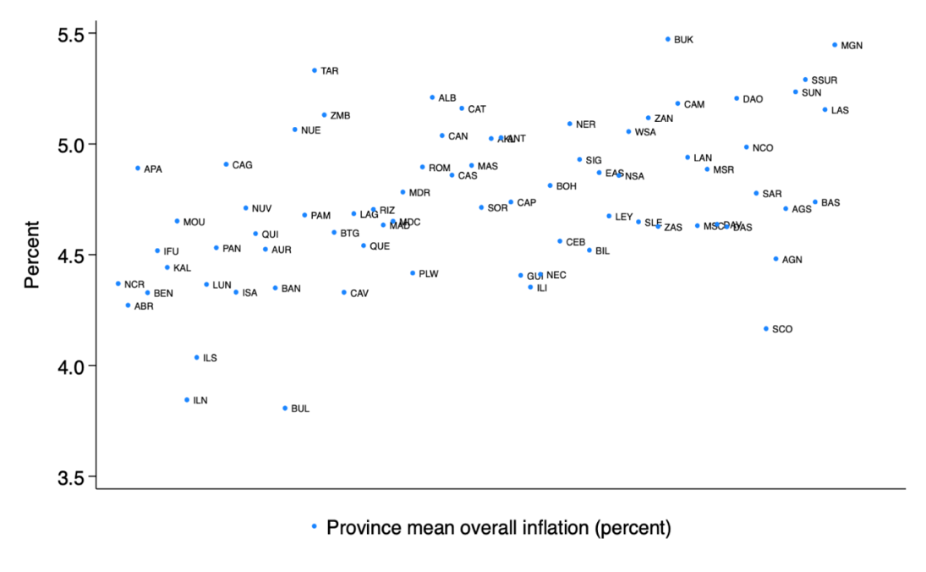

Source of raw data: Philippine Statistics Authority.

3.3 International comparison data

To go beyond the panel quantile regression outlined above, we offer an international comparison of the estimated impact of rice or fuel prices and remittances on overall inflation for the Philippines with matching estimates from India, Indonesia, and Thailand. Three motivations underlie this comparison. First, doing so will provide a better understanding of the sub-national dynamics of the overall inflation in major rice importers such as the Philippines and Indonesia and large rice exporters such as India and Thailand. We use a sample period from January 2015 to April 2024 to estimate each country's quantile panel regression model. The availability of consistent provincial or state-level data dictates the choice of sample period. We consider a sample of 34 provinces in Indonesia and 74 in Thailand. Indonesian data came from its national statistical agency called Badan Pusat Statistik. Data for Thailand were sourced from the Bank of Thailand. For India, we perform our quantile panel estimation for a sample of 30 states, with data collected from the private database called Dataful.

Second, inflation targeting has been in place in those countries, with Thailand adopting it in May 2000, the Philippines in January 2002, Indonesia in July 2005, and India in May 2016. Third, we select those countries to represent the broader set of emerging markets with large values of remittances in terms of dollar amount, as reported in Table 2. Regarding remittance data for India, Indonesia, and Thailand, we employ a similar approach to the one considered for the Philippines in terms of using sub-national annual population data as a proxy to estimate the shares of remittances across provinces or states. We also apply Silva and Cardoso's (2001) approach in interpolating annual population data into monthly frequency.

Table 2: Size of remittance inflows in 2023

Country | Value (USD billion) | Share of GDP (%)
India | 119.5 | 3.4
Indonesia | 14.5 | 1.1
Philippines | 39.1 | 8.9
Thailand | 9.6 | 1.9
Mean | 45.7 | 3.8
Aggregate | 182.7
Source: World Bank (2023).

4. Empirical results

This section discusses the fixed effect quantile regression results. Our aim is to examine whether changes in fuel prices, rice prices, and remittances constitute a factor that helps explain the dynamic behavior of overall inflation rates across provinces.

4.1 Fixed effects quantile regression results

Figure 3 displays the baseline results of estimating equation (3) based on the entire sample, along with the comparison of sub-sample estimates before and after the implementation of inflation targeting and the rice tariffication policy. The black solid line in Figure 3 refers to the point estimate, while the gray shaded areas indicate the 95% confidence interval. Table 3 reports the full results which also include the estimated coefficients for the lagged values of the three explanatory variables and overall inflation.

As shown in Figure 3a, an important finding from applying the fixed effects quantile regression model is the clear positive relationship between overall inflation and rice or fuel price inflation. The positive impact of rice prices is significant across all quantiles, while it is only significant at higher quantiles in the case of fuel prices. In terms of the short-run effect, we estimate that a 1% increase in rice prices corresponds to a 0.15% increase in overall inflation at the lowest and 0.16% at the highest quantiles. Where the short-run effect of fuel prices is significant, the results show that a 1% rise in fuel prices generates a 0.01% increase in overall inflation at $τ=0.8$ and $τ=0.9$. Those findings suggest that the effects of rice and fuel prices tend to increase at higher quantiles. When inflation is higher, the impact of rice and fuel prices is also higher. Yet it is important to note that overlapping confidence intervals can be seen for both estimates using the entire sample and sub-sample periods. For example, the short-run effect estimates for $β_{1,τ}$ and $β_{2,τ}$ rise with $τ$ in the cases of rice and fuel price inflation, but the upper part of their $τ=0.1$ confidence interval fits inside the $τ=0.9$ confidence band. This suggests that there is no discernable variation in the increasing short-run effects of rice or fuel price inflation between the lower and upper quantiles.

However, an insightful finding emerges from estimates for the long-run effect which lend quantitative support to the tendency that the increase in sensitivity to the impact of rice or fuel prices remains at the higher quantiles. In particular, plugging the short-run impact estimates and relevant coefficients for the lagged values of rice prices and overall inflation into equation (4) outlined in Section 3.1, the long-run effect is estimated at 0.1040 for $τ=0.1$ and 0.2857 $τ=0.9$. The increase in sensitivity of the impact of fuel prices is also pronounced at the higher quantiles with a long-run effect of 0.0617 for $τ=0.10$ compared to 0.4762 for $τ=0.9$.

The results also align with recent studies on emerging economies that highlight the role of rising food prices in both current and future inflation through expectations and wage negotiations (Pourroy et al., 2016). Using the quantile regression method, Iddrisu and Alagidede (2020) found that a 1% increase in world food prices raises domestic food prices in South Africa by 0.03% at the higher quantile. Similarly, Abbas and Lan (2020) used the self-exciting threshold autoregressive model and found that a 1% rise in food prices leads to a 0.04% and 0.10% inflation increase in the low-inflation regimes in China and Pakistan, respectively.

Overall, the empirical results align with evidence suggesting that modeling asymmetries and/or thicker tails in the distribution of inflation in the analysis of food and energy prices plays an important role in understanding the dynamics of inflation and commodity prices (Abbas & Lan, 2020; Choi et al., 2018; Ge & Sun, 2024; Iddrisu & Alagidede, 2021).

Existing studies offer a comparable estimate of the energy price effect on inflation. Iddrisu and Alagidede (2021) used wavelet-based quantile regression for South African provinces and showed that a 1% increase in transportation cost—reflecting fuel price changes and goods movement costs—raises overall inflation in the Gauteng province by 0.02–0.04%. Our estimate aligns with Abbas and Lan (2020), who reported that a 1.0% rise in energy prices increases inflation in China, India, and Pakistan by 0.01–0.50% under high-inflation regimes.

Our findings are also consistent with Grundler (2024), who showed that the pass-through of gasoline price shocks to inflation depends on the inflation level. For example, it might be harder for firms to predict a future price level when inflation is close to the central bank's target. In such cases, gasoline price shocks provide an incentive for firms to consider larger price adjustments as a hedge against a scenario where they are forced to sell below their marginal costs, in line with the precautionary pricing mechanism (Born & Pfeifer, 2021).

One can consider theoretical reasons behind our key finding that increasing rice and gasoline prices have a greater impact during times of higher overall inflation. The starting insights can be drawn from the time-dependent price-setting models proposed by Calvo (1983) and Taylor (2000). In these models, firms adjust their prices at fixed intervals, irrespective of current economic conditions. In the Calvo model, it posits that only a fraction of firms can adjust their prices at any given time, leading to differing degrees of price flexibility across the economy. In high inflation scenarios, those firms that can adjust their prices are likely to do so more swiftly in response to rising costs, which can exacerbate inflation. In contrast, Taylor's (2000)’s model also employed a time-dependent framework, where firms adjust prices at pre-determined intervals. According to Taylor (2000), firms tend to pass on their costs to consumer prices in an inflationary environment. However, it does not account for the randomness of which firms can change prices in any given period, potentially resulting in rigidities that prevent immediate responses to changes in costs or demand. Devereux and Siu (2007) also suggested that firms are more averse to underpricing than overpricing. In this case, firms strongly pass through higher costs to prices when they expect high inflation (Banerjee et al., 2024).

Figure 3: Fixed effects quantile regression results for the whole sample during inflation targeting and rice tariffication periods

 | (a) Baseline results |  | (b) Inflation targeting |  |  | (c) Rice tariffication
 | Whole sample period |  | Before | After |  | Before | After
Rice | 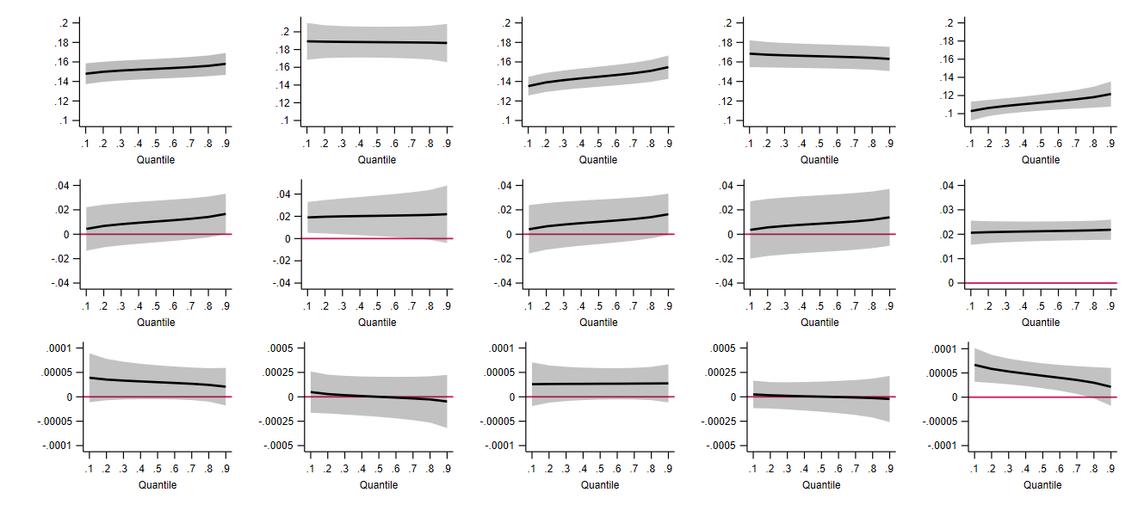
Fuel
Remittance

Note: Gray shaded area is the 95% confidence interval around the point estimates.
Table 3: Estimated fixed effects quantile regression results for the whole sample period

 |  | τ
Variables | OLS | 0.1 | 0.2 | 0.3 | 0.4 | 0.5 | 0.6 | 0.7 | 0.8 | 0.9
Rice price inflation | 0.1530*** | 0.1479*** | 0.1499*** | 0.1511*** | 0.1521*** | 0.1529*** | 0.1538*** | 0.1548*** | 0.1560*** | 0.1580***
 | (0.000) | (0.000) | (0.000) | (0.000) | (0.000) | (0.000) | (0.000) | (0.000) | (0.000) | (0.000)
Fuel price inflation | 0.0105*** | 0.0044 | 0.0068 | 0.0083 | 0.0094 | 0.0105 | 0.0115 | 0.0127 | 0.0142* | 0.0167**
 | (0.000) | (0.631) | (0.446) | (0.349) | (0.282) | (0.229) | (0.183) | (0.139) | (0.096) | (0.049)
Changes in remittances | 0.00003* | 0.00004 | 0.00003 | 0.00003* | 0.00003* | 0.00003* | 0.00003* | 0.00003 | 0.00002 | 0.00002
 | (0.070) | (0.127) | (0.102) | (0.092) | (0.088) | (0.090) | (0.098) | (0.117) | (0.162) | (0.289)
Rice price inflation (t-1) | -0.1432** | -0.1324*** | -0.1365*** | -0.1390*** | -0.1409*** | -0.1427*** | -0.1445*** | -0.1465*** | -0.1490*** | -0.1532***
 | (0.040) | (0.000) | (0.000) | (0.000) | (0.000) | (0.000) | (0.000) | (0.000) | (0.000) | (0.000)
Fuel price inflation (t-1) | -0.0021*** | 0.0048 | 0.0021 | 0.0005 | -0.0007 | -0.0019 | -0.0030 | -0.0043 | -0.0060 | -0.0087
 | (0.000) | (0.531) | (0.783) | (0.947) | (0.926) | (0.813) | (0.706) | (0.595) | (0.472) | (0.312)
Changes in remittances (t-1) | 0.0001*** | 0.0000 | 0.0000 | 0.0000 | 0.0000* | 0.0001** | 0.0001*** | 0.0001*** | 0.0001*** | 0.0001***
 | (0.000) | (0.866) | (0.480) | (0.182) | (0.062) | (0.018) | (0.004) | (0.001) | (0.000) | (0.000)
Overall inflation (t-1) | 0.9191*** | 0.8509*** | 0.8772*** | 0.8930*** | 0.9053*** | 0.9166*** | 0.9279*** | 0.9407*** | 0.9567*** | 0.9832***
 | (0.000) | (0.000) | (0.000) | (0.000) | (0.000) | (0.000) | (0.000) | (0.000) | (0.000) | (0.000)
Constant | 0.2292***
 | (0.000)
Observations | 24,568 | 24,568 | 24,568 | 24,568 | 24,568 | 24,568 | 24,568 | 24,568 | 24,568 | 24,568
R-squared | 0.909
Notes: ***, **, and * denote significance at the 1%, 5%, and 10% levels. Figures in parentheses are p-values. OLS is Ordinary Least Squares.

Golosov and Lucas (2007) offer a state-dependent approach which suggests that firms adjust their prices based on prevailing economic conditions, particularly in response to rising input costs and inflationary pressures. Their menu costs framework suggests that while firms may exhibit price rigidity, the urgency to adjust prices in high inflation contexts often outweighs their reluctance to change prices frequently. Devereux and Siu (2007) added to this discussion by suggesting that firms are more averse to underpricing than over-pricing goods. In this case, firms strongly pass higher costs to prices when they expect high inflation (Banerjee et al. 2024). By building on the work of Golosov and Lucas (2007), Gagnon (2009) showed that the relationship between aggregate inflation and average price adjustment frequencies becomes more evidednt during periods of elevated inflation (Benedict, Crucini, and Landry 2020).

Costain and Nakov (2011) refined this discussion through the analysis of different pricing mechanisms within a New Keynesian framework. Contrasting the Calvo model with more flexible pricing strategies and emphasizing the role of cost control, Costain and Nakov (2011) noted that firms with lower control costs are better positioned to adjust their prices in response to inflationary pressures. They explain that effectively managing the costs allows firms to be more agile in pricing decisions and facilitates quicker adjustments to rising input costs and inflation.

Given these economic rationales, our empirical results may suggest that when inflation is higher, firms adjust their prices more quickly, increasing the tendency for them to pass on rice and gasoline price increases. In other words, higher inflation prompts larger price responses from firms that are able to adjust their prices within each period.

Meanwhile, we also analyzed the effect of remittances. Figure 3-a shows that remittances generate an increase in overall inflation between the 20th and 60th quantiles. This finding is consistent with economic theory. When expatriates remit large inflows of foreign exchange to their home country, its conversion into domestic currency raises the money supply. If these funds are not channeled into productive sectors or capital investments, they contribute to consumption expenditure, increasing inflation (Narayan, Narayan, & Mishra, 2011). Remittances also boost real wealth, which further stimulates consumption expenditure. This creates short-run excess demand, increasing the price level.

However, the relationship between remittances and inflation is not uniform. Rivera and Tullao (2020) suggested that remittance inflows are not necessarily inflationary. If these inflows are directed toward savings, investment, or sectors with sufficient supply-side capacity, the inflationary effects may be dampened or even negligible. This highlights the importance of how remittances are absorbed in the economy. Furthermore, Lartey (2016) provided a contrasting finding, which shows that remittances have minimal impact on the Philippine CPI under an inflation-targeting regime, with little to no variation in non-tradeable inflation observed in non-tradeable inflation.

4.2 Importance of inflation targeting and the rice tariffication policy

We now analyze the fixed effects quantile regression model of inflation, moving from broader to policy-specific perspectives. In this section, we focus on the impact of rice and fuel prices on overall inflation under inflation targeting and the rice tariffication policy. These policies may have influenced the dynamics of inflation in distinct ways. For example, inflation targeting plays a crucial role in shaping the inflation process by anchoring inflation expectations, which is the most important aim of central banks. McKnight, Mihailov, and Rangel (2020) pointed out its significance, noting that the difference between inflation expectations and the inflation target may be viewed as a measure of the central bank’s overall credibility. On the other hand, the importance of the rice tariffication policy for the Philippine inflation process works through its strength in raising domestic rice supply through international trade. By enhancing private-sector participation and reducing government intervention, rice tariffication facilitates rice imports, which can lower domestic prices to align with world levels, ultimately benefiting consumers.

We considered subsample periods corresponding to inflation targeting and the rice tariffication policy. In particular, we analyzed subsample periods before and after the implementation of inflation targeting, covering August 1995 to December 2001 and January 2002 to April 2024, respectively. For the rice tariffication policy, we analyzed two subsample periods: August 1995 to February 2019 and March 2019 to February 2024.

Comparing the results from the three panels in Figure 3 shows the following observations: First, the fixed effects quantile regression continues to indicate that the impact of rice prices is positive and significant across all quantiles, both before and after the inflation targeting and rice tariffication periods. Notably, the impact of rice price inflation is smaller in periods following the implementation of these policies. In the case of fuel price inflation, Figures 3-b and 3-c indicate that the estimated coefficients are positive and significant at the lower quantiles before the inflation targeting regime and across all quantiles after the rice tariffication policy. Second, the stronger effect of rice and fuel price inflation on overall inflation at higher quantiles remains in the post-inflation targeting and post-rice tariffication policy periods.

4.3 Analysis of variation across provinces

We extended the analysis to a subsample of provinces to uncover variations in the impact of the rice tariffication policy for different poverty and rice self-sufficiency levels. Specifically, we estimated equation (3) for (a) low- and high-poverty provinces and (b) rice-surplus and -deficit provinces. This analysis could provide insights that may help shape policies addressing poverty and food insecurity.

To classify provinces by poverty level, we calculated the average national incidence of poverty from the Family Income and Expenditure Survey (FIES) for 2015, 2018, and 2021. The FIES is a nationally representative survey conducted by the PSA, covering approximately 41,000 households. Complete details of provincial poverty incidence are presented in Appendix Table 1-A. Figure 4 displays the average provincial poverty incidence over the 2015–2021 period. Provinces with poverty incidence of below 10%, 10-20% and above 20% were categorized as low, medium and high poverty, respectively.

In grouping rice-surplus and -deficit provinces, we followed Balié, Minot, and Valera (2021), who applied Deaton's (1989)’s net benefit ratio (NBR) analysis using the 2015 FIES data to classify regions into net sellers or net buyers. We extended their analysis by calculating rice self-sufficiency levels across provinces based on average rice production share, rice consumption share, and the NBR. These indicators are calculated using Deaton's (1989)’s formulation of the NBR:

$$\frac{CV}{Y}=\left(q-s\right)\hat{p}$$

where $CV$ is the compensating variation measure of welfare, $Y$ denotes household income or expenditure, $q$ is the value of rice production as a share of expenditure, $s$ is the share of total expenditure spent on rice, $\hat{p}$ is the proportional change in rice prices, and the term $(q-s)$ is the NBR. The NBR measures the short-term elasticity of household welfare in terms of the price of rice. A positive NBR indicates that a household is a net seller of rice, whereas a negative NBR suggests it is a net buyer.
Figure 4 and Appendix Table 1-A present the NBR by province. Only 11 out of 74 provinces had a positive NBR, indicating they were surplus rice producers or net sellers. The top three NBRs were obtained by the provinces of Kalinga (KAL) with 0.168, Cagayan (CAG) with 0.144, and Isabela (ISA) with 0.099. These findings align with expectations, as these provinces are considered the rice granaries of the Philippines.
Figure 4: Incidence of poverty and rice net benefit ratio by province

(a) Poverty incidence

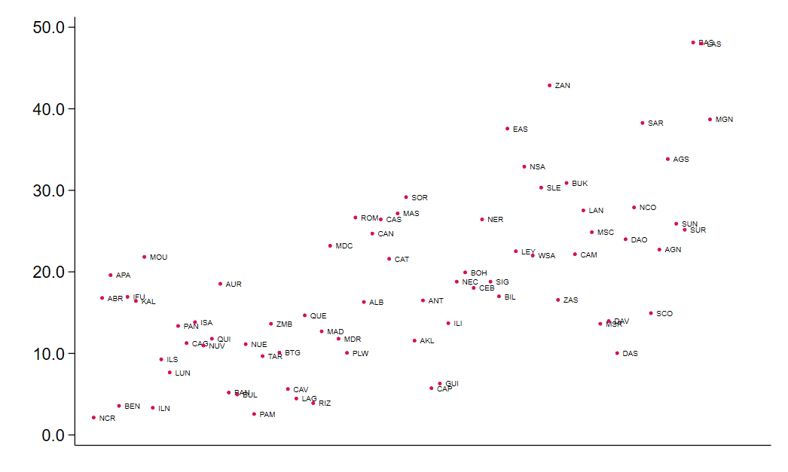

(b) Net benefit ratio

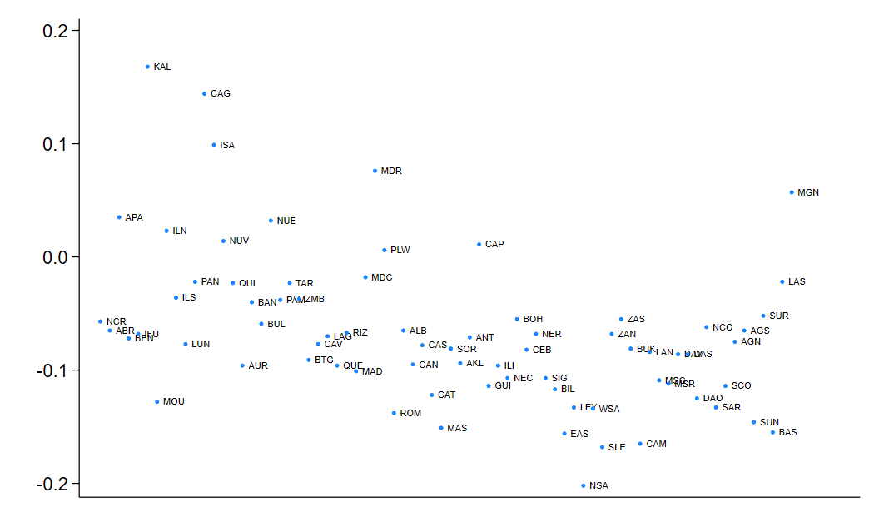
Source: Authors' work based on the analysis of data from the 2015 FIES.

In Figure 5, we present the quantile plots of the rice price inflation variable across the different categories of provinces. The plots present the coefficients at various quantiles, along with their respective confidence intervals. We observed that the rice price inflation variable still shows many instances of significance after the adoption of inflation targeting for the low- and high-poverty provinces. However, the impact of rice price inflation is much higher for high-poverty provinces than in the low-poverty group. This aligns with the findings of Valera, Balié, and Magrini (2022) on regional inflation in the Philippines. Meanwhile, the impact of rice price inflation is lower in rice-deficit provinces than in rice-surplus areas.

Building on these findings, we provide additional insights into the idea that the prices of some goods are more salient than others when it comes to forming inflation expectations. For this purpose, we organized consumer inflation expectations across provinces using data from the Consumer Expectations Survey (CES) conducted by the BSP's Department of Economic Statistics. The BSP conducts the CES on a quarterly basis with about 5,000 respondents from 52 provinces being asked about their demographic characteristics and expectations on inflation and other macroeconomic variables. In particular, we constructed the following quarterly data on one-year ahead inflation expectations across households from Q2 2014 to Q2 2024 and took the average for each province as follows:
$$E_{i}π_{it}^{e}=\frac{1}{N_{t}}\sum_{i=1}^{N_{t}^{*}}{π_{t}^{e}\left(i\right),}$$

where $E_{i}π_{it}^{e}$ refers to the empirical cross-sectional means of individual inflation expectations in period t, $π_{t}^{e}\left(i\right)$ is the 12-month ahead inflation expectation of individual i who was surveyed in period t, and $N_{t}$ is the total number of respondents in the relevant period. We constructed the cross-sectional means of inflation expectations for each of the 48 provinces included in the CES. We then matched the average for each province with secondary provincial data on rice and gasoline or diesel prices.

Figure 6 displays the correlation between $E_{i}π_{it}^{e}$ and the prices of those three commodities for each province. The results show that inflation expectations are positively and significantly correlated with rice and fuel prices in most provinces. This finding supports existing studies that highlight the role of food and gasoline prices in determining household inflation expectations due to their salience (Berge, 2018; Binder, 2018; Coibion & Gorodnichenko, 2015; Geiger & Scharler, 2019; Kikuchi & Nakazono, 2023).

4.4 Do prices diverge across provinces?

We uncovered an important finding: When inflation is higher or lower, increases in rice and fuel prices are a bigger or smaller contributor to inflation, respectively. However, the heterogeneous prices observed across our sample provinces do not necessarily imply that prices cannot diverge without limits across geographical areas. There could still be divergences in volatility in the short run, even if long-run convergence is confirmed.

Whether prices diverge across provinces remains an empirical question. We address this in the ensuing discussion using a suitable test for panel convergence comprising provincial-national inflation differential. To examine this, we implemented the cross-sectionally augmented Im–Pesaran–Shin (CIPS) test proposed by Pesaran (2007), a widely used panel unit root test in the literature. The CIPS statistic is based on augmented Dickey-Fuller (ADF)-type regressions augmented with cross-section averages and performed separately for each series in the panel:
Figure 5: Fixed effects quantile regression results by poverty and rice sufficiency levels before and after rice tariffication

 | Before rice tariffication | After rice tariffication
 | (a) Poverty levels
Low poverty | 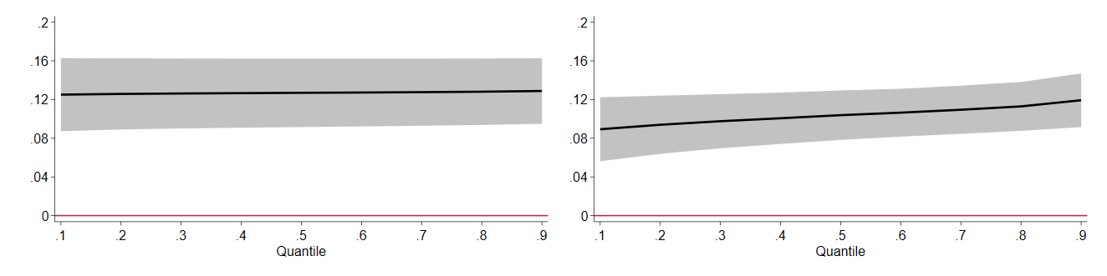
Medium poverty | 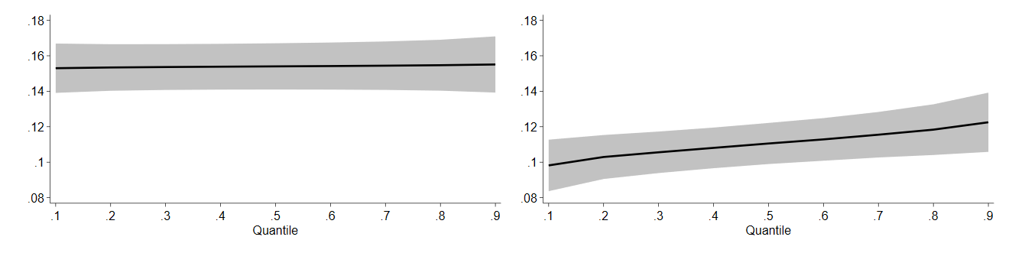
High poverty | 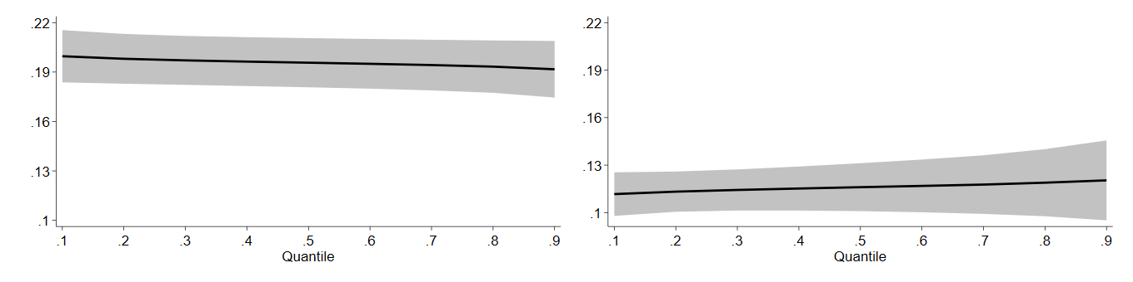
 | (b) Rice self-sufficiency levels
Rice surplus | 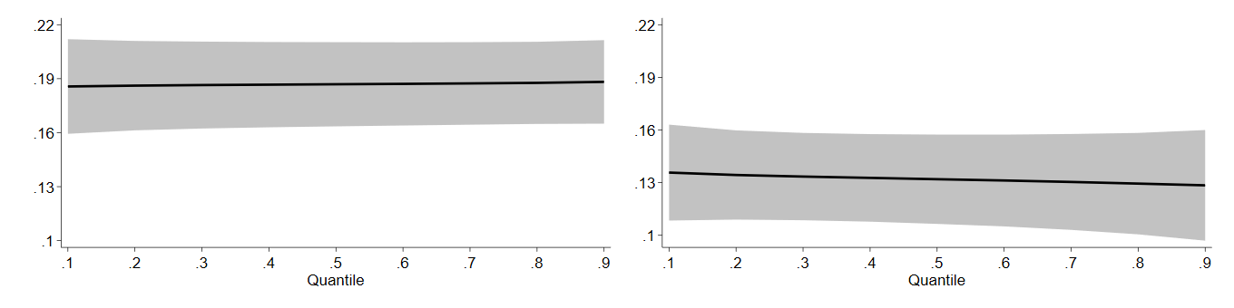
Rice deficit | 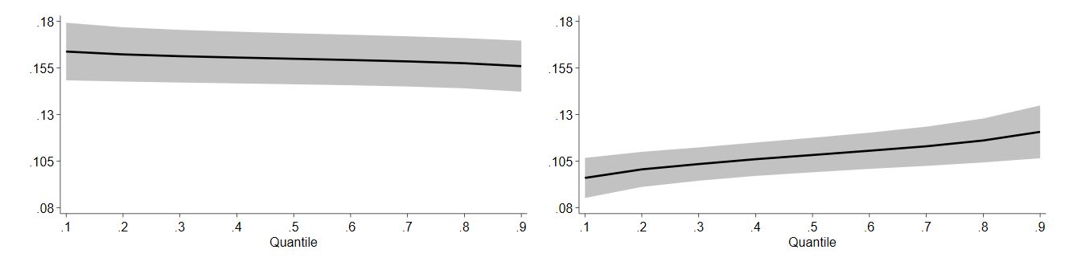
Note: Gray shaded area is the 95% confidence interval around the point estimates.

Figure 6: Province correlation of consumer inflation expectations and rice or fuel prices

(a) Rice price

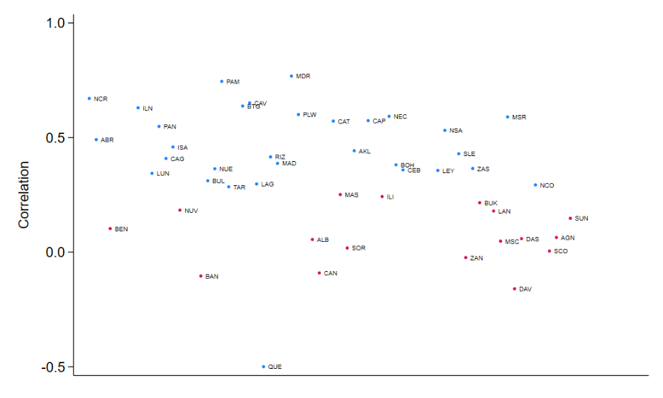
(b) Gasoline price

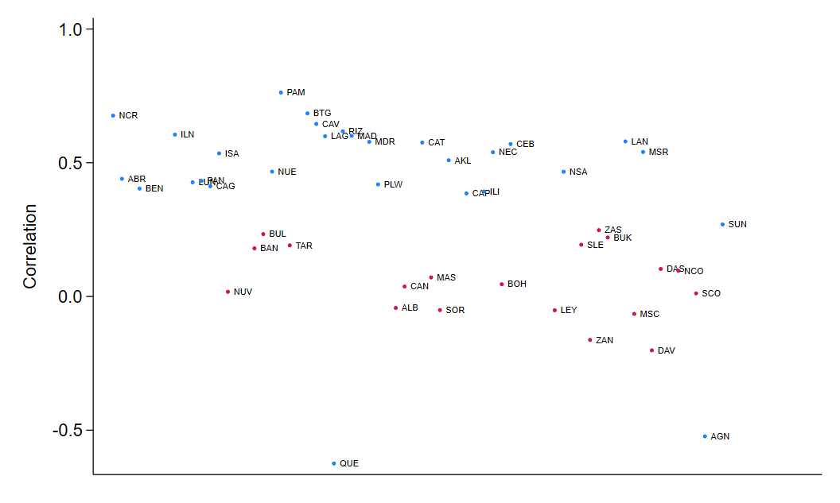
(c) Diesel price

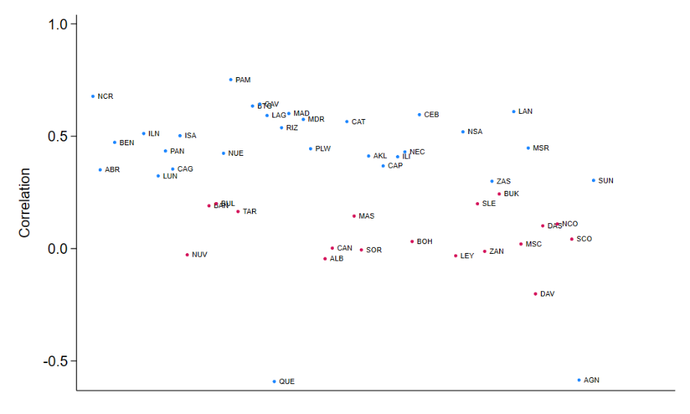

Source: Authors' work based on analysis of data from the 2014–2024 CES.
Note: The blue round dots are statistically significant.
$$Δy_{it}=a_{i}+b_{i}y_{i,t-1}+\sum_{r=0}^{p_{i}}{c_{ir}Δy_{i,t-r}+d_{i}{\overline{y}}_{t-1}}\sum_{r=0}^{p_{i}}{f_{ir}Δ{\overline{y}}_{i,t-r}+ξ_{it}}$$

where $y_{it}$ represents the provincial-national inflation differential; $Δ$ is the difference operator$; {\overline{y}}_{t}=N^{-1}\sum_{i=1}^{N}{y_{it}}$is the cross-section average of $y_{it}$, which accounts for cross-sectional dependence; $ξ_{it}$ is the effort term; $i=1,…,74$ provinces; and $T=1,…,342$ time observations.

The CIPS test statistic is computed as:

$$CIPS=N^{-1}\sum_{i=1}^{N}{t_{i}}$$

where $t_{i}$ is the ADF statistic based on the regression t-statistic for testing $H_{0}: b_{i}=0$ in equation (7). The CIPS statistic tests the joint null hypothesis of a unit root against the alternative of at least one stationary series in the panel.

For comparison, we also implemented the Im–Pesaran–Shin (IPS) panel unit root test (Im et al., 2003) and the general diagnostic test for cross-sectional dependence (CD) in panels, known as the CD statistic (Pesaran, 2021).

The results of the IPS, CD, and CIPS tests are reported in Table 4. The IPS test rejects the joint null hypothesis of a unit root, suggesting that the panel of provincial-national inflation differential can be treated as stationary. The CD and CIPS tests similarly reject the null hypothesis of joint non-stationarity in favor of the alternative. These findings support the convergence of prices across provinces.

Table 4: Panel convergence test

Panel unit root tests | Test statistic | p-value
IPS test (Im, Pesaran & Shin, 2003) | -31.47 | (0.000)
CD test (Pesaran, 2021) | 23.25 | (0.000)
CIPS test (Pesaran, 2007) | -4.47 | (0.000)
Notes: Lag lengths are determined by the Akaike information criterion. Figures in parentheses are p-values.

The above findings are somewhat in contrast to the existing literature suggesting that within-country price convergence is limited to some extent in Japan (Ikeno, 2014; Nagayasu, 2011), and the United States (Christou et al., 2018). However, this supports the idea that price adjustments across different locations within a country eventually converges to the national level. Similarly, Nath and Sarkar (2014) conform to the purchasing power parity (PPP) hypothesis with evidence of convergence in relative prices in Australian cities. This finding corroborates our panel quantile regression estimates.

4.5 Further analyses and robustness tests
In this section, we conduct further analyses to scrutinize the impact of rice and fuel prices on overall inflation and assess the sensitivity of our results across different subsample periods, alternative model specifications, and data frequencies.

4.5.1 Unknown breaks in general inflation

Comparisons of inflation targeting and rice tariffication before and after implementation may be influenced by other time-varying factors, particularly the share of household budgets going toward these items and the infrastructure for cross-province transportation and marketing of rice. This raises the question: Would dividing the sample at randomly selected years yield similar before or after results?

To answer this, we refined our analysis to identify structural changes by specific year. We used the panel test proposed by Ditzen et al. (2021), which is based on an F-test and a null hypothesis of no breakpoints.

The results reported in Table 5 were investigated for breaks in general price. We used the following breaks in defining our subsample periods: (a) August 1996 to July 2000, (b) September 2000 to April 2005, (c) June 2005 to May 2009, (d) July 2009 to May 2015, (e) July 2015 to February 2020, and (f) April 2020 to April 2024.

Table 5: Bai and Perron (2002) breakpoint dates

 |  |  | Critical values
Breaks | Test statistic |  | 1% | 5% | 10%
F(1|0) | 6.21 |  | 12.29 | 8.58 | 7.04
F(2|1) | 67.48 |  | 13.89 | 10.13 | 8.51
F(3|2) | 98.5 |  | 14.80 | 11.14 | 9.41
F(4|3) | 91.18 |  | 15.28 | 11.83 | 10.04
F(5|4) | 93.47 |  | 15.76 | 12.25 | 10.58
Unknown breaks: | 2000m8, 2005m5, 2009m6, 2015m6, 2020m3
Notes: Test statistics and critical values are based on Ditzen et al. (2021) sequential tests for multiple breaks at unknown breakpoints.

The results shown in Figure 7 are based on the estimation of fixed effects quantile regression in equation (3). It suggests that there is no significant change in either the direction or the magnitude of rice and fuel price inflation on overall inflation after taking into consideration different subsample periods. In other words, the subsample results are largely consistent with the full sample estimates, with the nonlinear impact of rice and fuel prices on overall inflation mostly similar across periods. The noticeable exception is fuel prices' positive and significant effect across quantiles for the four sub-sample periods between June 2005 and April 2024.

Regarding remittances, their significant positive impact on overall inflation is evident for the April 2020 to April 2024 sub-sample period. However, we also note that remittances have a zero slope inside the confidence interval across quantiles in most of the other sub-sample periods. Remittances shows a negative and significant effect on inflation across all quantiles for June 2005 to May 2009 sub-sample. Valera, Balié, and Magrini (2022) interpreted such a negative effect as reflecting whether the central bank offsets or sterilizes remittances to prevent inflation.

Figure 7: Fixed effects quantile regression results for different subsample periods
 | 1996m8-2000m7 | 2000m9-2005m4 | 2005m6-2009m5 | 2009m7-2015m5 | 2015m7-2020m2 | 2020m4-2024m4
Rice | 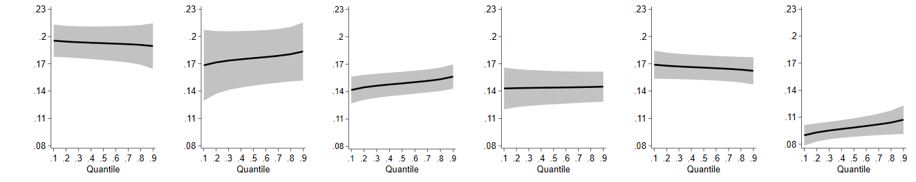
Fuel | 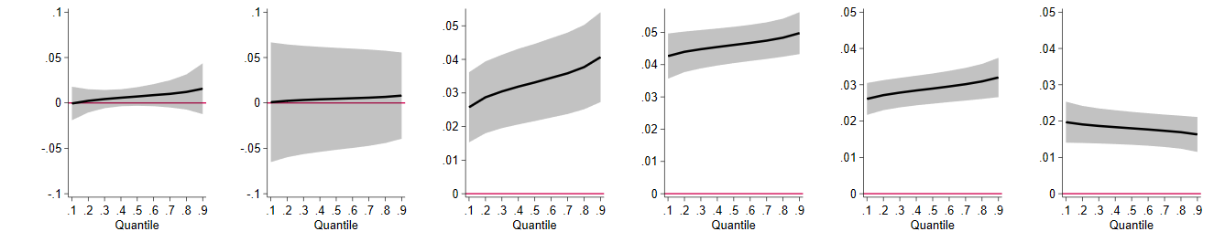
Remittance | 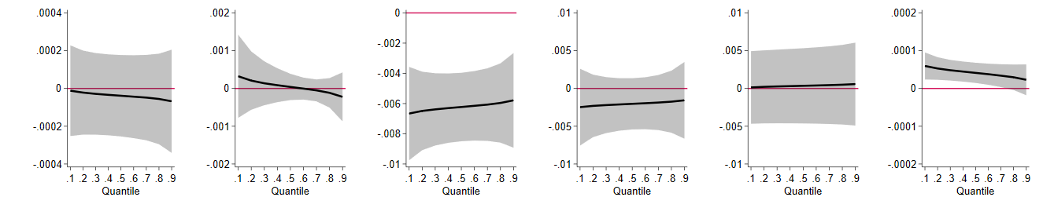
Note: Gray shaded area is the 95% confidence interval around the point estimates.
4.5.2 Alternative measures of rice surplus and deficit

Recall that our earlier calculation of the rice self-sufficiency levels across provinces relies on the NBR ratio in equation (5). One limitation of this measure is that the average rice production share and rice consumption share data are available for one period only based on the 2015 FIES. Thus, this approach does not consider the possibility that some rice deficit provinces in 2015 have transformed into rice surplus after a few years.

To resolve this issue, we create an indicative measure of rice self-sufficiency that offers another way of grouping rice surplus and deficit provinces using 2023 data. Following Clapp (2017), the self-sufficiency ratio ssr at the national level can be expressed more formally with a simple mathematical model:
$$ssr =\frac{vp}{vp+m-x}$$

where vp denotes the domestic volume of milled rice production, m denotes imports, and x denotes exports. An ssr of one indicates that the country is self-sufficient. An ssr lesser and greater than one indicates deficiency and surplus, respectively.

Analogous to equation (9), a provincial self-sufficiency indicator using 2023 data can be created based on the following procedures. First, the per capita rice availability is computed from the paddy production data, which were converted to milled rice equivalent using an appropriate milling recovery rate. The total milled rice equivalent in kilograms was divided by the projected population in 2023 to calculate the per capita rice availability. Second, we estimate the provincial per capita rice utilization to have a basis for comparing the provincial per capita rice availability in creating the rice self-sufficiency index per province. The provincial per capita rice use is estimated by dividing the 2023 per capita rice consumption with 0.9 because food use comprises only 90% of the total rice use. The data required for ssr's calculation are obtained from the PSA.

Accordingly, we calculate a provincial self-sufficiency index by dividing the per capita rice availability with the estimated per capita rice use. The resulting index was then used to identify a new set of deficit provinces with an ssr range of 0.00 – 0.99 and surplus provinces with an ssr of > 1.00. The estimates generated based on these rice self-sufficiency measures confirm the results displayed in Figure 5. Results for the ssr indices by province and quantile regression are not reported here to conserve space, but these are available upon request.

4.5.3 Alternative model specifications and quarterly frequency

We consider three alternative model specifications in the next set of robustness tests. First, we address the reverse causality issue by using up to four lags of rice prices, fuel prices, remittances, and overall inflation. Results of the Dumitrescu-Hurlin (2012) panel causality test in Table 6 indicate that overall inflation Granger causes rice and fuel prices. Second, we include the Thailand 5% broken rice export prices to reduce concerns about omitted variables. The third approach is to check whether a model different from fixed effects quantile regression leads to the same conclusions about the influence of drivers of inflation. We use the simultaneous quantile regression (SQR) model. Li and Wu (2011) explained that the SQR model produces better estimates for multiple quantiles simultaneously compared to individually generated quantile functions. Figure 8 displays that the estimates obtained using
Figure 8: Alternative model specifications and quarterly data frequency

 | Rice price | Fuel price | Remittance
(a) Four lags | 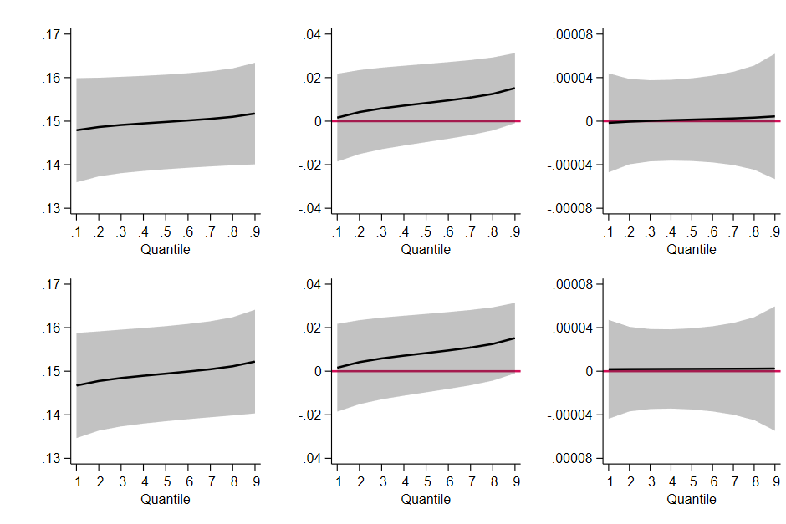
(b) Global rice price shock
(c) Simultaneous quantile regression | 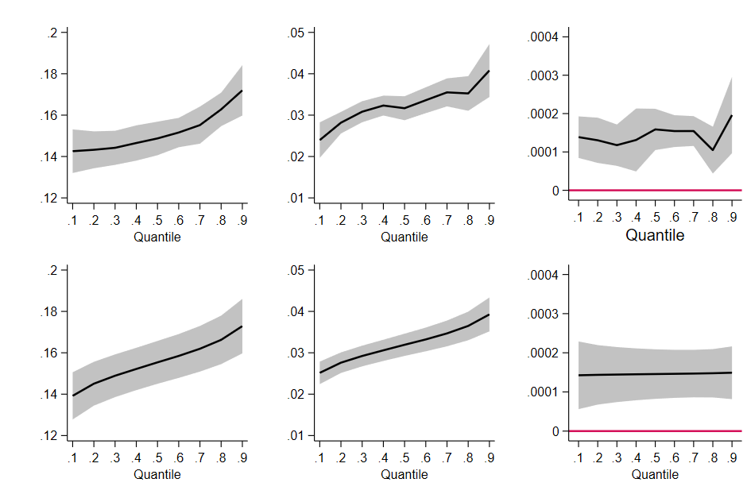
(d) Quarterly frequency
Note: Gray shaded area is the 95% confidence interval around the point estimates.

these three specifications are similar to those obtained using the fixed effects quantile regression, confirming the validity of the baseline results.

Our next set of robustness test tests deals with data frequency. Thus far, we have utilized monthly data and showed that rising rice and fuel prices have a greater impact when overall inflation is high. We then checked whether this differentiation is sensitive to quarterly data. The results are shown in Figure 8. Consistent with our findings from monthly data, the inflationary impact of rice and fuel prices remains stronger when overall inflation is higher. Therefore, the main conclusion is that the importance of rice and fuel prices in driving inflation holds regardless of data frequency.

4.6 International comparison with Indonesia, India and Thailand

Figure 9 presents the results of the international comparison of the four emerging markets. Despite differences in sample periods, the results remain consistent with the findings for the Philippines, suggesting a nonlinear impact of rice and fuel prices on overall inflation. The more substantial impact of rice or fuel prices is associated with more significant increases in overall inflation at the higher quantiles than in the lower ones. While the nonlinear impact of remittances remains, it induces more inflation in the lower quantiles than in the upper quantiles.

However, we did observe some differences in impact dynamics across the three countries. The significant positive impact of rice prices on overall inflation was also noticeable for Indonesia and Thailand, but the nonlinear effect in Indonesia mimics that of the Philippines. This is not surprising considering that Indonesia and the Philippines are traditional rice importers, with rice constituting a substantial share of total consumption. The significant positive impact of rice prices on overall inflation in Thailand is rather similar across all quantiles. Rice prices in India displayed a significant positive impact on overall inflation only at the lower quantiles. Notably, the effect of fuel prices on overall inflation is positive and significant across all quantiles for all countries. However, the relatively higher inflationary effect of fuel prices in Indonesia and Thailand.

Turning to remittances, it showed a nonlinear impact on the Philippine overall inflation like the baseline results, with positive and significant being more pronounced in most quantiles. Finally, the remittance effect on overall inflation displays asymmetries for India, Indonesia, and Thailand, where such inflows positively impact inflation in the lower quantiles while negative in the upper quantiles.

5. Conclusion

Understanding the sensitivity of inflation to food and energy prices has been a key challenge faced by policymakers. Economists have usually tackled this question with inflation models using aggregate data that may be uninformative because of the bias from the impact of endogenous monetary policy. This paper asked how our answers to this question become more informative if we jointly account for price heterogeneity and state-dependent effects within a panel setting with data spanning 74 provinces in the Philippines from August 1996 to April 2024. Our analysis shows a significant nonlinearity in the impact of rice and fuel prices on inflation at different inflation states. Notably, a pronounced positive and stronger impact of rice and fuel prices was observed during periods of higher inflation, as confirmed by the fixed effects quantile regression framework. These results suggest that the cost-push effect of rice or fuel price changes across provinces with different economic conditions and sensitivities to monetary policy may play a dominant role in driving inflation during times of higher inflation.

Moreover, we extend our investigation to analyze the consequences of rice tarrification, the monetary policy shift to inflation targeting, and the association with poverty and rice self-sufficiency. Our evaluation shows the important role of rice tariffication and inflation targeting in mitigating the impact effect of rice and fuel prices, both during lower and higher inflation. In light of our findings, it also becomes apparent that a central bank like the Philippines operating within an inflation targeting regime has gained from complementing it with the use of a rice tariffication policy that softened the impact of higher rice price inflation in provinces where poverty is higher, and rice supply is not sufficient.

To gain an insightful angle through an international comparison, we have quantitatively verified the significant nonlinear impact of rice and fuel prices on geographically disaggregated inflation in most cases in Indonesia, Thailand, and India. Finally, we also consider remittances and show that its nonlinear impact on Philippine inflation is positive and significant in most quantiles. In contrast, our analysis demonstrates a significant asymmetry in the impact of remittances on inflation in India, Indonesia, and Thailand. That is, remittance impact on inflation in these three countries is positively (negatively) associated with periods of low (high) inflation.

The findings have potentially significant implications for academic discourse and policy formulation. In particular, our empirical analysis underscores the importance of considering the changing economic conditions and regional sensitivities to monetary and food policies when assessing the impact of rice or fuel prices on inflation across geographical locations of a country. From a policy perspective, it appears that inflation targeting regime has the potential to mitigate inflation in times of high inflation when supported by the coordinated effort from the use of rice tariffication that eased restrictions on rice trade to help lower rice prices and overall inflation. It is noteworthy that there are many cereals that we did not consider in this study. An avenue for future research is to assess the relative impacts of different cereals on the Philippine inflation.

Figure 9: International comparison of fixed effects quantile regression results

 | Rice price | Fuel price | Remittance
Indonesia | 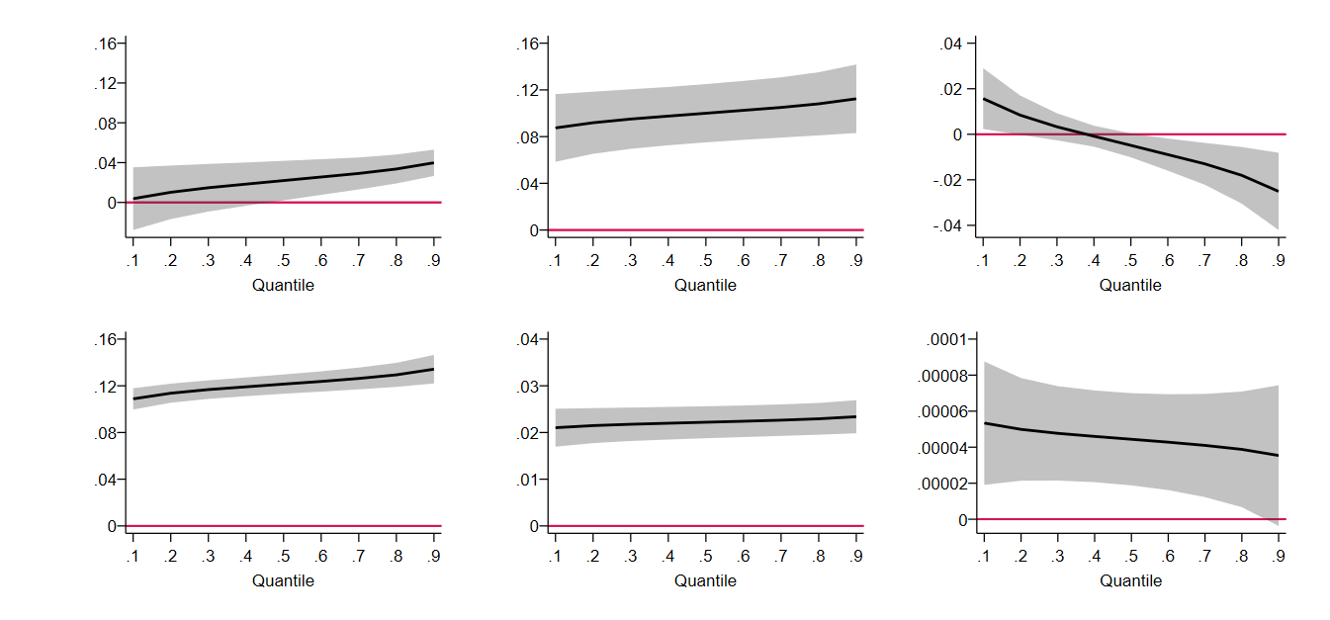
Philippines
India | 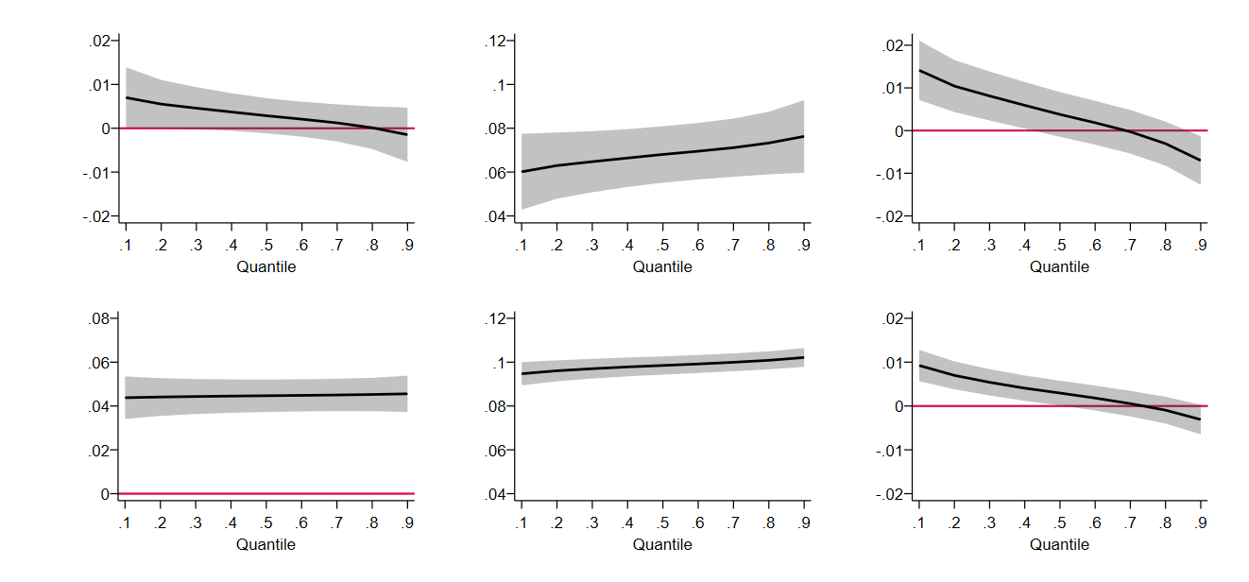
Thailand
Note: Gray shaded area is the 95% confidence interval around the point estimates.

References

Abbas, S. K. & Lan, H. (2020). Commodity price pass-through and inflation regimes. Energy Economics, 92, 104977. https://doi.org/10.1016/j.eneco.2020.104977
Bai, J. & Perron, P. (2002). Computation and analysis of multiple structural change models. Journal of Applied Econometrics, 18(1), 1–22. https://doi.org/10.1002/jae.659
Balié, J., Minot, N., & Valera, H. G. A. (2021). Distributional impacts of the rice tariffication policy in the Philippines. Economic Analysis and Policy, 69, 289–306.
https://doi.org/10.1016/j.eap.2020.12.005
Banerjee, R., Contreras, J., Mehrotra, A., & Zampolli, F. (2024). Inflation at risk in advanced and emerging market economies. Journal of International Money and Finance, 142, 103025. https://doi.org/10.1016/j.jimonfin.2024.103025
Benedict, C., Crucini, M. J., & Landry, A. (2020). On what states do prices depend? Answers from Ecuador. Journal of Money, Credit and Banking, 52(8), 1909–1935.
https://doi.org/10.1111/jmcb.12656
Berge, T. J. (2018). Understanding survey-based inflation expectations. International Journal of Forecasting, 34(4), 788–801. https://doi.org/10.1016/j.ijforecast.2018.07.003
Binder, C. (2018). Inflation expectations and the price at the pump. Journal of Macroeconomics, 58, 1–18. https://doi.org/10.1016/j.jmacro.2018.08.001
Born, B. & Pfeifer, J. (2021). Uncertainty-driven business cycles: Assessing the markup channel. Quantitative Economics, 12(2), 587–623. https://doi.org/10.3982/QE1297
Calvo, G.A. (1983). Staggered prices in a utility-maximizing framework. Journal of Monetary Economics, 12(3), 383–398. https://doi.org/10.1016/0304-3932(83)90060-0
Chiang, S., Lee, C., & Liao, Y. (2021). Exploring the sources of inflation dynamics: New evidence from China. Economic Analysis and Policy, 70, 313–332.
https://doi.org/10.1016/j.eap.2021.03.001
Choi, S., Furceri, D., Loungani, P., Mishra, S. & Poplawski-Ribeiro, M. (2018). Oil prices and inflation dynamics: Evidence from advanced and developing economies. Journal of International Money and Finance, 82, 71-96. https://doi.org/10.1016/j.jimonfin.2017.12.004
Christou, C., Gupta, R., Nyakabawo, W., & Wohar, M. E. (2018). Do house prices hedge inflation in the US? A quantile cointegration approach. International Review of Economics & Finance, 54, 15–26. https://doi.org/10.1016/j.iref.2017.12.012
Clapp, J. (2017). Food self-sufficiency: Making sense of it, and when it makes sense. Food Policy, 66, 88–96. https://doi.org/10.1016/j.foodpol.2016.12.001
Coibion, O., & Gorodnichenko, Y. (2015). Information rigidity and the expectations formation process: A simple framework and new facts. American Economic Review, 105(8), 2644–2678. https://doi.org/10.1257/aer.20130088
Costain, J. & Nakov. A. (2011). Price adjustments in a general model of state-dependent pricing. Journal of Money, Credit and Banking, 43(2-3), 385–406. https://doi.org/10.1111/j.1538-4616.2010.00378.x
Deaton, A. (1989). Rice prices and income distribution in Thailand: A non-parametric analysis. The Economic Journal, 99(395), 1–37. https://doi.org/10.2307/2234068
Devereux, M. B. & Siu, H. E. (2007). State-dependent pricing and business cycle asymmetries. International Economic Review, 48(1), 281–310. https://doi.org/10.1111/j.1468-2354.2007.00324.x
Ditzen, J., Karavias, Y., & Westerlund, J. (2021). Testing and estimating structural breaks in time series and panel data in Stata [Department of Economics, University of Birmingham Discussion Paper No. 21-14]. https://doi.org/10.48550/arXiv.2110.14550
Dumitrescu, E. I. & Hurlin, C. (2012). Testing for Granger non-causality in heterogeneous panels. Economic Modelling, 29(4), 1450–1460. https://doi.org/10.1016/j.econmod.2012.02.014
Fitzgerald, T., Jones, C., Kulish, M. & Nicolini. J. P. (2024). Is there a stable relationship between unemployment and future inflation? American Economic Journal: Macroeconomics, 16(4), 114–142. https://doi.org/10.1257/mac.20220273
Gagnon, E. (2009). Price setting during low and high inflation: Evidence from Mexico. Quarterly Journal of Economics, 124(3), 1221–1263. https://doi.org/10.1162/qjec.2009.124.3.1221
Ge, Z. & Sun, Y. (2024). Asymmetric impact of oil price shocks on inflation: Evidence from quantile-on-quantile regression. International Review of Financial Analysis, 92, 103097. https://doi.org/10.1016/j.irfa.2024.103097
Geiger, M. & Scharler, J. (2019). How do consumers assess the macroeconomic effects of oil price fluctuations? Evidence from US survey data. Journal of Macroeconomics, 62, 103134. https://doi.org/10.1016/j.jinteco.2022.103708
Gerlach, S. & Stuart, R. (2024). Commodity prices and international inflation, 1851–1913. Journal of International Money and Finance, 144, 103097. https://doi.org/10.1016/j.jimonfin.2024.103097
Golosov, M. & Lucas, R. E. (2007). Menu costs and Phillips curves. Journal of Political Economy, 115(1), 171–199. https://doi.org/10.1086/512625
Gründler, D. (2024). Does the inflation pass-through of gasoline price shocks depend on the level of inflation? Economics Letters, 243, 111928. https://doi.org/10.1016/j.econlet.2023.111928
Hwang, I. & Zhu, X. (2024). State-dependent oil price shocks on inflation and the efficacy of inflation targeting regime. Journal of International Money and Finance, 144, 103077. https://doi.org/10.1016/j.jimonfin.2024.103077
Iddrisu, A. & Alagidede, I. P. (2020). Monetary policy and food inflation in South Africa: A quantile regression analysis. Food Policy, 91, 101816. https://doi.org/10.1016/j.foodpol.2019.101816
Iddrisu, A. & Alagidede, I. P. (2021). Heterogeneous provincial prices and monetary policy in South Africa: A wavelet-based quantile regression analysis. Central Bank Review, 21(3), 87–103. https://doi.org/10.1016/j.cbrev.2021.06.001
Ikeno, H. (2014). Long-run analysis on convergence of Japanese local price levels: A pairwise approach. Economic Modelling, 42, 390–397. https://doi.org/10.1016/j.econmod.2014.07.015
Im, K. S., Pesaran, M. H., & Shin, Y. (2003). Testing for unit roots in heterogeneous panels. Journal of Econometrics, 115(1), 53–74. https://doi.org/10.1016/S0304-4076(03)00092-7
Kikuchi, J. & Nakazono. Y. (2023). The formation of inflation expectations: microdata evidence from Japan. Journal of Money, Credit and Banking, 55, (6): 1609–1632. https://doi.org/10.1111/jmcb.13004
Lartey, E. K. K. (2016). A note on remittances, monetary regimes, and nontradable inflation dynamics. Macroeconomic Dynamics, 20(6), 1668–1682. https://doi.org/10.1017/S1365100514001035
Lee, C. C., Yuan, Z. & Lee, C. C. (2023). A nonlinear analysis of the impacts of information and communication technologies on environmental quality: A global perspective. Energy Economics, 128, 107177. https://doi.org/10.1016/j.eneco.2023.107177
Liu, Y. & Wu, Y. (2011). Simultaneous multiple non-crossing quantile regression estimation using kernel constraints. Journal of Non-parametric Statistics, 23(2), 415–437. https://doi.org/10.1080/10485252.2010.537336
Li, H. (2023). The time-varying and volatile macroeconomic effects of immigration. Macroeconomic Dynamics, 27 (1), 72–92. https://doi.org/10.1017/S1365100521000462
Lopez-Salido, D. & Loria, F. (2024). Inflation at risk. Journal of Monetary Economics, 145, 103570. https://doi.org/10.1016/j.jmoneco.2023.103570
Machado, J. A. F. & Santos Silva, J. M. C. (2019). Quantiles via moments. Journal of Econometrics, 213(1), 145–173. https://doi.org/10.1016/j.jeconom.2019.04.009
McKnight, S., Mihailov, A., & Rangel, A. P. (2020). What do Latin American inflation targeters care about? A comparative Bayesian estimation of central bank preferences. Journal of Macroeconomics, 63, 103188. https://doi.org/10.1016/j.jmacro.2019.103188
Molyneux, P., Pancotto, L., Reghezza, A. & d'Acri, C. R. (2022). Interest rate risk and monetary policy normalization in the euro area. Journal of International Money and Finance, 124, 102624. https://doi.org/10.1016/j.jimonfin.2022.102624
Nagayasu, J. (2011). Regional inflation, spatial locations and the Balassa-Samuelson effect: Evidence from Japan. Urban Studies, 54(6), 1482–1499. https://doi.org/10.1177/0042098017705843
Narayan, P. K., Narayan, S., & Mishra, S. (2011). Do remittances induce inflation? Fresh evidence from developing countries. Southern Economic Journal, 77(4), 914-933. https://doi.org/10.4284/0038-4038-77.4.914
Nath, H. K. & Sarkar, J. (2014). City relative price dynamics in Australia: Are structural breaks important? The Economic Record, 90(288), 33–48.
https://doi.org/10.1111/1475-4932.12077
Pesaran, M. H. (2007). A pairwise approach to testing for output and growth convergence. Journal of Econometrics, 138(1), 312–355. https://doi.org/10.1016/j.jeconom.2006.05.024
Pesaran, M. H. (2021). General diagnostic tests for cross-sectional dependence in panels. Empirical economics, 60(1), 13-50. https://doi.org/10.1007/s00181-020-01875-7
Pourroy, M., Carton, B., & Coulibaly, D. (2016). Food prices and inflation targeting in emerging economies. International Economics, 146, 108-140. https://doi.org/10.1016/j.inteco.2015.12.001
Rivera, J. P. R., & Tullao Jr, T. S. (2020). Investigating the link between remittances and inflation: evidence from the Philippines. South East Asia Research, 28(3), 301-326. https://doi.org/10.1080/0967828X.2020.1793685
Sethi, C. & Mishra, B. R. (2024). Is inflation targeting effective? Lessons from global financial crisis and COVID-19 pandemic. International Journal of Finance & Economics. Advance online publication. https://doi.org/10.1002/ijfe.3018
Silva, J. S., & Cardoso, F. N. (2001). The Chow-Lin method using dynamic models. Economic modelling, 18(2), 269-280. https://doi.org/10.1016/S0264-9993(00)00039-0
Taylor, J. B. (2000). Low inflation, pass-through, and the pricing power of firms. European Economic Review, 44(7), 1389-1408. https://doi.org/10.1016/S0014-2921(00)00037-4
Valera, H. G., Balié, J., & Magrini, E. (2022). Is rice price a major source of inflation in the Philippines? A panel data analysis. Applied Economics Letters, 29(16), 1528–1532.
https://doi.org/10.1080/13504851.2021.1946470
Zhang, J., & Malikov, E. (2022). Off-balance sheet activities and scope economies in US banking. Journal of Banking & Finance, 141, 106534. https://doi.org/10.1016/j.jbankfin.2022.106534
Appendix

Table 1-A. Sample Provinces Description, Poverty Incidence, and Rice Self-sufficiency Level

Province |  |  | Incidence of poverty (%) |  |  |  |  | Rice self-sufficiency
Complete name | Abbreviation |  | 2015 | 2018 | 2021 | Mean |  | NBR | Description
National Capital Region | NCR |  | 2.8 | 1.4 | 2.2 | 2.1 |  | -0.057 | Deficit
Abra | ABR |  | 19.9 | 14.7 | 15.8 | 16.8 |  | -0.065 | Deficit
Apayao | APA |  | 38.1 | 16 | 4.7 | 19.6 |  | 0.035 | Surplus
Benguet | BEN |  | 2.6 | 4.2 | 3.9 | 3.6 |  | -0.072 | Deficit
Ifugao | IFU |  | 34.9 | 9.9 | 6 | 16.9 |  | -0.068 | Deficit
Kalinga | KAL |  | 34.5 | 9.2 | 5.6 | 16.4 |  | 0.168 | Surplus
Mt. Province | MOU |  | 33.1 | 17.1 | 15.3 | 21.8 |  | -0.128 | Deficit
Ilocos Norte | ILN |  | 5.2 | 3.1 | 1.7 | 3.3 |  | 0.023 | Surplus
Ilocos Sur | ILS |  | 10.8 | 5.5 | 11.5 | 9.3 |  | -0.036 | Deficit
La Union | LUN |  | 13.5 | 2.9 | 6.6 | 7.7 |  | -0.077 | Deficit
Pangasinan | PAN |  | 16.9 | 9.3 | 13.9 | 13.4 |  | -0.022 | Deficit
Cagayan | CAG |  | 14 | 12.5 | 7.3 | 11.3 |  | 0.144 | Surplus
Isabela | ISA |  | 12.4 | 13.2 | 15.9 | 13.8 |  | 0.099 | Surplus
Nueva Vizcaya | NUV |  | 10.5 | 11.6 | 10.8 | 11 |  | 0.014 | Surplus
Quirino | QUI |  | 20.3 | 8.9 | 6.2 | 11.8 |  | -0.023 | Deficit
Aurora | AUR |  | 27.3 | 11.8 | 16.5 | 18.5 |  | -0.096 | Deficit
Bataan | BAN |  | 0.8 | 5.8 | 9 | 5.2 |  | -0.04 | Deficit
Bulacan | BUL |  | 3.1 | 3.5 | 8.3 | 5 |  | -0.059 | Deficit
Nueva Ecija | NUE |  | 16.8 | 6.6 | 10 | 11.1 |  | 0.032 | Surplus
Pampanga | PAM |  | 2.7 | 2.1 | 2.9 | 2.6 |  | -0.038 | Deficit
Tarlac | TAR |  | 13.2 | 7.7 | 8.1 | 9.7 |  | -0.023 | Deficit
Zambales | ZMB |  | 12.3 | 10.9 | 17.7 | 13.6 |  | -0.037 | Deficit
Batangas | BTG |  | 17.4 | 8.6 | 4.3 | 10.1 |  | -0.091 | Deficit
Cavite | CAV |  | 6.1 | 3.7 | 7.1 | 5.6 |  | -0.077 | Deficit
Laguna | LAG |  | 3.8 | 2.7 | 6.9 | 4.5 |  | -0.07 | Deficit
Quezon | QUE |  | 18.4 | 9.3 | 16.3 | 14.7 |  | -0.096 | Deficit
Rizal | RIZ |  | 4.1 | 3.3 | 4.3 | 3.9 |  | -0.067 | Deficit
Marinduque | MAD |  | 12.5 | 10 | 15.6 | 12.7 |  | -0.101 | Deficit
Occidental Mindoro | MDC |  | 30.5 | 16.1 | 23 | 23.2 |  | -0.018 | Deficit
Oriental Mindoro | MDR |  | 15.3 | 7.3 | 12.8 | 11.8 |  | 0.076 | Surplus
Palawan | PLW |  | 12.6 | 8.2 | 9.4 | 10.1 |  | 0.006 | Surplus
Romblon | ROM |  | 29.3 | 19.7 | 31 | 26.7 |  | -0.138 | Deficit
Albay | ALB |  | 18.5 | 15 | 15.4 | 16.3 |  | -0.065 | Deficit
Camarines Norte | CAN |  | 35.1 | 22.4 | 16.6 | 24.7 |  | -0.095 | Deficit
Camarines Sur | CAS |  | 28.5 | 21 | 29.8 | 26.4 |  | -0.078 | Deficit
Catanduanes | CAT |  | 33.6 | 14.4 | 16.8 | 21.6 |  | -0.122 | Deficit
Masbate | MAS |  | 35.5 | 25.8 | 20.2 | 27.2 |  | -0.151 | Deficit
Sorsogon | SOR |  | 46.2 | 19.6 | 21.7 | 29.2 |  | -0.081 | Deficit
Aklan | AKL |  | 12 | 8.8 | 13.9 | 11.6 |  | -0.094 | Deficit
Antique | ANT |  | 18.4 | 12.9 | 18.2 | 16.5 |  | -0.071 | Deficit
Capiz | CAP |  | 7 | 4.1 | 6.1 | 5.7 |  | 0.011 | Surplus
Guimaras | GUI |  | 4.8 | 6.8 | 7.3 | 6.3 |  | -0.114 | Deficit
Iloilo | ILI |  | 16.4 | 12.1 | 12.6 | 13.7 |  | -0.096 | Deficit
Negros Occidental | NEC |  | 25.5 | 14.5 | 16.4 | 18.8 |  | -0.107 | Deficit
Bohol | BOH |  | 25.2 | 15.5 | 19.1 | 19.9 |  | -0.055 | Deficit
Cebu | CEB |  | 20 | 11.3 | 22.8 | 18 |  | -0.082 | Deficit

Table 1-A. (Continued)

Province |  |  | Incidence of poverty (%) |  |  |  |  | Rice self-sufficiency
Complete name | Abbreviation |  | 2015 | 2018 | 2021 | Mean |  | NBR | Description
Negros Oriental | NER |  | 36.3 | 19.4 | 23.6 | 26.4 |  | -0.068 | Deficit
Siquijor | SIG |  | 47 | 7.2 | 2.2 | 18.8 |  | -0.107 | Deficit
Biliran | BIL |  | 17.4 | 13.7 | 19.9 | 17 |  | -0.117 | Deficit
Eastern Samar | EAS |  | 42.4 | 40.9 | 29.4 | 37.6 |  | -0.156 | Deficit
Leyte | LEY |  | 25.1 | 21.7 | 20.8 | 22.5 |  | -0.133 | Deficit
Northern Samar | NSA |  | 51.8 | 27.6 | 19.3 | 32.9 |  | -0.202 | Deficit
Southern Leyte | WSA |  | 32.7 | 17.3 | 16 | 22 |  | -0.134 | Deficit
Samar | SLE |  | 41.8 | 22.2 | 27 | 30.3 |  | -0.168 | Deficit
Zamboanga del Norte | ZAN |  | 50.9 | 36.9 | 40.8 | 42.9 |  | -0.068 | Deficit
Zamboanga del Sur | ZAS |  | 18.9 | 17.4 | 13.4 | 16.6 |  | -0.055 | Deficit
Bukidnon | BUK |  | 47.6 | 22.3 | 22.8 | 30.9 |  | -0.081 | Deficit
Camiguin | CAM |  | 33.9 | 17.9 | 14.7 | 22.2 |  | -0.165 | Deficit
Lanao del Norte | LAN |  | 38.1 | 19 | 25.5 | 27.5 |  | -0.084 | Deficit
Misamis Occidental | MSC |  | 36.8 | 19.5 | 18.3 | 24.9 |  | -0.109 | Deficit
Misamis Oriental | MSR |  | 16.5 | 11.4 | 13 | 13.6 |  | -0.112 | Deficit
Davao del Norte | DAV |  | 24.3 | 10.3 | 7.3 | 14 |  | -0.086 | Deficit
Davao del Sur | DAS |  | 14.8 | 8.1 | 7.2 | 10 |  | -0.086 | Deficit
Davao Oriental | DAO |  | 22.5 | 27.7 | 21.8 | 24 |  | -0.125 | Deficit
Cotabato | NCO |  | 36.5 | 23.6 | 23.6 | 27.9 |  | -0.062 | Deficit
Sarangani | SAR |  | 45.2 | 36.1 | 33.5 | 38.3 |  | -0.133 | Deficit
South Cotabato | SCO |  | 18.3 | 13.7 | 12.8 | 14.9 |  | -0.114 | Deficit
Agusan del Norte | AGN |  | 25.8 | 18.9 | 23.5 | 22.7 |  | -0.075 | Deficit
Agusan del Sur | AGS |  | 37.5 | 30.6 | 33.4 | 33.8 |  | -0.065 | Deficit
Surigao Del Norte | SUN |  | 28.8 | 27.7 | 21.2 | 25.9 |  | -0.146 | Deficit
Surigao Del Sur | SUR |  | 32.3 | 19.2 | 24 | 25.2 |  | -0.052 | Deficit
Basilan | BAS |  | 35.6 | 66.3 | 42.5 | 48.1 |  | -0.155 | Deficit
Lanao del Sur | LAS |  | 72.4 | 64.2 | 7.4 | 48 |  | -0.022 | Deficit
Maguindanao | MGN |  | 45.7 | 40.6 | 29.8 | 38.7 |  | 0.057 | Surplus
Source: Authors' calculation based on the analysis of the 2015 Family Income and Expenditure Survey.
Note: NBR is net benefit ratio.

Recent empirical applications have been documented for inflation at risk (Banerjee et al., 2024; López-Salido & Loria, 2024), and interest rate risk (Molyneux et al., 2022).
Li (2023) employed a similar approach in interpolating official annual immigration data to quarterly frequency.
The applied tariff rates are as follows: (a) a 35% tariff for both in-quota and out-quota rice imports from ASEAN member states, (b) a 40% in-quota tariff for rice imports from non-ASEAN and World Trade Organization (WTO) member states within the minimum access volume (MAV) of 350,000 metric tons, (c) a 50% out-quota tariff for imports from non-ASEAN and WTO member states above the MAV, and (d) a 180% bound tariff rate for imports from non-ASEAN countries above 350,000 tons (Balié, Minot & Valera, 2021).

