UNIVERSITY OF WAIKATO
Hamilton
New Zealand

A New Way of Measuring Urban Expansion and Contraction in
New Zealand Towns and Cities, 1993-2021

John Gibson, Geua Boe-Gibson and Frank Scrimgeour

Working Paper in Economics 4/26

July 2026

Corresponding Author

John Gibson

Department of Economics
Waikato Management School
University of Waikato
Private Bag 3105
Hamilton, 3240
New Zealand

Tel: +64 (7) 838 4289
Email: jkgibson@waikato.ac.nz

Geua Boe-Gibson and Frank Scrimgeour

Department of Economics
Waikato Management School
University of Waikato

Abstract
Concerns about uneven regional development have focused attention on the long-run prospects of smaller towns in New Zealand. This paper examines changes in the physical extent of 133 New Zealand towns and cities between 1993 and 2021 using a reconstructed night-time lights dataset, exploiting the fact that urban areas emit light that can be observed from space. The reconstructed series combines the long temporal coverage of early satellite imagery with the spatial precision of modern sensors. A city-growing algorithm allows urban footprints to evolve rather than remaining constrained by administrative definitions. The results reveal substantial heterogeneity in urban trajectories. Rapid expansion is concentrated in commuter towns surrounding major cities and amenity-oriented settlements, while some smaller towns experience contraction associated with economic restructuring and changing locational advantages. Regional divergence in New Zealand therefore appears increasingly characterised by differentiated urban trajectories rather than by uniform decline among smaller settlements.

Keywords
Urban change
Small towns
Regional divergence
Night-time lights
New Zealand

JEL Codes
R11
R12
C81

Acknowledgement
We acknowledge the use of images and data processing originally provided by the Earth Observation Group, Payne Institute for Public Policy, Colorado School of Mines, and the collection of DMSP data by the US Air Force Weather Agency.
1. Introduction
Concerns about uneven regional development and the long-run viability of smaller towns are increasingly prominent in New Zealand. Commentators highlight the emergence of so-called “zombie towns” facing persistent stagnation or decline (Eaqub, 2014). At the same time, the research from demographic and regional studies perspectives points to ageing-driven slow growth, selective depopulation, and widening divergence across the urban hierarchy (Brabyn, 2017; Jackson and Cameron, 2018; Jackson et al., 2019). Similar concerns about the uneven fortunes of smaller settlements also show up in government policy research about regional adjustment and local economic resilience (Coleman et al., 2019). Yet alongside decline in some places, other smaller settlements have experienced rapid expansion associated with improved transport access, commuter-oriented development around major cities, amenity migration, and shifts in the spatial organisation of economic activity (Grimes et al., 2016). As Nel et al. (2019) note, small-town trajectories in New Zealand are increasingly differentiated, with some settlements adapting successfully to changing economic conditions while others continue to stagnate or decline.
Extant evidence on regional change in New Zealand mostly uses administrative population measures observed intermittently through censuses and official population estimates. These are key sources for demographic analysis but are less well suited to examining gradual spatial change within and around settlements because administrative boundaries are largely fixed and are often coarse relative to the scale at which urban expansion or contraction occurs. This issue especially matters for smaller towns, where modest changes in built-up area may be economically meaningful yet difficult to observe consistently over time with the conventional data. Cameron and Cochrane (2017), for example, highlight the challenges of projecting demographic change for small areas in New Zealand. More generally, the usual demographic datasets provide only intermittent snapshots of settlement change rather than continuous spatial evidence on how urban footprints evolve through time.
Satellite-detected night-time lights (NTL) data offer a potentially valuable alternative because they provide spatially continuous annual observations of human activity over several decades. Earlier work used NTL data to estimate extensive margin changes in illuminated land—the spatial footprint of lit area—to measure big city urban expansion internationally (Small et al., 2005; Gibson et al., 2015). These studies used first generation sensors from the Defense Meteorological Satellite Program (DMSP), which have now been found to suffer from severe spatial blurring, geolocation errors, and unstable temporal properties (Elvidge et al., 2013; Abrahams et al., 2018; Gibson et al., 2020). These measurement problems become especially consequential for smaller towns, because the exaggerated urban footprints may merge nearby settlements and compress differences in apparent growth trajectories. In contrast, second generation night-time lights data from the Visible Infrared Imaging Radiometer Suite (VIIRS) provide far more precise and radiometrically stable imagery but are only available from 2012 onwards. Consequently, there is a trade-off between the long temporal coverage offered by DMSP and the much finer spatial resolution and greater accuracy of VIIRS data.
To help overcome this trade-off, we use a recently developed deep-learning reconstruction of first generation night-time lights data (DeepNTL) that learns the relationship between modern high-resolution VIIRS imagery and the earlier DMSP observations in order to recover a temporally consistent, fine-grained annual series back to 1993 (Guo et al., 2025). There are several other approaches to creating harmonized NTL series that link DMSP and VIIRS data, but they mostly exploit overlaps in levels between the two sensors and as such are potentially of less interest in economics where NTL data are primarily for studying changes (Abramitzky et al., 2025). In contrast, DeepNTL explicitly incorporates temporal changes during training, making it conceptually better suited to studying long-run urban dynamics where changes over time, rather than cross-sectional relationships, are the central object of interest.
Using these reconstructed data, this paper examines long-run changes in the illuminated urban footprint of 133 New Zealand towns and cities over the period 1993–2021. Urban areas are identified using an algorithm that expands outwards from predefined settlement points until luminosity falls below a fixed threshold, letting the edges of urban footprints evolve continuously through time rather than remaining constrained by administrative boundaries. The results reveal substantial heterogeneity in urban trajectories. Some satellite and commuter towns, such as Rolleston, West Melton, and Pokeno, exhibit rapid long-run expansion, while several amenity-oriented settlements such as Wanaka, Whitianga, Omokoroa, and Queenstown also show sustained growth. In contrast, a number of smaller towns have experienced persistent stagnation or contraction as economic activity, employment opportunities, and locational advantages have shifted over time. Importantly, the reconstructed data reveal a substantially different picture of long-run urban change from that implied by the original DMSP imagery, both because more towns can be independently identified with the DeepNTL data and because the estimated growth rates are no longer systematically biased downwards.
The contribution of the paper is therefore both substantive and methodological. Substantively, it provides new evidence on long-run divergence in the spatial evolution of New Zealand towns using annual observations spanning three decades. Methodologically, it demonstrates how recent deep-learning reconstructions of night-time lights data can materially alter inference about urban growth and decline by reducing the spatial blurring inherent in the original DMSP imagery. The remainder of the paper proceeds as follows. Section 2 describes the night-time lights data used in the analysis and the spatial and temporal limitations of the original DMSP imagery, along with a validation of the DeepNTL data. Section 3 outlines the construction of urban footprints, the sample of towns, and the empirical approach used to estimate long-run growth trends. Section 4 presents the main results on urban expansion and contraction across New Zealand towns. Section 5 discusses implications for interpreting long-run regional divergence and concludes.
2. Measuring Long-run Urban Change with Night-Time Lights
Night-time lights (NTL) data have become widely used in economics and regional science as spatially continuous proxies for local economic activity (Abramitzky et al., 2025). The usual intuition is that brighter areas have more economic activity. A decomposition along intensive and extensive margins is also possible (Bilicka and Seidel, 2026). The intensive margin is the changes in brightness conditional on being already-lit, while the extensive margin is changes in the spatial footprint of illuminated land itself. For studying long-run urban expansion and contraction, the extensive margin is particularly informative because it more directly captures changes in the physical extent of settlements and built-up activity. Moreover, it appears that it is expansion of lit urban area that is more predictive of independently measured (e.g. from household surveys) indicators of economic development (Gibson et al., 2017).
Earlier work using DMSP data to measure urban extent was generally confined to large cities, in keeping with the provenance of these first-generation military-oriented satellites that were launched to monitor clouds for military purposes rather than to track ground-level changes in economic activity and population. Specifically, with their coarse spatial resolution and weak detection of dimly lit areas it was often only major metropolitan areas that could be studied (Small et al., 2005). For example, these data were used to study the expansion rates of urban agglomerations with populations above one million in India (Gibson et al., 2015). In contrast, the present paper focuses on urban change in much smaller towns, where the limitations of the original DMSP imagery become far more consequential.
Figure 1 shows the satellite systems used in this paper and highlights the trade-off between temporal coverage and spatial resolution. The DMSP series provides annual global coverage from the early 1990s onwards (by combining time-series of six overlapping satellites) while the newer VIIRS data offer substantially finer and more stable imagery but only from 2012 onwards.
Figure 1: Satellite Coverage for the Night-Time Lights Time-Series
The overlap period between the two systems facilitates recent reconstruction efforts that attempt to recover VIIRS-like spatial detail for the earlier DMSP era. Throughout the paper, urban extent is defined using pixels with radiance values exceeding 2 nW/cm²/sr, following Elvidge et al. (2024), which provides a consistent threshold for distinguishing urban from non-urban areas across both DeepNTL and VIIRS imagery.
2.1 Problems with DMSP data
The DMSP data have been widely used to study urban growth and regional development because they provide the only globally available NTL series extending back to the early 1990s. Nevertheless, they have several well-documented spatial measurement problems that especially matter when studying smaller urban areas and changes in urban extent over time. A key issue is that the apparent fineness of the published output grid greatly overstates the true spatial resolution of the underlying sensor. While DMSP data are released on a 30 arc-second grid (corresponding to cell sizes of about 0.7 km² for New Zealand), the pixel footprint of the sensor is far coarser. Early literature referred to ‘blooming’ effects, attributed to atmospheric conditions or reflection off water or ice. More recent appraisals describe these as ‘blurring’ due to inherent limitations of DMSP sensors and data management (Abrahams et al., 2018).
The first source of distortion arises because the original fine-resolution pixels were averaged across 5×5 blocks before transmission to Earth in order to reduce memory and bandwidth requirements (Elvidge et al., 1997). A second problem is random geolocation error. Using an experimental light source placed in a wilderness area, Tuttle et al. (2013) showed that the location recorded by DMSP could differ from the true location by several kilometres, with the error varying stochastically rather than as a fixed offset. Third, the pixel footprint expands away from the nadir because the Earth is viewed at an angle towards the edge of the scan but all light from the expanded footprint is attributed to the smaller pixel in its centre. As shown in Elvidge et al. (2013), the sensor pixel footprint of DMSP is approximately 25 km² at nadir and becomes substantially larger (over twice as large) off-nadir. Consequently, the true spatial resolution of DMSP is many times coarser than implied by the published output grid.
The blurred images due to these issues suggest that luminosity spills over urban boundaries and into genuinely unlit areas. The result is that urban areas appear systematically larger than they truly are, with the proportional exaggeration especially severe for smaller towns (Gibson et al., 2020; Gibson, 2021). This has two implications for studies of long-run urban change. First, nearby towns may appear artificially merged into larger urban footprints, reducing the number of independently observed urban areas available for analysis. Second, the extent of urban area is especially overstated for smaller settlements, so when a settlement does truly expand the estimated rate of expansion is likely to be understated because the proportionate error is smaller once the settlement has grown.
Figure 2 illustrates the first of these issues using Lincoln, which is now about 7 km from the outskirts of Christchurch. Lincoln expanded as population moved out of Christchurch after the Canterbury earthquakes, so in the 1990s the edge-to-edge distance was even larger. We use imagery composited from aerial photographs taken from 1995 to 1999 as the ‘ground truth’ indicator of how large the urban area was early in our time series. In the reconstructed DeepNTL data (using satellite F12 for 1997), Lincoln is clearly distinguishable as a separate town, with the edge of the illuminated area (shown by the dashed lines) enveloping the shaded area in the map (the shading is the built-up area from aerial mapping). Yet when the original (coarse and blurred) DMSP imagery from F12 in 1997 is used (the solid dark line), Lincoln seems to be merged into an enlarged Christchurch footprint, obscuring the rural buffer between the two urban areas. Similar instances of being absorbed arise for other satellite towns (e.g. Pukekohe and Rangiora) outside of cities with big urban footprints.
These measurement problems have broader implications for the structure of the panel dataset used to estimate long-run urban growth trends. Using the original DMSP data, only 123 urban areas can be consistently identified because some smaller towns are repeatedly absorbed into neighbouring cities due to the exaggerated DMSP footprint. The resulting panel contains just 4,774 satellite-year observations, averaging less than 39 observations per town because some settlements effectively disappear in years where they are merged into nearby urban areas. In contrast, the sharper spatial resolution of DeepNTL allows 133 urban areas to be separately identified, producing a panel of 5,985 satellite-year observations and an average of more than 45 observations per town. Thus, beyond reducing measurement error in urban area itself, the reconstructed data materially increase the number of independently observed towns and the temporal continuity available for estimating long-run growth and decline trajectories.
Figure 3 shows the second issue with coarse DMSP imagery: exaggeration of urban area is proportionately greatest for smaller towns. The maps compare Amberley in North Canterbury (current population of ca. 3000, ranked 103rd), with the much larger South Canterbury city of Timaru (population of ca. 30,000 and ranked 21st). The 1990s aerial mapping benchmark used in Figure 2 and the original and reconstructed 1997 NTL data from satellite F12 are used to show estimates of the urban area. For both places, DMSP substantially overstates the spatial footprint of urban development relative to what both aerial mapping and the reconstructed DeepNTL data show. However, the exaggeration is proportionately much larger for Amberley than for Timaru, causing the relative size difference between the two urban areas to be greatly understated. With aerial mapping, Timaru was about eleven times larger than Amberley in the late 1990s, while DeepNTL closely reproduces this ratio at roughly ten-to-one. In contrast, the original DMSP data suggests a ratio of only around five-to-one. This bias matters for studies of long-run urban change because smaller towns often experience faster percentage growth in area than larger cities. If the initial footprint of smaller towns is disproportionately exaggerated by DMSP blurring, subsequent rates of expansion will tend to be understated relative to larger urban areas where the proportional measurement error is smaller.
Figure 2: DMSP Blurring Causes Light from Separate Towns to Merge
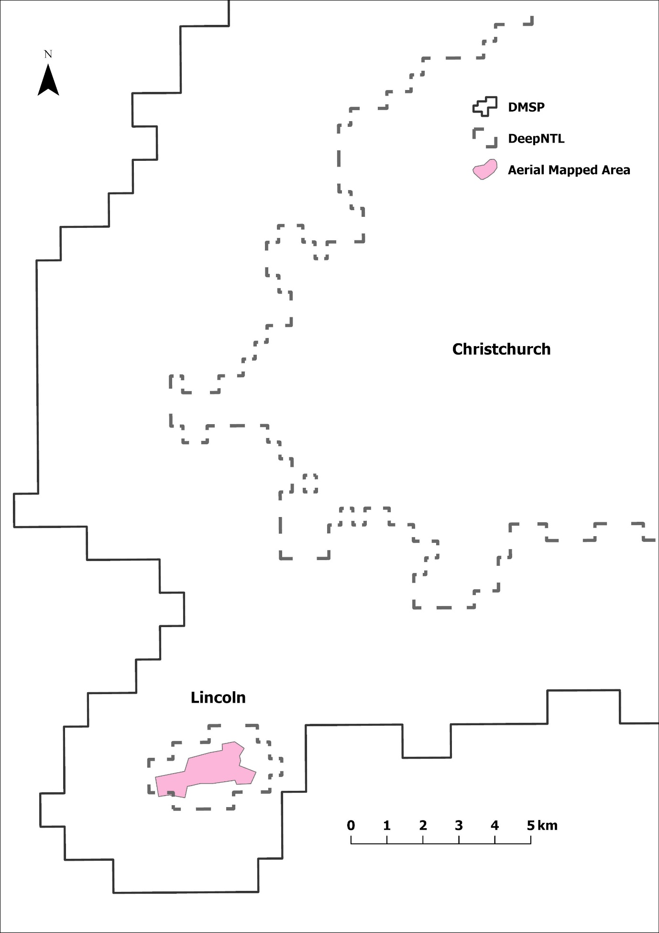

Figure 3: Area Exaggeration in DMSP is Proportionately Larger for Smaller Towns
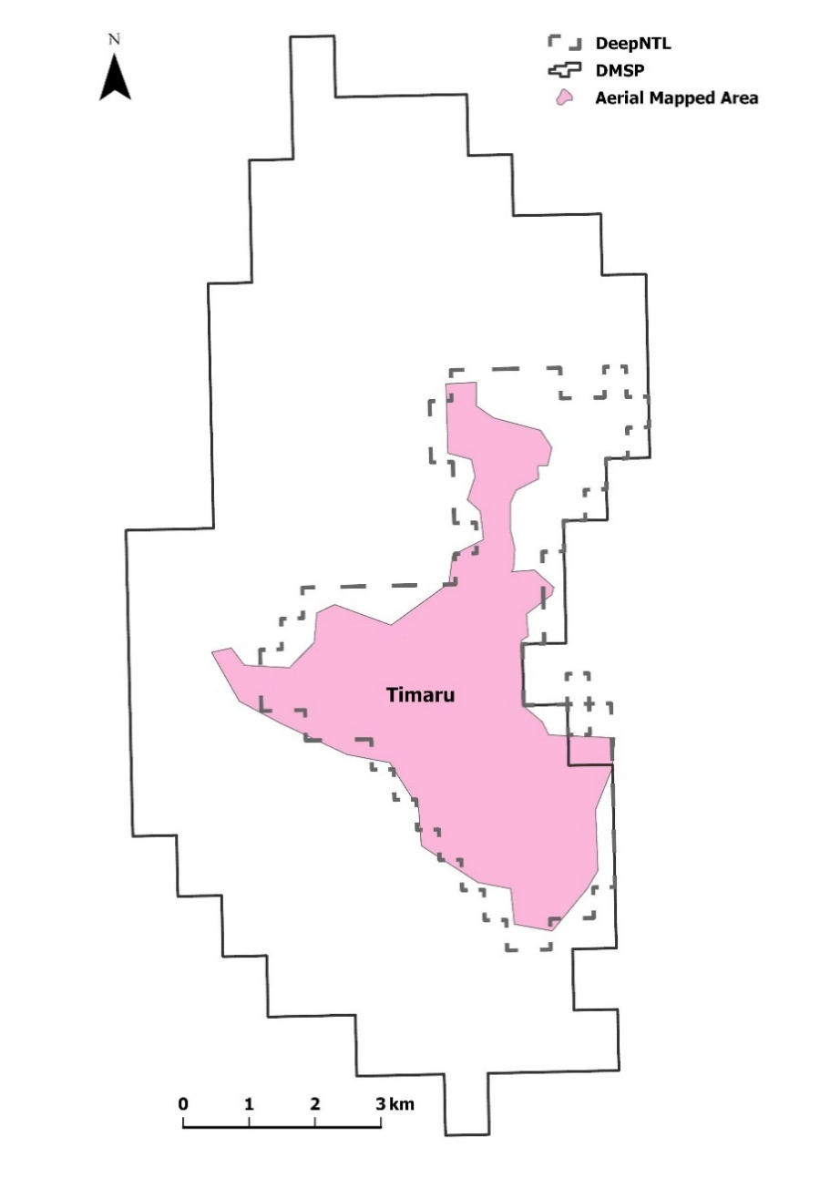 | 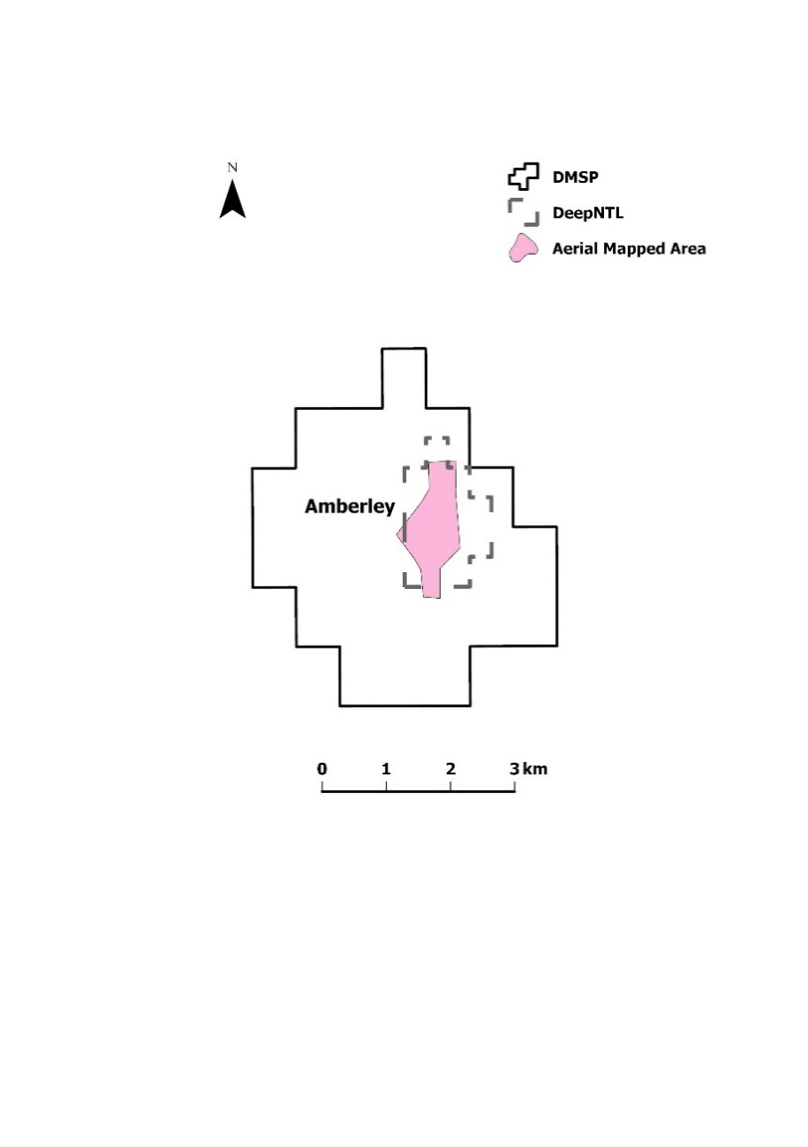

In addition to these spatial problems, the original DMSP series has several time-series inconsistencies that complicate estimation of long-run urban growth trends. The sensors lacked on-board calibration (amplification varied over the lunar cycle with no record kept of setting changes), so the same digital number (DN) across different satellites or years does not necessarily correspond to the same underlying radiance (Gibson et al., 2020). Also, orbital decay caused overpass times to drift progressively earlier as satellites aged. Thus, some apparent changes in lit area may be due to instability in the measurement system itself rather than genuine urban expansion or contraction. Together with the spatial problems discussed above, these limitations motivate the use of reconstructed DeepNTL radiance estimates that attempt to recover a more spatially and temporally consistent long-run series.
2.2 Validation of DeepNTL data
A concern with using harmonization processes to reconstruct NTL data from the DMSP era is that attempts to make VIIRS and DMSP data more alike may inadvertently transfer artefacts from the coarse DMSP imagery into the higher-quality VIIRS era. For example, Gibson et al. (2024) find that harmonized NTL products exaggerate spatial autocorrelation relative to what original VIIRS observations show, giving larger apparent spillovers in their study of typhoon damages in the Philippines. Relatedly, Zhang et al. (2023) show that a common artefact in DMSP data is to understate spatial inequality due to the smoothing of luminosity differences across nearby areas. Such effects would be especially problematic for analysing trends in urban growth (including shrinkage) because blurred urban boundaries and apparent merging of nearby settlements may attenuate differences in local growth trajectories. At the same time, relying solely on the post-2012 VIIRS period, to avoid the need for any data harmonization, is also unsatisfactory because the time-series is then too short for analysing long-run urban change. Consequently, an important first step in our analysis is to assess whether the DeepNTL harmonized data that we use reproduce the spatial structure and temporal evolution observed in actual VIIRS data in the period from 2012, before using the DeepNTL data to extend the study back to the early 1990s.
Specifically, to validate whether DeepNTL provides a credible basis for analysing long-run changes in urban extent, we compare estimates of lit urban area derived from DeepNTL with those obtained from Version 2 VIIRS night-time lights (VNL) during the 2012–2021 overlap period. The correspondence is extremely close. For the average of 2012–13 and across our sample of 133 urban areas, the Pearson correlation between lit areas estimated from VNL and DeepNTL is 0.999, while for 2020–21 it is 0.998. It is more demanding to compare temporal changes rather than levels, and is also more salient given that our interest is in whether towns expand or contract over time. The correlation for long differences in lit area (for 2012–13 to 2020–21) between the VNL and DeepNTL series is 0.855. Thus, based on these exercises, DeepNTL closely reproduces both the spatial extent and temporal evolution of urban areas observed in the higher-quality VIIRS data. This provides support for using DeepNTL to extend analysis of town growth and decline back to the pre-VIIRS era from 1993 onwards.
3. Data and Estimation Strategy
3.1 Sample of Urban Areas
The starting point for the analysis is the 150 most populous urban places in New Zealand as of June 2025. The most populated of these is Auckland, with over 1.5 million people, while the least populous settlement has fewer than 2000 people. In a few cases, individually listed urban areas form part of a larger continuous urban system and therefore are not able to be detected as independent settlements, even using DeepNTL or VIIRS. The largest examples are within the Wellington region, where Lower Hutt, Porirua and Upper Hutt form part of the wider Wellington urban footprint. For smaller towns in that region, Waikanae is not able to be distinguished from the adjacent (and larger) Paraparaumu urban area. A few of the least populated and dimly lit places, such as Lake Hawea, cannot be detected in a majority of the years, and so are dropped from the sample. Overall, we have 133 urban areas that are able to be independently detected in almost all of the 46 satellite-year images.
Figure 4 maps the 133 urban areas included in the analysis. Each urban area is numbered according to its population rank, from Auckland (1) to the least populous settlement in the sample (133), with corresponding names and regions reported in Appendix Table A1. The map uses urban footprints estimated from the F16 satellite in 2007, which is approximately the midpoint of the study period. The overall illuminated urban area covers about 2,300 km², equivalent to just under one percent of New Zealand's land area. Even a cursory inspection of Figure 4 suggests that there is substantial variation in both the size and spatial distribution of the urban settlements in New Zealand, motivating the estimation of town-specific trends.
3.2 Constructing Urban Footprints
For each of the urban areas shown in Figure 4, urban footprints are constructed using a city-growing algorithm that expands outward from a predefined settlement centre until luminosity falls below a specified threshold. The starting point is a centrally located landmark, such as the town hall or a major intersection. Contiguous pixels are then added recursively provided that their luminosity exceeds 2 nW cm⁻² sr⁻¹. This luminosity threshold has previously been used to distinguish urban from non-urban area by Elvidge et al. (2024) and gives estimates for New Zealand that correspond with other independent measures, such as aerial mapping.
The procedure is repeated separately for each satellite-year image, allowing urban footprints to evolve through time in response to expansion or contraction. In other words, this approach contrasts with using administrative boundaries, which may change only slowly, if at all, as settlement patterns evolve. A similar approach has previously been used to study urban expansion in Indonesia (Olivia et al., 2018), where much of the growth occurred beyond the administrative limits of cities. However, that earlier application focused on urban areas with an average population of almost one million. By contrast, the improved spatial fidelity of DeepNTL allows the same city-growing algorithm to be applied to much smaller settlements. As illustrated in Figures 2 and 3, the original DMSP imagery frequently merges neighbouring settlements and disproportionately exaggerates the area of smaller towns, making DMSP a less suitable source for estimating long-run trends in urban extent outside of the largest cities.
For each urban area and satellite-year image, total urban area is calculated as the sum of all contiguous illuminated pixels above the threshold. The resulting panel has 5,985 observations spanning 133 urban areas over the period 1993–2021. These annual measures of illuminated urban area form the basis for estimating long-run rates of expansion and contraction.
3.3 Estimation of Long-Run Rates of Change in Urban Footprints
To estimate town-specific trend rates of area expansion (or contraction), the logarithm of urban area is modelled as a function of a linear time trend interacted with urban-area fixed effects, and also as a function of an additional set of satellite fixed effects:
$lnA_{its}=α_{i}+δ_{s}+\sum_{i}{β_{i}\left({Area}_{i}×t\right)+ε_{its}}$ (1)
where $A_{its}$ is the urban area of settlement $i$in year $t$ as measured by satellite $s$, the $α_{i}$ are urban-area fixed effects, the $δ_{s}$ are satellite fixed effects, and $ε_{its}$ is a random error term. The coefficient $β_{i}$ measures town-specific annual percentage rates of expansion (or contraction) of urban area after controlling for persistent differences across settlements and systematic differences across satellites. The model is estimated using weighted least squares, with observations receiving weight 0.5 when two satellites observe the same calendar year (see Figure 1 for the years with these overlaps amongst the F10, F12, F14, F15, F16 and F18 satellites) and weight 1.0 otherwise. Standard errors are clustered at the urban-area level.

Figure 4: Location of the 133 Urban Areas (see Appendix Table A1 for names)
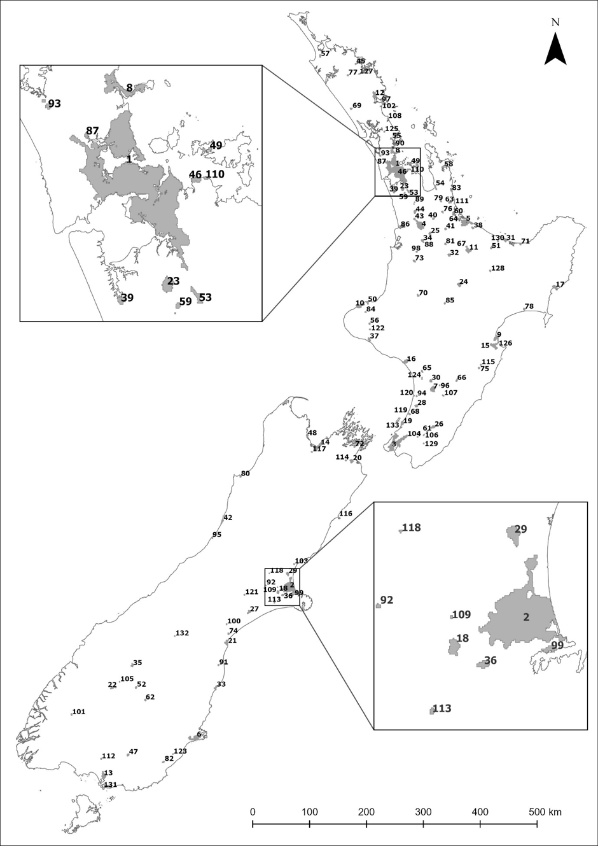

4. Results
The measurement issues documented in Section 2 matter only if they affect conclusions about long-run urban change. To assess importance of these issues (or equivalently, the value-added from using reconstructed DMSP data rather than the original DMSP data), we first compare the distribution of estimated urban growth rates obtained from the DeepNTL series with those obtained from DMSP imagery. Because some towns cannot be independently identified if the original (coarse and blurred) DMSP data are used, the tabular comparison has results for both the full sample of 133 areas and for the 123 urban areas that had expansion rates that could be estimated with the DMSP data. The summary statistics for the estimated trend expansion rates are supplemented with a distributional indicator in the form of smoothed density plots (this is only for the common sample of 123 urban areas).
Figure 5 and Table 1 show that the choice of night-time lights dataset has a substantial effect on estimated urban growth rates. The mean estimated trend using the reconstructed DeepNTL data is positive (0.67% for the n=133 sample and 0.80% for the n=123 sample), so the lit area of the average New Zealand town expanded over the study period at a rate consistent with a doubling time of about one century. Auckland, despite accounting for a large share of New Zealand's absolute urban expansion, recorded an estimated growth rate of only 0.35 percent per annum (p<0.01). Thus, the most rapid growth in proportional terms occurred elsewhere, particularly in smaller commuter and amenity towns.
In contrast to what the DeepNTL data show, the trends estimated with the uncorrected DMSP imagery suggest that the average town or city experienced declining illuminated area. This difference is not because the DMSP estimates are less precise. Indeed, a higher proportion of the DMSP-based trends are statistically significant at the 5 percent level than is the case for when DeepNTL data are used. Instead, the principal effect of the DMSP measurement problems appears to be a systematic downward bias in estimated rates of urban expansion, consistent with the overstatement of illuminated area being proportionately larger when towns were smaller. The complete set of town-specific trend estimates, together with their standard errors, t-statistics and p-values, is reported in Appendix Table A1.
While Figure 5 and Table 1 establish that the distribution of estimated growth rates differs markedly between the reconstructed and original night-time lights data, aggregate statistics conceal considerable variation across individual towns. Some settlements expanded at rates far above the national average, while others experienced sustained contraction over the three decades of observation. Examining these tails of the distribution helps to clarify some of the factors associated with long-run urban growth and decline.
Figure 5: Distribution of Estimated Urban Area Expansion Rates from DMSP and DeepNTL

Table 1: Summary Statistics for the Estimated Trend Rates of Urban Area Change
 | DeepNTL |  | DMSP
 | N=133 | N=123 | N=123
Mean | 0.0067 | 0.0080 | −0.0191
5th percentile | −0.0164 | −0.0102 | −0.0724
50th percentile (median) | 0.0030 | 0.0030 | −0.0197
95th percentile | 0.0521 | 0.0521 | 0.0373
% of statistically significant trends | 82.7% | 81.3% | 95.9%
Note: The trends are estimated using equation (1) with standard errors clustered at the town level.

4.1 Fast-Growing and Declining Towns
Tables 2 and 3 list the towns at the upper and lower tails of the growth-rate distribution, from the estimates using the DeepNTL data. Table 2 is for the 12 towns with estimated expansion rates exceeding 2.5 percent per annum (more than 1 standard deviation above the mean) and with statistically significant trends (p < 0.05). At the other end of the distribution, Table 3 has details on the 33 towns that had statistically significant negative growth rates in lit area over the 1993–2021 period (in contrast, 77 towns had positive growth rates with p < 0.05).

The expansion of the towns at the upper tail of the growth-rate distribution in Table 2 is due to several causes, with no obvious relationship between their population rank (that also serves as the key in the Figure 4 location map) and their estimated rate of expansion. The fastest growing town is Rolleston, with a trend expansion rate of 10.3 percent per annum, and this is an example of a commuter and satellite town whose growth appears to be closely linked to a nearby metropolitan centre (Christchurch). Likewise, nearby West Melton and Oxford have grown rapidly - consistent with population spreading after the Christchurch earthquakes, with post-earthquake growth occurring in neighbouring districts (Selwyn and Waimakariri) rather than just in Christchurch itself. While Pokeno and Te Kauwhata are in the northern part of the Waikato region, they are commuter-oriented towns benefitting from proximity to Auckland.
Table 2: Towns Where Illuminated Area is Expanding Rapidly
Population Rank | City/Town | Region | Trend | Std error | t-statistic
18 | Rolleston | Canterbury | 0.1026 | 0.0005 | 191.3852
22 | Queenstown | Otago | 0.0256 | 0.0009 | 28.1643
35 | Wanaka | Otago | 0.0568 | 0.0009 | 64.4152
53 | Pokeno | Waikato | 0.0452 | 0.0009 | 50.1263
58 | Whitianga | Waikato | 0.0462 | 0.0009 | 51.9697
64 | Omokoroa | Bay of Plenty | 0.0878 | 0.0008 | 106.4452
89 | Te Kauwhata | Waikato | 0.0485 | 0.0009 | 54.2724
97 | One Tree Point | Northland | 0.0655 | 0.0009 | 71.9820
102 | Ruakaka | Northland | 0.0788 | 0.0010 | 81.7510
109 | West Melton | Canterbury | 0.0539 | 0.0004 | 135.8298
118 | Oxford | Canterbury | 0.0501 | 0.0009 | 54.5707
133 | Paekakariki | Wellington | 0.0521 | 0.0009 | 58.2135
Note: The population rank is also the map key in Figure 4. Robust standard errors clustered at city/town-level.

A second group of towns consists of amenity and tourism-oriented settlements, including Queenstown and Wanaka, together with coastal destinations such as Whitianga, Omokoroa and Paekakariki. These locations appear to have benefited from the increasing importance of lifestyle migration, domestic tourism and, in the case of the Queenstown-Lakes settlements, the rapid expansion of Queenstown Airport (now the fourth busiest in New Zealand, despite Queenstown-Lakes district being only the 25th (out of 67) most populated territorial local authority).
Finally, two nearby Northland settlements—Ruakaka and One Tree Point—also expanded but trends for these two towns should be interpreted cautiously. They are both near to Marsden Point, where the oil refinery ceased operation in 2022 (just after our time-series ends) and the conversion of that industrial facility to an oil import terminal entailed a considerable loss of employment which may affect the ongoing expansion prospects for these two nearby towns. Once the VIIRS time-series becomes long enough, it may be possible to test whether these two settlements reversed their expansion after the closure of the oil refinery.
The contraction of lit area of the NZ towns listed in Table 3 is also from several causes. Large changes in rural land use, with sheep replaced by dairy and forestry, caused major disruptions to many rural towns. The sheep flock fell from around 70 million in the 1980s to 23 million, with closure of many export meat works and wool processing (scouring, milling, knitting) plants—at peak these contributed about four percent of total employment (ca.50,000 workers) but now just over one percent of total New Zealand employment is in these industries. For example, when the Waingawa freezing works closed in 1989 it was the largest employer in the Wairarapa, creating a negative effect on nearby Masterton. Likewise, Oringi freezing works closed in 2008 with negative impacts on Dannevirke, while Godfrey Hirst and AFFCO closures in 2009 impacted Feilding and Foxton. Closure of the Alliance woollen mill in 1999 impacted Milton, and closure of Summit Woolspinners in 2013 impacted Oamaru.
Table 3: Towns Where Illuminated Area is Contracting
Population Rank | City/Town | Region | Trend | Std error | t-statistic
16 | Whanganui | Manawatu-Whanganui | −0.0033 | 0.0009 | 3.6683
26 | Masterton | Wellington | −0.0019 | 0.0009 | 2.0872
30 | Feilding | Manawatu-Whanganui | −0.0021 | 0.0009 | 2.3113
33 | Oamaru | Otago | −0.0063 | 0.0009 | 6.9273
37 | Hawera | Taranaki | −0.0056 | 0.0009 | 6.1642
47 | Gore | Southland | −0.0026 | 0.0009 | 2.8544
49 | Waiheke Island | Auckland | −0.0596 | 0.0009 | 67.0545
54 | Thames | Waikato | −0.0164 | 0.0009 | 18.0667
56 | Stratford | Taranaki | −0.0102 | 0.0009 | 11.2573
61 | Carterton | Wellington | −0.0025 | 0.0009 | 2.7332
62 | Alexandra | Otago | −0.0121 | 0.0009 | 13.3010
63 | Waihi | Waikato | −0.0040 | 0.0009 | 4.3405
66 | Dannevirke | Manawatu-Whanganui | −0.0021 | 0.0009 | 2.3316
67 | Ngongotaha | Bay of Plenty | −0.0180 | 0.0007 | 25.7381
70 | Taumarunui | Manawatu-Whanganui | −0.0171 | 0.0009 | 18.7760
71 | Opotiki | Bay of Plenty | −0.0019 | 0.0009 | 2.0371
75 | Waipukurau | Hawke's Bay | −0.0030 | 0.0009 | 3.3412
77 | Kaikohe | Northland | −0.0080 | 0.0009 | 8.7467
80 | Westport | West Coast | −0.0020 | 0.0009 | 2.1989
82 | Balclutha | Otago | −0.0069 | 0.0009 | 7.5367
84 | Inglewood | Taranaki | −0.0027 | 0.0009 | 3.0099
85 | Turangi | Waikato | −0.0126 | 0.0009 | 13.8632
87 | Riverhead | Auckland | −0.0360 | 0.0009 | 39.1178
94 | Foxton | Manawatu-Whanganui | −0.0041 | 0.0009 | 4.4992
100 | Geraldine | Canterbury | −0.0032 | 0.0009 | 3.5123
101 | Te Anau | Southland | −0.0075 | 0.0009 | 8.2667
106 | Greytown | Wellington | −0.0044 | 0.0009 | 4.9507
119 | Otaki Beach | Wellington | −0.0360 | 0.0009 | 40.1079
120 | Foxton Beach | Manawatu-Whanganui | −0.0024 | 0.0009 | 2.5410
123 | Milton | Otago | −0.0048 | 0.0009 | 5.2940
126 | Clive | Hawke's Bay | −0.0446 | 0.0009 | 49.0209
130 | Edgecumbe | Bay of Plenty | −0.0021 | 0.0009 | 2.3316
132 | Twizel | Canterbury | −0.0152 | 0.0009 | 16.6081
Note: The population rank is also the map key in Figure 4. Robust standard errors clustered at city/town-level.

While the switch from sheep to dairy farming gives a more intensive use of land with higher on-farm labour use, far less labour is used to process dairy products for export than was used for exports from the sheep industry. Moreover, dairy industry expansion occurred elsewhere, such as Canterbury and Southland, and so did not necessarily offset the employment losses from closure of meat works and wool processing plants. The conversion of North Island hill country farms to forestry has also adversely affected rural towns, especially in the Gisborne, Manawatu and Hawke’s Bay regions, for two reasons. First, there is less labour needed to plant and maintain trees (primarily Pinus Radiata) especially where the tree-planting is for carbon-farming reasons and so there may be little harvest-related labour demand. Second, even with expansion of forested area, there has been a sustained contraction in timber milling and wood processing due to high domestic energy prices and so more wood is being exported as logs. For example, the closure of Mataura Paper in 2000 negatively affected nearby Gore, and closure of the Kopu sawmill in 2008 affected Thames (which had earlier been affected by closure of the Toyota car assembly plant after the removal of tariffs in 1987). More recently, there have been mill closures near Edgecumbe, Kaikohe, Taumarunui and Turangi.
Resource depletion and changing energy policies have also contributed to contraction in some towns. The depletion of gas fields in Taranaki affected settlements such as Stratford and Hawera. On the West Coast, declining demand for coal and restructuring of the mining sector contributed to contractions in towns such as Westport following the collapse of Solid Energy and the subsequent downsizing of mining operations. In Waihi, suspension of mining at the Martha Pit in 2015 reduced economic activity in a town whose development had long been tied to mineral extraction. These examples show how towns dependent on non-renewable resources can face contraction when resource endowments diminish, extraction becomes uneconomic, or environmental policies alter the viability of particular industries.
Natural hazards and changing perceptions of environmental risk may also influence long-run urban trajectories. Edgecumbe provides a notable example, where an earthquake and then a sequence floods have harmed urban development. Other towns, including Ngongotaha and Westport, have experienced repeated flooding events, while concerns about future flood or coastal inundation risk may have affected development in locations such as Riverhead, Clive and Otaki Beach. Thus, contraction is not solely a consequence of changing commodity markets and industrial restructuring. Natural hazards, environmental risks, and rationalization of services in smaller centres can also contribute to declining urban footprints.
There is at least one anomaly in Table 3, which is Waiheke Island, located 40 minutes from Auckland city by public ferry. While the resident population is growing slowly, from about 8,300 in 2013 to around 9,000 in both the 2018 and 2023 censuses, this population swells seasonally due to visitors and so the lit area footprint from accommodation and hospitality is likely greater than for typical towns with population of around 9,000. Moreover, Waiheke is also one of New Zealand’s most expensive housing markets, with average house prices more than double those of the greater Auckland area, so it is not plausibly a declining or distressed settlement in the usual regional-development sense. A more likely explanation for its negative trend in illuminated area is deliberate restraint on artificial lighting, associated with local efforts to obtain dark-sky recognition. Thus, Waiheke illustrates an important limitation of using night-time lights: in places where reduced illumination is itself an amenity or policy objective, falling luminosity may reflect environmental preferences rather than contraction of settlement or economic activity.
5. Discussion and Conclusions
This paper has examined long-run changes in the physical extent of 133 New Zealand towns and cities using reconstructed night-time lights data from 1993 to 2021. The results reveal substantial heterogeneity in urban trajectories. Rapid expansion is concentrated in commuter settlements surrounding major cities, particularly in Canterbury and the northern Waikato, and in amenity-oriented locations such as the Queenstown Lakes district and selected coastal towns. At the same time, a number of smaller settlements exhibit persistent contraction. These declines are not attributable to a single cause but instead reflect a range of processes, including restructuring of pastoral agriculture and associated processing industries, changing patterns of employment and service provision, natural hazards and shifts in the relative attractiveness of different locations. Taken together, the results suggest that regional change in New Zealand is characterised less by uniform growth or decline than by increasingly differentiated urban trajectories.
A second contribution of the paper is methodological. Previous studies have often treated night-time lights data as a homogeneous source of information, with relatively little attention paid to differences between sensor generations and the implications of spatial resolution for the questions being studied. For large metropolitan areas, the coarse spatial footprint of the original DMSP imagery may be of limited consequence. However, for the smaller settlements that comprise much of New Zealand’s urban system, the measurement problems inherent in DMSP can materially affect inference. The results reported here show that the original DMSP imagery both obscures the independent evolution of some towns and seems to systematically understate rates of urban expansion, to the point that the average settlement appears to be shrinking rather than growing. More generally, our findings highlight the importance of considering the spatial properties of remotely sensed data when using them to study long-run urban dynamics, regional inequality, or local economic development.
The availability of reconstructed night-time lights series also creates new opportunities for regional science research. In New Zealand, annual measures of urban extent provide a useful complement to census-based population statistics because they allow settlement footprints to evolve through time rather than remaining fixed by administrative definitions. More broadly, the approach developed here could be used to examine changing urban hierarchies, the effects of transport infrastructure, the growth of commuter belts around major cities, and the role of natural amenities in shaping settlement patterns. The results described here suggest that concerns about “zombie towns” capture only part of the story of regional change despite their prominence in the media. While some settlements have experienced long-run contraction, others have expanded rapidly through amenity migration, tourism growth, and closer integration with larger urban centres. Understanding these increasingly differentiated trajectories remains an important challenge for both regional science and regional policy.

References
Abrahams, A., Oram, C., & Lozano-Gracia, N. (2018). Deblurring DMSP nighttime lights: A new method using Gaussian filters and frequencies of illumination. Remote Sensing of Environment, 210, 242-258.
Abramitzky, R., Boustan, L. P., & Storeygard, A. (2025). New Data and Insights in Regional and Urban Economics. In Handbook of Regional and Urban Economics D. Donaldson and S. Redding (eds), Vol. 6, Chapter 11, pp. 715-777.
Bilicka, K., & Seidel, A. (2026). Measuring firm activity from outer space. Journal of Economic Geography (https://doi.org/10.1093/jeg/lbag021)
Brabyn, L. (2017). Declining towns and rapidly growing cities in New Zealand: developing an empirically-based model that can inform policy. Policy Quarterly, 37(1): 37-46.
Cameron, M. P., & Cochrane, W. (2017). Using land-use modelling to statistically downscale population projections to small areas. Australasian Journal of Regional Studies, 23(2), 195-216.
Coleman, A. M. G., Maré, D. C., & Zheng, G. (2019). New jobs, old jobs: The evolution of work in New Zealand's cities and towns. Working Paper No. 2019/1. New Zealand Productivity Commission, Te Kōmihana Whai Hua o Aotearoa.
Eaqub, S. (2014). Growing Apart: Regional Prosperity in New Zealand. Wellington: Bridget Williams Books.
Elvidge, C. D., Baugh, K. E., Kihn, E. A., Kroehl, H. W., & Davis, E. R. (1997). Mapping city lights with nighttime data from the DMSP Operational Linescan System. Photogrammetric Engineering and Remote Sensing, 63(6), 727-734.
Elvidge, C. D., Baugh, K. E., Zhizhin, M., & Hsu, F. C. (2013). Why VIIRS data are superior to DMSP for mapping nighttime lights. Proceedings of the Asia-Pacific Advanced Network, 35(1), 62-69.
Elvidge, C. D., Zhizhin, M., Ghosh, T., Hsu, F. C., & Taneja, J. (2021). Annual time series of global VIIRS nighttime lights derived from monthly averages: 2012 to 2019. Remote Sensing, 13(5), 922.
Elvidge, C. D., Hsu, F. C., Zhizhin, M., Ghosh, T., & Sparks, T. (2024). Statistical moments of VIIRS night-time lights. International Journal of Remote Sensing, 45(21), 7778-7802.
Ghosh, T., Baugh, K., Elvidge, C., Zhizhin, M., Poyda, A., & Hsu, F-C. (2021). Extending the DMSP nighttime lights time series beyond 2013. Remote Sensing, 13(24), 5004.
Gibson, J., Boe-Gibson, G., & Stichbury, G. (2015). Urban land expansion in India 1992–2012. Food Policy, 56, 100-113.
Gibson, J., Datt, G., Murgai, R., & Ravallion, M. (2017). For India’s rural poor, growing towns matter more than growing cities. World Development, 98, 413-429.
Gibson, J., Olivia, S., & Boe‐Gibson, G. (2020). Night lights in economics: Sources and uses. Journal of Economic Surveys, 34(5), 955-980.
Gibson, J. (2021). Better night lights data, for longer. Oxford Bulletin of Economics and Statistics, 83(3), 770-791.
Gibson, J., Jiang, Y., Zhang, X., & Boe-Gibson, G. (2024). Are disaster impact estimates distorted by errors in popular night-time lights data? Economics of Disasters and Climate Change, 8(3), 391-416.
Grimes, A., & Young, C. (2011). Spatial effects of ‘mill’ closures: Does distance matter? Australasian Journal of Regional Studies, 17(3), 264-299.
Grimes, A., Apatov, E., Lutchman, L., & Robinson, A. (2016). Eighty years of urban development in New Zealand: impacts of economic and natural factors. New Zealand Economic Papers, 50(3), 303-322.
Guo, J., Zhang, F., Zhao, H., Pan, B., & Mei, L. (2025). Global reconstruction of three decades of fine-grained nighttime light data with analysis of large-scale infrastructure and landmarks. Remote Sensing of Environment, 331, 115036.
Jackson, N., & Cameron, M. P. (2018). The unavoidable nature of population ageing and the ageing-driven end of growth–an update for New Zealand. Journal of Population Ageing, 11(3), 239-264.
Jackson, N., Brabyn, L., Maré, D., Cameron, M., & Pool, I. (2019). From ageing-driven growth towards the ending of growth. Subnational population trends in New Zealand. In J. Anson, W. Bartl, A. Kulczycki (eds) Studies in the Sociology of Population: International Perspectives (pp. 161-193). Cham: Springer International Publishing.
Nel, E., Connelly, S., & Stevenson, T. (2019). New Zealand's small town transition: The experience of demographic and economic change and place based responses. New Zealand Geographer, 75(3), 163-176.
Olivia, S., Boe‐Gibson, G., Stitchbury, G., Brabyn, L., & Gibson, J. (2018). Urban land expansion in Indonesia 1992–2012: Evidence from satellite‐detected luminosity. Australian Journal of Agricultural and Resource Economics, 62(3), 438-456.
Small, C., Pozzi, F., & Elvidge, C. D. (2005). Spatial analysis of global urban extent from DMSP-OLS night lights. Remote Sensing of Environment, 96(3-4), 277-291.
Tuttle, B. T., Anderson, S. J., Sutton, P. C., Elvidge, C. D., & Baugh, K. (2013). It used to be dark here. Photogrammetric Engineering & Remote Sensing, 79(3), 287-297.
Zhang, X., Gibson, J., & Deng, X. (2023). Remotely too equal: Popular DMSP night‐time lights data understate spatial inequality. Regional Science Policy & Practice, 15(9), 2106-2126.

Appendix

Media coverage of this issue goes back more than a decade. An early example is: https://www.nbr.co.nz/nz-has-zombie-towns-that-need-to-close-economist/ and a more recent one is: https://www.stuff.co.nz/nz-news/350434392/nzs-zombie-towns-rural-areas-edge-extinction
DMSP and DeepNTL data are available for 1992 but data for that year are not used in this analysis because many towns have zero detected illuminated area in 1992 and aggregate illuminated area is anomalously low relative to subsequent observations and to independent measures. The last year with DMSP data available is 2021 so the estimation sample covers 1993–2021.
Post-2013 DMSP observations shown in Figure 1 are the DMSP extension series developed by Ghosh et al. (2021). The unstable DMSP orbits, where earth was observed earlier as the satellite aged, yielded pre-dawn NTL observations from some older satellites, such as F15 and F16, that had first provided data in the early 2000s.
Source: https://ecanmaps.ecan.govt.nz/portal/home/item.html?id=d5a534bd1620498e941b620267ceeab7 with the Ministry of Primary Industries acknowledged for the original provision of these data.
One reason the DeepNTL boundaries show an outer envelope (i.e., larger than what the aerial mapping shows) is that the 30 arc-second (ca. 0.7 km²) grid-cell is classified as illuminated if any part of it exceeds the detection threshold of 2 nW/cm²/sr. In contrast, the aerial mapping has a finer (35 metre) resolution.
This comparison uses the masked average VNL product from Elvidge et al. (2021).
See here: https://www.stats.govt.nz/information-releases/subnational-population-estimates-at-30-june-2025/ A concern with using end-period data to define a sample is ‘survivorship bias’ where declining towns disappear from the population rankings. However, using a similar ranking of the most populated towns and cities from the 2013 Census shows that none of them had dropped out of the 2025 rankings used here.
Other examples include Richmond as not distinguished from Nelson, Havelock North as not distinguished from Hastings, and Kaiapoi, Woodend and Prebbleton as part of Christchurch.
The appendix has the full set of estimated growth trends, standard errors, t-statistics and significance levels for each urban area, as a more practical way of presenting the detailed results than a conventional regression table (with an intercept fixed effect per urban area interacted with the slope such a table would have over 250 rows).
This is only one-half of the expansion rate of Christchurch (0.73% per annum), and also less than the rate for Hamilton (0.50%) and Tauranga (1.17%) amongst the cities with population exceeding 100,000. For the other two cities in this population size-class (Dunedin and Wellington), the null hypothesis of no lit area expansion over the 1993–2021 period could not be rejected.
This result may appear counterintuitive because more accurate data are often expected to yield more precise estimates. However, the measurement errors in DMSP are mean-reverting rather than random noise (Gibson, 2021), and strong mean reversion reduces variance and so can lead to smaller standard errors and a higher proportion of statistically significant coefficients, even when the estimated trend rates themselves are biased.
While the Waingawa closure is prior to our sample, effects likely persisted well into the 1990s. Grimes and Young (2011) show that after plant closures in ‘mill’ towns in New Zealand the workers may remain stuck there even after losing their jobs because local house prices fall, making relocation costly and slowing the adjustment.
For example, development of a large Fonterra dairy factory in Darfield, Canterbury since 2010 contributed to the 1.6% per annum expansion rate for that town. Notably, Canterbury is a new area for (irrigated) dairying. At the beginning of our time-series, dairying was predominantly in Taranaki and Waikato (just 4% of the national dairy herd was in Canterbury and Southland). By the end of our time-series one-third of the national herd was in these two South Island regions, at the expense of a declining share for Taranaki. Towns such as Inglewood (with a trend contraction rate of −0.3% per annum) were negatively affected by dairy factory closures in Taranaki.
Changes in land levels after the 1987 earthquake increased flood exposure and contributed to a sequence of later flood events, showing how natural disasters can cumulatively affect long-run development trajectories.
Twizel may partly reflect a similar mechanism because it lies within the Aoraki Mackenzie International Dark Sky Reserve. However, Twizel also suffered a planned decline early in our time series, with population falling from ca. 6,000 in the 1970s to only 1,000 in the 1990s after the construction phase of the Upper Waikato hydro scheme was completed. Many of the dwellings were relocated elsewhere or demolished, thereby reducing the urban footprint.

